Improving Vending Services for Universities

Victor Rodriguez
Arch 272 Research Paper Outline
Professor Ralph Bennett
Teaching Assistant Nichelle Ellyce Rahming Williams
April 24, 2025

Improving Vending Services for Universities

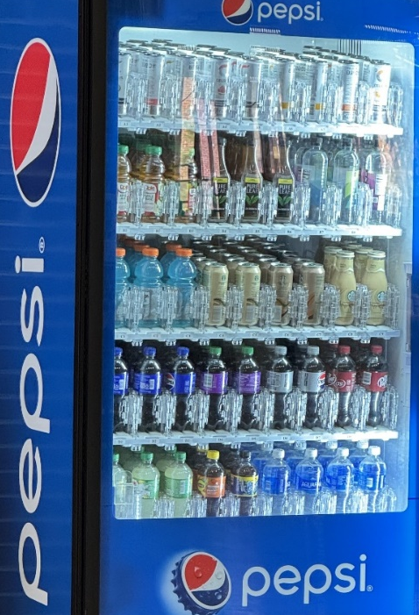
University of Maryland (UMD) campus vending machines have 45 drink choices with only 15 nonplastic container options. Photo evidence attained during on campus research. UMD encourages solid waste reduction as part of various climate action plan goals, but vending machine plastic waste sets us back. Fiber or metal bottles provide sustainable plastic substitutes and adding refill stations across campus reduces plastic emissions. Investing in metal cans drives the campus to use efficiently recyclable containers and decreases plastic waste while advancing carbon reduction. Students who do not use vending machines but have reusable bottles, installing self-serve fountain options with diverse drinks in dining halls benefits sustainability. Fully recyclable fiber-based bottles can be tested at universities, supporting efforts of innovating recyclable technology.
Figure 1 UMD Vending Machine

The Problem
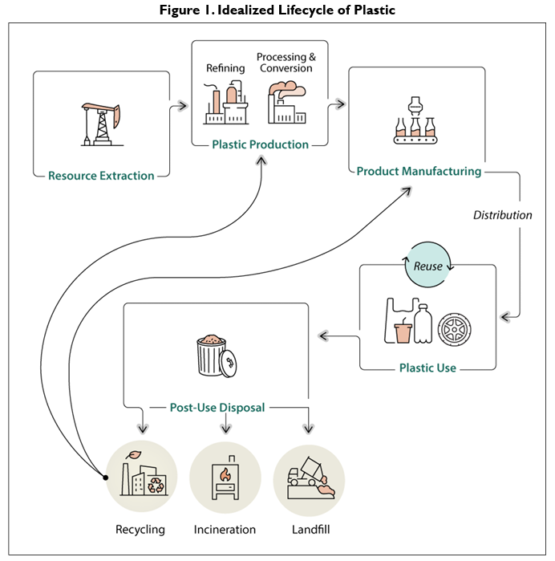
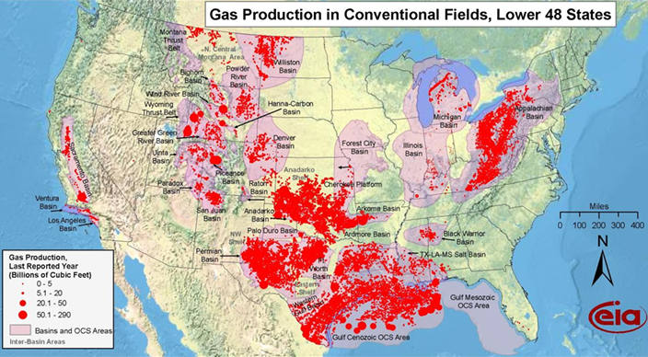
Plastics produce less greenhouse gases (GHG) than steel production, but the effect of plastic carbon emissions grows exponentially because everything manufactured uses plastic, like tires, electronics, and clothes. Plastic is the prime material in household items on Earth and humanity is paying the consequences with polluted air. The Environmental Protection Agency (EPA) reported in their 2024 GHG inventory that ethylene production accounts for a 43% rise in carbon dioxide emissions from 2019 to 2022. Critical problems of plastic greenhouse gas emissions start with how it’s made at oil refineries. The first stage of primary plastic production involves extracting ethylene from crude oil or natural gas, then refining the extracted hydrocarbons in stage two, the last stage is molding bottles from virgin plastic materials. A detailed diagram is pictured here, including the recycling and reuse phases. Polyethylene terephthalate (PET) is the most common plastic used in drink containers and clothes; it is also the most recyclable. Due to increasing market demand, PET production emits 21% of plastic greenhouse gas emissions globally, the highest amount of any plastic produced. Global markets produce plastic at industrial levels, leading to high emission costs, thus counteracting recycling attempts and negating carbon neutrality. Plastics are better eliminated from all industrial manufacturing and engineering. For now, society can only mitigate by installing carbon capture systems at plastic refining plants across the United States, detailed locations below.
Figure 2 Plastic Lifecycle
Figure 3 Fossil Fuel deposits in the United States, where plastic starts it lifecycle as ethylene.
Plastic is an affordable material for companies to generate moldable bottled products, leaving high levels of waste behind in the process. For individual consumers all we can do is recycle, but who holds corporations accountable. Negatives of plastic recycling are most recycled PET bottles are only reused in nonfood containers due to possible hazardous plastic contamination after remolding. Regulations limit how many times plastics can be recycled until it ends up in a landfill due to degradation. A better solution is to start at the source of the problem and pivot alternatives like metal or fiber food safe products. In an interview with Simon Lowden, former Pepsi Co Chief Sustainability Officer, he speaks on plastic reusability “Two thirds of the world’s population today cannot use PET recycled products in food grade products due to government regulations. Solving this problem requires us as an industry”. Mr. Lowden emphasizes a future of corporate collaborations and partnerships for industrial waste management. Communities participate in plastic collection and mitigation across campus and the United States, so one would assume they are doing their part to offset waste. Reality is the number of bottles going missing in recycling facilities is overwhelming. In the United States 18% of all PET plastics are recycled, but 27% of product is lost in sorting and processor facilities.

Solutions
Metal can versions of most beverage brands are already industrialized but costly to produce compared to plastic bottles. Corporations can choose to offset costs and carbon emissions in metal smelting processes by replacing factory power generation with hydropower plants. Adding carbon capture systems at metal refining plants would reduce GHG emissions levels closer to plastic refining standards.
Altering the University of Maryland PepsiCo contract with canned drink companies like Liquid Death or Aura Bora supports an adaptable solution. Restructuring negotiations to existing vending contracts to support plastic free campus solutions may lead Pepsi to providing their own canned beverage options. UMD could set an example for major universities to follow for their own environmental benefits. Replacing plastics in the vending machines with metal cans will lead to reduced waste in landfills and on campus.
Exchanging plastics with steel creates a shift in which natural biocapacity is used, from fossil fuels to raw natural ores. Both materials are naturally limited in the environment, but when plastic ends up in a landfill’s, decades pass before plastic biodegrades compared to metals, which oxidize and decompose in shorter lifespans. Changes can be implemented in how blast furnaces produce iron with advancements in carbon capture recycling at plants. Advancements in carbon capture technology allow carbon dioxide generated to be converted into hydrogen that can be reused as energy. Steel furnace energy will be repurposed within the same facilities, creating a net zero circular economy of production. Carbon reuse technology is expensive but the cost of sustainability for future generations is priceless, so we must act sooner before the effects are irreversible.
Eliminating vending machines completely and using fountain stations would force students into acquiring reusable bottles, promoting sustainable living. New fountains can have options of sports drinks, coffee stations exist, why not healthier choices. Universities could even provide students with bottles in student welcome care packages. Issued bottles can be stainless-steel, which has a longer shelf life and are durable. Students that use vending machines due so because they have a preferred beverage. Giving the students unlimited refills at dining halls can make sure they don’t have to pay for these drinks. Changing how students refill drinks at dining halls affects existing contracts, but reducing vending machine usage means less PET waste and a sustainable campus.
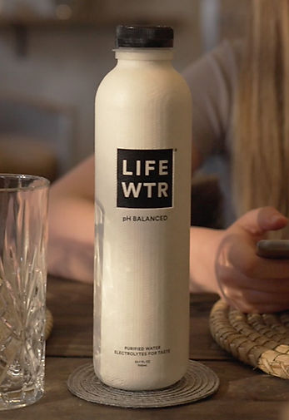
Pulpex developed a fiber technology that blends cellulose tree fibers into bottle molds to create a revolutionary 100% recyclable container. PepsiCo began partnering with Pulpex in 2021 to sponsor a plasticless future. Lifewtr is one of the first Pepsi water brands that has a useable prototype, imaged here. While the technology is not ready for public release, PepsiCo was able to reduce virgin plastic tonnage by 6% in 2023. Rapid growth at Pulpex requires real world integration testing, UMD may be able to assist. New fiber bottles can be used on the 40000-student campus for market testing research. Incorporating the sustainability fund grant to lease the technology may lead to UMD students improving the product within our materials engineering labs.
Figure 4 PepsiCo LIFEWTR brand Pulpex sample.
The versatility of paper bottles creates no change to existing recycling programs, since fiber qualifies as paper waste. Pulpex production generates 30% less carbon emission than PET, changing carbon reduction at an industrial level. Pulpex cannot move forward alone, Universities can provide industry level expertise. University of Surrey and Bangor University have helped advance the manufacturing process with new watertight inner lining barriers and cellulose derived from sugar beet. University of Maryland and PespiCo could be the first partnership to put into practice a revolutionary material.
The University of Maryland is on a long journey to create a sustainable environment for students and local communities. Being a leader in plastic elimination cements foundations for sustainable waste change, involving less work and waste for everyone. Replacing plastics with sustainable fiber or metal materials makes waste more manageable at landfills. Suppose someone leaves a bottle in a creek, these new options will efficiently biodegrade. Plastic does not have the luxury of quick decomposition and is micromanaged throughout the recycling process. Our future relies on humanity expediting waste mitigation efforts in local communities, and College Park can motivate its partners for necessary changes in how we consume and create waste.

Bibliography

Atanu, Mukherjee. Carbon Capture Program R&D Compendium of Carbon Capture Technology 2024. Compendium of Carbon Capture Technology, Ridgewood, NJ: National Energy Technology Laboratory, 2025. https://netl.doe.gov/sites/default/files/2025-01/Carbon-Capture-Compendium-2024.pdf.

EPA. Inventory of U.S. Greenhouse Gas Emissions and Sinks: 1990-2022. GHG Inventory EPA 430-R-24-004, Washington, DC: U.S. Environmental Protection Agency, 2024. https://www.epa.gov/ghgemissions/inventory-us-greenhouse-gas-emissions-and-sinks-1990-2022.

Gatz, Laura, Clare Y. Cho, Omar M. Hammad, Jonathan D. Haskett, Kristen A. Hite, Angela C. Jones, Claire M. Jordan, Eva Lipiec, and Jerry H. Yen. Plastic Pollution and Policy Considerations: Frequently Asked Questions. CRS R48293, Washington, DC: Congressional Research Service, 2025. https://www.congress.gov/crs-product/R48293.

Innovate UK. “Sustainable Bio-Based Materials and Manufacture Case Study: Pulpex.” Case Study Video: IUK SusBioMM Programme, February 17, 2025. https://iuk-business-connect.org.uk/programme/sustainable-bio-based-materials-and-manufacture/.

Jones, Angela C., and Ashley J. Lawson. Carbon Capture and Sequestration (CCS) in the United States. CRS R44902, Washington, DC: Congressional Research Service, 2022. https://www.congress.gov/crs-product/R44902.

Karali, Nihan, Nina Khanna, and Nihar Shah. Climate Impact of Primary Plastic Production. LBNL-2001585, Berkeley, CA: Lawrence Berkeley National Laboratory, 2024. https://eta-publications.lbl.gov/sites/default/files/2024-09/climate_and_plastic_report_lbnl-2001585.pdf.

Musick, Nathan. Carbon Capture and Storage in the United States. CBO 59345, Washington, DC: Congressional Budget Office, 2023. http://www.cbo.gov/publication/59345.

PepsiCo. Pepsico 2023 ESG Summary. PepsiCo, August 6, 2024. https://www.pepsico.com/docs/default-source/sustainability-and-esg-topics/2023-esg-summary/pepsico-2023-esg-summary.pdf.

Pulpex Ltd. LIFEWTR. Pulpex Home. Pulpex Ltd, 2025. https://www.pulpexhome.com/.

———. “Mission: Pulpex: Renewable Packaging.” Pulpex Mission. Last modified 2025. https://www.pulpex.com/mission.

Rodriguez, Victor. personal photograph, “UMD Vending Machine”, 2025.

Schmida, Steve. “PepsiCo on Partnerships and the Circular Economy (Q&A)”. Interview. Resonance, April 20, 2020.

Selke, Susan. “Recycling: Polymers.” Encyclopedia of Materials - Science and Technology. Kidlington, Oxford: Elsevier Science Ltd, 2001.

Thomas, Douglas, Joshua Kneifel, and David Butry. The U.S. Plastics Recycling Economy: Current State, Challenges, and Opportunities. NIST Advanced Manufacturing Series 100-64, Gaithersburg, MD: National Institute of Standards and Technology, 2024. https://doi.org/10.6028/NIST.AMS.100-64.

Victor Rodriguez, personal photograph, “UMD Vending Machine”, 2025.
EPA, Inventory of U.S. Greenhouse Gas Emissions and Sinks: 1990-2022, GHG Inventory EPA 430-R-24-004 (Washington, DC: U.S. Environmental Protection Agency, 2024), 2-21, https://www.epa.gov/ghgemissions/inventory-us-greenhouse-gas-emissions-and-sinks-1990-2022.
Laura Gatz et al., Plastic Pollution and Policy Considerations: Frequently Asked Questions, CRS R48293 (Washington, DC: Congressional Research Service, 2025), 3, https://www.congress.gov/crs-product/R48293
Nihan Karali, Nina Khanna, and Nihar Shah, Climate Impact of Primary Plastic Production, LBNL-2001585 (CA: Lawrence Berkeley National Laboratory, 2024), 55, https://eta-publications.lbl.gov/sites/default/files/2024-09/climate_and_plastic_report_lbnl-2001585.pdf.
Douglas Thomas, Joshua Kneifel, and David Butry, The U.S. Plastics Recycling Economy: Current State, Challenges, and Opportunities, NIST Advanced Manufacturing Series 100-64 (Gaithersburg, MD: National Institute of Standards and Technology, 2024), 14, https://doi.org/10.6028/NIST.AMS.100-64.
Susan Selke, “Recycling: Polymers,” Encyclopedia of Materials - Science and Technology Kidlington, Oxford: Elsevier Science Ltd, 2001, 8076.
Steve Schmida, “PepsiCo on Partnerships and the Circular Economy (Q&A)”, interview, Resonance, April 20, 2020.
Douglas Thomas, Joshua Kneifel, and David Butry, The U.S. Plastics Recycling Economy: Current State, Challenges, and Opportunities, NIST Advanced Manufacturing Series 100-64 (Gaithersburg, MD: National Institute of Standards and Technology, 2024), 5, https://doi.org/10.6028/NIST.AMS.100-64.
Mukherjee Atanu, Carbon Capture Program R&D Compendium of Carbon Capture Technology 2024, Compendium of Carbon Capture Technology (Ridgewood, NJ: National Energy Technology Laboratory, 2025), 537, https://netl.doe.gov/sites/default/files/2025-01/Carbon-Capture-Compendium-2024.pdf.
Pulpex Ltd, LIFEWTR, Pulpex Home Pulpex Ltd, 2025, https://www.pulpexhome.com/.
PepsiCo, rep., Pepsico 2023 ESG Summary PepsiCo, August 6, 2024, 62.
Pulpex Ltd, “Mission: Pulpex: Renewable Packaging,” Pulpex Mission, Last modified 2025, https://www.pulpex.com/mission.
Innovate UK, “Sustainable Bio-Based Materials and Manufacture Case Study: Pulpex,” Case Study Video: IUK SusBioMM Programme, February 17, 2025, 1:52, https://iuk-business-connect.org.uk/programme/sustainable-bio-based-materials-and-manufacture/.

