COMMUNICATIONS NARRATIVE:

reACT, adapt, respond

reACT is an innovative building system designed to adapt and respond to diverse communities and ecosystems. Team Maryland created Resilient Adaptive Climate Technology to showcase how a sustainable future is more than just designing a better built home; it is a lifestyle system that incorporates a home with its surrounding environment, interacts with its occupants, and strives to give back more than it takes. This lifestyle system is supported by regeneratively mindful innovations that can be seen and explored throughout reACT communications. A modular ‘kit-of-parts’ home is the base of reACT as a lifestyle system. The ability to customize a home to adapt to the occupant’s unique needs is complimented by the technologies and innovations that increase energy efficiency, power generation, comfort, self-reliance, and overall enhance sustainable living.

Why do we reACT?

reACT emphasises regenerative principles as it strives to promote positive sustainable lifestyles and self-reliance within communities. Traditional Native American knowledge was blended with western scientific thinking to develop a set of regenerative principles Team Maryland specifically recognizes as part of reACT’s lifestyle system.

Replace power with knowledge: knowledge is power. reACT supports sustainability by educating and informing the occupant how to maximize energy usage and minimize waste. The automation developed with virtual house technology learns from its environment. For example, a prediction in heavy rainfall or a peak in energy producing hours is used to suggest to the occupant the best times to perform resource intensive tasks such as washing the laundry or using appliances through the user interface system.

Redefine waste as resources. Both sustainable and economical, what once may have gone to the landfill, water treatment centers, or lost in the form of heat energy, can be collected, recycled and reused with reACT. A micro-ecosystem is created with reACT. The water systems that collects greywater and rainwater sending to irrigate the landscaping or through a filtration system that aspires net-zero water balance and production of potable water. The heart of the home, the central Greencourt (both a courtyard and greenhouse) was a key design feature for recapturing resources. Heat is collected at the top of the Greencourt and directed to the mechanical systems for use in several functions. Heat pumps precondition refrigerant lines and the water heater while the ventilation system pre-conditions incoming air temperature. The heat is channeled to a solar oven and dryer accessible in the attic via a lift system. Organic waste can be composited and used to support the landscaping and growth of plants that are an integrated system in the home.

Self-regulating building systems are achieved through automation. Although the occupants can choose to use the systems in a manual mode or by customizable schedules, the automation ability allows for greater efficiency and independence. Energy modeling and virtual house technology are utilized to give input to the power, HVAC, and water systems to maximize energy/resource generation and minimize energy/resource loss.

Affordable lifestyles are promoted by reACT. Aside from the customizable modular design, it features disentangled systems, for easier access to all the plumbing, electrical and HVAC systems via removable wall panels throughout the home. The automation system educations and informs occupants of their energy production and usage making suggestions for ways to improve the energy balance. During times of surplus, electrical energy can be send back to the grid, the utility company pays the home occupant for the power generated. reACT allows for greater flexibility in growing food, water recycling, and energy usage reducing the cost of procurement.

Promotes wellness, a good home means good health. Active and passive systems interact to promote wellness. reACT utilizes a ventilation system to circulate fresh air in a home designed to enable intelligent airflow. Exterior air is preconditioned to approach the interior ambient air temperature before being circulate when it is drawn into the ERV, Energy Recovery Ventilation. Interior air being exhausted exchanges energy in the form of heat with the exterior air entering the ventilation system. reACT automates temperature and humidity to maximize occupant comfort. Plants grown on the greenwalls contribute to the air quality and the hydroponics systems provides food for consumption. Indoor outdoor connection is important to promoting physical and social wellness which starts with the Greencourt, the central greenhouse courtyard. Serving to increase not only light and connect living spaces the Greencourt collects heat to be used with the energy efficient mechanical systems such as the heat pump water heater and solar oven. The Greencourt is a flexible space where indoors and outdoors meet and the occupant can enjoy natural sunlight in a transitional space that can store plants or be opened up so living space blends with the landscape and surrounding environment.

Grows nutrient rich foods. The hydroponics system consists of edible plants that thrive in a soilless nutrient enhanced water solution. The plants are low maintenance and readily available for use and consumption within reACT. The greenwall and planter boxes offer space for a variety of plant life. reACT’s water system regulates irrigation using both rainwater and graywater for all the landscaping components lowering maintenance required to have a diverse selection of plant life. Organic waste can be gathered and used to generate compost that supports growth of nutrient rich foods.

Generates clean energy, and promotes self-reliance. reACT has roof mounted PV array oriented to be compatible with various diverse environments depending on the occupants requirements. Energy storage via an on-site battery is a key component of the power system to enable energy usage at times when energy production is low. reACT further empowers occupants to be self-reliant by allowing them to decide if and when energy can be sent back to the grid. During these times of surplus, reACT generates income for the occupants. A net-zero balance aspiring water system intelligently recycles greywater from the sinks and rainwater collected from the roof before filtering and sending clean water back into circulation. reACT supports an urban lifestyle, but has the ability to go off grid and support individuals or communities removed from utilities.

Over the past two years, a journey to understand and learn from traditional Native American knowledge and values has guided Team Maryland towards reaching harmony between the built and natural environments. reACT’s target market is represented by a young Nanticoke Indian couple starting a family in Denver, CO. Inspiration was found in a well defined market whose members are deeply tied to nature, whose values are ecologically grounded, and whose culture reveres Mother Earth. Team Maryland hopes all American’s will ultimately embrace these values, however, we are conscious that currently there is no well-defined cultural, political or ethnic group that is actively seeking sustainability and regeneration as we discovered Native Americans to be. By promoting balance in the natural world with western scientific innovations and design reACT developed a unique identity that presented a solution for a more sustainable living model. With this balance in mind, reACT promotes a lifestyle which reevaluates what is considered waste while recapturing energy and resources. The modular design allows for change according to the occupants needs. A uniquely reACTive ‘DNA’ makes it possible to custom the home to meet those needs. Much like a turtle, reACT learns from its environment, constantly adapting the regenerative systems to optimize energy use, comfort, and efficiency. In these ways, reACT is a solution, a living organism - not a static object, immune to change. As such, our communications strategies bring reACT to life, in order to eliminate any disconnect between design intent and public perception.

Goals

Ultimately, Team Maryland strives to educate the general public on how reACT’s innovative systems model can shift the built environment towards a more resilient future. A future whose benefits can not only enjoyed seven generations from now, but right now. These values are embraced by Native American’s through traditional knowledge systems and play a strong supporting role in persuading western thinking throughout reACT’s goals and strategies. Empowering individuals through education that is more than theoretical, rather hands-on and experiential, shares a more impactful message increasing the likelihood such a message will be internalized. Both a broad understanding of the importance of resiliency in design - and solutions for aspects of sustainable living are presented in Team Maryland communications. Self-Reliance for individuals as well as in communities is emphasized. Strategies, activities and materials were all developed to engage curiosity and encourage exploration. reACT aims to create a shift in the current housing paradigm which has followed a non-sustainable building model for generations by embracing traditional Native American values of living in balance with nature. Team Maryland aims to demonstrate feasibility of innovations & concepts. The Native American tribes identified as reACT’s target market, the Ojibwe in particular, serve as proof of concept for plausibility of adaptability to the larger housing market. Developed strategies work to persuade audience to first recognize the importance of developing a more sustainable future and that it is an achievable reality, then influence audience to develop a desire for such a future. Lastly, strategies utilized are intended to incite audience to internalize their personal ability to achieve the goal of more sustainable future through individual and collaborative action.

Strategies

The overarching strategy employed in reACT’s communications mirrors the concepts emphasized in the home and reACT lifestyle system. The approach to communications is a modular, customizable kit-of-parts style of communication. There is a centralized core in which disentanglement - messaging is separated from strategy - comes into play. Team Maryland’s messaging is concentrated and integrated with traditional values, regenerative principles, as well as project and communication goals. These centralized messages can be used in conjunction with specific strategies to promote consistency in output communication and reach the array of target audiences. The particular methods or packages of communication identified for the greatest communication potential are Impact Items. Impact Items combine with prepared messaging and strategies to form a module. The combination of communications modules employed is dependant on the differing stages of the project and intended audience. Team Maryland aims to present graphically driven concepts and innovations in a clear and precise manner to be digestible by a broad audience. Accessibility to a wide range of ages and learning is at the forefront of communications efforts. The first level of interaction the general public experience should be quickly recognizable and easily understood. Opportunities for more complex information, as desired, are made available beyond initial content. Customizing the individual experience beyond the group experience is made possible through this strategy. A key communications strategy was the creation of a brand rather than a name or a product.

Brand

reACT’s messaging is rooted in the development of a strong brand identity - allowing us to deeply understand the DNA of what we have created, and to effectively convey this identity to the public eye. Creating a strong Brand is a way to insure reACT’s balanced identity and messaging remains constant beyond our time at the U.S. Department of Energy Solar Decathlon. Much like a product brand, our brand for reACT is applied to different areas of our communications package, referred to as Impact Items. Impact Items are the communications platforms determined to have the greatest ability to convey our identity to the public, both at Solar Decathlon 2017 and in future iterations of reACT. Digital communications, audiovisual presentation, public exhibition at Solar Decthalon 2017, media interaction, and education & outreach.
Team Maryland brand begins with the name: reACT, or Resilient Adaptive Climate Technology. The name, although intended to incorporate layered symbolism along with the logo, was developed to recall readily identifiable concepts. React: To adapt, or respond to change. The reACT identity reflects the outlined goals Team Maryland hopes to achieve while conveying and the messages of resilience, adaptability, and regenerative principles needed to respond to the call for more sustainable living. Innovation is presented in a stylish and welcoming ‘home’ environment. In the public realm sustainability is often viewed as having a negative connotation. All too often consideration focuses on what must be given up in order to live ‘green’. This misconception is addressed by carefully considered presentation; perception drives behavior and communications are employed to direct those perceptions. The regenerative principles and innovations illustrate the positive impact reACT offers. This lifestyle system addresses “what’s in it for me” while cultivating an attitude for community and beyond. reACT highlights the overwhelming positives of and gains available through ‘sustainable living’ while demonstrating how the system can easily react to each individual’s, family’s, or community’s specific needs, cultures, and aesthetics.

Logo

The reACT logo is comprised of elements which are inspired by the prototype house, the brand identity of the University of Maryland, and traditional cultural elements. The goal was to develop a logo which could have multiple readings. Much like an Escher drawing, our logo incorporates multiple readings and represents reACT’s integrated systems.

The mascot for the University is a terrapin, and Native American Ojibwe folklore often depicts ‘Turtle Island’ as the representation of the North America. reACT’s logo incorporates this iconography in the general form of a shell, with the turtle shell being broken up into five pieces separated by negative space. The form of the pieces was inspired by the prototype house’s front elevation, and is assembled in a cyclical manner. Cycles represent items working together and reacting to one another, and so our logo thus represents the idea of reACT.
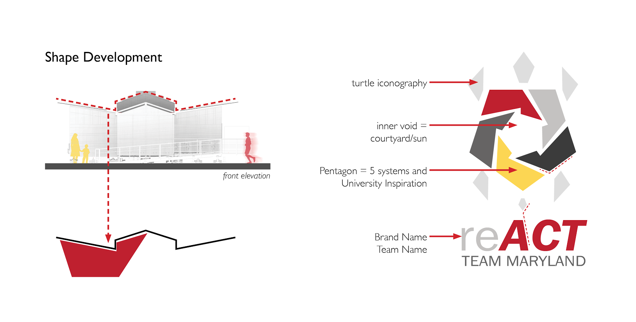
Each of these five pieces represents the innovative systems of the house: water, power, living systems, HVAC, and automation, tied all together by architectural design. Additionally, the five pieces can also represent the five modules of the house: east, west, mechanical, bathroom, and attic; each of these five modules is linked together by our Courtyard, represented by the negative space. This reading of a linked cycle is representative of our concepts of disentanglement and modularity - showing how different units can be woven together to create a whole. The resulting figure is a turtle with an interwoven shell, which represents itself in our signage and wayfinding. As a way to engage younger audiences, reACT’s turtle logo becomes a mascot for Team Maryland itself, and can be used in engaging manners during the public exhibition period.
When developing reACT’s brand, these themes were important to consider, and actually assisted our communication design strategies. In order to maintain consistent references, each team leader is issued a standard email signature, listing their title and the correct presentation of Team Maryland. This allows team members to use their signatures when contacting potential sponsors and mentors, in order to maintain a cohesive appearance. These are issued to all student and faculty leaders on Team Maryland, and are often updated to reflect changing titles and job descriptions as the team evolves.

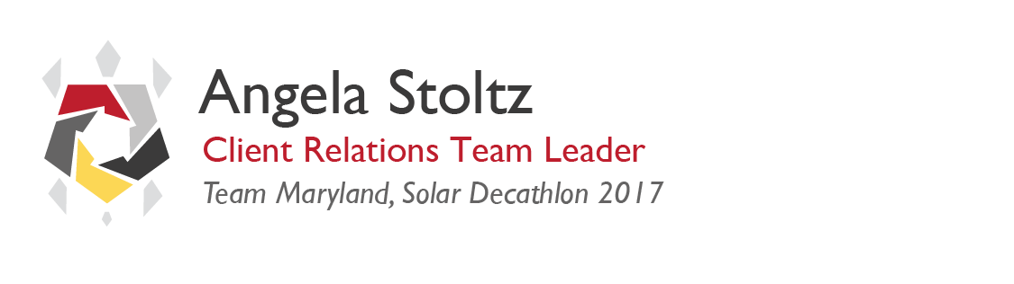
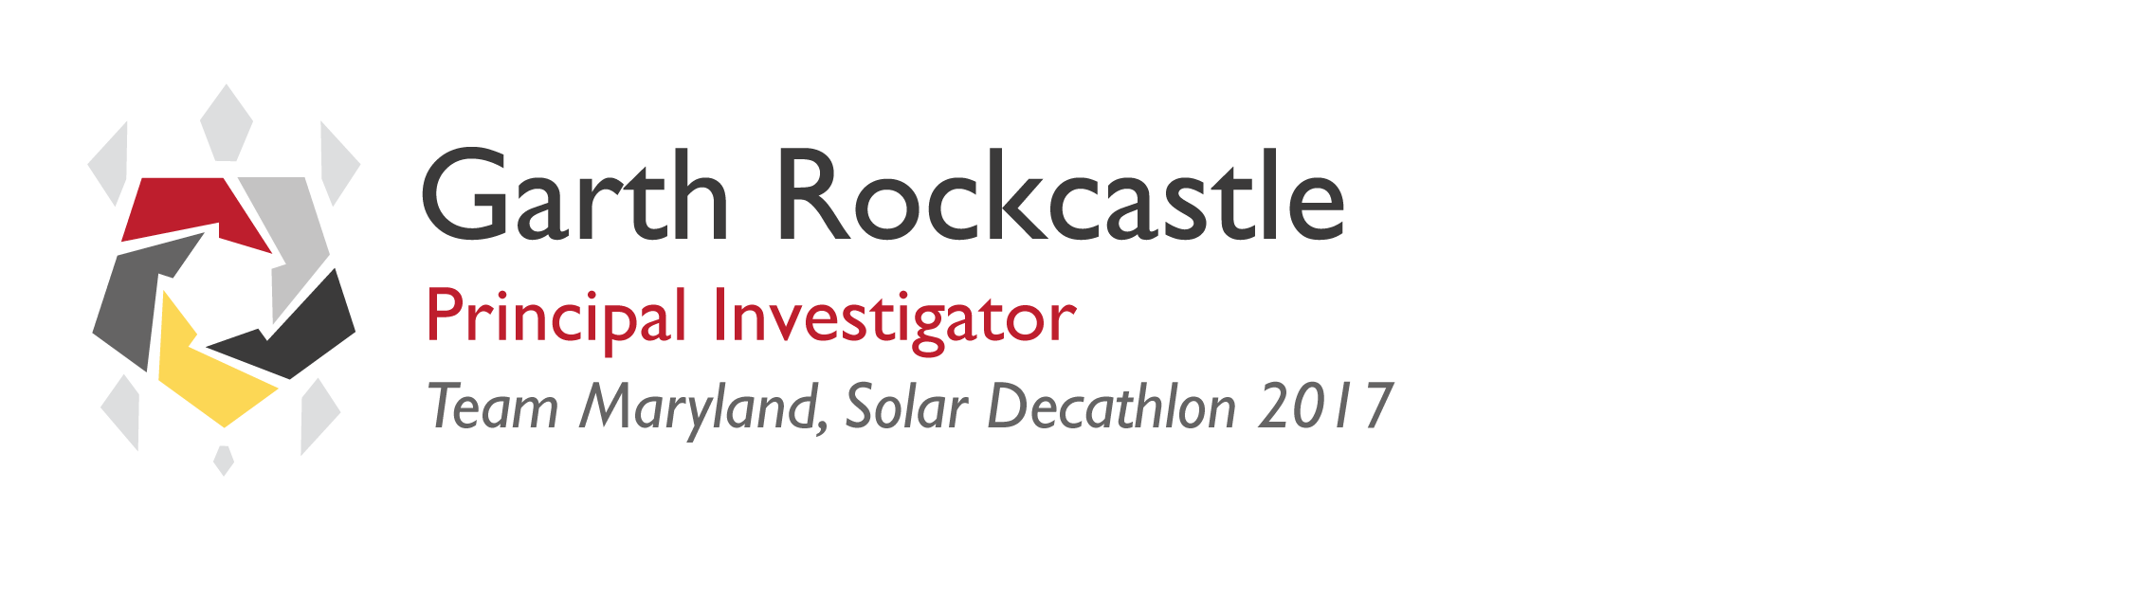
Team Maryland’s reACT logo is used on many different components of the project, including videos, event invitations, promotional materials, website, social media, and more. Modularity is a driving design feature of the project, which is reflected in the communication designs. The website is developed using a modular system, allowing for customized pages based on our narratives and graphics package.

The ability to apply our brand identity to the identified Impact Items allows for effectively communicate the strengths of reACT. Brand identity supports the continued development and success of our regenerative model for the general public.

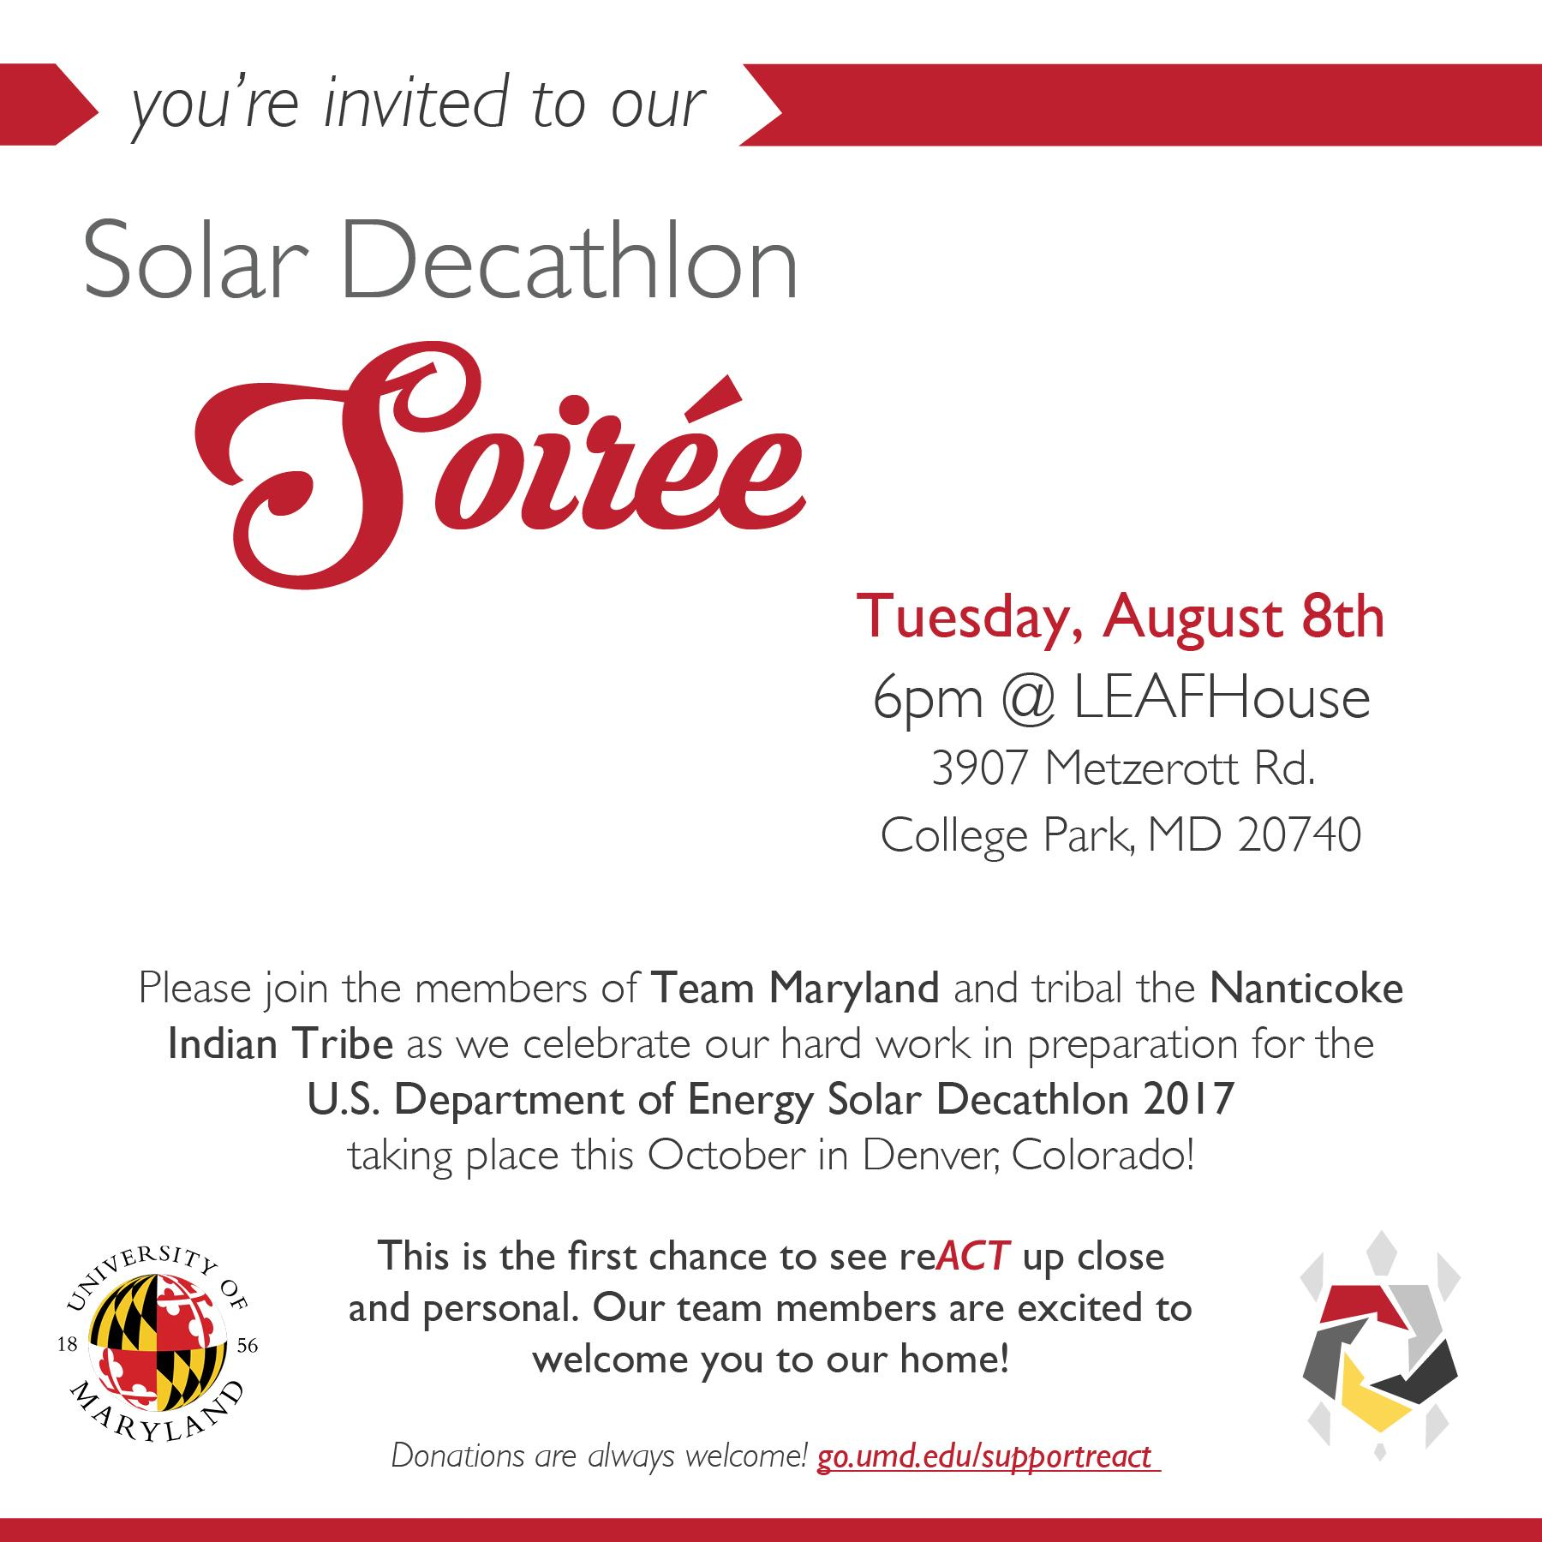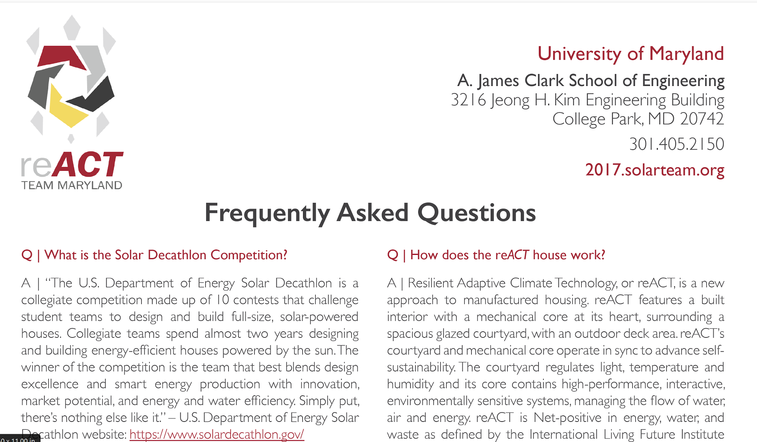
Communications Items employed by Team Maryland

Impact Items:
Digital Communications
Audiovisual Presentation
Public Exhibition at Solar Decathlon 2017
Media Interaction
Education and Outreach
Digital Communications
Website

One of the first opportunities the public has to interact with Team Maryland is with a visit to our website. Websites are easily available for public access, and can be a powerful tool in selling an idea or a project. Creation of a clean, interactive website is a clear way to support the concepts embodied by reACT. Team Maryland has been hard at work crafting a website which reflects our key messages. The format is developed through a modular, multi-purpose template. Utilizing a template allows our website to evolve and change with the reACT concept, and will also ensure continued communications as we continue development post-Decathlon. The template also allows for rapid changes and personalized solutions, which supports the individual needs of each topic and sub-team. User experience drives conversion on reACT’s website to ultimately influence the visitor why they should reACT.
The structure of the website is designed in a cycle, which leads visitors through the narrative of our design and messaging. The home page provides a first impression of reACT through text, logo, and image. A walkthrough of the reACT home prototype is available, and support for our Virtual reACT, a virtual reality walkthrough is under construction. Content tabs lead to an understanding of how key systems link together in the house – for example, HVAC works with the Architecture pages to show how passive heating design strategies can decrease energy expenditure of the HVAC system.
reACT’s exhibit program includes compatibility of the website. The page will provide ‘bonus content’ to guests, who may want more time with or information regarding a specific sign than tour time permits. NFC-compatible tags through the tour incorporates URLs, QR codes, and NFC-touch technology for guests to have instant access to more information.
Social Media
Intended to grab their attention and encourage visitors to move into reACT’s website. We use Social media accounts spread the word, show the public recent accomplishments, and connect reACT to the world beyond the Solar Decathlon.
Team UMD has a Instagram(https://www.instagram.com/umdsd2017/)
Twitter (https://twitter.com/umd_sd2017?lang=en)
and Facebook (https://www.facebook.com/UMDSD2017/)
Social media is an excellent tool to relate reACT and its principles to other projects, initiatives, and the greater world. It is a prime outlet to give updates on project development: Using social media to prove our relevance.
Audiovisual Presentation
Quick shorts from team leaders bring a personal touch to our content – and the presentation documents our house, sans interior finishes due to weather and manufacturer delays. The personal nature of team members presenting condensed information on the systems they have worked tireless on for months is meant to resonate the importance of reACT and it’s underlying principles and goals.
Public Exhibition at Solar Decathlon 2017
Graphical Materials
Communications strategies at competition include OCC training, media training, and mock tours. The communications team and given considerable thought to the tour and the unique experience offered by face-to-face interaction with the public and media. Supporting materials have been carefully crafted to educate a diverse audience on the importance of a sustainable future, empower the individual in such a cause, while demonstrating feasibility of concepts in reACT.
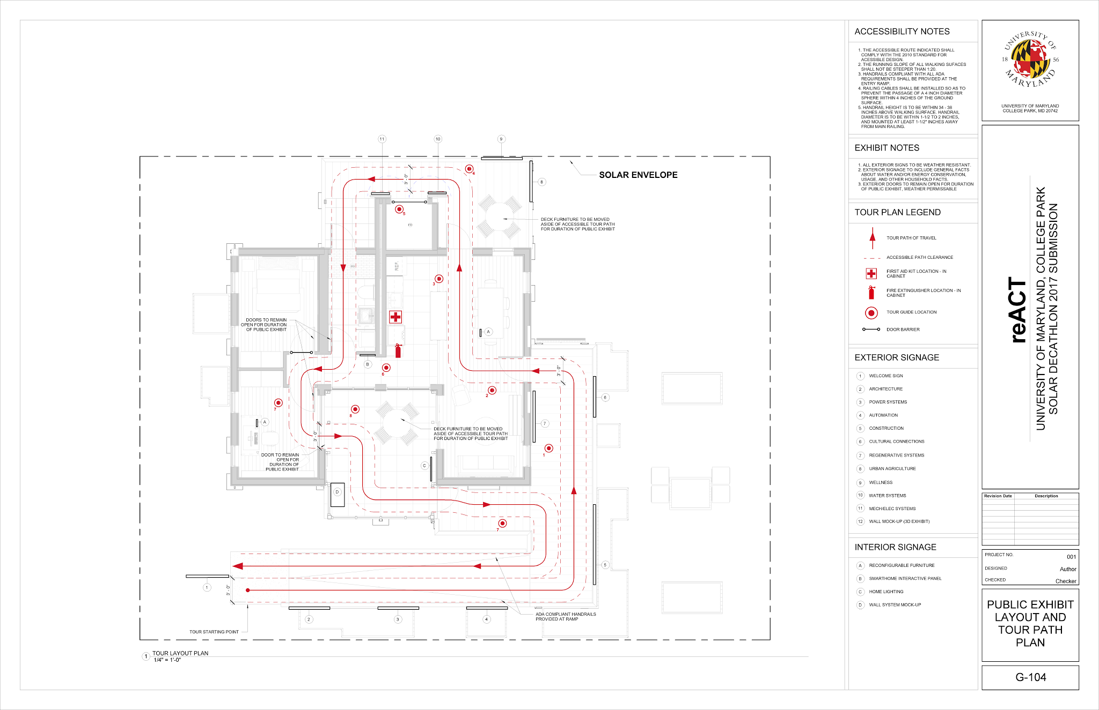
Tour path and signage

As the touring patrons approach Team Maryland’s home reACT they are greeting by a welcome sign. This sign gives a compact and quick introduction on our team, our home, and why reACT. Featured low on the board is a white turtle challenging young visitors to “find me” throughout the home with kids facts to engage the younger audience. Sharing why reacting has value opens a dialogue between reACT the tour patrons that continues throughout the tour. Walking up the ramps architecture, engineering, power & automation are each posted sequentially. Each sign correlates to the physical location on the tour and it’s associated conceptual introductions.

Architecture is the first visual element the audience will experience. Notable features such as the roofline and Greencourt, courtyard greenhouse, are introduced. Engineer signage follows to open up curiosity for what is within the home. The integration of HVAC, power, water and automation plays an important role in the performance and appeal of reACT. Due to its prominence in the name of the competition, the solar aspects of reACT will be among the first topics presented in the signage. Power and Automation signage delves into the basics of solar, adding what differentiates Team Maryland’s system. Part of this uniqueness is the automation using virtual house technology that is based on predictive modeling, learning from and educating the occupant.

Construction is the next sign that comes into view at the top of the ramp. The process of construction and design decisions of the reACT home are presented before the touring public enter the structure. Signage lays out the process of taking the architecture and engineering designs and turning them into a tangible reality.

Approaching the landscaping planter boxes cultural connection and regenerative systems are presented. Indigenous knowledge systems of Native Americans are outlined emphasising the blend of these values with western scientific thinking. Regenerative design signage touches on the guiding regenerative principles that fuses all reACT’s designs and systems together to create a better home and lifestyle system. Urban Agriculture signage educates on the principles of food sovereignty and the benefit food production that extends beyond the individual. Wellness signage showcases greenwall, hydroponics system, landscaping and the ventilation system working in concert for the wellness of the home and occupant.

After passing the landscaping areas there are signs on either side of the mechanical room hung on the doors. Water signage diagrams the design of the filtration system, clearly labeling and describing each component. Similarly the mechanical signage diagrams and labels HVAC components in a numbering system that can be seen on the diagrams as well as in the mech room. Both signs strive to simplify information, educate the audience on the meanings of each component and their importance to reACT. The last sign featured on the tour is in the Greencourt. The Greencourt plays such a literal and conceptual central room to reACT that this feature is highlighted multiple times during the tour. Greencourt signage illuminates the immeasurable importances of lighting on top of the other functions it performs.

Tour

The personalized tour reflects the messaging that is representative of the our entry reACT. We took a modular approach to customize each tour to the specific group experiencing the home. We promote both a community connection as well as building an individualized interaction during the tour. Our home supports both the community and the individual and can change to meet the needs of its occupants. The pace of the tour matches the group dynamic; if a group has many questions the pace slows down to accommodate answering those questions in the most relevant area. Areas of interest to a group can receive more time while areas less of interest to the group experience a briefer presentation. Throughout the home positions are chosen to present information in a setting conducive to demonstrating the topic and stimulating the senses. Graphical representations of information supplement hearing information shared by team presenters. Each area encourages the individual to explore their surroundings. Unique features in the home are highlighted in red accents. Labels, NFC, and QR allow patrons to instantly access information on individual features of the home. Some labeled and accented features are presented in tour, while many others are available as bonus content to create an individualized and modular tour. Engaging a younger audience, white turtles with kids facts are displayed subtly throughout the home. Children are encourage to find these interest points placed lower to the floor than signage intent for an older audience.

Staging
House interiors will reflect reACT design strategies, and convey a ‘welcome home’ feeling. Guests should feel like they could belong and be comfortable in this home – not like they are visiting a museum. Art is a communications strategy, which will help tying market messaging in with livability of the house. Some level of customization is appropriate – reACT is meant to be more than just a model house. Consideration has been give to conveying culture responsibly and representing the target market from the Native American community. Agriculture, sustainable design, nursing, home maintenance, and various cultural elements are found in the office books, accessories, and items placed around the house. Featuring appropriate items the staging will be done comfortably and stylish within a budget typical of the target market representational young Nanticoke Indian couple starting a family. “The Possibilities of your react Home” as a ‘house catalog’ will sit on the reading chair or desk. Plants will be incorporated throughout reACT to blend the natural balance in accessories. Guests are encouraged to touch many of the home elements – this house shouldn’t feel fragile to visitors, but real and usable.
Brochure
reACT brochure represents the logo, and folds out to create an interactive experience. The turtle logo design folds out to create a bowl with interlocking tabs. The handout conveys design ideas, why reACT principles and goals, features the five systems categories, and client relations/target market. This tangible, interactive, and visually stimulating brochure is appropriate to educate and engage a diverse audience.

Outreach and Education
How our house ties to Native ideas while still remaining accessible to the general public
Summarize CR communications
With outreach and education, we need to allude specifically to our client relations document, to develop what we’re doing to promote cultural awareness in a responsible manner

Public Events [Patti to Complete summaries of events]
Maryland Day
Solar Decathlon Soiree
· Building a sense of community through the introduction of our house YES!
· Tribal leaders, sponsors, family, friends media. Interaction of our team with the public and have a first opportunity to convey our message – test run for Decathlon

ADDRESSING JUDGING CRITERIA
Strategy
S1 • How well did the team’s communications materials and activities work together to convey a comprehensive, consistent, and integrated communications strategy?
Materials & Activities: (IMPACT ITEMS)
Website, social media accounts, handouts, signage, tours, graphics, logo & name, events - soiree, design review.
Strategy:
- Present graphically driven concepts/innovations in a clear and precise manner to be digestible by a broad audience.
- Creation of a ‘brand’ identity for the house to tie concepts together
- Impact Items are identified methods of greatest communication potential
S2 • How clearly defined are the team’s target audiences and communications goals?
Audiences:
Target market, local community, general touring public, renewable energy industry companies & organizations, residential housing developers/builders/contractors, students (elementary school through college) …
Goals:
Educate!
Both a broad understanding of the importance of resiliency in design - and solutions for aspects of sustainable living.
Engage curiosity: encourage exploration (exhibit design).
Create a shift in the current housing paradigm.
Demonstrate feasibility of innovations & concepts.
Persuade audience to first recognize the importance of developing a more sustainable future and that it is an achievable reality.
Influence audience to develop a desire for such a future.
Incite audience to internalize their personal ability to achieve the goal of more sustainable future through individual and collaborative action.
Describing our system’s innovations to present solutions for sustainable living. Self-Reliance -

S3 • How creative, original, and successful are the team’s communications strategies?
Unique & Creative:
Logo, name & deep symbology
Graphical representations of house, project, concepts & innovations (iconography)
NFC(& QR) phone accessible links to more intensive information
Virtual information online tour that follows physical tour with in-depth information and educational material
Broad concepts simplified to be understandable by children, or other audience members unfamiliar with concepts
S4 • How well do the team’s communications strategies align with the team’s stated goals and objectives?

Implementation
I1 • How successfully did the team conduct outreach and education in its local market?
Events:
Maryland day, design review, soiree, tribal relations, outreach efforts. Inclusion in UMD magazine publication(s). Media invites, relating social media posts… Visit to NMAI

I2• How successfully does the team incorporate digital communications strategies and products to engage online Audiences?
Impact Items:
Website - modular design for seamless implementation and reflection of reACT.
Social media - encouraging sustainable living, critical thinking, and positive impacts of our strategies in the public (like the Marriott Story) - It’s possible, it’s happening in the industry, and it goes beyond housing.
Virtual reACT - both engineering model website and Virtual Reality model - allows people to gather real-time information and experience the house, even if they can’t travel to Denver or College Park. Improving accessibility.
I3 • How effective are the team’s educational and outreach messages about the Solar Decathlon, the team, and the Design?

Ask patti for educational and outreach messages.

On-Site Communications
C1 • How informative, interesting, engaging, and audience-appropriate was the team’s personalized tour?
Personalized tour:
Appropriate for older children with sprinklings of more complex information mixed in
Instead of delving straight into the complexities of design, basic concepts are presented tying in uniqueness of our systems.
Technical jargon is never used without first introduction on concepts and meaning
Presenters share information on the home through speech and demonstration, encouraging interaction with the space.
Each spot in the home is assigned specific information to share. The environment promotes the chosen messages.
Signage compliments shared information and helps audience visualize concepts introduced
Personalized tour is a sensory experience. Sight, smell, sound, and touch are intentionally woven into the tour plan. Our home is your home!
Pace is comfortable and is individualized to the touring group. Tours for groups that have many questions can slow down to allow for a through interaction with the home and team members.
The end of the tour has an interactive area to relax and intake the information.
Team members are available for post tour questions
Team members are encouraged to engage patrons with questions
Unique features in the home are highlighted in red accents. Fast Facts are provided on the turtle logo.
Labels, NFC, and QR allow patrons to instantly access information on individual features of the home.
Some labeled features are presented in tour, while many others are available as bonus content to create an individualized and modular tour.
Providing decathletes with pocket cards for each sub-team’s systems, with the most up to date technical system, and a directory of who to direct guests to if they cannot answer the question.

C2 • How effectively does the team use on-site features, displays, models, or other materials to engage and educate the public?
Features/displays/models:
Wall diagram/cut out - what’s behind the aesthetics? Peek into materials for better understanding of why the home design is effect. Brings SIPS to life.
Interactive home automation/smarthome display panel - See how the home engages, interacts with, educates, and learns from the user and environment.
Open/viewable water filtration system with labels - View water cleansing in action,
NFC (near-field communication) latest technology for digital interaction to enhance physical tour experience
Sun Tubes - passive lighting strategy, viewable lighting alternative to replace or supplement electrical features depending on time of day during tour.
Greenhouse automation panel & shade positioning - active energy efficiency enhancing feature, viewable positioning in action
Removable plywood wall panels - see into interior structure
Living systems/landscaping - engaging the senses with smell and touch
Movable/configurable desk, table, island - experience modularity in action, visualization of ‘DNA’, modular customization enabling solutions catered to meet occupants unique needs.
Versalift attic oven & clothes dryer (can we build a model)
C3 • How effective is the team’s strategy for accommodating large crowds and long lines?
Well versed and trained presenters
Intentional and intelligent information presentation
Topical transitions that promote house flow during tour
Scripting consistent information & talking points for each team member
Elevator pitch that condenses important information into short concise statements.
Building in areas for gathering after tour versus before or during
Allowing opportunity for questions to team members at exit gathering location, end of the tour
NFC - quick tap ability to get more information from any topic on the online tour
Clear tour path that keeps groups from intermingling
Entrances and exits assigned single direction tour flow
Team members trained in referring questions to the right people
C4 • How well do the onsite communications materials educate and inform the visiting public?
Write as if they these graphics are done. Structure by signage content topic & goals.
Unique handout, drives curiosity
Memorable shape that matches logo, adds levels of symbology to messaging, demonstrates concept of modularity through interaction, all while presenting selective home information
Most important home concepts listed and illustrated with pictures
Signage content is designed to educate wide audience in both age knowledge/familiarity.
Engineering signs contain basic introduce to “how it works” in a simplistic fashion
Signage graphics include what sets us apart in our designs by illustrating our unique system elements.
Cast of characters representing inhabitants of reACT help audiences make personal connections with information presented.
NFC/QR allow patrons to seamlessly find more information from the companion online tour
Individuals more knowledgeable/familiar with concepts have more detailed information to browse through

