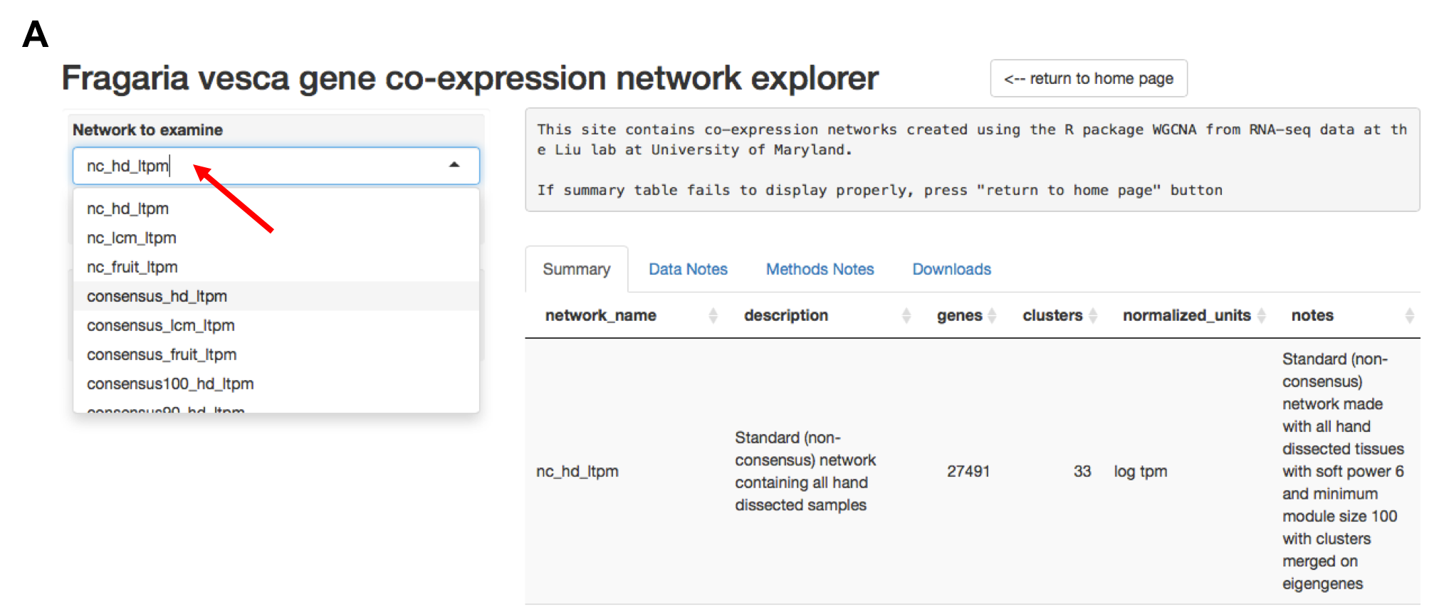

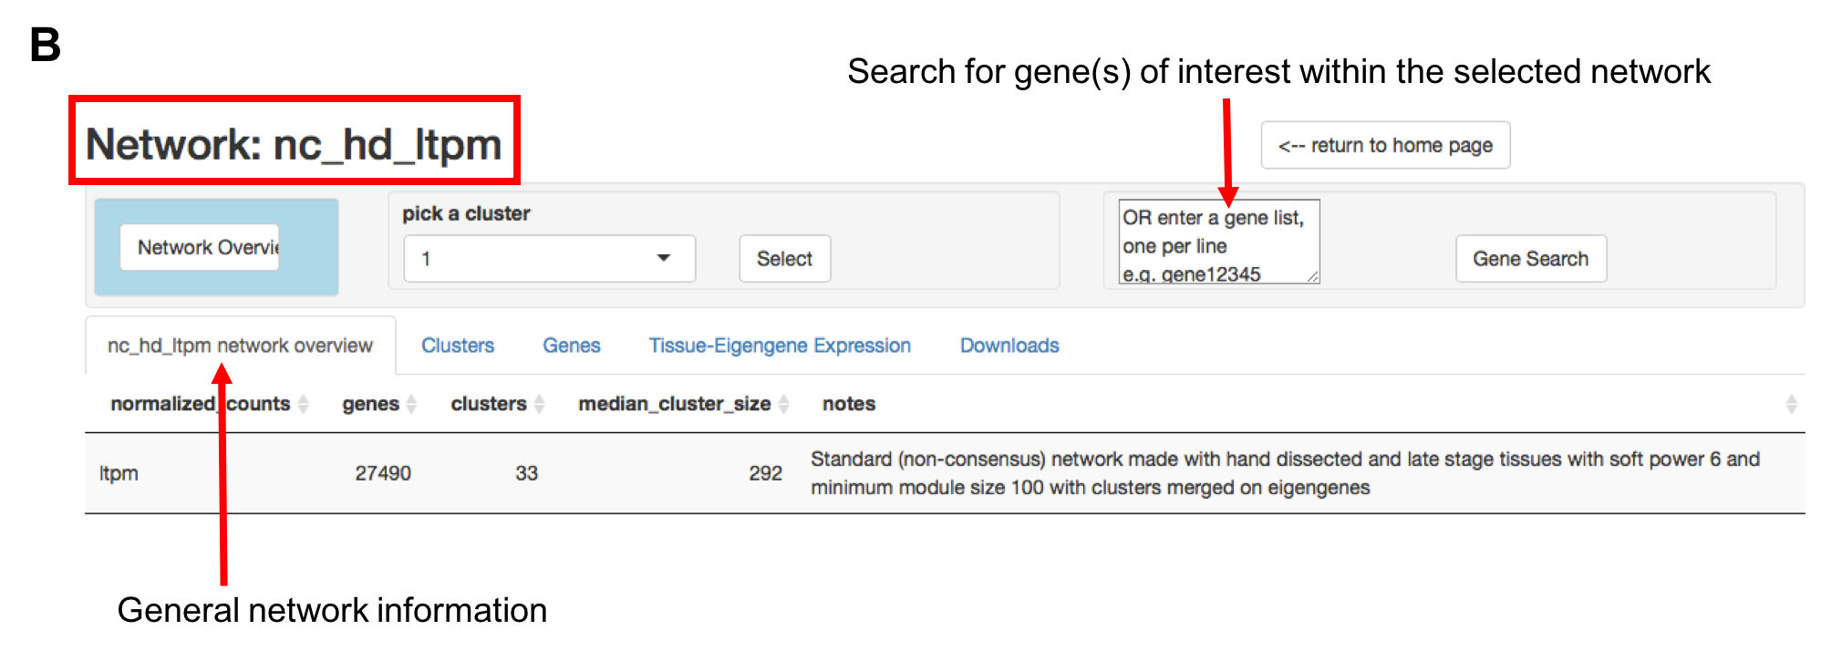

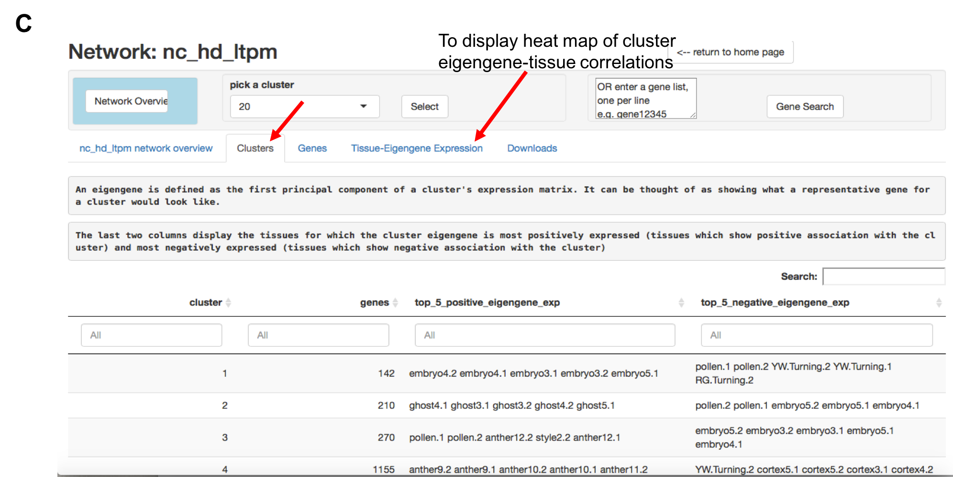

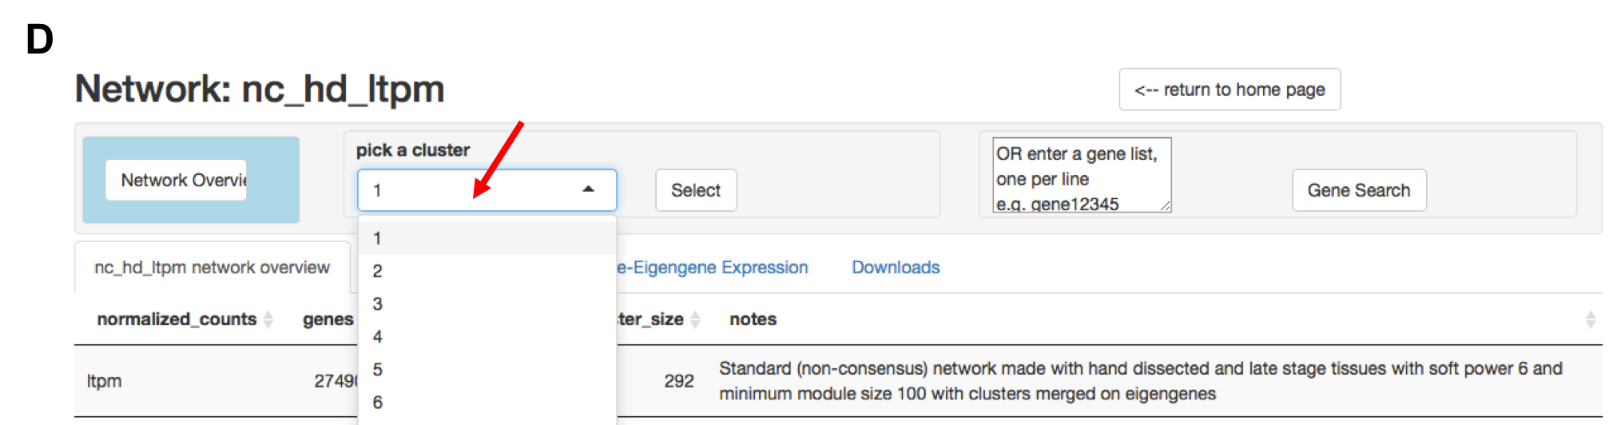

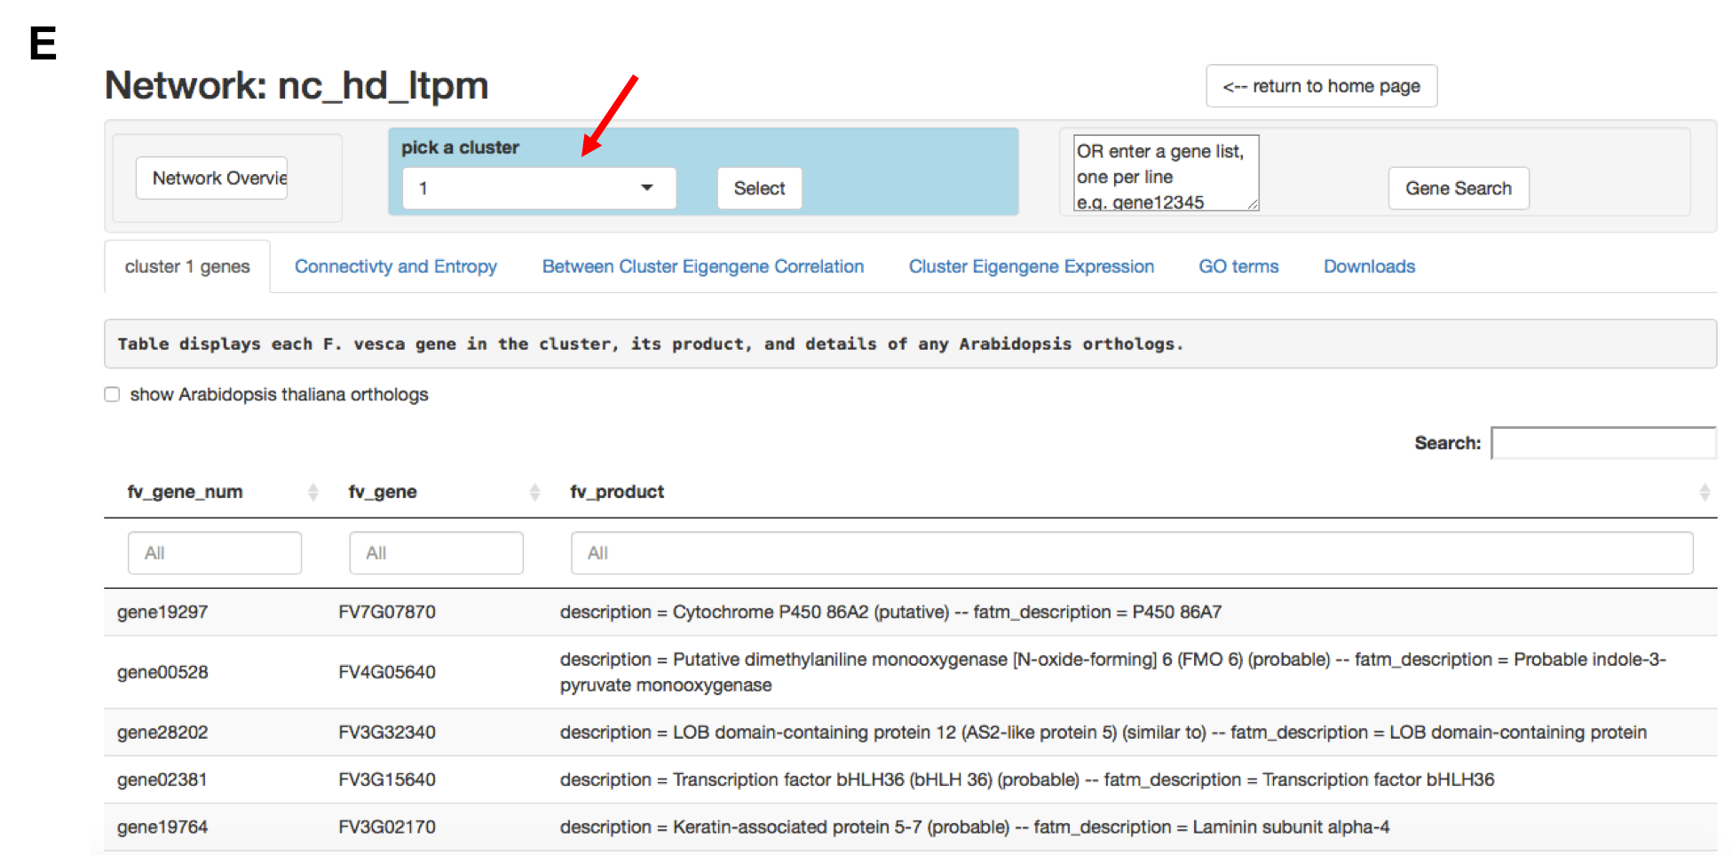

Figure S2.1 Fragaria vesca gene co-expression network explorer, a user-friendly web interface for mining co-expression network data.
- The site (www.fv.rosaceaefruits.org) hosts general information about methods and RNA-Seq data used in the generation of each network. A summary table quickly provides access to a description of each network along with total number of genes and clusters. Users can select one of the twelve available networks from the dropdown menu for further examination (red arrow).
- Once choosing a network, users are directed to a page with more detailed information and a search bar in which gene(s) of interest can be entered to determine the cluster(s) to which they belong.
- The network-specific page allows users to quickly determine the tissues to which a cluster of interest is associated. The ‘cluster’ tab displays the number of genes in each cluster as well as the top five tissues to which the cluser eigengene is most positively correlated and the top five tissues to which the eigengene is most negatively correlated. The ‘tissue-eigengene expression’ tab shows positive and negative eigengene-tissue correlations in a heat map for every cluster in the network (see Figure 1B, C and Figure 3A and B as examples).
- The network-specific page has a dropdown menu from which users can choose an individual cluster to explore (arrow) by picking a cluster number and then clicking “select”.
- Navigation to an individual cluster page is denoted by a blue box around the cluster dropdown menu. Detailed information for the selected cluster, including lists of genes with annotations and Arabidopsis homologs, connectivity scores, and GO enrichment data, is available from individual tabs. All data can be downloaded in .csv format by selecting the ‘Downloads’ tab.

