U.S. DEPARTMENT OF ENERGY SOLAR DECATHLON 2017



U.S. DEPARTMENT OF ENERGY SOLAR DECATHLON 2017
Contest 1: Architecture Narrative
August 10, 2017

reACT (resilient Adaptive Climate Technology) represents a new paradigm for housing, one built on a regenerative model of sustainability, able to serve diverse communities, and be integrated with diverse natural ecosystems. The concepts, processes and technologies demonstrated in reACT are applicable to a wide range of scales, densities and formal configurations. The prototype is built upon providing a common ‘DNA’ for not just one house, but an entire range of community of buildings. Regenerative design principles (responsiveness, flexibility, and adaptability) guided the Architectural design process used to give rise to this prototype; recognizing that local climate, individual choice and culture influence the specific forms employed in the design of the reACT prototype, advanced for this competition.
Our initial target market is represented by a young Nanticoke Indian couple starting a family in Denver, CO. Although it needs to be emphasized that the the architecture of our Solar Decathlon dwelling in this offering, is not limited to any specific Native American Tribe or vernacular tradition, but rather addresses the deeper traditional cultural values that seek balance and harmony with Nature. We believe that to build a truly sustainable future, these are the values that must be adopted by mainstream culture as well, and reACT is designed to help foster that shift to a broader market.

Guiding Principles
The primary concepts which define UMD’s architectural design are:
- Integrated use and reuse of resources (sunlight, heat, water, air, organic matter)
- Flexibility of technological systems and architectural spaces to support multiple housing resulting forms and patterns
- Adaptive responses to regional climates and diverse geomorphologies
- Adaptive response to diverse and dynamic resident needs
Tight integration of systems implies the ability to transfer resources, like heat and water, between components and for changing needs, which in turn suggests close physical proximity and well-ordered structure of connections and some capacity for storage and retrieval. Team Maryland focused on exploring compact forms cable of harnessing, storing and transmuting resources from the house and the surrounding environment. Ultimately, this led to the creation of a linear spine and a cooperating attic that connects the major mechanical, electrical and plumbing components of the house in a central Core. This horizontal and vertical organization also offers flexibility for expansion and aggregation of the building form, easily attaching living modules and new MEP components to the spine and attic in its core.
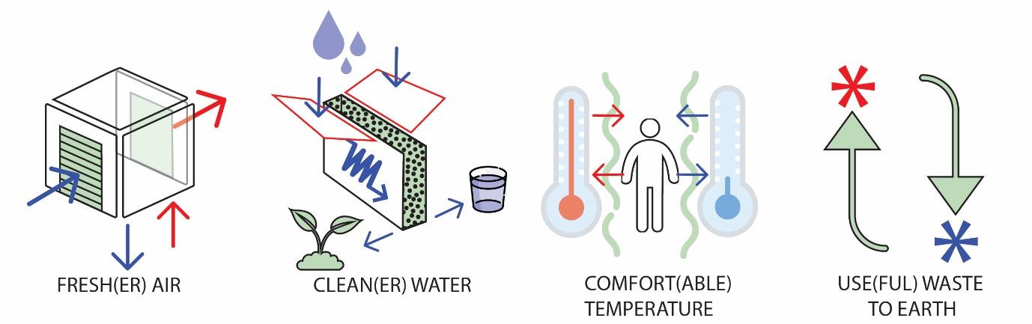

Prototypical Variations

reACT’s essential “DNA” is rooted in the idea that, at its heart, there are systems and components that are efficiently configured to serve and support its regenerative agenda, and easily respond to expansion, update and reassembly as needed. While Team Maryland’s submission utilizes the Court DNA, two other DNA’s have been envisioned as complimentary companions; the Cluster DNA and the Compact DNA. The three conceptual illustrations of these essential DNA’s are illustrated, each in a typical, hypothetical form, below:

Court DNA
The Court DNA for reACT utilizes an enclosed Greencourt to augment its core of compact systems and infrastructure to achieve an efficient distribution, exchange, processing and storage of excessive resources and waste. As is typical of all of our prototypical variations, we are showing only the essential ingredients in these cut-away isometrics where the attendant accommodating rooms for residential occupation flank and are served by these alternative utility cores and spines.
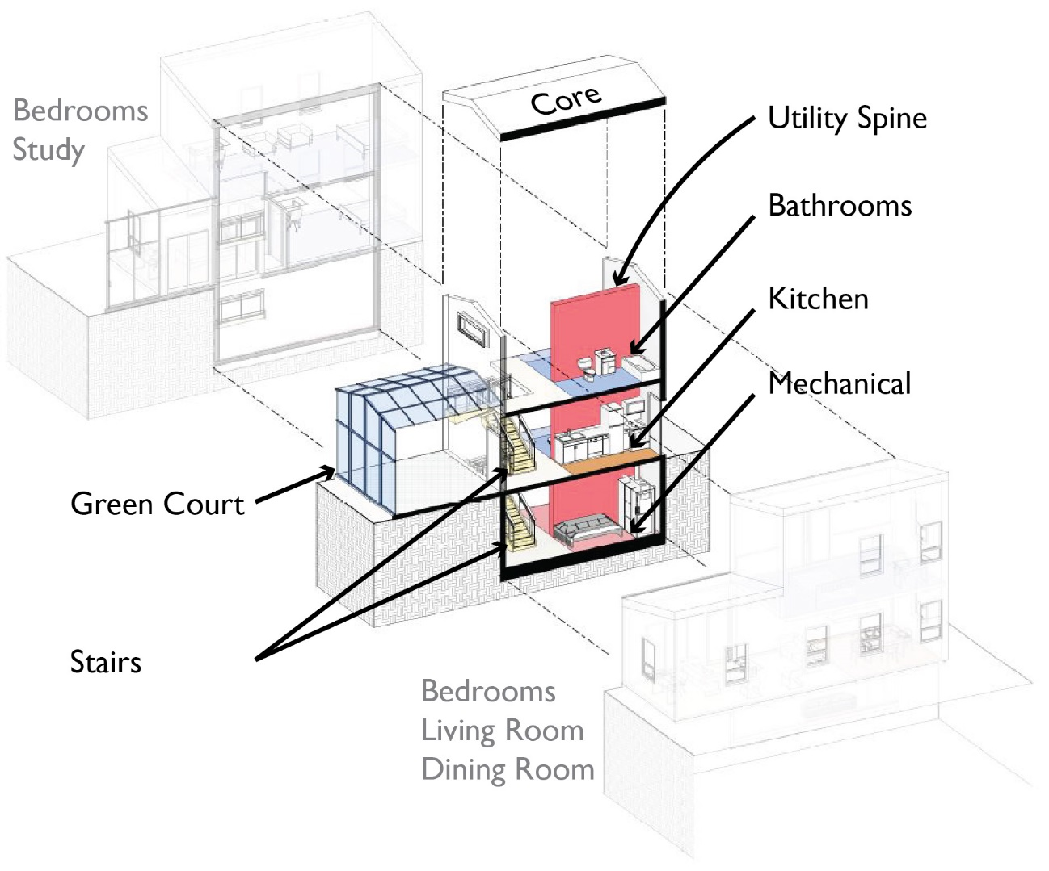

Cluster DNA
The Cluster DNA version envisions the core of the house as both primary supporting structure and vehicle for conveyance of utilities and circulation, much like the way most living plant forms on the earth are configured.
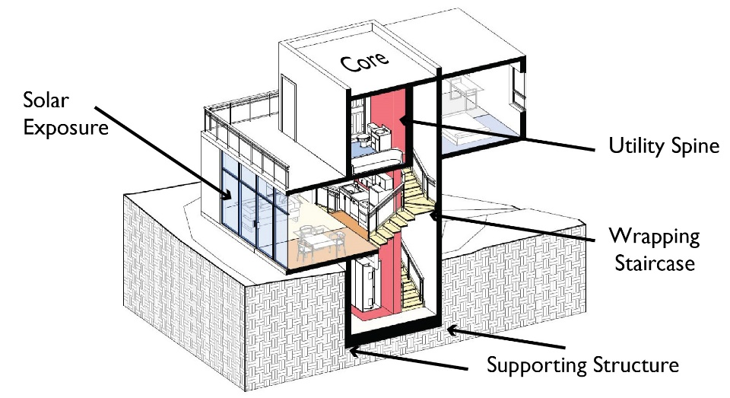
The Compact DNA concept envisions the core of the house to be a hyper distillation of the essential ingredients (kitchen, bath, mechanical and any stairs, etc.), while the occupying rooms (living, dining, bedroom, study, etc.) extend or even fold out from a compaction ring of architecture, much like seeds, nuts and shells permit expansion or growth, when desired or needed. This allows the house to be more energy and space conserving when not in use, yet expand and flourish to accommodate and use much more on occasions only.
Compact DNA
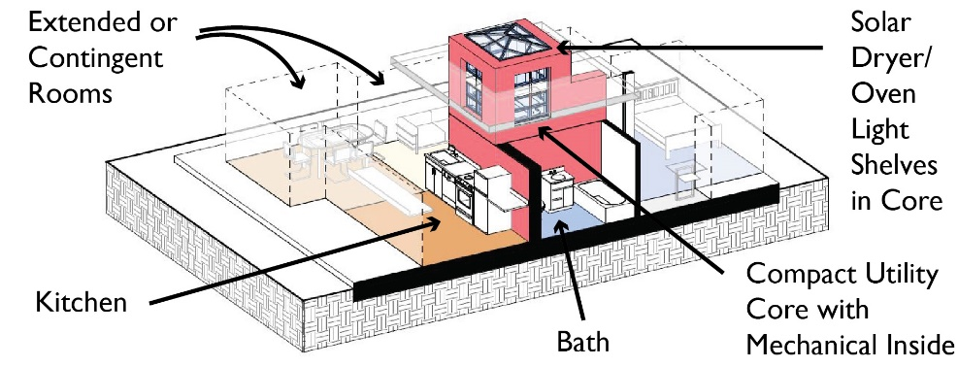

The GreenCourt DNA is the basis for Team Maryland’s competition entry, reACT, but it is important for all to understand that this particular version is only one of a family of alternatives, extending out from its essential ingredients or characteristics to contingent and variable amendments and additions. The GreenCourt prototype presented in the competition is, of course, limited by the restrictions the competition places on entrants with size, height and ground plane restrictions, and the impacts touring thousands of visitors has on any home design. While a full-blown illustration of all these variations are not possible here, we have provided a potential some type variants to illustrate how these related versions might be developed and deployed by different designers, diverse communities, ecologies and sites, all growing out of a set of common internal, infrastructural ingredients. Below are four such variations:
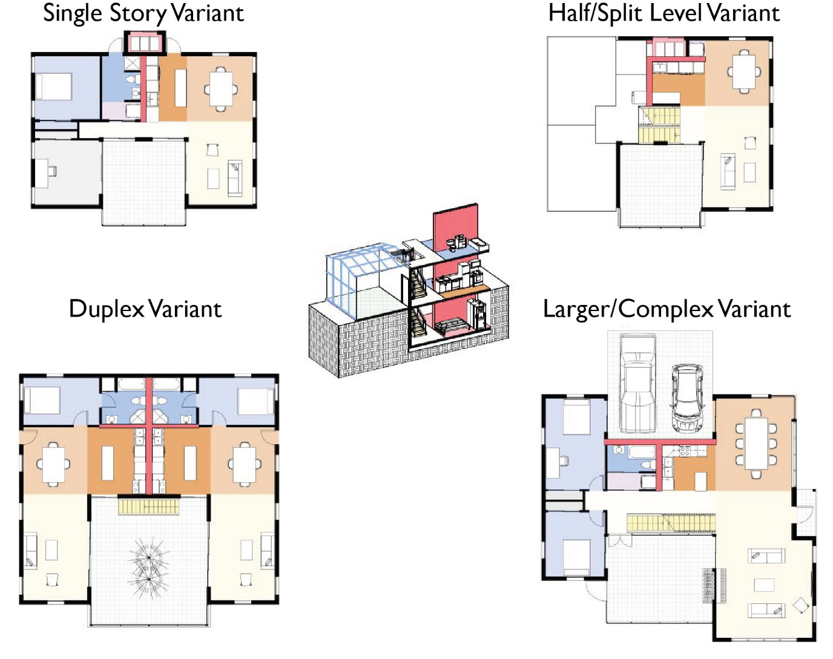
reACT’s spine connects the heart of the house, the Greencourt to the Attic and the Mechanical Room (which in some applications can be a basement or crawl space). The Greencourt’s purpose in the UMD Decathlon competition is to harvest, mediate and distribute daylight, temperature, and fresh air, while supporting the home’s social hub. Our Greencourt, like traditional architectural courtyards, is a common feature in dry climates like Denver and throughout the Southwest, as well as many other cultures and climates around the world. What makes reACT’s Greencourt distinct is its management of it resources, and its flexible transparent envelope, with large folding doors and operable sky-vents that allow the space to be either wide open or closed and protected, a space between indoors and outdoors, embracing both. When closed, typically in the winter or on days with cold nights, the Greencourt space can be used to collect solar energy, creating a thermal buffer for the interior and offering outdoor-like space for extended comfort and use. This excess heat can also be harvested by heat pumps in the Attic and reused for space heating or hot water. In this way, the Core and Greencourt form an integrated active/passive system. The Greencourt’s reactive skin also includes an automated shading layer that buffers the space from excess solar heat while encouraging natural ventilation. By opening and closing this skin, the shading layer and other windows throughout the house, the house’s brain, the SmartHouse controller, can adapt the operation of the house to the local climate and the desired comfort of its residents.
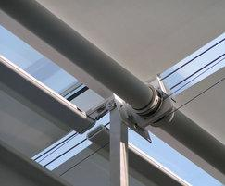
Greencourt and shading system options
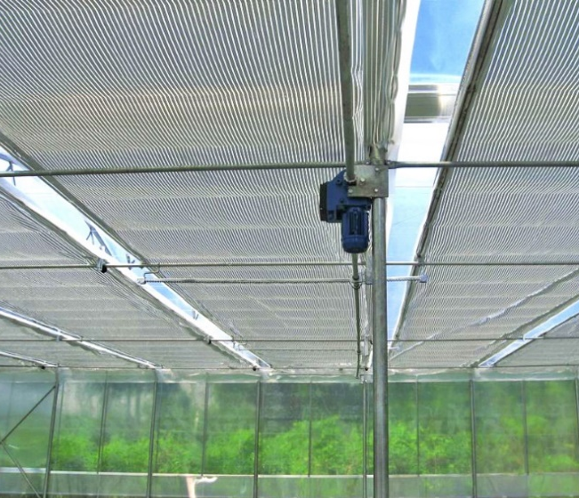

The Greencourt and roof downspouts also serves to gather and store rainwater from the roof, connected by the spine to the Mechanical core, which filters the rainwater for reuse in the house and garden. The Greencourt also shelters storage for greywater harvested from the house and filtered for reuse.
reACT GreenCourt as water collection hub
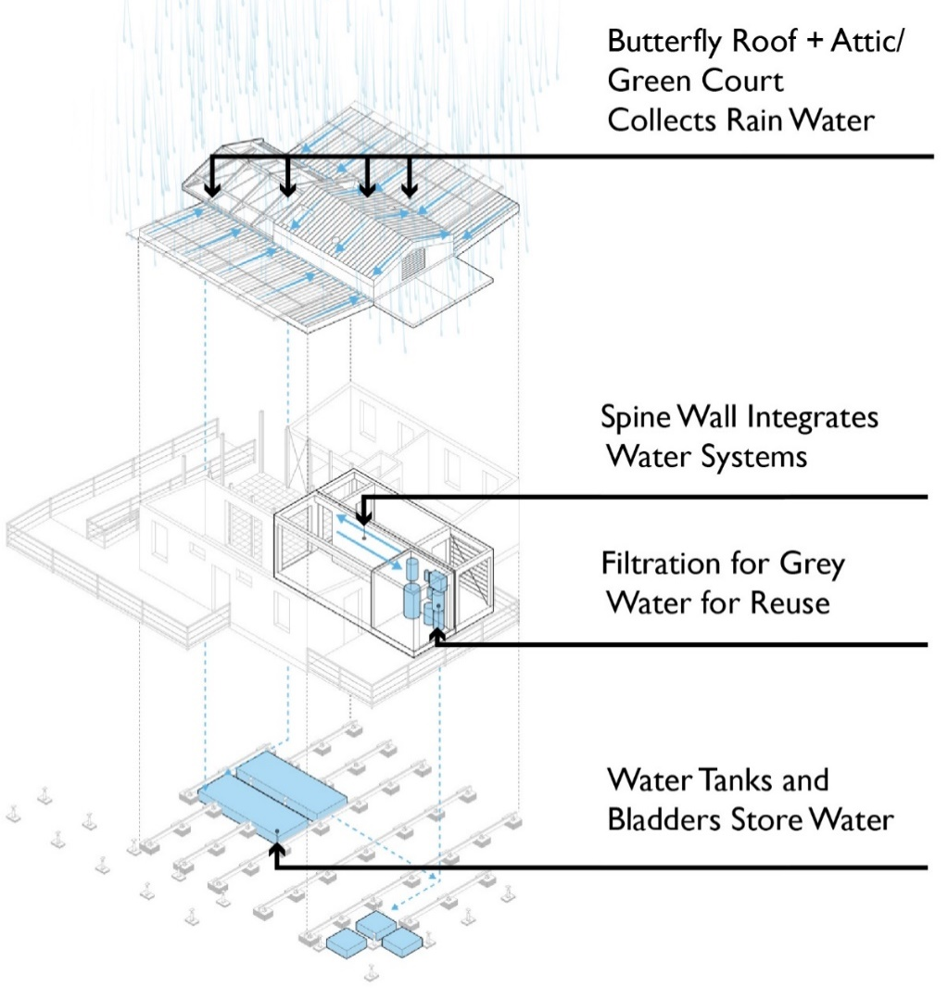
Of course, the Greencourt plays a critical role in the social life of reACT as well. It serves as a protected, mediated, and private/public zone of the outdoor environment throughout the year, immediately accessible to the interior spaces that surround it and the street or pedestrian paths it might face. In the summer, it is a shaded space open to the prevailing southern breezes while acting as a porch for desired public engagements. In the winter, it is a conservatory that shelters residents, their shared activities and plants that help nourish both body and soul through the long cold season. As a conservatory, the Greencourt serves an essential need for the human/nature connection.
The Greencourt shares duty as an outdoor dining area with the Dining Deck on the North side of the house. The Dining Deck serves as a shaded space to hangout in the late afternoon and early evening. It also functions as a mediating space between Garden and interior. An exterior door to the bathroom provides an optional place to cleanse and refresh after working or playing outside and before entering the house. Residents can enter this threshold space, strip off their dirty clothes, take a shower and add to the laundry before entering the house. A Versalift elevator outside the laundry allows clothes to be sun-dried in the Attic above, along with its sister component, the solar dryer/oven in the same corridor.
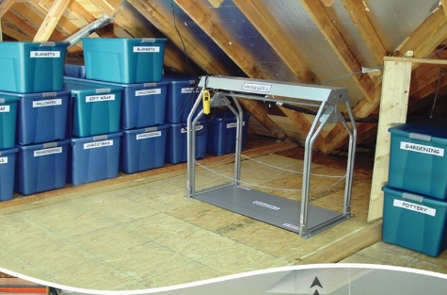
Food from the garden can be carried directly to the kitchen adjacent to the Dining Porch for preparation and storage. Herbs and greens can be picked from the hydroponic garden as needed by recipes. A Versa Lift storage elevator has been adaptively reused to transport food or clothes to the attic zone, where solar heat can dry clothes or fruit and vegetables (to preserving them) or even slow-cook meals. In this way, the Core (which includes the Bathroom, Kitchen and Attic) will function as a place of transformation not only for water and energy, but for food, body and spirit.
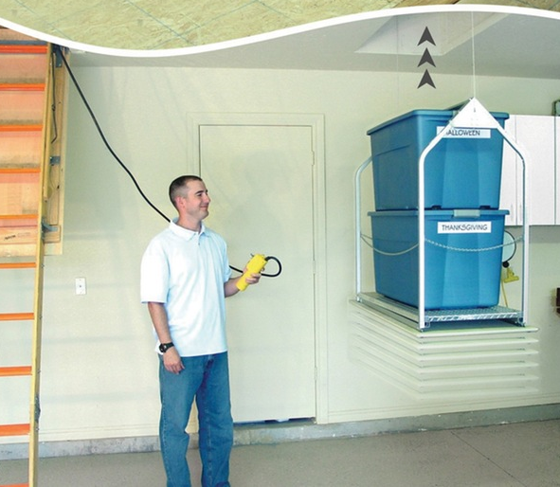
The Wings that enclose the Core and Greencourt are similarly responsive to the needs of residents. The large open space of the Living Room and Dining Room allows either space to expand or contract, or to blend as one for different functions. Bedrooms are designed for flexibility for use as office, as den, or for one or more beds as needed.
Custom furniture designed specifically for the competition house to illustrate the shared principles of flexible, adaptable and combinable, in a modular format is able to be reconfigured and adjusted for diverse needs. The dining table and kitchen island are made of identical, smaller components that can be assembled in diverse ways to serve a small family of four at a smaller table, or up to six at the kitchen island, as well as accommodating a dinner party of six, eight or twelve, …and even, when adding the bedroom desks to the configuration (designed in the same modular manner) can host a gathering of up to 16. So as a companion, the bedroom closets can be transformed to host the desk (or table), with flexible amounts and types of closet space as needed for different families. The kitchen/dining and desk furnishings are not only movable on lockable casters, but are adjustable in height from 28”to 48” above the floor and able to lock together. Between alternative heights and various combinations, reACT has illustrated how domestic furniture can reach a new dynamic and responsive level.
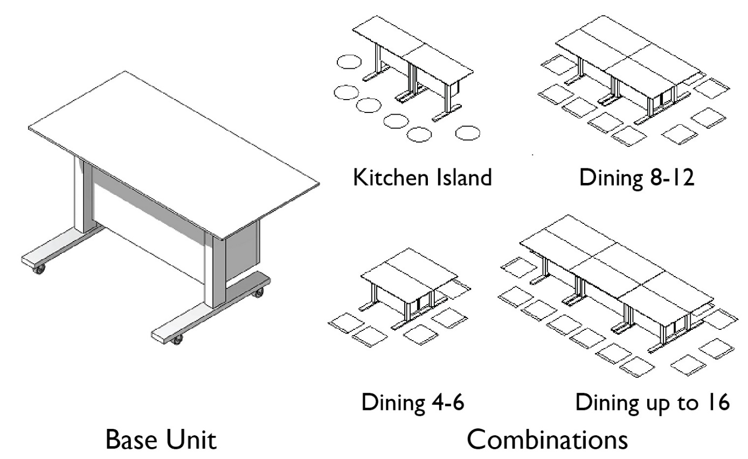
The main illumination scheme for the house interior is designed using flexible track lights, which provide maximum variability for different uses of space and furniture arrangements. These lights are operated by the SmartHouse controller, facilitating balanced daylighting, and energy conservation based on activity levels at various times of the day, and appropriate lighting levels for different functions. The home lighting automation system also allows residents to control lighting using their laptop computers or smart phones when away from the house. The house wakes up with them in the morning and lights up to welcome them home in the evenings. Task lighting throughout the home provides additional illumination for critical tasks; undercabinet lighting in the kitchen, reading sconces in the bedrooms and closet lighting are a few examples of task lighting used in reACT. Wall and floor outlets are located within the house to facilitate the use of table and floor lamps as needed or preferred.
reACT s infrastructure is also reconfigurable to facilitate evolution over time. Removable wall panels on the face of the spine permits access to the mechanical, electrical and plumbing systems that run through it, disentangling the systems from the structure of the house. Wall panels throughout the home’s interior use concealed fasteners to maintain a simple, clean appearance, but can be easily removed with standard vacuum holders allowing wiring to be easily modified, moved and upgraded as the needs of the resident’s change. This has the benefits residents by minimizing the home’s footprint efficiently in balance to their needs.

Construction
reACT also intends to prototype new construction and transportation paradigms. The modular components of reACT - Bath, Kitchen & Mechanical Room, Solar Attic, Bedroom Wing, Living / Dining Wing, and Greencourt – comprise a kit of parts from which many different designs may be developed. We have developed three basic alternatives from which dozens of variations are possible, based on site, climate, budget, family make-up and levels of commitment to regeneration and sustainability. Additional components based on the same principles of sustainability will be developed over time.
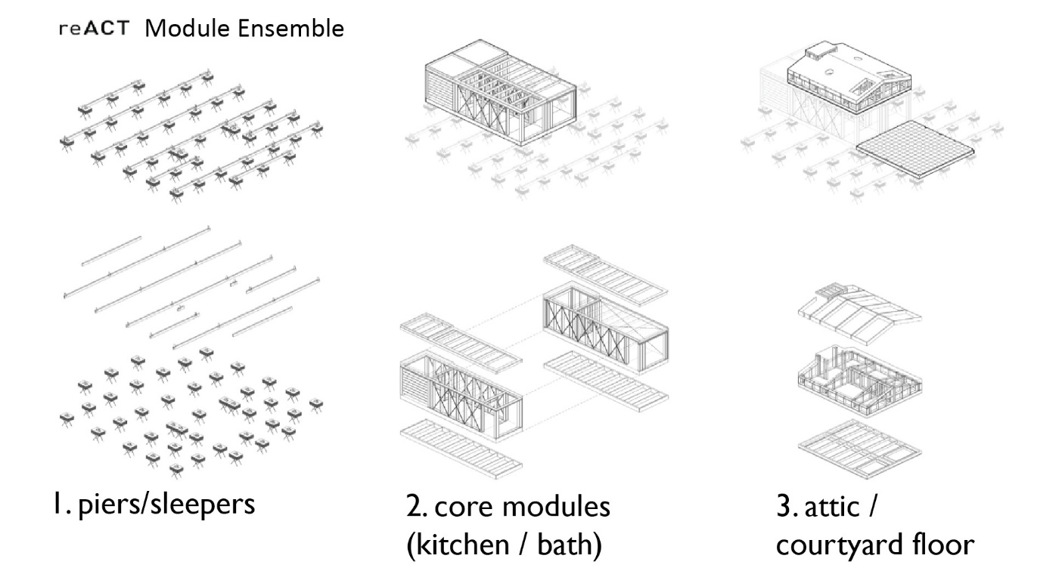
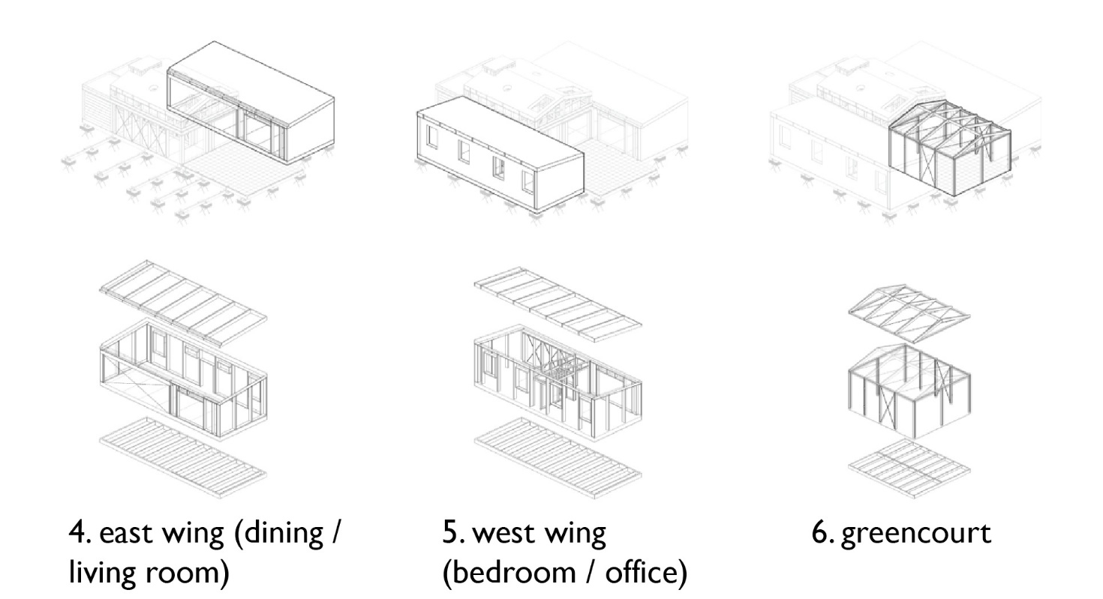
reACT’s kit of parts is, in turn, comprised of components that can be mass produced in factories, efficiently transported to the building site and assembled by local labor. Structural Insulated Panels (SIPs) were a natural choice for the walls and roof. They can be rapidly fabricated under controlled factory conditions using a variety of materials, both natural and industrial. The insulation core used in the reACT prototype is made of expanded polystyrene, but other materials can be used instead: cellulose honeycombs, mycelium (mushroom based) foam, mineral wool. The sheathing used in reACT’s SIPs is oriented strand board, but could also be made of fiber cement, wheat board or other composites. Materials may therefore be selected based on locally / regionally available materials to enhance sustainability and affordable, and to promote local industry.
SIPs provide superior performance because they do not have interior studs that create thermal bridging. The structural junctures (at the recommended eight foot intervals) do produce some modest thermal bridging, but a fraction of the typical framed and insulated wall. Also, when the insulating core is air and vapor impermeable, there is no place inside the SIP wall where moisture can condense and lead to mold. SIPs therefore provide more durability, stability, and thermal integrity, promoting better indoor air quality and human comfort. SIPs and many of the other components (windows, siding, interior finishes, and railings) can be flat-packed and transported via flatbed truck or train.
Similarly, the Core components (Bathroom, Kitchen and Solar Attic) are designed to be discrete modules which can be built in the factory, with all systems, wiring, plumbing and ducting included, and shipped to the building site for integration with the rest of the house. Components and materials may be customized for different climate conditions and resident preferences so that in a given community or subdivision, personal and site variations will contribute to a rich diversity of alternatives. The individual Core modules are sized for easy transportation by truck or train.
Using the kit-of-parts approach described above, final assembly of the components can be accomplished using local labor, with homes enclosed in as little as a week, with relatively little specialized training. This also promotes local industry and owner assisted “sweat equity” opportunities that can reduce construction costs and enhance owner meaning by underscoring housing as a “verb,” or activity as much as it is a “noun,” or commodity.

Summary
The Architectural design of reACT is guided by a paradigm shift toward regenerative practices and technologies including renewable (solar) energy generation, energy reuse, water conservation and recycling, waste repurposing, responsive/flexible/expansive systems and spatial configurations and permaculture landscaping. These principles have driven all aspects of reACT’s Architectural Design process, including formal arrangements, selection of materials and construction systems. Efficient, regionally sourced manufacturing, construction and transportation methods have also been an important inspiration for the design team.

