Age-related temporal processing deficits: The relationship between gap detection and temporal cue discrimination

Vanessa Reyes

Committee:

Matthew Goupell
Anna Tinnemore
Erin Doyle
Samira Anderson
Abstract

Temporal processing abilities are crucial for encoding auditory information. These abilities decline with age, particularly impacting the ability to perceive brief temporal cues. Furthermore, age-related temporal processing deficits appear to be particularly detrimental for speech processing with degraded auditory input, such as that experienced by cochlear-implant users. The goal of this study was to investigate how aging affects performance on different auditory temporal processing tasks in individuals with normal hearing presented simulated electric hearing. First, we hypothesized that reducing spectral information and increasing temporal complexity in a sound would negatively impact temporal processing, with older listeners showing greater deficits. The listeners completed a gap detection task with four stimuli varying in temporal complexity and spectral information. Gap detection thresholds were influenced by both spectral and temporal characteristics of the stimuli, as well as by the listeners’ age although no significant interaction between condition and age group were observed. Second, we hypothesized that reducing spectral information would affect listeners’ ability to discriminate between temporal speech cues, with older listeners showing more difficulty. Listeners completed a temporal cue discrimination task where they identified differences in silent interval durations using the word pair “Dish” and “Ditch” presented on a 7-step continuum, ranging from 0-60 ms of silence. Stimuli were presented in both unprocessed and vocoded conditions. Slope values of the psychometric functions for the vocoded stimuli were shallower compared to unprocessed speech, demonstrating that reduced spectral information made the task more difficult and increased reliance on temporal cues. In addition, no significant effects of age group across conditions were observed, suggesting that age did not impact performance on the temporal cue categorization task. Finally, we hypothesized that the individual variability in speech discrimination performance would correlate with gap detection thresholds. No significant correlations were found between performance on gap detection and temporal cue discrimination tasks, suggesting that these tasks may rely on different auditory, linguistic, or cognitive mechanisms. Overall, these findings highlight the importance of temporal processing for understanding speech with degraded spectral input and raise important considerations for older cochlear-implant users. Addressing temporal processing deficits through improvements in device programming may help audiologists enhance speech perception and listening experiences for individuals with cochlear implants.
Introduction

By the year 2030, Americans born between 1946 and 1964 will be 65 years or older, leading to a significant rise in the aging population in the United States. The number of individuals over 65 with age-related hearing loss is projected to grow to 36 million, creating growing concerns regarding age-related hearing challenges (Lin, 2024; Slade et al., 2020). As individuals age, they often experience peripheral hearing loss, also called presbycusis, which is caused by the progressive loss of sensory hair cells in the cochlea (Lin, 2024). Declines in central auditory processing also become more prevalent with age, especially in areas like temporal processing, the brain’s ability to encode auditory information over time. Age-related changes in neural processing can cause the precise encoding of temporal cues to diminish over time (Anderson et al., 2011; Roque et al., 2019). As these abilities diminish, everyday conversations can become frustrating for older adults. They often struggle in situations requiring divided attention, such as engaging in group discussions and listening to multiple speakers at once (Gatehouse & Noble, 2004). These difficulties can reinforce feelings of social isolation and emotional distress (Anderson et al., 2011; Gatehouse & Noble, 2004; Roque et al., 2019).
Age-related declines in temporal processing contribute to difficulties understanding speech in noise, reverberant, accented, and time-compressed speech (Golomb et al., 2007; Gordon-Salant et al., 2006; Gordon-Salant & Fitzgibbons, 2001; Ji et al., 2014; Tinnemore et al., 2022; Waddington et al., 2020). Those with hearing loss particularly struggle in these settings and even older adults with normal hearing experience related challenges.
Temporal processing deficits reduce the ability to identify and discriminate between word contrasts based on temporal cues, an important component of speech recognition, and these deficits have been shown to worsen with age (Gordon-Salant et al., 2006, 2008). Gordon-Salant (2006) investigated age-related differences in the identification and discrimination of temporal cues in speech. Compared to younger listeners, older individuals had greater difficulty identifying words that relied on brief temporal cues, such as distinguishing between “Dish” and “Ditch”. These findings support the idea that older individuals, especially those with hearing loss, require longer duration cues for recognizing target speech sounds, emphasizing the importance of temporal processing for speech recognition.
A. Spectral Degradation with a CI Forces the Processing of Temporal Cues
Older adults with peripheral hearing loss may benefit from hearing assistive devices, such as hearing aids. If there comes a point where hearing aids are no longer effective in aiding hearing loss, then individuals may consider the use of a cochlear implant (CI), which is a device that helps partially restore hearing and speech understanding to individuals with moderate to profound hearing loss (Carlyon & Goehring, 2021; Zeng, 2020). Older CI users rely heavily on temporal cues due to the limited spectral input provided by the device. Waddington et al. (2020) found that older CI users struggled more with accented speech and Tinnemore et al. (2022) found that time-compressed speech was especially challenging for this population.
CIs process speech by dividing the signal into a bank of 12-22 different frequency channels that convey a range of frequencies important for speech (~200-8000 Hz). The temporal envelope, which contains slow varying changes in intensity, is extracted from each channel and the temporal fine structure which reflects fast changes in sound pressure is discarded (Cychosz et al., 2024; Loizou, 2006; Shannon et al., 1995). The smearing of the temporal envelope, the current stimulating the electrodes, the broad spread of neural activation along the auditory nerve, and the broadening of auditory tuning curves all limit spectral resolution when listening through a CI (Fu & Nogaki, 2005; Goehring, et al., 2019).
In normal-hearing individuals, a channel vocoder can be used to simulate aspects of hearing with a CI, helping researchers understand how CI users might perform on auditory tasks (Cychosz et al., 2024). Vocoded speech perception reflects the range of functionally useful channels in real CI users, which is as low as 4 to 8 frequency channels (Berg et al., 2019; Souza & Rosen, 2009; Tinnemore et al., 2022; Wilson & Dorman, 2008). Recent studies have shown that modern CI users can benefit from a larger number of active channels, with improvements in speech intelligibility with as high as 22 channels (Croghan et al., 2018). Vocoded speech perception also declines with age, as older individuals struggle more with processing temporal information, which are the cues that become increasingly important as the input is altered by a reduction in frequency information (Cychosz et al., 2024; Goupell et al., 2017; Xie et al., 2022). This decline emphasizes the challenges CI users face when understanding speech in the real world, as they are already listening to signals with degraded spectral resolution and must rely heavily on temporal information, which deteriorates with age.
In a similar study to Gordon-Salant et al. (2006), Goupell et al. (2017) explored the relationship between age-related declines in temporal processing and single-word discrimination by testing acoustic-hearing listeners’ ability to distinguish between the words “Dish” and “Ditch”, where the temporal contrast was in the duration of the silent interval between the vowel and the final consonants. The silent intervals in the experiment varied from 0 to 60 ms. To simulate listening with a CI, vocoded speech was used (Goupell et al., 2017). The results indicated that older individuals required longer silent gaps to perceive the word “Ditch”, revealing age-related temporal processing deficits. These deficits became more apparent when the spectral cues were degraded as the number of channels were decreased from 16 to 4 frequency channels. As the number of frequency channels was reduced, participants had to rely more heavily on those temporal cues.
Previous research indicates that real CI users also experience similar challenges to acoustic listeners in studies that used vocoding. Xie et al. (2019) found that older CI users exhibited shallower discrimination slopes and required longer silent intervals to perceive temporal cues accurately. This difficulty likely occurs due to age-related neural changes in the auditory system, such as the loss of spiral ganglion cells (Xie et al., 2019). Age-related temporal processing also appears to cause temporal smearing, as increased forward masking in older CI users leads to greater processing deficits and reduced access to temporal cues leading to poor performance on auditory tasks (Tinnemore et al., 2024; Xie et al., 2022).
In summary, the combined effects of spectral degradation from CIs and age-related declines in temporal processing make speech perception increasingly difficult for older CI users. As a result, they rely more on temporal cues compared to normal-hearing individuals (Goupell et al., 2017; Winn et al., 2012). Similarly, vocoded speech studies in older acoustic hearing listeners show that the combination of spectral degradation and age-related temporal processing deficits reduce speech understanding. This emphasizes the critical role temporal cues play in speech perception for older CI users.
B. Temporal Processing and Gap Detection
Gap detection tasks are commonly used to measure an individual’s temporal processing abilities; gap detection thresholds are the smallest temporal gap a person can detect within a stimulus (Lister & Tarver, 2004; Pichora-Fuller et al., 2006). The ability to detect gaps within speech stimuli is essential, as it provides information regarding the phonemic cues necessary for speech perception (Pichora-Fuller et al., 2006). Older individuals tend to have larger gap detection thresholds than younger individuals, reflecting a decline in temporal processing abilities that becomes more prominent with complex stimuli, like speech (Lister & Tarver, 2004; Pichora-Fuller et al., 2006).
Plomp (1964) showed that younger normal-hearing individuals typically have small gap detection thresholds (around 2 ms), allowing them to process temporal cues more effectively. In contrast, other studies have found that older adults typically require gaps longer than 2 ms, especially depending on characteristics of the stimuli (Fitzgibbons & Gordon-Salant, 1994; Gordon-Salant et al., 2011; He et al., 1998). This delayed ability to detect these changes affects their ability to perceive phonemic contrasts, which are important for accurate speech recognition.
Auditory tasks used to assess temporal processing abilities include gap detection tasks, which measure an individual’s ability to perceive small temporal differences, and categorization tasks, which examine how well someone can distinguish sounds based on different temporal characteristics. Gap detection tasks are simpler psychoacoustic tasks, while categorization tasks are more complex speech perception tasks, both aimed at assessing temporal processing abilities in older adults.
In summary, previous research has established that aging negatively impacts both gap detection performance and word discrimination ability based on temporal cues. However, it remains unclear whether these two abilities are closely related. It is possible that individuals who excel at gap detection may also perform well on categorization tasks involving more complex stimuli like speech, as both tasks rely on the individual’s responsiveness to temporal cues. If this is the case, it could highlight the importance of understanding how well individuals can process and distinguish temporal information in speech, which becomes important when looking at the effects of aging, spectral degradation, and complex speech signals.
The purpose of the study was to investigate how age-related declines in temporal processing are related to gap detection thresholds and the ability to discriminate temporal contrasts in word stimuli. Specifically, we wanted to know if there is a relationship between individuals’ performance on gap detection tasks and their ability to discriminate temporal cues, particularly in complex speech stimuli. We hypothesized that individuals who excel at gap detection tasks would also excel at temporal cue discrimination tasks that involve more complex stimuli, like speech. This is because success in basic psychophysical temporal processing tasks may indicate better temporal processing, which should logically improve temporal speech discrimination abilities.
Another key research question guiding this study is whether the amount of spectral information present in a speech stimulus, particularly as the spectro-temporal complexity (i.e., the addition of temporal and frequency variations that are characteristic of speech sounds) of that stimulus, affects an individual’s performance on temporal processing tasks, such as gap detection and temporal cue discrimination. We hypothesized that a reduction in spectral information in a speech stimulus and increasing temporal complexity of a sound will negatively impact performance on temporal processing tasks. Speech is a spectrally complex signal that contains many frequencies, and as more spectral information is removed, the speech becomes degraded and more difficult to understand. Goupell et al. (2017) demonstrated that this degradation likely forces listeners to rely more on temporal cues as they found that listeners with better temporal processing abilities performed better when spectral information was reduced, while those with weaker temporal processing abilities struggled. Increasing temporal complexity refers to comparing performance on simpler temporal processing tasks, such as detecting silent gaps in noise, to more complex tasks that require identifying silent gaps within speech, such as distinguishing between words like “Dish” and “Ditch”. These more complex tasks can place greater demands on temporal processing abilities which is critical for speech perception. Therefore, we also hypothesized that degraded speech may correlate with basic temporal processing abilities, as listeners are forced to rely mainly on temporal cues. Furthermore, we wanted to explore whether performance varied depending on the specific task- whether measuring gap detection thresholds or temporal cue discrimination.

Materials and Methods
A. Participants

Thirty-one individuals participated in this study, uniformly distributed across decades ranging from 20-70 years old, with at least five participants per decade. The participants were then divided into three groups: a younger normal hearing group (YNH) (20-44 yrs), a middle-aged normal hearing group (MNH) (45-65 yrs), and an older normal hearing group (ONH) (66-74 yrs). All participants had normal hearing in the right ear defined by pure tone thresholds less than or equal to 25 dB HL across octave frequencies from 250-4000 Hz. All participants were native speakers of English to avoid confusion regarding phonemic boundaries. Participants gave their written consent to participate in the study and were compensated for their time. The experiment was approved by the University of Maryland Institutional Review Board (IRB).
B. Behavioral Methods
Participants were seated in a double-walled sound-treated booth (IAC Acoustics, Naperville, IL) in front of a touchscreen computer monitor, keyboard, and mouse. The stimuli were presented over one channel of a set of circumaural open-back headphones (Sennheiser HD650; Sennheiser, Old Lyme, CT) to the participant’s right ear. MATLAB (The MathWorks, Inc., Natick, MA) was used to present stimuli and collect responses by means of a graphical user interface.
1. Gap Detection Discrimination Task
a. Stimuli
For the discrimination task, our stimuli were all extracted from the word “Dish” (Tinnemore et al., 2022). The word “Dish” was low pass filtered at 4000 Hz to ensure equal audibility across stimulus cues for listeners of all ages because older listeners may have potential age-related hearing loss, such as presbycusis, which typically affects the higher frequencies. Filtering the speech at 4000 Hz allows older participants with potential high frequency hearing loss to have access to the same acoustic information as the younger listeners. This approach ensures performance on the task is not influenced by differences in hearing ability but on their temporal processing abilities instead. The word was divided into two parts, “Di” and “Sh”. The “Di” portion had a 127 ms duration and the “Sh” had a 195 ms duration. The “Di” and “Sh” tokens were used on either side of a silent gap. Speech shaped noise tokens were created to have the same average spectrum and duration as the “Di” and “Sh” speech tokens. The spectrum of each token was analyzed, a filter was created, and white noise was passed through it to match each token’s average spectrum. Broadband noise was low pass filtered at 4000 Hz and generated with the same duration as the “Di” and “Sh” speech tokens.
The broadband noise tokens had an equal RMS amplitude to the “Di” token. This was done because previous research suggests better performance on gap detection tasks when the RMS amplitudes are equal on both sides of the gap (Fitzgibbons & Gordon-Salant, 1995). This approach allows us to obtain an accurate assessment of an individual’s temporal processing.
The “Di” and “Sh” speech tokens and the speech shaped noise “Di” and “Sh” tokens retained the initial RMS amplitude of the word “Dish”. In the word “Dish”, the RMS amplitude of the “Di” token is higher than that of the “Sh” token. This makes detecting gaps in speech more challenging than broadband noise. The decision to keep the initial RMS amplitude of the word “Dish” for the “Di” and “Sh” speech tokens allows us to closely mimic real world listening situations. This is especially notable as a participant’s ability to distinguish “Dish” and “Ditch” can be influenced by natural variations in the speech. This is because differences in gap detection abilities are influenced by spectral characteristics of the stimuli (Pichora-Fuller, 2006).
The speech shaped noise token serves as an intermediate condition between broadband noise and the speech stimuli, allowing us to examine how variations in stimulus complexity influence gap detection performance. This is because silent intervals in a stimulus might be more challenging for older individuals, especially as the stimulus increases in complexity (Pichora-Fuller et al., 2006).
The “Di” and “Sh” speech stimuli tokens were vocoded using a sine wave vocoder. This degrades the speech signal in a way that closely models the way in which a CI processor degrades speech. CI users experience reduced frequency resolution, and the quality of the CI signal is influenced by the number of activated channels (Cychosz et al., 2024). The more channels available, the better the spectral resolution, leading to improved performance on speech perception tasks (Cychosz et al., 2024). The filtering of the vocoded stimuli was done in the same manner as used in previous investigations (Goupell et al., 2017). The sine vocoder bandpass filtered signals into six frequency channels. The filter bank used logarithmically spaced channels ranging from 250-4000 Hz. The envelope extraction was done using half-wave rectification with a 150-Hz lowpass envelope cutoff with a 2nd-order Butterworth filter applied forward and backwards in the time domain. This doubled the filtering order, and a -36 dB/octave attenuation slope was placed on the filters (Goupell et al., 2017).
Gaps in the stimuli were created by inserting a silent interval between the two tokens while maintaining the overall duration of the “Di” and “Sh” tokens with no gap. Half of the gap duration in ms was taken from the end of the first token and half was taken from the beginning of the second token. Initially, a 5 ms cosine ramp was applied both at the beginning and end of each token. Once a silent gap was introduced, a 2 ms cosine ramp was applied to the shortened sides of the tokens.
b. Procedure
The discrimination task utilized a 3-interval 2-alternative forced choice task. During testing, participants were presented with a screen that had three boxes labeled 1, 2, and 3. The second interval (2) on each trial contained a reference (no gap) for the condition being presented and the first (1) and third (3) intervals either contained a gap or no gap in either order with equal probability. The participant must click using the mouse or touchscreen to begin each trial. After they listened to all three intervals, the participants responded by clicking the mouse or touching the screen to indicate if interval 1 or 3 was different from interval 2, which was the reference. At the beginning of each experimental run, participants had to correctly identify the interval with the gap six times in a row before the size of the gap began to decrease. Correct response feedback was provided during the training period.
After the training period, the procedure followed a 3-down-1-up adaptive rule, to find the 79.4% correct threshold (Levitt, 1971). In other words, there was a decrease in gap duration following three consecutive correct responses and an increase in gap duration after each incorrect response.
Each gap duration was changed by a factor of two after the initial gap duration for the first two reversals. After that, the gap duration was changed by a factor of the square root of two for the remainder of the experimental block. Data collection was stopped after ten reversals for each block and the last six reversals were averaged to determine their threshold performance. After three blocks of each condition, the standard deviation of the thresholds of those blocks was compared to the average threshold. If the standard deviation was greater than 25% of the average threshold for the condition, then an additional experimental run was presented. This criterion was checked after each additional staircase and testing was stopped once the criterion was reached. No more than six blocks were collected. Each participant initially completed 12 blocks; three blocks were collected for each condition. The presentation order of the blocks was randomized. Testing lasted approximately 1-1.5 hours per participant.
2. Temporal Cue Categorization Task
a. Stimuli
For the categorization task, the stimuli used were created in the same manner as the speech tokens used in prior investigations (Gordon-Salant, 2006; Goupell et al., 2017; Tinnemore et al., 2024). The stimuli were created from the natural words, “Dish” and “Ditch”, and were recorded by an adult male speaker of general American English in a double walled sound-treated booth (IAC Acoustics, Naperville, IL) using a condenser microphone (Shure, KSM 141, Niles, IL) and audio recorder (Zoom H4n Pro, Hauppauge, NY), with a sampling rate of 44,100 Hz.
To create a continuum between the speech tokens “Dish” and “Ditch”, the fricative and burst were removed from the word “Ditch” and replaced with the fricative in the word “Dish”. The continuum was made up of 7 steps, with step 1 being perceived as the word “Dish” and step 7 being perceived as the word “Ditch”. The first step had no silent interval (“Dish”) and steps 2-7 each increased by increments of 10 ms of silence. The seventh step had a 60 ms silent interval (“Ditch”). Once the continuum was established, the stimuli were vocoded using a sine wave vocoder in the same manner as the discrimination stimuli described above.
b. Procedure
During training, the participants were presented with the endpoint stimuli step 1, corresponding to the word “Dish”, and step 7, corresponding to the word “Ditch”. Both stimuli were presented in two processing conditions; one was unprocessed, and the other was sine vocoded. The participants heard six repetitions of each processing condition and were asked to click on the word they heard, receiving feedback after each response. A minimum score of 90% was required during training. This tells us whether participants can clearly tell the difference between the two endpoints.
After they became familiar with the task, the participants were presented with the full 7-step continuum in a random order in both the unprocessed and vocoded conditions. Each stimulus was presented 20 times for a total of 140 trials per processing condition. Each experimental run included five repetitions resulting in four runs per processing condition with a total of 35 trials each. The experimental runs alternated between the unprocessed and vocoded conditions, with half of the participants starting with the unprocessed condition and half starting with the vocoded condition to avoid any possible order effects.
There was a programming error in which, for the vocoded conditions, instead of including steps 1-7 on the continuum (representing 0-60 ms), only steps 2-7 were included, corresponding to 0-50 ms. This accidentally included the use of the natural token of the word “Dish”, which was not intended to be part of the original continuum. As a result, fewer steps are shown in Fig. 1B for the vocoded condition. Once the error was identified, the correct set of steps was used for new participants. In addition, the slopes and crossover points from participants tested prior to the correction were recalculated, excluding the natural token that should not have been present.

c. Data Analysis
In this experiment, our data analysis plan included conducting several correlations. Psychometric functions for each participant were estimated by fitting the responses on the temporal cue discrimination task to a logistic sigmoid function with free upper and lower asymptotes using the psignifit Matlab (MathWorks, Natick, MA) toolbox (Wichmann & Hill, 2001). The psychometric function plotted the percentage of “Dish” responses as a function of the silent interval duration. The point at which the function crossed 50%, which is the point at which they shifted their perception from the word “Dish” to “Ditch”, and the slope at that point were then extracted. This allowed for an analysis of whether age or the amount of spectral information in a signal affects performance on temporal cue discrimination tasks. Participants’ 50% crossover point, and the slope of the function were also compared to the participants’ gap detection threshold, measured in ms. This specifically addressed the research question about whether performance on gap detection tasks correlates with the ability to discriminate temporal cues in speech. A separate analysis displayed the gap detection thresholds for each of the four test conditions to investigate if a reduction in spectral information in a speech stimulus and if increasing the complexity of a sound would affect performance.

Results
A. Dish-Ditch Discrimination Psychometric Function
Figure 1 shows the Dish/Ditch continuum for both the unprocessed and vocoded conditions, with each curve representing a different participant group (YNH, MNH, ONH). Each curve represents the percentage of “Dish” responses at each step along the silence duration continuum (x-axis). Figure 1A displays the results for the unprocessed condition, while Figure 1B shows the same data for the vocoded condition.
In the unprocessed condition (Figure 1A), all age groups performed similarly, responding with nearly 100% dish at 0 ms and 0% “Dish” at 60 ms. In the vocoded condition (Figure 1B), the listeners’ “Dish” responses decreased to around 80% at 0 ms and approximately 10% at 50 ms.
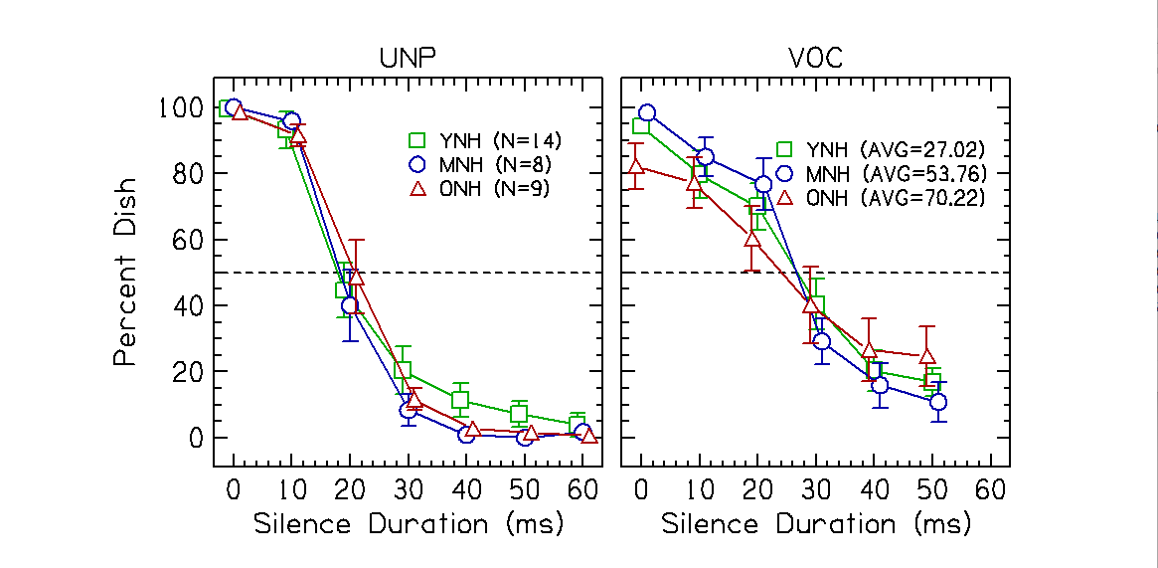
Figure 1. Percent Dish responses as a function of silence duration in ms. The error bars represent ±1 standard error.
B. Crossovers
From the psychometric functions in Fig. 1, the average crossover points for the subject groups across the Dish/Ditch continuum are shown in Fig. 2. A crossover point is interpreted as the point where the listeners’ perception shifts from “Dish” to “Ditch”. In other words, it reflects the amount of silence in ms needed for the listener to perceive the word “Ditch”. The shorter the silence duration, the better the listener’s performance on the task, which is interpreted as better temporal processing abilities. The longer silence duration to perceive “Ditch”, the poorer temporal processing abilities. A two-way mixed analysis of variance (ANOVA) was conducted on the crossover points with factors groups (between subjects, 3 levels: YNH, MNH, ONH) and condition (within subjects, 2 levels: unprocessed and vocoded). There was no main effect of age group [F(2,29) = 0.038, p = 0.963, $η_{p}^{2}$= 0.003] or condition [F(1,29) = 0.610, p = 0.441, $η_{p}^{2}$= 0.021]. There was also no significant Condition × Age Group interaction [F(2,29) = 0.134, p = 0.875, $η_{p}^{2}$= 0.009]. In summary, crossover was unaffected by condition or age group.
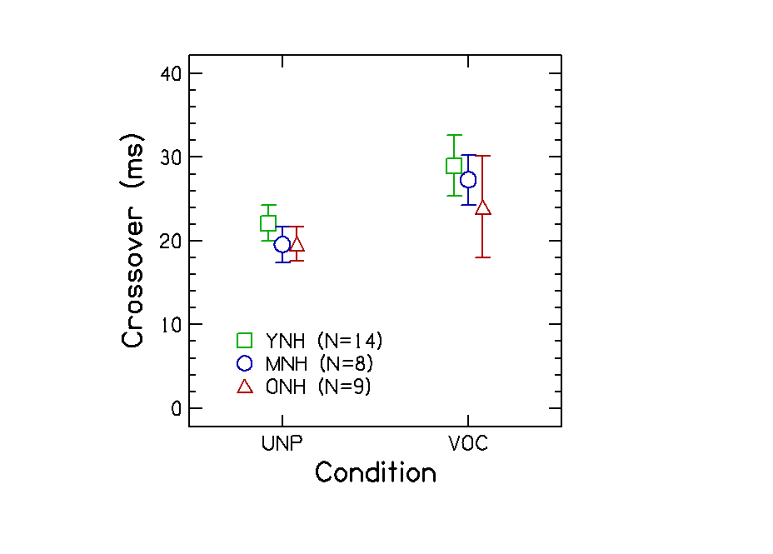
Figure 2. Crossover values as a function of the amount of spectral information. The error bars represent ±1 standard error.

C. Slopes
The slope data for the subject groups are shown in Fig 3. A steeper slope value suggests a better categorization ability. A two-way mixed ANOVA was conducted on the slope values with factors group (between subjects, 3 levels: YNH, MNH, ONH) and condition (within subjects, 2 levels: unprocessed and vocoded). There was a significant main effect of condition [F(1,28) = 23.578, p < 0.001, $η_{p}^{2}$= 0.457] with participants demonstrating shallower slopes when the stimuli were vocoded compared to when they were unprocessed. There was no main effect of age group [F(2,28) = 1.362, p = 0.273, $η_{p}^{2}$= 0.089] and no significant Condition × Age Group interaction [F(2,28) = 0.571, p = 0.571, $η_{p}^{2}$= 0.039].
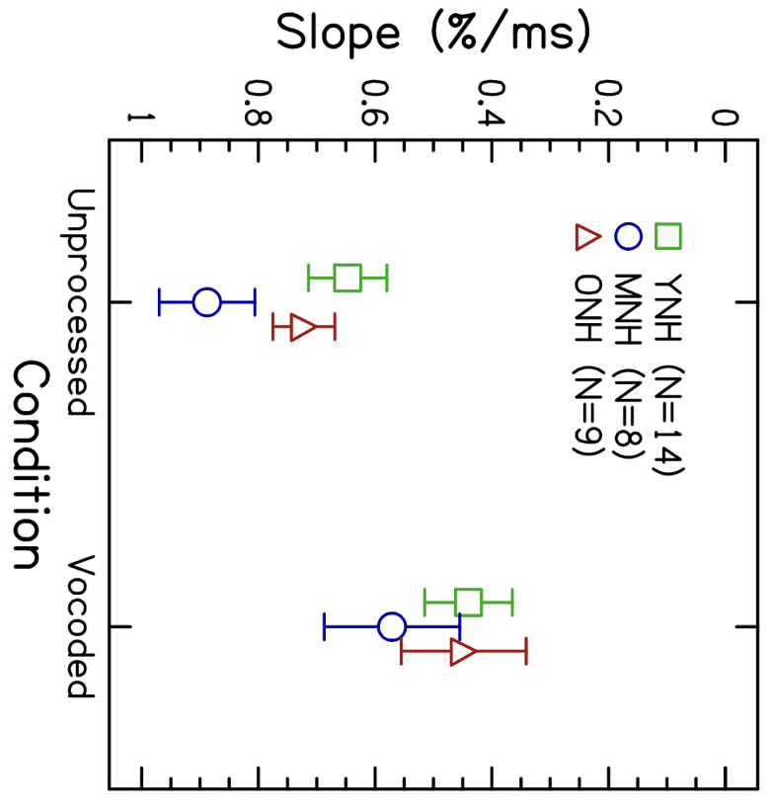
Figure 3. Slope values in % per ms as a function of the amount of spectral information. The error bars represent ±1 standard error.

D. Gap Detection Thresholds
The data for gap detection thresholds are shown in Fig 4. Gap detection thresholds were first averaged across conditions for each participant and then averaged within each age group. These group averages were compared across conditions to determine whether age influenced performance on the gap detection task. A two-way mixed ANOVA was conducted on the gap detection thresholds with factors group (between subjects, 3 levels: YNH, MNH, ONH) and condition (within subjects, 4 levels: BBN, SSN, Unprocessed Speech, Vocoded Speech).
There was a significant main effect of age group [F(2,28) = 3.680, p = 0.038, $η_{p}^{2}$= 0.208]. Three Bonferroni-corrected post-hoc two-sample independent samples t-tests were conducted to examine the effect of age group. There were no significant differences between the YNH and MNH groups [t(86) = 1.395, p = 0.083]. There was a significant difference between the MNH and ONH groups [t(66) = -2.713, p = 0.004] and the YNH and ONH groups [t(90) = -2.384, p = 0.010].
There was a significant main effect of condition [F(2,84) = 64.666, p < 0.001, $η_{p}^{2}$ = 0.698]. Six Bonferroni-corrected post-hoc two-sample paired t-tests were conducted to compare gap detection thresholds between conditions. All comparisons were significant (p < 0.01 for all), except for the comparison between the Unprocessed and Vocoded Speech [t(30) = -1.201, p = .239].
Finally, there was no significant Condition × Age Group interaction [F(6,84) = 0.522, p = 0.790, $η_{p}^{2}$= 0.036].
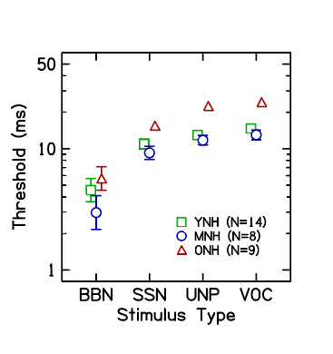
Figure 4. Gap detection thresholds as a function of stimulus type. The error bars represent ±1 standard error. BBN=Broadband Noise, SSN=Speech Shaped Noise, UNP=Unprocessed Speech, VOC=Vocoded Speech.

E. Correlation between speech discrimination and gap detection
To examine the relationship between gap detection thresholds and performance on temporal cue categorization tasks, linear regressions were conducted comparing gap detection threshold conditions to unprocessed (Fig. 5) and vocoded (Fig.6) slope and crossover values.
Separate regressions were conducted for each condition. There were no significant correlations found when comparing gap detection thresholds to unprocessed and vocoded slope and crossover values for the BBN, SSN, Unprocessed Speech, and Vocoded Speech conditions (p > 0.05 for all).
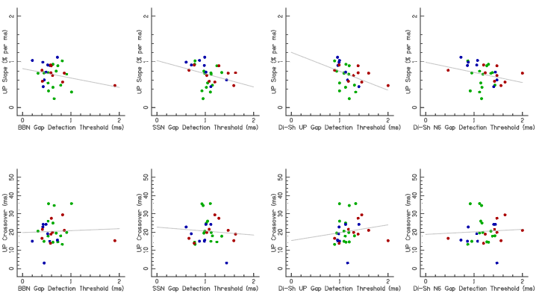
p = 0.399, r = 0.157
p = 0.092 , r = 0.308
p = 0.255, r = 0.211
p = 0.237, r = 0.219
p = 0.874, r = 0.030
p = 0.998, r = 0
p = 0.363, r = 0.169
p = 0.616, r = 0.094

Figure 5. Correlations between performance on gap detection thresholds and temporal cue discrimination tasks for unprocessed conditions
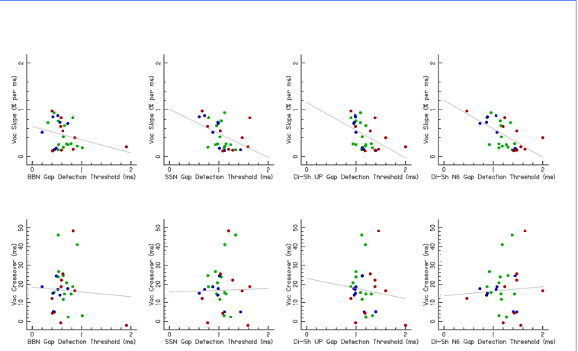
p = 0.027 , r = 0.396
p = 0.083 , r = 0.317
p = 0.134 , r = 0.276
p = 0.290 , r = 0.196
p = 0.743, r = 0.061
p = 0.289, r = 0.196
p = 0.790 , r = 0.050
p = 0.194 , r = 0.239
Figure 6. Gap detection thresholds as a function of vocoded slope values for each condition.
Discussion
In this study, we investigated the relationship between individuals’ performance on gap detection tasks and their ability to discriminate temporal speech cues. First, we wanted to determine if reducing spectral information in a sound would affect listeners’ temporal cue discrimination abilities depending on age. We hypothesized that a reduction in spectral information would decrease listeners’ ability to discriminate between different temporal speech cues, especially older adults. Then, we wanted to determine if reducing the spectral information and increasing the temporal complexity of a sound would affect gap detection thresholds depending on age. We hypothesized that reducing the spectral information and increasing the temporal complexity of a sound would lead to larger gap detection thresholds, especially for older adults. Lastly, we wanted to determine if there is a relationship between individuals’ performance on gap detection tasks and their ability to discriminate temporal cues, particularly in complex speech stimuli. We hypothesized that individuals who excel at gap detection tasks would also excel at temporal cue discrimination tasks that involve more complex stimuli, like speech.
A. Temporal Cue Discrimination Task Performance
Our hypothesis that age would negatively impact performance on a temporal cue discrimination task when there was a reduction in spectral information was only partially supported. While we did observe declines in performance in vocoded speech, we did not find significant aging effects across age groups, which disagrees with previous studies that used the word pair “Dish” and “Ditch”.
Figure 1 shows the results of the temporal cue discrimination task across the YNH, MNH, and ONH groups. Conflicting with the results of Gordon-Salant (2006), our results did not have a significant age-related difference in performance in the unprocessed condition. Both the 50% crossover points and slope values were similar between YNH and ONH participants in our study, as seen in Figs. 1-3. For example, the YNH group showed a 50% crossover point at approximately 22 ms, like the YNH group in Gordon-Salant’s paper. Our ONH group had a ~19 ms crossover, compared to 25 ms in the original study, suggesting no clear age-related declines in our study.
A notable difference from Gordon-Salant et al. (2006) is our addition of a MNH group (ages 46-64), which was not examined in the previous study. The crossover values in the unprocessed condition were similar between the MNH (19.56 ms) and ONH groups (19.63 ms). But the crossover values in the vocoded condition for MNH (27.96 ms) were more like the YNH group (28.96 ms).
During data analysis, a small discrepancy was observed between the unprocessed crossover values shown in Fig. 1 and those plotted in Fig. 2. It was found that the psychometric function fitting process contributes to this small inconsistency across figures. The 50% crossover points are derived from the fitted functions and do not always align precisely with the unprocessed data. This can make the psychometric function 50% crossover occur at a point that does not exactly match the pattern of the data. The current script uses a logistic sigmoid to fit the data, but taking a different approach may produce a more accurate representation of the data.
In the vocoded condition, all listener groups demonstrated shallower slopes compared to the unprocessed condition (Fig. 2). Even though the 50% crossover points were not statistically different between the two conditions, the shallower slope suggests a greater difficulty in distinguishing between “Dish” and “Ditch”. These results are in line with the results from Goupell et al. (2017), which found that reduced spectral information causes declines in listeners’ ability to discriminate between different temporal cues. In addition, the greatest differences in performance appeared to be on both ends of the 7-step continuum, consistent with previous findings that degraded spectral input exacerbated temporal processing abilities (Goupell et al., 2017).
Several factors may have contributed to the differences in aging effects observed by both Gordon-Salant et al. (2006) and Goupell et al. (2017). First, the inclusion of the MNH group may have unintentionally obscured any aging effects seen in studies with only YNH and ONH participants. The MNH and ONH groups’ surprising performance on the task raises some possibilities regarding prior experience with psychoacoustic testing or familiarity with the test stimuli (“Dish” and “Ditch”) that could have influenced results. A lack of motivation or attentiveness among our YNH group could have contributed to their poorer performance on the task. An individual’s performance on different psychoacoustic tasks can be influenced by attention, motivation, and task demands (Bertoli et al., 2002). These elements can complicate the way we interpret our results and can make it more challenging to see temporal processing deficits.

B. Gap Detection Threshold Performance
Our hypothesis was partially supported by the results shown in Fig. 4, which revealed significant main effects of age and stimulus type on gap detection thresholds. The smallest gap detection thresholds were observed for the BBN condition, with MNH and YNH listeners showing thresholds of around 3 ms. This finding aligns with previous studies using broadband or narrowband noise stimuli, where gap detection thresholds were normally between 2-3 ms (Formby et al., 1993; Plomp, 1964). Because broadband noise has identical spectral and temporal characteristics on both sides of the gap, it facilitates gap detection performance (Harris et al., 2010; Lister & Tarver, 2004; Pichora-Fuller et al., 2006). In our study, the YNH listeners had an average BBN threshold of approximately 4.5 ms and the ONH listeners had higher thresholds of around 5.7 ms. These results are consistent with Roberts and Lister (2004), who found that when the gap was in a fixed location in the middle of a white noise burst, thresholds were similar across age groups, approximately 2.7 ms for YNH listeners and 4.9 ms for ONH listeners (Roberts & Lister, 2004). Other studies have reported similar findings, showing similar performance across age groups in simpler conditions using pure tones or broadband noise (Bertoli et al., 2002; Harris et al., 2010; Lister et al., 2002; Lister & Tarver, 2004).
Gap detection thresholds increased significantly for the SSN condition, with averages ranging from approximately 9 to 15.5 ms. This suggests that speech-shaped noise, which spectrally resembles speech, introduces additional challenges for listeners. A likely explanation is that the SSN condition had unequal RMS intensity on both sides of the gap. In the word “Dish” the RMS intensity of the “Di” token is higher than that of the “Sh” token. In our BBN condition, the RMS intensity was equal on both sides of the gap which, according to previous research, suggests better performance on gap detection tasks (Fitzgibbons & Gordon-Salant, 1995). This asymmetry could have contributed to the difference in gap detection thresholds observed in our study.
The highest gap detection thresholds are seen in the unprocessed (approximately 11-22 ms) and vocoded (approximately 13-24 ms) speech conditions. These conditions are more spectrally and temporally complex stimuli, which may have contributed to the increased difficulty observed in the task. This finding is consistent with Gordon-Salant and Fitzgibbons (1995), who found differences in gap detection thresholds as the stimuli became more complex.
One contributing factor may have been the asymmetry in the word “Dish”, where the “Di” portion is more intense than the “Sh” portion (Pichora-Fuller et al., 2006). This asymmetry is a good reminder that speech is dynamic in nature, and includes changes to frequency and intensity that occur over time which make the speech stimuli more complex than non-speech sounds, further complicating gap detection performance (Lister & Tarver, 2004).
The higher gap detection thresholds seen in the vocoded speech conditions could be due to the reduced spectral resolution that occurs when we vocode a signal. A study by Zhang et al. (2015) investigated the effect of noise vocoding on gap detection thresholds for CI users. They found gap detection thresholds got worse when vocoded stimuli were introduced, especially when they vocoded using fewer frequency channels (4 channels) (Zhang et al., 2015). In contrast, our study used a sine vocoder, which also reduces the spectral resolution of the speech signal and makes it more spectrally sparse, making it more difficult to identify the location of the gap in the stimuli due to the reduction in frequency.
It is also worth mentioning that the increased difficulty of the task may have been due to the speech-like nature of some stimuli. When the stimuli more closely resembled speech, participants may have focused more on the speech-like qualities of the stimuli rather than the gap itself. This shift in attention could have made it more challenging to detect the gap.
Furthermore, we observed aging effects, with ONH listeners exhibiting higher gap detection thresholds compared to YNH and MNH participants across conditions. These findings agree with previous studies that showed age can impair temporal resolution, especially as stimuli become more complex (Fitzgibbons & Gordon-Salant, 1994b, 1995). This highlights the emergence of age-related declines in auditory temporal processing, which becomes even more pronounced when additional temporal and spectral complexities are introduced.

C. Correlations between performance on gap detection tasks and temporal cue discrimination tasks
Given that both tasks are considered measures of temporal processing abilities, we hypothesized that performance on gap detection would predict performance on temporal cue discrimination tasks. Our hypothesis was not supported as we found no significant correlations between the two tasks (Figs. 5-6). This suggests that these tasks may rely on different auditory mechanisms and may not both solely rely on temporal processing abilities as initially assumed. It appears that the way listeners process brief gaps in different sounds is not the same as how they process temporal cues in speech. Gap detection tasks are often thought to reflect basic auditory temporal processing abilities, while temporal cue discrimination tasks may include additional processes such as lexical access and phonological awareness (Pichora-Fuller et al., 2006).
Speech perception often involves identifying brief gaps that cue phonemic differences, which can affect how we perceive the word being said. Because of this, it is possible there is a relationship between the ability to detect brief gaps and the ability to distinguish speech sounds that have similar temporal components (Gordon-Salant et al., 2006). It is interesting to note that natural speech can also provide listeners with other acoustic cues beyond temporal ones, as more than one cue can differ between two phonetically contrasting words (Gordon-Salant et al., 2008).
In our study, older adults showed poorer performance on the gap detection task, but there were no significant effects of age on the temporal cue discrimination task. Natural speech contains redundant temporal and spectral cues, which listeners can use to facilitate word recognition (Gordon-Salant et al., 2008). Motivation and attention can also enhance performance in older adults, especially when using meaningful stimuli like speech. This may indicate that temporal cue discrimination tasks that are speech-based, may not highlight deficits in temporal processing as effectively as non-speech tasks like gap detection.
Another possible explanation worth considering is the order in which the tasks were administered. Participants completed the gap detection task first and were given minimal information about the stimuli. They were instructed to listen for a gap, rather than focusing on identifying the sound. In contrast, the temporal cue discrimination task required participants to identify meaningful words (“Dish” vs “Ditch”), which may have increased their attentiveness, since they knew what to listen for and could focus on distinguishing the words. It is also worth noting that the word “Dish” was used in the gap detection task (both unprocessed and vocoded). This could have unintentionally familiarized participants with the word, potentially making it easier to later discriminate between “Dish” and “Ditch” in the speech task.
The acoustic properties of the stimuli should also be considered. They may influence how well listeners can use the silent duration cue (Roque et al., 2019). For example, the /d/ in “Dish” and “Ditch” is a stop consonant that generates a transient burst of energy, which can make the silent cue easier to encode. This differs from speech contrasts like “Wheat” vs. “Weed” that rely more on gradual formant transitions and vowel duration differences which do not have those transient bursts of sounds (Roque et al., 2019). Gradual changes such as these may place greater demands on temporal processing. Differences in neural synchrony, especially when processing rapid acoustic changes, could help explain variability in listener performance.
In contrast, performance on gap detection tasks showed age-related declines, which are commonly associated with deteriorating temporal processing abilities. Cognitive factors have been associated with performance on speech perception tasks, but their influence on basic psychoacoustic tasks like gap detection is not observed as often (DeVries et al., 2022; Gordon-Salant & Cole, 2016). This suggests that the age-related declines we observed could reflect changes in basic temporal processing abilities more so than on broader non-auditory cognitive abilities.
Overall, the lack of correlation between the two tasks supports the idea that while both involve temporal processing, they are not equivalent measures of temporal processing that rely on the same processing mechanisms. Temporal cue discrimination and gap detection tasks may engage with a larger range of perceptual or cognitive systems.
D. Limitations
Some limitations of this study include the need to increase the number of participants in the MNH group and to ensure a more balanced distribution of participants across age decades. Future analyses could benefit from using a mixed-effects model, which would include random effects and improve our ability to model performance on these tasks. Providing additional training for the gap detection task could also improve participants’ understanding and allow them more time to become familiar with the task. Additionally, attention and fatigue may have influenced performance.

E. Future Directions
a. Cochlear-Implant Listeners
While vocoded speech provides a useful simulation of CI listening, it can fail to capture the actual CI experience. Testing CI users offers deeper insights into how temporal processing differs from that of normal-hearing individuals, especially related to age. Our preliminary results from the temporal cue discrimination task for four CI users showed a later crossover point (around 35 ms) compared to the NH listeners in the vocoded condition (Fig. 7). These findings suggest that even young CI users may experience temporal processing challenges, highlighting the need for further investigation into this population. These difficulties could be influenced by device-related factors, such as limitations in signal processing strategies, which can reduce access to important temporal cues needed for speech perception (Litovsky et al., 2012).
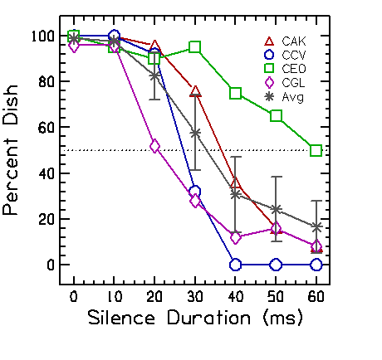
Figure 7. Psychometric functions for unprocessed conditions for four CI users.

b. Bilingual Listeners
Some studies have suggested that bilingual and multilingual individuals may have enhanced auditory processing abilities, perhaps due to increased cognitive or linguistic demands (Kumar et al., 2020; Oppitz et al., 2014). However, others suggest that listeners perform better on speech recognition tasks in dialects familiar to them, indicating that language background and dialect can impact performance (Rodriguez & Shader, 2025).
In our study, preliminary data in Fig. 8 from three bilingual participants (one 20-year-old and two 50-year-olds) showed similar performance to our NH listeners on the unprocessed temporal cue discrimination task. Interestingly, in the vocoded condition, these participants showed earlier crossover points (around 10 ms), although their slope values were shallow. While this might initially suggest better performance, a shorter crossover in this case may suggest it is possible these participants never perceived the word dish and defaulted to hearing ditch for most steps along the continuum. This raises questions about the role of bilingualism as a possible advantage when listening to degraded speech. Further research will need to be done to further explore these trends.
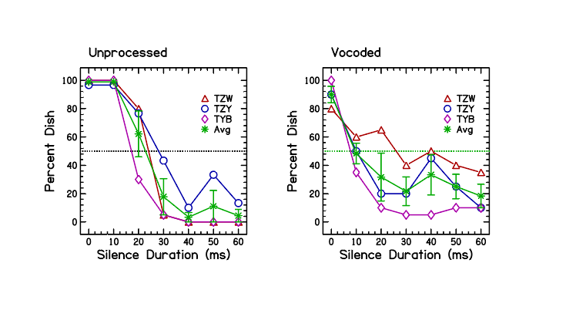
Figure 8. Psychometric functions for unprocessed and vocoded conditions for bilingual listeners.

C. Clinical Implications
Improving CI programming or offering other strategies may be a helpful way to address temporal processing deficits and enhance speech perception, especially for older users. Speaking at slower rates gives CI users extra time to process important timing cues (Tinnemore et al., 2024). Aural rehabilitation programs can teach CI users to advocate for their communication needs and apply listening strategies in everyday situations, helping them make the most of their hearing devices. Various CI programming strategies, like sharpening temporal envelopes, may be useful for speech clarity (Tinnemore et al., 2024), and adjusting stimulation rates on an individual basis could be used to help optimize speech understanding (Doyle, 2025; Shader et al., 2020). Stimulation rate does not consistently impact performance across all users, but older adults may benefit from lower rates, especially when in challenging listening conditions (Shader et al., 2020). Factors like duration of severe-to-profound hearing loss (Kelly et al., 2025) and the ability to use temporal cues may significantly influence performance, highlighting the importance of adjusting programming to individual needs.

Bibliography
Anderson, S., Parbery-Clark, A., Yi, H.-G., & Kraus, N. (2011). A Neural Basis of Speech-in-Noise Perception in Older Adults. Ear and Hearing, 32(6), 750–757. https://doi.org/10.1097/AUD.0b013e31822229d3
Berg, K., Noble, J., Dawant, B., Dwyer, R., Labadie, R., & Gifford, R. (2019). Speech recognition as a function of the number of channels in perimodiolar electrode recipients. The Journal of the Acoustical Society of America, 145(3), 1156. https://doi.org/10.1121/1.5092350
Bertoli, S., Smurzynski, J., & Probst, R. (2002). Temporal resolution in young and elderly subjects as measured by mismatch negativity and a psychoacoustic gap detection task. Clinical Neurophysiology, 113(3), 396–406. https://doi.org/10.1016/S1388-2457(02)00013-5
Carlyon, R. P., & Goehring, J. L. (2021). Cochlear Implant Research and Development in the Twenty-first Century: A Critical Update. J. Assoc. Res. Otolaryngol., 22, 481–508. https://doi.org/10.1007/s10162-021-00811-5
Croghan, N., Duran, S., & Smith, Z. (2018). Re-examining the relationship between number of cochlear implant channels and maximal speech intelligibility. The Journal of the Acoustical Society of America, 142(6), 537-543. https://doi.org/10.1121/1.5016044
Cychosz, M., Winn, M., & Goupell, M. (2024). How to vocode: Using channel vocoders for cochlear-implant research. The Journal of the Acoustical Society of America, 155(4), 2407–2437. https://doi.org/10.1121/10.0025274
DeVries, L., Anderson, S., Goupell, M. J., Smith, E., & Gordon-Salant, S. (2022). Effects of aging and hearing loss on perceptual and electrophysiological measures of pulse-rate discrimination. The Journal of the Acoustical Society of America, 151(3), 1639–1650. https://doi.org/10.1121/10.0009399
Doyle, E., Tinnemore, A., Nguyen, N., & Goupell. M (2025). The Effects of Stimulation Rate on Speech Cue Detection in Cochlear-Implant Users. University of Maryland-College Park, Capstone Research Day.
Fitzgibbons, P. J., & Gordon-Salant, S. (1994a). Age Effects on Measures of Auditory Duration Discrimination. Journal of Speech, Language, and Hearing Research, 37(3), 662–670. https://doi.org/10.1044/jshr.3703.662
Fitzgibbons, P. J., & Gordon-Salant, S. (1994b). Age Effects on Measures of Auditory Duration Discrimination. Journal of Speech, Language, and Hearing Research, 37(3), 662–670. https://doi.org/10.1044/jshr.3703.662
Fitzgibbons, P. J., & Gordon-Salant, S. (1995). Age effects on duration discrimination with simple and complex stimuli. The Journal of the Acoustical Society of America, 98(6), 3140–3145. https://doi.org/10.1121/1.413803
Formby, C., Barker, C., Abbey, H., & Raney, J. J. (1993). Detection of silent temporal gaps between narrow-band noise markers having second formant-like properties of voiceless stop/vowel combinations. The Journal of the Acoustical Society of America, 93(2), 1023–1027. https://doi.org/10.1121/1.405550
Fu, Q.-J., & Nogaki, G. (2005). Noise Susceptibility of Cochlear Implant Users: The Role of Spectral Resolution and Smearing. Journal of the Association for Research in Otolaryngology, 6(1), 19–27. https://doi.org/10.1007/s10162-004-5024-3
Gatehouse, S., & Noble, W. (2004). The Speech, Spatial and Qualities of Hearing Scale (SSQ). International Journal of Audiology, 43(2), 85–99. https://doi.org/10.1080/14992020400050014
Goehring, T., Archer-Boyd, A., Deeks, J., Arengerg, J., & Carlyon, R. (2019). A Site-Selection Strategy Based on Polarity Sensitivity for Cochlear Implants: Effects on Spectro-Temporal Resolution and Speech Perception. Journal of the Association for Research in Otolaryngology, 20(4), 431–448. https://doi.org/10.1007/s10162-019-00724-4
Golomb, J. D., Peelle, J. E., & Wingfield, A. (2007). Effects of stimulus variability and adult aging on adaptation to time-compressed speech. The Journal of the Acoustical Society of America, 121(3), 1701–1708. https://doi.org/10.1121/1.2436635
Gordon-Salant, S., & Cole, S. S. (2016). Effects of Age and Working Memory Capacity on Speech Recognition Performance in Noise Among Listeners with Normal Hearing. Ear & Hearing, 37(5), 593–602. https://doi.org/10.1097/AUD.0000000000000316
Gordon-Salant, S., & Fitzgibbons, P. J. (2001). Sources of age-related recognition difficulty for time-compressed speech. Journal of Speech, Language, and Hearing Research, 44(4), 709-719. https://doi.org/10.1044/1092-4388(2001/056)
Gordon-Salant, S., Fitzgibbons, P. J., & Yeni-Komshian, G. H. (2011). Auditory Temporal Processing and Aging: Implications for Speech Understanding of Older People. Audiology Research, 1(1), e4. https://doi.org/10.4081/audiores.2011.e4
Gordon-Salant, S., Yeni-Komshian, G., & Fitzgibbons, P. (2008). The role of temporal cues in word identification by younger and older adults: Effects of sentence context. The Journal of the Acoustical Society of America, 124(5), 3249–3260. https://doi.org/10.1121/1.2982409
Gordon-Salant, S., Yeni-Komshian, G., Fitzgibbons, P., & Barrett, J. (2006). Age Related Differences in Identification & Discrimination of Temporal Cues in Speech Segments. The Journal of the Acoustical Society of America, 119(4), 2455–2466. https://doi.org/10.1121/1.2171527
Goupell, M., Gaskins, C., Shader, M., Walter, E., Anderson, S., & Gordon-Salant, S. (2017). Age-Related Differences in the Processing of Temporal Envelope and Spectral Cues in a Speech Segment. Ear and Hearing, 38(6), 335–342. https://doi.org/10.1097/AUD.0000000000000447
Harris, K. C., Eckert, M. A., Ahlstrom, J. B., & Dubno, J. R. (2010). Age-related differences in gap detection: Effects of task difficulty and cognitive ability. Hearing Research, 264(1–2), 21–29. https://doi.org/10.1016/j.heares.2009.09.017
He, N., Dubno, J. R., & Mills, J. H. (1998). Frequency and intensity discrimination measured in a maximum-likelihood procedure from young and aged normal-hearing subjects. The Journal of the Acoustical Society of America, 103(1), 553–565. https://doi.org/10.1121/1.421127
Ji, C., Gavin, J., Chang, Y., Xu, A., & Fu, Q.-J. (2014). Perception of speech produced by native and nonnative talkers by listeners with normal hearing and listeners with cochlear implants. Journal of Speech, Language, and Hearing Research, 57(2), 532–554. https://doi.org/10.1044/2014_JSLHR-H-12-0404
Kelly, R., Tinnemore, A. R., Nguyen, N., & Goupell, M. J. (2025). On the Difficulty of Defining Duration of Deafness for Adults with Cochlear Implants. Ear and Hearing, 46(5), 1125–1129. https://doi.org/10.1097/AUD.0000000000001666
Kumar, K., Sreeshma, R., & Kalaiah, M. K. (2020). A comparison of temporal processing and spectral processing abilities of monolingual, bilingual and multilingual children. International Journal of Audiology, 59(7), 501–505. https://doi.org/10.1080/14992027.2020.1720921
Lin, F. (2024). Age-Related Hearing Loss. The New England Journal of Medicine, 390(16), 1505–1512. https://doi.org/10.1056/NEJMcp2306778
Lister, J., Besing, J., & Koehnke, J. (2002). Effects of age and frequency disparity on gap discrimination. The Journal of the Acoustical Society of America, 111(6), 2793–2800. https://doi.org/10.1121/1.1476685
Lister, J., & Tarver, K. (2004). Effect of age on silent gap discrimination in synthetic speech stimuli. Journal of Speech, Language, and Hearing Research, 47(2), 257–268. https://doi.org/10.1044/1092-4388(2004/021)
Litovsky, R. Y., Goupell, M. J., Godar, S., Grieco-Calub, T., Jones, G. L., Garadat, S. N., Agrawal, S., Kan, A., Todd, A., Hess, C., & Misurelli, S. (2012). Studies on bilateral cochlear implants at the University of Wisconsin’s Binaural Hearing and Speech Laboratory. Journal of the American Academy of Audiology, 23(6), 476–494. https://doi.org/10.3766/jaaa.23.6.9
Loizou, P. (2006). Speech processing in vocoder-centric cochlear implants. Advances in Oto-Rhino-Laryngology, 64, 109–143. https://doi.org/10.1159/000094648
Oppitz, S., Pelissari, I., Gois, M., Garcia, M., Bruno, R., & Filha, V. (2014). Temporal Processing in Monolingual and Bilingual Normal Hearing Adults. International Archives of Otorhinolaryngology, 18(S 01), s-0034-1388725. https://doi.org/10.1055/s-0034-1388725
Pichora-Fuller, M. K., Schneider, B. A., Benson, N. J., Hamstra, S. J., & Storzer, E. (2006). Effect of age on detection of gaps in speech and nonspeech markers varying in duration and spectral symmetry. The Journal of the Acoustical Society of America, 119(2), 1143–1155. https://doi.org/10.1121/1.2149837
Plomp, R. (1964). Rate of Decay of Auditory Sensation. The Journal of the Acoustical Society of America, 36(2), 277–282. https://doi.org/10.1121/1.1918946
Roberts, R. A., & Lister, J. J. (2004). Effects of Age and Hearing Loss on Gap Detection and the Precedence Effect: Broadband Stimuli. Journal of Speech, Language, and Hearing Research, 47(5), 965–978. https://doi.org/10.1044/1092-4388(2004/071)
Rodriguez, E. R., & Shader, M. J. (2025). Comparing the AzBio Sentence-in-Noise Test in English and Spanish in Bilingual Adults. Journal of the American Academy of Audiology.36(1), 2-10. https://doi.org/10.3766/jaaa.230120
Roque, L., Karawani, H., Gordon-Salant, S., & Anderson, S. (2019). Effects of Age, Cognition, and Neural Encoding on the Perception of Temporal Speech Cues. Frontiers in Neuroscience, 13, 749. https://doi.org/10.3389/fnins.2019.00749
Shader, M. J., Nguyen, N., Cleary, M., Hertzano, R., Eisenman, D. J., Anderson, S., Gordon-Salant, S., & Goupell, M. J. (2020). Effect of Stimulation Rate on Speech Understanding in Older Cochlear-Implant Users. Ear and Hearing, 41(3), 640–651. https://doi.org/10.1097/AUD.0000000000000793
Shannon, R., Kamath, V., Zeng, F. G., Wygonski, J., & Ekelid, M. (1995). Speech recognition with primarily temporal cues. Science, 270(5234), 303–304. https://doi.org/10.1126/science.270.5234.303
Slade, K., Plack, C., & Nuttal, H. (2020). The Effects of Age-Related Hearing Loss on the Brain and Cognitive Function. Trends in Neurosciences, 43(10), 810–821. https://doi.org/10.1016/j.tins.2020.07.005
Souza, P., & Rosen, S. (2009). Effects of envelope bandwidth on the intelligibility of sine- and noise-vocoded speech. The Journal of the Acoustical Society of America, 126(2), 792–805. https://doi.org/10.1121/1.3158835
Tinnemore, A., Doyle, E., & Goupell, M. (2024). Temporal speech cue perception in listeners with cochlear implants depends on the time between those cues and previous sound energy. The Journal of the Acoustical Society of America, 154(4), 2851–2859. https://doi.org/10.1121/10.0029020
Tinnemore, A., Montero, L., Gordon-Salant, S., & Goupell, M. (2022). The recognition of time-compressed speech as a function of age in listeners with cochlear implants or normal hearing. Aging Neuroscience, 14. 887581. https://doi.org/10.3389/fnagi.2022.887581
Waddington, E., Jaekel, B., Tinnemore, A., Gordon-Salant, S., & Goupell, M. (2020). Recognition of Accented Speech by Cochlear-Implant Listeners: Benefit of Audiovisual Cues. Ear and Hearing, 41(5), 1236–1250. https://doi.org/10.1097/AUD.0000000000000842
Wichmann, F. A., & Hill, N. J. (2001). The psychometric function: I. Fitting, sampling, and goodness of fit. Percept. Psychophysics, 63(8), 1293–1313. https://doi.org/10.3758/bf03194544
Wilson, B., & Dorman, M. (2008). Cochlear implants: A remarkable past and a brilliant future. Hearing Research, 242(1–2), 3–21. https://doi.org/10.1016/j.heares.2008.06.005
Winn, M., Chatterjee, M., & Idsardi, W. (2012). The use of acoustic cues for phonetic identification: Effects of spectral degradation and electric hearing. The Journal of the Acoustical Society of America, 131(2), 1465–1479. https://doi.org/10.1121/1.3672705
Xie, Z., Anderson, S., & Goupell, M. (2022). Stimulus context affects the phonemic categorization of temporally based word contrasts in adult cochlear-implant users. The Journal of the Acoustical Society of America, 151(3), 2149. https://doi.org/10.1121/10.0009838
Xie, Z., Gaskins, C., Shader, M., Gordon-Salant, S., Anderson, S., & Goupell, M. (2019). Age-Related Temporal Processing Deficits in Word Segments in Adult Cochlear-Implant Users. Trends in Hearing, 23. 2331216519886688. https://doi.org/10.1177/2331216519886688
Zeng, F. (2020). Celebrating the one millionth CI. JASA. https://doi.org/10.1121/10.0012825
Zhang, F., Blankenship, C., Xiang, J., Houston, L., & Samy, R. (2015). The effects of noise vocoding on gap detection thresholds. Cochlear Implants International, 16(6), 331–340. https://doi.org/10.1179/1754762815Y.0000000009

