Enabling community-higher education partnerships: common challenges, multiple perspectives
Clara Irazabal, Carmen Mendoza-Arroyo,
Catalina Ortiz Arciniegas, Rubyselen Ortiz Sanchez and Jairo Maya

Since planning is an applied discipline that deals with real places and communities and has urban environmental sustainability as one of its primary raison deter, we believe cooperation between communities and higher education helps realize planning principles and strengthen social responsibility and ‘service-learning’ ethics in young professionals. This paper offers an open reflection from local community representatives, students, and professors from diverse institutional and geographic settings on a joint experience in an international, community-higher education planning studio. It focused on analyzing and proposing alternatives to a greenbelt project conceived as a mechanism to contain urban growth while controversially causing the relocation of dwellers of the self- built ‘Commune 8’ located in Medellı´n, Colombia. We stress the relevance of community-higher education partnerships when developing action-oriented research and contextually relevant solutions. We also examine critical factors for these partnerships, such as motivations, approaches to community engagement, protocols for knowledge transfer, challenges, and future visions and directions.

Introduction
For growing metropolises, sustainability heavily depends on their urban growth management practices. One of the quintessential planning tools for growth management has been greenbelts [1]. However, the conception and im- plementation of this strategy are politically contested and produce large socio-spatial impacts. In this context, Medellı´n, Colombia, recently acclaimed as the bench- mark of urban and social innovation [2], has overlapping initiatives to intervene urban fringes and prevent further encroachment on the fragile high slopes of the Aburra Valley Mountains. The Aburra Valley Metropolitan Plan- ning Authority and the Urban Development Enterprise (UDE, the public company in charge of projects’ execu- tion) are proposing these interventions in the midst of public debate on the new Strategic Spatial Plan. Its most controversial proposal is the project of a greenbelt called ‘Encircling Garden’ — Jardı´n Circunvalar — led by the UDE. Its pilot project is been implemented in ‘Com- mune 8’, a self-built settlement in the center-east area of Medellı´n. The initial planning process and ideas revealed serious limitations for citizens’ involvement and diver- gence in the scope and the priorities of public expendi- tures with the community-led Local Development Plan for Commune 8.

Given this collision of visions, the National University of Colombia (UNC) promoted a community-higher educa- tion partnership between community leaders of the Com- munity Planning Council of Commune 8 (CPCC8) and students and faculty of the UNC, Medellı´n and Bogota´, Colombia; Columbia University (CU), New York, USA; and the Universitat International de Catalunya (UIC), Barcelona, Spain. This partnership promoted an Interna- tional Planning Studio, ‘Rethinking Urban Fringes in Medellı´n: An Alternative Intervention Model’ to analyze and produce recommendations to bridge visions and offer potential solutions for the community’s urban sustainabil- ity challenges, including significant environmental risks due to its hilly emplacement and threats of evictions due to the Jardı´n Circunvalar project.

The site became a fertile scenario for unveiling the clashes and potentials between bottom up and top down planning challenges and initiatives at play. With this in mind, the partnership sought to: first, provide students, community leaders, and other participants with a safe

space to exchange insider and outsider assessments and proposals about the official greenbelt schemes; second, innovate in planning praxis by contrasting bottom up and top down approaches, as well as local, national, and international precedents; and third, enhance the role of social responsibility in planning practice when working in context-specific proposals (which for some participants included an international setting). The specific studio was developed over one semester and the encounter of local and international participants occurred over two weeks in March 2013. However, the collaborative studio involving the local university and local community continued for over two years through different iterations of three se- mester-long studios and two other intensive one-week workshops with different international universities.

Through the open reflections of representatives of the main participants of the partnership (university professors, students, and community leaders), this essay offers different perspectives on the issues suggested in the call
for this special issue: motivation for establishing partner- ships, approaches to community engagement, protocols for knowledge transfer, challenges for community-higher education partnerships, and future visions and directions (Figure 1).

Motivation for establishing partnerships
Addressing transbordering challenges
Irazabal, CU
If planning projects are intrinsically defined by their ‘interconnectedness and complexity’ [3], that is, they are ‘wicked problems’ [4], they become exponentially more so when they become ‘transbordering’ challenges [5], crossing national and other types of borders (of class, race, ethnicity, migratory status, rural–urban dynamics, etc.). The transbordering dimensions of the Medell´ın case were particularly salient, considering that the com- munity we worked with is largely composed of rural-to- urban migrants. Issues of successful integration into a new urban culture and set of economic opportunities where

Figure 1

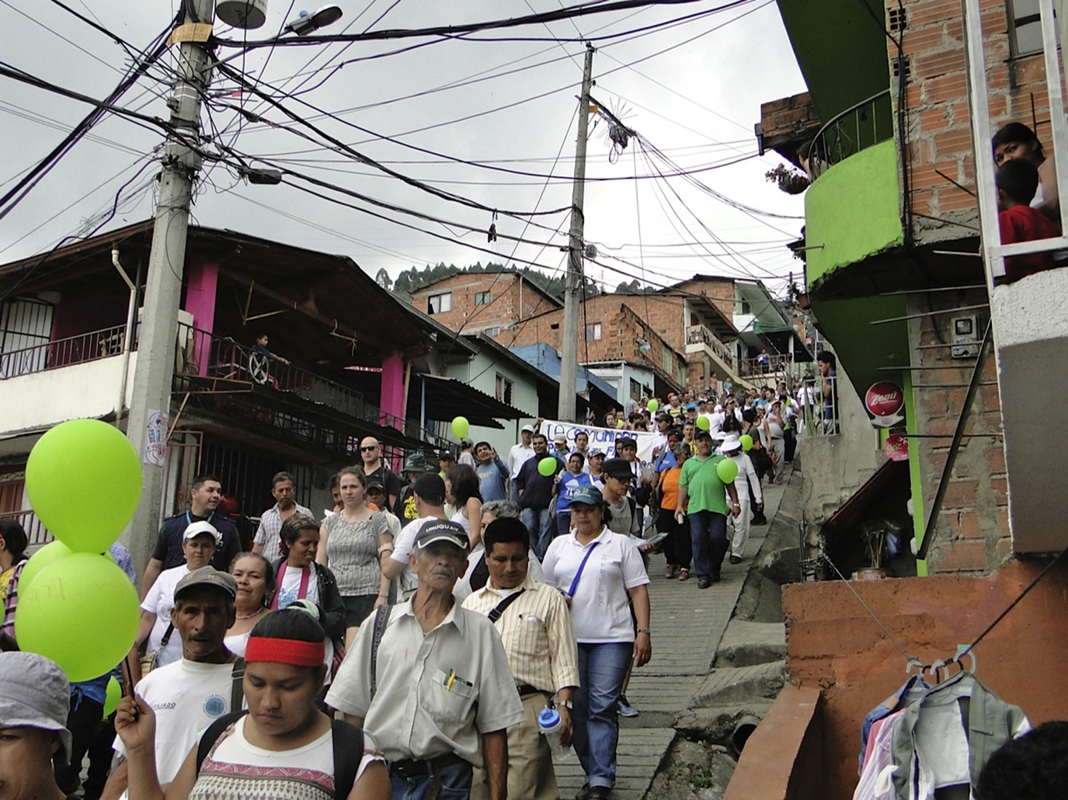
March through the informal settlement ‘Comuna 8’ for the ‘right to remain in the territory’ vis-a` -vis the greenbelt proposal.

Current Opinion in Environmental Sustainability
Photo: Catalina Ortiz Arciniegas, 2013.

compounded by challenging dynamics of gender, poverty, and violence. We therefore needed to work with the community and its designated representatives, rather than for them for analyses and proposals to be contextually sensitive and culturally appropriate. Given the constraints of time (international planning studios usually last one semester), it also became imperative to create partnerships to be able to handle transbordering interconnectedness and complexity to a minimum acceptable degree. Learn- ing to work collaboratively with multiple partners is a very critical part of the training of new planning professionals, which representedits own set of transbordering challenges.

Promoting socially relevant education
Ortiz Arciniegas, UNC
The motivation for developing a partnership comes from a constant inquiry about the role of the university in com- munity development and space production and the need to explore innovative pedagogies for contemporary urban planning. The case of the international alliance among universities and a community planning council enabled to expose the students and other participants to a real plan- ning challenge and multiple agents’ perspectives on what constituted planning interventions to move us closer to the ‘just city’ [6,7]. Some of the main aims were to help students develop both technical and argumentative plan- ning skills while contributing to enhance the community’s negotiation leverage, and to enrich the public debate about the Jardı´n Circunvalar with the UDE.

Building contextually relevant proposals
Mendoza-Arroyo, UIC
Planning offices frequently promote urban proposals, such as the Medellı´n’s Greenbelt, as ‘flagship projects’ for urban betterment linked to the imagery of stardom architecture and planning. This approach generates a gap between technicians and community members, which diminishes their opportunity for an egalitarian and pro- ductive engagement. The motivation behind the com- munity-higher education partnership is to help link knowledge to action [8] offering technical support for the realization of community’s goals while leveling the power balance [9]. This experience delved on systemic proposals such as an alternative to the conventional greenbelt, a ‘green network,’ which proposed densifica- tion in opportunity sites in proximity to the community hubs, and a technical map of risk areas, which enabled the community to negotiate the relocation areas the plan proposed. The community knowledge of the site en- hanced these ‘socio-spatial’ proposals. The reciprocally beneficial outputs of this partnership lie in both service and learning experiences (service-learning) by the part- ners and the recognition of the knowledge that resides in the community’s deep cultural and physical understand- ing of their lives and territory [10–12]. Partnerships should not be conceived of and managed as primarily technical processes, but rather as political and human
endeavors that should strive to employ and enhance democratic practices [13,9].

Universities as community allies
Rubyselen Ortiz Sa´nchez and Jairo Maya, CPCC8
As community leaders, we believe in partnerships. The relevance of community-academic partnerships resides on being long-term and relying on mutual trust between the partners. This alliance allowed us to technically ground our proposals and thus helped us to gain leverage in public debates vis-a`-vis city authorities and promote public policy change. The outcomes of the partnership gave us arguments to build upon and strengthen our ongoing local planning process. It gave us substantive basis not only for deepening our communitarian dialogue, but also for negotiations with the city council. We saw the universities as our allies in this process. This alliance contributed to change our self-perception and the per- ception of the ‘community’ by outsiders. We underwent a transformation from been perceived as, and self-perceive as the ‘poor’ or ‘in need’ and the objects of planning, to subjects of planning, interlocutors collaboratively defin- ing technically what we wanted. This horizontal ex- change enabled us to avoid becoming objects of a patronizing approach and enhanced the capabilities of already organized groups in public debates. The social recognition and enhanced self-esteem of the community also expanded due to the public legitimacy and prestige of the higher education institutions we partnered with.

Approaches to community engagement
Ongoing dialogue and methods
Iraza´bal
Partnering with communities is important to plan with/for them in manners that are respectful, relevant, and sus- tainable. You can learn from residents what their needs and expectations are for the transformation of their places and communities, as well as what it would mean and what it would take to attain change in manners that are just and sustainable [9]. The most important factor for actors in higher education to consider for community engagement is developing the ability to listen empathetically with an open heart and mind, while avoiding ethnocentrism. In addition to a transparent and ongoing dialogue with community representatives and other members, aca- demics and students can use observation, participant observation, interviews, surveys, focus groups, guided site visits, brainstorming sessions, workshops (charrette work), pin-up reviews, journal writing, and reflection in action, among other methods, as productive approaches to community engagement when they perform fieldwork in their project’s sites and communities [14,15].

Co-production
Ortiz Arciniegas
The approach to engage with Commune 8’s CPC focused on recalibrating traditional concepts about who plans and

who are legitimate knowledge producers. The co-con- struction of knowledge is central to planning practices [16]. Rather than considering community members as passive receptacles of technical recommendations by university members, we considered them as crucial inter- locutors and carriers of everyday knowledge in social and place-based living, as well as mobilization strategies. We borrowed Sletto’s [17,2] concept of interlocutors as those ‘who open up the possibility of some alternative type of communication that itself can produce new forms of work’ regardless of their institutional position. Thus, the proposals built along the semester were co-produc- tions that creatively introduced insights from local and international students as well as members from the CPC and other studio collaborators (Figure 2).

Common ground for different voices
Mendoza-Arroyo
Setting common goals between the higher education part- ners and the community partners enabled a cooperative
start to working together. Having community leaders actively participating in the studio helped bridge the gap between academic professional wisdom and commu- nity knowledges [18]. The studio goals were primarily set by the community and pursued hand in hand with the academic partners. The relevance of the work developed by the partnership became a great asset towards further engaging the community. The community leaders partici- pated equally as part of the ‘technical groups’ developing proposals. Equitable treatment in partnerships helped prevent the negative effects of preconceptions, including pigeonholing people into traditional roles, thus enabling a stage for all voices to be involved and new systems of interaction, creativity, and empowerment.

Protocols for knowledge transfer
Multi-directional knowledge transfer
Iraza´bal
All exchanges among universities and communities should explicitly pursue and be open to knowledge

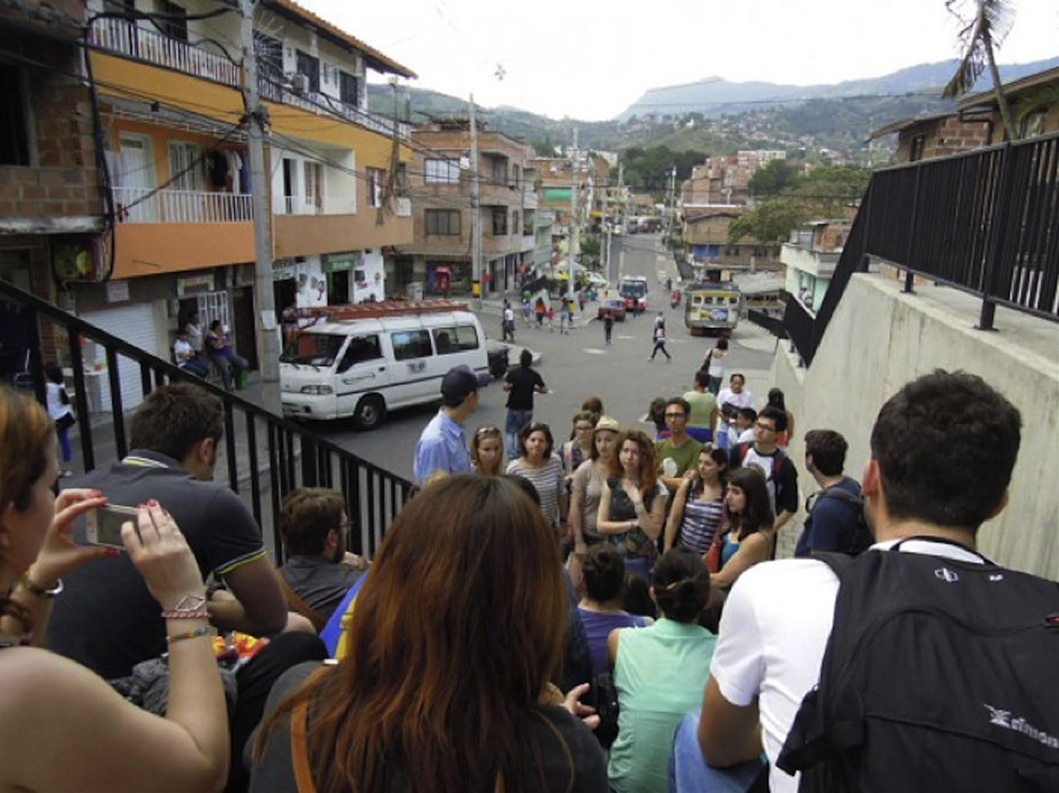
Figure 2

Current Opinion in Environmental Sustainability

Students visiting Comuna 8 with representative of the Urban Development Enterprise of the Municipality of Medellı´n.
Photo: Allison Koornneef, 2013.

transfers. There are different types of knowledge that need to be acknowledged, negotiated, and ideally trans- ferred among participants in community-higher educa- tion partnerships. The ongoing myth of ‘expert’ knowledge brought about by formally educated profes- sionals (even if they have not yet graduated, such as in the case of students participating in a studio course) as been more valuable than that of the non-formally educated local residents is ethnocentric and neocolonialist [19]. Those assumptions ought to be explicitly problematized and avoided. In the exchange, not only do students and professors gain valuable knowledge about the conditions of the project site and the needs and expectations of the community that are critical for relevant planning. They can also develop and improve their cultural competency and translation skills [20,11]. Community members, on their part, can expand their language toolkit, including acquiring technical planning knowledge for the articula- tion and negotiation of their needs and expectations.

Evolving protocols of knowledge
Ortiz Arciniegas, Mayas, and Ortiz Sa´nchez
Money does not necessarily lead to development; rather, development takes place where there is shared knowledge.
This approach to knowledge sharing and co-production framed our relationship. The protocols of knowledge transfer of the partnership were not pre-defined, but evolved through the process of mutual learning. In the analytical stage of the project, specific challenges were prioritized for each team of students. Once the main planning strategies for overcoming the limitations of the ‘official’ greenbelt proposal were agreed on, the work was presented to a community assembly — over 800 inhabi- tants — who voted on a public consultation about priorities of state investments. The proposals were explained through social cartography produced by inhabitants of four neighborhoods. In this way, a vision of concrete goals was socially constructed, represented in maps and spatial plan- ning proposals (Figure 3).

The outputs of the process were final reports that each university produced from its team’s vantage point. The reports became political and technical tools for the com- munity, as they were socialized and appropriated in an empowering process. The technical and legal recommen- dations have had indirect impact on the fate of one of the most contested proposals of the current administration in Medellı´n: a monorail included as part of the greenbelt

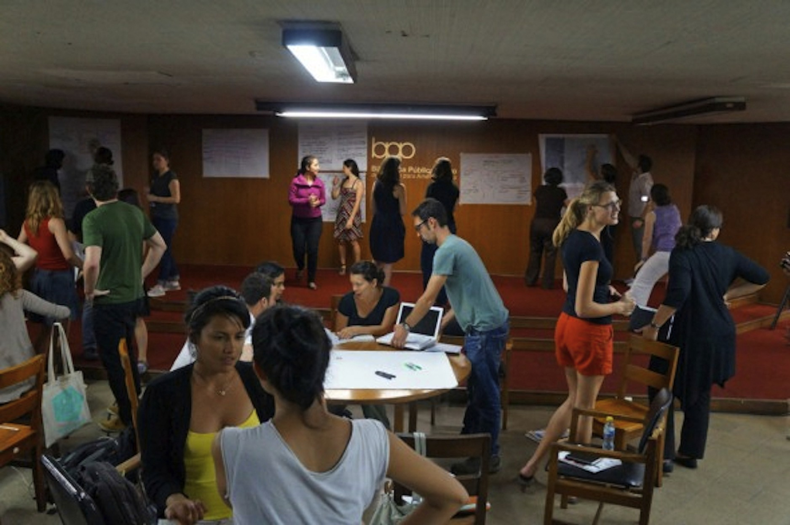
Figure 3

Current Opinion in Environmental Sustainability

Brainstorming session with community leaders and student groups.
Photo: Natalia Vilamizar, 2013.

plan. Therefore, the partnership outputs have already served the purpose of contributing to the greenbelt’s ongoing definition through public negotiations.

From the students’ perspective, Giselle Sebag commen- ted:
The most meaningful part of the experience was getting to interact personally with residents and activists of the community. I was extremely impressed by the organiza- tion, complexity, and completeness of the community proposals for the Greenbelt project. The community showed the power of political will and desire regardless of formal education or technical tools. The document that was produced and the subsequent protest actions, to me, reinforce the notion that in many cases the community does actually know what is best for itself.

Some students participating in this studio opted to con- tinue their involvement with the community beyond the
studio project through community activism, internships, or thesis development.

Challenges for community-higher education partnerships
Establishing honest dialogue and clarifying roles
Iraza´bal
There are multiple challenges for community-higher edu- cation partnerships in international urban environmental sustainability studios. To an important extent, challenges stem from the different needs and expectations that the three main interacting players — professors, students, and community members — bring into the partnership. In basic terms, professors organize a project as a finite peda- gogic engagement with objectives, activities, and deliver- ables realizable in a delimited timeframe. Students need to comply with course requirements and acquire skills that make them qualified for the job market. Community members, in general, have longer-term investments and more multifaceted interests in the betterment of the sites

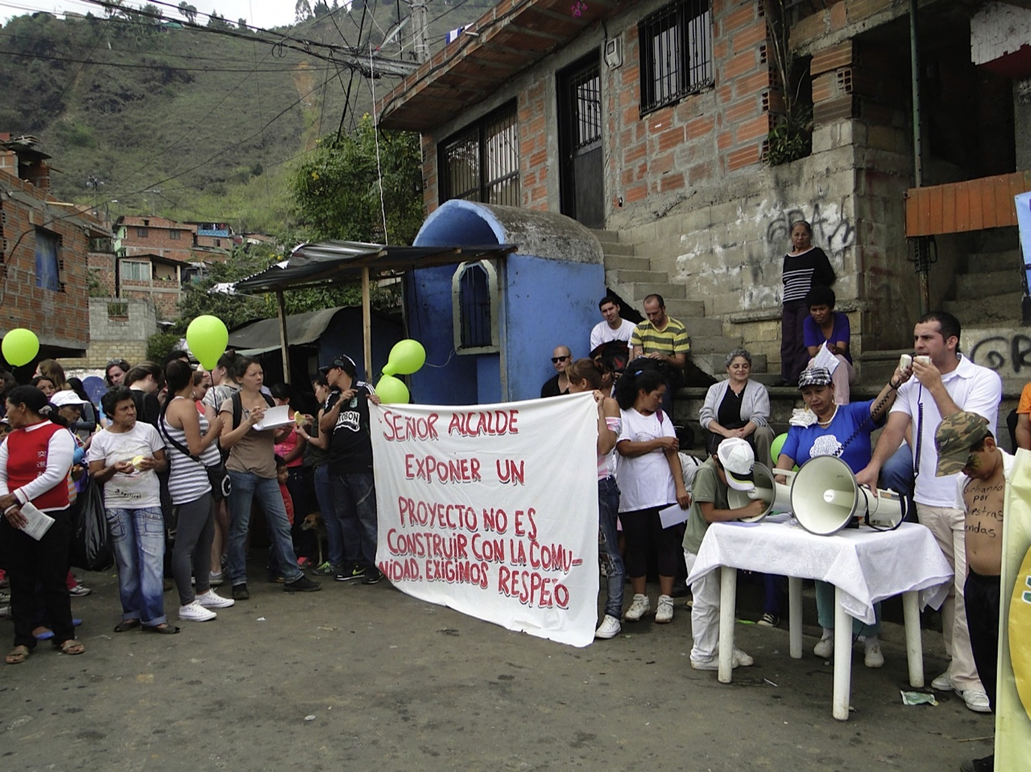
Figure 4

Current Opinion in Environmental Sustainability

Mr. Mayor: presenting a project is not constructing it with the community. We demand respect.
Photo: Catalina Ortiz Arciniegas, 2013.

object of the partnership’s study. Through honest dia- logue, expectations can be made explicit and managed, clarifying each other’s roles, contributions, and timeframes. The cultivation of transparency, trust, and empathy among all members can make the experience rewarding for both the individuals and the collective (Figure 4).

Students became aware of this ongoing challenge and the fact that resolutions derive from trade-off compromises. Student Shareen Elnaschie, expressed:
Working directly for the community was acknowledged to be a positive and rare opportunity for all concerned, but I am unconvinced that the agendas of both the community and the academic institutions are entirely compatible. The
main challenge relies on the time dedicated to develop the necessary proposals, and sufficient opportunity for debate, prioritizing outputs over learning experience; a recurring issue that I identify with education more generally.

Some community members demanded from their aca- demic partners to openly manifest their political views with regards to developmental interventions and their impacts on socio-environmental justice. Community leader Maya expressed:
It is important to continue working with academia and relying on their technical support and knowledge. Howev- er, we also call on them to assume a stronger political stance, because so far they have concentrated on proposing,

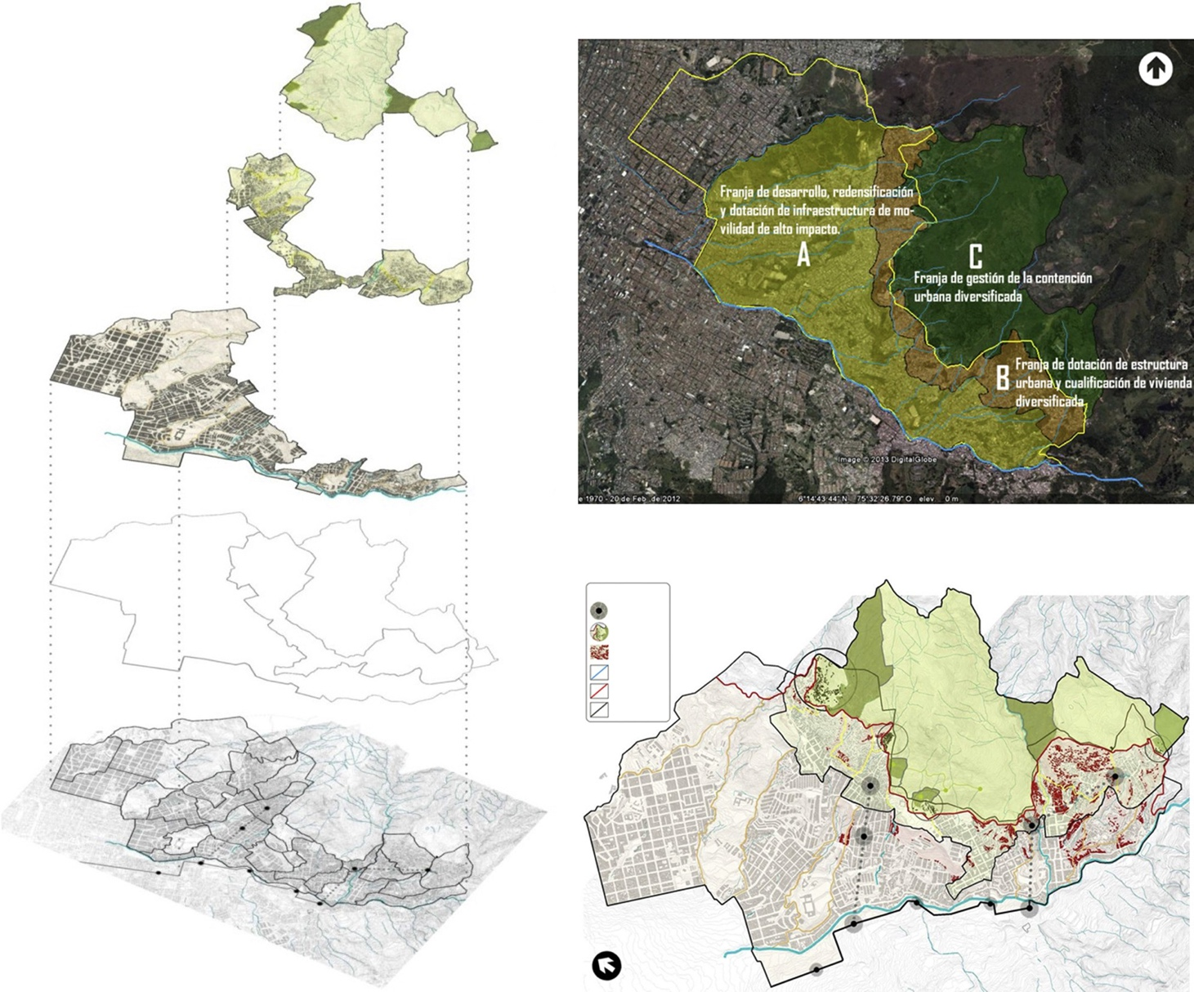


Figure 5
Definición de Franjas de Intervención

C

B

A

Visualización General de la Propuesta
CONVENCIONES
Tranvía/Cable

Viv. Fuera del PU.

Viv. en ZRNR Quebradas Perimetro Urbano Franjas

Current Opinion in Environmental Sustainability

Synthesis of alternative greenbelt proposal.
Source: UNC student report 2012.

advising, and researching, but haven’t fully expressed a political position, which the community questions.

Conclusions and future directions Collaboration, reciprocity, and continuous dialogue The data and proposals built throughout the iteration of workshops and studios have contributed to renegotiate the terms of the planning initiatives around the greenbelt, by: first, contributing technical and legal arguments to dissuade the construction of a monorail, a central proposal of the Jardı´n Circunvalar, by considering environmental risks, enhancements of community food production areas, and the promotion of ecological connectivity of the Santa Elena river basin structure (Figure 5); second, advancing the discussion around mixed land use and densities around the new cable car stations, and demarcating areas subject to neighborhood upgrading to be included in the new Strategic Spatial Plan; and third, spearheading a pilot experience for the creation of a ‘school of community- driven risk management’ supporting the priorities of the Local Development Plan.

One of the main objectives of an egalitarian and productive partnership is to synergistically bridge the gap between academic and community knowledges. Such partnerships need to be based on collaboration and reciprocity, enabling permanent spaces of dialogue. The motivation for estab- lishing a partnership with international universities and a local community-planning group is primarily twofold: to offer transnational technical capacities to organized inha- bitants to address a contested intervention project and to catalyze collaboration as a pedagogical tool. In order to achieve authentic community-higher education partner- ships, they must aim to be sustainable; therefore, the follow-through and the aftermath involvement are of great importance. In this sense, the commitment of a local university partner plays a crucial role in producing a sus- tainable processes and outcomes.

Finally, the dialogue must continue about how best to sustain and replicate these experiences, deepening and reinforcing the work with communities, government institutions, universities, and public, private, and third sectors for the joint construction of sustainable, resilient, and just cities.

References

- Hack G: Shaping urban form. Planning Ideas that Matter. Cambridge: MIT Press; 2012.
- UN Habitat: Medellı´n Declaration Equity as a foundation for Sustainable Urban Development. Seventh world Urban Forum; 2014 http://wuf7.unhabitat.org/Media/Default/PDF/ Medell%C3%ADn%20Declaration.pdf. (retrieved January 2015).

- Levy JM: Contemporary Urban Planning. Routledge; 2012.

- Rittel H, Webber M: Dilemmas in a general theory of planning.
Policy Sci 1973, 4:155-169.

- Iraza´ bal C (Ed): Transbordering Latin Americas: Liminal Places, Cultures, and Powers (T)Here. New York, London: Routledge, Taylor & Francis Group; 2014.

- Fainstein S: The Just City. Cornell University Press; 2010.

- Marcuse P et al.: Searching for the Just City. Debates in Urban Theory and Practice. Routledge; 2011.

- Friedmann J: Planning in the Public Domain: From Knowledge to Action. Princeton University Press; 1987.

- Iraza´ bal C: Realizing planning’s emancipatory promise: learning from regime theory to strengthen communicative action. Plan Theory 2009, 8:115-139.

- Moreno-Leguizamon C, Tovar-Restrepo M, Iraza´ bal C, Locke C: The learning alliance methodology: contributions and challenges for multicultural planning in health service provision. A case-study in Kent, UK. Plann Theory Pract 2015:1-18.

- Umemoto K: Walking in another’s shoes: epistemological challenges in participatory planning. J Plan Educ Res 2001, 21:17-31.

- Iraza´ bal C: Revisiting urban planning in Latin America and the Caribbean. One of Eight Regional Studies prepared as Inputs for the Seventh Issue of the Global Report on Human Settlements 2009 Planning Sustainable Cities: Policy Directions GRHS. United Nations Human Settlement Programme; 2009.

- Morse SW: Smart Communities: How Citizens and Local Leaders can use Strategic Thinking to Build a Brighter Future. San Francisco, CA: Jossey-Bass; 2004.

- Bose M, Horrigan P, Doble C, Shipp SC (Eds): Community Matters: Service-Learning in Engaged Design and Planning. Routledge; 2014.

- Harris SC, Iraza´ bal C: Transforming subjectivities service
that expands learning in urban planning. In Service-Learning in Design and Planning: Educating at the Boundaries. Edited by Angotti T, Doble CS, Horrigan P. New Village Press; 2012:107-124.

- Rydin Y, Amjad U, Whitaker M: Environmentally sustainable construction: knowledge and learning in London planning departments. Plan Theory Pract 2007, 8:363-380.

- Sletto B: Insurgent planning and its interlocutors: studio pedagogy as unsanctioned practice in Santo Domingo, Dominican Republic. J Plan Educ Res 2012, 33:228-240.

- El Ansari W, Phillips CJ, Zwi AB: Narrowing the gap between academic professional wisdom and community lay knowledge: perceptions from partnerships. Public Health 2002, 116:151-159.

- Angotti T: New Century of the Metropolis. Routledge; 2012.

- Agyeman J, Erickson JS: Culture, recognition, and the negotiation of difference: some thoughts on cultural competency in planning education. J Plan Educ Res 2012, 3:358-366.

