Evaluating Tropical Cyclone Intensity Forecasts from HAFS Using Satellite-Derived Ocean Profiles

Paige D. Lavin,^{a,b} Deirdre A. Byrne,^{b} Lewis J. Gramer,^{c.d} David S. Trossman,^{a,b}
ª Cooperative Institute for Satellite Earth System Studies/Earth System Science Interdisciplinary Center, University of Maryland, College Park, MD.
^{b} NOAA/NESDIS Center for Satellite Applications and Research, Laboratory for Satellite Altimetry, College Park, MD.
^{c} Cooperative Institute for Marine and Atmospheric Studies, University of Miami, Miami, FL.
^{d} NOAA/OAR Atlantic and Oceanographic and Meteorological Laboratory, Miami, Hurricane Research Division, FL, U.S.A.

Corresponding author: Paige D. Lavin, plavin@umd.edu

ABSTRACT
As the ocean warms, tropical cyclones (TCs) may become more dangerous and costly for coastal communities since oceanic heat can increase TC intensity. Accurately modeling and forecasting TC intensity changes, especially from rapid intensification (RI) events, is challenging. Both RI and rapid weakening (RW) events can be strongly influenced by the heat content and stratification of the upper ocean, particularly for larger and slower-moving TCs. Better information about upper ocean conditions can thus aid in the evaluation and potentially the improvement of RI/RW forecasts.
The National Oceanic and Atmospheric Administration (NOAA) Next Generation Enterprise Ocean Heat Content (NGE OHC) algorithm, an empirical parameterization, generates depth-resolved ocean temperature and salinity profiles that will be used operationally to estimate daily upper OHC fields and support detailed analysis of the potential oceanic contributions to RI/RW. The method leverages known ocean dynamics from relatively sparse in situ data to directly estimate profiles at high vertical and horizontal resolution from satellite data. In case studies from the 2020–2022 Atlantic hurricane seasons, daily oceanic conditions from the NGE OHC are retrospectively compared with in situ Argo float observations, model initializations from the Hurricane Analysis and Forecast System (HAFS version 1.0B), and a current operational NOAA OHC product to illustrate how the NGE OHC would have helped improve the model’s initial ocean state in the Gulf of Mexico and Caribbean Sea. These comparisons show that many HAFS forecasts with intensity busts miss near-surface heat and barrier layers found in observations and the NGE OHC synthetic profiles.
SIGNIFICANCE STATEMENT
Tropical cyclones (TCs) are the costliest natural hazard impacting the U.S. annually. TC intensity forecasting is particularly critical for protecting life and property, and presents substantial challenges to modelers. We introduce the new National Oceanic and Atmospheric Administration (NOAA) Next Generation Enterprise Ocean Heat Content (NGE OHC) algorithm that provides daily upper ocean temperature/salinity information and OHC at high horizontal resolution. We compare the subsurface ocean conditions from this algorithm with the current operational NOAA OHC product and the operational ocean-atmosphere coupled Hurricane Analysis and Forecast System (HAFS) in the Gulf of Mexico and Caribbean Sea. We find our algorithm better captures warm near-surface temperatures and barrier layers missed by HAFS that are frequently linked to rapid TC intensity change.

1. Introduction
On average, a tropical cyclone making landfall in the United States (U.S.) causes an estimated $23.0 billion in damage (NOAA National Centers for Environmental Information (NCEI), 2025). The intensification of tropical storms over the ocean can lead to stronger winds and greater rainfall once they reach land, making these events even more dangerous and costly. A few notable storms where this occurred include Hurricane Katrina (2005), which caused $201.3 billion in damage; Hurricane Ida (2021), which intensified rapidly from a category 2 to a category 4 storm within 6 hours (before making landfall the same day) and caused $84.6 billion in damage; and Hurricane Ian (2022), a storm of historic proportions with $119.6 billion in damage. All damages here are adjusted using the current Consumer Price Index (CPI). See Table S1 (Supplemental Material) for a full list of acronyms used throughout this paper.
Although forecasting of tropical cyclone (TC) intensity has shown improvement in recent years (Cangialosi et al., 2020; DeMaria et al., 2021; Zhang et al., 2023; W. G. Wang et al., 2023), TC intensification, particularly rapid intensification (RI), has historically been difficult to forecast accurately. This is of concern as these extremely damaging RI events have become increasingly frequent for Atlantic TCs (Bhatia et al., 2019; Balaguru et al., 2022; Majumdar et al., 2023). Both RI and its opposite, rapid weakening (RW), have been shown to be closely tied to ocean heat content (OHC) (Shay et al., 2000; Mainelli et al., 2008; Lin et al., 2013). In this work, we demonstrate how estimates of upper ocean structure and OHC from the new National Oceanic and Atmospheric Administration (NOAA) Next-Generation Enterprise Ocean Heat Content (NGE OHC) algorithm could enable better RI/RW forecasts by improving a forecast model’s initial ocean state. The NGE OHC is being developed to replace the existing operational NOAA National Environmental Satellite, Data, and Information Service (NESDIS) Satellite Ocean Heat Content Suite (SOHCS) product.
Many early TC forecast models treated the ocean as a “boundary condition” and only assimilated sea surface temperature (SST). While SST is helpful for TC forecasts, it does not provide enough information to understand the full coupling between the atmosphere and ocean during these events (Bender and Ginis, 2000). By contrast, OHC is an integrated metric of upper ocean temperature (defined as the amount of heat energy stored between the ocean surface and the depth of a given isotherm) that better represents the full amount of ocean heat a storm may be able to access (Wada and Usui, 2007; Yablonsky and Ginis, 2008; Lin et al., 2013). The depth of the 26°C isotherm is often used as the lower bound for the OHC calculation in TC applications and this formulation is referred to as the tropical cyclone heat potential (TCHP; Leipper and Volgenau, 1972; Cione, 2015). However, other aspects of the upper ocean temperature and salinity (θ/S) structure are also important for TC forecasting, with factors relating to the near-surface stratification—such as the mixed layer depth and the presence/absence of a barrier layer—being particularly critical (e.g., Balaguru et al., 2012; Androulidakis et al., 2016; Rudzin et al., 2017, 2018; Domingues et al., 2021; Le Hénaff et al., 2021).
When a TC moves over the ocean, the strong winds induce energetic vertical mixing, which dramatically changes the structure of the near-surface ocean (e.g., Bender and Ginis, 2000). This mixing can deepen the mixed layer and cool the sea surface due to denser waters from depth being entrained upward, though this effect is more limited in shallow coastal regions with less underlying cool water (e.g., Potter et al., 2019), and may even be reversed where shelf oceanographic processes dominate (Gramer et al., 2022). A barrier layer (BL) occurs when there is a stratified layer (e.g., due to a large salinity gradient with depth) within the surface isothermal layer; the difference between the density-based mixed layer depth and the isothermal layer depth is known as the BL thickness (Lukas and Lindstrom, 1991; Sprintall and Tomczak, 1992). When a BL is present, the wind-driven mixing of the ocean will be greatly reduced due to this robust near-surface stratification and the enthalpy flux into the atmosphere will be larger, greatly increasing the risk of RI (Balaguru et al., 2012).
The present study demonstrates how improved information on upper ocean θ/S and TCHP can aid in the evaluation of TC intensity forecasts, particularly those with RI events. However, we note that other factors can play a critical role in whether RI occurs (e.g., Bhatia and Nolan, 2013). Upper-level convergence/divergence and upper-level trough interactions (e.g., Kimball and Evans, 2002), including positive vorticity advection, size/resilience of the vortex (e.g., Fischer et al., 2023), and the location of both convective development and air-sea enthalpy fluxes relative to the radius of maximum winds (Musgrave et al., 2012; Maclay et al., 2008) are all implicated in TC intensity and structure change. Environmental deep vertical wind shear (VWS), in particular, generally weakens TCs (Wong and Chan, 2004; Wang et al., 2015) through a variety of processes, including vortex misalignment (Kaplan and DeMaria, 2015), mid-level dry-air intrusion (Tang and Emanuel, 2012; Bhalachandran et al., 2019), divergent upper-tropospheric mass and entropy fluxes (Riemer et al., 2010), and downdrafts (e.g., Riemer et al., 2010; Tang and Emanuel, 2010; Bhalachandran et al., 2019).
There are many approaches for operationally estimating OHC fields from surface measurements. Some methods take advantage of the physical relationship between the sea surface height anomaly field and the variability of selected isotherm depths. For example, the current operational SOHCS product uses a two-layer reduced gravity model to estimate TCHP, the depth of the 20°C and 26°C isotherms, and mixed layer depth daily at ¼° gridded resolution (Shay et al., 2000; Mainelli et al., 2008; Donahue, 2015; Maturi et al., 2022). However, this method is climatologically-based so it may not continue to have high accuracy as the ocean rapidly warms. This algorithm is also time-intensive to update when a new altimeter begins sampling. Another common alternative that previous studies have used is surface quasi-geostrophic (SQG) theory (e.g., Isern-Fontanet et al., 2008; Wang et al., 2013; LaCasce and Wang, 2015).
In this work, we introduce the NGE OHC algorithm that instead uses the gravest/geostrophic empirical mode (GEM) method, first introduced by Meinen and Watts (2000). This method enables us to connect the widespread and dominant low-mode baroclinic variability resolved by historical in situ θ/S profile data to coincident near real-time satellite measurements of ocean properties. The GEM method parameterizes the subsurface θ/S variability as a function of an integrated metric of water column density (e.g., vertical acoustic travel time or steric height). The integrated metric is often sampled at a higher horizontal resolution and/or temporal frequency than is possible for full-depth θ/S profiles, which are typically collected via ship-based or autonomous platforms. Each unique value of the integrated metric is linked to an unique θ/S profile in a lookup table (LUT), allowing estimates of θ/S profiles to be made at the resolution of the integrated metric. Here, the integrated metric (steric height anomaly) is then also matched to satellite-based measurements of sea level anomaly as described below. GEM parameterizations for θ/S are commonly calculated using a tensioned cubic spline function and have been shown to describe 90% or more of the observed variance within the main thermocline in regions with strong horizontal gradients such as the Antarctic Circumpolar Current, Kuroshio, northern North Atlantic, and the Gulf of Mexico (e.g., Meinen and Watts, 2000; Sun and Watts, 2001; Book et al., 2002; Pérez-Brunius et al., 2004; Meijers et al., 2011; Zhang and Sun, 2012; Meunier et al., 2022).
The NGE OHC algorithm builds off of previously published applications of the GEM method by including a few additive corrections (e.g., for time of year) to operationally estimate depth-resolved ocean θ/S profiles at high horizontal (∼10 km along-track or ¼° gridded) and vertical resolution (2 dbar from 0–1800 dbar) in our basins of interest. Previous work has shown that such corrections (e.g., for SST; Mitchell et al., 2004) can significantly improve the performance of the LUTs. θ/S profiles (and thus TCHP) can be estimated daily using the NGE OHC algorithm wherever near real-time altimetry is available and will provide more comprehensive insight into the near-surface ocean conditions (e.g., regarding BL presence) than the current operational SOHCS product, which provides metrics of upper ocean structure but not the full θ/S profiles.
Here, we use the Gulf of Mexico (GoM) and the northern Caribbean Sea as our testbed region for evaluating the TC intensity forecasts from one of the NOAA operational hurricane forecasting models (Hurricane Analysis and Forecast System (HAFS)) using the NGE OHC algorithm and the SOHCS product (when possible). Many of the TCs that have strong impacts on Caribbean islands and along the U.S. and Mexico Gulf Coasts undergo RI events in these basins. The GoM is warming rapidly (Z. Wang et al., 2023) so RI events in this basin will likely increase in frequency in the future (Webster et al., 2005; Xi et al., 2023; Patricola et al., 2024). Furthermore, the testbed region contains a number of coral reefs so more accurate and higher resolution operational subsurface θ/S information in this basin could be used to enhance forecasts of the intensity and extent of coral bleaching events during marine heat waves (e.g., Dzwonkowski et al., 2020; Gramer et al., 2023; Voolstra et al., 2024).
We examine deep and mid-layer VWS and mid-tropospheric relative humidity (RH) for several of the case study TC forecasts presented below, using both traditional and newer approaches. Our goal is not to exhaustively analyze potential atmospheric influences on TC intensity change; such analysis can be found in other recent works, including for some of these same forecast cycles (Alvey et al., 2022; Fischer et al., 2023; Hazelton et al., 2023; Gramer et al., 2024; Hazelton et al., 2024; Alvey et al., 2025). Rather, our goal in the present work is to identify multiple case studies in which the TC intensity forecast skill could potentially have been improved, had the ocean initial state been more accurate.

2. NOAA Next-Generation Enterprise Ocean Heat Content (NGE OHC) algorithm
The NGE OHC algorithm enables the prediction of synthetic ocean θ/S profiles and derived metrics where absolute dynamic topography (ADT) is measured by satellite altimetry. This is accomplished by using the GEM method and a set of additive corrections to create LUTs between 2-dbar resolved θ/S profiles for 0–1800 dbar and sets of ADT, yearday, satellite SST, and satellite sea surface salinity (SSS) values, as detailed below.
a. Datasets
The GEM LUT is generated using historical in situ θ/S profile data collected in the testbed region from the NOAA National Centers for Environmental Information (NCEI) World Ocean Database (WOD) 2018, downloaded on 11 Jun 2019 and updated on 26 Jul 2019 (Boyer et al., 2018; https://www.ncei.noaa.gov/products/world-ocean-database), and more recent Argo data (described below). WOD profiles come from a wide variety of shipboard and autonomous instruments/observing platforms, so the quality and depth resolution of these profiles vary. Since poor quality data can significantly impact the skill of the NGE OHC algorithm, it was important to quality control (QC) these data. QC flags are available for the WOD profiles, but they flag both erroneous and anomalous data together in order to identify climatologically representative profiles. We wanted to retain the “anomalous” data removed by these flags that may represent important subsurface signatures from transient events like eddies and marine heatwaves. Therefore, we performed our own manual QC to remove only the erroneous data. This QC included removing profiles with no measurements in the upper 20 m of the ocean, profiles with too few salinity measurements compared to temperature, and profiles with fewer than 12 measurements in the upper 700 m. Salinity values were also examined and, if necessary, despiked. Overall, 6,242 profiles from WOD were retained.
More recent Argo profiles in the testbed region were downloaded from an Argo Global Data Assembly Center (GDAC) on 16 Feb 2023 (Argo, 2024). Only delayed mode adjusted data with QC flags indicating “good” or “probably good” data were retained (QC flags = 1, 2). Profiles with gaps exceeding 5 dbar were removed. The delayed mode Argo data undergo rigorous scientific QC so we did not need to perform further QC. Ultimately, 2,954 profiles remained from 15 December 2018 to 21 May 2022 that contained both θ and S data.
The final combined WOD and Argo profile dataset used to construct the GEM LUTs included 9,196 profiles from 08 Mar 1985 to 21 May 2022 (Fig. 1a). Of these, the 993 profiles observed during the 2020 and 2021 hurricane seasons (June 1 to November 30) were excluded from creation of the LUTs to ensure the independence of the comparisons performed in this study. The 2022 season was excluded by default as the profile database only extends to 21 May 2022. We calculate steric height for each profile relative to a reference pressure of 1448 dbar and subtract a regional mean value to obtain steric height anomaly (SHA). The selected reference level is a trade-off between including more profiles and including more of the total water column steric height variability, which is the dominant signal in ADT.
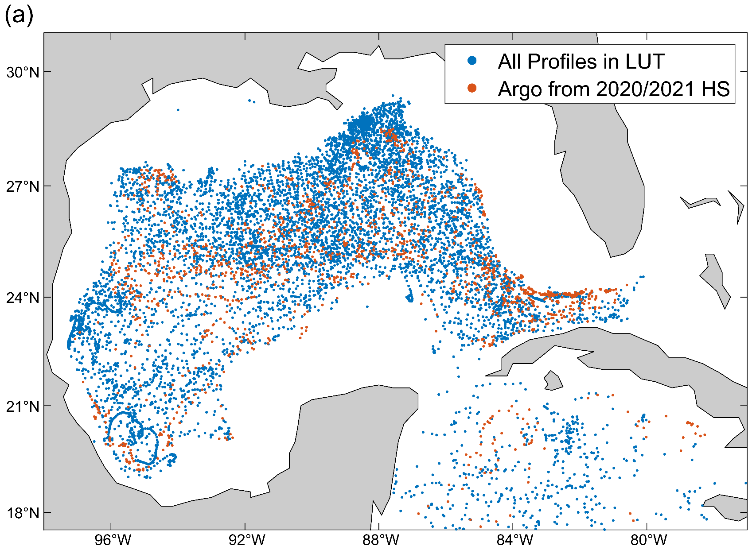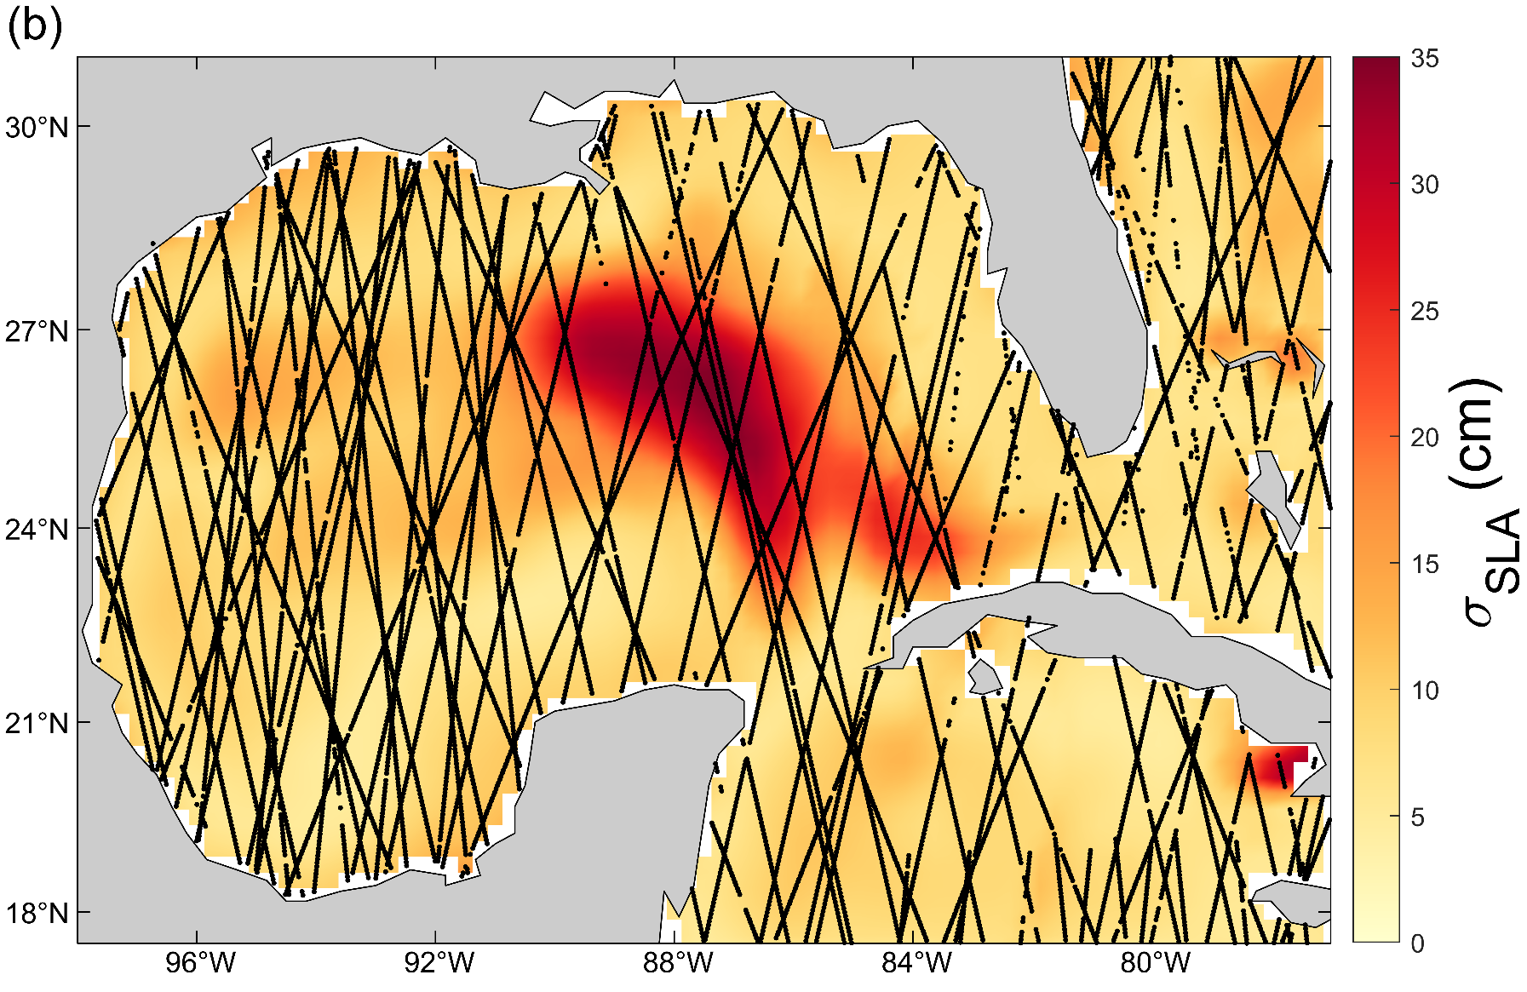
Figure 1. (a) Locations of all profile data used to generate the lookup tables for the NGE OHC method (blue) and of the 1521 Argo profiles from the 2020 and 2021 hurricane seasons (June 1 to November 30; orange) in the NGE OHC testbed region that are used for the method intercomparisons below. (b) Standard deviation of the Radar Altimeter Database System (RADS) ¼°-gridded sea level anomaly (SLA, cm) field over the 2020 and 2021 hurricane seasons. Altimeter measurement locations for one 11-day period (01 Sep 2020 ± 5 days) shown to illustrate track density (black dots).

The primary satellite input to the NGE OHC algorithm is the sea level anomaly (SLA) data from the Radar Altimeter Database System (RADS), which is produced in near real-time (3–5 hour latency) at Level-2 (~10 km, along-track) and daily at Level-4 (¼°-gridded, gap-free via optimal interpolation) by correcting and inter-calibrating measurements from over a dozen altimeter missions (Scharroo et al., 2013). RADS is produced jointly by the NOAA Laboratory for Satellite Altimetry (LSA), the European Organisation for the Exploitation of Meteorological Satellites (EUMETSAT), and the Delft University of Technology (TU Delft). The along-track data from 1986 to present are available through RADS (https://github.com/remkos/rads) and a RADS-based gridded data product from Feb 2017 to present is available via NOAA CoastWatch (https://coastwatch.noaa.gov/). By using RADS, the NGE OHC algorithm can readily utilize data from new altimeters without needing to update the algorithm (as is needed for the SOHCS product). SLA data are converted to ADT by adding the Technical University of Denmark version 15 mean dynamic topography (DTU15 MDT, https://ftp.space.dtu.dk/pub/DTU15/; see Andersen et al., 2015 on DTU13 MDT, updated by Andersen et al., 2016) to the SLA values. In this study, we solely use the gridded ADT data interpolated to the relevant in situ profile locations to produce the NGE OHC-based θ/S profile estimates shown below and in the Supplemental Material (SM), which are from the 2020/2021 hurricane seasons and from the life cycle of Hurricane Ian (2022). ADT in the testbed region varies over numerous temporal and spatial scales, but over the 2020/2021 hurricane seasons it is especially variable over the Loop Current region (Fig. 1b). This region frequently contains warm core Loop Current eddies that can provide fuel for substantial TC RI events, as was the case for Hurricane Ida in 2021 (Miles et al., 2023).
The additional satellite-derived measurements used in the NGE OHC algorithm include SST and SSS. We use nighttime SST data from the daily operational NOAA GeoPolar Blended 5 km SST product (Maturi et al., 2017), which is available from 2 June 2014 to present via NOAA CoastWatch (https://coastwatch.noaa.gov/). Nighttime SST retrievals more accurately represent typical in situ ocean temperatures compared to daytime values due to the varying impact of solar warming on the ocean surface throughout the day and because the signal contamination from reflected and scattered solar radiation is reduced at night (Minnett et al., 2019). The SSS data are from the Multi-Mission Optimally Interpolated Sea Surface Salinity (OISSS) Level-4 v2.0 product, which combines data from the Level-2 Soil Moisture and Ocean Salinity (SMOS) and Soil Moisture Active Passive (SMAP) satellite data products (Melnichenko et al., 2014, 2016, 2023; Melnichenko, 2023). These data are available at ¼° spatial and 4-day temporal resolution (8-day overlapping windows) from 24 Aug 2011 to 08 Aug 2022 from the National Aeronautics and Space Administration (NASA) archive (https://podaac.jpl.nasa.gov/). While these SSS data are used for the retrospective comparisons using the NGE OHC shown here, they include forward data and are not able to be used operationally. The SST and SSS data are interpolated to the in situ profile locations and used for the additive corrections to the GEM output.
b. NGE OHC algorithm development
The NGE OHC algorithm (Fig. 2) synthesizes historical ocean profile data, ADT from satellite altimetry, and other relevant information (e.g., yearday, satellite SST and SSS) to provide high-quality near real-time estimates of upper ocean structure (e.g., synthetic θ/S profiles, TCHP estimates). This is accomplished by parameterizing the subsurface (0–1800 dbar) variability of θ and S from in situ profiles with respect to ADT, yearday, SST, and SSS, where the contribution of each factor is represented by a LUT. The parameterizations are calculated in order of their contribution to describing the variance of the original θ/S profile dataset. After each parameterization is computed, it is subtracted from the θ/S profiles and then the resulting residual is examined for dependencies on other variables with available measurements. This process provides a simple framework for the inclusion of additional parameterizations if further predictable structure is discovered in the residuals. We tested various methods of creating the LUTs, including least squares and reduced major axis (RMA) regressions, iterative regressions with noise filtering, tensioned cubic splines, higher-order polynomials, and generalized additive models. The skill of each parameterization with respect to bias, root mean squared error, and percent variance explained are all considered.
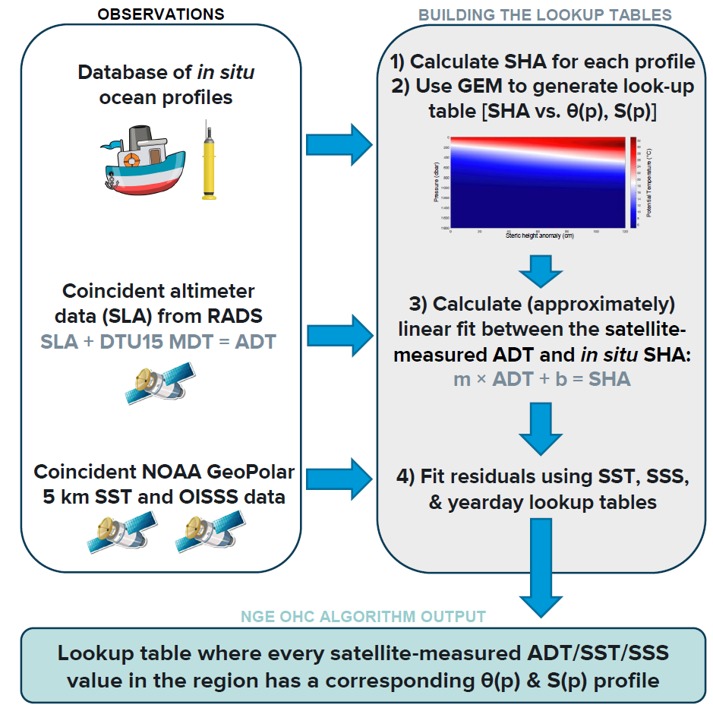
Figure 2. Summary of the National Oceanic and Atmospheric Administration (NOAA) Next Generation Enterprise Ocean Heat Content (NGE OHC) algorithm. SLA = sea level anomaly; RADS = Radar Altimeter Database System; DTU15 MDT = Technical University of Denmark version 15 mean dynamic topography; ADT = absolute dynamic topography; SST = sea surface temperature; OISSS = Multi-Mission Optimally Interpolated Sea Surface Salinity; SHA = steric height anomaly; GEM = Geostrophic Empirical Mode; SSS = sea surface salinity; θ(p) = ocean temperature as a function of pressure; S(p) = ocean salinity as a function of pressure.

The first and most important parameterization in the NGE OHC algorithm is calculated with respect to SHA, as approximated by satellite-observed ADT. ADT and SHA are related here through a nearly linear approximation (SHA = 0.002 $×$ ADT ² + 0.756 $×$ ADT − 36.7) since they are strongly correlated in this region (R² > 0.91). The parameterization using ADT explains the most variance because it is approximating the dominant low-mode baroclinic variability in the observed θ/S. At each pressure level (every 2 dbar from 0 to 1800 dbar), the observed potential temperature (θ) and practical salinity (S) values are estimated as functions of SHA (and thereby ADT). As noted above, this approach for parameterizing subsurface θ/S variability with respect to a related integrated quantity is known as the GEM method. When calculated using a cubic spline function in the testbed region, the “first-guess” GEM fields (θ_{GEM} and S_{GEM}) describe 82% and 72%, respectively, of the variance between 100 and 800 dbar in the observed profiles.
After calculating the θ_{GEM} and S_{GEM} fields, we use a sine function to fit an annual cycle to the residual fields, θ’ = θ − θ_{GEM} and S’ = S − S_{GEM}, at every pressure level, parameterizing the seasonal variability of the fields as θ_{season} and S_{season}. As with the ADT/GEM parameterization, the full impact of this parameterization extends throughout the entire depth of the water column analyzed. However, the largest impact of the seasonal parameterizations is near the surface where they describe an additional 40% of the variance in θ in the upper 60 dbar and an additional ~4% of the variance in S from 0–60 dbar.
The remaining variability related to SST (θ_{SST}) is then parameterized using the de-seasoned residual, θ’’ = θ − θ_{GEM} − θ_{season}. Unlike the ADT/GEM and seasonal parameterizations, the SST parameterization only extends to 42 dbar as it shows little skill below this level. This parameterization is done using a tensioned spline followed by an RMA linear fit. Finally, the remaining variability in S related to SSS (S_{SSS}) is parameterized using the de-seasoned residual of the salinity, S’’ = S − S_{GEM} − S_{season}. This parameterization is calculated using a least-squares linear fit over the top 50 dbar of the water column. SST was found to have a negligible effect on estimating S’’ so it is not used to parameterize S. SSS was similarly found to have a negligible effect on estimating θ’’ and therefore is not used to parameterize θ. By combining these parameterizations of θ/S, we can estimate the synthetic θ/S profiles (θ_{est} and S_{est}, at 2-dbar vertical resolution from 0 to 1800 dbar) for a given set of ADT, yearday, SST, and SSS values in the testbed region as:
θ_{est} = θ_{GEM} + θ_{season} + θ_{SST} (1)
S_{est} = S_{GEM} + S_{season} + S_{SSS} (2)
As a final step, θ and S values are converted to conservative temperature (Θ) and absolute salinity (S_{A}), which are then used to compare with Argo and to calculate metrics such as TCHP (TCHP_{est}). Raw TCHP_{est} values from the θ_{est}/S_{est} profiles were found to slightly underestimate the observed values. A final linear correction is applied to the NGE OHC TCHP estimates to minimize this bias, resulting in a separate TCHP LUT. LUTs may be included for additional metrics (e.g., mixed layer depth) as desired.

3. Comparisons with HAFS-B
We compare “sea truth” TCHP measurements from Argo floats in our testbed region to the TCHP estimates from the current operational SOHCS product, the NGE OHC algorithm, and the initial ocean conditions for HAFS version 1.0B (hereafter, HAFS-B; see below for model details), to determine which of these estimation methods has the most skill in replicating TCHP. These comparisons are done for the entirety of the 2020 and 2021 Atlantic hurricane seasons and for 14 case study forecasts from the 2020–2022 Atlantic hurricane seasons where issues with the HAFS-B ocean initialization may have had a role in the forecast’s ability to rapidly intensify as much as the observed storm. These seasons and case studies were selected in part because initial conditions from the operational configuration of HAFS-B were readily available from the pre-operational retrospectives, as were the profile data used in the NGE OHC algorithm (see below for more details regarding the case study selection). We also compared the Argo profiles with synthetic θ/S profiles in the upper 200–300 dbar from the NGE OHC algorithm and from the HAFS-B model initialization to investigate the role of upper ocean stratification on rapid TC intensity change broadly for the 2020/2021 hurricane seasons and specifically for the 14 case studies. Greater detail is provided for two forecasts of interest (with three additional forecasts of interest analyzed in the SM).
a. HAFS-B model initial conditions and output
The HAFS became operational as part of NOAA’s Unified Forecast System (UFS) in summer 2023 after showing promise for improving track and intensity forecasts during several years of real-time experiments through the Hurricane Forecast Improvement Project (HFIP) (e.g., Dong et al., 2020; Hazelton et al., 2021, 2022). Here, we use output from the “HAFS-B” configuration (for model details, see Hazelton et al., 2024) that can provide operational forecasts out to 7 days.
From the output of pre-operational retrospectives conducted for the 2020–2022 Atlantic hurricane seasons, we identified 14 case study TC model forecasts (across 9 TCs) of interest for examining the potential interplay between the model initialization of upper ocean stratification and rapid TC intensity change during these storms (Table 1). To identify these case studies, we compared the best track data (which are described below) with HAFS-B model intensities and storm positions at 3-hourly resolution, starting from the initialization time of each forecast. We specifically focused on forecasts that represented particular challenges in terms of the ocean initialization. Relative to the best track data, the 14 selected HAFS-B forecasts: (a) had a fairly small track error (maximum 24-hour running track error up to that point of ≤ 50 km), and (b) had a difference in the 24-hour running-average intensity error of ≥ 10 kt (1 kt = 0.5144 m s⁻¹). The uncertainty in the best track intensity is estimated to be between 5 to 10 kt for the forecast lead times shown here (Landsea and Franklin, 2013; Cangialosi, 2023). All but 4 of the 14 case study forecasts have differences in peak intensity relative to the best track in excess of 10 kt. Despite the intensity differences for these four forecasts being close to the uncertainty in the best track (for the appropriate lead times), close examination of the HAFS-B model results suggested that these were forecasts for storms of wide interest where issues in the model’s initial ocean state may have had a role in the forecast’s ability to rapidly intensify (not shown). Therefore, we chose to still include these forecasts in our analysis.
Storm Name | Forecasts | Ocean Region Impacted | IBTrACS Best Track Peak Intensity (kt) [Concurrent HAFS-B Intensity for Each Forecast (kt)]
Hurricane Hanna (AL082020) | 20200723Z12; 20200724Z00 | Western GoM | 80 [50, 45]
Hurricane Laura (AL132020) | 20200821Z12; 20200822Z00* | Central GoM | 130 [83, 87]
Hurricane Sally (AL192020) | 20200911Z18* | Eastern and Central GoM | 95 [40]
Hurricane Delta (AL262020) | 20201005Z18⁺; 20201006Z06 | Central GoM | 120 [100, 95]
Hurricane Elsa (AL052021) | 20210701Z00; 20210706Z06 | CarSea and Eastern GoM | 75 [68, 47]
Tropical Storm Fred (AL062021) | 20210814Z18 | Eastern GoM | 55 [45]
Hurricane Grace (AL072021) | 20210818Z00⁺; 20210818Z18 | Northern CarSea and Southwestern GoM | 105 [68, 82]
Hurricane Ida (AL092021) | 20210827Z18 | Central GoM | 130 [120]
Hurricane Ian (AL092022) | 20220927Z18⁺ | Northern CarSea and Eastern GoM | 140 [145]
Table 1. The 14 case study tropical cyclone (TC) forecasts of interest from the Hurricane Analysis and Forecast System (version 1.0B; HAFS-B). These were selected based on the criteria described in the main text. Forecasts indicated by * (or ⁺) are case studies discussed in detail in the main text (or Supplemental Material). Ocean regions that had substantial impacts from each storm are noted. Peak storm intensities from the International Best Track Archive for Climate Stewardship (IBTrACS) best track and concurrent HAFS-B intensity from each forecast are listed (all in kt). GoM = Gulf of Mexico and CarSea = Caribbean Sea.

Storm track and wind speed data were downloaded from the International Best Track Archive for Climate Stewardship (IBTrACS v04r00; Knapp et al., 2010, 2018), a dataset which includes the National Hurricane Center (NHC) official “best track” data augmented by information such as landfall data and other direct observations of storm size, wind speed, and intensity. U.S. agency wind speeds from IBTrACS were used, and the data—typically at 3-hourly or finer temporal resolution—were subsampled to the times and locations of the 3-hourly storm positions from the HAFS-B forecasts.
To evaluate the potential contribution of the ocean to forecast errors for intensity, we first considered evidence within the forecasts for substantial contributions from environmental atmospheric factors. We analyze deep VWS, mid-layer VWS, and mid-layer dry-air intrusion for all cases, together with vortical atmospheric interaction and upper level divergence for a few case studies of interest. We examine these properties from model output at forecast hours relevant to the periods of largest forecast intensity error for each case study. Representation of deep VWS in the present study was approached in two ways: (1) individual VWS vectors colored by mean RH to explore the variability within the inner (moving-nest) domain of the HAFS model, and (2) annual averages to capture the broader environment around the TC. For the first approach, which we use in the figures for the five storm case studies in the main text and in the SM, we note that when low to mid tropospheric cyclonic flow is overlaid with an anticyclone aloft, plan view or map presentation of the shear vectors may show a spuriously large amount of shear. To attempt to minimize such artificial effects from the opposing rotational wind at differing heights, we remove the layer-mean wind at each model output layer (consistent with Alvey et al,. 2022, 2025; Hazelton et al., 2024). The second approach for examining deep VWS mid-level dry air intrusion uses more traditional metrics: annular average VWS calculated as the vector difference between mean winds at 200 and 850 hPa averaged within an annulus from 200 to 800 km distance from storm center; and annular average RH between 700 to 500 hPa and within a 200 to 800 km annulus around storm center. The results using this second approach are found only in the SM.
We also evaluated the θ/S fields derived from the NOAA Global Real-Time Ocean Forecast System version 2 (RTOFSv2), an implementation of the Hybrid Coordinate Ocean Model (HYCOM; Bleck, 2002), that were used to initialize the ocean model for each HAFS-B forecast. Specifically, we assessed the θ/S initial conditions (9-km horizontal resolution) for HAFS-B/HYCOM that come from the operational RTOFSv2 with high resolution ocean data assimilation (Mehra and Rivin 2010; Garraffo et al., 2020). The HAFS-B/HYCOM initial conditions used here either came from the RTOFSv2 daily 0000 UTC analysis or from the appropriate RTOFSv2 forecast hour (6, 12, or 18). The data assimilated into RTOFSv2 for the ocean include ADT from RADS; SST from satellite products (NOAA and Meteorological Operational satellite program (MetOp)) and from in situ measurements (buoys, ships); subsurface θ/S profiles from Argo floats, eXpendable BathyThermographs (XBTs), other conductivity-temperature-depth (CTD) sensors, and gliders; and satellite-based sea ice coverage.
We then utilized forecast hour 0 post-processed HAFS-B/HYCOM output based on the initial conditions from the appropriate RTOFSv2 analysis or forecast hour; these are available for the upper 350 m, interpolated to 26 vertical levels (Aristizabal et al., 2024). We interpolated these fields to the location of Argo float profiles that sampled within 4 days before or 1 day after each forecast initialization date (both for the 14 case studies specifically and for all available HAFS-B forecasts from the 2020/2021 Atlantic hurricane seasons) and within 280 km of the forecast track.
b. Other comparison datasets
The Argo data for these comparisons were obtained separately from the Argo profiles used in the LUTs. Argo data from the five-day period of interest for each case study were downloaded via an Argo GDAC on 18 Dec 2023 and from the entire 2020/2021 Atlantic hurricane seasons on 07 April 2024 for the GoM and Caribbean Sea (Argo, 2024). Data of all QC types (i.e., real time, real time adjusted, and delayed mode adjusted) and with QC flags of 1 or 2 were retained. Profiles with gaps exceeding the maximum allowable gap formulation from Logan and Johnson (2017) and those lacking observations in the upper 20 dbar were removed. Furthermore, since we wanted to compare TCHP values as part of our analysis, profiles were removed from that dataset if they did not extend below the 26°C isotherm. This most commonly occurs in areas of very shallow bathymetry (e.g., eastern GoM), though in most of GoM the Argo profiles are from open ocean locations with seafloor depths exceeding ~2000 dbar. After applying these QC procedures, we checked for the availability of relevant HAFS-B θ/S estimates and coincident ADT/SST data. After this procedure, 197 Argo profiles for the case studies and 1521 profiles for the 2020/2021 hurricane seasons remained that contained both θ and S data. These profiles are used to “sea truth” the TCHP estimates and θ/S profiles from the SOHCS product (TCHP only), NGE OHC algorithm, and HAFS-B initializations.
TCHP estimates from the current operational SOHCS product were also acquired for the same days and locations as the Argo profiles so that TCHP estimates from Argo, the SOHCS, the NGE OHC, and HAFS-B could all be compared. The SOHCS product (Shay et al., 2000; Mainelli et al., 2008; Donahue, 2015; Maturi et al., 2022) provides daily, near real-time estimates of TCHP, the depth of the 20°C and 26°C isotherms, and mixed layer depth at ¼° resolution in the North Atlantic (Aug 2012 to present), North Pacific (Aug 2013 to present), and South Pacific (Sep 2015 to present). For this analysis, we downloaded the gridded fields of TCHP for every day an Argo profile was measured during the 5-day window noted above for each HAFS-B forecast from the 2020/2021 hurricane seasons and for the 2022 case study forecast from NOAA CoastWatch (https://coastwatch.noaa.gov/). We then interpolated these fields to the Argo profile locations for our comparisons.
4. Results
a. Regional TCHP estimation skill
Each method of OHC estimation shows skill in replicating Argo observations of TCHP throughout the 2020 and 2021 hurricane seasons and we assess their relative advantages using multiple error metrics (Table 2). The NGE OHC algorithm outperforms both the SOHCS product and the HAFS-B model initializations in terms of the bias and overall fit (R²) to these Argo observations. The root-mean-square error (RMSE) values from the three approaches are fairly similar with the NGE OHC estimates having slightly smaller RMSEs (16.49 kJ cm⁻²) than those from the SOHCS (19.65 kJ cm⁻²) and HAFS-B (20.92 kJ cm⁻²). We also evaluate how the R² values decrease for the three methods of TCHP estimation as we limit the observed TCHP values to progressively warmer ranges (Fig. 3a). For example, if we evaluate the R² only on observed TCHP values (TCHP_{obs}) ≥ 60 kJ cm⁻², we find that all three methods decrease in skill; though the NGE OHC estimates retain a substantially better correlation to TCHP_{obs} (R² = 0.68) than either the SOHCS (R² = 0.56) or HAFS-B (R² = 0.55) estimates. The bias for TCHP_{obs} ≥ 60 kJ cm⁻² is larger for all three TCHP estimates, increasing in magnitude to ~6 kJ cm⁻² for both the NGE OHC and SOHCS estimates and to ~17 kJ cm⁻² for the HAFS-B estimates, while the RMSEs for all three estimates increased by 2–6 kJ cm⁻² (Table 2). The SOHCS estimates outperform those from the NGE OHC (with respect to R²) at the warmest TCHP_{obs} cutoff values (TCHP_{obs} ≥ 110 kJ cm⁻²), but this advantage is small, only for the very warmest TCHP_{obs} values (Fig. 3a), and disappears when profiles only from the TC case studies are examined (Fig. 3b, see discussion below). Overall, it is encouraging that the NGE OHC algorithm continues to generally perform extremely well for TCHP_{obs} values above 60 kJ cm⁻² since this is the minimum TCHP value thought to contribute to increased TC intensity (Mainelli et al., 2008). Specifically, this 60 kJ cm⁻² threshold has been found empirically to be the approximate value at which TCHP is sufficiently large to meaningfully reduce the TC-induced cooling of SST in a given region.

 | 2020/2021 Hurricane Seasons |  |  | 14 Case Studies (2020–2022)
 | R² | Bias | RMSE | R² | Bias | RMSE
SOHCS | 0.74  (0.56) | −1.59  (−6.40) | 19.65  (23.04) | 0.69  (0.53) | 0.19  (−3.04) | 22.08  (24.77)
NGE OHC | 0.81  (0.68) | 0.66  (−6.02) | 16.49  (18.55) | 0.80  (0.70) | 0.59  (−4.49) | 17.21  (17.90)
HAFS-B | 0.74  (0.55) | −8.39  (−16.88) | 20.92  (26.19) | 0.76  (0.71) | −8.41  (−14.39) | 20.62  (22.29)
Table 2. Error metrics when comparing the tropical cyclone heat potential (TCHP; kJ cm⁻²) observations from Argo profiles to TCHP estimates from the current operational SOHCS product, the NGE OHC algorithm, and the model initializations from HAFS-B. Each comparison is done separately for profiles from the entire 2020 and 2021 hurricane seasons (up to 1521 profiles) and from the 14 case studies only (up to 197 profiles). Only profiles for which solutions were available for all three methods were used in this table. R², bias, and root-mean-square error (RMSE) are noted for each comparison over the full range of TCHP values (bold) and for TCHP ≥ 60 kJ cm⁻² (in parentheses).

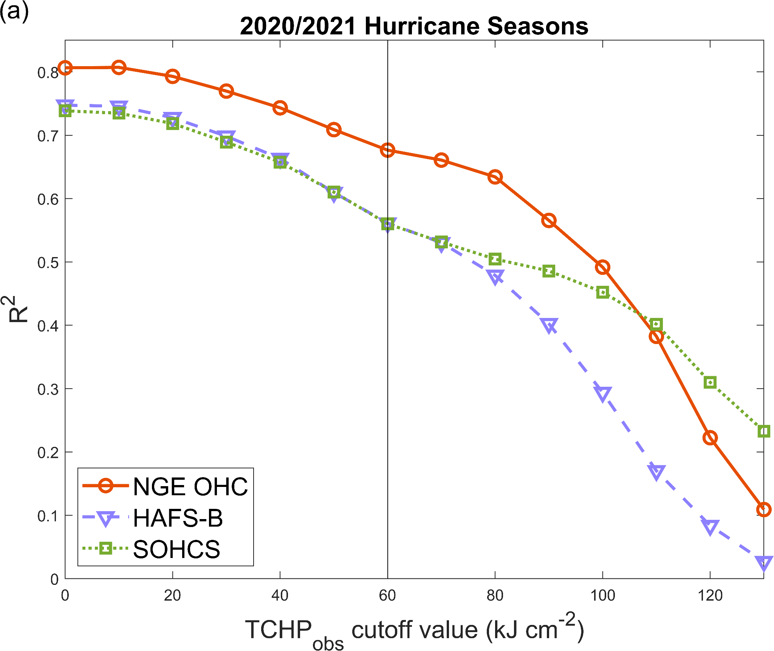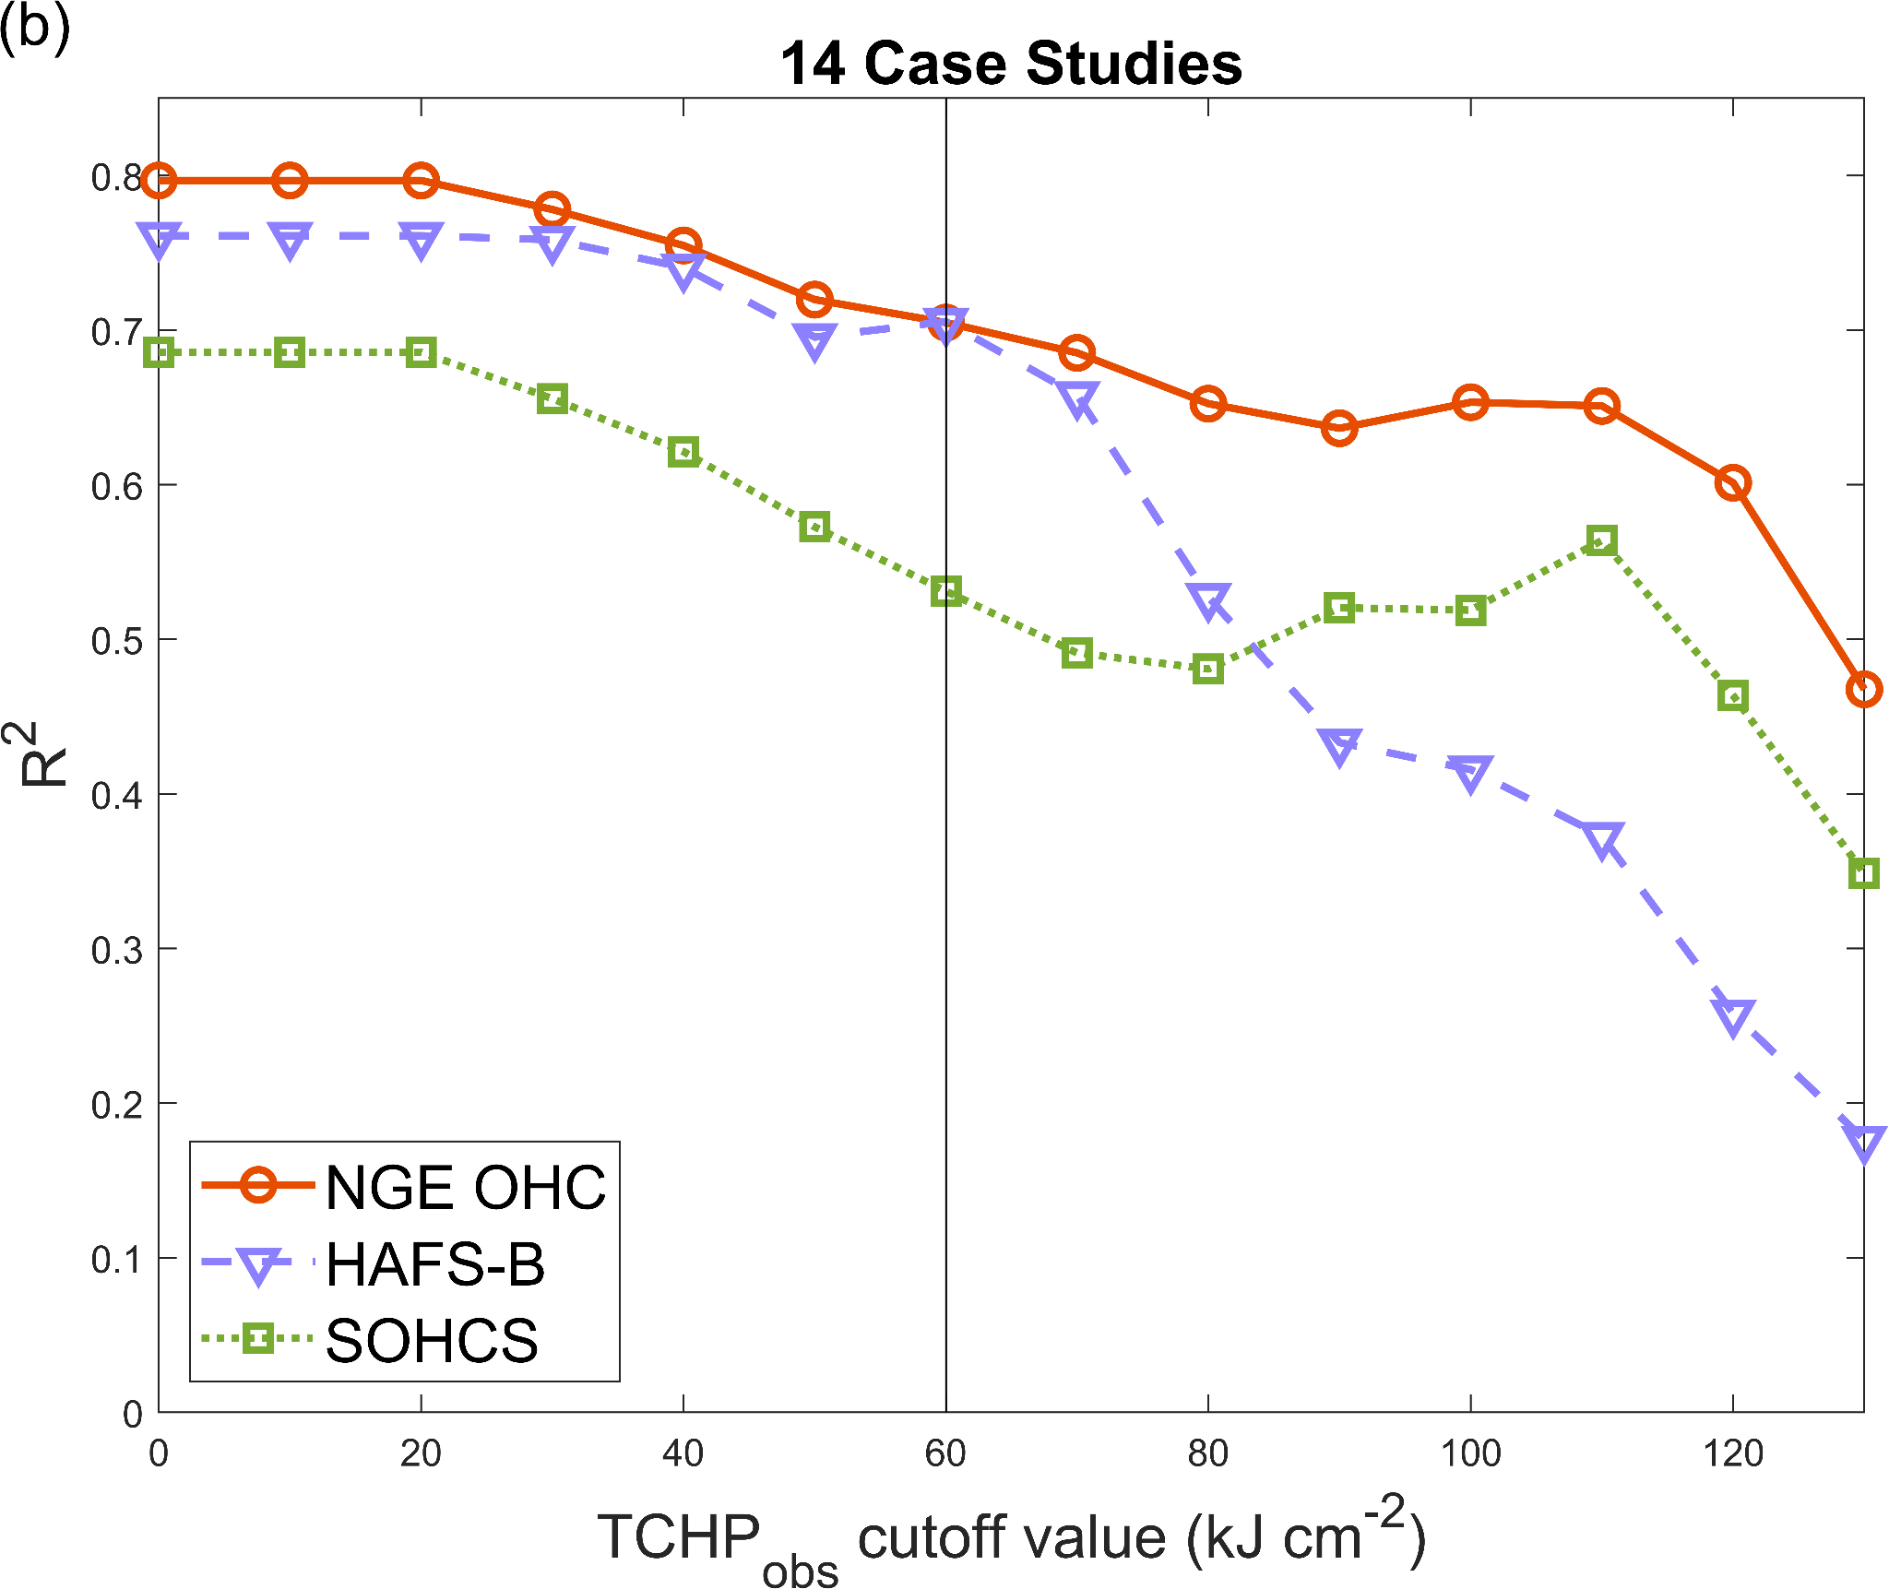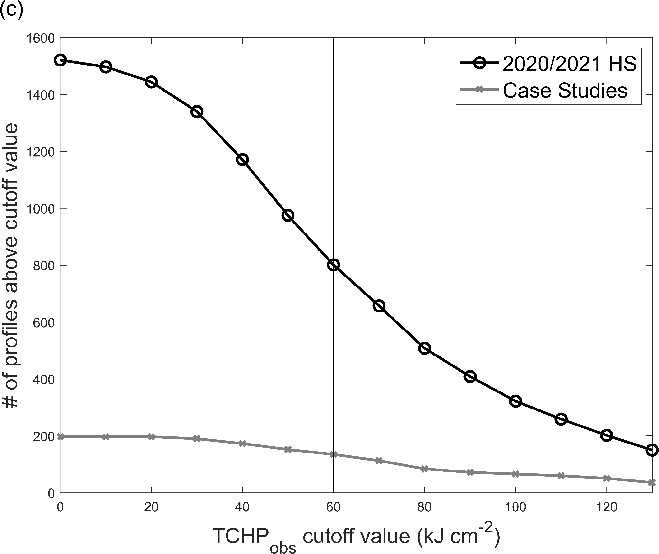
Figure 3. R² values calculated between TCHP observations (TCHP_{obs}; kJ cm⁻²) from Argo profiles and either the SOHCS (green), NGE OHC (orange), or HAFS-B (periwinkle) TCHP estimates (kJ cm⁻²) as the observed TCHP values are limited using progressively warmer cutoff values for profiles from (a) the entire 2020/2021 hurricane seasons and (b) the 14 case studies only. (c) The number of profiles observed with TCHP above the cutoff value in (a) (black circles) and (b) (gray squares). Not all methods produced a solution for each observed profile. TCHP_{obs} = 60 kJ cm⁻² is highlighted (gray line) due to the importance of TCHP_{obs} values above this threshold to TC intensification (Mainelli et al., 2008).

To see if there are any differences in performance for conditions related to rapid storm intensity change specifically, we do the same comparison between the three estimates of TCHP and the Argo observations for profiles that occurred within the −4 to +1 day window noted above for any of the 14 case studies (Table 2). The NGE OHC estimates still have a better overall fit to the Argo observations (R² = 0.80) than those from HAFS-B (R² = 0.76) and SOHCS (R² = 0.69); though the R² values relative to these case study data are lower for the NGE OHC and SOHCS estimates and slightly higher for the HAFS-B estimates than for the full 2020/2021 hurricane seasons. The lower R² values may be in part because there are significantly fewer points in the case study Argo dataset (N = 197) than in the full Argo dataset from the 2020/2021 hurricane seasons (N = 1521) (Fig. 3c). Compared to the results using the full set of profiles from the 2020/2021 hurricane seasons, the magnitude of the bias decreased substantially for the SOHCS estimates (0.19 kJ cm⁻²) and slightly for the NGE OHC estimates (0.59 kJ cm⁻²), while remaining about the same for those from HAFS-B (−8.41 kJ cm⁻²) using the profiles from the case studies. These bias estimates for the NGE OHC and SOHCS estimates can be considered comparable since they are below the noise thresholds for the methods. Concurrently, the RMSE increased for the SOHCS (22.08 kJ cm⁻²) and NGE OHC (17.21 kJ cm⁻²) estimates while remaining relatively steady for the HAFS-B estimates (20.62 kJ cm⁻²). When calculating R² over different ranges of observed TCHP values for these profiles, we again find that the R² of all three methods declines at larger TCHP values (Fig. 3b). The NGE OHC and HAFS-B estimates have nearly identical R² values when the TCHP_{obs} cutoff is ≤ 70 kJ cm⁻², while above this cutoff the HAFS-B performance declines sharply. For both the full range of TCHP_{obs} cutoff values and those relevant to TC intensification (TCHP_{obs} ≥ 60 kJ cm⁻²), the NGE OHC algorithm performs the best on these case study data for all metrics, except for the bias where the performance of SOHCS is comparable (Table 2).
b. Regional θ/S profile estimation skill
Since both the NGE OHC and HAFS-B output synthetic θ/S profiles, we can compare their skill with respect to depth in replicating all of the Argo profile data from the 2020 and 2021 hurricane seasons. The NGE OHC profiles slightly outperform those from HAFS-B in terms of the percent variance explained (PVE) in temperature above 250 dbar and below that depth their PVE values are nearly identical (Fig. 4a). Similarly, the temperature RMSE is smaller for the NGE OHC profiles in most of the upper 250 dbar (Fig. 4b). The magnitude of the temperature bias is slightly smaller for the NGE OHC profiles than for HAFS-B profiles from 0 to 35 dbar, larger than for the HAFS-B profiles from 35–83 dbar (though only by < 0.2°C), and smaller than for the HAFS-B profiles below 83 dbar, especially below 100 dbar (Fig. 4c). The bias in temperature for the NGE OHC profiles is positive at all depths, while for the HAFS-B profiles it is negative at all depths. Overall, the NGE OHC algorithm more accurately reproduces the observed ocean temperatures over most of the upper 300 dbar.
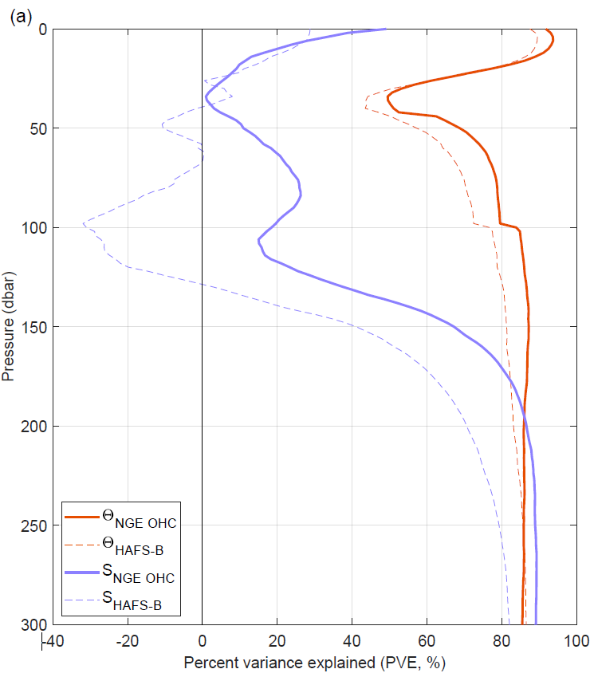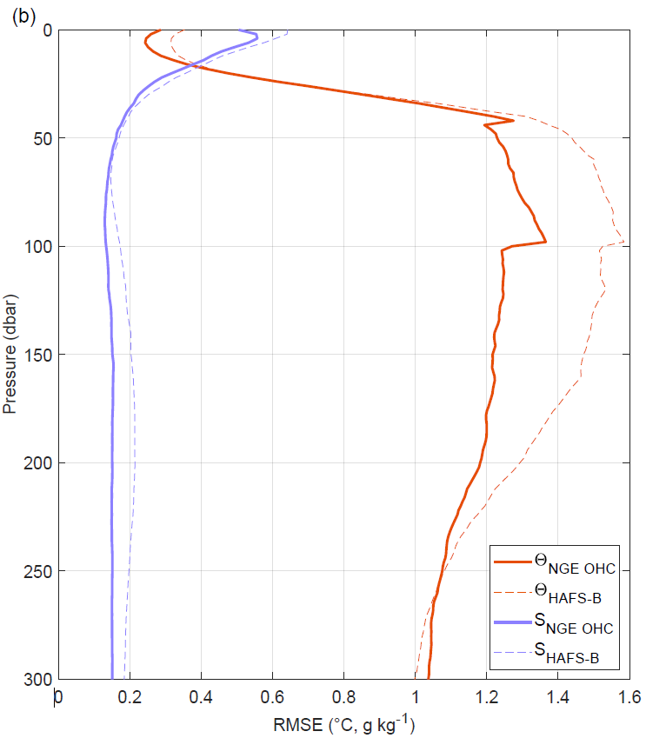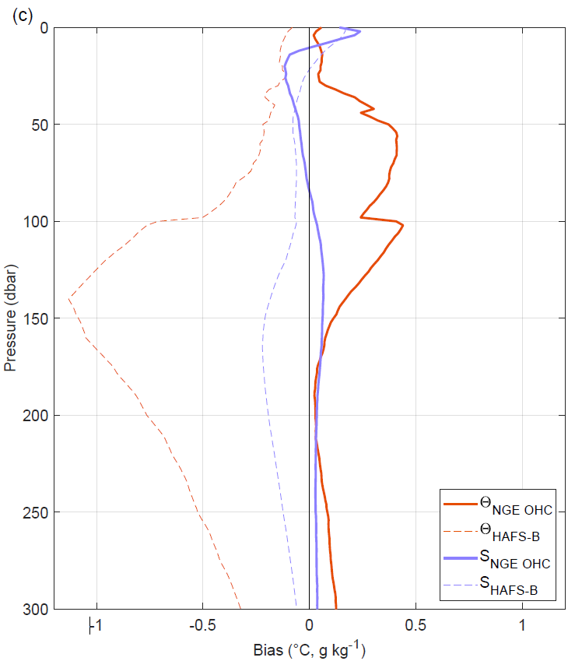
Figure 4. (a) Percent variance explained (PVE), root-mean-square-error (RMSE), and bias for conservative temperature (Θ, periwinkle) and absolute salinity (S_{A}, orange) estimates over the upper ocean (0–300 dbar) from the NGE OHC algorithm (solid lines) and HAFS-B model initializations (dotted lines), compared to the 1521 Argo Θ/S_{A} profile observations from the 2020/2021 hurricane seasons.

The relative skill of the NGE OHC and HAFS-B profiles at representing near-surface salinity is more complex. Above 38 dbar the PVE in salinity of the two methods are fairly similar (Fig. 4a), except for at the surface where the PVE from the NGE OHC estimates is ~20% higher (likely due to the SSS-based parameterization in that algorithm). Below 38 dbar the NGE OHC estimates consistently explain far more of the variance in salinity than do those from HAFS-B. Moreover, from 40 to 130 dbar, a critical depth range for heat content and vertical mixing tendency in the region, HAFS-B notably has negative PVE values for salinity. Around 34 dbar both methods yield a PVE of approximately zero. A PVE of zero indicates that the synthetic profiles explain none of the variance found in the observations and a negative PVE signifies that the profile estimates are so different from the observations that a random sample of values can explain a higher percent of the variance. The RMSEs for the NGE OHC salinity profiles are consistently smaller from 0–300 dbar than those from the HAFS-B profiles (Fig. 4b). In the upper 10 dbar, both the NGE OHC and HAFS-B profiles exhibit a salty bias (Fig. 4c). The magnitude of the salinity biases in the HAFS and NGE OHC estimates is comparable between the surface and 40 dbar, and both switch signs. Below 40 dbar, the salinity bias for the NGE OHC estimates is consistently smaller in magnitude than for those from HAFS-B, even as the bias for the NGE OHC estimates changes sign again at 85 dbar. In addition, the salinity gradient, which is crucial to model accurately to resolve barrier layers, is often more accurate in the NGE OHC algorithm (discussed below).
c. Case study: Hurricane Laura (AL132020)
Laura first appeared as a tropical wave off the western coast of Africa on 16 Aug 2020 and strengthened to tropical storm intensity on 21 Aug before passing over the Lesser Antilles (Pasch et al., 2021). From 23–24 Aug it made landfall in Hispaniola, Eastern Cuba, and then Western Cuba. Once in the GoM, Laura became a category 1 hurricane around 1200 UTC 25 Aug before rapidly intensifying on 26 Aug until it reached peak intensity (130 kt) around 0000 UTC 27 Aug. Laura made landfall at Cameron, Louisiana at ~0600 UTC 27 Aug as a category 4 storm with an intensity of 130 kt, the strongest storm to hit the state since 1969. The HAFS-B forecast initialized at 0000 UTC on 20 Aug 2020 did not capture this RI event and substantially underpredicted the intensity throughout the GoM (Fig. 5a), only reaching a peak intensity of 75 kt (figure not shown).
The underpredicted RI for Laura occurred during forecast hours 96 to 120 in the selected HAFS-B forecast. During this time (e.g., at forecast hour 108, less than 24 h before landfall), HAFS-B forecast light to moderate VWS and maintained a moist envelope of mid-tropospheric air in the core of the TC (Fig. 5b and 5c). By subtracting the vortex shear related to the cyclone/anticyclone pairing within the TC from the environmental VWS, we see that the core of the TC (within 200 km of storm center) was subject to light shear (< 10 kt), with higher northerly and westerly shear values of 10–22 kt being present only in the outer regions (beyond 200 km) of the forecast domain. Similarly, dry air present in the outer region generally did not intrude into the inner 200 km, except for forecast humidity values of 60–70% present only in the southwest quadrant of the storm. This quadrant was also where shear values throughout the domain were smallest (7–12 kt). Finally, the forecast translation speed of Laura during this period slowed to < 5 m s⁻¹, giving the forecast TC ample opportunity to interact with the ocean beneath (Halliwell et al., 2015). This combination of very moderate shear, very limited dry-air intrusion, and slow forward motion suggests that the failure to intensify in the forecast was at least in part related to ocean conditions beneath the storm.
Comparison of Argo profiles near the forecast track with both the HAFS-B model output and NGE OHC synthetic profiles support this view (Fig. 5d–g). Much of the upper 60 dbar of the water column in HAFS-B, especially within the top 10–15 dbar of the surface boundary layer (which we refer to as the “near-surface isothermal layer”), was consistently too cool relative to both the in situ observations and satellite-derived NGE OHC profile estimates (Fig. 3d, f). Within this near-surface isothermal layer specifically, the HAFS-B profiles were 0.3°C–0.5°C cooler than the observations. Furthermore, HAFS-B lacked the strong BL (high salinity gradient within the near-surface isothermal layer) that was present in both the Argo and NGE OHC profiles, especially in Fig. 5g from 2 to 10 dbar, and could potentially have contributed to the RI of the true storm. This highly stratified layer would have potentially reduced the storm-induced SST cooling, leading to a higher enthalpy flux into the storm that could have allowed it to more readily intensify.
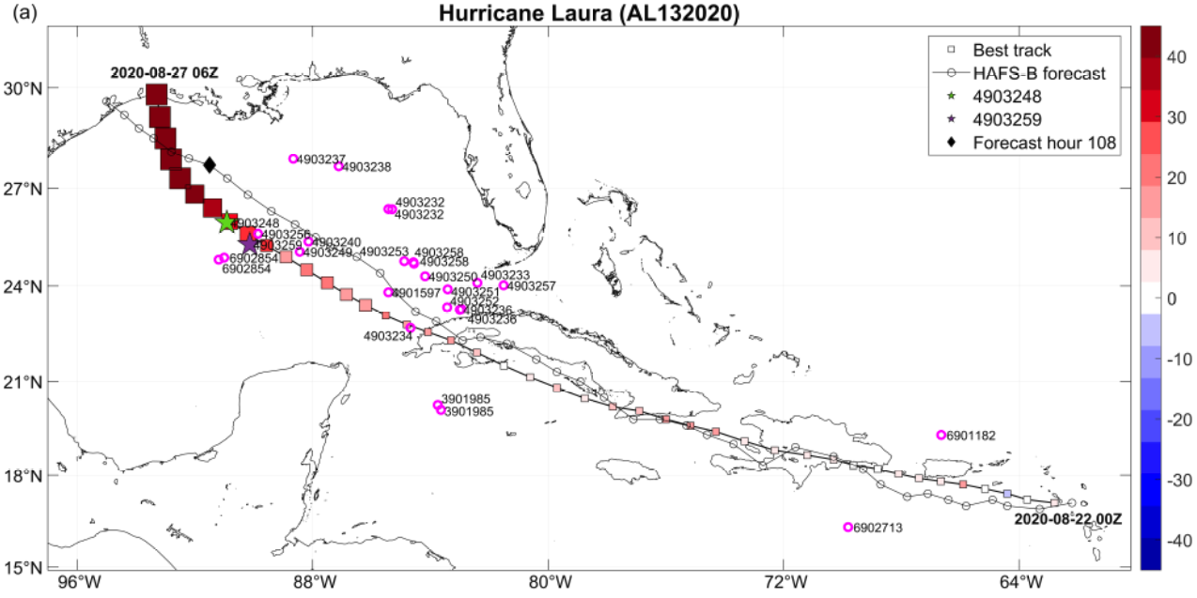
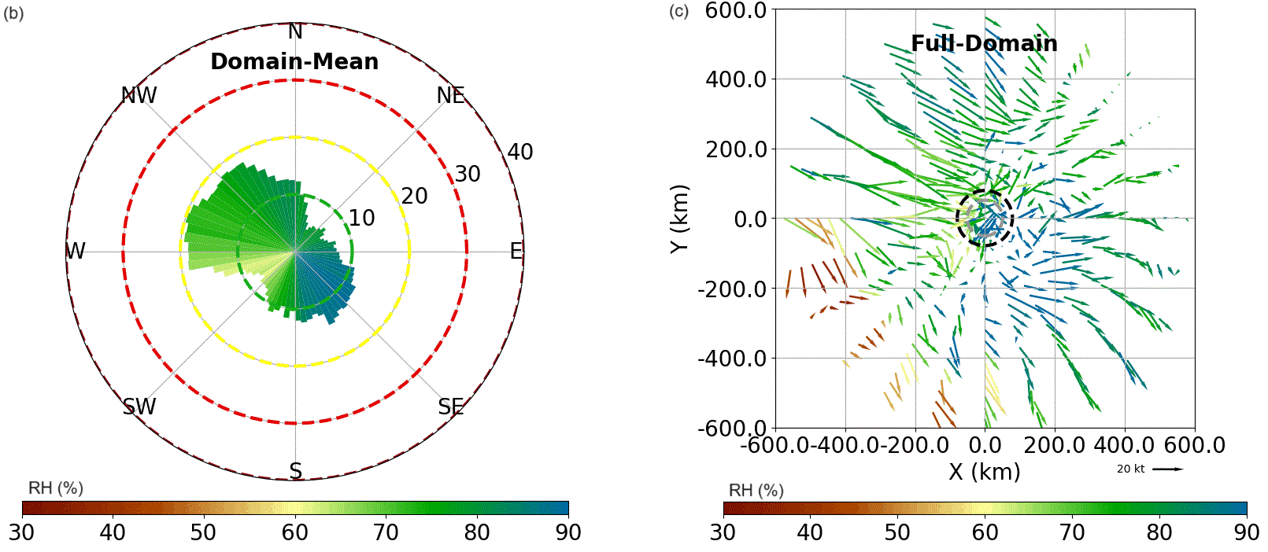
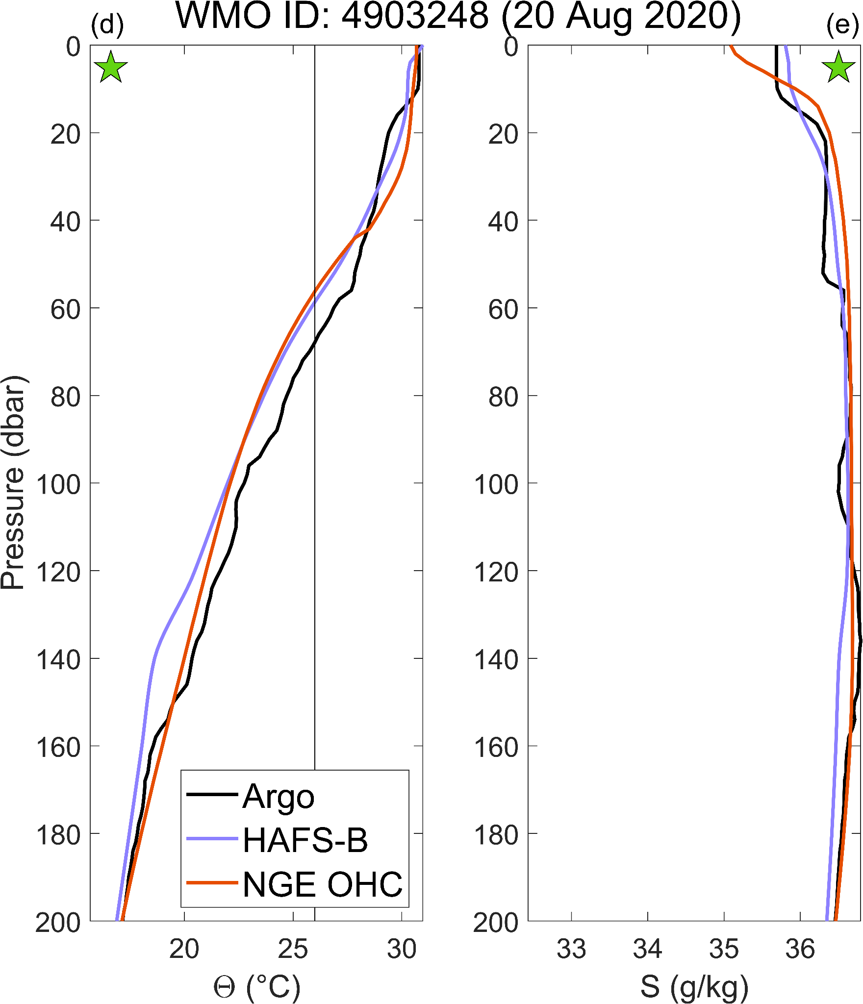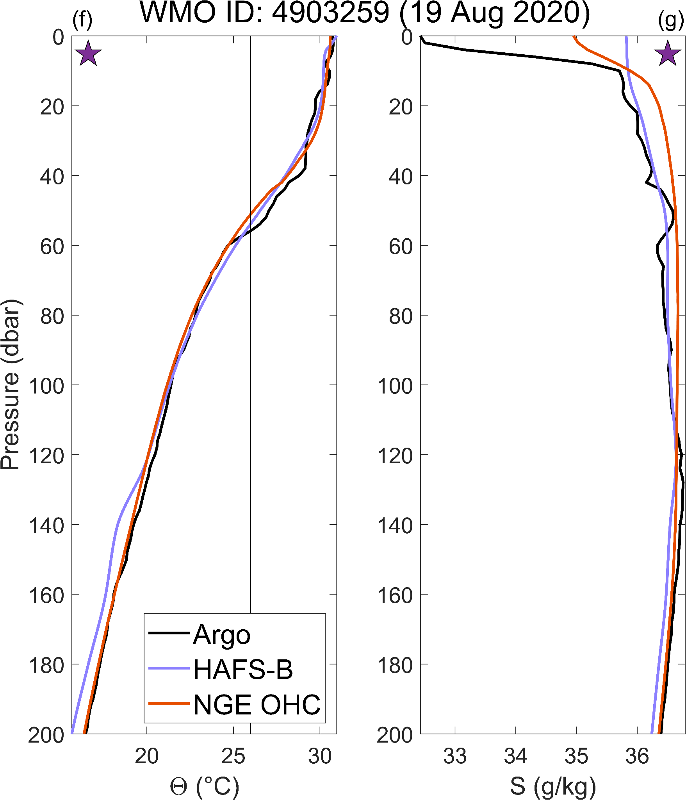
Figure 5. Analysis of the HAFS-B forecast initialized at 0000 UTC on 22 Aug 2020 and run to 0600 UTC on 27 Aug 2020 for Hurricane Laura. (a) IBTrACS best track with storm intensities every 3 hours (kt, square size) and the difference from the HAFS-B forecast intensities every 3 hours (kt, square color). Red (blue) squares indicate that HAFS-B underpredicted (overpredicted) the true intensity. HAFS-B forecast storm center position at forecast hour 108 (black diamond). All nearby Argo profiles with high-quality data (pink circles with World Meteorological Organization (WMO) identifier noted). HAFS-B fields at forecast hour 108 (onset of RI) for: (b) radially averaged deep (200–850 hPa) VWS (slices, with distance from center indicating speed in kt) colored by radially averaged RH between 3 and 5 km altitude above the surface (%) across the high-resolution, inner HAFS-B moving nest domain (i.e., the full region shown in (c)), and (c) individual deep VWS vectors (kt; barbs) colored by RH (%), with circles denoting model radius of maximum winds at 3 km (black dashed) and at 5 km (gray dashed). (d–g) Three-way comparison of Θ (°C; d, f) and S_{A} (g kg⁻¹; e, g) profiles with respect to pressure (dbar) observed by Argo floats (black), estimated by the NGE OHC algorithm (orange), and from the HAFS-B model ocean initialization (periwinkle) for the profile locations indicated by the stars on (a).

d. Case study: Hurricane Sally (AL192020)
Sally formed over the Bahamas from a broad area of low pressure leftover from Tropical Storm Omar and organized into a tropical depression by 1800 UTC 11 Sep 2020 (Berg and Reinhart, 2021). It made landfall near Cutler Bay, Florida just after 0600 UTC 12 Sep, strengthened to a tropical storm by 1200 UTC when centered over the Everglades, and then propagated into the GoM. Sally reached category 1 intensity when it underwent an intensification event on 14 Sep and reached a relative peak intensity of 75 kt at 1800 UTC. It then weakened to an intensity of 70 kt by 0600 UTC 15 Sep. Another intensification event started that evening, increasing the intensity to 95 kt (category 2) before it made landfall at Gulf Shores, Alabama at 0945 UTC 16 Sep.
The HAFS-B forecast for Sally initialized at 1800 UTC on 11 Sep 2020 missed both intensification events in the GoM (Fig. 6a). This forecast reached a peak intensity of only 50 kt at forecast hour 72 (the end of the first observed intensification event in the GoM) and declined steadily thereafter –- with an intensity of only 40 kt at the time of the observed 95 kt peak intensity at forecast hour 108 (figure not shown). Here, we focus our analysis on the first GoM intensification event, which occurred before the HAFS-B track began to develop a substantial westward bias relative to the best track. Much earlier (from forecast hours 6 to 36) the forecast storm began experiencing moderate to high VWS as it approached the U.S. Gulf Coast (figure not shown). At forecast hours 42 through 54 though, just before the first intensification event, environmental VWS had moderated to near 10 kt (seen for hour 48 in Fig. 6b), and the forecast TC remained wrapped in a cocoon of mid-tropospheric moist air (RH > 75% in all quadrants, Fig. 6c) throughout the forecast hours when this intensification event would have occurred. In addition, the horizontal propagation speed of Sally (both in the best track and the HAFS-B forecast) slowed substantially during this period to approximately 5 m s⁻¹ (figure not shown). These analyses again suggest that ocean conditions could have played a role in this forecast bust for Sally.
We see important subsurface θ/S differences relating to these differences in forecast intensity when we compare the profiles from the initial conditions of HAFS-B to those from the in situ Argo and synthetic NGE OHC profiles (Fig. 6d–g). In the central GoM prior to Sally’s passage, a warm BL (from 10 to 20 dbar; Fig. 6d, e) is present in both the Argo and NGE OHC profiles close to the region where the onset of the first GoM intensification event occurred. By contrast, the matching HAFS-B profile lacks a BL and is both too cool (by 0.2°C–0.5°C) and generally too saline in the upper 50 dbar, relative to the observations. The difference in vertical salinity gradient associated with this BL is even more apparent in the Argo and NGE OHC profiles from the northern GoM and this feature is again not resolved in the corresponding HAFS-B profile (from 4 to 10 dbar; Fig. 6f, g). The HAFS-B conditions at these two locations would have resulted in both lower available enthalpy at the air-sea interface as Sally passed overhead, and perhaps more importantly, a tendency for the modeled sea surface to cool more quickly in response to wind forcing in the model, as compared with what the Argo and NGE OHC profiles would have suggested. Both the too cool near-surface conditions and lack of BL in the HAFS-B initializations could help explain its lack of intensification in Sally during this critical phase of its evolution in the GoM.
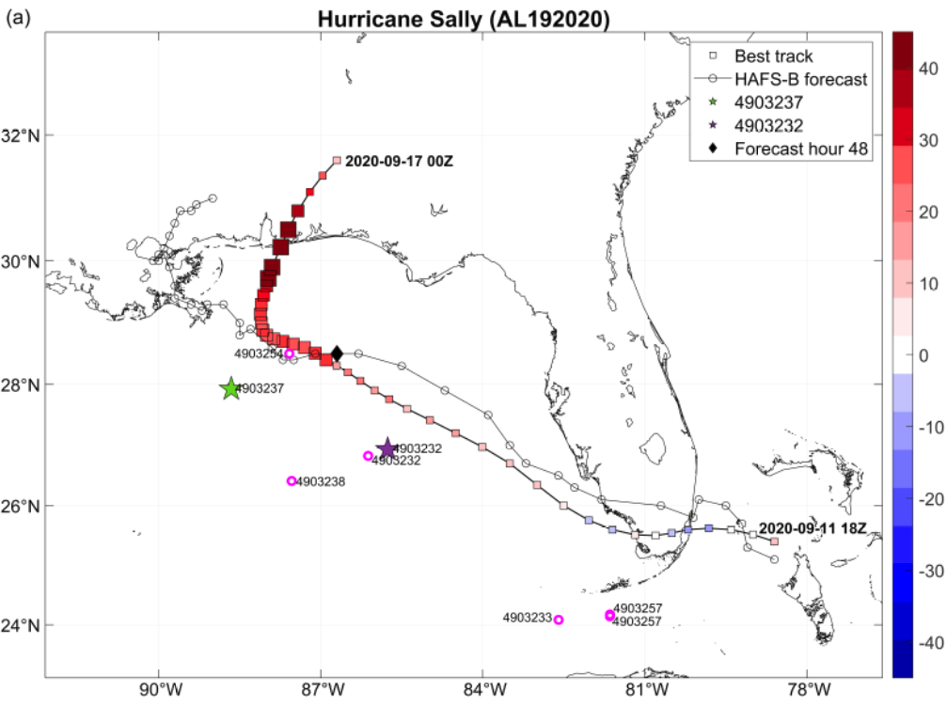
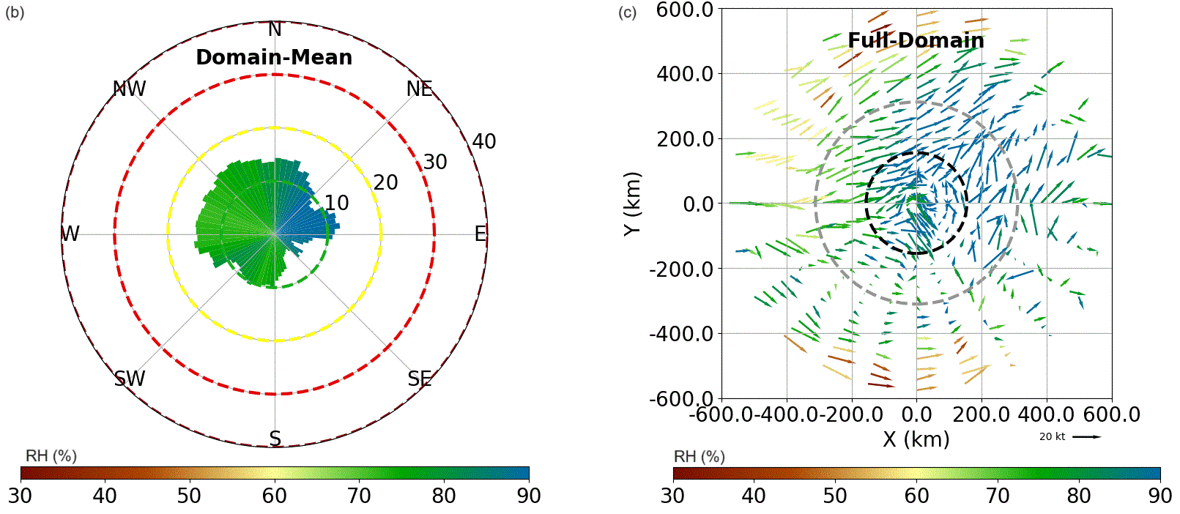
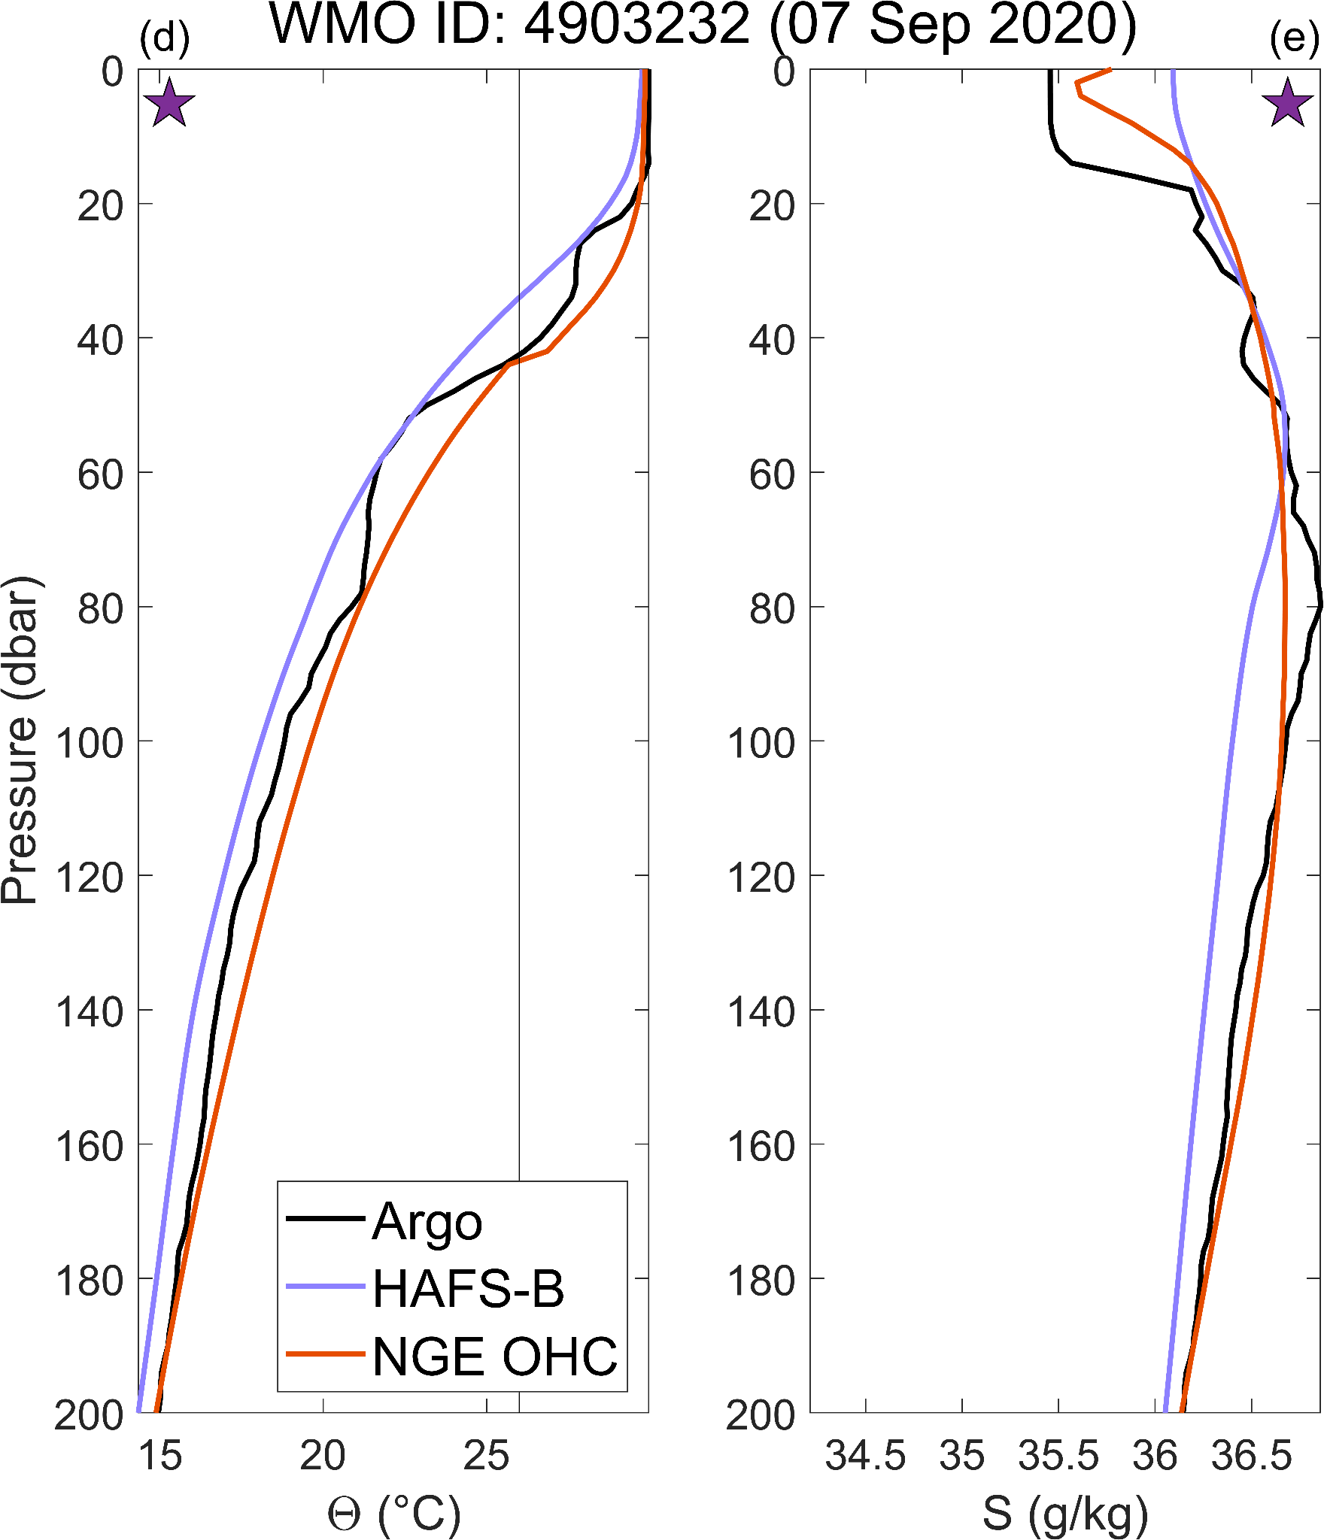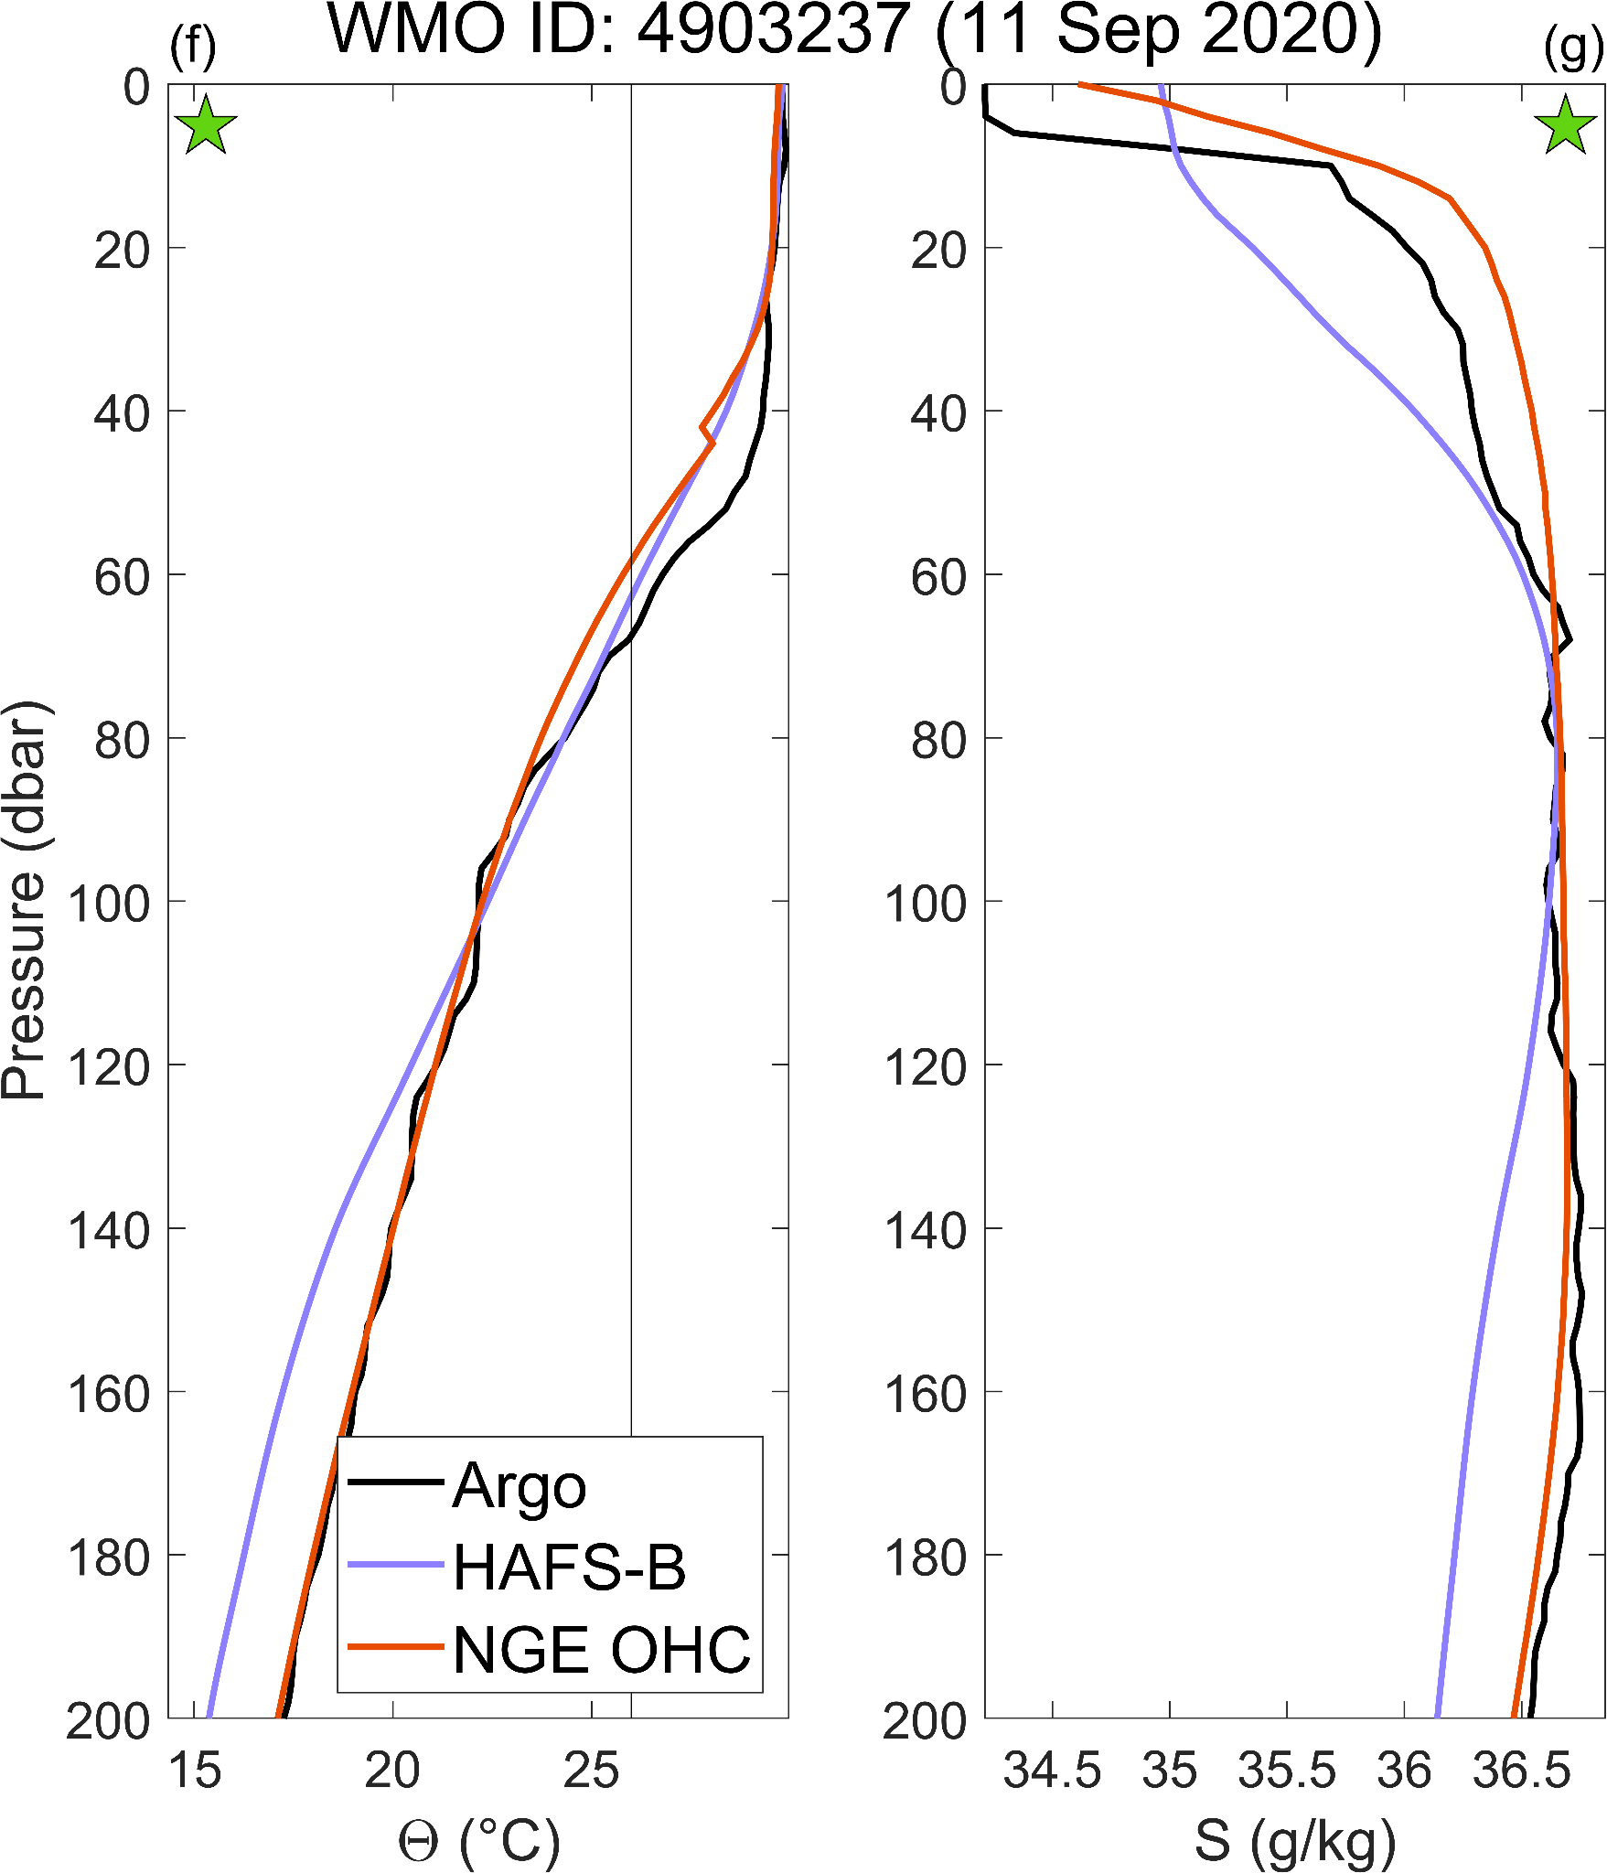
Figure 6. Same as Fig. 5 but for the HAFS-B forecast initialized at 1800 UTC on 11 Sep 2020 and run to 0000 UTC on 17 Sep 2020 for Hurricane Sally. HAFS-B atmospheric fields here are from the onset of the first intensification event in the GoM (forecast hour 48; b, c) with the forecast storm center position for that hour indicated in (a) by a black diamond.

e. Additional meteorological analysis and case studies
Three additional case studies, for forecast cycles of Hurricanes Delta, Grace, and Ian, are examined in the SM. Extensive additional evaluations of atmospheric conditions are also found in the SM, both for the two case studies explored above, and for the three additional case studies from the SM. These evaluations include both forecast and observation-assimilating analysis fields for the valid times of specific case studies, including discussions of: (a) time series of 200–800 km annular average deep VWS and mid-tropospheric RH for all five case studies of interest, (b) time series of 200–800 km annular average upper-level divergence for a subset of these case studies, and (c) total reflectivity and 200 hPa relative vorticity and winds for two of the case studies.
Forecasts for Delta (initialized at 1800 UTC on 05 Oct 2020) and Grace (initialized at 0000 UTC on 18 Aug 2021) both showed substantial underintensification relative to the best track (Fig. S1, S3). Specifically, this was the case for the RI event just prior to Delta’s Yucátan landfall (and to a lesser degree its Louisiana landfall) and the one preceding Grace’s second landfall near Tecolutla, Mexico. As with the two case studies described above, the atmospheric and ocean model outputs, Argo observations, and NGE OHC profiles suggest that ocean initialization could well have played a role in those underforecasts during these RI events for Delta and Grace. By contrast, the Ian case study in the SM focuses on a forecast (initialized at 1800 UTC on 27 Sep 2022) that intensified too rapidly and reached a peak wind that did not verify in the best track. The analysis in the SM (Fig. S4) suggests that for this case, the HAFS-B ocean initialization was missing some near-surface heat and a BL present in the Argo observations and NGE OHC estimates. For this case, however, properly accounting for these upper ocean features in the ocean initialization could potentially have exacerbated the existing issues with the intensity forecast, as further discussed in the SM.

5. Discussion
The NGE OHC algorithm produces daily, high resolution synthetic θ/S profiles that can help in the evaluation of TC intensity forecasts, and potentially be used to improve these forecasts. By deriving functional relationships between satellite data and upper ocean θ/S structure, this algorithm will enable us to project satellite information down through the subsurface ocean to estimate upper ocean θ/S profiles operationally wherever altimetry data are available. Blending in situ and satellite data streams is a powerful tool for combining high-resolution sea surface information with the high accuracy of in situ samples from platforms like the Argo array. The implementation of this technique globally will exponentially increase the amount of “data” available to the TC forecasting community for the evaluation of and data assimilation with forecast models, from a handful of high-quality in situ Argo profiles per TC to high-resolution gridded and along-track sets of synthetic, data-derived θ/S profiles. Previous work (Liu et al., 2023) has shown that assimilating ocean observations from satellites and subsurface gliders can improve the representation of the barrier layer in the HAFS model initialization, which in turn improved the intensity forecast for Hurricane Isaias (2020). We are therefore optimistic about the utility of the NGE OHC profiles for this purpose. However, future work will be needed first (and is planned) to estimate the uncertainty for the synthetic θ/S NGE OHC profiles, which are dynamically balanced below the mixed layer.
By first comparing TCHP observations from Argo profiles with TCHP estimates from the current operational SOHCS, the NGE OHC, and HAFS-B, we find that the NGE OHC consistently outperforms the SOHCS product in R², RMSE, and bias over the 2020/2021 hurricane seasons and in R² and RMSE for the 14 case studies (with comparable bias over these profiles). The NGE OHC generally matches or outperforms HAFS-B with respect to estimating TCHP for the 2020/2021 hurricane seasons and the 14 case studies, retaining more of its skill at high TCHP values than does HAFS-B. In particular, for TCHP observations above 60 kJ cm⁻² the HAFS-B R² value quickly drops. Previous work demonstrated that TCHP values > 60 kJ cm⁻² have potential to increase TC intensity, while values below this may stall or even reverse intensification (Mainelli et al., 2008). This suggests that improvements to the HAFS-B initial ocean state should be considered to resolve this decline in performance at higher TCHP values, which are likely important for RI events.
With respect to emulating the observed θ/S Argo profiles from the entire 2020/2021 Atlantic hurricane seasons, the NGE OHC has higher accuracy than HAFS-B over much of the upper 300 dbar for temperature (all error metrics) but only above ~6 dbar and below ~40 dbar for salinity (when considering the PVE and RMSE alone). Additionally, both products have some clear biases: HAFS-B is consistently too cool through the water column, too fresh below 22 dbar, and too salty above; the NGE OHC is consistently too warm and also has small biases of both signs for salinity. From the case study profile comparisons, we find that the near-surface salinity gradient is frequently more accurately estimated by the synthetic profiles from the NGE OHC algorithm than by those from HAFS-B. All of these differences in θ/S estimation skill with depth should be kept in mind while examining these results and considered for focused further exploration by the respective model/algorithm development teams. Seasonal and mixed-layer-only LUTs for the GEM, in particular, are possibilities being considered for implementation in the NGE OHC.
The two detailed case studies presented here (Laura, Sally) and the three in the SM (Delta, Grace, Ian), emphasize the importance for TC forecasting of incorporating observations of both ocean thermal conditions and salinity profiles with depth wherever possible. In particular, for the intensification events during these storms that were not modeled well by HAFS-B, the surface mixed layer in HAFS-B was often too cold, consistent with its cold bias noted above over 0–300 dbar for the entire dataset of profiles from the 2020/2021 hurricane seasons. Additionally, the Argo and NGE OHC profiles sometimes showed the presence of a barrier layer that was not replicated by HAFS-B. The combination of unrealistically cool and well-mixed near-surface layers seems to be a potential contributor to the lack of RI in these forecasts. Comparisons with Argo observations and the observationally-derived NGE OHC profiles estimates provides important insight into some challenging model forecasts from HAFS-B, suggesting that development of the NGE OHC real-time, operational product could be invaluable for model evaluation in operational and research contexts during upcoming Atlantic hurricane seasons, and that this product would be a strong candidate for future HAFS ocean data assimilation efforts. To aid in these data assimilation efforts, we plan to include rigorous uncertainty estimates in our next iteration of the NGE OHC algorithm. We also plan to update the profile database that the LUTs are based on at regular intervals, which should help minimize the bias in the NGE OHC algorithm in future years. Future work could also evaluate the impact of information from the NGE OHC algorithm on forecasting the intensity and extent of coral bleaching events, e.g., during marine heat waves, another important use case for this algorithm.

Acknowledgments
PDL and DST were supported by the NOAA grant NA19NES4320002 (Cooperative Institute for Satellite Earth System Studies, CISESS) at the University of Maryland/ESSIC. This research was supported by the NOAA Product Development, Readiness, and Application (PDRA) / Ocean Remote Sensing (ORS) Program. Funding from NOAA projects GR013873 and GR021701 (A. Hazelton, PI) supported LJG in performance of analyses and preparation of this manuscript. We gratefully acknowledge the insightful comments of two internal reviewers, E. Leuliette (NOAA/STAR/LSA) and F. Marks (NOAA/AOML/HRD), Ghassan Alaka, George “Trey” Alvey, and Andrew Hazelton of NOAA/AOML/HRD, Christopher Landsea, and the anonymous peer reviewers. The Argo float image used in Fig. 2 is originally from https://argo.ucsd.edu/argo-yellow-01/. The scientific results and conclusions, as well as any views or opinions expressed herein, are those of the authors and do not necessarily reflect those of NOAA or the Department of Commerce.

Data Availability Statement
Ocean temperature and salinity profiles from WOD 2018 are available from NOAA/NCEI (https://www.ncei.noaa.gov/products/world-ocean-database; Boyer et al., 2018). Argo temperature and salinity profiles were downloaded from an Argo GDAC (https://doi.org/10.17882/42182). Argo data were collected and made freely available by the International Argo Program and the national programs that contribute to it (https://argo.ucsd.edu, https://www.ocean-ops.org). The Argo Program is part of the Global Ocean Observing System. Gridded sea level anomaly data from RADS, nighttime SST data from the daily operational NOAA GeoPolar Blended 5 km SST product, and TCHP estimates from NOAA/NESDIS SOHCS product are all available through NOAA CoastWatch, either through the product search portal (https://coastwatch.noaa.gov/cwn/products.html) or the data viewer (https://coastwatch.noaa.gov/cw_html/cwViewer.html). The DTU15MDT are available from the Technical University of Denmark (https://ftp.space.dtu.dk/pub/DTU15/). The SSS data from the Multi-Mission OISSS Level-4 v2.0 product are available from the NASA Physical Oceanography Distributed Active Archive Center (PODAAC; https://podaac.jpl.nasa.gov/). Atmospheric and ocean model output from HAFS-B are available on the NOAA Research and Development High Performance Computing Systems (RDHPCS) archive system, or upon request. Sample HAFS-B data are available from the NOAA Environmental Modeling Center (https://www.emc.ncep.noaa.gov/gc_wmb/vxt/zack/HAFS_Sample_Files/). Graphics for retrospective forecasts are available on the AOML Hurricane Viewer (https://storm.aoml.noaa.gov/viewer/). Storm track and wind speed data from the IBTrACS are available from NOAA/NCEI (https://www.ncei.noaa.gov/products/international-best-track-archive). Software for the NGE OHC testbed algorithm is held in the NOAA Center for Satellite Applications and Research (STAR) GitLab and not publicly available, following NOAA/NESDIS technical development practices; once the algorithm meets NOAA Readiness Level 7 a publicly accessible Algorithm Theoretical Basis Document will be developed.

REFERENCES
Alvey, G. R., III, G. J. Alaka Jr, L. Gramer, A. Hazelton, 2025: Evaluation of Hurricane Analysis and Forecast System (HAFS) Error Statistics Stratified by Internal Structure and Environmental Metrics. Wea. Forecasting, 40(1), 131–147, https://doi.org/10.1175/WAF-D-24-0030.1.
Alvey, G. R., III, and A. Hazelton, 2022: How Do Weak, Misaligned Tropical Cyclones Evolve Toward Alignment? A Multi‐Case Study Using the Hurricane Analysis and Forecast System. J. Geophys. Res. Atm., 127(20), p.e2022JD037268, https://doi.org/10.1029/2022JD037268.
Andersen, O. B., P. Knudsen, and L. Stenseng, 2015: The DTU13 MSS (Mean Sea Surface) and MDT (Mean Dynamic Topography) from 20 Years of Satellite Altimetry. International Association of Geodesy Symposia (pp. 1–10). Springer. https://doi.org/10.1007/1345_2015_182.
Andersen, O. B., P. Knudsen, and N. Maximenko, 2016: The updated geodetic mean dynamic topography model - DTU15MDT, abstract #PO54F-3318, Ocean Sciences Meeting 2016, 21–26 February, New Orleans, LA, USA.
Androulidakis, Y., V. Kourafalou, G. Halliwell, M. Le Hénaff, H. Kang, M. Mehari, and R. Atlas, 2016: Hurricane interaction with the upper ocean in the Amazon-Orinoco plume region. Ocean Dyn., 66, 1559–1588, https://doi.org/10.1007/s10236-016-0997-0.
Annane, B., and L. J. Gramer, 2024: Influence of CyGNSS L2 Wind Data on Tropical Cyclone Analysis and Forecasts in the Coupled HAFS/HYCOM System. Front. Earth Sci., 12:1418158, https://doi.org/10.3389/feart.2024.1418158.
Argo, 2024: Argo float data and metadata from Global Data Assembly Centre (Argo GDAC). SEANOE. https://doi.org/10.17882/42182.
Aristizábal Vargas, M. F., H.-S. Kim, M. Le Hénaff, T. Miles, S. Glenn, and G. Goni, 2024: Evaluation of the ocean component on different coupled hurricane forecasting models using upper-ocean metrics relevant to air-sea heat fluxes during Hurricane Dorian (2019). Front. Earth Sci., 12, 1342390, https://doi.org/10.3389/feart.2024.1342390.
Atlas, R., R. N. Hoffman, J. Ardizzone, S. M. Leidner, J. C. Jusem, D. K. Smith, and D. Gombos, 2011: A cross-calibrated, multiplatform ocean surface wind velocity product for meteorological and oceanographic applications. Bull. Amer. Meteor. Soc., 92, 157–174, https://doi.org/10.1175/2010BAMS2946.1.
Balaguru, K, P. Chang, R. Saravanan, L. R. Leung, Z. Xu, M. Li, and J.-S. Hsieh, 2012: Ocean barrier layers' effect on tropical cyclone intensification. Proc. Natl. Acad. Sci. USA, Sep 4;109(36):14343-7. https://doi.org/10.1073/pnas.1201364109.
Balaguru, K., G. R. Foltz, L. R. Leung, W. Xu, D. Kim, H. Lopez, and R. West, 2022: Increasing Hurricane Intensification Rate Near the US Atlantic Coast. Geophys. Res. Lett., 49, https://doi.org/10.1029/2022GL099793.
Bender, M. A., and I. Ginis, 2000: Real-Case Simulations of Hurricane–Ocean Interaction Using A High-Resolution Coupled Model: Effects on Hurricane Intensity. Mon. Wea. Rev., 128(4), 917–946, https://doi.org/10.1175/1520-0493(2000)128<0917:RCSOHO>2.0.CO;2.
Berg, R., and B. J. Reinhart, 2021: Tropical cyclone report: Hurricane Sally (National Hurricane Center). Available at https://www.nhc.noaa.gov/data/tcr/AL192020_Sally.pdf (Accessed 06 May 2024).
Bhalachandran, S., Z. S. Haddad, S. M. Hristova-Veleva, and F. D. Marks, 2019: The Relative Importance of Factors Influencing Tropical Cyclone Rapid Intensity Changes. Geophys. Res. Lett., 46, 2282–2292, https://doi.org/10.1029/2018GL079997.
Bhatia, K. T., and D. S. Nolan, 2013: Relating the skill of tropical cyclone intensity forecasts to the synoptic environment. Wea. Forecasting, 28(4), pp.961–980, https://doi.org/10.1175/WAF-D-12-00110.1.
Bhatia, K. T., G. A. Vecchi, T. R. Knutson, H. Murakami, J. Kossin, K. W. Dixon, and C. E. Whitlock, 2019: Recent increases in tropical cyclone intensification rates. Nat. Commun., 10, 635, https://doi.org/10.1038/s41467-019-08471-z.
Bleck, R., 2002: An oceanic general circulation model framed in hybrid isopycnic-Cartesian coordinates. Ocean Modell., 4, 55–88, https://doi.org/10.1016/S1463-5003(01)00012-9.
Book, J. W., M. Wimbush, S. Imawaki, H. Ichikawa, H. Uchida, and H. Kinoshita, 2002: Kuroshio temporal and spatial variations south of Japan determined from inverted echo sounder measurements. J. Geophys. Res. Oceans, 107, 3121, https://doi.org/10.1029/2001JC000795.
Boyer, T. P., O. K. Baranova, C. Coleman, H. E. Garcia, A. Grodsky, R. A. Locarnini, A. V. Mishonov, C. R. Paver, J. R. Reagan, D. Seidov, I. V. Smolyar, K. Weathers, and M. M. Zweng, 2018: World Ocean Database 2018. A.V. Mishonov, Technical Ed., NOAA Atlas NESDIS 87, 207 pp.
Bucci, L., L. Alaka, A. Hagen, S. Delgado, and J. Beven, 2023: Tropical cyclone report: Hurricane Ian (National Hurricane Center). Available at https://www.nhc.noaa.gov/data/tcr/AL092022_Ian.pdf (Accessed 15 May 2024).
Cangialosi, J. P., 2023: National Hurricane Center forecast verification report: 2022 hurricane season. 75 pp., https://www.nhc.noaa.gov/verification/pdfs/Verification_2022.pdf.
Cangialosi, J. P., and R. Berg, 2021: Tropical cyclone report: Hurricane Delta (National Hurricane Center). Available at https://www.nhc.noaa.gov/data/tcr/AL262020_Delta.pdf (Accessed 06 May 2024).
Cangialosi, J. P., E. Blake, M. DeMaria, A. Penny, A. Latto, E. Rappaport, and V. Tallapragada, 2020: Recent progress in tropical cyclone intensity forecasting at the national hurricane center. Wea. Forecasting, 35, 1913–1922. https://doi.org/10.1175/WAF-D-20-0059.1.
Cione, J. J., 2015: The Relative Roles of the Ocean and Atmosphere as Revealed by Buoy Air–Sea Observations in Hurricanes. Mon. Wea. Rev., 143(3), 904–913, https://doi.org/10.1175/MWR-D-13-00380.1.
DeMaria, M., J. L. Franklin, M. J. Onderlinde, and J. Kaplan, 2021: Operational Forecasting of Tropical Cyclone Rapid Intensification at the National Hurricane Center. Atmosphere, 12(6), 683, https://doi.org/10.3390/atmos12060683.
Domingues, R., M. Le Hénaff, G. Halliwell, J. A. Zhang, F. Bringas, P. Chardon, H.-S. Kim, J. Morell, and G. Goni, 2021: Ocean conditions and the intensification of three major Atlantic hurricanes in 2017. Monthly Weather Review, 149(5), 1265–1286. https://doi.org/10.1175/mwr-d-20-0100.1.
Dong, J., B. Liu, Z. Zhang, W. Wang, A. Mehra, A. T. Hazelton, H. R. Winterbottom, L. Zhu, K. Wu, C. Zhang, V. Tallapragada, X. Zhang, S. Gopalakrishnan, and F. Marks, 2020: The evaluation of real-time Hurricane Analysis and Forecast System (HAFS) Stand-Alone Regional (SAR) model performance for the 2019 Atlantic hurricane season. Atmosphere, 11, 617, https://doi.org/10.3390/atmos11060617.
Donahue, D., NOAA Office of Satellite and Product Operations; US DOC/NOAA/National Environmental Satellite, Data, and Information Service, 2015: Satellite Ocean Heat Content Suite. Data used from 01 Jun 2020 to 27 Sept 2022. NOAA National Centers for Environmental Information. Dataset. https://www.ncei.noaa.gov/archive/accession/NESDIS-OHC, accessed 12 Apr 2024.
Dzwonkowski, B., J. Coogan, S. Fournier, G. Lockridge, K. Park, and T. Lee, 2020: Compounding impact of severe weather events fuels marine heatwave in the coastal ocean. Nat. Commun., 11, 4623, https://doi.org/10.1038/s41467-020-18339-2.
Fischer, M. S., P. D. Reasor, B. H. Tang, K. L. Corbosiero, R. D. Torn, and X. Chen., 2023: A tale of two vortex evolutions: Using a high-resolution ensemble to assess the impacts of ventilation on a tropical cyclone rapid intensification event. Mon. Wea. Rev., 151(1), pp.297–320, https://doi.org/10.1175/MWR-D-22-0037.1.
Garraffo, Z. D., J. A. Cummings, S. Paturi, Y. Hao, D. Iredell, T. Spindler, B. Balasubramanian, I. Rivin, H-C. Kim, and A. Mehra, 2020: RTOFS-DA: Real Time Ocean-Sea Ice Coupled Three Dimensional Variational Global Data Assimilative Ocean Forecast System. Research Activities in Earth System Modelling, edited by E. Astakhova, WMO, World Climate Research Program Report No.6, July 2020.
Gramer, L.J., J. A. Zhang, G. Alaka, A. Hazelton, and S. Gopalakrishnan, 2022: Coastal Downwelling Intensifies Landfalling Hurricanes. Geophys. Res. Lett, 49(13). https://doi.org/10.1029/2021gl096630.
Gramer, L. J., M. Soden, and J. C. Hendee, 2023: Operational ecoforecasting for coral reefs using artificial intelligence and integrated near real-time environmental data. Bull. Mar. Sci, 99(3), pp.379–394, https://doi.org/10.5343/bms.2022.0012.
Gramer, L. J, J. Steffen, M. Aristizabal, H.-S. Kim, 2024: The Impact of Coupling a Dynamic Ocean in the Hurricane Analysis and Forecast System. Front. Earth Sci. Special Edition, https://doi.org/10.3389/feart.2024.1418016.
Halliwell, G. R., S. Gopalakrishnan, F. Marks, and D. Willey, 2015: Idealized study of ocean impacts on tropical cyclone intensity forecasts. Mon. Wea. Rev., 143(4), 1142–1165, https://doi.org/10.1175/MWR-D-14-00022.1.
Hazelton, A., Z. Zhang, B. Liu, J. Dong, G. Alaka, W. Wang, T. Marchok, A. Mehra, S. Gopalakrishnan, X. Zhang, M. Bender, V. Tallapragada, and F. Marks, 2021: 2019 Atlantic hurricane forecasts from the global-nested Hurricane Analysis and Forecast System: Composite statistics and key events. Wea. Forecasting, 36, 519–538, https://doi.org/10.1175/WAF-D-20-0044.1.
Hazelton, A., K. Gao, M. Bender, L. Cowan, G. J. Alaka Jr., A. Kaltenbaugh, L. Gramer, X. Zhang, L. Harris, T. Marchok, M. Morin, A. Mehra, Z. Zhang, B. Liu, and F. Marks, 2022: Performance of 2020 real-time Atlantic hurricane forecasts from high-resolution global-nested hurricane models: HAFS-globalnest and GFDL T-SHiELD. Wea. Forecasting, 37(1), 143–161, https://doi.org/10.1175/WAF-D-21-0102.1.
Hazelton, A., X. Chen, G. J. Alaka Jr., G. R. Alvey III, S. Gopalakrishnan, and F. Marks, 2024: Sensitivity of HAFS-B Tropical Cyclone Forecasts to Planetary Boundary Layer and Microphysics Parameterizations. Wea. Forecasting, 37, 143–161, https://doi.org/10.1175/WAFD-21-0102.1.
Hazelton A., G. J. Alaka Jr., L. Gramer, W. Ramstrom, S. Ditchek, X. Chen, B. Liu, Z. Zhang, L. Zhu, W. Wang, B. Thomas, J. Shin, C.-K. Wang, H.-S. Kim, X. Zhang, A. Mehra, F. Marks, and S. Gopalakrishnan, 2023: 2022 real-time Hurricane forecasts from an experimental version of the Hurricane analysis and forecast system (HAFSV0.3S). Front. Earth Sci. 11:1264969, https://doi.org/10.3389/feart.2023.1264969.
Isern-Fontanet, J., G. Lapeyre, P. Klein, B. Chapron, and M. W. Hecht, 2008: Three-dimensional reconstruction of oceanic mesoscale currents from surface information. J. Geophys. Res. Oceans, 113, C09005, https://doi.org/10.1029/2007JC004692.
Kaplan, J., and M. DeMaria, 2003: Large-scale characteristics of rapidly intensifying tropical cyclones in the North Atlantic basin. Wea. Forecasting, 18, 1093–1108, https://doi.org/10.1175/1520-0434(2003)018<1093:LCORIT>2.0.CO;2.
Kimball, S. K., and J. L. Evans, 2002: Idealized numerical simulations of hurricane–trough interaction. Mon. Wea. Rev., 130(9), pp.2210–2227, https://doi.org/10.1175/1520-0493(2002)130%3C2210:INSOHT%3E2.0.CO;2.
Knapp, K. R., H. J. Diamond, J. P. Kossin, M. C. Kruk, C. J. Schreck, 2018: International Best Track Archive for Climate Stewardship (IBTrACS) Project, Version 4. Data used from 07 Jul 2020 to 02 Oct 2022. NOAA National Centers for Environmental Information. https://doi.org/10.25921/82ty-9e16, accessed 07 May 2023.
Knapp, K. R., M. C. Kruk, D. H. Levinson, H. J. Diamond, and C. J. Neumann, 2010: The International Best Track Archive for Climate Stewardship (IBTrACS): Unifying tropical cyclone best track data. Bull. Amer. Meteor. Soc., 91, 363–376. https://doi.org/10.1175/2009BAMS2755.1.
LaCasce, J. H., and Wang, J., 2015: Estimating subsurface velocities from surface fields with idealized stratification. J. Phys. Oceanogr., 45, 2424–2435, https://doi.org/10.1175/JPO-D-14-0206.1.
Landsea, C. W., and J. L. Franklin, 2013: Atlantic Hurricane Database Uncertainty and Presentation of a New Database Format. Mon. Wea. Rev., 141, 3576–3592, https://doi.org/10.1175/MWR-D-12-00254.1.
Le Hénaff, M., R. Domingues, G. Halliwell, J. A. Zhang, H.-S. Kim, M. Aristizabal, T. Miles, S. Glenn, and G. Goni, 2021: The role of the Gulf of Mexico Ocean conditions in the intensification of Hurricane Michael (2018). J. Geophys. Res. Oceans, 126(5), e2020JC016969, https://doi.org/10.1029/2020JC016969.
Leipper, D., and D. Volgenau, 1972: Hurricane heat potential of the Gulf of Mexico. J. Phys. Oceanogr., 2, 218–224, https://doi.org/10.1175/1520-0485(1972)002<0218:HHPOTG>2.0.CO;2.
Liu, L., A. Mehra, D. Kleist, G. Vernieres, T. Sluka, K. Bhargava, P. Stegmann, H.-S. Kim, S. Paturi, J. Xu, and I. Rivin, 2023: Impact of Assimilating Satellite and Glider Observations on Hurricane Isaias (2020) Forecast Using Marine JEDI. Wea. Forecasting, 38, 1807–1826, https://doi.org/10.1175/WAF-D-22-0014.1.
Logan, P. D., and G. C. Johnson, 2017: Zonal evolution of Alaskan Stream structure and transport quantified with Argo data. J. Geophys. Res. Oceans, 122, 821–833, https://doi.org/10.1002/2016JC012302.
Lin, I.-I, G. J. Goni, J. A. Knaff, C. Forbes, and M. M. Ali, 2013: Ocean heat content for tropical cyclone intensity forecasting and its impact on storm surge. Nat. Hazards, 66, 1481–1500, https://doi.org/10.1007/s11069-012-0214-5.
Lukas, R., and E. Lindstrom, 1991: The mixed layer of the western equatorial Pacific Ocean. J. Geophys. Res. Oceans, 96, Suppl., 3343–3357, https://doi.org/10.1029/90JC01951.
Lyu, X., and X. Wang, 2024: The Impact of High-Density Airborne Observations and Atmospheric Motion Vector Observation Assimilation on the Prediction of Rapid Intensification of Hurricane Matthew (2016). Atmosphere, 15(4), 395, https://doi.org/10.3390/atmos15040395.
Maclay, K.S., M. DeMaria, and T.H. Vonder Haar, 2008: Tropical cyclone inner core kinetic energy evolution. Mon. Wea. Rev., 136, 4882–4898, https://doi.org/10.1175/2008MWR2268.1.
Mainelli, M., M. DeMaria, L. K. Shay, and G. Goni, 2008: Application of Oceanic Heat Content Estimation to Operational Forecasting of Recent Atlantic Category 5 Hurricanes. Wea. Forecasting, 23(1), 3–16, https://doi.org/10.1175/2007waf2006111.1.
Majumdar, S. J., S. Nebylitsa, P. J. Klotzbach, C. Masiello, and Z. R. Michael, 2023: North Atlantic tropical cyclone intensification: Regional drivers and trends. Geophys. Res. Lett., 50, e2023GL104803, https://doi.org/10.1029/2023GL104803.
Maturi, E., A. Harris, J. Mittaz, J. Sapper, G. Wick, X. Zhu, P. Dash, and P. Koner, 2017: A New High-Resolution Sea Surface Temperature Blended Analysis. Bull. Amer. Meteor. Soc., 98, 1015–1026, https://doi.org/10.1175/BAMS-D-15-00002.1.
Maturi, E. M., L. N. Shay, D. R. Donahue, and D. A. Byrne, 2022: NOAA’s operational satellite ocean heat content products. J. Operational Oceanogr., 17(2), 93–102, https://doi.org/10.1080/1755876X.2022.2147701.
Meijers, A., N. Bindoff, and S. Rintoul, 2011: Estimating the four-dimensional structure of the Southern Ocean using satellite altimetry. J. Atmos. Oceanic Technol., 28, 548–568, https://doi.org/10.1175/2010JTECHO790.1.
Meinen, C. S., and D. R. Watts, 2000: Vertical structure and transport on a transect across the North Atlantic Current near 42°N: Time series and mean. J. Geophys. Res. Oceans, 105, C9, 21869–21891, http://doi.org/10.1029/2000JC900097.
Melnichenko, O., 2023: Multi-mission L4 Optimally Interpolated Sea Surface Salinity. Ver. 2.0. PO.DAAC, CA, USA. Dataset accessed 24 Mar 2024 at https://doi.org/10.5067/SMP20-4U7CS.

Melnichenko, O., P. Hacker, N. Maximenko, G. Lagerloef, and J. Potemra, 2014: Spatial Optimal Interpolation of Aquarius Sea Surface Salinity: Algorithms and Implementation in the North Atlantic. J. Atmos. Oceanic Technol., 31, 1583–1600, https://doi.org/10.1175/JTECH-D-13-00241.1.
Melnichenko, O., P. Hacker, N. Maximenko, G. Lagerloef, and J. Potemra, 2016: Optimum interpolation analysis of Aquarius sea surface salinity. J. Geophys. Res. Oceans, 121, 602–616, https://doi.org/10.1002/2015JC011343.
Melnichenko, O., P. Hacker, J. Potemra, T. Meissner, and F. Wentz, 2023: Multi-Mission Sea Surface Salinity Optimum interpolation (OISSS) Analysis Version 2.0, ESR Technical Report ESR-TR-2023-001, February 1, 2023, 26p. http://oisss.esr.org/data/docs/OISSS_Product_Notes_v2.pdf.
Meunier, T., P. Perez-Brunius, & A. Bower, 2022: Recontracting the three-dimensional structure of loop current rings from satellite altimetry and in situ data using the gravest empirical modes method. Remote Sensing, 14(17), 4174. https://doi.org/10.3390/rs14174174.
Miles, T. N., S. J. Coakley, J. M. Engdahl, J. E. Rudzin, S. Tsei, and S. M. Glenn, 2023: Ocean mixing during Hurricane Ida (2021): the impact of a freshwater barrier layer. Front. Mar. Sci., 10, 15, https://doi.org/10.3389/fmars.2023.1224609.
Minnett, P. J., A. Alvera-Azcárate, T. M. Chin, G. K. Corlett, C. L. Gentemann, I. Karagali, X. Li, A. Marsouin, S. Marullo, E. Maturi, R. Santoleri, S. Saux Picart, M. Steele, and J. Vazquez-Cuervo, 2019: Half a century of satellite remote sensing of sea-surface temperature. Remote Sens. Environ., 233, 111366, https://doi.org/10.1016/j.rse.2019.111366.
Mitchell, D. A., M. Wimbush, D. R. Watts, and W. J. Teague, 2004: The residual GEM technique and its application to the southwestern Japan/East Sea. J. Atmos. Oceanic Technol., 21:1895–1909, https://doi.org/10.1175/JTECH-1668.1.
Musgrave, K. D., R. K. Taft, J. L. Vigh, B. D. McNoldy, and W. H. Schubert, 2012: Time evolution of the intensity and size of tropical cyclones. J. Adv. Model. Earth Syst., 4, M08001, https://doi.org/10.1029/2011MS000104.
NOAA National Centers for Environmental Information (NCEI) U.S. Billion-Dollar Weather and Climate Disasters, 2025: https://www.ncei.noaa.gov/access/billions/, https://doi.org/10.25921/stkw-7w73.
Pasch, R. J., R. Berg, D. P. Roberts, and P. P. Papin, 2021: Tropical cyclone report: Hurricane Laura (National Hurricane Center). Available at https://www.nhc.noaa.gov/data/tcr/AL132020_Laura.pdf (Accessed 05 May 2024).
Patricola, C. M., G. E. Hansen, and A. C. T. Sena, 2024: The influence of climate variability and future climate change on Atlantic hurricane season length. Geophys. Res. Lett., 51, https://doi.org/10.1029/2023GL107881.
Pérez-Brunius, P., T. Rossby, and D. R. Watts, 2004: A method for obtaining the mean transports of ocean currents by combining isopycnal float data with historical hydrography. J. Phys. Oceanogr., 21, 298–316, https://doi.org/10.1175/1520-0426(2004)021%3C0298:AMFOTM%3E2.0.CO;2.
Potter, H., S. F. DiMarco, and A. H. Knap, 2019: Tropical Cyclone Heat Potential and the Rapid Intensification of Hurricane Harvey in the Texas Bight, J. Geophys. Res. Oceans, 124, 2440–2451, https://doi.org/10.1029/2018JC014776.
Reinhart, B. J., A. Reinhart, and R. Berg, 2022: Tropical cyclone report: Hurricane Grace (National Hurricane Center). Available at https://www.nhc.noaa.gov/data/tcr/AL072021_Grace.pdf (Accessed 15 May 2024).
Riemer, M., M. T. Montgomery, and M. E. Nicholls, 2010: A new paradigm for intensity modification of tropical cyclones: thermodynamic impact of vertical wind shear on the inflow layer, Atmos. Chem. Phys., 10, 3163–3188, https://doi.org/10.5194/acp-10-3163-2010.
Rudzin, J. E., L. K. Shay, B. Jaimes, and J. K. Brewster, 2017: Upper ocean observations in eastern Caribbean Sea reveal barrier layer within a warm core eddy. J. Geophys. Res. Oceans, 122, 1057–1071, https://doi.org/10.1002/2016JC012339.
Rudzin, J. E., L. K. Shay, and W. E. Johns, 2018: The Influence of the Barrier Layer on SST Response during Tropical Cyclone Wind Forcing Using Idealized Experiments. J. Phys. Oceanogr., 48, 1471–1478, https://doi.org/10.1175/JPO-D-17-0279.1.
Scharroo, R., E. W. Leuliette, J. L. Lillibridge, D. Byrne, M. C. Naeije, and G. T. Mitchum, 2013: RADS: Consistent multi-mission products. Proc. of the Symposium on 20 Years of Progress in Radar Altimetry, Venice, 20-28 September 2012, European Space Agency Special Publication, ESA SP-710, p. 4 pp.
Shay, L.K., G. J. Goni, and P.J. Black, 2000: Role of a Warm Ocean Feature on Hurricane Opal. Mon. Wea. Rev., 128, 1366–1383, https://doi.org/10.1175/1520-0493(2000)128<1366:EOAWOF>2.0.CO;2.
Sprintall, J., and M. J. Tomczak, 1992: Evidence of the barrier layer in the surface layer of the tropics. J. Geophys. Res. Oceans, 97, 7305–7316, https://doi.org/10.1029/92JC00407.
Sun, C., and D. R. Watts, 2001: A circumpolar gravest empirical mode for the Southern Ocean hydrography. J. Geophys. Res. Oceans., 106, C2, 2833–2855, https://doi.org/10.1029/2000JC900112.
Tang, B., and K. Emanuel, 2010: Midlevel ventilation's constraint on tropical cyclone intensity. J. Atmos. Sci., 67, 1817–1830, https://doi.org/10.1175/2010JAS3318.1.
Tang, B., and K. Emanuel, 2012: A Ventilation Index for Tropical Cyclones. Bull. Amer. Meteor. Soc., 93, 1901–1912, https://doi.org/10.1175/BAMS-D-11-00165.1.
Voolstra, C.R., R. Alderdice, L. Colin, S. Staab, A. Apprill, and J. B. Raina, 2024. Standardized Methods to Assess the Impacts of Thermal Stress on Coral Reef Marine Life. Annu. Rev. Mar. Sci., 17, https://doi.org/10.1146/annurev-marine-032223-024511.
Wada, A., and N. Usui, 2007: Importance of tropical cyclone heat potential for tropical cyclone intensity and intensification in the western North Pacific. J. Oceanogr., 63, 427–447, https://doi.org/10.1007/s10872-007-0039-0.
Wang, J., G. R. Flierl, J. H. LaCasce, J. L.MacClean, and A. Mahadevan, 2013: Reconstructing the Ocean's Interior from Surface Data. J. Phys. Oceanogr., 43, 1611–1626, https://doi.org/10.1175/JPO-D-12-0204.1.
Wang, W. G., Z. Zhang, J. P. Cangialosi, M. Brennan, L. Cowan, P. Clegg, H. Takuya, I. Masaaki, A. K. Das, M. Mohapatra, M. Sharma, J. A. Knaff, J. Kaplan, T. Birchard, J. D. Doyle, J. Heming, J. Moskaitis, W. A. Komaromi, S. Ma, C. Sampson, L. Wu, and E. Blake, 2023: A review of recent advances (2018-2021) on tropical cyclone intensity change from operational perspectives, part 2: Forecasts by operational centers. Trop. Cyclone Res. Rev., 12, 50–63, https://doi.org/10.1016/j.tcrr.2023.05.003.
Wang, Z., J. Luo, H. Li, Y. Zhu, and R. He, 2024: The Direct Assimilation of Radar Reflectivity Data with a Two-Moment Microphysics Scheme for a Landfalling Typhoon in an OSSE Framework. Remote Sens., 16(22), 4286, https://doi.org/10.3390/rs16224286.
Wang, Y. Q., Y. J. Rao, Z. M. Tan, and D. Schonemann, 2015: A Statistical Analysis of the Effects of Vertical Wind Shear on Tropical Cyclone Intensity Change over the Western North Pacific. Mon. Wea. Rev., 143, 3434–3453, https://doi.org/10.1175/MWR-D-15-0049.1.
Wang, Z., T. Boyer, J. Reagan, and P. Hogan, 2023: Upper-Oceanic Warming in the Gulf of Mexico between 1950 and 2020. J. Climate, 36, 2721–2734, https://doi.org/10.1175/JCLI-D-22-0409.1.
Webster, P. J., G. J. Holland, J. A. Curry, and H.-R. Chang, 2005: Changes in Tropical Cyclone Number, Duration, and Intensity in a Warming Environment. Science, 309(5742), 1844–1846, https://doi.org/10.1126/science.1116448.
Wong, M. L. M., and J. C. L. Chan, 2004: Tropical cyclone intensity in vertical wind shear. J. Atmos. Sci., 61, 1859–1876, https://doi.org/10.1175/1520-0469(2004)061<1859:TCIIVW>2.0.CO;2.
Xi, D., N. Lin, and A. Gori, 2023: Increasing sequential tropical cyclone hazards along the US East and Gulf coasts. Nat. Climate Change, 13, 258–265, https://doi.org/10.1038/s41558-023-01596-6.
Yablonsky, R. M., and I. Ginis, 2008: Improving the ocean initialization of coupled hurricane-ocean models using feature-based data assimilation. Mon. Wea. Rev., 136, 2592–2607, https://doi.org/10.1175/2007MWR2166.1.
Zhang, Z., W. Wang, J. D. Doyle, J. Moskaitis, W. A. Komaromi, J. Heming, L. Magnusson, J. P. Cangialosi, L. Cowan, M. Brennan, S. Ma, A. K. Das, H. Takuya, P. Clegg, T. Birchard, J. A. Knaff, J. Kaplan, M. Mohapatra, M. Sharma, I. Masaaki, L. Wu, and E. Blake, 2023: A review of recent advances (2018-2021) on tropical cyclone intensity change from operational perspectives, part 1: Dynamical model guidance. Trop. Cyclone Rese. Rev., 12, 30–49, https://doi.org/10.1016/j.tcrr.2023.05.004.
Zhang, L., and Sun, C., 2012: A geostrophic empirical mode based on altimetric sea surface height. Sci. China Earth Sci., 55, 1193–1205, https://doi.org/10.1007/s11430-011-4293-z.

