Beyond ‘Latino New Urbanism’: advocating ethnurbanisms
Clara Irazábal

Columbia University, Graduate School of Architecture, Planning and Preservation, New York City, USA

This paper discusses the notion of Latino New Urbanism (LNU) and reﬂects on the signiﬁcance of ethnic-based reformulations of urban practices and living preferences in Los Angeles and the potential these have for the transformation of policy making and development practices in the region and beyond. Can LNU truly avoid the pitfalls of New Urbanism and represent a new way of conceiving urbanism – one that is explicit and inclusive in its ways of recognizing and addressing ethnoracial and class diver- sity? Can LNU instead be intentionally or unintentionally used to mask some struc- tural social problems that Latina/os face in the US? All of this poses questions related to the assessment of LNU in the context of tensions between structure vs. agency, diluting vs. celebrating ethnoracial differences, and oppressive vs. liberating urban design and community-building practices. Based on those considerations, I offer an alternate notion of multiple and evolving ethnurbanisms.
Keywords: Latino New Urbanism (LNU); ethnurbanisms; Los Angeles

Introduction
This paper discusses Latino New Urbanism (LNU) as scholars, policy makers and NGO professionals have brought it to the public arena and the urban planning, design and development ﬁelds. It reﬂects on the signiﬁcance of ethnic-based reformulations of urban practices and living preferences in Greater Los Angeles and the Southwest¹ and the potential these have for the transformation of policy making and development practices in the region and beyond. The basic assumptions behind LNU are that Latina/os have a culturally-driven preference for living more compactly, living in multi-generational house- holds, relying heavily on public transportation and personal mobility (walking, bicycling), and socializing in public spaces thus transforming the uses and meanings of front yards, sidewalks, streets and parks.
Can LNU avoid the pitfalls of New Urbanism (NU) and represent a new way of con- ceiving urbanism – one that is explicit and inclusive in its ways of recognizing and addressing ethno-racial and class diversity? Can LNU instead be intentionally or uninten- tionally used to mask some structural social problems that Latina/os (and other minori- tized² groups) face in the US, if it is used for romanticizing poverty, justifying overcrowding, ‘orientalizing’ or ‘othering’ Latina/os and Latina/o-based building prac- tices, ‘domesticating’ Latina/os, balkanizing multi-ethnic societies, and ultimately produc- ing stereotypical and/or inﬂexible designs that do not accommodate diverse and diversifying Latinidades (Latina/o cultures and heritages)? All of this poses fundamental questions related to the assessment of the phenomenon of LNU in the context of tensions

\

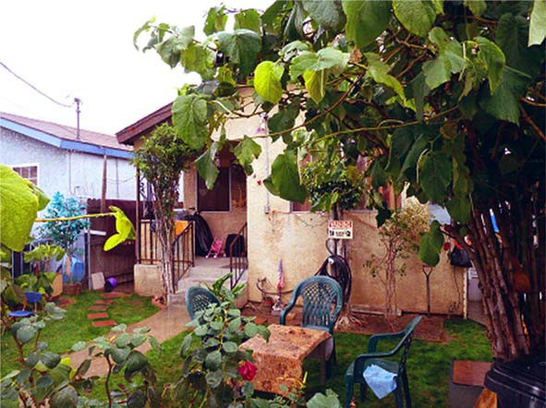

Figure 1. Personalization and heavy usage of frontyard in Boyle Heights, LA. Source: Albert Lopez, 2011.
between structure vs. agency, diluting vs. celebrating ethno-racial differences, and oppres- sive vs. liberating urban design and community-building practices.
Reﬂections derived from theoretical and empirical work on Latina/o communities in Southern California prompt me to theoretically scrutinize and problematize Latino New Urbanism. Through a literature review, interviews of scholars and advocates, observation of community dynamics, and participation at the ﬁve LNU Dialogues and two LNU major conferences in Southern California between 2003 and 2005, I critically explore potential discriminatory and essentializing risks that surround the use of the concept and its implications in practice. I claim that an analysis of the advantages and disadvantages of LNU, free from the advocacy- and design-oriented euphoria that drove its rise in popu- larity, is relevant in times of economic recession and heated debates about immigration and multicultural, urban policy making.
I offer an alternate notion of multiple and evolving Latina/o urbanisms, or even more generally, ethnurbanisms. Although this notion complicates urban design, policy making, planning and development, it also makes them more responsive to our intercultural, multi-ethnic urban conditions in fundamental ways. Since Latina/os and immigrants from Latin America are signiﬁcant components of the population growth and demographics in Los Angeles, the Southwest and other areas of the country, this reﬂection should prove valuable to professionals and policymakers that must serve these or similarly diverse/ diversifying communities.

The evolution of LNU in theory and practice
Background
Extensive literature has revealed major ﬂaws in the patterns of (sub)urbanization in Southern California (Soja 2000, Pastor 2001, Dear and Dahmann 2008). As urban pundits warned a few years ago, metropolitan sprawl has ‘hit the wall’ in the ﬁve-county South- land region (Wolch et al. 2004). Meeting the needs of the existing population of nearly

18 million people (US Census 2010) has already proved vexing: water and energy resources are under great strain, transportation infrastructure continues to decline, con- cerns over environmental pollution and environmental justice grow, and the shortage of affordable housing appears permanent.³ Moreover, residents themselves have grown increasingly frustrated by the extended commute times, lack of pedestrian friendly spaces, limited public amenities, and the sense of atomization and isolation that metropolitan sprawl has wrought.⁴
Although projections are being revised due to changes on the economic situation fol- lowing the late 2000s recession, current data show that Southern California had a 14% growth of population between 2000 and 2010 following the overall growth trends of the state. California as a whole is projected to grow from its 38 million population to almost 55 million by 2040 (SCAG 2010). This addition of approximately 9 million new inhabit- ants in the Southern California region is equivalent to adding ‘one Chicago’ to the region. This will prove actions pursued by earlier generations, including expanding the suburban fringe, importing new water and energy resources from ever farther away places, and building new freeways and shopping centers to be environmentally unsustain- able and economically unviable options to tackle the expected growth.
Since the 1980s, a signiﬁcant number of designers, planners and developers in the US have followed New Urbanism as a proposal to help address these challenges. For almost three decades, New Urbanism advocates have aimed to revitalize US cities by promoting living in compact neighborhoods with an array of different housing choices and mixed- use development, with more effective use of space, improved public transportation and pedestrian-friendly environments (Katz 1994). The proposal of such conditions directly contests the practices of divisive highways and mono-functional built elements that appealed to the far-ﬂung urban model of the twentieth century – a utopia for adherents to the policies of the Athens Charter, an ‘autopia’ for later critics such as Reyner Banham (Banham 1971). This model is largely regarded as a prime example of anti-urbanism



Figure 2. Large nativity scene celebrating Christmas in East LA’s frontyard. Source: Albert Lopez, 2011.

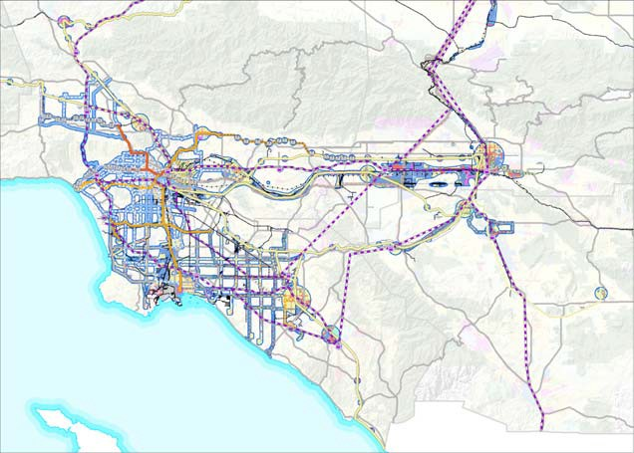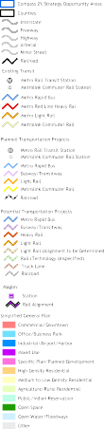
Figure 3. Compass 2% strategy in urbanized areas in Southern California. Source: Available from: http://www.compassblueprint.org/ﬁles/region-urbanarea.pdf [Accessed 27 February 2011].

(Beauregard 1993) as well as a framework that aids in the alienation of class and race groups through distance as well as physical boundary-making (Irazábal and Farhat 2008, Diaz 1995, Villa 2000).
NU instead advocates for the attainment of greater environmental sustainability, reduc- tion of sprawl, more efﬁcient and accessible mobility, and spatial arrangements that improve opportunities for the creation of sense of place and community through expanded choices for people of all economic strata (Talen 1999, 2005). While many NU projects have taken place at the suburban fringe, others are situated in urbanized commu- nities in close proximity to job and transit centers, retail activity and recreational ameni- ties. Such examples have been aimed at the renewal of numerous urban centers that have depreciated since their initial periods of development. Examples of this new urban sensi- bility are reﬂected in high proﬁle development projects in downtowns of Southland cities such as Los Angeles, Pasadena and Long Beach.
New Urbanism, however, has received great criticism. It has been accused of being elitist, formalistic, and environmental deterministic (Ellis 2002, Day 2003). More tren- chantly, it is argued that it fails to accomplish spatial equity; many NU developments increase social segregation and function as exclusive enclaves for residents and guests (Webster 2002, Vanderbeek and Irazábal 2005). Although New Urbanists have expressed high hopes of serving the disadvantaged, in practice they have done more to suppress cultural differences, reduce social diversity, serve the interests of developers, enable sprawl and reduce housing affordability and public housing (Vanderbeek and Irazábal 2005, p. 47; Al-Hindi and Staddon 1997, Till 1993, Pyatok 2000, Zimmerman 2001,
Grant 2006, González and Lejano 2009).
A critical aspect of the problem has been that advocates and practitioners of NU have largely ignored a central demographic dynamic to understand the Southland population and its continued growth. Today, in Southern California, Latina/os already are the larger

demographic group at 45%, followed by non-Hispanic Whites at 34%.⁵ An even higher percentage of 49% of San Bernardino residents and 48% of Los Angeles County resi- dents are Latina/o (US Census Bureau 2010). Every one of Southern California region’s 190 cities has been transformed in some way by the immigration from Mexico and other Latin American countries, as well as by the larger number of newer generations of native-born Latina/os. Thus, it is important to understand the role of cultural speciﬁcities in conﬁguring urban patterns and incorporating diverse cultures, incomes and ethnicities to achieve inclusive urban spaces (Irazábal 2011, Londoño 2010). Southern California is also facing growth challenges, with the projected growth of 30% adding up to a popula- tion of 24 million within the next two decades, including a larger share of foreign-born and minoritized residents (SCAG 2007, 2010).
This NU omission is more than a statistical oversight. If retroﬁtted and new develop- ment projects do not attend to speciﬁc class and ethnic needs and the ways in which intended users, and Latina/os in particular, utilize domestic and urban spaces, their effec- tiveness would be limited. Greater knowledge about how foreign-born and Latina/o popu- lation impact, use and demand urban goods and services is especially important in California and the Southwest, where planners and policy makers face great challenges in meeting the needs and expectations of these populations (Rocco 1996, Myers and Pitkin 2001). Building practices in the state and the region, however, are not responding effec- tively to these challenges. They continue to create suburban sprawling patterns of growth with negative consequences for the environment and the quality of community life (Talen 1999, Day 2003).

Genealogy of Latino New Urbanism
Latino New Urbanism (LNU) emerged in response to these dual lacunae – the unsustain- ability of sprawling development patterns and the insensitivity of NU towards multiculturalism – by explicitly examining the ways in which ethnic identity and tradi- tions shape city-making practices, urban preferences and lifestyles of Latina/os. The assumptions behind LNU are that Latina/os have a culturally driven preference for living more compactly and in multi-generational households, relying more on public transporta- tion and socializing in public spaces (Mendez 2005); and that these are lifestyle patterns that can nurture more sustainable cities can be adopted by other ethnic groups and sup- ported by design, planning and developmental practices.
For a long time, it has been observed that Latina/os in the Southland have transformed the uses and meanings of front yards, sidewalks, streets and parks in manners that are differ- ent from Anglo Americans’ culturally-driven preferences (Rojas 1991, Loukatous-Sideris 2002). Many Latina/os and Latin American immigrants in Los Angeles shape their built environment by reinterpreting and syncretizing Latin American traditional urban and hous- ing typologies. For example, one can note compact, mixed-use urban blocks, often with some retail attached; single and multi-family housing aligned to the streets, often with inner courtyards or re-purposed driveways; well-contained public spaces acting as plazas or open markets where there once laid parking lots; soccer ﬁelds (futbol) where there once laid Eng- lish-style manicured parks, etc. They recreate their found spatial typologies (especially the suburban single-family detached house) into new syntheses in combination with traditional Latin American urban and housing models (Rojas 1993). By adapting many of the former Anglo neighborhoods, they are able to create spatially reorganized hybrid versions of their traditional domestic and public spaces (Davis 2000). Currently, these processes happen mostly haphazardly, and sometimes clandestinely, since some conversion practices are not

permitted by zoning and development codes (such as some additions to houses and conver- sions of garages into bedrooms or family rooms).
The conceptualization of Latino New Urbanism currently draws from three main con- nected scholarly interventions. The ﬁrst is the work of James Rojas, an urban planner whose 1991 masters thesis at MIT, ‘The Enacted Environment: The Creation of ‘Place’ by Mexi- cans and Mexican Americans in East Los Angeles’, laid much of the groundwork for future conceptualizations of LNU. Based on extensive living experience and ﬁeldwork in East Los Angeles, Rojas argued that the increasing numbers of Latina/o immigrants and US born Mexican Americans in Los Angeles made use of urban space in ways distinct from other Angelinos. Traditional design and usage of homes and cities in Latin America (and speciﬁ- cally in Mexico) differs physically and socially from the American suburb, thus the urban living practices of Latina/os in the US have reshaped the urban environment of cities such as Los Angeles. Rojas demonstrated that in heavily Latina/o East Los Angeles, the use of residential streets and front yards for multiple social and recreational purposes differed markedly from the use of those areas in other non-Latina/o single-family dwelling neigh- borhoods (Rojas 1991, 1993). However, as Rojas’ thesis and activist work claim, a lack of understanding of this type of urbanism prevents municipal land use policies from meeting the spatial needs of many Latina/o communities in Los Angeles, which today constitute nearly half of the county’s population (US Census Bureau 2010).
A second important inﬂuence on the idea of Latino New Urbanism comes from Dowell Myers’ award-winning journal article in the American Planning Association Jour- nal (2001), ‘Demographic Futures as a Guide to Planning: California’s Latina/os and the Compact City’. His study argued that two-thirds of the 15 million people of projected growth in California between 2000 and 2020 would be Latina/o. In Los Angeles, where an acute housing shortage is present, these new people will face enormous challenges in ﬁnding affordable housing. Yet, according to Myers, “the Latino population … has a pro- pensity for lifestyles that are compatible with compact cities” (2001, p. 389). He based this assertion on micro-data samples from the US Census 1990, comparing Latina/o and non-Latina/o residents of California across three key indicators: mean persons per house- hold, percentage of households living in apartments, and percentage of ‘compact’ com- muters. Myers used the data to determine whether Latina/os across the spectrum of income levels lived in larger households, used more apartments, and were more likely to be public transit users, use bicycles or walk between home and work more frequently than non-Latina/os. He concluded that, regardless of income, the identiﬁed indicators proved Latina/os engaged in compact city-associated activities more than non-Latina/os. Myers also determined that Latina/os, regardless of class, have a much higher number of mean persons per household than any other ethnic or racial group. Accordingly, since lar- ger households require fewer separate housing units to accommodate the same size popu- lation, this indicator demonstrates a compatibility with compact living. Working with 2010 data, Myers has maintained that the relations he demonstrated in his 2001 article are holding true. He put into perspective that the large number of settled immigrants who had been in the US for more than 30 years in the 1990 data, have now spent 50 years of their lives in the US, and have multiple native-born children over the age of 25 (Myers, personal interview, 4 January 2011). Despite this critical work, the relative manner in which the factors of economic affordability and cultural preferences play out vis-à-vis each other in Latina/os’ urban lifestyles and how their relationship transform over an extended stay in the US or across several generations have not been fully elucidated. Myers’ provocative ﬁndings need to be further tested using qualitative as well as quanti- tative data.

The ﬁnal inﬂuence on the conceptualization of LNU comes from Michael Mendez’s 2003 thesis for the Master of City Planning at MIT, ‘Latino Lifestyle and the New Urbanism: Synergy against Sprawl’. Mendez later summarized his claims in a 2005 scholarly journal article, ‘Latino New Urbanism: Building on Cultural Preferences’, published in Opolis: An International Journal of Suburban and Metropolitan Studies. Building on the work of Rojas and Myers, and using 1990 census data to generalize Latina/o preferences (compared to non-Latina/os) in the Southland for living in apartments, larger household sizes (4.7 people per household), and compact commuting, Mendez engaged the policy-making arena. He argued that such preferences create models for housing that change the urban development status quo while targeting middle-class households in new suburban development, as well as ‘Generation ñ’ (upwardly mobile, yet culturally rooted Chicanos/ Latina/os). Mendez comparatively discussed the impacts on the environment and sustainability of the region if other racial and ethnic groups, especially non-Hispanic Whites, were to adopt these practices of compact living – what some call a trajectory of “reversed assimilation” (Mendez 2005, p. 40). Ultimately, Men- dez (2005, p. 33) claimed, “the development and advancement of compact cities in California may be dependent on the ability of policy makers to sustain and support the Latino lifestyle”. In a strategic political move and in accordance to his involvement in the California legislature, Mendez linked the well-established planning and design move- ment of New Urbanism to that of Latino urbanism, coining the new term ‘Latino New Urbanism’. By presenting this move as a strategy for ethnoracial/cultural integration, he hoped to make it marketable to a broader audience, rather than relegating it to the narrow niche of ‘Latino urbanism’, or even worse – ‘low-income urbanism’.
Inspired by these ideas, the Transportation and Land Use Collaborative (TLUC) of Southern California, a non-proﬁt advocacy organization committed to promoting efﬁcient land use co-ordinated with new and existing transportation infrastructure, embraced and took a leading role in advocacy for planners, designers, developers and public ofﬁcials to incorporate the Latino New Urbanism paradigm into their practices. Between 2003 and 2005, TLUC developed a series of ﬁve ‘Diálogos’ (dialogues or middle-sized confer- ences) and two major conferences in different cities of Southern California to educate and engage the public on Latino New Urbanism ideas in areas such as housing, educa- tion, health, and open-space and recreation. The intention of these workshops and confer- ences was to promote development awareness and public policy formulation that were consistent with Latino New Urbanism. The effort of this organization and its collabora- tors won the Advocacy Award of the California Chapter of the American Planning Asso- ciation in 2004.⁶ This regional attention and several media news items gave the LNU movement prominence (Villaraigosa 2003, El Nasser 2005, The Planning Report 2006, McKone 2010, 2011, Razzetti 2011). By successful advocacy and mobilization efforts, the TLUC and its collaborators made progress in strategically linking Latino New Urban- ism to New Urbanism, mainstreaming Latina/o urbanism ideas and the pleas of urban Latina/o communities in the process.
Since 2003, Latino New Urbanism has often been proposed as a way to redress New Urbanism’s failures to acknowledge and respond to the ethnic needs and lifestyles of US Latina/os in the built environment, as well as overcome NU failures to deliver on its promise of socio-economic inclusivity. It is claimed that, by tapping into the greater propensity of compact living and transit use of Latina/os in California compared to the population at large, LNU presents a sustainable development alternative to the suburban, low-density patterns that have been prevalent in the state and country for decades (Méndez 2003, 2005, TLUC 2004, 2005). Design professionals, developers, advocacy

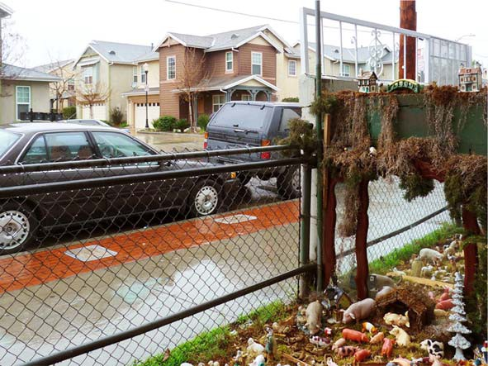

Figure 4. Nativity scenes in a frontyard in LA, while recently built NU-styled houses with porches are shown in the background. Source: Albert Lopez, 2011.

groups, and policy-making ofﬁcials started to pay closer attention to LNU ideas both in California and the rest of the country. The two national Congresses of New Urbanism in 2004 and 2005 included sessions on LNU, Henry Cisneros – the ﬁrst Latino to serve as mayor of a major US city, San Antonio, and ex-Secretary of Housing and Urban Devel- opment – called LNU ‘a revolution’ (Cisneros 2005), and Antonio Villaraigosa, mayor of Los Angeles, also praised it (Villaraigosa 2003).

Problematizing Latino New Urbanism
I acknowledge the potential of LNU for conceiving Latina/o city-making practices and spatial arrangements as policy and development alternatives with practical, cost-effective and culturally-sensitive solutions to the urban challenges faced today in the LA region and beyond. However, I claim that an open-ended, theoretical and empirical analysis of the advantages and disadvantages of LNU, free from the advocacy- and design-oriented euphoria that drove its rise in popularity, is both timely and beneﬁcial, particularly in a difﬁcult economic urban recovery period in which we should press for more sustainable and equitable development strategies to follow during the coming years.
Reﬂections derived from my theoretical and empirical work on Latina/os in Southern California prompt me to theoretically scrutinize and problematize Latino New Urbanism to critically explore potential discriminatory and essentializing risks that surround the use of the concept and its implications in practice. I move beyond the extensive literature that criticizes New Urbanism, claiming that it is physically deterministic, too formalistic and reliant on thematization, a barrier rather than promoter of mixed-income and socially diverse neighborhoods (Marcuse 2000, Harvey 2001, González and Lejano 2009, Garde 2010). Not only is this homogeneity in the name of community/order elitist, it is also ethnocentrist, reinforcing White privilege with its assumptions of appropriate cultural preferences, family sizes and income levels, often leading to large tracts of largely unaf-

fordable and homogenous houses (Marcuse 2000, Al-Hindi 2001). This assumptive nature of many planners and designers points directly to the ﬂaws in their top-down design approaches (Ochoa and Ochoa 2005). I explore whether Latino New Urbanism can be intentionally or unintentionally used to mask some structural social problems that Latina/ os face in the US. These include the possibility that it could be used for romanticizing poverty, justifying overcrowding, ‘orientalizing’, ‘exotisizing’ or ‘othering’ Latina/os and Latina/o-based building practices, ‘domesticating’ Latina/os, balkanizing multi-ethnic societies, excluding others and alienating potential coalition allies, and producing stereo- typical and/or inﬂexible designs that do not accommodate diverse and diversifying Lati- nidades and the rapidly changing Latina/o demographics.

Structure vs. agency
In order to understand the complex dynamics of ethnic formation, reproduction, resistance and assimilation at play, it is important to analyze, on the one hand, the historical, cul- tural, economic and regulatory forces that shape these processes – the structure – and the acts that emerge in response to them – the agency of people – on the other. This helps to explain whether what has been identiﬁed as Latina/o lifestyle choices are enforced by the limited economic resources of immigrants and minoritized groups – embedded within structural conditions of discrimination based on ethnorace, class, origin, language, etc. – or are a matter of choice, and accordingly, what factors and how can they be considered as basis for future policy making and development in Southern California and the coun- try.
Masking Latina/o poverty, overcrowding and overall deﬁcient access to urban services and opportunities not only would perpetuate the structural racism (Irazábal and Punja 2009, Pulido 2000) that causes these conditions in the ﬁrst place. It would make it harder to identify it and hence to overcome it.

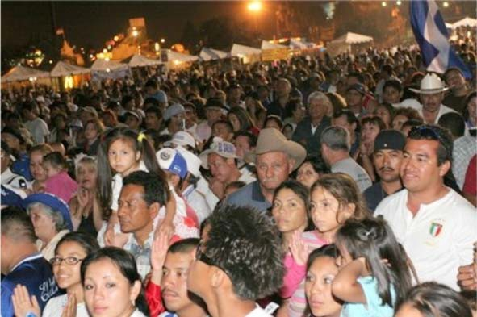

Figure 5. Religious Salvadorian event at Exposition Park, Los Angeles. Latina/os of different origins share a larger propensity to use public spaces for recreational and religious events than non-Hispanic Whites.

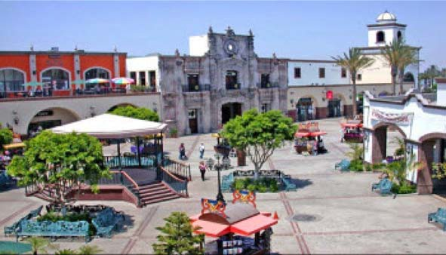

Figure 6. Outdoor space surrounded by Mexican-themed architecture in Plaza Mexico, California. Source: Available from: http://plazamexico.com/ [Accessed 21 February 2010].

Romanticizing poverty?
As the proponents of LNU praise the compact living patterns of many Latina/os, it is important to question whether or not LNU pundits are romanticizing the effects of the lack of economic resources that are partially driving some of these practices of efﬁcient use of land, conversion and extension of Victorian-era single-family houses, and adaptive reuse of garage and driveway space. This situation is salient in California, and particu- larly in the greater Los Angeles region. Historically, California has had substantially higher poverty than the rest of the nation: 16.1% vs. 12% (Reed 2006, p. 1).⁷ Poverty among Latina/os and African Americans is signiﬁcantly higher than the state’s level, with percentages of 22.8% and 22.1%, respectively (Public Policy Institute of California (PPIC) 2011). Poverty levels are reﬂective of a grossly uneven distribution of income. In 2010, Latina/o families were 120% more likely to have an income under $15,000 than non-Hispanic Whites in Los Angeles. This is further reﬂected when comparing median household incomes between Latinos and non-Hispanic Whites, which are $44,989 and
$71,768, respectively (ACS 2010a). Within the Latina/o demographic, however, poverty was also drastically divided. US-born Latina/os’ poverty level is substantially lower than among foreign-born Latina/os (14% vs. 27%). This difference meant that non-native Lati- na/os could earn, on average, only one-third of the average LA salary (Economic Round- table 2006). This division in income levels reﬂects the strong progress of Latina/os across immigrant generations (Myers, personal interview, 4 January 2011). Despite improving conditions as their length of stay in the US and their number of generations increase, there still exists a dire economic reality for Latina/os, which conditions their liv- ing arrangements and practices by their level of affordability.
On the other hand, studies have shown that the increase in afﬂuence amongst Latina/ os over time and across generations has caused a tendency to assimilate consumptive patterns (in housing and vehicles) and living styles (driving, commuting) of mainstream American citizens (Rodriguez 1997, Myers 2001). In Southern California, this means moving to larger houses in car-driven suburbs. This is only partially driven by prefer- ences and the effect of the still strong mythology of the so-called ‘American Dream’ – traditionally viewed as the owning of a suburban house on a large plot covered with a

well manicured lawn (Wright 1981) – the symbol of ‘having made it’ in post-war Amer- ica. One other reason for this continued outward suburban expansion has been that the housing market did not offer much choice, as is evident in the seemingly endless growth of houses that emerged within the last 20 years alongside the main freeways connecting Los Angeles county to Orange and San Bernardino counties (Painter et al. 2001). Given other housing choices, however, this explosive development pattern may not have to con- tinue. According to a PPIC’s 2004 ‘Special Survey on Californians and their Housing’, 70% of Californians want to live in a single-family detached home, yet over half (53%) of all respondents would prefer to live in a smaller dwelling if it meant that they would have a smaller commutes (Baldassare 2004, p. vii). Combined with expressed desires for shorter commutes, walking-distance amenities, and access to public transportation, these preferences strongly point to the desire for a more compact urban model. These prefer- ences are higher amongst Latina/os than non-Hispanic Whites, with 52% vs. 46% desir- ing mixed-use neighborhoods and 39% vs. 24% desiring to live in high-density urban environments (Mendez 2005, p. 41, based on PPIC 2002 data).
With regard to satisfaction with the public transit available for commuting to work, Latinos (29%) are more likely than other racial/ethnic groups to say they are very satis- ﬁed. Yet, satisfaction with public transit declines with age, education, homeownership and income (Baldassare 2004, p. 3), and Latina/os rank low along those indicators. Sup- port for the state government’s role in promoting smart growth – integrated planning of housing and land use that would encourage more efﬁcient commuting patterns – is much higher among Latinos (68%) than among Blacks (59%), Asians (59%) and Whites (55%). Yet, this support also declines with age, homeownership, length of residence and income (Baldassare 2004, p. 15). In some aspects, the fact that the preference for residen- tial-only neighborhoods increases with income and is higher among Whites (53%) than among Latina/os (44%), Blacks (44%) and Asians (39%) (Baldassare 2004, p. 11) not only demonstrates that class plays a role, but also that other ethnoracial groups have simi- lar or higher preferences for compact-living arrangements than Latina/os.

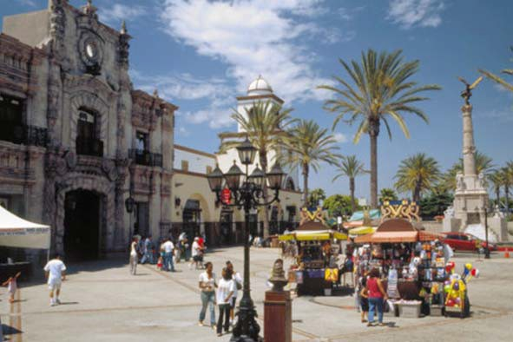

Figure 7. Plaza Mexico shopping mall depicting replicas of Guadalajara’s Palace of Jalisco (façade) and Mexico City’s Angel of Independence. Source: Available from: http://plazamexico. com/ [Accessed 21 February 2010].

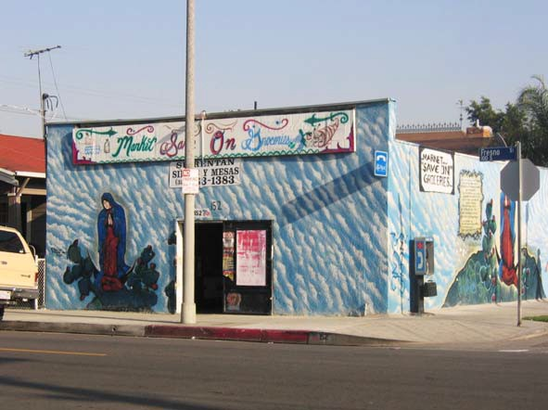

Figure 8. Local market on LA’s Fresno Street depicting a Virgin of Guadalupe mural. Aside from serving as Latina/o marker and sign of faith, these murals prevent grafﬁti vandalizing. Source: Clara Irazábal, 2009.

Lower incomes are associated with a greater likelihood of living in crowded hous- ing (Myers et al. 1996). Yet, low-income immigrants are substantially less likely to receive housing assistance, as many immigrants are non-citizens and ineligible for fed- eral assistance. Given the conditions faced by numerous immigrants who live compactly in or near major urban nodes of Los Angeles, as well as the price of housing in urban areas, the standards of living for many Latina/os are considerably lower. In 2005, Lati- na/o homeownership stood at 38% compared to 59% among Whites, a disproportion due to lower income levels as well as the ineligibility to receive the necessary loans for home acquirement (Guerra et al. 2006, p. 1). In addition, a tremendous increase in home prices and inner city rents (until the recession) combined with a relatively low increase in incomes meant that the average Latina/o family was spending almost half of its income on housing when the advised maximum is up to 30% of income (Guerra et al. 2006, p. 1). Little money remained for the basic necessities of living, and even less for the improvement of their living spaces, either by moving up from smaller housing units to larger ones to accommodate growing families, or through investment in their existing properties through proper renovation and addition. Combined with inﬂexible legal and zoning policies, a large amount of the extending of living space through renovation and addition has remained clandestine, and its construction repre- sents at times a dearth in quality materials or code-compliant design, posing high risks to the inhabitants.
Justifying overcrowding?
As mentioned earlier, the average Latina/o family spends nearly half of its income on housing. This is referred to as ‘severe cost-burden’ by housing analysts. Basic needs for transportation, child-care, education and health – even food – are often sacriﬁced to pay

rent or mortgage. For a large percentage of apartment dwellers, more than half of all rent- ers in the Los Angeles area are paying 30% or more of their income on housing. Thus, many Latina/o families are forced to live in housing units that do not accommodate the size of their larger families, experiencing less square footage per person, more people per room, and housing of a generally more shabby condition than their non-Latina/o counter- parts (except Blacks).
Relying on data from the American Housing Survey for the US in 2003, Vargas-Ramos (2005, p. 4) found that 10% of Latina/os vs. 2% of households in the overall population lived in crowded housing conditions, deﬁned as more than one person living in a room. The situation was even worse in homes that were severely overcrowded, deﬁned as more than 1.5 persons per room – more than six times as many Latina/os (2.5%) lived in severely overcrowded homes compared to the population overall (0.4%). Estimates for Los Angeles put half of Latina/o households averaging more than one per- son per room (Guerra et al. 2006, p. 9). In addition to their larger number of children per household on average, it is not unusual to have extended family members or even unre- lated individuals living within the dwelling in order to contribute to the overall household income. Individuals and families often double- or triple-up with non-related individuals or families to be able to afford housing. According to the American Community Survey (ACS) 3-year estimate 2008–2010, Latina/o households in the Los Angeles metropolitan area have an average household size of 3.96, as opposed to 2.52 of their non-Latina/o counterparts. Similarly, 82% of the households are family households, with 50% of those having children under the age of 18; this compares to the non-Latina/o population in Los Angeles, where 61% of the households are family households, with only 25% of them having children under the age of 18. A total of 16% of Latina/o households have other relatives while 7.2% include non-relatives, whereas the percentage of non-Latina/o house- holds having extended family members is only 8% (ACS 2010b). Ironically, this challenging living arrangement has prevented some Latina/o families from losing their

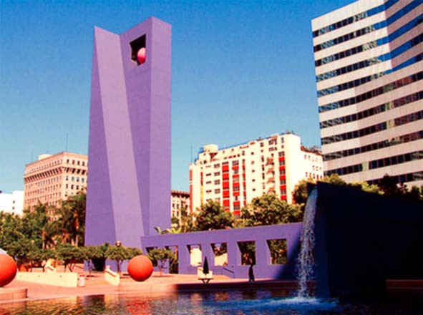

Figure 9. Modern Mexican design motifs and colors at Pershing Square, designed by architect Ricardo Legorreta. Source: Available from: laist.com [Accessed 25 February 2011].

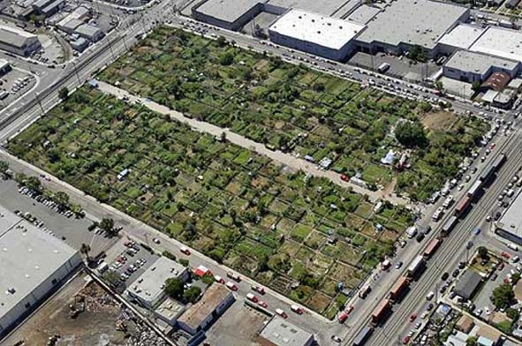

Figure 10. The South Central Farm in LA site and the story of how the farmers made it ﬂourish had become a symbol of hope to many. Source: Javier Manzano, Los Angeles Times, 13 June 2006.

homes during the current economic crisis; there are more people employed in a house- hold that are able to pay for mortgages or rents when a contributing member becomes unemployed (Myers, personal interview, 4 January 2011). Nonetheless, this has not pre- vented a greater net loss among Latina/os as one of the groups (together with Blacks) most impacted by the foreclosure crisis (Bocian et al. 2010).
Despite an apparent recent drop in overcrowding within the Los Angeles area within the period of 2000–2007 (Ong and Ong 2009), the recent collapse in construction follow- ing this period combined with current population projections may see a serious reversal in this trend. Overcrowding issues and the decline in living standards will continue unless substantial action to address those conditions is taken. Together with the current housing deﬁcit, the expected growth within the next 20 years of 600,000 in Los Angeles County⁸ (SCAG 2007, 2011) represents a demand for housing and infrastructure in the region that must be addressed to avoid a growing crisis of urban congestion and poverty. Housing overcrowding together with closing of public schools has contributed to school over- crowding and the burdening of the city’s parks and infrastructure. Yet, the areas most impacted by school overcrowding and heavily populated by Latina/os – Central and South Los Angeles, East San Fernando Valley, and San Pedro – have seen little new housing or infrastructure construction in the past decade. This is consistent with the belief of a majority of Californians (55%) that low-income and minoritized neighborhoods are less likely than other neighborhoods to attract developers to build new single-family homes (Baldassare 2004, p. 12).
Overcrowding issues will probably be compounded in the Latina/o community by the ongoing foreclosure crisis. Although ofﬁcial statistics have shown that the majority of families who have lost their homes in past years have been non-Hispanic Whites, it must be noted that non-Whites have been disproportionately affected relative to their mortgage originations (Bocian et al. 2010). In addition, the possibility of future foreclosures is a clear and present danger with 21.4% of Latina/o borrowers being at ‘imminent’ risk of foreclosure, compared with only 14.8% of their non-Hispanic White counterparts (Bocian

et al. 2010). In addition, by more than a two-to-one margin, Californians are more likely to think that buyers in low-income and minoritized neighborhoods have a more difﬁcult time qualifying for loans than in other neighborhoods, with Blacks (74%), Latinos (62%), and Asians (60%) much more likely than Whites (48%) to say that it is relatively harder for buyers in low-income and minoritized neighborhoods. This belief is strongest among lower-income residents and among renters (Baldassare 2004, p. 12).
According to Janet Murguía, President and CEO of the National Council of La Raza, studies have estimated that within the years 2009–2012 nearly 1.3 million Latina/o fami- lies will have lost their homes to foreclosure (Bowdler et al. 2010). This growing issue has already contributed to numerous adaptive moves, such as downsizing to small apart- ments and the doubling up of families, and in addition has added to the growth of illegal garage conversions, particularly in the greater Los Angeles area (Bowdler et al. 2010, Rojas, personal comm., 13 February 2011). As the effects of the crisis continue to be felt throughout the decade, the dream of the single family home and sizeable manicured plot of land will most probably be held with skepticism by future generations of Latina/os who will grow up through the crisis. Further estimates show that the 2009–2012 period will have seen a loss of over $177 billion from the Latina/o community in the US, much of this centered in areas of high foreclosure rates (Bocian et al. 2010).
This loss in capital that otherwise could have contributed to local communities is causing severe psychological effects amongst Latina/os. More than 36% of Latina/o homeowners feel that they are in danger of losing their homes, a number that is signiﬁ- cantly higher at 53% amongst the foreign-born population (López et al. 2009, Bowdler et al. 2010). This uncertainty has been felt throughout the entire Latina/o community, lowering consumer conﬁdence and therefore hurting local businesses. In addition, these difﬁcult economic times are negatively affecting the Latina/o community as a whole, with ﬁnancial woes causing stress amongst working age adults, behavioral issues amongst Latina/o youths affected by domestic stress, and interfamilial issues as informal loans and

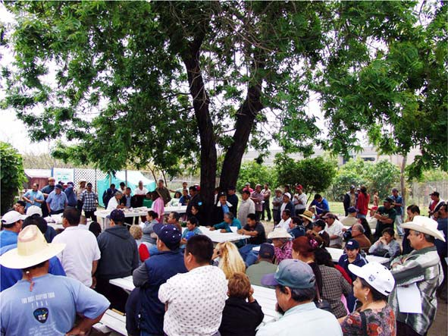

Figure 11. Community meeting at the South Central Farm. Source: Wikipedia commons, 25 February 2011.

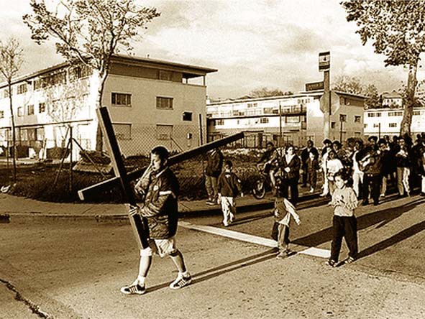

Figure 12. Religious procession in front of Aliso Village in LA. Circa 1980. Source: Available from: laeastside.com

the sharing of homes has stretched family ties in the most awkward of circumstances. Some analysts argue that the latter circumstances are evidence of strong communal and familial bond amongst Latina/os, something weaker within Anglo communities and an important factor in preventing higher foreclosure rates amongst Latina/os (Myers, per- sonal interview, 4 January 2011, López et al. 2009, Bowdler et al. 2010). With this major tremble in the ‘American Dream’, a number of Latina/os are now searching for other alternatives in housing, often closer to their jobs or in lower-priced urban neighborhoods. However, a lack of construction in these areas has caused further overcrowding in exist- ing units.
According to California’s Department of Housing and Community Development (DHCD), the rate of building in the state does not meet the concurrent population growth. In the 2000s, residential new construction permits averaged 150,000/year, behind the state’s annual average need of 220,000 (DHCD 2011, p. 3). Furthermore, residential per- mits plummeted in 2009 to over 35,000 and have not recovered much, worsening the state’s housing deﬁcit and compromising its economic recovery (DHCD 2011, p. 4). Eco- nomic factors, e.g. a high vacancy rate in the urban periphery, many units resulting from foreclosures or few buyers following the crisis, combined with changing values is shifting people’s preferences and promoting the location of new housing in or close to existing urban centers. The projected population growth will probably exacerbate the situation. Foreseeing this, the Southern California Association of Governments (SCAG) has pro- posed the Compass Blueprint, a plan aimed at increasing residents’ mobility, livability, prosperity and sustainability (SCAG 2004). One of the key parts of this proposal is the ‘2% strategy’, which shows that the projected growth in the area could be accommodated within and around current existing urban centers and transportation corridors, needing to alter only 2% of the currently urbanized land use. If implemented, it would be a major reversal of sprawl trends, and could mean a 10% decrease in total vehicle miles traveled, a 1.5% vacancy rate for owner-occupied units, as well as a 5% vacancy rate for renter-

occupied units – signs of a robust housing market (SCAG 2004). The plan would also avoid a lot of NIMBY-type resistance originating in the suburbs, as it would not advocate for their transformation. This plan for a denser Southland region would begin to address the housing cost issue that grew partly out of the housing deﬁcit of the previous two dec- ades, reducing by up to 20% the severe housing costs spent by the region’s poorest resi- dents (SCAG 2004). Needless to say, with the majority of Los Angeles’s residents below the poverty line coming from minoritized backgrounds, these people stand to beneﬁt the most from a denser residential model with more affordable housing units embedded in multi-modal transportation systems.

Diluting vs. celebrating ethnoracial differences
Domesticating Latina/os?
Mendez (2005, p. 40) urged for the planning of more compact living spaces to be “broadly acceptable” to include the participation and inclusion of non-Latina/os. In an effort to make a more ethnoracially and culturally integrated urban environment, he advo- cated a form of development that would appeal to a large audience, encouraging a mutual exchange of living practices, while also strongly urging for non-Latina/os to “adopt a por- tion of the compact lifestyle of Latinos”. He encouraged an urbanizing pattern that would prevent the growth of a divided city. Ethnoracial integration would be promoted by the planned exchange of living practices as well as the adoption of New Urbanism practices of compact living, reliance on public transportation (promoting further social interaction), as well as the utilization of semi-public spaces such as porches and balconies fostering a closer sense of community.
According to Mendez, Rojas and others, porches serve as hubs for social activities. As a Latina/o colloquial architecture, the informal practice of converting and extending

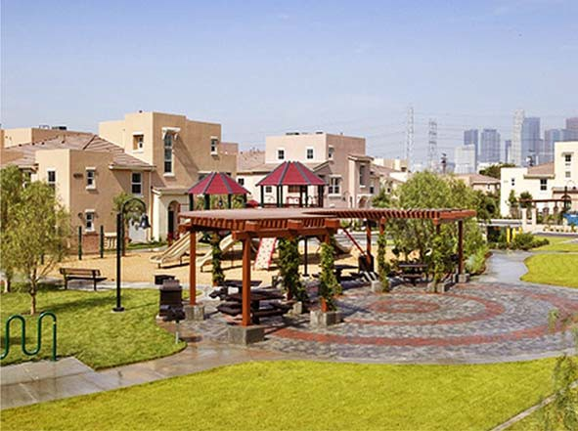
Figure 13. Pueblo del Sol replaced Aliso Village’s public housing buildings with NU-styled development with a Latina/o-ish ﬂavor. Source: McCormack Baron Salazar’s photostream ﬂickr. com [Accessed 25 February 2011].

porches in East Los Angeles has aided in the promotion of tighter-knit communities, and could therefore act as a tool to promote more uniﬁed neighborhoods with residents of mixed ancestry. The question that arises out of this planning strategy, however, is whether the adoption of a New Urbanist plan loosely modeled after the East Los Angeles arche- type will have the effect of building a community that will reinforce the Latinidad of its residents or will, as other New Urbanist projects have been accused of, dissolve ethnic traits and indeed the individuality of its residents by forcing them to conform to the American traditional suburban neighborhood through strict social and aesthetics code enforcements (Marcuse 2000). The self-containment of these communities and the emphasis on ‘community’ itself may prove to be the efforts of planners to quell any per- ceived social disorder through a spatial determinism that promotes surveillance (Harvey 2001).
A portion of LNU schemes in Southern California denote longing or nostalgia on behalf of their designers for a pattern of living that historically did not originate in the Latina/o communities of the region. The insular nature of a layout emphasizing small single family homes closely placed together, semi-private porches and self-contained rec- reation and community centers, typiﬁed by developments such as Pueblo del Sol, in Boyle Heights, is actually more akin to both a small US town archetype and newer gated communities. This conservative, middle-class small town tastes appear similar enough to the current ‘enacted environment’ mentioned in Rojas’s thesis (which should be regarded as a 60-year-long organic process of transformation and face-lifting of an Anglo arche- type). Thus, some planners have decided to apply it in a top-down fashion to a vibrant and rapidly transforming ethnic community. Although probably not the intention of some of its creators and promoters, the development of such a stereotyped, rigid and top-down LNU aesthetics may turn out to be, in practice, an attempt to domesticate Latina/os, mak- ing them conform to what are conceived to be normative urban lifestyles and patterns.

Balkanizing multi-ethnic societies?
The large Mexican-American community that inhabits the ﬂatlands east of the Los Angeles River has largely inspired LNU architectural and communal concepts. Although Mexican Americans account for a vast majority of the Southland Latina/o population, the signiﬁcant number of Central Americans, and to a lesser extent South Americans and Caribbean people, must also be taken into account when analyzing variances in their liv- ing practices and community structures. Although the single-family detached home is common throughout Latina/o communities in Los Angeles, many Latina/os have settled and formed communities within the old apartment blocks of the MacArthur Park/West- lake district as well as the Wilshire corridor, or have settled into post-war ranch-style homes and ‘dingbat’ apartments of the San Fernando Valley. The diversity of housing typologies and living practices among Latina/os in the Southern California region pre- vents deﬁning their way of life and the spaces they occupy solely considering a speciﬁc living pattern amongst a speciﬁc group of Latina/os. Therefore, it is important to further account for the wider variety of urban practices of the diverse and diversifying Latina/o make ups. By doing so, the social mixing envisioned in LNU work will serve not only to reduce the ethnic divisions between Latina/os and non-Latina/os, but also amongst the wide variety of different and at times conﬂicting Latina/o identities.
The type of reconceptualization of urban growth strategies that need to take place in Southern California ought to be responsive to its ethnic diversity, which can only be explored in practice via neighborhood planning efforts that genuinely take the time to

capture such complexity. Not only are Latina/os of diverse cultural origin, but they are also part of a region populated with a large and diverse Asian population, and a sizeable well-rooted African American population. In addition, it must be remembered that native Latina/os are in turn descended from an equally variegated society made up of Indige- nous, European, African, Asian and Middle-Eastern backgrounds.

Othering Latina/o urban environments?
While the core principle of Latino New Urbanism is very much a celebration of ethnora- cial identity, its practice can have the effect of further segregating Latina/os. A narrow vision of what the institutionalization of LNU urban practices could architecturally and culturally mean may place some subcultural groups among Latina/os into spatial and infrastructural contexts that are alien to them. The easiest means of marking LNU devel- opments arises from an over-simpliﬁcation of what is perceived to be ‘Latina/o’ architec- ture. This aesthetic has been roughly deﬁned as a combination of primary geometric forms, polychromy and distinct texture and materiality. Employment of these features var- ies, however, and can reﬂect either a sincere effort in creating syntheses of current and/or historic Latina/o formal and spatial environments, or a vulgarization of the most basic aspects of these features. Perhaps the most noticeable of these aesthetic qualities is the polychromy or use of color. Pre-Columbian and colonial architecture are well known for their use of color, a quality that numerous designers have caught on to. In contemporary architecture, however, it has been employed with mixed results, often due to the fact that the original symbolism in color usage has been lost. In many design scenarios throughout the Southland, this has also manifested itself in the abusive use of bright colors on spatial types that have little if any connection to actual Latina/o living practice. By often utiliz- ing a primary and secondary colors-based palette, these developments are marketed toward lower-income Latina/o families with the expectation that color alone will make them feel satisfaction in their domestic environments.
In broad terms, the Latin American (and speciﬁcally the Mexican) conception of his- torical time is composed of three layers: the indigenous, the colonial, and the modern (Herzog 2001). Based on these grand categories, an essential sense of history has been a major deﬁning factor in the formation of Latina/o architecture in the US. The ﬁrst epoch, the indigenous, is typically referenced by some designers’ interpretations of the mono- lithic practices of pre-Aztec Teotihuacán or Chichen Itza, transformed and transmutated into stylistic glyphs in plaster or feathered serpents in cast resin. What signiﬁcance can such motifs hold if they are employed in public developments that will cater to an increasingly diverse and non-Mexican Latina/o community? The second epoch and most commonly utilized is the colonial, with its romantic tile roofs, bright primary and second- ary colored façades, wrought iron balustrades and window grilles. It remains a distin- guishing feature of design in Latin America, and ever since the ﬁrst decades of the twentieth century with the craze for the mission revival style, it has been a deﬁning fea- ture of the Southern California landscape (Irazábal and Farhat 2008). Use of ceramic tiles and terracotta roofs continue to be used throughout the state in non-Latina/o oriented pro- jects, but have been almost mandatory requirements in buildings and spaces that target the Latina/o demographic, such as the Plaza Mexico complex, a shopping mall in Los Angeles conceived by Korean investors for Latina/o patrons with the desire to make them feel ‘as if they were in Mexico’ (Irazábal and Gómez-Barris 2007).
Highly ornamental design is also ubiquitous, with reliance on either indigenous sym- bolism, or in the case of the neo-colonial, a high emphasis on Catholic iconography; a

frequent example being the use of La Virgen de Guadalupe in tile, mural or sculptural form (Gómez-Barris and Irazábal 2009, Irazábal and Dyrness 2010). This aesthetic is used with such popularity that designers seem to forget that Los Angeles was a colonial outpost of mud and tar roofs, alien to the glamour of the colonial capitals of the south. Furthermore, it is also forgotten that colonial architecture is the original architecture of oppression, at least for the percentage of Latina/os who are more connected to their indigenous roots rather than inﬂuenced by the Hispanic hegemony of their colonial motherland.
Finally, the third and last epoch of Latina/o cultural design pertains to the modern era. This design aesthetic, greatly inﬂuenced by the work of Mexican architect Luis Bar- ragán (one of the most esteemed of Latin American architects and often one of the very few that North American architecture students will ever hear of), has inspired large public commissions within Latina/o neighborhoods. Perhaps the most notable example in the city of Los Angeles is the design of Pershing Square by Mexican architect Ricardo Legorreta, whose work largely recalls that of Barragán’s. Clearly intended as a bridging element between the city’s business center and the Latina/o shopping district on Broad- way and Hill Street, it was designed as a symbol of the city’s growing Latinidad. Unfor- tunately, as a third possible archetype of Latina/o architecture, it is still found to be inadequate since even Barragán was primarily an architect for the wealthy of Mexico, a clientele who possessed a nostalgia for the days of the hacienda, peones and all.
These categorizations of Latina/o architecture may end up doing more damage to the Latina/o populations than good since they enable the othering, orientalizing or exotisizing of their demographic through the built environment. In addition, the ‘Mexicentrism’ in design is particularly incongruent with the identities of non-Mexican Latina/os whose spatial and formal environments developed in differing manners, either due to their respective histories/geographies or other cultural inﬂuences.

Oppressive vs. liberating urban design and community-building practices
For a revised concept of Latino New Urbanism, or indeed ethnurbanisms, it is necessary to involve the members of the community that it will affect (Ochoa and Ochoa 2005). In numerous examples of community redevelopment, the actual members of the community have been incorporated in the design process all too infrequently. Some of the New Urbanist charrette and neighborhood planning methods are not culturally sensitive and it is not transparent how community knowledge is integrated into plan making. In the recent revitalization planning of Santa Ana, California, for example, the ‘community’ was consulted, yet Gonzalez (2012) contends the process has been a charade, casting doubt to participatory practices of public-private partnerships, particularly those between some New Urbanists and cities. Ultimately, the quality and quantity of participatory methods matter (Irazábal 2005).
There are numerous examples of municipal and private forces dismantling many care- fully long-woven community structures and enterprises with little regard for the citizens who are invested in their existence. Perhaps, a most famous example is the Chavez Ravine incident were an entire barrio was demolished with the promise of being replaced by public housing designed by the renowned architect Richard Neutra. Community mem- bers were opposed to the plan because they would be transferred to a dwelling typology alien to them, where they could not plot a garden or raise animals as they were used to. In addition, they would have to pay for a housing unit (as supposed to being homeown-

ers where they were) that they could not organically adapt to their needs and likes. If this plan had not been disenfranchising enough for this community, a grotesque turn of events had the community evicted, the housing plans ditched, and the land ultimately granted to the Dodgers baseball team for a stadium (Irazábal and Farhat 2008, López II 2009).
More recent examples of this practice also exist. One of the most notorious examples of this blatant disregard for communities was the 2006 destruction of the South Central Farm, a 14-acre urban farm that served as a communal focal point for one of the most impoverished and park-poor communities in the County of Los Angeles (Irazábal and Punja 2009). Originally set aside by the Los Angeles Regional Foodbank as a ‘survival garden’ to aid the community’s dietary needs as well as providing a surplus for sale, this symbol of urban sustainability was demolished in the name of private interest. After hel- meted ofﬁcers of the Los Angeles Police Department cleared the site of resisting residents participating in civil disobedience, the site was bulldozed. Meanwhile the city’s ﬁrst Latino mayor in over 100 years, Antonio Villaraigosa, remained relatively indifferent to the plight of the people on the farm. At the end, he voiced understanding for both sides in an act of political ‘sitting on the fence’ (Irazábal and Punja 2009). After six years with the lot vacant, Ralph Horowitz, who bought the land in a back-room deal below market price, is working with Forever 21 (contributor to the Villaraigosa political machine) and the city to develop the land as a trucking center for the women’s clothing manufacturer.
Another example that occurred recently in Los Angeles was the demolition of Aliso Village. Although cut off from the city due to the construction of the East Los Angeles freeway interchange, in the last decades the involvement of community members and the local Catholic parish of Dolores Mission had ﬁnally begun the process of improving ser- vices as well as easing the conﬂict of the numerous gangs that had torn the neighborhood apart. After years of ‘barrioization’, i.e. “the formation of residentially and socially segre- gated Chicano barrios or neighborhoods” (Villa 2000, p. 4, Herzog 2004), the imposed marginalization of a community due to insensitive planning moves, divisive infrastructure layout, and neglect of city services, the neighborhood was beginning to unify through community organization. As this was being achieved, however, the Housing Authority of the City of Los Angeles abandoned Aliso Village, allowing it to be demolished against the residents’ wishes, in favor of a lower density, New Urbanist housing scheme named Pueblo del Sol. Residents were vacated after units were declared either unsafe or obsolete (Burnett-Stuart n.d.). Arguably, the construction of Pueblo del Sol, although physically superior to its predecessor after the former’s years of neglect, symbolizes a perpetuation of ‘barrioization’ of urban Latina/os, understood by Villa as a “complex of dominating social processes originating outside of the barrios” (Villa 2000, p. 4). The residents’ opin- ions did not matter by-and-large to the development envisioned, and they were given a place to live that was largely not of their choosing. In addition, of the existing 685 units that existed, only 469 were constructed to replace those demolished, with 403 being reserved for former residents (Villa 2000). The new complex had replaced a bottom-up process that could be referred to as an example of ‘barriology’, where

the practice of everyday life… manifesting alternative needs and interests from those of the dominant public sphere… reveal[ing] multiple possibilities for re-creating and re-imagining dominant urban space as community-enabling place… contribute to a cumulative “anti-disci- pline” [where] collectively, these community-sustaining practices constitute a tactical ethos (and aesthetic) of barriology ever engaged in counterpoint to external barrioization. (Villa 2000, p. 6)

Pueblo del Sol replaced the former organic social structure by a homogeneity typical of many New Urbanist plans. In this case, however, it was masked with an architectural style vaguely reminiscent of the East LA design approach in stucco and tile, followed in the remodeling and expansion of the numerous Victorian and early twentieth-century homes in that area. Pueblo del Sol, however, has been heralded as a successful LNU intervention. The quality of its urban design and its level of relative affordability are indeed valuable examples of what a socio-culturally sensitive design practice could accomplish when the project is considered in a vacuum, i.e. without the socio-historical context commented about above. If the historical and social setting is considered more systematically and the trajectory and the input of the community recognized, however, the project becomes more questionable as a model of LNU. Particularly in question would be the failure to facilitate residents’ involvement and the integration of their desires and hopes for the future of their community. Not only do Latina/os assert owner- ship over the neighborhoods that they inhabit through ethnic marking of the built envi- ronment, but most importantly, through community involvement as well as the acquisition of political power (Irazábal and Dyrness 2010, Kotin et al. 2011).
The paradigm of barriology – encouraging and supporting the practices of endogenous community building by Latina/os, and by extension, other minoritized populations – should form the backbone of renewed ethnurbanisms that can better reﬂect the living preferences of an already diverse and rapidly diversifying Southern California region. Ultimately, community involvement, together with the efforts of policy makers, planners and designers, is required to spark and nurture desired ethnurbanisms. However, main- taining meaningful involvement is particularly challenging for low-income and minori- tized communities, as demonstrated by the Santa Ana revitalization process. As analyzed by Gonzalez (2012), community members in Santa Ana felt they needed to go beyond the ‘community involvement’ opportunities provided within the formal public-private pro- cesses. They had to work both inside and outside the formal process, creating its own multi-year process and eventually negotiating with the city through a Community Bene- ﬁts Agreement in order to try to affect a real inﬂuence in the planning process.

Towards ethnurbanisms
The research work produced so far on Latina/o urbanism helps to disentangle Latina/o urban living preferences from constraints determined by economic circumstances, but more is needed. Culture needs to be understood in dynamic and intersectional terms. While there are certain cultural traditions and desires that incline certain Latina/o groups, especially recent immigrants, to favor living more compactly, composing multi- generational households, relying on public transportation and socializing in public spaces, those preferences tend to change as people age, increase their income, expand their stay in the US (in the case of immigrants), and assimilate conventional capitalist conceptions of individualism, comfort, security, consumption and the need to show-off ascending social status. Intersectionality also alerts us to the fact that in any given context, ethnic conditions and identity markers are compounded by classist, racialized and gendered systems that impact individuals and collectives differently. This is why the importance of looking at speciﬁc communities’ relations to their built environment – something that some of the papers in this collection do – cannot be over-emphasized if we are serious about contributing to interventions in the built environment that do empower communi- ties in place. The built environment is the material basis of city life that supports the everyday-life practices of its inhabitants. It is visible and constitutes a shared space of

conviviality where placemaking dynamics and negotiations around identity formulations and reformulations take place. Thus, material transformations of the urban realm can be a more tangible indicator of identity, city-making practices, assimilation/integration dynam- ics and contestations thereof than education, economic and immigration cohort indicators, although the latter factors often receive much more research and policy-making attention. Latino New Urbanism has been instrumental in raising the attention of designers, planners, developers and policy makers to the plight and needs of Latina/os in Califor- nia and the Southwest, and also to the beneﬁts of learning from and catering to some of their urban practices that could spur more sustainable growth patterns if mainstrea- med and adopted more broadly (Irazábal 2011). Having done so, the concept has already outlived its usefulness. To prevent the risks of running into the counter-pro- ductive practices referred to in this paper, and to be able to more inclusively respond to both a diverse body of Latinidades and an ever more multi-ethnic and multicultural society, a notion of ethnurbanisms – multiple, evolving and intermixing practices of placemaking that spring from and resonate with people’s cultural traits – should replace it. Ethnurbanisms as heuristic motivation can help us move beyond the prob- lems inherent to LNU, including its Latino-centrism and LA-speciﬁcity. This notion complicates urban design, policy making, planning and development, problematizing prevalent top-down, technically driven and proﬁt-seeking approaches for the transfor- mation of communities. Sensitivity towards inclusion of indigenous ethnurbanisms, earned through ethnographic community learning, genuine community participation in planning and design, and service-learning project-making and implementation would make urban design, policy making, planning and development more responsive to intercultural, multi-ethnic urban conditions. This supposes a substantial overhaul of the way we conceive of both design/development pedagogies and professional practice, but would ultimately move us closer to the more equitable and sustainable city we
want to contribute shape.
Holding ethnurbanisms in front of us as a heuristic concept and benchmark that guides our pedagogy and practice may help us deepen our appreciation and understand- ing of actually-existing (and often subtle) ethnic urbanisms, underscoring the dynamic, varied and contested character of ethnoracial ‘integration’ in US society. This would bring to our awareness the under-appreciated ways that subordinate groups’ cultural prac- tices negotiate and remake dominant US urban patterns, and in the process, pose more sustainable and equitable urban lifestyles and patters that could be adopted across ethno- racial groups. The search for ethnurbanisms suggests an attitude of close monitoring and appraisal of ethnic-based practices to learn how they can widen effective and sustainable building options that can be supported with ofﬁcial urban planning, design and develop- ment codes, regulations and building practices in Los Angeles and other multi-ethnic metropolitan regions in the US and abroad. By systematically investigating how Latina/o and other ethnic-based urban preferences are conceived, enacted, transmitted and ulti- mately transformed, we can forge more culturally sensitive, equitable and inclusive solu- tions to the urban challenges faced by urban regions today. In order to make urbanism responsive to these challenges, urban research and design/development practices have to pay increased and more sophisticated attention to issues of ethnicity, identity and both culturally-based and class-based urban lifestyle practices. Such research should aim to understand and address the challenges posed by multiculturalism, different and divergent Latinidades and other ethnic-based practices, demographic dynamics, as well as the speci- ﬁcities of class and urban change patters in each locality and region. This exercise can prove valuable to professionals and policy makers that must serve diverse/diversifying

communities facing the unprecedented challenges and opportunities of twenty-ﬁrst cen- tury multi-ethnic cities.

Acknowledgments
This project received support from a Diversity Fellowship at Columbia University and an Urban Initiative Grant from the University of Southern California. The author wishes to thank the able research assistance of Albert López and Lucrecia Montemayor and the comments received from interviewers and reviewers.

Note on contributor
Clara Irazábal is Assistant Professor of Urban Planning at Columbia University’s Graduate School of Architecture, Planning and Preservation in New York City. Her research focuses on processes and politics of placemaking, especially in Latin America and Latina/o US, and their impact on community development and socio-spatial justice.

Notes
- This paper focuses on California, and primarily on the ﬁve counties comprising the Southland Greater Los Angeles area (Los Angeles, Orange, Ventura, San Bernardino and Riverside coun- ties), whose reality inspired Latino New Urbanism. The urban demographics and development patterns and trends in the region have some similarity across the US Southwest, but the paper neither implies to generalize the Southland characteristics to refer to the broad range of urban patterns and practices in other regions of the country nor attempts to compare them.
- I prefer to use the term ‘minoritized’ rather than minority in the context of Latina/os in Southern California because this population is already a majority in this region, but it is still largely considered a minority population and politically disenfranchised as such.
- The 2007 ‘State of California’ gradebook by the Southern California Association of Govern- ments (SCAG) suggested the following grades for critical planning areas: Mobility (D-), Air Quality (D), Housing (D) (SCAG, 2007).
- The 2004 survey of housing choices in California by the Public Policy Institute of California (PPIC) revealed signiﬁcant housing trade-offs that California residents were willing to make in order to have less reliance on private cars, shorter commutes, and more places accessible from their home by foot (PPIC 2004).
- Data calculated from US Census 2010 sf1 from individual data of ﬁve counties comprising Southland Greater Los Angeles area: Los Angeles, Orange, Ventura, San Bernardino and Riverside counties.
- This author was a Steering Committee member for the ‘Latino New Urbanism’ ﬁve-Dialogue Series.
- The latest Census count shows that the poverty level in the US has risen to 15.3% while California’s poverty level has been sustained at 15.8% (US Census Bureau, SAIPE 2010). Ofﬁcial estimates from the US Census Bureau have reﬂected a growth in unadjusted levels from 13.1% in 2006 to 15.8% in 2010 (US Census Bureau, SAIPE 2010). The Public Policy Institute of California contrasted the state poverty level with that of the county of Los Angeles taking into account dissimilar factors due to higher rents. These showed that Los Angeles County has a poverty rate of about 25% – in the range of the 10 highest poverty counties in the nation, signiﬁcantly higher than the state’s (PPIC: Poverty in California 2009). Poverty levels vary substantially within California, not only by region but also by other demographic characteristics.
- Although the Southern California Association of Governments had projected an increase of almost 3 million in the Los Angeles County population, according to the latest US Census count the growth rate was substantially lower, from a projected 9% to a count of 3%.

References
Al-Hindi, K.F. and Staddon, C., 1997. The hidden histories and geographies of neotraditional town planning: the case of Seaside, Florida. Environment and Planning D, 15, 349–372.
Al-Hindi, K.F., 2001. The New Urbanism: where and for whom? Investigation of an emergent par- adigm. Urban Geography, 22 (3), 202–219.
American Community Survey (ACS), 2010. ACS 5-year estimates 2006–2010. Washington DC: US Census Bureau.
American Community Survey (ACS) 2010b. ACS 3-year estimates 2008–2010. Washington DC: US Census Bureau. Available from: http://www.scag.ca.gov/publications/pdf/2007/SOTR07/ SOTR07_FullReport_ [Accessed 27 February 2011].
Baldassare, M., 2004. PPIC statewide survey November 2004: special survey on Californians and their housing. San Francisco: Public Policy Institute of California.
Banham, R., 1971. Los Angeles: the architecture of four ecologies. New York: Harper and Row. Beauregard, R., 1993. Voices of decline: the postwar fate of U.S. cities. Cambridge, MA: Oxford
University Press.
Bocian, D.G., Li, W., and Ernst, K.S., 2010. Foreclosures by race and ethnicity: the demographics of a crisis. Durham, NC: Center for Responsible Lending.
Bowdler, J., Quercia, R., and Smith, D.A., 2010. The foreclosure generation: the long-term impact of the housing crisis on Latino children and families. National Council of La Raza. Available from: http://www.ccc.unc.edu/documents/NCLR.ForeGen.Impact.Latinos_ﬁnal2.2010.pdf [Accessed 28 January 2011].
Burnett-Stuart, J., nd. The new Aliso Village and the ideology of the fresh start. Los Angeles Forum for Architecture and Urban Design. Available from: http://www.laforum.org/content/online-arti- cles/the-new-aliso-village-and-the-ideology-of-the-fresh-start. [Accessed 18 February 2011].
Cisneros, H., 2005. Latino New Urbanism. Video presented at the 2nd LNU Conference, Cal State Los Angeles.
Davis, M., 2000. Magical urbanism: Latinos reinvent the US big city. London: New York: Verso. Day, K., 2003. New Urbanism and the challenges of designing for diversity. Journal of Planning
Education and Research, 23 (1), 83–95.
De Wolf, C., 2007. Where Latinos Speak Korean. Urban Photo. Available from: http://www.urban- photo.net/blog/2007/06/04/where-latinos-speak-korean [Accessed 18 February 2011].
Dear, M. and Dahmann, N., 2008. Urban politics and the Los Angeles School of Urbanism. Urban Affairs Review, 44 (2), 266–279.
Department of Housing and Community Development, 2011. The state of housing in California 2011: supply and affordability problems remain. Available from: http://www.hcd.ca.gov/Hous- ingNeeds090809.pdf [Accessed 28 January 2011]
Diaz, D., 2005. Barrio urbanism: Chicanos, planning and American cities. New York: Routledge. El Nasser, H., 2005. ‘New urbanism’ embraces Latinos. USA TODAY. Posted 2/15/2005 11:35 pm.
Available from: http://www.usatoday.com/news/nation/2005-02-15-latinos-usat_x.htm.
Ellis, C., 2002. The New Urbanism: critiques and rebuttals. Journal of Urban Design, 7 (3), 261–291.
Economic Roundtable, 2006. Poverty, inequality and justice. Los Angeles: Pat Brown Institute Lecture.
Garde, A., 2010. Learning from Southern California: a typology of neighborhood- scale projects, the emerging metropolitan form and the implications for public policy. Journal of Urbanism, 3 (2), 185–208.
Gómez-Barris, M. and Irazábal, C., 2009. Transnational meanings of La Virgen de Guadalupe: reli- giosity, space, and culture at Plaza Mexico. Culture and Religion, 10 (3), 339–357.
Gonzalez, E.R., et al., 2012. The grassroots and New Urbanism: a case from a Southern California Latino community. Journal of Urbanism, 5 (2/3), 223–244.
González, E. and Lejano, R.P., 2009. New Urbanism and the barrio. Environment and Planning A, 41 (12), 2946–2963.
Grant, J., 2006. Planning the good community: New Urbanism in theory and practice. Oxford: Routledge.
Guerra, F., Barreto, M. Marks, M., and Morgan, D., 2006. Latino Scorecard 2006: road to action. United Way of Greater Los Angeles. http://unitedwayla.org/wp-content/uploads/2011/11/Latino- ScorecardFull_Jan2006.pdf [Accessed 13 January 2011].

Harvey, D., 1997. The New Urbanism and the communitarian trap. Harvard Design Magazine, 1, 1–3. (reprinted 2001).
Herzog, L.A., 2001. From Aztec to high tech: architecture across the Mexico- United States bor- der. Baltimore, MD: Johns Hopkins University Press.
Herzog, L.A., 2004. Globalization of the barrio: transformation of the Latino cultural landscapes of San Diego, California. In: D.D. Arreola, ed. Hispanic spaces, Latino places: community and cultural diversity in contemporary America. Austin: University of Texas Press.
Irazábal, C., 2011. Ethnoscapes. In: T. Banerjee and A. Loukaitou-Sideris, eds. Companion to urban design. Abingdon: Routledge, 562–573.
Irazábal, C., 2005. City making and urban governance in the Americas: Curitiba and Portland.
Aldershot, UK: Ashgate.
Irazábal, C. and Dyrness, G.R., 2010. Promised land? Immigration, religiosity, and space in South- ern California. Space and Culture, 13 (4), 356–375.
Irazábal, C. and Farhat, R., 2008. Latino communities in the United States: place-making in the pre-World War II, post-World War, and contemporary city. Journal of Planning Literature, 22 (3), 207–228.
Irazábal, C. and Gómez-Barris, M., 2007. Bounded tourism: immigrant politics, consumption, and traditions at Plaza Mexico. Journal of Tourism and Cultural Change, 5 (3), 186–213.
Irazábal, C. and Punja, A., 2009. Cultivating just planning and legal institutions: a critical assessment of the Southern Central Farm struggle in Los Angeles. Journal of Urban Affairs, 31 (1), 1–23.
Katz, P., 1994. The New Urbanism: toward an architecture of community. New York: McGraw-Hill. Kotin, S., Dyrness, G.R., and Irazábal, C., 2011. Immigration and Integration: Religious and Political
Activism for/with Immigrants in Los Angeles. Progress in Development Studies, 11 (4), 263–284.
Londoño, J., 2010. Latino design in an age of neoliberal multiculturalism: contemporary changes in Latin/o American urban cultural representation. Identities, 17 (5), 487–509.
López, R.II, 2009. Community resistance and conditional patriotism in Cold War Los Angeles: the battle for Chavez Ravine. Latino Studies, 7 (4), 457–479.
López, M.H., Livingston, G., and Kochhar, R., 2009. Hispanics and the economic downturn: hous- ing woes and remittance cuts. Pew Hispanic Center. Available from: http://pewresearch.org/ pubs/1073/hispanics-and-the-economic-downturn-housing-woes-and-remittance-cuts [Accessed 20 February 2011].
Loukatous-Sideris, A., 2002. Regeneration of urban commercial strips: ethnicity and space in three Los Angeles neighborhoods. Journal of Architectural and Planning Research, 19 (4), 334–350.
Marcuse, P., 2000. The New Urbanism: the dangers so far. DISP, 140, 4–6.
McKone, J., 2010. Cities in ﬂux: Latino New Urbanism. 2 November. TheCityFix. Available from: http://thecityﬁx.com/blog/cities-in-ﬂux-latino-new-urbanism/
McKone, J., 2011. Case studies of Latino New Urbanism: San Ysidro. TheCityFix. 12 January. Avail- able from: http://thecityﬁx.com/blog/case-studies-of-latino-new-urbanism-san-diego-and-hudson/
Mendez, M.A., 2003. Latino lifestyle and the New Urbanism: synergy against sprawl. Thesis, Masters of City Planning. MIT Department of Urban Studies and Planning.
Mendez, M.A. 2005. Latino New Urbanism: building on cultural preferences. Opolis: An Interna- tional Journal of Suburban and Metropolitan Studies, 1 (1), 33–47.
Myers, D., 2001. Demographic Futures as a Guide to Planning. California’s Latinos and the Com- pact City. APA Journal, 67 (4), 383–397.
Myers, D. and Pitkin, J., 2001. Demographic futures for California. Los Angeles: Population Dynam- ics Group, School of Policy, Planning, and Development, University of Southern California.
Myers, D., Baer, W.C., and Choi, S.Y., 1996. The changing problem of overcrowded housing.
Journal of American Planning Association, 62 (1), 66–84.
Ochoa, E. and Ochoa, G.L., 2005. Latino Los Angeles: transformations, communities, and activ- ism. Tucson: University of Arizona Press.
Ong, P. and Ong, J., 2009. Pragmatic decline in household overcrowding? An analysis of Califor- nia and Los Angeles. Los Angeles: UCLA School of Public Affairs.
Painter, G., Gabriel, S.A., and Myers, D., 2001. Race, immigrant status, and housing tenure choice.
Journal of Planning Literature, 16 (1), 80–163.
Pastor, M.Jr., 2001. Geography and opportunity. In: N.J. Smelser, W.J. Wilson, and F. Mitchell, eds. Amer- ica becoming: racial trends and their consequences. Washington DC: National Academy Press.
Public Policy Institute of California (PPIC), 2004. Special survey on Californians and their hous- ing. Available from: http://www.ppic.org/content/pubs/survey/S_1104MBS.pdf [Accessed 28 January 2011].

Public Policy Institute of California (PPIC), 2011. Poverty in California: just the facts. Available from: http://www.ppic.org/main/publication_show.asp?i=261 [Accessed 27 December 2011].
Pulido, L., 2000. Rethinking environmental racism: white privilege and urban development in Southern California. Annals of the Association of American Geographers, 90 (1), 12–40.
Pyatok, M., 2000. Comment on C.C. Bohl’s ‘New Urbanism and the City’: the politics of design: the New Urbanists vs. the grass roots. Housing Policy Debate, 11 (4), 803–814.
Razzetti, G., 2011. The Latino shift. ClickZ. 15 March. Available from: http://www.clickz.com/ clickz/column/2033955/latino-shift
Reed, D., 2006. Poverty in California: moving beyond the federal measure. California Counts: Population Trends and Proﬁles, 7, 4. Available from: http://www.ppic.org/content/pubs/ cacounts/CC_506DRCC.pdf [Accessed 28 January 2011].
Rocco, R.A., 1996. Latino Los Angeles: reframing boundaries/borders. In: A.J. Scott and E.W. Soja, eds. The city Los Angeles and urban theory at the end of the twentieth century. Berkeley: University of California Press.
Rodriguez, G., 1997. The emerging Latino middle class. Malibu, CA: Pepperdine University. Rojas, J.T., 1991. The enacted environment: the creation of ‘place’ by Mexicans and Mexican
Americans in East Los Angeles. Thesis. Masters of City Planning and of Science of Architec- ture Studies. MIT Department of Architecture.
Rojas, J.T., 1993. The enacted environment of East Los Angeles. Places, 8 (3), 42–53.
Soja, E.W., 2000. Postmetropolis: critical studies of cities and regions. Malden, MA: Blackwell.
Southern California Association of Governments (SCAG), 2004. Growth vision report Available from: http://www.compassblueprint.org [Accessed 29 January 2011].
Southern California Association of Governments (SCAG), 2007. State of the region.
Southern California Association of Governments (SCAG), 2010. 2010 RTP one state, many regions, our future. Available from: http://www.scag.ca.gov/publications/pdf/2010/CARegional- Progress2010.pdf [Accessed 30 December 2011].
Southern California Association of Governments (SCAG) 2011. Proﬁle of Los Angeles County. Avail- able from: http://www.scag.ca.gov/resources/pdfs/2011LP/LosAngelesCounty.pdf [Accessed 30 December 2011].
Talen, E., 1999. Sense of community and neighbourhood form: an assessment of the social doc- trine of New Urbanism. Urban Studies, 36 (8), 1361–1379.
Talen, E., 2005. New Urbanism and American planning: the conﬂict of cultures. New York: Routledge.
The Planning Report, 2006. Latino urban forum envisions a New Urbanism of density. 13 April. Available from: http://www.planningreport.com/2006/04/13/latino-urban-forum-envisions-new- urbanism-density
Till, K., 1993. Neotraditional towns and urban villages: the cultural production of a geography of
‘otherness’. Environment and Planning D: Society and Space, 11, 709–732.
TLUC (Transportation and Land Use Collaborative) 2004, 2005. Latino New Urbanism Conferences.
US Census Bureau, SAIPE, 2010. Available from: http://www.census.gov/did/www/saipe/data/ index.html [Accessed 27 December 2011].
US Census Bureau, 2010. State and county quick facts. Available from: http://quickfacts.census. gov/qfd/states/06000.html [Accessed 29 January 2011].
Vanderbeek, M. and Irazábal, C., 2005. Urban design as a catalyst for social change: a comparative look at Modernism & New Urbanism. Kansas. Presentation at the Association of Collegiate Schools of Planning 2005 annual conference.
Vargas-Ramos, C., 2005. The state of housing for Hispanics in the United States. NYLARNet Pol- icy Paper. Available from: http://www.nylarnet.org/reports/occ_State%20of%20Housing.pdf [Accessed 13 January 2012].
Villa, R.H., 2000. Barrio-Logos: space and place in urban Chicano literature and culture. Austin, TX: University of Texas Press.
Villaraigosa, A., 2003. Antonio Villaraigosa offers an agenda: the emerging Latino New Urbanism. The Planning Report. 19 November. Available from: http://www.planningreport.com/2003/11/ 19/antonio-villaraigosa-offers-agenda-emerging-latino-new-urbanism
Webster, C., 2002. Property rights and the public realm: gates, greenbelts and Gemeinshaft. Envi- ronment and Planning B, 29, 397–412.
Wolch, J.R., Pastor, M., and Dreier, P., 2004. Up against the sprawl: public policy and the making of Southern California. Minneapolis: University of Minnesota Press.

Wolfe, A., 2004. Native son in who are we? Samuel Huntington turns his formidable intellect to the challenges posed by immigration. Unfortunately, he has abandoned the clear-eyed realism of his past work in favor of disdainful moralism, whipping up nativist hysteria instead of offer- ing real solutions. Foreign Affairs New York, 83 (3), 120–125.
Wright, G., 1981. Building the dream: a social history of housing in America. New York: Pantheon.
Zimmerman, J., 2001. The ‘nature’ of urbanism on the New Urbanist frontier: sustainable develop- ment, or defense of the suburban dream? Urban Geography, 22 (3), 249–267.

