U.S. DEPARTMENT OF ENERGY SOLAR DECATHLON 2017

reACT
Primary Student Contact
Ana Vlajnic
A James Clark School of Engineering
University of Maryland
1131 Glenn Martin Hall, College Park, MD 20742
avlajnic@terpmail.umd.edu

U.S. DEPARTMENT OF ENERGY SOLAR DECATHLON 2017
STRUCTURAL DESIGN CALCULATIONS
February 23, 2017

Design Load Assumptions:

(from Solar Decathlon Building Code)
Design Wind Speed: 115 mph
Wind Exposure: C
Site Soil Class: D
Seismic Site Class: B
Interior Floor Live Load: 50 psf
Exterior Deck Live Load: 100 psf
Roof Live Load: 30 psf
Ground Snow Load: 35 psf

Dead Loads Calculation:

(calculated for roof panel thickness of 12”)
SIP Panel = 9 psf
PV Panels = 5 psf
Misc = 1 psf
Total Dead Load = 15 psf

Snow Load Calculation

Live Loads:
P_{interior} = 50 lb/ft²
P_{exterior} = 100 lb/ft²
P_{roof} = 30 lb/ft²

Snow Loads:
Risk Category: 1
I_{s} = 0.8
C_{e} = 0.9
C_{t} = 1.0
p_{g} = 35 lb/ft²

Balanced Snow Load:
p_{f} = 0.7 × C_{e} × C_{t} × I_{s} × p_{g} = 17.64 lb/ft²

Unbalanced Snow Load (valleys):
p_{u-valley} = (2 × p_{f}) / C_{e} = 39.20 lb/ft²

Unbalanced Snow Load (top ridge):
p_{u-top} = p_{f} / 2 = 8.82 lb/ft²
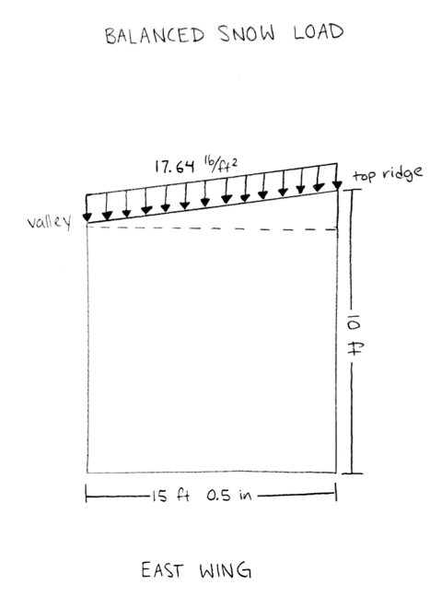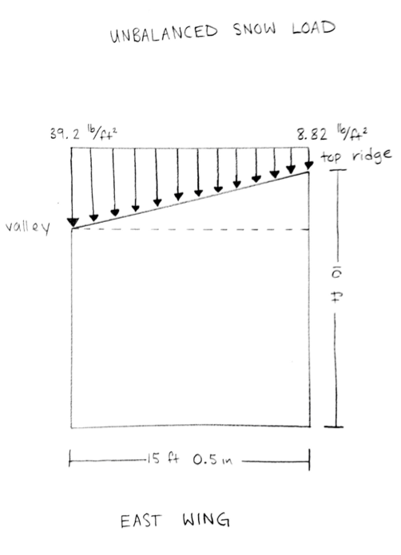

Wind Loads Calculation:

P_{net} = 0.00256 * V² * C_{net} * K_{z} * K_{zt}

Wind Pressure (walls):
-assume positive inside pressure
V = 115 mph
K_{z} = 0.9 (from ASCE 7-10 Table 27.3-1)
K_{zt} = 1 (from ASCE 7-10 Table 26.8-1)
C_{net} winward = 0.43 (from IBC 2015 Table 1609.6.2)
C_{net} leeward = -0.51 (from IBC 2015 Table 1609.6.2)
C_{net} side = -0.66 (from IBC 2015 Table 1609.6.2)

Wind Pressure - P_{net} on walls:
Windward P_{net} = 13.10 lb/ft²
Leeward P_{net} = -15.54 lb/ft²
Side P_{net} = -20.11 lb/ft²

Wind Pressure - P_{net} on roof:
-sloped roof <10 degrees
-used highest C_{net} for calculations
V = 115 mph
K_{z} = 0.9 (from ASCE 7-10 Table 27.3-1)
K_{zt} = 1 (from ASCE 7-10 Table 26.8-1)
C_{net} windward = -1.09 (from IBC 2015 Table 1609.6.2)
C_{net} leeward = -0.66 (from IBC 2015 Table 1609.6.2)
C_{net} parallel = -1.09 (from IBC 2015 Table 1609.6.2)

Windward P_{net} = -33.21 lb/ft²
Leeward P_{net} = -20.11 lb/ft²
Side P_{net} = -33.21 lb/ft²

Our supposition is that because the exposed area of each wing of the house is greatest on the East and West faces, and because the shear walls that must resist those forces are shortest in this same direction, that the wind forces in the East-West direction will control.

Wind force on East Wing Module (wind from East):
East wall of East module consists of walls W4E1-7. West wall of East module consists of walls W4W1-2.
H_{E_East} = 10 ft (Height of East wall of East module, W4E1-7)
L_{E_East} = 29.75 ft (Length of East wall of East module)
A_{E_East} = 10*29.75 = 297.5 ft² (Area of East wall of East module)
F_{E_win} = A_{E_East}*P_{net_win} = 297.5*13.10 = 3897 lb (Winward force on East module)
H_{E_West} = 7.583 ft
L_{E_West} = 13.54 ft
A_{E_West} = 13.542*7.583 = 102.7 ft²
F_{E_lee} =A_{E_West}*P_{net_lee} = 102.7*(-15.54) = -1596 lb (Leeward force on East module)
F_{East} = F_{E_win} - F_{E_lee} = 5493 lb (Total wind force from Eastern direction)
F_{E_bot} = F_{E_top} = F_{East} /2 = 2746.5 lb (Force into bottom and top of E module from E wind)

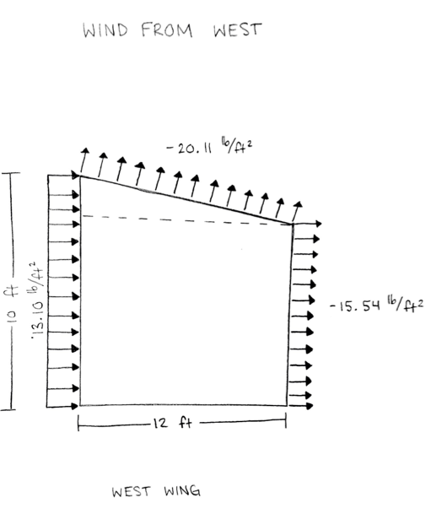

Wind force on West Wing Module (wind from West):
West wall consists of walls W1W1-7. East wall consists of walls W1E2, W1E3, W1E5.
The West (winward) wall is the same height and length of the East module’s East wall. The East (leeward) wall is the same height and length of the East module’s West wall.
Therefore F_{West} = F_{East}
F_{W_top} = F_{W_bot} = F_{E_bot} = 2746.5 lb

Seismic Loads:

Total mass of the top half of structure (transferring seismic load to the roof diaphragm)
W = 6104 lb calculated for top half of West module

Coefficients:
Risk Category: II
C_{vx} = 0.946
R = 6.5
I_{e} = 1.00
S_{s} = 17.5% = 0.175
F_{a} = 1.00

S_{MS} = F_{a}S_{s} = 0.175
S_{DS} = (⅔)S_{MS} = 0.117
C_{s} = S_{DS} / (R / I_{e}) = 0.018

V = C_{s}W / 2 = 54.94 lb transferred to each shear wall
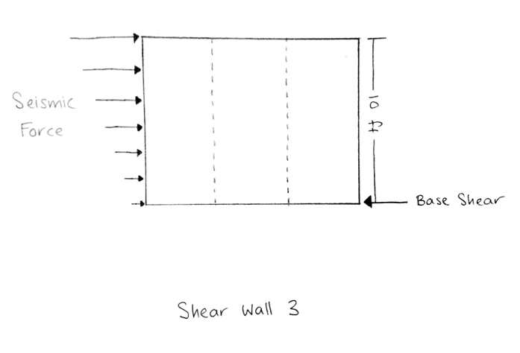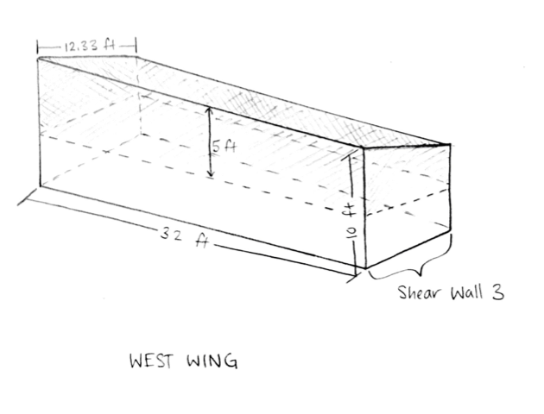

F_{x} = C_{vx}V = (0.946)(54.63) = 51.68 lb
(this is significantly less than the shear forces calculated for wind, so wind loads will govern in the following calculations)

Overturning

East Wing
Weight = 10349.3 lb (Total combined weight of roof, wall, and floor panels of E module)
L_{c} =6.25 ft (Distance from E or W wall to center of module)
H_{j} = 1.5 ft (Height from bottom of jacks to bottom of the floor)
α = Weight*L_{c}/(F_{E_bot}*H_{j} + F_{E_top}*(H_{j}+H_{E_East})) = 10349.3*6.25/(2746.5*1.5+2746.5*11.5) = 1.81
α = (Ratio of weight to wind force. Essentially the safety factor)
Since 1.81 >> 1, there will not be overturning from wind from East direction.

West Wing
Weight =10136.6 lb (Total combined weight of roof, wall, and floor panels of W module)
L_{c} = 6 ft
H_{j} = 1.5 ft
β = 10136.6*6/(2746.5*1.5+2746.5*11.5) = 1.70 (Weight/wind force ratio.)
Since 1.7>>1, there will not be overturning from wind from West direction.

Wind from North and South directions not considered because the wind force on each module from those directions is substantially less than those from the East and West.
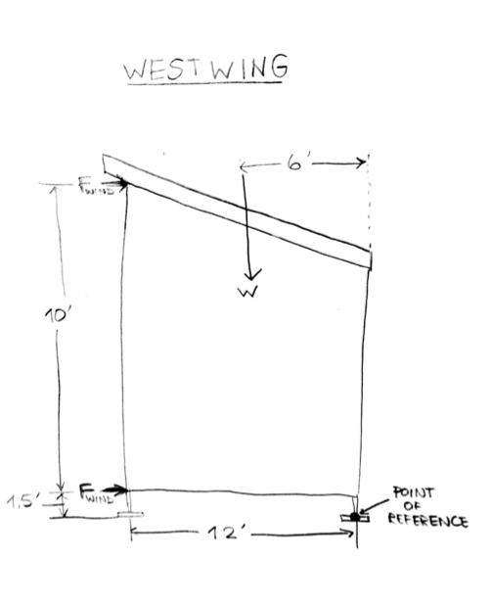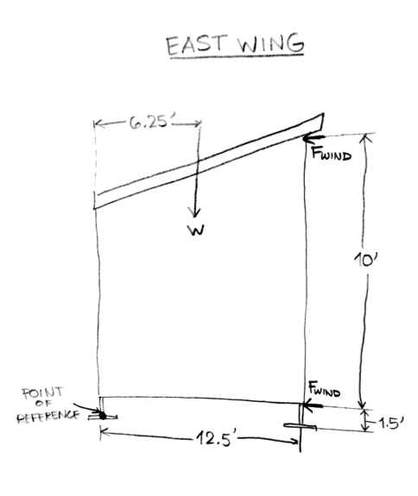

Gravity Loads on Panels

- Allowable Loads for SIP Panels, beams, columns, and posts
Combined (factored) Load (LRFD):
W_{u} = 1.2DL + 1.6(SL or L_{roof})

Roof Panels: INSULSPAN 12 ¼ ‘’ thick (L/360); 12 ft span (for inner East wing, panel R4A7)
Combined Load (LRFD), (using unbalanced snow load for valleys to be conservative):
W_{u} = 1.2DL + 1.6(SL or L_{roof}) = 1.2(15) + 1.6(39.2) = 80.72 psf
W_{allow} = 142 psf (according to Insulspan Out of Plane Load Tables below)
W_{allow} > W_{u} → 142 > 80.72
SF = W_{allow} / W_{u} = 142 / 80.72 = 1.76
Therefore, span appears feasible for general loading.
(This is conservative for West wing - 11 ft span)

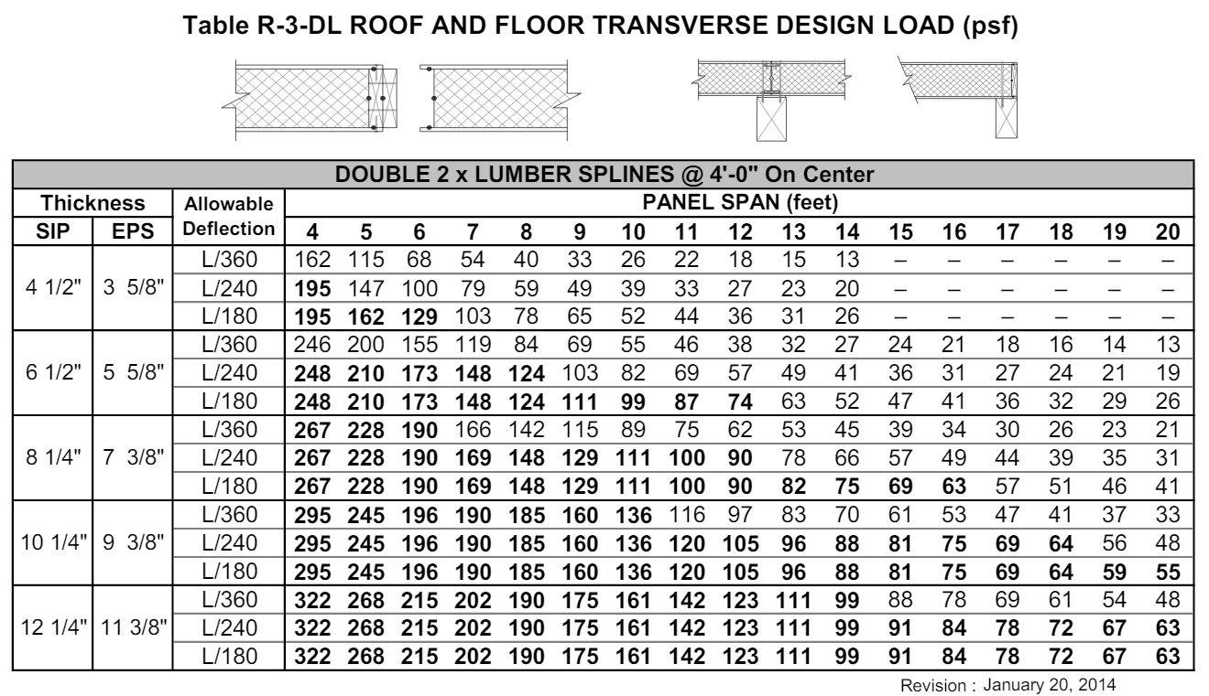

Wall Panels: INSULSPAN 8 ¼ ‘’ thick; height of 10 ft (for inner East wing, panel W4W2, supporting roof panel R4A7)
W_{u} = W_{u} x (panel length / 2) = 80.72 x (15.04 / 2) = 607 lb/ft
W_{allow} = 2720 lb/ft (from Insulspan axial load table below)
W_{allow} > W_{u} → 2672 > 607
SF = W_{allow} / W_{u} = 2720 / 607 = 4.48
Therefore, wall appears feasible for general loading.
(This is conservative for outer wall panels, which will support smaller snow load)
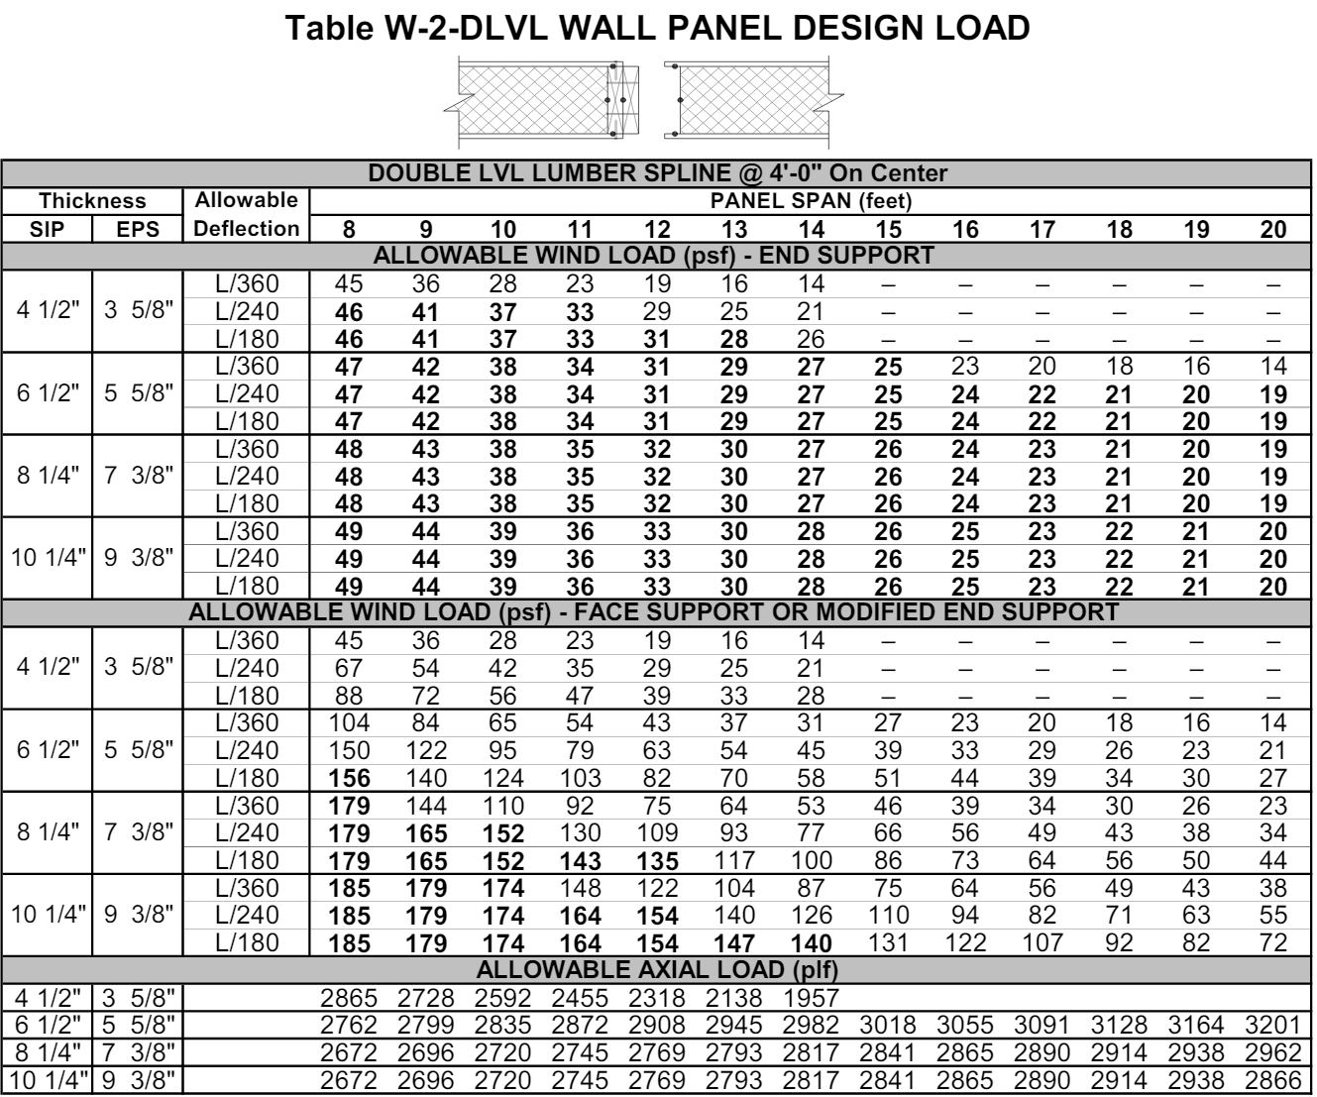

Gravity Loads on Beams
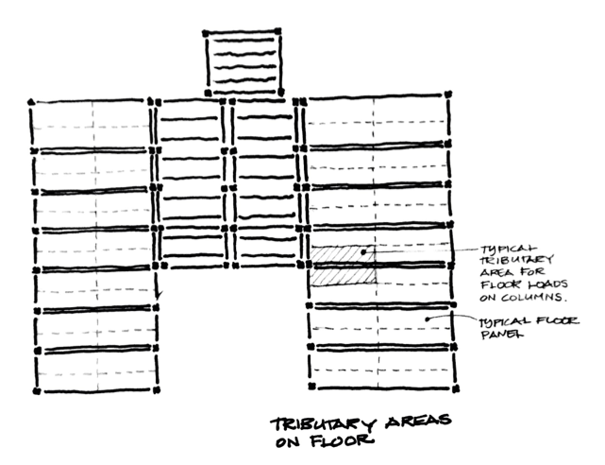
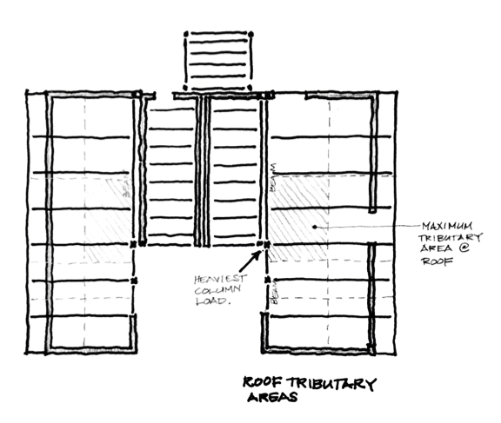
From the framing sketches shown above, it is evident that the greatest load experienced by beams is at the opening between kitchen and dining room in the East Wing (supporting roof panels R4A1-R4A4)

In accordance with the ANSI/AF&PA NDS-2015 using the LRFD method
Combined Load (LRFD), (using unbalanced snow load for valleys): 80.72 psf
W_{u} = W_{u} x (panel length / 2) = 80.72 x (15.04 / 2) = 607 lb/ft
Beam length = 16.875 ft → assume 17 ft
Maximum bending moment:
M_{max} = (W_{u} x L²) / 8 = (607 x 17²) / 8 = 21,928 lb-ft = 263,136 lb-in

Beam Type (selected using LP SolidStart LVL Technical Guide 2900F_{b} - 2.0E):
Allowable Stress Design Values:
F_{b} = 2900 psi
F_{v} = 285 psi
F_{c} = 3200 psi
F_{c-perp} = 750 psi
E = 2.0 x 10⁶ psi

Member Details:
b = 5 ¼ ‘’
d = 14’’
L = 17 ft
A = 14 x 5.25 = 73.5 in²
I = (b)(d³) / 12 = (5.25)(14³) / 12 = 1200.5 in⁴
Stress: f_{b} = (y)(M_{max}) / I = (7)(263,136) / 1200.5 = 1535 psi

Adjustment Factors:
Φ_{b} = 0.85
K_{Fb} = 2.54
λ = 1.00
C_{t} = 1.00
C_{Fb} = 1.00
C_{i} = 1.00
C_{L} = 0.968

Design (allowed) Bending Stress:
F_{b}’ = F_{b} x K_{Fb} x Φ_{b} x λ x C_{t} x C_{Fb} x C_{i} x C_{L} = 6061 psi

Applied Bending Stress:
f_{b} = 1535 psi
f_{b} / F_{b}’ = 0.253
Therefore, beam appears feasible for general loading.

Header Beam Design
(above door on East wing; supporting roof panel R4A4)
(In accordance with the ANSI/AF&PA NDS-2015 using the LRFD method)
Combined Load (LRFD), (using balanced snow load for top ridge of roof):
W_{u} = 1.2DL + 1.6(SL or L_{roof}) = 1.2(15) + 1.6(17.64) = 46.25 psf
W_{u} = W_{u} x (panel length / 2) = 46.25 x (15.04 / 2) = 347.8 lb/ft
Header length = 4.83 ft → assume 5 ft
M_{max} = (W_{u} x L²) / 8 = (348 x 5²) / 8 = 1088 lb-ft = 13,056 lb-in

Beam Type (selected using NDS 2015 Supplement):
Allowable Stress Design Values:
F_{b} = 2050 psi
F_{v} = 175 psi
F_{c} = 1800 psi
F_{c-perp} = 480 psi
E = 1.6 x 10⁶ psi

Member Details:
Southern Pine, non-dense select structural, 2’’-4’’ wide (other types of wood or lower grades may not be sufficient for the stresses calculated on this member - check before using something else)
b_{nom} = 2 ‘’
b = 1 ½ ‘’
d_{nom} = 8 ’’
d = 7 ¼ ‘’
L = 5.7 ft
A = 1.5 x 7.25 = 10.875 in²
I = (b)(d³) / 12 = (1.5)(7.25³) / 12 = 47.63 in⁴
Stress: f_{b} = (y)(M_{max}) / I = (3.625)(13,056) / 47.63 = 994 psi

Adjustment Factors:
Φ_{b} = 0.85
K_{Fb} = 2.54
λ = 1.00
C_{t} = 1.00
C_{Fb} = 1.2
C_{i} = 1.00
C_{L} = 1.00

Design Bending Stress:
F_{b}’ = F_{b} x K_{Fb} x Φ_{b} x λ x C_{t} x C_{Fb} x C_{i} x C_{L} = 5311.14 psi

Applied Bending Stress:
f_{b} = 994 psi
f_{b} / F_{b}’ = 0.187
Therefore, header appears feasible for general loading.

Header Design
(above window on East wing; roof panel R4A7)
Combined Load (LRFD):
(using balanced snow load for top ridge of roof)
W_{u} = 1.2DL + 1.6(SL or L_{roof}) = 1.2(15) + 1.6(17.64) = 46.25 psf
W_{u} = W_{u} x (panel length / 2) = 46.25 x (15.04 / 2) = 347.8 lb/ft
Header length = 5.625 ft → assume 5.7 ft
M_{max} = (W_{u} x L²) / 8 = (348 x 5.7²) / 8 = 1413.32 lb-ft = 17,000 lb-in

Beam Type (selected using NDS 2015 Supplement):
Allowable Stress Design Values:
F_{b} = 2050 psi
F_{v} = 175 psi
F_{c} = 1800 psi
F_{c-perp} = 480 psi
E = 1.6 x 10⁶ psi

Member Details:
Southern Pine, non-dense select structural, 2’’-4’’ wide (other types of wood or lower grades may not be sufficient for the stresses calculated on this member - check before using something else)
b_{nom} = 2 ‘’
b = 1 ½ ‘’
d_{nom} = 8 ’’
d = 7 ¼ ‘’
L = 5.7 ft
A = 1.5 x 7.25 = 10.875 in²
I = (b)(d³) / 12 = (1.5)(7.25³) / 12 = 47.63 in⁴
Stress: f_{b} = (y)(M_{max}) / I = (3.625)(17,000) / 47.63 = 1293.83 psi

Adjustment Factors:
Φ_{b} = 0.85
K_{Fb} = 2.54
λ = 1.00
C_{t} = 1.00
C_{Fb} = 1.2
C_{i} = 1.00
C_{L} = 0.7

Design Bending Stress:
F_{b}’ = F_{b} x K_{Fb} x Φ_{b} x λ x C_{t} x C_{Fb} x C_{i} x C_{L} = 3717.8 psi

Applied Bending Stress:
f_{b} = 1293.83 psi
f_{b} / F_{b}’ = 0.348
Therefore, header appears feasible for general loading.

Header Design:
(above door on East side of courtyard, wall panel W4W1; roof panels R4A5, R4A6)
Combined Load (LRFD):
(using unbalanced snow load for valleys)
W_{u} = 1.2DL + 1.6(SL or L_{roof}) = 1.2(15) + 1.6(39.2) = 80.72 psf
W_{u} = W_{u} x (panel length / 2) = 80.72 x (15.04 / 2) = 607 lb/ft
Header length = 8 ft
M_{max} = (W_{u} x L²) / 8 = (607 x 8²) / 8 = 4856 lb-ft = 58,272 lb-in

Beam Type (selected using LP SolidStart LVL Technical Guide 2900F_{b} - 2.0E):
Allowable Stress Design Values:
F_{b} = 2900 psi
F_{v} = 285 psi
F_{c} = 3200 psi
F_{c-perp} = 750 psi
E = 2.0 x 10⁶ psi

Member Details:
b = 3 ½ ‘’
d = 7 ¼ ’’
L = 8 ft
A = 7.25 x 3.5 = 25.38 in²
I = (b)(d³) / 12 = (3.5)(7.25³) / 12 = 111.15 in⁴
Stress: f_{b} = (y)(M_{max}) / I = (3.625)(58,272) / 111.15 = 1900.46 psi

Adjustment Factors:
Φ_{b} = 0.85
K_{Fb} = 2.54
λ = 1.00
C_{t} = 1.00
C_{Fb} = 1.2
C_{i} = 1.00
C_{L} = 0.98

Design Bending Stress:
F_{b}’ = F_{b} x K_{Fb} x Φ_{b} x λ x C_{t} x C_{Fb} x C_{i} x C_{L} = 7363.05 psi

Applied Bending Stress:
f_{b} = 1900.46 psi
f_{b} / F_{b}’ = 0.258
Therefore, header appears feasible for general loading.

Gravity Loads on Columns

Based on the sketches of tributary are above, it is evident that the heaviest loaded column will be that supporting the beam over the kitchen-dining room opening located at bottom left corner of dining area, supporting 16 ft beam)
Load on column (calculated by halving total load on beam):
P = (607 lb/ft) x (17 ft / 2) = 5160 lb

Column Type:
Allowable Stress Design Values:
F_{b} = 1752 psi
F_{v} = 160 psi
F_{c} = 1750 psi
F_{c-perp} = 215 psi
E = 1.494 x 10⁶ psi
E_{min} = 759,350 psi

Member Details:
b = 3 ½ ‘’
d = 7 ¼ ’’
h = 8 ft
A = 7.25 x 3.5 = 25.38 in²
I_{x} = (b)(d³) / 12 = (3.5)(7.25³) / 12 = 111.15 in⁴
I_{y} = (d)(b³) / 12 = (7.25)(3.5³) / 12 = 25.9 in⁴
Compressive Stress: f_{c} = P / A = 203.31 psi

Adjustment Factors:
C_{Mc} = 0.80
C_{t} = 1.00
C_{Fc} = 1.05
C_{Fb} = 1.3
C_{i} = 0.80
C_{P} = 0.94
K_{Fc} = 2.40
Φ_{c} = 0.9
Λ = 1.00

Strength in compression parallel to grain:
Design compressive stress:
F_{c}’ = F_{c} x C_{t} x C_{Fc} x C_{i} x C_{P} = 1382 psi
Applied compressive stress:
f_{c} = 203.31 psi
f_{c} / F_{c}’ = 0.147
Therefore, column appears feasible for general loading.
Wood blocking under columns:
P = 5160 lb
(this is from the column load calculated above; the column at the corner of floor panel F4A4 is supporting half the load from the 16 ft beam, so this should be conservative for other wood blocking in the house)

Beam Type (selected using NDS 2015 Supplement):
Allowable Stress Design Values:
F_{b} = 2050 psi
F_{v} = 175 psi
F_{c} = 1800 psi
F_{c-perp} = 480 psi
E = 1.6 x 10⁶ psi

Member Details:
Southern Pine, non-dense select structural, 2’’-4’’ wide (other types of wood or lower grades may not be sufficient for the stresses calculated on this member - check before using something else)
b_{nom} = 4 ‘’
b = 3 ½ ‘’
d_{nom} = 8 ’’
d = 7 ¼ ‘’
A = 3.5 x 7.25 = 25.375 in²
I = (b)(d³) / 12 = (3.5)(7.25³) / 12 = 111.15 in⁴
Stress: f_{c} = P / A = 5160 / 25.375 = 203.35 psi

Adjustment Factors:
C_{Mc} = 0.80
C_{t} = 1.00
C_{Fc} = 1.05
C_{Fb} = 1.3
C_{i} = 0.80
C_{P} = 0.94
K_{Fc} = 2.40
Φ_{c} = 0.9
Λ = 1.00

Strength in compression parallel to grain:
Design compressive stress:
F_{c}’ = F_{c} x C_{t} x C_{Fc} x C_{i} x C_{P} = 1618.7 psi
Applied compressive stress:
f_{c} = 203.35 psi
f_{c} / F_{c}’ = 0.126
Therefore, blocking appears feasible for general loading.

Wooden Foundation Posts:
Column: P_{column} = 5160 lb
Floor Panels: P_{floor} = (½)(1.2DL + 1.6L_{floor}) = (½)[1.2(354.862)+1.6(2333.33)] = 2079.58 lb (calculated using factored load of floor panels F4A4 and F4A5, post supports half of each panel)
Total Load: P = P_{column} + P_{floor} = 7239.58 lb

Member Details:
Southern Pine, non-dense select structural, 2’’-4’’ wide (other types of wood or lower grades may not be sufficient for the stresses calculated on this member - check before using something else)
b_{nom} = 4 ‘’
b = 3 ½ ‘’
d_{nom} = 4 ’’
d = 3 ½ ‘’
A = 3.5 x 3.5 = 12.25 in²
I = (b)(d³) / 12 = (3.5)(3.5³) / 12 = 12.51 in⁴
Stress: f_{c} = P / A = 7240 / 12.25 = 591 psi

Allowable Stress Design Values:
F_{b} = 2050 psi
F_{v} = 175 psi
F_{c} = 1800 psi
F_{c-perp} = 480 psi
E = 1.6 x 10⁶ psi

Adjustment Factors:
C_{Mc} = 0.80
C_{t} = 1.00
C_{Fc} = 1.15
C_{Fb} = 1.3
C_{i} = 0.80
C_{P} = 0.94
K_{Fc} = 2.40
Φ_{c} = 0.9
Λ = 1.00

Strength in compression parallel to grain:
Design compressive stress:
F_{c}’ = F_{c} x C_{t} x C_{Fc} x C_{i} x C_{P} = 1772.8 psi
Applied compressive stress:
f_{c} = 591 psi
f_{c} / F_{c}’ = 0.333
Therefore, post appears feasible for general loading.

Roof Diaphragm Loads

Assumptions
- Pressure forces towards interior of structure are assumed positive.
- Suction forces from pressure are assumed negative.
- Suction forces on roof are perpendicular to slope of roof.
- Lateral forces from suction of roof are F*sin(9 degrees).
- When wind forces come from North or South directions, roof suction force is out of plane and thus irrelevant.
- Largest shear force (psf) is assumed to be in West module on North and South shear walls (W1N1-3 & W1S1-3) when wind is blowing from E→ W. Explanation: Wind pressure should be the same in all modules and directions, the largest exposed areas are on the E and W walls of the East and West wings, but the shear walls of the West Wing are slightly shorter than those in the East Wing.

Wall to Roof Diaphragm - West Wing
Windward wall = wall G = panels W4E4, W1E5 Windward p_{net} = 13.10 psf (see calc above)
Leeward wall = wall A = panels W1W1-7 Leeward p_{net} = -15.54 psf (see calc above)
Roof = leeward roof = panels R1A1-7 Leeward p_{net} = -20.11 psf (see calc above)

F_{w} = A_{wall}*p_{net-wall} (wind load on wall surface)
F_{R} = (F_{w_A} / 2) + (F_{w_G} / 2) - (F_{w}*sin(9 deg)) (wind load on roof diaphragm)
F_{F} = (F_{w_A} / 2) + (F_{w_G} / 2) (wind load on floor diaphragm)

Half the force on the wall area above is assumed to be transferred to the roof diaphragm, and the other half will be transferred to the floor diaphragm.

Surface | Height (ft) | Length (ft) | Area (sf) | F_{w} (lb)
W wall of W wing | 10 | 29.75 | 297.5 | 4623.15
S wall of W wing | 7.583 | 12.875 | 97.64 | 1277.25
Roof W wing* | 12.33 | 31.25 | 385.42 | 7750.73
Floor W wing* | 10.33 | 29.75
* Heights of Roof and floor are actually their ‘widths’ for this calculation

F_{R} = 4623.15/2 + 1277.25/2 - 7750sin(9) = 4202.09 lb (in W direction)
F_{F} = 4623.15/2 + 1277.25/2 = 3588.83 lb (in W direction)

⍵_{R} = F_{R}/L_{R} = 4202.09/31.25 = 134.45 psf (distributed load on roof diaphragm)
⍵_{F} = F_{F}/L_{F} = 3588.83/29.75 = 122.70 psf (distributed load on floor diaphragm)

Half of the roof diaphragm is transferred to the North shear wall and half to the South shear wall.

M_{max}=⍵_{R}*L_{R}²/8 = 134.45*31.25²/8 = 16412.35 lb-ft (Maximum moment in roof diaphragm)
C_{u} = M_{max}/d = 15311.28/10.33 = 1588.8 lb (Maximum chord force in diaphragm)

FASTENER REQUIREMENTS FOR DIAPHRAGM SHEAR
The length in which the Max Shear Force to the shear walls in the East-West Direction (V_{N} =2101.045) can be distributed will be the length of the walls as they will be fully connected to the roof diaphragm.

Therefore: ω_{N} = V_{N}/d = 2101.05/10.33 = 203.39 lb/ft (Distributed shear force on N shear wall)

The fastener will be a 3 in. long ¼ in. thick A36 steel angle bracket. The bolts are made of galvanized shear. Three aspects of the fastener can fail, the plate, the bolts, and the wood that the plate is fastened into.

The bolts can fail from shear force from suction on the roof and shear force from the roof.
The plate can fail in shear and from bending.
The wood can fail from tension, compression, and shear.

There are 4 fasteners on the North and South walls of the West modules (one at each intersection between wall panels).

Assumptions:
- The load is evenly distributed with a distributed shear force of 203.99 lb/ft or 16.95 lb/in.
- Each fastener is responsible for absorbing half the force between adjacent joints.
- The joint that experiences the largest load is located between walls W1N2 and W1N3
- This joint is responsible for absorbing 48 in. worth of shear force.

V_{J_max} = ω_{N}*48 in.* (1 ft/12 in) = 813.57 lb (Maximum shear force at a joint)

Chord
Moment
Shear
V_{S}
F_{R}
⍵_{R}

V_{N}

Plate:
Calc 1 - shear at intersection of plates in angle bracket.

Member details of one plate
Thickness t = 0.25 in.
Length L = 8 in.
Depth d = 3 in.
Area of intersection A_{i} = t x d = 0.75 in²
Yield strength of A36 steel σ_{y} = 36000 psi
Min. ultimate strength of A36 steel σ_{u} = 58000 psi
Shear strength A36 steel τ = σ_{u}*0.6 =34800 psi
Distributed shear force at intersection τ_{I} =V_{J_max}/A = 1084.76 psi

τ >> τ_{I} therefore the intersection of the angle bracket will not fail from shear

DIAPHRAGM CHORD DESIGN
Panel edge has a 2x8 serving as a diaphragm chord. However, at the top of every panel joint the chord has a cutout. At these joints the chord is essentially a 2x4.
STRUCTURAL WOOD BEAM DESIGN (NDS) - COMPRESSION
In accordance with the ANSI/AF&PA NDS-2012 using the LRFD method

Analysis results
Design axial compression (2x4)
P = 1588 lb

3.5”
1.5”
Sawn lumber section details
Nominal breadth of sections
Nominal breadth of sections b_{nom} = 2 in
Dressed breadth of sections b = 1.5 in
Nominal depth of sections d_{nom} = 4 in
Dressed depth of sections d = 3.5 in
Number of sections in member N = 1
Overall breadth of member b_{b} = N x b = 1.5 in
Species, grade and size classification Hem-Fir, No. 2 grade, 2” & wider (this is an assumption)
Bending parallel to grain F_{b} = 850 psi
Tension parallel to grain F_{t} = 525 psi
Compression parallel to grain F_{c} = 1300 psi
Compression perpendicular to grain F_{c_perp} = 405 psi
Shear parallel to grain F_{v} = 150 psi
Modulus of elasticity E = 1.3*10⁶ psi
Modulus of elasticity, stability calculations E_{min} = 4.7*10⁵ psi
Mean shear modulus G_{def} = E/16 = 81250 psi

Member details
Service condition Dry
Unbraced length in y-axis L_{y} = 4 ft
Effective length factor in y-axis K_{y} = 1
Effective length in y-axis L_{ey}= L_{y} x K_{y} = 4 ft

Section properties
Cross sectional area of member A = N x b x d = 5.25 in²

Adjustment factors
Resistance factor for compression - Table 2.3.6 ϕ_{c} = 0.90
Resistance factor for modulus of elasticity - Table 2.3.6
ϕ_{s} =0.85
Format conversion factor for compression - Table 2.3.5
K_{Fc} = 2.40
Format conversion factor for modulus of elasticity - Table 2.3.5
K_{FE} = 1.76
Time effect factor - Table N.3 λ = 1.00
Wet service factor for compression - Table 4A C_{Mc} = 1.00
Temperature factor - Table 2.3.3 C_{t} = 1.00
Size factor for compression C_{Fc} = 1.15
Incising factor for modulus of elasticity - Table 4.3.8
C_{iE} = 1.00
Incising factor for bending, shear, tension & compresion - Table 4.3.8
C_{i} = 1.00
C_{ME} = 1.00
Adjusted modulus of elasticity for column stability
E_{min}’ = E_{min} x K_{FE} x ϕ_{s} x C_{ME} x C_{t} x C_{iE} = 703120 psi
Reference compression design value F_{c}*=F_{c} x K_{Fc} x ϕ_{c} x λ x C_{Mc} x C_{t} x C_{Fc} x C_{i} = 3229 lb
Critical buckling design value or compression F_{cE} =0.822 x E_{min}’ / (L_{ey} / b)² = 564 psi
c = 0.80 (because sawn lumber)
Column stability factor - eq.3.7-1 C_{P} = (1 + (F_{cE} / F_{c}*)) / (2 x c) - √[((1 + (F_{cE} / F_{c}*)) / (2
x c))² - (F_{cE} / F_{c}*) / c] = 0.168
Beam stability factor - cl.3.3.3 C_{L} = 1.00

Strength in compression parallel to grain - cl.3.6.3
Design compressive stress F_{c}’ =F_{c} x K_{Fc} x ϕ_{c} x λ x C_{t} x C_{Fc} x C_{i} x C_{p}= 711.5 psi
Applied compressive stress f_{c} = P / A = 302.5 psi
f_{c} / F_{c}’ = 0.425

STRUCTURAL WOOD BEAM DESIGN (NDS) - TENSION
In accordance with the ANSI/AF&PA NDS-2012 using the LFRD method

Analysis results
P = 1588 lb
Design axial tension

3.5”
1.5”
Sawn lumber section details
Nominal breadth of sections b_{nom} = 2 in
Dressed breadth of sections b = 1.5 in
Nominal depth of sections d_{nom} = 4 in
Dressed depth of sections d = 3.5 in
Number of sections in member N = 1
Overall breadth of member b_{b} = N x b = 1.5 in
Species, grade and size classification Hem-Fir, No. 2 grade, 2” & wider (this is an assumption)
Bending parallel to grain F_{b} = 850 psi
Tension parallel to grain F_{t} = 525 psi
Compression parallel to grain F_{c} = 1300 psi
Compression perpendicular to grain F_{c_perp} = 405 psi
Shear parallel to grain F_{v} = 150 psi
Modulus of elasticity E = 1.3*10⁶ psi
Modulus of elasticity, stability calculations E_{min} = 4.7*10⁵ psi
Mean shear modulus G_{def} = E/16 = 81250 psi

Member details
Service condition Dry

Section properties
Cross sectional area of member A = N x b x d = 5.25 in²

Adjustment factors
Resistance factor for tension - Table 2.3.6 ϕ_{t} = 0.80
Resistance factor for modulus of elasticity - Table 2.3.6
ϕ_{s} =0.85
Format conversion factor for tension - Table 2.3.5
K_{Ft} = 2.70
Format conversion factor for modulus of elasticity - Table 2.3.5
K_{FE} = 1.76
Time effect factor - Table N.3 λ = 1.00
Temperature factor - Table 2.3.3 C_{t} = 1.00
Size factor for tension C_{Ft} = 1.5
Incising factor for modulus of elasticity - Table 4.3.8
C_{iE} = 1.00
Incising factor for bending, shear, tension & compresion - Table 4.3.8
C_{i} = 1.00
Tension parallel to grain - cl.3.8.1
Design tensile stress F_{t}’ = F_{t} x K_{Ft} x ϕ_{t} x λ x C_{t} x C_{Ft} x C_{i} = 1701 psi
Applied tensile stress f_{t} = P / A = 302.5 psi
f_{t} / F_{t}’ = 0.178

FAILURES IN FLOOR CONNECTIONS

Withdrawal of bolts:
Wind load into the roof can be the cause of withdrawal in bolts connecting the walls to the floor.

West Module:
W = 7607 lb (Combined weight of roof and wall dead load)
F_{top} = 2746.5 lb (Wind force into top of diaphragm system)
L_{c} = 6 ft (Distance from wall to center of floor)
H = 10 ft (Height of W wall of W module)
α = W*L_{c} / (H*F_{top}) = 7607*6/(2746.5*10) = 1.66
1.66 >> 1, therefore floor connection in West module will not fail from bolt withdrawal.

East Module:
W = 7787 lb (Combined weight of roof and wall dead load)
F_{top} =2746.5
L_{c} = 6.25 ft
H = 10 ft
β = 7787*6.25/(2746.5*10) = 1.77
1.77 >> 1, therefore floor connection in East module will not fail from bolt withdrawal.

Floor Shear (welds):

Assumptions:
- ⅛” thick plates made of A36 steel → a_{max} = 6 mm = 0.236 in
- Fillet welds (fail in shear)
- 2” is smallest weld length
- E70 filler material (F_{y} = 58 ksi)

Used in calculations:
- Eq. J2.4 in AISC
- Max Base Shear is from Eastern wind on Shear Wall 3 (W1S1-W1S3) = 5814.5 lb
- Max shear on single floor connection = 5814.5/4 = 1453.6 lb

Calc:
L_{w} = 2 in. (Length of weld)
F_{EXX} = 58 ksi (Strength of E70 filler)
F_{EXX_S} = 0.6*58 = 34.8 ksi (Strength of E70 filler in shear)
a_{w} = 0.236 in. (Height of weld)
Φ = 0.75
P_{u} = L_{w}*Φ*F_{EXX_S}*cos45*a_{w} = 2*0.75*34.8*0.707*0.236 = 8710 lb (Ultimate Weld Strength)
8710>>1453.6, therefore weld will not fail from base shear.

Bolt Shear:
Max shear is on shear wall 3, walls W1S1-W1S3.
Situation I_{S} is most likely failure scenario.
N = 4 (Number of bolts per plate)
D = ⅜ in. (Diameter of bolt)
L = 2 in. (Length of bolt)
V_{max} = 1453.6 (Max shear on a connection)
V_{b_max} = V_{max}/N = 1453.6/4 = 363.4 lb (Max shear on single bolt)
F_{es} = 2950 psi (from Table 12.3.3 of NDS)
R_{d} = 4K_{Ө} = 4*(1+0.25(Ө/90)) = 4*(1.25) = 5 (from Table 12.3.1B of NDS)
f_{v}’ = D*L*F_{es} /R_{d} = ⅜*2*2950/5 = 442.5 (Design load)
SF = f_{v}’/f_{v} = 442.5/363.4 = 1.22 (Safety factor)
1.22>1, therefore bolts will not fail in shear.

ROOF FASTENER FAILURE
Withdrawal:
Assumptions:
- Largest potential for failure is on the roof of the east wing since it has the largest area of any roof.
- Fastener between roof panels 1 & 2 and panels 6 & 7 have largest tributary areas, meaning they are most likely to fail from withdrawal.
- Largest suction force on roof happens when wind is coming from West direction because it makes the roof winward, giving the roof a higher P_{net} value (P_{net_w} = -33.21) than the leeward direction (P_{net_L} = -20.11).
A = 475.26 ft² (Area of roof)
L = 31.25 ft (Length of roof)
w_{1/2} = w_{6/7} = 0.5*4 + 0.5(5+7.5/12) = 4.8125 ft (width of fastener tributary area)
F_{R} = A*P_{net_w} = 475.26*39.24 = 15784.68 (perpendicular to roof) (Suction force on roof)
ω = F_{R}/L = 15784.68/31.25 = 505.11 lb/ft (suction force per linear ft)
F_{B} = 505.11*4.8125 = 2430.84 lb (Upward force on bolts)
Since F_{B} is less than the weight of the roof, the bolts will not fail from withdrawal.

Allowable tensile stress in bolts
W_{R} = 900 + 5229.33 = 6129.33
S_{t} = 70 ksi (conservative estimation of strength of bolts)
D = ⅜ in (diameter of bolts)
A_{s} = 0.106 in² (Tensile stress area according to Fastenel)
P_{allow} = S_{t} * (A*4) = 29680 lb (Allowable tensile force in bolt according to Fastenel)
F_{B_S} = 15567.2-6129.33 = 9437.87 lb (Suctional force on bolts from roof)
9437.89 << 29680, therefore the bolts will not fail due to tension from suctional roof force.

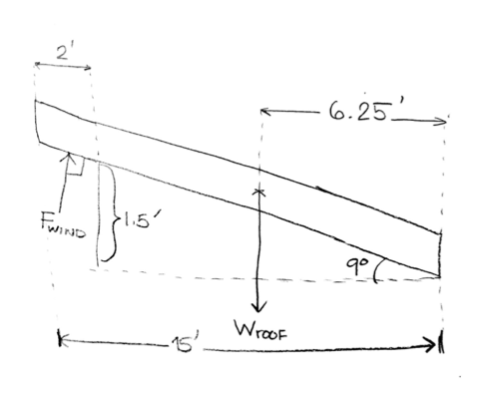

Gravity Loads on Decking

Based on a survey of the decking tributary areas, it was determined that the greatest loads on support beams and columns would occur in the middle of the Rear-East (NE) deck.

Governing loads:
- Column: 5 (between A and B in drawing S-102
- Beam: 5 (facing 4.1, top beam)
DL = 4.625 psf (Dead load per sq. ft.)
LL = 100 psf (Live load per sq. ft.)
CL = 1.2DL + 1.6LL = 165.55 (Combined load)

Column:
A_{C} = (⅛(95*108+108*77) + ¼(108*70))/144 in² = 29.25 ft² (Tributary area of column 5)
L_{C} = A_{C}*CL = 29.25*165.55 = 4842.3 lb (Load on column 5)
A_{B} = ½*108*½*95/144 in² = 17.82 ft² (Tributary area of beam)
L_{B} =A_{B}*CL = 17.82*165.55 = 2950.1 lb (Load on beam)
ω = 2950.1 / 4.5 = 655.6 lb/ft (Load per linear foot on beam)

Tension on Deck Beams:
L = 4.5 ft. (Length of beam)
M = ωL²/8 = 655.6*4.5²/8 = 1659.5 lb*ft = 19914 lb*in (Moment equation)
I = 1/12*b*h³ = 1/12*(1.5”)(9.25”)³ = 98.938 in⁴ (Moment of Inertia)
c = 9.25/2 = 4.625 in. (Centroid)
σ = Mc/I = 19914*4.625/98.932 = 930.96 psi (Tensile stress equation)

Foundation Footing Design

As described above, the greatest single load on any footing will be 7240 lb at the column supporting the S end of the beam spanning the opening between kitchen and dining room.

If the soil bearing capacity is 2500 psf, then the required area of the footing under this column would be

A = 7240 lb / (2500 lb/sq.ft.) = 2.896 sq.ft.

In general, therefore, a square footing 20.5” on a side would be adequate for this purpose. Although the Drawings current reference footings that are 30 “ square, a more logical size would be 24” square. This revision is still being considered, including the effect on the footing thickness if the material is stacked plywood.

