Exploring Differences in Hippocampal Structure between Habitual vs Non-habitual Nappers during Early Childhood
Lena Meredith
Department of Psychology, University of Maryland
Undergraduate Psychology Honors Thesis

Author Note
The Undergraduate Honors Thesis Committee consisted of Dr. Tracy Riggins, Dr. Robert Slevc, and Dr. Amanda Chicoli. Special thanks to graduate student Tamara Allard for her mentorship and to the Neurocognitive Development Lab at the University of Maryland, under Dr. Tracy Riggins.
Abstract
When we sleep, our memories are consolidated and become less vulnerable to interference, both during overnight sleep and during naps. Previous research in adults suggests this effect is at least partially due to a “transfer” of these memories from the hippocampus to the cortex. Although a similar process likely takes place in young children, there is little research investigating it. The existing literature suggests habitually napping children may need naps more than non-habitually napping children because their brain is less mature. This study aims to examine relations between habitual versus non-habitual nappers and brain development in early childhood. The focus was on the hippocampus, a structure that is critical for memory and shows protected development during early childhood. At the time of this report, 21 children provided useable data (M_{age} = 4.49 years, SD = 0.51, 9 female). Of these participants, 8 were habitual nappers and 13 were non-habitual nappers. Hippocampal volumes were extracted using a combination of manual and automated methods. Results revealed in the left hippocampal tail, habitual nappers had larger volumes compared to non-habitual nappers. Although these are preliminary results and do not survive correction for multiple comparisons, the findings support that variation in hippocampal development may relate to nap status in developing children. Future research will examine a larger sample size and investigate other brain regions to determine the specificity of these effects.
Keywords: hippocampus, memory, sleep, napping, child development

Exploring Differences in Hippocampal Structure between Habitual vs Non-habitual Nappers during Early Childhood
Memory is a complex and multifaceted process that is critical for daily functioning. We use it every day, from mundane things like where you parked the car or what was on the grocery list, to the memory of the first time you rode a bike or your graduation day. Imagine how life would be without a functioning memory. Many factors influence our ability to remember. One of these factors is sleep (Stickgold & Walker, 2013). Sleep plays a role in memory consolidation, or how the memories are solidified and made less vulnerable to interference. It is thought that memories are at least partially consolidated during sleep, and these memories are transferred from the hippocampus to the cortex. This process not only occurs during overnight sleep but also during daytime naps.
Memory consolidation across sleep has been demonstrated in both adults and children. Although the importance of sleep has been well-established in adults, there have been fewer studies in childhood, specifically during the preschool years. This developmental period (i.e., ages 3 - 5 years) is particularly interesting because children begin to transition out of their afternoon nap. One pioneering study investigated memory to explore the potential impact of nap transition on memory using behavioral and sleep physiology measures (Kurdziel et al., 2013). This study used a spatial memory game and compared children’s memory in the afternoon on days when they napped and days when they were kept awake. The results showed children who were prevented from napping performed worse on the memory task compared to those who did nap, and that this effect was more apparent in habitual nappers, regardless of the child’s age. Measures of sleep physiology (i.e., brain activity during sleep) were related to memory performance, which the authors argued supported the notion that sleep distributed throughout the day is necessary for memory consolidation in early stages of development (Kurdziel et al., 2013). This could provide some critical insight to the connection between brain development, sleep, and memory.
These findings suggest children need to nap because their brain is less mature, which is consistent with more general literature on sleep and cognitive development that suggests phasing out of napping is a “developmental milestone” (Lam et al., 2011). Therefore, examining the brain directly in young children could give insight to what neural changes might occur as a result of this transition, or perhaps the neural changes are what cause the transition out of naps.
One candidate brain region is the hippocampus, which has been shown to be related to many types of memory, including spatial memory, verbal/narrative memory, episodic memory, and general encoding (Burgess et al., 2002). The hippocampus can be divided in multiple ways. For example, there exist defined subfields within the hippocampus – four cornu ammonis structures (CA1, CA2, CA3, and CA4), the dentate gyrus, and the subiculum (Giuliano et al., 2017). It can also be separated into subregions of head, body, and tail. Research suggests in adults, larger posterior hippocampal volumes and smaller anterior hippocampal volumes have been shown to relate to increased recollection (Poppenk & Moscovitch, 2011). In children, hippocampal subregions are also related to memory, but the direction of these effects vary across age, meaning larger volumes are not always better. For example, across a few studies, it has been reported that larger volumes may be associated with better memory performance in younger children but that in older children smaller volumes are associated with better memory performance (Canada et al., 2019; Riggins et al., 2015, 2018). This is interesting as this “transition” is near the age when children transition out of napping.
In summary, research has shown both sleep and the hippocampus are related to memory in developing children. Although the field has started to investigate the role naps play in memory, it has yet to start thoroughly investigating the relation between brain development and napping. The present study seeks to address this gap this by comparing hippocampal volumes in children of the same age, half of whom are napping habitually and half of whom have transitioned out of the nap. The main question of interest is whether there exists a difference in hippocampal volumes – total and subregion volumes – based on nap status. Based on previous developmental studies that show age-related differences in hippocampal volumes, it was hypothesized there would be significant differences in hippocampal volumes between these nap groups, even after controlling for possible confounding factors (gender, age, and intracranial volume). These findings will not only extend previous research (Kurdziel et al., 2013) but also provide empirical support for the idea that brain development, specifically the hippocampus, is related to memory improvement and children’s phasing out of naps.
Method
This paper is part of a larger study and may be included in future papers from the Neurocognitive Development Lab at the University of Maryland. The analyses included in this paper have been pre-registered on the Open Science Framework (OSF).
Participants
Participants were part of a longitudinal study investigating the effects of napping on memory and hippocampal development in early childhood. Participants were recruited from the D.C. metropolitan area primarily through the Infant and Child Studies consortium (ICS), an existing University recruitment database. Upon recruitment, all participants were 3 to 5 years old and habitually napping (defined as napping five or more days per week). Children were excluded from the study if they had any of the following – abnormal circadian functions, history of head trauma (that involved losing consciousness), history of any brain abnormality, neurological disorder, premature birth (pregnancy less than 35 weeks), diagnosed learning disability, diagnosed psychiatric disorder, history of any developmental delay/disorder, history of autism spectrum disorder, or anything that would exclude the participant from having an MRI. The present report includes data collected during the second wave of a longitudinal study. All participants tested by March 2020 were included; note sample size is smaller than expected due to the COVID-19 outbreak, which halted data collection on March 21st, 2020.
A total of 25 participants met criteria for inclusion. However, 4 of these participants were excluded due to unusable MRI data (9 female, 12 male; M_{age at time of MRI scan} = 4.49 years, SD = 0.51). Of the remaining 21 participants, 8 were considered nappers (napping 5 or more days per week) and 13 were considered non-nappers (napping 4 or less days per week). All participants were reimbursed $80 per wave and given prizes at each visit (e.g. books, toys, a printed brain t-shirt, and a 3D-printed model of their brain).
Procedures
Data collection involved a set of three visits – each visit approximately one week apart. The first two visits took place in the home during which memory and sleep physiology data were obtained. The third took place at the Maryland Neuroimaging Center (MNC) and consisted of structural and functional MRI scans. The focus of the present report is on structural MRI data collected at the third visit.
Questionnaires
Questionnaires were provided to the parents to help determine the child’s nap status. Four different questionnaires were acquired: a lab-based nap transition questionnaire, a daily sleep diary, the Child Sleep Habits Questionnaire (Owens et al., 2000), and a parent email or phone interview. Note the collection of questionnaire data occurred at multiple points across the Wave, which spanned three or more weeks. The Nap Transition Questionnaire asked, “How many days a week does your child nap?” Parents were allowed to answer with any numeric value. The sleep diaries were provided to the parent at the first visit of each Wave. Parents were asked to record their child’s sleep habits over a two-week period (both overnight sleeping and naps). Nap status was calculated by averaging the total number of days spent napping per week. The Child Sleep Habits Questionnaire asked, “How often does your child nap?” given the following options – usually (5+ days/week), sometimes (3-4 days/week), or never (less than 2 days/week). The initial parent interview took place when the participant was first scheduled for the study. If the participant did not have a sleep diary or questionnaire data, their nap status was determined by the parent’s answer to the phone interview at the start of wave 2. The question asked was “Does your child nap?”
Questionnaires were used in a hierarchal order: If a participant did not complete the nap transition questionnaire, nap status was determined by the sleep diary. If they did not have the sleep diary, it was determined by the Child Sleep Habits Questionnaire, and so on. Participants were then categorized into two groups based on nap status; nappers (children napping 5 or more days per week) and non-nappers (children napping 4 or less days per week) (Kurdziel et al., 2013).
MRI
During one of the home visits prior to coming to the MNC, participants were introduced to lab MRI procedures. This allowed children to feel comfortable before entering the MRI facility. Specifically, participants listened to MRI sounds while lying in a toy tunnel to help simulate the MRI machine and data collection. At the MNC, children participated in a mock scan before scanning. The purpose of this was to offer a sense of familiarity for the child and to allow experimenters to provide feedback on movement. Participants were then scanned in a Siemens 3.0-T scanner (MAGNETOM Trio Tim System, Siemens Medical Solutions, Erlangen, Germany) using a 32-channel coil. A high resolution structural T1-weighted image was obtained via a magnetization-prepared rapid gradient-echo sequence with 176 contiguous sagittal slices (.9 mm isotripc; 1900 ms TR; 2.32ms TE; 900ms inversion time; 9° flip angle; pixel matrix = 256 x 256). While in the scanner, the participants had padding around their head to try and minimize movement and were able to view a movie of their choice. Children were accompanied in the scanner room during the scan by an undergraduate research assistant to watch and provide movement feedback.
In order to process the T1 structural scans, the images were segmented with a program called FreeSurfer Version 6.0.0., which automatically completes volumetric segmentation (Fischl et al., 2002). The program has been shown to be fairly accurate in calculating subcortical volumes (Lehmann et al., 2010) and can be used for young children (Ghosh et al., 2010). After the scans were run through FreeSurfer, the hippocampal volumes were further segmented into the subregions of head, body, and tail using standard anatomical landmarks (Watson et al., 1992; Weiss et al., 2005). This was completed manually by identifying two landmarks in order to delineate which slices were part of each subregion – the uncal apex identified the end of the head and start of the body, and the fornix identified the end of the body and the beginning of the tail (Figure 1).

Figure 1
Defined Hippocampal Subregions
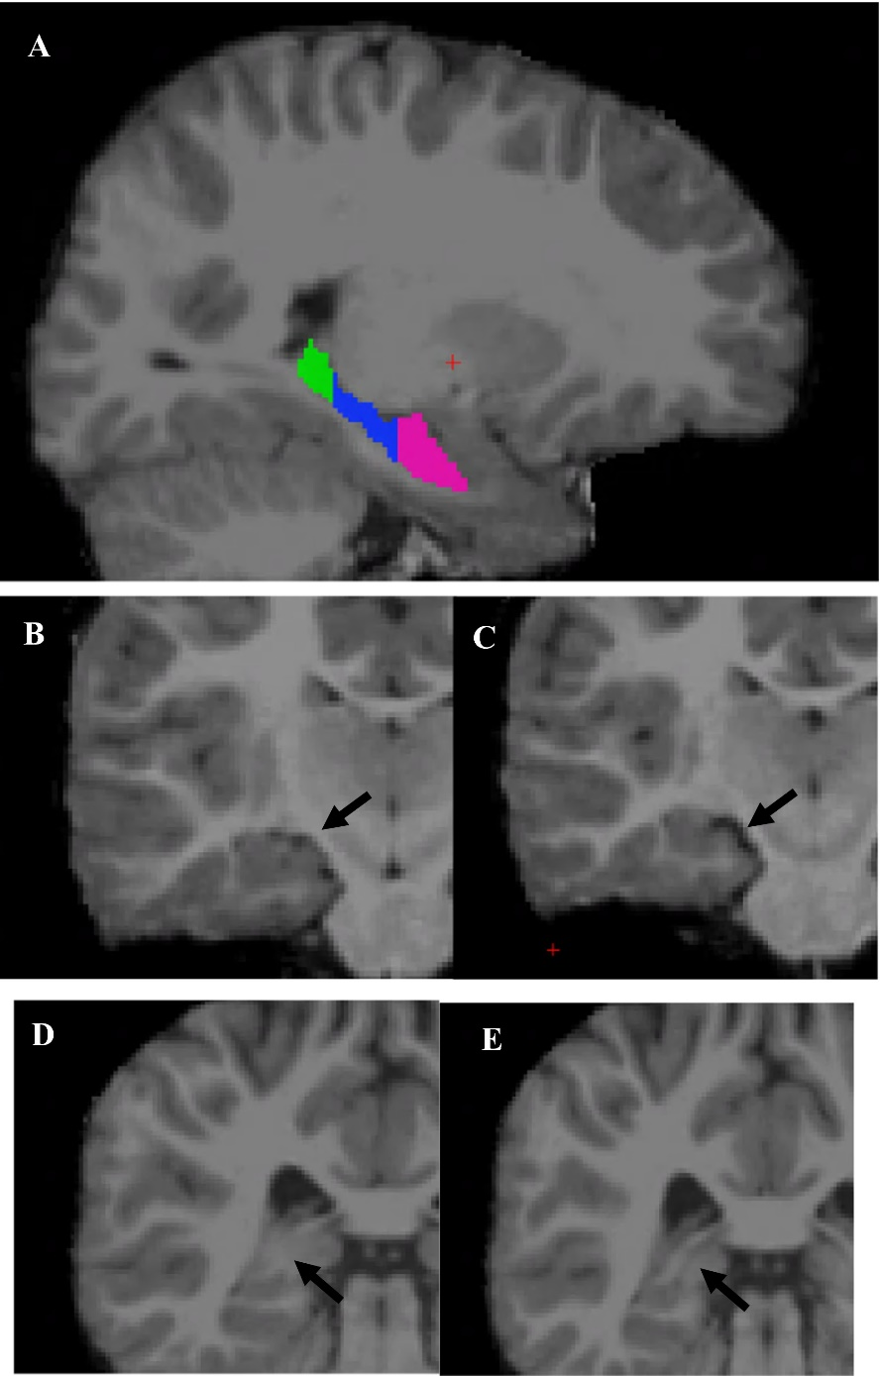

Note. A) Head (pink), body (blue), and tail (green) subregions shown. B) Slice where uncal apex is visible (last slice of head), C) slice where uncal apex is no longer visible (first slice of tail). D) Slice where fornix has not separated from the hippocampus (last slice of body), E) slice where fornix has separated from the hippocampus (first slice of tail). This figure was reproduced from (Riggins et al., 2015).
After landmarks were identified and subregions defined, the scans were refined using a Segmentation Adapter Tool, which improves FreeSurfer accuracy by using a machine learning algorithm to reduce errors in segmentation (Morey et al., 2009; Wang et al., 2011).
Analytic Approach
First, possible confounding factors were examined, namely gender, age at the time of the MRI, and intracranial volume (ICV). This was done in order to determine whether it was necessary to control for these external factors in the analyses of interest. Gender was compared based on nap status with a chi square analysis. Age and ICV were each compared with an ANOVA. These factors were controlled for in subsequent analyses only if they showed significant differences between groups.
Second, hippocampal volumes were compared between nappers and non-nappers using ANOVAs. We did this first with total bilateral hippocampus, then bilaterally with each subregion (head, body, tail). Finally, we tested lateralized differences in those subregions only if findings approached significance (p < .10). This sequence of analyses was used to limit the number of total analyses and thus lower type 1 error.
Results
Table 1
Descriptive Statistics for Possible Confounds
Descriptive Statistics for Sex, Age, and ICV
Statistic | Napper | Non-napper
Age (Mean, SD) | 4.45, 0.46 | 4.47, 0.55
Sex (male:female) | 4:4 | 5:8
ICV (Mean, SD) | 1280808, 27126.48 | 1307854, 27727.41

Possible confounds (age, sex, and ICV), described in Table 1, were examined for significant differences between the groups. Age at the time of the MRI scan showed no significant differences, F(1, 21) = 0.001, p = .97. Gender showed no significant differences, χ² (1, N = 21) = 0.29, p = .59. Last, ICV showed no significant differences between groups, F(1, 19) = 0.37, p = .55. These results suggest the groups were well-matched on these potentially confounding variables. Given these findings and the small sample size, these factors were not controlled for in subsequent analyses.
Results of the ANOVA analyses comparing volumes of bilateral hippocampal subregions between nap status groups are shown in Table 2. Total, head, and body hippocampal volumes showed non-significant differences, but differences in hippocampal tail volumes between groups approached significance (p = .081).
Table 2
Bilateral Hippocampal Volume Analyses Between Nappers and Non-nappers
ANOVA Results of Hippocampal Volumes Between Nappers and Non-nappers
Hippocampal volume | df | F | SD | p
Total | 20 | 0.218 | 46.651 | 0.646
Head | 20 | 1.283 | 94.188 | 0.271
Body | 20 | 0.673 | 48.895 | 0.422
Tail | 20 | 3.400 | 96.432 | 0.081†
Note. † = p < .10
Because hippocampal tail volumes approached significance (defined by p < .10), we conducted analyses to determine if there were differences between the hemispheres. Hippocampal tail volumes in the right hemisphere did not show differences between nap status groups, F(1, 21) = 0.627, p = .438. However, hippocampal tail volumes in the left hemisphere did show significant differences between groups, F(1, 21) = 8.502, p < .01. Figure 2 illustrates volumes in left and right tail. Results specifically showed larger left hippocampal tail volumes in nappers than in non-nappers.
Figure 2
Hippocampal tail volumes between left and right hemispheres in nappers versus non-nappers
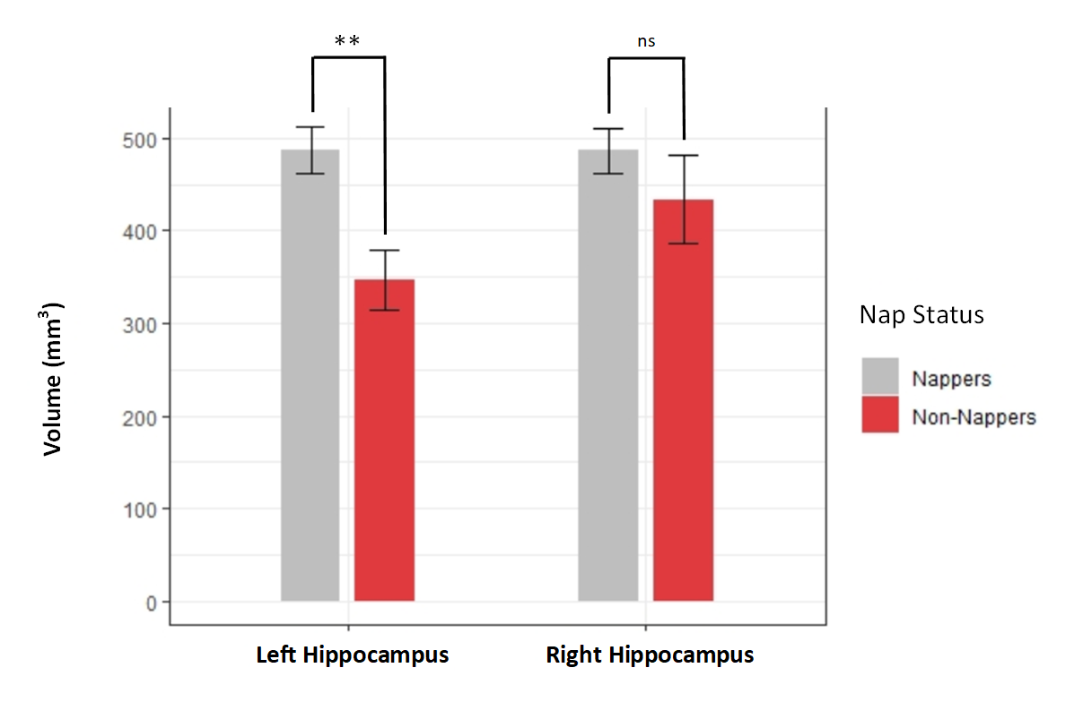

Discussion
The goal of this study was to investigate differences in hippocampal structure between habitually napping and non-habitually napping preschool children. Results showed marginally significant differences in bilateral hippocampal tail volumes. Follow-up analyses revealed significant differences in left hippocampal tail volumes. Specifically, in the left hemisphere, volumes of the hippocampal tail were larger in nappers than in non-nappers. This difference was observed despite the fact there were no differences in ICV overall. We expect these results are due to the hippocampus’ role in memory, and this specificity may relate to the fact that the hippocampus is an important neural component for memory that changes as children develop.
These findings are consistent with the current literature that suggests children may phase out of their naps because of specific brain maturation (Lam et al., 2011). As suggested by Kurdziel et al. (2013), the transition from napper to non-napper takes place because children need distributed sleep during early learning to successfully consolidate memories, and that is no longer the case past a certain point of development. This alignment of neural and behavioral findings (hippocampal and memory, respectively) is consistent with the present findings and is promising for future research into hippocampal structure and function. Additionally, we are motivated to understand the underlying causes of why children nap and what changes when they stop napping. This transition does not occur at the same time for every child, though it does typically happen during early childhood, but we do believe it is an important development milestone. Structure lends itself to function, and these finding implicate the hippocampus as a memory-consolidation structure that is at least partially responsible for the change in function.
In the present study, hippocampal volumes were larger in nappers compared to non-nappers. This volumetric difference may imply differences in brain maturation between the groups. Though we expected hippocampal volume differences between groups, we only found differences in the tail of the hippocampus. Though this finding seems counterintuitive, that earlier developmental stages should have larger volumes, it has been suggested in the literature that bigger is not always better (Van Petten, 2004). For example, during development, smaller hippocampal volumes have been related to better memory performance (Riggins et al., 2018). It is unclear why the differences were observed in the tail and not the head or body, but the tail (posterior hippocampus) has previously been related to memory in children (DeMaster & Ghetti, 2013).
Overall, the present study suggests relations may exist between the transition out of napping and brain development. Specifically, hippocampal volumes differed between habitual nappers and non-nappers. This may have implications for memory development, as sleep has been related to the consolidation of memories. It is possible that structural changes in the hippocampus relate to a developmental change in memory consolidation processes and in napping behavior. Additionally, this has implications for research moving forward in the field, as well as for policymaking concerning nap lengths in pre-schools and daycares.
There are several limitations to the present study. First, our sample size is small (N = 21). Second, the results do not survive correction for multiple comparisons. Third, we were not able to distinguish semi-nappers as a third group in the analyses (due to low numbers of participants that qualified), which may have additionally lessened the effects. Fourth, the nap status variable of napper or non-napper had some limitations – as this itself is a “moving target.” The process of determining a participant’s nap status was dependent on the parent or guardian having completed the questionnaires they were given at multiple points during each Wave of data collection spanning 3 or more weeks. Because of this variation, determining nap status was not always clear. However, despite these limitations, this study is a critical piece of understanding how sleep, memory, and the brain relate to each other. Much of the current literature that describes neural effects related to memory do not use MRI data (Lam et al., 2011). MRI data collection is difficult to obtain and is a major strength of this study. Because we have physical brain data, we can observe the physical differences without making assumptions.
These results are promising for future investigations into the structural changes of the hippocampus. They implicate neural changes that occur during the transition of habitually napping to no longer habitually napping. With such small effects, it would be worthwhile to analyze smaller structures within the hippocampus. Hippocampal subfields, for example (CA1-4, the dentate gyrus, and the subiculum), are so small that MRI scans with magnetic fields lower than 3T cannot detect small volume differences within the subfields (Giuliano et al., 2017). Because the subfields are smaller defined areas than the subregions of head, body, and tail, it would be interesting to analyze based on subfields instead of the subregions used in this study. In addition to possible subfield analyses, future investigations could examine the relation between memory and measures of cortical maturation such as cortical thickness. This approach would, instead of focusing specifically on the hippocampus, examine the brain on a larger scale and give insight to underlying neural structure that supports relations between sleep and memory during development.
Overall, the goal of this and future research is to fully understand the relationship of these results to sleep and memory, as well as the function of the hippocampus. This study is the first to examine hippocampal differences between nappers and non-nappers during early childhood. As such, it is valuable to continue to investigate in a similar fashion using a larger sample size and to strive to understand the hippocampus and the specificity of these effects.
References
Burgess, N., Maguire, E. A., & O’Keefe, J. (2002). The human hippocampus and spatial and episodic memory. In Neuron. https://doi.org/10.1016/S0896-6273(02)00830-9
Canada, K. L., Ngo, C. T., Newcombe, N. S., Geng, F., & Riggins, T. (2019). It’s All in the Details: Relations Between Young Children’s Developing Pattern Separation Abilities and Hippocampal Subfield Volumes. Cerebral Cortex. https://doi.org/10.1093/cercor/bhy211
DeMaster, D. M., & Ghetti, S. (2013). Developmental differences in hippocampal and cortical contributions to episodic retrieval. Cortex. https://doi.org/10.1016/j.cortex.2012.08.004
Fischl, B., Salat, D. H., Busa, E., Albert, M., Dieterich, M., Haselgrove, C., Van Der Kouwe, A., Killiany, R., Kennedy, D., Klaveness, S., Montillo, A., Makris, N., Rosen, B., & Dale, A. M. (2002). Whole brain segmentation: Automated labeling of neuroanatomical structures in the human brain. Neuron. https://doi.org/10.1016/S0896-6273(02)00569-X
Giuliano, A., Donatelli, G., Cosottini, M., Tosetti, M., Retico, A., & Fantacci, M. E. (2017). Hippocampal subfields at ultra high field MRI: An overview of segmentation and measurement methods. Hippocampus. https://doi.org/10.1002/hipo.22717
Kurdziel, L., Duclos, K., & Spencer, R. M. C. (2013). Sleep spindles in midday naps enhance learning in preschool children. Proceedings of the National Academy of Sciences of the United States of America, 110(43), 17267–17272. https://doi.org/10.1073/pnas.1306418110
Lam, J. C., Mahone, E. M., Mason, T., & Scharf, S. M. (2011). The effects of napping on cognitive function in preschoolers. Journal of Developmental and Behavioral Pediatrics. https://doi.org/10.1097/DBP.0b013e318207ecc7
Morey, R. A., Petty, C. M., Xu, Y., Pannu Hayes, J., Wagner, H. R., Lewis, D. V., LaBar, K. S., Styner, M., & McCarthy, G. (2009). A comparison of automated segmentation and manual tracing for quantifying hippocampal and amygdala volumes. NeuroImage. https://doi.org/10.1016/j.neuroimage.2008.12.033
Poppenk, J., & Moscovitch, M. (2011). A hippocampal marker of recollection memory ability among healthy young adults: Contributions of posterior and anterior segments. Neuron. https://doi.org/10.1016/j.neuron.2011.10.014
Riggins, T., Blankenship, S. L., Mulligan, E., Rice, K., & Redcay, E. (2015). Developmental Differences in Relations Between Episodic Memory and Hippocampal Subregion Volume During Early Childhood. Child Development. https://doi.org/10.1111/cdev.12445
Riggins, T., Geng, F., Botdorf, M., Canada, K., Cox, L., & Hancock, G. R. (2018). Protracted hippocampal development is associated with age-related improvements in memory during early childhood. NeuroImage. https://doi.org/10.1016/j.neuroimage.2018.03.009
Stickgold, R., & Walker, M. P. (2013). Sleep-dependent memory triage: Evolving generalization through selective processing. In Nature Neuroscience. https://doi.org/10.1038/nn.3303
Van Petten, C. (2004). Relationship between hippocampal volume and memory ability in healthy individuals across the lifespan: Review and meta-analysis. In Neuropsychologia. https://doi.org/10.1016/j.neuropsychologia.2004.04.006
Wang, H., Das, S. R., Suh, J. W., Altinay, M., Pluta, J., Craige, C., Avants, B., & Yushkevich, P. A. (2011). A learning-based wrapper method to correct systematic errors in automatic image segmentation: Consistently improved performance in hippocampus, cortex and brain segmentation. NeuroImage, 55(3), 968-85. https://doi.org/10.1016/j.neuroimage.2011.01.006
Watson, C., Andermann, F., Gloor, P., Jones-Gotman, M., Peters, T., Evans, A., Olivier, A., Melanson, D., & Leroux, G. (1992). Anatomic basis of amygdaloid and hippocampal volume measurement by magnetic resonance imaging. Neurology. https://doi.org/10.1212/wnl.42.9.1743
Weiss, A. P., Dewitt, I., Goff, D., Ditman, T., & Heckers, S. (2005). Anterior and posterior hippocampal volumes in schizophrenia. Schizophrenia Research. https://doi.org/10.1016/j.schres.2004.05.018

