Supplementary Table 1. Functional annotations for C. sakazakii virulence plasmids conserved domains.ª
Region | Length (referenced to pCsaCS09a) | Genes | Length
Yellow | 382…13645 | CpmJ protein CDS | 543
 |  | CpmK protein CDS | 492
 |  | DNA-binding response regulator CDS | 693
 |  | drug:proton antiporter CDS | 384
 |  | histidine phosphatase family protein CDS | 618
 |  | hypothetical protein CDS | 1,059
 |  | hypothetical protein CDS | 768
 |  | MFS transporter CDS | 1,209
 |  | MipA/OmpV family protein CDS | 771
 |  | N-acetyltransferase CDS | 531
 |  | omptin family outer membrane protease CDS | 939
 |  | RepB family plasmid replication initiator protein CDS | >588
 |  | transcriptional regulator CDS | 891
 |  | two-component sensor histidine kinase CDS | >1164
 |  | YafY family transcriptional regulator CDS | 696
Light Green | 13646…67283 | AcrB/AcrD/AcrF family protein CDS | 3,051
 |  | alpha/beta hydrolase CDS | 822
 |  | amino acid-binding protein CDS | 399
 |  | antibiotic biosynthesis monooxygenase CDS | 324
 |  | arsC CDS | 414
 |  | arsenical efflux pump membrane protein ArsB CDS | 1,284
 |  | ArsR family transcriptional regulator CDS | 726
 |  | cell envelope biogenesis protein OmpA CDS | 1,704
 |  | clpV CDS | 2,661
 |  | darcynin CDS | 321
 |  | diguanylate cyclase CDS | 486
 |  | diguanylate phosphodiesterase CDS | 1,218
 |  | dihydrodipicolinate synthase family protein CDS | 888
 |  | EamA/RhaT family transporter CDS | 879
 |  | efflux RND transporter periplasmic adaptor subunit CDS | 1,149
 |  | four-helix bundle copper-binding protein CDS | 327
 |  | GGDEF domain-containing protein CDS | 1,464
 |  | glyoxalase CDS | 387
 |  | GntR family transcriptional regulator CDS | 720
 |  | Hcp1 family type VI secretion system effector CDS | 483
 |  | helix-turn-helix-type transcriptional regulator CDS | 744
 |  | hypothetical protein CDS | 939
 |  | hypothetical protein CDS | 930
 |  | hypothetical protein CDS | 816
 |  | hypothetical protein CDS | 432
 |  | hypothetical protein CDS | 312
 |  | hypothetical protein CDS | 300
 |  | hypothetical protein CDS | >292
 |  | hypothetical protein CDS | 246
 |  | LysR family transcriptional regulator CDS | 900
 |  | metallophosphoesterase CDS | 741
 |  | methyl-accepting chemotaxis protein CDS | 1,911
 |  | MFS transporter CDS | 1,308
 |  | molybdenum ABC transporter substrate-binding protein CDS | 807
 |  | N-acetyltransferase CDS | 516
 |  | NINE protein CDS | 294
 |  | nuclear transport factor 2 family protein CDS | 357
 |  | nuclear transport factor 2 family protein CDS | 348
 |  | NUDIX domain-containing protein CDS | 444
 |  | PLP-dependent aminotransferase family protein CDS | 1,335
 |  | potassium transporter TrkG CDS | 1,476
 |  | PTS sugar transporter CDS | 1,377
 |  | starvation-sensing protein RspA CDS | 1,200
 |  | TetR family transcriptional regulator CDS | 558
 |  | TetR/AcrR family transcriptional regulator CDS | 591
 |  | transcriptional regulator CDS | 336
 |  | tssB CDS | 498
 |  | tssC CDS | 1,536
 |  | tssK CDS | 1,341
 |  | two-component sensor histidine kinase CDS | >15
 |  | two-component-system connector protein AriR CDS | 279
 |  | two-component-system connector protein YcgZ CDS | 240
 |  | type IV secretion protein Rhs CDS | 554
 |  | type VI secretion system protein ImpK CDS | 654
 |  | type VI secretion system tip protein VgrG CDS | 2,910
 |  | type VI secretion system tube protein Hcp CDS | 492
Orange | 69542…67284 | DUF2931 domain-containing protein CDS | 648
 |  | hypothetical protein CDS | 789
 |  | hypothetical protein CDS | >389
 |  | PAAR domain-containing protein CDS | 267
Magenta | 69543...88209 | ABC transporter ATP-binding protein CDS | 759
 |  | ABC transporter substrate-binding protein CDS | 984
 |  | copper-binding protein CDS | 459
 |  | DUF255 domain-containing protein CDS | 2,022
 |  | DUF2534 domain-containing protein CDS | 261
 |  | DUF2543 domain-containing protein CDS | 246
 |  | helicase CDS | 3,162
 |  | hypothetical protein CDS | 1,818
 |  | hypothetical protein CDS | 1,224
 |  | hypothetical protein CDS | 390
 |  | hypothetical protein CDS | 198
 |  | integrase CDS | 975
 |  | iron ABC transporter permease CDS | 1,041
 |  | MFS transporter CDS | 1,236
 |  | SDR family oxidoreductase CDS | >48
 |  | SMI1/KNR4 family protein CDS | 522
 |  | thiol:disulfide interchange protein DsbG CDS | 750
 |  | tssJ CDS | 390
Red | 94689...104067 | AAA family ATPase CDS | 1,185
 |  | glutathione S-transferase family protein CDS | 597
 |  | hypothetical protein CDS | 771
 |  | hypothetical protein CDS | 327
 |  | methyl-accepting chemotaxis protein CDS | 1,947
 |  | mgtA CDS | 2,715
Light Pink | 104068...105920 | autotransporter domain-containing protein CDS | >13
 |  | cupin domain-containing protein CDS | 1,122
Dark Purple | 105921...131195 | aerobactin synthase IucA CDS | 1,749
 |  | autotransporter domain-containing protein CDS | >2927
 |  | glgX CDS | 2,076
 |  | hypothetical protein CDS | 195
 |  | IucA/IucC family siderophore biosynthesis protein CDS | 1,746
 |  | lysine 6-monooxygenase CDS | 1,323
 |  | MFS transporter CDS | 1,212
 |  | N-acetyltransferase CDS | 948
 |  | ParA family protein CDS | 1,200
 |  | ParB/RepB/Spo0J family partition protein CDS | 969
 |  | RepB family plasmid replication initiator protein CDS | 87
 |  | siderophore-interacting protein CDS | 885
 |  | TonB-dependent siderophore receptor CDS | 2,196
 |  | transcriptional regulator CDS | 282
 |  | treY CDS | 2,532
 |  | treZ CDS | 1,785
 |  | type II toxin-antitoxin system HipA family toxin CDS | 1,320
ª Conserved domain for plasmids pictured in Figure 4.

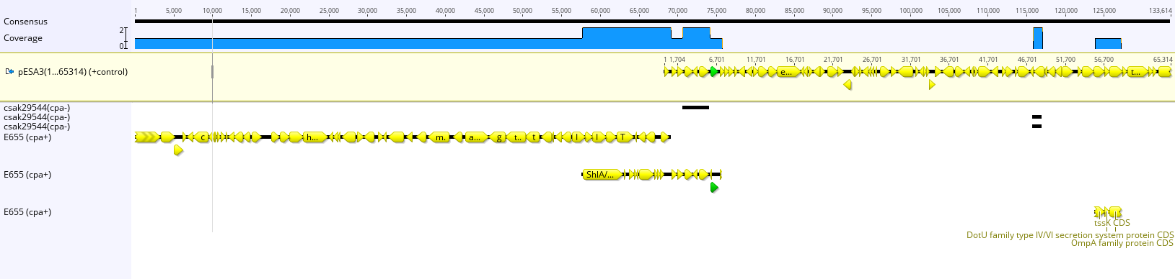
Supplementary Figure 1. Geneious 9.1 map to reference toolkit was used to map ST8 cpa⁺ isolates against ST8 cpa⁻. pESA3 plasmid sequence (1…65314 bp) was used as a positive control, and CSAK29544_1p plasmid sequence as a negative control. Because the latter plasmid sequence does not share homology with flanking regions of cpa gene cluster, then it did not map and is not shown in the alignment. Minimum mapping quality was set to 20 meaning a 99% minimum confidence that the mapping is correct. Minimum support for structural variant discovery for reads to use during the next iteration was set to 2. Blue bar (top) signifies % coverage between mapped regions and reference sequence (pESA3).
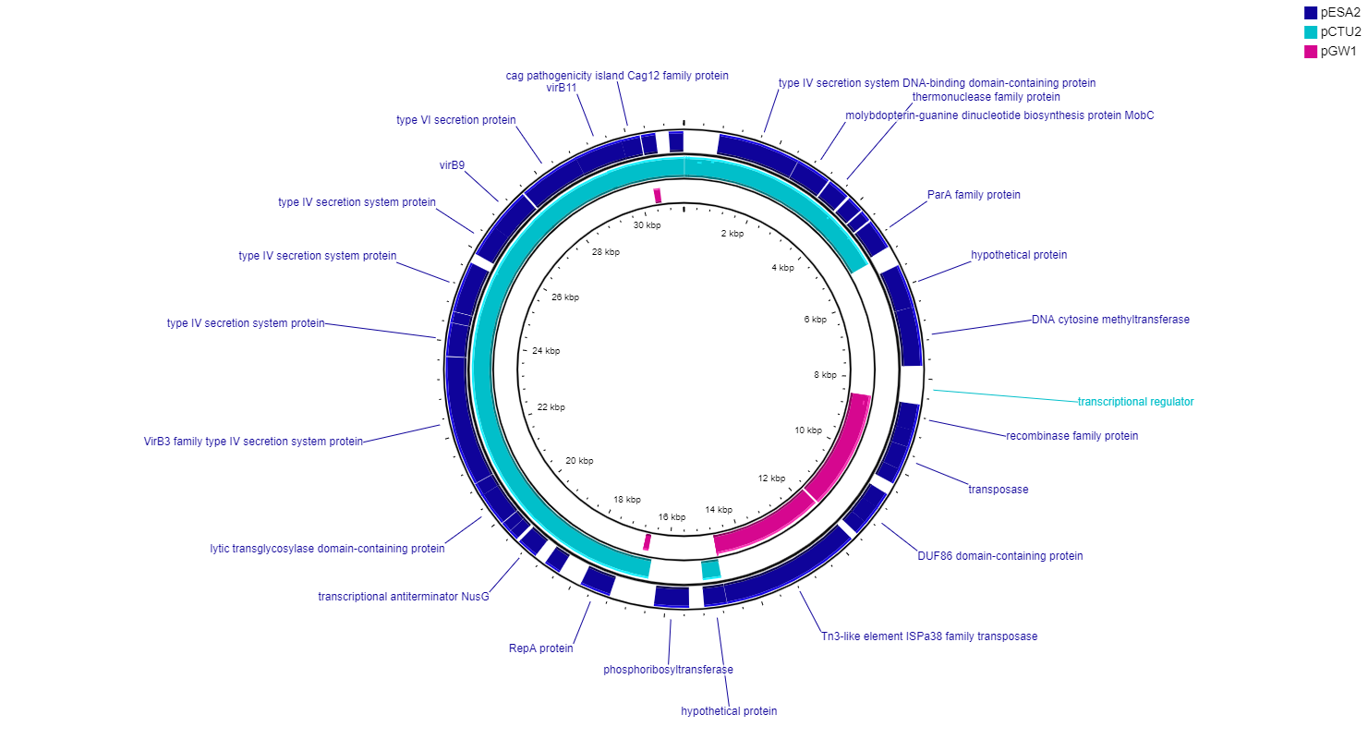
Supplementary Figure 2. Cronobacter Conjugative Type IV plasmids as analyzed using the PROKSEE Server from the Stothard Research Group. PROKSEE uses BLAST analysis to illustrate conserved and missing genomic sequences (available online: https://beta.proksee.ca/tools). Sequence alignment of Conjugative-Type IV plasmid class members produced on the PROKSEE Server from the Stothard Research Group that uses BLAST analysis to illustrate conserved and missing genomic sequences (available online: https://beta.proksee.ca/tools). The reference pESA2 (CDS in dark blue arranged outside ring) was downloaded as a GFF file and analyzed on the PROKSEE server using the default settings. If pGW1 shares any significant sequence similarity with the other two members of the Conjugative-Type VI class members, pESA2 and pCTU2, it is from 8527...11677 bp (%ID=99.6). On each of the circular genomes, missing sections detected by the BLAST analysis on the CGView server are displayed as ‘gaps.'

Supplementary Table 2. Cronobacter strains evaluated in this study.ª
[See Attachement]

Supplementary Table 3. Cronobacter isolates evaluated by species for presence of Cronobacter plasmids. ª
 | Number of Strains by Species with Origin of Replication Gene for Plasmid
Plasmid | C. sakazakii | C. dublinensis | C. malonaticus | C. muytjensii | C. turicensis | C. universalis | C. condimenti
pCCO1 | 1 | 0 | 0 | 0 | 0 | 0 | 2
pCDU1 | 3 | 19 | 0 | 0 | 0 | 0 | 0
p1 | 0 | 0 | 38 | 0 | 0 | 0 | 0
p2 | 162 | 5 | 12 | 2 | 9 | 0 | 0
pCMA1 | 0 | 0 | 38 | 0 | 0 | 0 | 0
pCMA2 | 162 | 5 | 12 | 2 | 9 | 0 | 0
CmuyJZ38_p1 | 0 | 0 | 0 | 1 | 0 | 0 | 0
CmuyJZ38_p2 | 0 | 0 | 0 | 6 | 0 | 0 | 0
CSAK29544_1p | 464 | 0 | 5 | 0 | 0 | 0 | 0
CSAK29544_2p | 206 | 2 | 13 | 0 | 1 | 0 | 0
CSAK29544_3p | 162 | 5 | 12 | 2 | 9 | 0 | 0
p505108-MDR | 31 | 0 | 3 | 0 | 0 | 0 | 0
p505108-NDM | 1 | 0 | 0 | 0 | 0 | 0 | 0
p505108-T6SS | 488 | 0 | 5 | 0 | 0 | 0 | 0
pCS1 | 140 | 0 | 3 | 0 | 0 | 0 | 0
pCS2 | 486 | 0 | 5 | 0 | 0 | 0 | 0
pCS3 | 162 | 5 | 12 | 2 | 9 | 0 | 0
pCSA2 | 224 | 2 | 14 | 1 | 2 | 0 | 0
pCsaCS09a | 488 | 0 | 5 | 0 | 0 | 0 | 0
pESA2 | 11 | 0 | 0 | 0 | 0 | 0 | 0
pESA3 | 488 | 0 | 5 | 0 | 0 | 0 | 0
pGW1 | 5 | 0 | 1 | 0 | 0 | 0 | 0
pGW2 | 200 | 0 | 0 | 0 | 0 | 0 | 0
pH322_1 | 140 | 0 | 3 | 0 | 0 | 0 | 0
pH322_2 | 113 | 0 | 4 | 0 | 0 | 0 | 0
pSP291-1 | 486 | 0 | 5 | 0 | 0 | 0 | 0
pSP291-2 | 162 | 5 | 12 | 2 | 9 | 0 | 0
pSP291-3 | 61 | 0 | 4 | 0 | 0 | 0 | 0
pCTU1 | 1 | 0 | 0 | 1 | 17 | 0 | 0
pCTU2 | 14 | 0 | 0 | 0 | 3 | 0 | 0
pCTU3 | 161 | 5 | 12 | 2 | 9 | 0 | 0
pCUNV1 | 0 | 0 | 0 | 0 | 1 | 3 | 0
ª Origin of replication gene, repA or repB of each plasmid located in various Cronobacter isolates, sorted by species.

Supplementary Table 4. Cronobacter isolates evaluated by ST for presence of Cronobacter plasmids.^{a,b}
 | Number of Strains by Sequence Type with Origin of Replication Gene for Plasmid
Species | C. sakazakii |  |  |  |  | C. dublinensis |  | C. malonaticus |  |  | C. muytjensii |  |  | C. turicensis |  |  | C. universalis |  | C. condimenti
Sequence Type  (Total) | 1  (148) | 4  (192) | 8  (28) | 64  (31) | 83  (25) | 106  (4) | 79  (3) | 60  (5) | 7  (20) | 129  (5) | 546  (3) | 81  (1) | 294  (1) | 19  (5) | 32  (4) | 569  (2) | 54  (3) | 622  (1) | 98  (1)
pCCO1 | 1 | 0 | 0 | 0 | 0 | 0 | 0 | 0 | 0 | 0 | 0 | 0 | 0 | 0 | 0 | 0 | 0 | 0 | 1
CmuyJZ38_p2 | 0 | 0 | 0 | 0 | 0 | 0 | 0 | 0 | 0 | 0 | 2 | 0 | 1 | 0 | 0 | 0 | 0 | 0 | 0
pCDU1 | 0 | 0 | 0 | 0 | 0 | 4 | 3 | 0 | 0 | 0 | 0 | 0 | 0 | 0 | 0 | 0 | 0 | 0 | 0
CSAK29544_1p | 134 | 179 | 25 | 29 | 1 | 0 | 0 | 0 | 4 | 1 | 0 | 0 | 0 | 0 | 0 | 0 | 0 | 0 | 0
p2 | 2 | 110 | 21 | 2 | 0 | 0 | 0 | 0 | 9 | 3 | 1 | 0 | 1 | 3 | 0 | 2 | 0 | 0 | 0
pCMA2 | 2 | 110 | 21 | 2 | 0 | 0 | 0 | 0 | 9 | 3 | 1 | 0 | 1 | 3 | 0 | 2 | 0 | 0 | 0
p1 | 0 | 0 | 0 | 0 | 0 | 0 | 0 | 4 | 12 | 4 | 0 | 0 | 0 | 0 | 0 | 0 | 0 | 0 | 0
pCMA1 | 0 | 0 | 0 | 0 | 0 | 0 | 0 | 4 | 12 | 4 | 0 | 0 | 0 | 0 | 0 | 0 | 0 | 0 | 0
CmuyJZ38_p1 | 0 | 0 | 0 | 0 | 0 | 0 | 0 | 0 | 0 | 0 | 0 | 0 | 0 | 0 | 0 | 0 | 0 | 0 | 0
pESA2 | 3 | 1 | 0 | 0 | 0 | 0 | 0 | 0 | 0 | 0 | 0 | 0 | 0 | 0 | 0 | 0 | 0 | 0 | 0
pGW1 | 1 | 0 | 0 | 1 | 1 | 0 | 0 | 0 | 0 | 0 | 0 | 0 | 0 | 0 | 0 | 0 | 0 | 0 | 0
CSAK29544_2p | 37 | 93 | 22 | 3 | 9 | 0 | 0 | 4 | 4 | 3 | 0 | 0 | 0 | 0 | 0 | 0 | 0 | 0 | 0
pCSA2 | 40 | 105 | 22 | 3 | 9 | 0 | 0 | 4 | 4 | 3 | 1 | 0 | 0 | 0 | 0 | 0 | 0 | 0 | 0
pSP291-3 | 18 | 24 | 1 | 0 | 6 | 0 | 0 | 3 | 0 | 0 | 0 | 0 | 0 | 0 | 0 | 0 | 0 | 0 | 0
p505108-MDR | 7 | 14 | 3 | 1 | 1 | 0 | 0 | 0 | 2 | 0 | 0 | 0 | 0 | 0 | 0 | 0 | 0 | 0 | 0
p505108-NDM | 1 | 0 | 0 | 0 | 0 | 0 | 0 | 0 | 0 | 0 | 0 | 0 | 0 | 0 | 0 | 0 | 0 | 0 | 0
p505108-T6SS | 134 | 179 | 25 | 29 | 1 | 0 | 0 | 0 | 4 | 1 | 0 | 0 | 0 | 0 | 0 | 0 | 0 | 0 | 0
CSAK29544_3p | 2 | 110 | 21 | 2 | 0 | 0 | 0 | 0 | 9 | 3 | 1 | 0 | 1 | 3 | 0 | 2 | 0 | 0 | 0
pCS1 | 12 | 63 | 0 | 13 | 8 | 0 | 0 | 0 | 1 | 2 | 0 | 0 | 0 | 0 | 0 | 0 | 0 | 0 | 0
pCS3 | 2 | 110 | 21 | 2 | 0 | 0 | 0 | 0 | 9 | 3 | 1 | 0 | 1 | 3 | 0 | 2 | 0 | 0 | 0
pH322_1 | 12 | 63 | 0 | 13 | 8 | 0 | 0 | 0 | 1 | 2 | 0 | 0 | 0 | 0 | 0 | 0 | 0 | 0 | 0
pSP291-2 | 2 | 110 | 21 | 2 | 0 | 0 | 0 | 0 | 9 | 3 | 1 | 0 | 1 | 3 | 0 | 2 | 0 | 0 | 0
pCS2 | 134 | 179 | 25 | 29 | 1 | 0 | 0 | 0 | 4 | 1 | 0 | 0 | 0 | 0 | 0 | 0 | 0 | 0 | 0
pCsaCS09a | 134 | 179 | 25 | 29 | 1 | 0 | 0 | 0 | 4 | 1 | 0 | 0 | 0 | 0 | 0 | 0 | 0 | 0 | 0
pESA3 | 134 | 179 | 25 | 29 | 1 | 0 | 0 | 0 | 4 | 1 | 0 | 0 | 0 | 0 | 0 | 0 | 0 | 0 | 0
pCUNV1 | 0 | 0 | 0 | 0 | 0 | 0 | 0 | 0 | 0 | 0 | 0 | 0 | 0 | 0 | 0 | 0 | 3 | 1 | 0
pGW2 | 130 | 2 | 0 | 0 | 1 | 0 | 0 | 0 | 0 | 0 | 0 | 0 | 0 | 0 | 0 | 0 | 0 | 0 | 0
pH322_2 | 3 | 3 | 0 | 29 | 23 | 0 | 0 | 0 | 4 | 0 | 0 | 0 | 0 | 0 | 0 | 0 | 0 | 0 | 0
pSP291-1 | 134 | 179 | 25 | 29 | 1 | 0 | 0 | 0 | 4 | 1 | 0 | 0 | 0 | 0 | 0 | 0 | 0 | 0 | 0
pCTU2 | 3 | 2 | 0 | 0 | 0 | 0 | 0 | 0 | 0 | 0 | 0 | 0 | 0 | 3 | 0 | 0 | 0 | 0 | 0
pCTU3 | 2 | 110 | 21 | 2 | 0 | 0 | 0 | 0 | 9 | 3 | 1 | 0 | 1 | 3 | 0 | 2 | 0 | 0 | 0
pCTU1 | 0 | 0 | 0 | 0 | 0 | 0 | 0 | 0 | 0 | 0 | 1 | 0 | 0 | 3 | 4 | 2 | 0 | 0 | 0
ª Origin of replication gene, repA or repB of each plasmid located in various Cronobacter isolates, sorted by sequence type.
^{b} Prevalence-based Cronobacter ST isolates were analyzed.

