Methane Emissions Vary by Rainfall in Wetland and are Mediated by Vegetation

Authors: Chloë Kesey, Sean Sharp, Margaret Palmer

Affiliations:
Department of Entomology, University of Maryland, College Park, MD 20742, USA

Abstract
Investigating the effects of rainfall on methane emissions within wetlands, and the effect of the presence of vegetation. We measured methane flux using floating chambers with 3 replicates in two patches: Open Water (OPW) and Submerged Aquatic Vegetation (SAV), before and after storm events. Dissolved methane concentration was also investigated using Rhizons at two different depths (Shallow and Deep) with 3 replicates in OPW and SAV patches. We observed a trend that methane flux decreased after storms in the SAV patch, with an average difference of -114.18 ± 89.88 mg/m²/hr before and after, but the OPW patch’s mean and variance highly overlapped, seeming negligent with a mean difference of -4.28 ± 15.69 mg/m²/hr. For the dissolved methane, we found that the SAV patches generally increased in dissolved methane concentration, the Shallow depth average difference of 0.41 ± 0.23 𝛍mol/l before and after, while the deep had 41.34 ± 36.84 𝛍mol/l before and after. The dissolved methane in the OPW patches also highly overlapped, seeming negligent with a Shallow depth average difference of -0.45 ± 0.31 𝛍mol/l, and a Deep depth average difference of -4.89 ± 17.01 𝛍mol/l. A potential explanation for the negligent results from the OPW patch could be due to its fast methane recharge rate. While in the SAV patch, diffusive transport and pressurized gas flow can occur, releasing methane in the upper part of the water column. Increased photosynthesis after storm events could also lead to increased gas transport through plant tissue. This study shows that storm events can have important effects on wetland methane flux and complex interactions with vegetation.

Introduction
The greenhouse effect occurs when atmospheric gasses, such as carbon dioxide (CO₂), methane (CH₄), nitrous oxide (N₂O), and chlorofluorocarbons (CFCs), create an insulating layer in the atmosphere and trap the heat produced by solar radiation against the earth. The combined atmospheric concentration of these greenhouse gasses has increased over the decades, contributing to global warming and rising temperatures (Lamb et al., 2021). Methane plays a large part in the greenhouse gas effect as it has 25x more global warming potential than carbon dioxide over 100 years (Bridgham et al., 2013). Methane emissions are partly due to human activity, such as burning fossil fuels for energy, industrial agriculture, and consumer waste (Lamb et al., 2021). There are also natural contributors of methane, the largest of which are wetlands with estimated median emissions of 164 Tg yr (Bridgham et al., 2013).
Methane is produced by microbes (i.e. methanogens) requiring anaerobic conditions and a source of organic carbon (Mobilian & Craft, 2022). Thus, wetlands rich in organic matter with flooded and anoxic soils that stifle aerobic decomposition are ideal environments for methanogens and methane production (Bartlett & Harriss, 2003). Methane is mostly produced in sediments at anoxic sites through the mineralization of organic matter (Tittel et al., 2019). Methane then enters the atmosphere through 3 main pathways: physical diffusion (slow and constant), ebullition (fast and episodic), and transportation through plant tissues (fast and constant) (Bridgham et al., 2013). Diffusion rates are affected by factors such as near-surface turbulence, increasing winds, concentration gradients and the diffusion medium (i.e. overlying soil and water depth; McClure et al., 2020). However, gas diffuses through water about 10,000 times slower than it does through air and methane emissions are limited by this slow rate of diffusion (Cussler, 2009). Ebullition allows methane to quickly reach the atmosphere, limiting contact time with aerobic zones or methanotrophic bacteria that oxidation and consume methane. Ebullition rates are related to water depth, confining layers that prevent diffusion resulting in methane accumulation in bubbles (e.g. plant litter), and physical disturbances that cause trapped bubbles to be released (Whelan, 2005). Methane transport through aerenchyma or other plant tissues also allows methane to bypass oxygenated zones or hotspots of methanotrophy, but is less episodic than ebullition (Bridgham et al., 2013). This plant-mediated transport can be affected by plant physiology that varies across plant species and functional types, response to environmental conditions including increasing temperature and atmospheric CO₂ concentrations, and timing of plant emergence and senescence (Noyce and Megonigal, 2021). Specifically, the rate of methane transportation through plant tissue is affected by plant characteristics such as the plant’s capacity to generate positive pressure in shoot tissues, resistance to flow in aerenchyma tissue, and environmental conditions affecting leaf-to-air gradients depending on humidity and temperature (Colmer, 2003).
Wetlands exist across a range of conditions characterized by their vegetation, climate, and hydrology which each affect methane diffusion, ebullition, and plant-mediated transport differently (Cowardin et al., 1979). The role of climate and weather in mediating methane flux, include rain, wind, surface turbulence, flow around vegetation, and wind-induced movement of emergent vegetation, has received little attention. Rain-induced air-water exchange significantly enhances the rate of gas across the air-water interface and is mainly caused by turbulence driven exchange (Ho et al., 2000). In addition to increasing the turbulence on the water surface, rain also affects heat flux because rain is often colder than the water surface (Ho et al., 2018). It reasons that the higher the intensity of the storm and the longer the duration of rainfall, the more turbulence and gas exchange will occur. Storm events could also interact with many other mediators of methane dynamics, including plant or microbial processes, causing methane flux after storms with varying degrees of duration and intensity to respond nonlinearly. Yet, due to limitations in current monitoring techniques, including interference caused by water causes on optical methane sensors, bursts of emissions caused by storms could be underrepresented in global methane flux estimates (Nemitz et al., 2018)
Vegetation may also have a role in modulating methane emissions during storm events that disturb and mix the surface of the water. In wetlands, rain contributes significantly to gas exchange and submerged vegetation can act as a barrier for air-water gas exchange (Ho et al., 2018). Emergent vegetation can also affect air-water exchange by sheltering the water surface from wind, increasing hydraulic turbulence due to water flowing around stems, and wind-induced plant movement (Ho et al., 2018). Vegetation is known to mitigate rainfall intensity in upland ecosystems resulting in decreased soil erosion (Bochet, Poisen, and Rubio, 2006). It reasons that vegetation also buffers surface water from rain disturbance by baffling water movement, mixing in the water column, and reducing methane emissions to the atmosphere.
The objective of my research is to determine if storm events result in episodic pulses of methane emissions in wetlands, and whether the presence of submerged vegetation decreases or enhances the effect of the rain. I predict that more methane will be emitted before a storm event than after because rain will disturb the water surface, causing more mixing with the overlying atmosphere and releasing a pulse of methane. This results in less dissolved methane in the soil and overlying water column, a weaker diffusion gradient from water to atmosphere, and less emissions. Furthermore, I predict dissolved methane concentrations will also be lower after a storm event, as higher rates of methane emissions reduce surface water methane concentrations. Finally, I predict that the presence of submerged aquatic vegetation will lead to lower levels of methane emission from the water during storm events as the vegetation will buffer the rain disturbance and decrease the penetration of rain droplets compared to unvegetated open water areas, leading to comparatively high levels of emissions after the storm compared to the OPW Patches. I will conduct this experiment through a series of field observations and sample collections in wetland patches at two different depths with and without vegetation. Due to difficulty measuring flux during summer thunderstorms, I will account for methane flux using a mass balance approach to estimate methane lost during storm events by estimating the difference in methane concentrations and fluxes before and after storms.

Methodology
Study Site
The study was done in an approximately 9-hectare freshwater emergent wetland on the Delmarva Peninsula (35.055° N, 75.753° W), with dominant vegetation patches including sedges, grasses, low-growing forbs, aquatic vegetation, and open water (Yepsen et al. 2014). Other biota include algal mats that develop on the surface of the water capable of trapping the gas emissions underneath (SJ Sharp pers. comm). The annual precipitation in this region is approximately 110 cm, and the average summer and winter temperatures are 24°C and 2.5°C (1985-2010 at Goldsboro, MD; PRISM climate mapping system). This wetland was previously drained and converted to pastureland in the 1980s and was restored in 2003 (Samson et al., 2011).

Sampling Dissolved Methane
To test the effect of rain on wetland methane emissions and how vegetation might influence this, I sampled overlying water in the flooded wetland for dissolved methane concentrations (𝛍mol/l) before and after storm events in unvegetated (OPW) and vegetated (SAV) patches with 3 replicate plots of each patch type. OPW patches were largely devoid of any vegetation while SAV patches were characterized by dense submerged aquatic vegetation dominated by Juncus repens, Persicaria spp. and Proserpinica spp. All field sampling was done no more than 5 hours before and 3 hours after rainstorms. Sampling plots were established along a transect with a permanent boardwalk to prevent any disturbance to the soil or overlying water column. I only sampled when plots had standing water (27-69 cm deep). To test the effect of vegetation on the penetration of rain disturbance into the water column, I sampled water at two depths: one near the sediment bottom (Deep) and one near the surface of the water (Shallow). Deep water samples were collected 5 cm above the soil surface and Shallow water samples were collected 5 cm below the water surface in each replicate of both patch types for 4 storms throughout the season. Before I began sampling, I conducted the same experiment twice to see how fast dissolved methane concentration would recover from a physical disturbance. I took an initial measurement, and then disturbed the surface water and took samples at 5, 30, and 60 minutes after (Figure 5).
To exclude large suspended particulate matter, water samples were collected using submerged Rhizons (Rhizoshpere Research Products, Wageningen, The Netherlands) connected to 60 mL syringes. The dissolved methane was extracted from the collected water using the Headspace Equilibrium Kling method, which was conducted within 2 hours of sampling (Kling, Kipphut, & Miller, 1991). The method uses two 60 mL syringes fitted with three-way stopcocks. First, a syringe was completely rinsed with sample water with no air bubbles. Next, I collected 60 mLs of sample water and expelled 30 mLs of the water. Then, I drew 30 mLs of ambient air, closed the air valve, and shook the syringe for two minutes. In some cases, it wasn’t possible to collect 60 mLs, in which case I drew in the same amount of ambient air as there was in the syringe. Next, I attached a dry syringe to the side port of the wet syringe, opened the dry stopcock, and turned the wet syringe toward the dry syringe, so that the gas from the wet syringe entered the dry syringe. Then, I flushed the dry syringe and took another gas sample using the dry syringe plunger until the water in the wet syringe began to bubble and closed and detached the syringes. Finally, I attached a needle to the dry stopcock, flushed out the needle, and put the air sample into an evacuated vial for testing. The samples were transported to the University of Maryland, College Park, MD, in exetainer vials and then analyzed for methane concentrations (𝛍mol/l) using a gas chromatograph within a week (SRI 8610c, SRI Instruments, Torrance, CA, USA). The gas samples maintained stable over this period, as samples stored in glass vials with silicone septums have been found to maintain a vacuum level of 98% after 136 days (Rochette & Bertrand, 2003).

Sampling Atmospheric Methane
Similarly, to the sampling of dissolved methane, I measured methane emissions <5 hours before and <2 hours after a storm event. Here, floating flux chambers were used to measure methane flux. The floating chambers were 40cm x 40cm x 40cm constructed with clear plastic walls, with floatation devices on the sides, equipped with temperature and humidity sensors, battery-powered fans, and a sampling port at the top. Gas samples were collected every 10 minutes during 30-minute chamber incubations and measured for methane concentrations in the lab. I used a hypodermic needle attached to a 60 mL syringe with a three-way stopcock to take the samples from the sampling port. I carefully lowered chambers onto the water surface to minimize water disturbance and closed the chamber stopcock to initiate the 30-minute incubation period. Next, using a flushed-out 60 mL syringe, I drew in 30 mL chamber air into the syringe, taking care to keep the incubation chamber sealed. Then, the samples were put into pre-evacuated 12 mL vials. The methane concentrations (𝛍mol/l) were measured from each sample using a gas chromatograph (SRI 8610c, SRI Instruments, Torrance, CA, USA) correcting for chamber volume, atmospheric pressure, and air temperature. Sample concentrations were then used to estimate emission rates by plotting gas concentrations through the incubation period and using the slope of a linear function to estimate the rate of methane flux (mg/m²/hr) for each chamber.
To account for the presence and absence of vegetation and its effect on methane emissions, I visually estimated the vegetation cover in each plot using 0.25m² quadrats. The amount of plant biomass can have a density-dependent influence on gas dynamics and rainfall disturbance in the water column with denser patches buffering disturbance more than less dense patches. Providing each plot with a corresponding vegetation cover value also helps standardize for variability between patches and plots and will link vegetation cover to the dissolved gas samples.

Rainfall Data
To track weather events, I used NOAA weather monitoring software (National Weather Service). I accounted for variation in storm events and subsequent methane flux using rainfall intensity (mm precipitation/hr) and duration (hrs). I calculated these metrics by using precipitation totals and storm duration obtained from a tipping bucket rain gauge (Texas Electronics TR-525M) attached to a LI-COR eddy covariance system (unpublished data). Dissolved oxygen was also obtained from DO sensors already in place (unpublished data).

Statistical analysis
To test for the effect of storm events on dissolved methane concentration and flux, I used a two-sample t-Test to compare dissolved methane concentration before and after storm events in both OPW and SAV patches and at both Shallow and Deep depths, with P<0.05 from this test considered to be significant. I also used a Paired Sample t-Test to compare methane concentration and fluxes before and after on individual sampling dates in OPW and SAV patches. All analyses and visualization were performed in Microsoft Excel.

Results
Wetland Conditions
Water depth was deepest in the OPW patches ranging from 35.5 to 69.0 cm, and shallowest in the SAV patches ranging from 32.5 cm to 48.3 cm. Sampling date 8/21/22 was omitted from my analyses of dissolved gas as water was 11-21 cm deep in OPW and at the soil surface in SAV, two low to collect water samples. In this sampling campaign, only OPW chamber measurements were taken. The water temperature (mean ± S.E.) was 30.5 °C ±0.82 °C (mean ± S.E.).

Table 1. Rainfall totals, duration, and storm intensity of storms sampled.
Date | Rainfall Total (mm) | Duration (hrs) | Intensity (mm/hr)
6/22-23/22 | 12.6 | 19 | 0.66
6/27/22 | 10.8 | 2 | 5.4
7/6-7/22 | 7.2 | 13 | 0.55
8/22-23/22 | 14.4 | 7 | 2.06

Methane Across Patches
Overall, I found greater differences of flux (mean ± S.E.) before and after storms in SAV patches (before: 88.77 ± 31.64 mg/m²/hr, after:-25.41 ± 60.92 mg/m²/hr, average difference: -114.18 ± 89.88 mg/m²/hr) compared to OPW patches (before: 23.00 ± 9.96 mg/m²/hr, after:18.74 ± 14.67 mg/m²/hr, average difference: -4.28 ± 15.69 mg/m²/hr; Fig 1.), with both patches fluxing more negatively after storms. Unlike OPW patches, which were consistent methane emitters before and after storms, SAV patches flipped from an average positive flux (methane emitter) before the storm to an average negative flux (methane absorber) after the storm.
I also found dissolved methane concentrations generally increased in SAV patches at both sampling depths after storms while decreasing in OPW patches (Fig 3). At Shallow depths, the difference in concentrations was less in SAV patches (before: 0.32 ± 0.10 𝛍mol/l, after: 0.72 ± 0.23 𝛍mol/l, average difference: 0.41 ± 0.23 𝛍mol/l) than OPW patches (before: 0.75 ± 0.31 S.E. 𝛍mol/l, after: 0.30 ± 0.05 𝛍mol/l, average difference: -0.45 ± 0.31 𝛍mol/l; Fig 3). However, at Deep depths, SAV differed more on average before and after storms (before: 54.08 ± 14.69 𝛍mol/l, after: 95.42 ± 32.93 𝛍mol/l, average difference: 41.34 ± 36.84 𝛍mol/l) compared to OPW (before: 63.64 ± 27.59 𝛍mol/l, after: 58.75 ± 22.37 𝛍mol/l, average difference: -4.89 ± 17.01; Fig 3).

Figure 1. Box plots representing the difference in methane flux from surface water in open water (OPW) and submerged aquatic vegetation (SAV) patches before and after storms. Positive values indicate higher fluxes after storm events.

Figure 2. Box plots representing methane flux in open water (OPW) and submerged aquatic vegetation (SAV) wetland patches before and after storm events (OPW on left, SAV on right).

Figure 3. Box plots representing the difference in methane concentration between open water (OPW) and submerged aquatic vegetation (SAV) patches before and after storms at Deep (D) and Shallow (S) sampling depths (Shallow on left, Deep on right). Positive values indicate higher concentrations after storm events.

Open Water
Methane flux in OPW patches differed across the two storms sampled, increasing after the storm on 7/6/22 (storm intensity, SI: 0.55 mm/hr) and decreasing after the storm on 8/21/22 (SI: 2.06 mm/hr). However, due to a particularly dry summer, water levels were significantly lower at the later date which likely interacted with the storm event differently than during the wetter July sampling (Figure 2). Dissolved methane concentrations in the Shallow depths had much lower concentrations of methane overall (0.16-1.52 𝛍mol/l) than the Deep depths (0.18-175.34 𝛍mol/l; Fig 4). In the OPW Shallow depth, dissolved methane concentrations increased after the storm event on the first sampling event (6/22/22, SI: 0.66 mm/hr) while decreasing after subsequent storm events (6/27/2022; SI: 5.40 mm/hr, 7/6/2022; SI: 0.55 mm/hr). OPW Deep depths had similarly inconsistent temporal patterns with concentrations decreasing after the first storm event (6/22/22), increasing after subsequent storms, and exhibiting much higher variation than Shallow depth samples (Figure 4).

Figure 4. Box plots representing dissolved methane concentrations in open water (OPW) and submerged aquatic vegetation (SAV) Shallow and Deep wetland patches before and after storms (OPW on the left, SAV on the right).

Submerged Aquatic Vegetation
In SAV patches methane flux decreased after both storm events sampled (Figure 2). Like OPW, dissolved methane concentrations in the Deep patches had higher concentrations of methane overall (range: 8.52-279.00 𝛍mol/l) than the Shallow patches (range: 0.13-1.84 𝛍mol/l; Fig 4). In the SAV Shallow depths, we observed an increase in dissolved methane concentration after the storm events across all the sampling events (Figure 4). For SAV Deep patches, dissolved methane concentrations were higher after the first storm event (6/22/22; SI: 0.66 mm/hr) but lower after subsequent storms sampled.

Figure 5. Graph of dissolved methane concentrations at 0, 5, 30, 60 minutes after two replicate manual physical disturbance experiments.

SAV patch
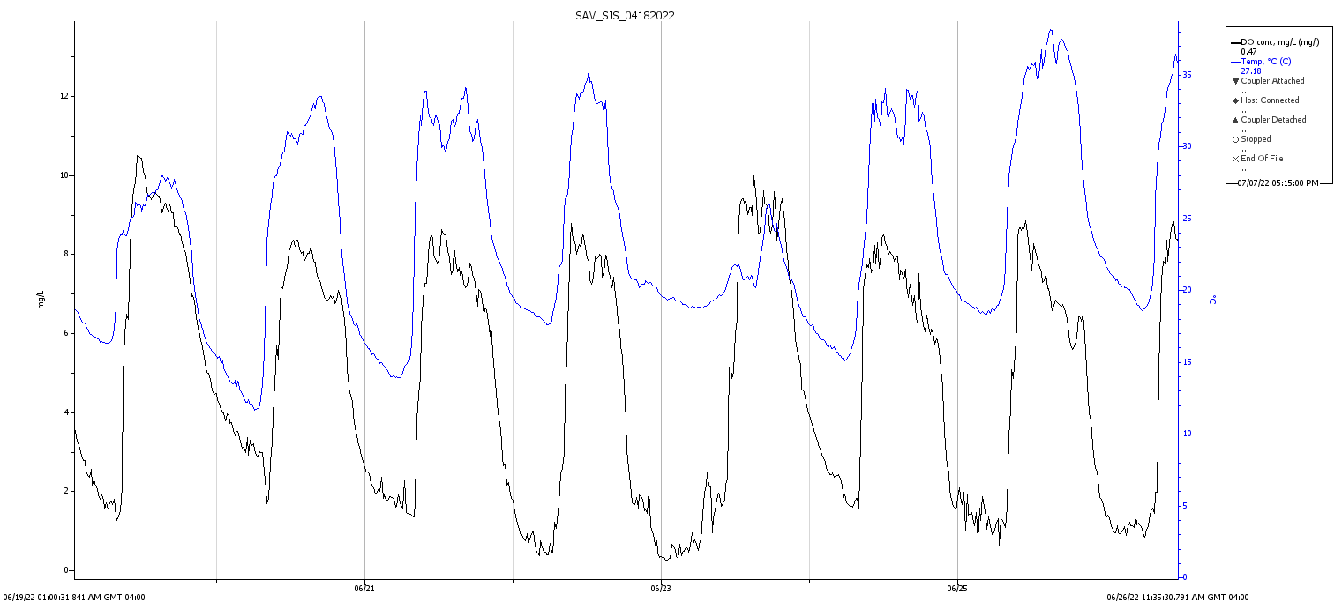
6/23/22

6/25/22

6/21/22

OPW patch
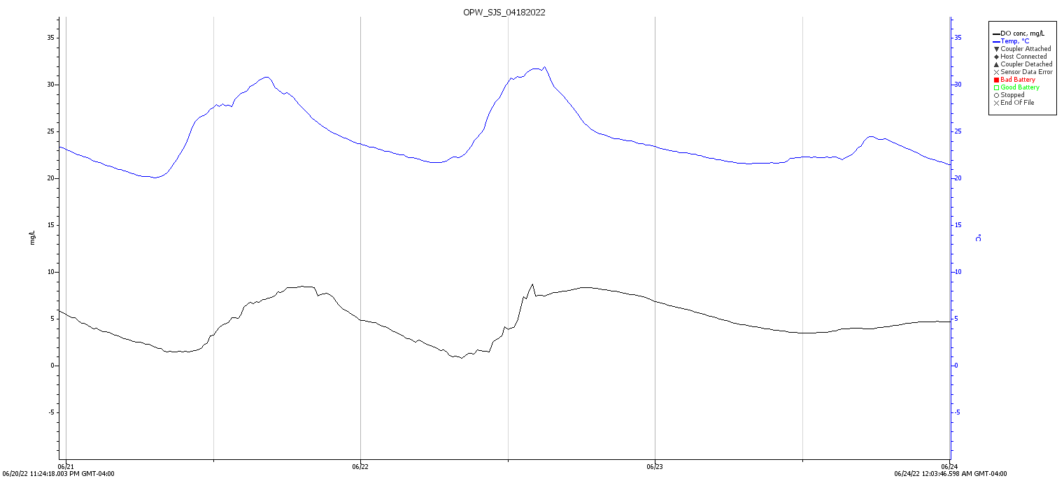
6/23/22

6/24/22

6/22/22

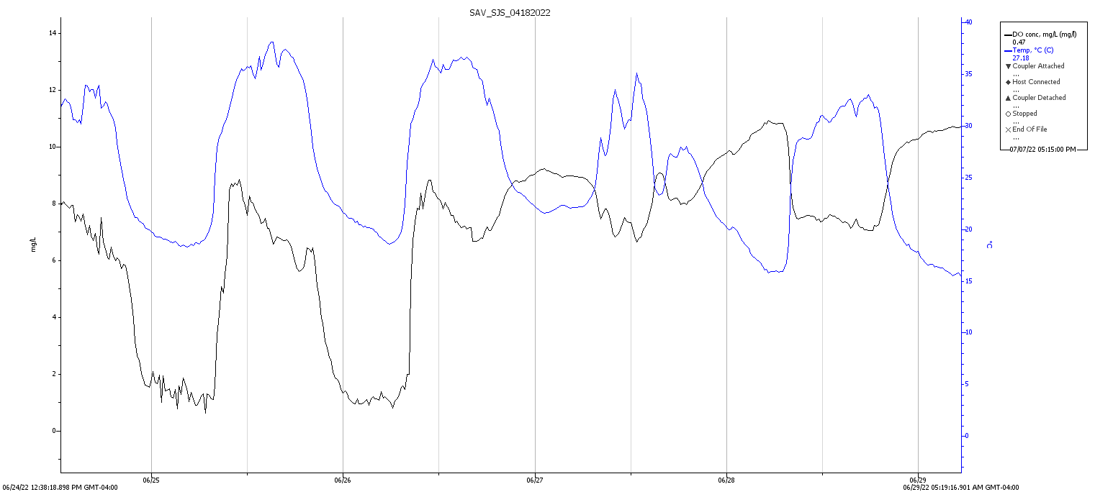
SAV patch
6/27/22

6/28/22

6/26/22

OPW patch
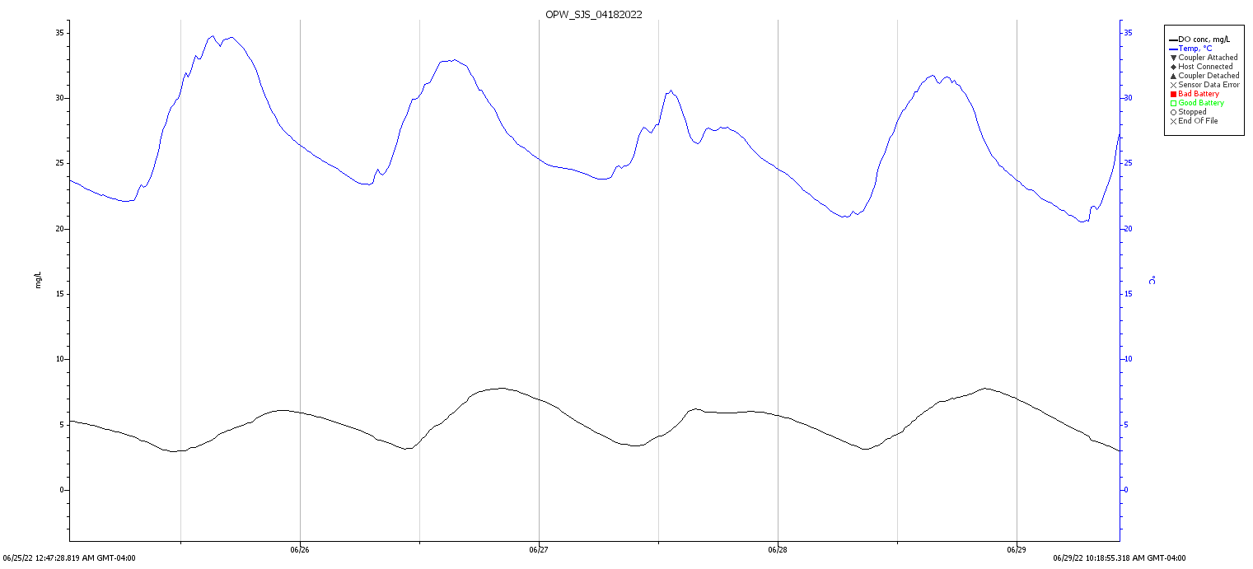
6/26/22

6/28/22

6/27/22

SAV patch
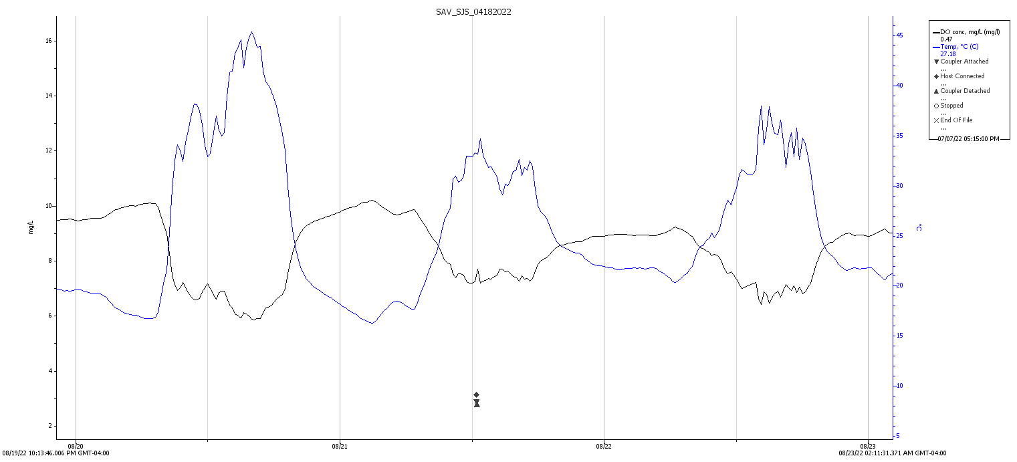
8/23/22

8/21/22

8/22/22

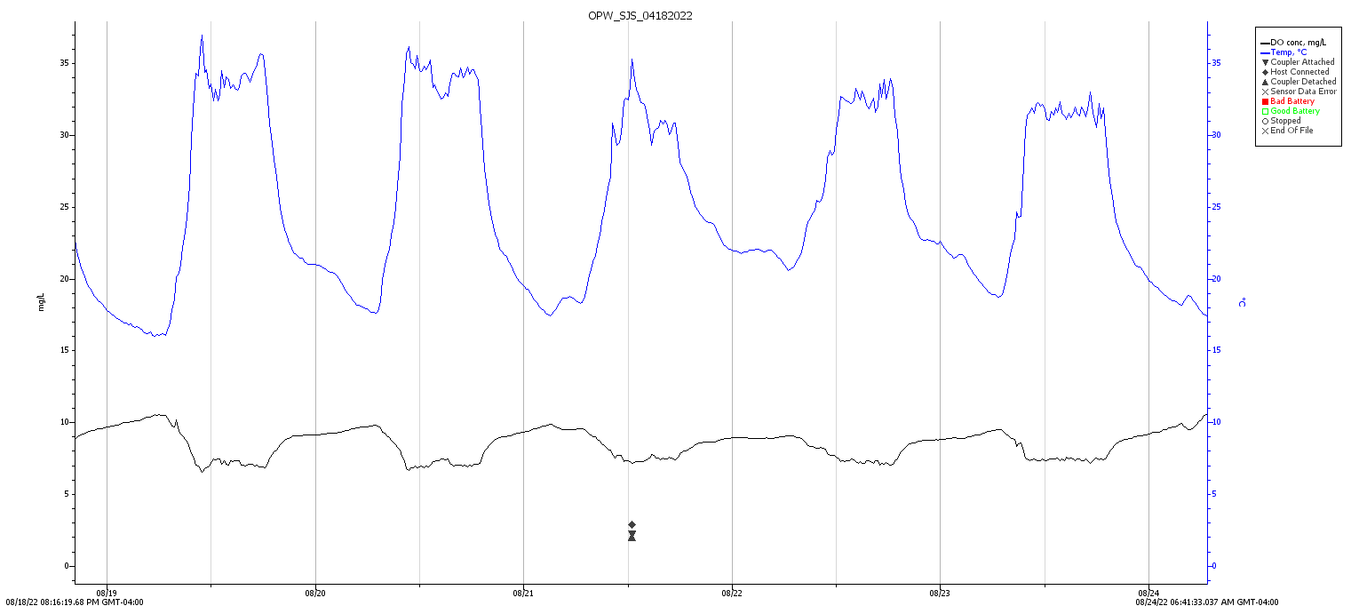
OPW patch
8/23/22

8/22/22

8/21/22

Figure 6. Dissolved oxygen concentration (mg/L) plotted with temperature (°C) over the sampled storm dates in SAV and OPW patch, excluding 7/6, which was not available. The graphs are not at the same scale, and the highlighted areas indicate estimated storm duration.

Table 2. T-test paired two sample for means of methane flux for open water and submerged aquatic vegetation patches before and after storms.
 | Variable |  | df |  | t-stat |  | P-value
OPW |  | 5 |  | 0.271 |  | 0.398
SAV |  | 4 |  | 1.27 |  | 0.136

Table 3. T-test paired two sample for means of methane concentration for open water and submerged aquatic vegetation patches Shallow samples before and after storms.
Variable | df | t-stat | P-value
OPW 6/22/22 | 1 | -4.024 | 0.078
OPW 6/27/22 | 2 | 1.277 | 0.165
OPW 7/6/22 | 2 | 2.431 | 0.068
SAV 6/22/22 | 1 | -1.093 | 0.236
SAV 6/27/22 | 1 | -10.984 | 0.029 *
SAV 7/6/22 | 2 | -1.207 | 0.175

Table 4. T-test paired two sample for means of methane concentration for open water and submerged aquatic vegetation patches Deep samples before and after storms.
Variable | df | t-stat | P-value
OPW 6/22/22 | 1 | 3.495 | 0.089
OPW 6/27/22 | 1 | -1.054 | 0.242
OPW 7/6/22 | 1 | -0.622 | 0.323
SAV 6/22/22 | 2 | -3.515 | 0.0361*
SAV 6/27/22 | 2 | 0.922 | 0.227
SAV 7/6/22 | 1 | 0.800 | 0.285

Discussion

Methane Flux Across Patches
The results show that rainfall has a substantial influence over methane flux and concentrations within wetlands. There was a trend of decreasing flux levels after a storm event in the SAV patches (Figure 1 & 2), but for OPW patches there was much overlap in the data, and differences are negligible (Figure 2). A potential issue is that the turnover of methane in the OPW patch might be too fast to capture with my measurements. In the experiments conducted before sampling, by the time an hour had passed after the manual physical disturbance, the dissolved methane concentration had largely recovered (Figure 5). However, the trend of decreasing methane flux in the SAV patch does support my hypothesis that rainfall will disturb the water surface and release pulses of methane (Whelan, 2005), but it was not statistically significant.
Interestingly, SAV had much lower flux after the storms compared to OPW (Figure 1), which contradicts my hypothesis that the vegetation would baffle the rain’s effect of mixing during the storm, leading to comparatively higher fluxes to OPW after the storm. The comparatively higher OPW flux could again be due to how quickly OPW recovers dissolved methane (Figure 5). Another effect that was not predicted was the flip in the SAV patch from methane emitter to methane absorber before and after storm events (Figure 2). Submerged aquatic vegetation may still be buffering the rain disturbance and decreasing the penetration of rain, but there may be another mechanism affecting methane emissions. It’s also possible that SAV plants are experiencing a boost in photosynthetic activity after storms, resulting from increased water clarity and removal of surface films, which I observed in field after storms. This photosynthesis boost would lead to more dissolved oxygen being released from the leaves of SAV oxidizing methane before it’s fluxed into the atmosphere (Liu et al., 2016). In fact, there was often elevated dissolved oxygen in SAV patches after storm events (SJ Sharp pers comm) Elevated DO was found during the storm event on 6/27, which was the only storm sampled that occurred during the day (Figure 6). Another possible explanation for the lowered methane flux is that the methane in the water was being consumed by methanotrophs before it could be emitted. Bacterial methanotrophy associated with macrophyte roots have been found to act as a filter-- removing methane in flux (King, 1994).

Dissolved Concentrations in Open Water
In both Shallow and Deep depths of the OPW patch, difference before and after storms are negligible (Figure 3). I had predicted that the turbulence from the rainfall would induce air-water exchange significantly (Ho et al., 2000). However, based on the experiment to see how fast methane recovers after a disturbance it’s possible that the methane had recovered by the time I sampled (Figure 5). Indeed, the average difference before and after storms was close to 0 (-0.45 ± 0.31 𝛍mol/l difference before and after storms in the Shallow depth, and -4.89 ± 17.01 𝛍mol/l in the Deep depth, Figure 3) indicating that if storms caused a large pulse of methane, dissolved concentrations returned to reference conditions before my sampling period. Additionally, the dissolved methane concentrations in the Deep patches had much higher concentrations of methane overall than the Shallow patches, likely due to the proximity to the soil where methane is produced (Figure 4).

Dissolved Concentrations in Submerged Aquatic Vegetation
SAV dissolved methane concentrations in the Shallow depth generally increased after a storm, contradicting my hypothesis that methane concentration would decrease. However, in the Deep depth, 2 out of 3 sampling events show lower methane concentrations after storm events, possibly due to diffusive transport across methane concentrations after storm events, or plant mediated transport from Deep to Shallow depths. According to Vroom et al. (2022), both diffusive transport and pressurized gas flow occur in submerged aquatic vegetation. Since the SAV is underwater, it releases methane in the upper part of the water column. As these plants may become more photosynthetically active after storm events, increased gas transport through plant tissue and passive relocation of porewater methane could lead to higher concentrations in the Shallow patches (Vroom et al. 2022).
Similarly to the OPW patch, dissolved methane concentrations in the SAV Deep patches had much higher concentrations of methane overall than the Shallow patches, likewise due to the proximity to the soil where methane is produced (Figure 4).

Conclusion
This study shows that rainfall can have substantial effects on wetland methane emissions, and that vegetation can have complex effects on this process. My SAV flux findings suggest that storm events do cause pulses of methane to be released through physical disturbance, but limitations on current sampling techniques prevent me from seeing the full effect in the OPW patch. My dissolved methane results also suggest complex interactions between vegetation, rain, and methane flux. It is important to continue to study the various factors that can affect emissions of methane by its largest natural producers. Possible areas of research for the future include developing a method to sample methane flux during the storm events and better understanding the response of submerged aquatic vegetation to rain events. With this work, I stress the importance of plant influence on methane flux during rain events and encourage future research to continue focusing on the influence of episodic weather events on methane dynamics in wetlands ecosystems.

Acknowledgements
Many thanks to Aileen Taylor and Graham Stewart for their help in field sampling and laboratory assistance.
References cited
Bansal, S. et al. (2020). Vegetation Affects Timing and Location of Wetland Methane Emissions. Journal of Geophysical Research: Biogeosciences 125, e2020JG005777. DOI: 10.1029/2020JG005777.
Bartlett, K., Harriss, R., Review and assessment of methane emissions from wetlands. Chemosphere, Volume 26, Issues 1–4, 1993, Pages 261-320, ISSN 0045-6535, https://doi.org/10.1016/0045-6535(93)90427-7.
Bochet E., Poesen J., Rubio J.L. (2006) Runoff and soil loss under individual plants of a semi-arid Mediterranean shrubland: influence of plant morphology and rainfall intensity. Earth Surf. Proc. Land. 31, 536–549.
Bridgham, S. D. et al. (2013). Methane emissions from wetlands: biogeochemical, microbial, and modeling perspectives from local to global scales. Global Change Biology 19: 1325-1346.
Colmer, T.D. (2003). Long-distance transport of gases in plants: a perspective on internal aeration and radial oxygen loss from roots. Plant, Cell & Environment, 26: 17-36. https://doi.org/10.1046/j.1365-3040.2003.00846.x
Cowardin, L. M., Carter, V., Golet, F. C., & LaRoe, E. T. (1979). Classification of wetlands and deepwater habitats of the United States. US Fish and Wildlife Service, Office of Biological Services, Washington, DC, USA. DC, Pub. No. FWS/OBS, 79(31), 107.
Cussler, E.L. (2009). Diffusion: mass transfer in fluid systems. Cambridge University Press. 1-697.
Green, T., & Houk, D. (1979). The mixing of rain with near-surface water. Journal of Fluid Mechanics, 90(3), 569-588. doi:10.1017/S0022112079002408
Ho, D. T., Engel, V. C., Ferrón, S., Hickman, B., Choi, J., & Harvey, J. W. (2018). On factors influencing air-water gas exchange in emergent wetlands. Journal of Geophysical Research: Biogeosciences, 123, 178– 192. https://doi.org/10.1002/2017JG004299.
Ho, D. T., Asher, W. E., Bliven, L. F., Schlosser, P., and Gordan, E. L. (2000). On mechanisms of rain-induced air-water gas exchange. J. Geophys. Res., 105( C10), 24045– 24057, doi:10.1029/1999JC000280.
Joabsson, A., Christensen, T., & Wallén, B. (1999). Vascular plant controls on methane emissions from northern peat-forming wetlands. ScienceDirect. https://www.sciencedirect.com/science/article/pii/S0169534799016493.
King, G. M. (1994). Associations of methanotrophs with the roots and rhizomes of aquatic vegetation. American Society for Microbiology. https://doi.org/10.1128/aem.60.9.3220-3227.1994
Kling, G. W., Kipphut, G. W., & Miller, M. C. (1991). Arctic Lakes and Streams as Gas Conduits to the Atmosphere: Implications for Tundra Carbon Budgets. Science, 251(4991), 298–301. http://www.jstor.org/stable/2875261
Köppen, W. (2007). Köppen climate classification. World Map of köppen-geiger climate classification. map, St. Catharines, Ont.; Brock University Map Library.
Lamb, W., Wiedmann, T., Pongratz, J., & Andrew, R. (2021). A review of trends and drivers of greenhouse gas emissions by sector from 1990 to 2018. IOPscience. https://iopscience.iop.org/article/10.1088/1748-9326/abee4e/meta.
Liu, H. et al. (2016). Optimizations on supply and distribution of dissolved oxygen in constructed wetlands: A review. Bioresource Technology, Volume 214, Pages 797-805, ISSN 0960-8524, https://doi.org/10.1016/j.biortech.2016.05.003.
McClure, R. P., Lofton, M. E., Chen, S., Krueger, K. M., Little, J. C., & Carey, C. C. (2020). The magnitude and drivers of methane ebullition and diffusion vary on a longitudinal gradient in a small freshwater reservoir. Journal of Geophysical Research: Biogeosciences, 125, e2019JG005205. https://doi.org/10.1029/2019JG005205
Mobilian, C., Craft, C. (2022). Wetland Soils: Physical and Chemical Properties and Biogeochemical Processes Encyclopedia of Inland Waters (Second Edition), Elsevier, Pages 157-168, https://doi.org/10.1016/B978-0-12-819166-8.00049-9.
National Oceanic and Atmospheric Administration. (n.d.). National Weather Service. Retrieved from https://forecast.weather.gov/MapClick.php?lat=39.03589000000005&lon=-75.78564999999998#.ZFPmsezMLpA
Nemitz E, Mammarella I, Ibrom A, et al. Standardisation of eddy-covariance flux measurements of methane and nitrous oxide. Int. Agrophys. 2018;32(4):517-549. doi:10.1515/intag-2017-0042.
Noyce, G. and Megonigal, P. J. (2021). Biogeochemical and plant trait mechanisms drive enhance methane emissions in response to whole-ecosystem warming. Biogeosciences. 2449-2463.
Poindexter, C. M. and Varian, E. A. (2013). Gas exchange in wetlands with emergent vegetation: The effects of wind and thermal convection at the air-water interface. Journal of Geophysical Research: Biogeosciences 118: 1297-1306.
R Core Team. (2022). R: A language and environment for statistical computing. R Foundation for Statistical Computing, Vienna, Austria. https://www.R-project.org/.
Rochette, P. & Bertrand. N. (2003). Soil air sample storage and handling using polypropylene syringes and glass vials. Soils and Crops Research and Development Centre, Agriculture and Agri-Food Canada, 2560 Hochelega Blvd., Sainte-Foy, Québec, Canada G1V 2J3.
Samson, D. A., Wilson, R., & Zimmerman, J. K. (2011). Plant community composition and hydrological dynamics in created, restored, and natural depressional wetlands on the central Delmarva Peninsula. The Nature Conservancy, Bethesda, Maryland.
Temmerman, S., T. J. Bouma, G. Govers, Z. B. Wang, M. B. De Vries, and P. M. J. Herman (2005), Impact of vegetation on flow routing and sedimentation patterns: Three-dimensional modeling for a tidal marsh. J. Geophys. Res.,110, F04019, doi:10.1029/2005JF000301.
Tittel, J., Hüls, M. & Koschorreck, M. Terrestrial Vegetation Drives Methane Production in the Sediments of two German Reservoirs. Sci Rep 9, 15944 (2019). https://doi.org/10.1038/s41598-019-52288-1
USEPA Mid-Atlantic Region III. (2014). Climate change adaptation implementation plan.
Vroom, R.J.E., van den Berg, M., Pangala, S.R., van der Scheer, O.E., Sorrell, B.K. (2022). Physiological processes affecting methane transport by wetland vegetation – A review. Aquatic Botany, Volume 182, 103547, ISSN 0304-3770, https://doi.org/10.1016/j.aquabot.2022.103547.
Whelan S. C. (2005). Biogeochemistry of methane exchange between natural wetlands and the atmosphere. Environmental Engineering Science. 22(1): 73-94.
Wiegleb G. (1988). Analysis of flora and vegetation in rivers: Concepts and applications. In: Symoens JJ, Hooper S, Compere P, eds. Studies on Aquatic Vascular Plants. Brussels: Royal Botanical Society of Belgium, pp. 311-341.
Yepsen, M. et al. (2014). Agricultural wetland restorations on the USA Atlantic Coastal Plain achieve diverse native wetland plant communities but differ from natural wetlands. Agriculture, Ecosystems, and Environment 197: 11-20.

