Swing State Survey: Majorities Favor Path to Citizenship over Mass Deportation, While Strengthening the Border
October 10, 2024

Favor Deterring Illegal Border Crossings by Mandating E-Verify for Employers, While Also Increasing Number of Work Visas
As the issue of immigration figures prominently in campaigns across the country, a new survey by the Program for Public Consultation (PPC) in six swing states and nationally finds numerous policies on which majorities of Americans agree, including, in most cases, majorities of both Republicans and Democrats.

To deal with the millions of undocumented immigrants who have been living in the US, a majority in every swing state and nationally prefer offering them a path to citizenship, provided they meet several requirements, over mass deportation.

To deter illegal border crossings, swing state and national majorities favor strengthening the border and making it harder for illegal immigrants to get employment by requiring that employers use the E-Verify system. At the same time, majorities favor increasing the number of work visas to meet the demand for workers through legal channels.

Director of the Program for Public Consultation, Steven Kull, comments, “Majorities favor reforms that would reduce the number of undocumented immigrants, not via mass deportation, but by creating more legal pathways for people who want to live and work here, and by strengthening the border to make it more difficult for people to enter the country illegally.”

This survey is the ninth in a series – the Swing Six Issue Surveys – being conducted in the run-up to the November election in the swing states of Arizona, Georgia, Michigan, Nevada, Pennsylvania and Wisconsin, as well as nationally, on major policy issues. Unlike traditional polls, respondents in a public consultation survey go through an online “policymaking simulation” in which they are provided briefings and arguments for and against each policy. Content is reviewed by experts on different sides to ensure accuracy and balance. All Americans are invited to go through the same policymaking simulation as the survey sample.

Path to Citizenship vs Mass Deportation
Respondents were told that there are about 11 million people who have been living in the US without legal status, most for over a decade. They evaluated two significantly different proposals for dealing with this population – a path to citizenship and mass deportation – including strong arguments for and against each. Finally, they were asked to choose one of the proposals or neither.

Overall, majorities in every swing state prefer the path to citizenship (55-65%), which was summarized as follows:

Create a new type of visa that would be available to undocumented immigrants who have been living in the US for some years and have not committed a serious crime. They would pay a penalty, and any taxes they owe. After several years, they would be allowed to apply for citizenship. Those who do not apply or qualify for the visa would be subject to deportation.
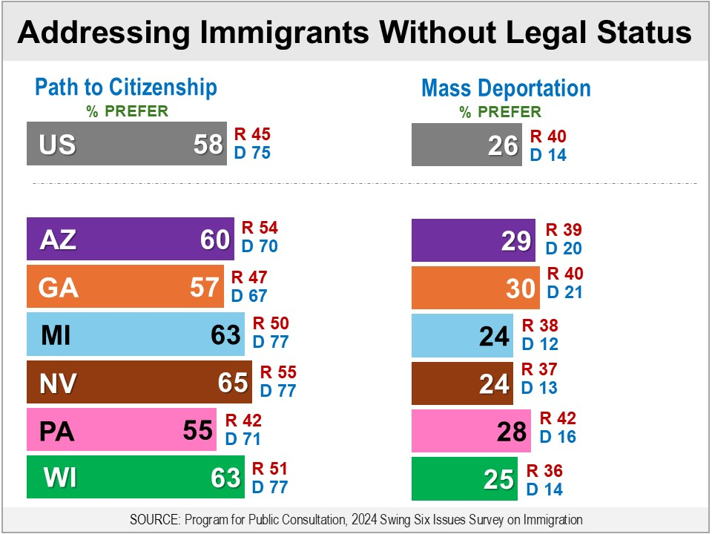
Just 24-30% in the swing states prefer mass deportation, which was summarized as follows:

Undertake a program of mass deportation throughout the country, with the goal of finding, detaining and deporting most or all of the 11 million people who have been living in the US without legal status. States would be asked to use their local law enforcement or National Guard, and the Federal government may use the military. Large facilities would be built to hold people who have been detained. The cost would be $100 billion or more.

Among Republicans, in five of the six swing states, a path to citizenship is preferred over mass deportation. Modest majorities prefer a path to citizenship in Arizona, Nevada and Wisconsin (51-55%). In Michigan, 50% prefer a path to citizenship (38% for mass deportation). In Georgia, it is 47% to 40%. Republicans In Pennsylvania are evenly divided (42% for each option).

Among Democrats, majorities in all states prefer a path to citizenship, ranging from 67% in Georgia to 77% in Michigan, Nevada and Wisconsin. It is favored by 70% in Arizona and 71% in Pennsylvania.

Nationally, 58% prefer a path to citizenship and 26% mass deportation. More Republicans prefer a path to citizenship (45%) than prefer mass deportation (40%). Among Democrats, 75% prefer a path to citizenship.

Neither option is chosen by 9-15% in the swing states, including 7-14% of Republicans and 9-11% of Democrats. Nationally, 15% do not want either option.

Among every demographic group – including by race, ethnicity, gender, age, income and education – a majority prefers a path to citizenship, in the swing states as a whole and nationally.

Strengthening the Border
A legislative proposal to increase the number of Border Patrol agents from about 20,000 to 22,000, and to provide more funding for surveillance, is favored by bipartisan majorities in the swing states (71-77%), including 77-82% of Republicans and 65-79% of Democrats. Nationally, a bipartisan majority of 70% are in favor (Republicans 74%, Democrats 71%). [BAR GRAPH]

Building more walls along the southern border, by replacing existing fencing with walls and building walls where no barriers currently exist, which is estimated to cost around $25 billion is favored by majorities in every swing state (57-64%), but it is not bipartisan.

Majorities of Republicans (76-83%) are in favor in all states. But among Democrats, majorities are opposed in Arizona, Michigan, Pennsylvania, and Wisconsin (53-57%). Views are divided in Nevada (48% in favor 51% opposed), while a majority are in favor in Georgia (56%).

Nationally, a modest majority of 55% are in favor, including 72% of Republicans, while 57% of Democrats are opposed. [BAR GRAPH]

Deterring Illegal Entry While Increasing Work Visas
Americans show support for steps that would deter illegal border crossings by making it more difficult for undocumented immigrants to get employment while also increasing the availability of work visas.

One proposal is to require employers to verify that all new hires are legally allowed to work in the US by using the E-Verify system. This proposal is favored by bipartisan majorities in the swing states (67-73%), including 66-77% of Republicans and 71-78% of Democrats. Nationally, a bipartisan majority of 68% are in favor (Republicans 64%, Democrats 74%). [BAR GRAPH]

Respondents also evaluated a proposal to increase the number of migrant workers who enter the US legally by increasing the number of work visas available, provided there is a demand for such workers. Respondents were informed that: work visas are only granted if the employer has tried and failed to fill the position with an American worker; that employers must pay migrant workers the same wages they would to American workers; and that currently offering more visas would substantially increase the number of legal migrant workers.

This proposal was supported by majorities in the swing states (65-71%), including majorities of Democrats (79-84%). Among Republicans, majorities are in favor in Arizona, Georgia, Nevada and Wisconsin (58-64%), and half are in support in Michigan and Pennsylvania (51% in each state). Nationally, 67% are in favor, including 84% of Democrats and a modest majority of Republicans (53%). [BAR GRAPH]

Support is higher when requiring E-Verify and more work visas are combined as a package. Respondents who favored only one proposal were asked whether they would support both proposals as a package. Combining those who favored both proposals on their own, with those who favored both proposals only as a package, support rises to 72-79%, including 63-78% of Republicans and 81-86% of Democrats. Nationally, support rises to a bipartisan majority of 74% (Republicans 67%, Democrats 85%). [BAR GRAPH]

This follow-on question was asked because support for one of the above proposals may depend on whether the other is passed into law. For example, a person may only want to increase the number of work visas if it will also be harder for employers to hire undocumented workers.

Hiring More Judges for Asylum Cases
Respondents were informed that there is a record-high backlog of asylum cases, and that as a result, asylum seekers are now waiting in the US for an average of four years before their cases are heard.

A proposal to hire several hundred more immigration judges, in order to speed up the processing of asylum cases, is favored by majorities in the swing states (58-68%), including majorities of Democrats (73-77%). Views are mixed among Republicans: majorities are in favor in Arizona, Georgia and Nevada (57-63%), views are divided in Michigan, while majorities are opposed in Pennsylvania and Wisconsin (54% in each).

Nationally, 58% are in favor, including a majority of Democrats (74%), while a majority of Republicans are opposed (54%). [BAR GRAPH]

About the Survey
The survey was fielded September 23rd through October 1st, 2024 with 4,640 adults by the Program for Public Consultation at the University of Maryland’s School of Public Policy, including approximately 600 in each state of Arizona, Georgia, Michigan, Nevada, Pennsylvania and Wisconsin, and 1,216 nationally. Samples were obtained from multiple online opt-in panels, including Cint, Dynata and Prodege. Sample collection and quality control was managed by QuantifyAI under the direction of the Program for Public Consultation. Samples were pre-stratified and weighted by age, race, gender, education, income, metro/non-metro, marital status, home ownership, and partisan affiliation (nationally and in some states) to match the general adult population. The survey was offered in both English and Spanish. The confidence interval for the national sample is +/- 3.2%, and for the state samples it ranges from +/- 4.5 to 4.6%.

- Immigration Questionnaire with Toplines, Crosstabs, and Methodology
- National and Six State Full Report, Including Sources of Proposals Tested
- Go Through the Policymaking Simulation

