Preparing for Organizational Policy-Crafting Around genAI Usage
Williams-Pierce, C., Ashwathanarayana, S., & Nathan, M. J.
Deposited in UMD’s Digital Repository on September 8, 2026

Introduction
Currently, various educational organizations have cobbled together a wide variety of generative AI (genAI) use policies, to govern the ways in which students are permitted to use these advanced tools during their learning. The best way forward is not yet known, and the forking paths are complex. In this piece, we propose flexible but unified principles for guiding educators and learners in the determining and communicating the appropriate uses of genAI. We have developed these principles specifically for post-secondary institutions and programs, as we work and teach at the university level; however, we consider these principles broadly applicable across educational organizations.
Given that the field of genAI is rapidly moving, and that education is - as always - at the forefront of how those changes impact and involve society, simply keeping up with what is happening is a Herculean task. Therefore, we begin by describing some past and current approaches to using genAI in schools, so that the lay of the land is established. We then offer a flexible and unified approach to policy and classification of how genAI can be used for educational purposes. Finally, we conclude with recommendations for how educators can think about the benefits and risks of genAI in their classrooms.

Blanket Ban to Support Learning?
Some schools, districts, and states reacted to the genAI onslaught in 2023 by simply banning the use of genAI in classwork (e.g., the New York City and Seattle Public School Systems in the USA, New South Wales in Australia). From one perspective, such blanket bans make sense, as if we are hoping to go back a mere handful of years to when teaching and learning was ‘simply’ a matter of supporting the construction of knowledge. After all, research suggests that experts evaluate and manage the unreliable nature of genAI outputs better than novices (e.g., Chen et al., 2024; Williams-Pierce, 2025), which logically then suggests that our learners need to gain expertise before they are able to use genAI tools to full and appropriate advantage. So, people may ask, why not force learners down the tried and true path of painstaking ‘manual’ learning, before handing them the keys to the proverbial kingdom?
From other perspectives, though, a blanket ban will simply result in sneaky use by learners, and educators will continue to be inundated with genAI produced products that cannot be consistently identified (Gaines, 2025). Although there are anecdotal reports of people developing a ‘sense’ for identifying genAI produced materials (Kriss, 2025; West-Knights, 2026), we lack empirical evidence that such judgment is unfailingly correct. And indeed, there is reason to believe that certain writing styles and educational approaches lead to humans writing like genAI - or as Lang (2025) says in his title, “I don’t write like ChatGPT. ChatGPT writes like me.”
So, a blanket ban will only result in one of two outcomes: we penalize excellent and hardworking students for writing or drawing or coding too much like genAI, with potentially severe consequences for their future; or we turn a blind eye in order to avoid that risk, and it becomes possible to complete courses by simply handing in the products that educational institutions value as evidence of learning. And that latter possibility is one that begs the question: if the process of human learning is not the purpose of our teaching, what is?

Blanket Usage Judgments and Stipulations?
If a blanket ban does not work, then, what else could we do? One possibility is for institutions to craft a universal policy for every instructor and student to abide by. The benefit here is consistency: faculty and students know appropriate expectations for use, regardless of which class and which instructor. The drawback, however, is that each industry we are training students for is managing genAI differently, so each discipline will have different needs, expectations, and requirements. For example, the field of law has been rocked by some pretty terrible uses of genAI recently (e.g., Kaste, 2026), so we expect that law instructors desperately need to include careful training on how to use genAI safely and appropriately for their field. On the other hand, the field of human-computer interaction regularly embraces genAI in their education: after all, those students need to know these tools intimately to be competitive in the workforce, and even contribute to its next generation of AI development.
So, different content areas and courses need to use genAI differently. To manage this, the institution of the first two authors decided that each instructor dictates appropriate genAI usage in their classroom. As a result, our students are kind of spinning around - in one class, they’re encouraged to take full advantage of these tools; in another, they risk expulsion for the same actions. From the instructor perspective, this is also high maintenance: the rush of genAI tools to market and common usage, and the infusion of genAI components into just about every modern digital tool, means that they are always scrambling to even know when they are using it, and what it is capable of - much less develop a reliable rule of thumb for identifying inappropriate usage or keep up with how it is being used in the modern industry their students will join.

Flexible and Consistent Messaging Around genAI Usage
Consequently, we propose a flexible approach to categorizing and communicating the use of genAI at two grain sizes: by assignment, and by course. Different organizations can take up one or both approaches - after all, courses are composed of assignments - but the key here is consistency and communication until additional empirical research is conducted to inform policy around genAI and education. In either assignment or course classifications, we recommend that instructors think deeply about the role genAI plays in future career needs, while simultaneously seeking to ensure that genAI usage be part of the process of learning, instead of a focus on products that may end up as ways learning is avoided.

Course Classification Levels
Below, we describe five levels for classifying courses, ranging from “Generative AI is a Prohibited Material” to “Required GenerativeAI Usage.” For each, we give an illustrative example at the course level, followed by assignment classification examples.
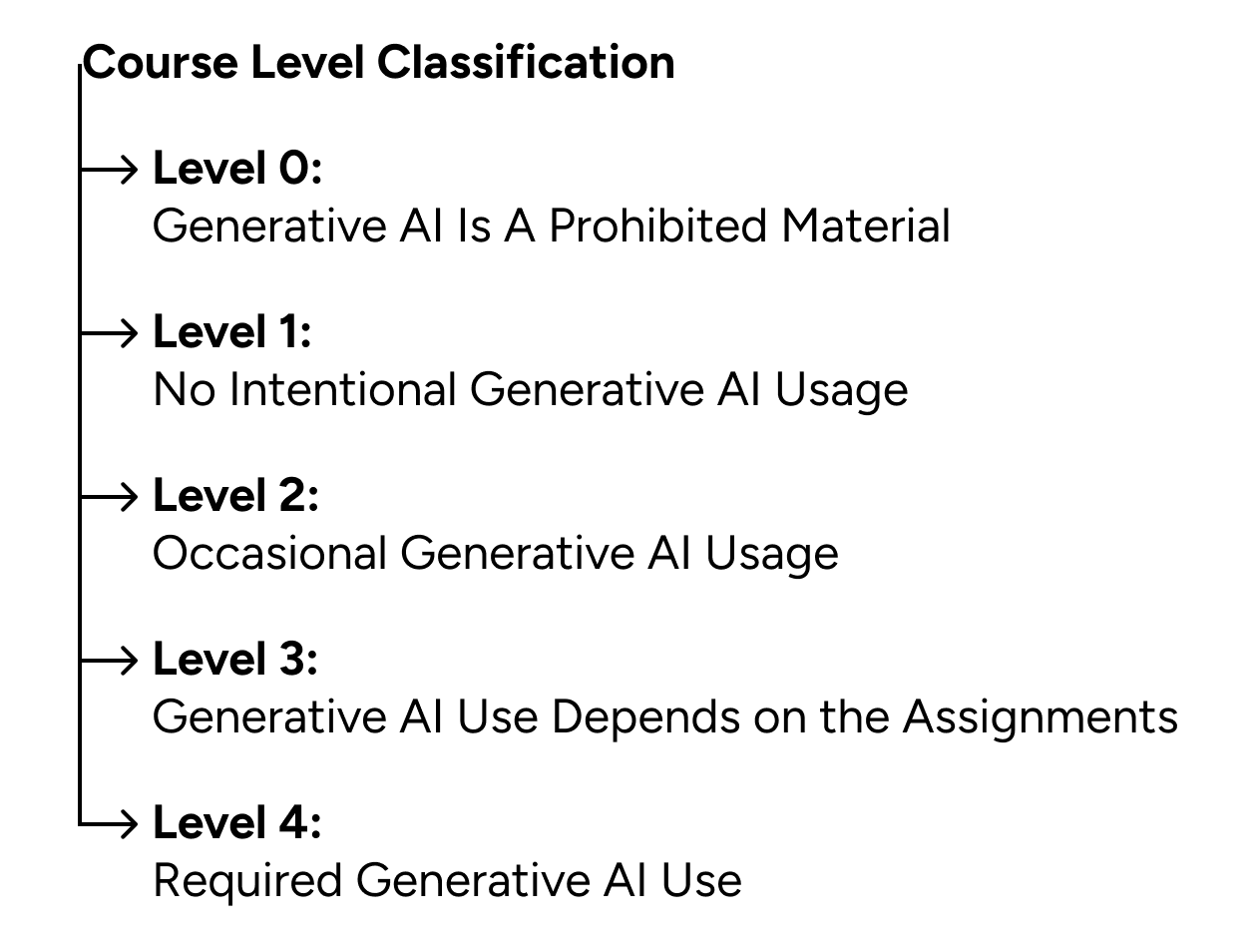
Figure 1: The five different levels of Course Classification.

Level 0 Course: genAI is a Prohibited Material
Level 0 courses take a very strict approach to genAI, with such tools being considered ‘prohibited materials’. This is particularly likely to include courses that are about learning ‘the fundamentals’ of something. For example, the second author is the teaching assistant for an undergraduate Introduction to Statistics course. The professor has carefully curated materials to support the learning of fundamentals of statistics, such as sample annotated code in R Studio to guide learners in advancing their statistics understanding. In this example, using genAI is a way to avoid learning, simply letting the learner shortcut to the resulting product and avoiding the more complex and time-consuming experience of actually learning, so genAI is prohibited. There are also writing teachers using in-class, handwritten assignments to preserve those skills.

Level 1 Course: No Intentional genAI Usage
As genAI is sneakily manifesting in all of our modern tools, any learning experience that uses any digital tools may randomly have some form of genAI that is unavoidable. The first author doesn’t know how to not get text recommendations when she’s writing in this google doc, or none of us know what Grammarly will do next (Tiffany, 2026). And in the Introduction to Statistics course mentioned above, R Studio infused genAI into their tool in February 2026 - making it even harder for the students to avoid genAI in a course in which such assistance is prohibited.
All of this is to say, the line between “getting help catching typos or poor grammatical structures” and “passing off genAI content as one’s own” is very thin, and it is getting thinner every day. A Level 1 course label means, “Look, we’re not holding you responsible for Grammarly acting weird and changing randomly, but avoid genAI for this class as much as you possibly can!”

Level 2: Occasional genAI Usage
This is for a course where the default expectation is DO NOT USE GEN AI - but where the instructor may occasionally offer or assign a genAI tool or experience. These occasional assignments where genAI is required or encouraged need to be clearly marked as the exception they are, as described in the following section about assignment classification. We anticipate these occasional assignments to focus on two different needs: 1) introducing crucial tools that the future career will require (e.g., Figma Make for website designers); or 2) offering supplemental learning activities for students. For example, genAI can be a very patient tutor that is willing and able to answer endless questions from learners, and can rephrase key terms and concepts over and over. For example, if a student is struggling to understand what a ‘manipulation check’ is, perhaps the rephrasing and examples provided by Perplexity would better support their understanding.

Level 3: genAI Use - Depends on the Assignments
This is for a course that has a lot of genAI use, but it is clearly described and/or limited for each assignment. For example, perhaps Discussion Posts are not allowed to be crafted using genAI, and that is clearly outlined in the syllabus. But perhaps the final project actually requires that you explore advanced genAI tools, and compare them to the work you’ve been doing and learning over the semester. We imagine this to be the most used, but also the most complex Level to communicate, and we encourage instructors to clearly identify in their syllabus and their course schedule which assignments have which policies. Specifically, we recommend that instructors in Level 3 courses use the assignment classification given in more detail below, to guide students appropriately.

Level 4: Required genAI Use
This is for a course that requires genAI use frequently, where the default expectation is that students will use genAI for an assignment. For example, a CS course that does not include at least some co-coding with CoPilot or similar will poorly prepare its students for an industry rocked by this sea change. And coders who are not fully prepared for the outsized impact a poorly generated piece of code can have, will continue to rock the world by not keeping the human properly in the loop (Nolan, 2026).

Assignment Classification Examples
We anticipate Levels 2-4 benefiting in different ways from classifying assignments. In Level 2 courses, for example, with the default expectation of not using genAI, exceptions need to be clearly marked; same with Level 4, but in reverse. Level 3 will particularly need assignment level classification, and we recommend three different classification types at most. If we keep with the Discussion Post example, then in the syllabus where they are being described (word count, frequency, associated grading, etc.), also add information about genAI use. Then, in the course schedule - whether physical or digital - use emoji or other symbols that refer back to that information (see Figure 2).

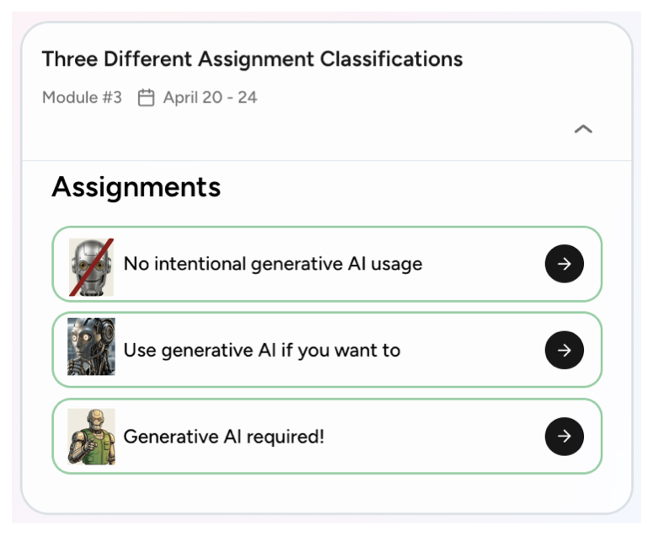
Figure 2: Using emoji to quickly and succinctly communicate an assignment’s genAI classification. Screenshot from Playwise ©, a teaching and learning management system (Williams-Pierce, 2026).

In Figure 2, we use a “no robots” symbol to indicate no intentional genAI usage is allowed; a thoughtful robot for “use genAI if you want”; and a “we want YOU” pointing robot for “you must use genAI.” This is a supplement to the descriptions and details in your syllabus - the goal here is to quickly and easily remind students enrolled in Levels 2-4 courses which assignment is in which category of genAI usage. We also highly recommend students additionally provide a ‘cover page’ for all assignments in these courses, in which students describe how and why they used genAI. For example, a cover page for this white paper would say,
We didn’t use genAI, but we did use Google Docs for the majority of the writing. Google Docs suggests tweaks to grammar - which we generally agreed with and accepted - as well as proposing entire words and phrases as we’re actively writing - which we generally rejected. We have no control over these suggestions, nor what role genAI plays in producing these suggestions, so we consider ourselves to be adhering to No Intentional GenAI Usage.
Students could also be asked to include additional information, such as: the prompts they used with products such as Claude, and/or the entire conversation transcript; an elucidation of why they chose ChatGPT to use and how it supported their learning; and how they were careful to verify any and all the information ChatGPT provided.

genAI Usage: Product or Process?
Our focus thus far has been on the product side of genAI: that is, learners hand over products to their educators, who use those products to determine whether learning has occurred. But the history of using products as a proxy for learning may have finally met its end. A product can be easily produced by genAI, while the process of learning remains the learner’s remit, so we want both instructors and students to distinguish the process of learning from the product of learning. One of the reasons why genAI is such a complicated and nuanced contributor to education - why it has transformed the field overnight - is because much of our formal education system is oriented around the products of learning, and those products can now often be created quickly and easily without students actually engaging in the process of learning.
If a student can create a five page research paper with a single one line prompt in a genAI tool, then they are missing out on numerous learning processes that we value, such as reviewing literature, engaging in critical thinking across that literature, practicing writing and revising, learning to recognize specialized differences between and across disciplines, learning to value what their field values, and so on. In this case, the process of learning is being sidestepped, and the purpose of education is completely missed - even if the student is handing in a fully appropriate and accurate product.
In other cases, however, genAI is a tool that can support and amplify the process of learning. For example, if a student learning to design websites for clients can quickly use genAI to mock up several different prototypes to present to their client for review, they can focus their efforts on iterating the design and developing the website. In this case, the time-consuming work of designing multiple prototypes at the beginning of the client relationship is side-stepped, and the student can focus their time, energy, and learning on iterating the preferred prototype - while also learning how and when to use common genAI tools for their future design career. So genAI tools can be required for professional preparation for future jobs, but they can also be used to amplify learning or avoid learning. These truths combine to make genAI such a complex topic for institutions, instructors, and students alike.

Additional nuances to this framework will need to be developed, based upon disciplines and available tools. For example, some assignments may require the use of a specific genAI tool because it is a key tool in the discipline: so the goal of the assignment is to learn how to use genAI in your future field. Other assignments may require the use of a genAI tool as a useful collaborator in learning or understanding the content (e.g., Zhang & Gao, 2026), or are intended as a practice tool for reinforcing prior classroom learning (Muncey, 2025). Still other assignments may use genAI as a cautionary tale (such as in AI ethics training modules; Kaste, 2026), and engagement with such tools is intended specifically to teach careful and ethical use of such tools. These nuances, however, are field- and tool-specific, and time-intensive to determine. Furthermore, as the flood of tools continues, and research on best practices for learning about/from/with such tools emerges over time, we anticipate continued radical changes. Consequently, reifying classifications or categories at that close grain level right now is not particularly useful - a new tool or new research results may emerge soon that upends any developing detailed classification efforts.

Instructors and Students Have an Immediate Need
The state of the field of genAI is so chaotic that it's a full time job just to keep up with what’s happening. Different content areas and future careers all have different needs and visions for the role of genAI in education as well, and instructors may be using tools in their classrooms that are implementing genAI in a way that directly conflicts with the learning goals of the class. To that end, there is a real need for educator-specific genAI updates, so that each instructor doesn’t have to become an expert in genAI alongside the very high demands of teaching. We recommend that established and reliable content-specific educator sources offer monthly ‘state of the field’ newsletters that summarize timely advances and changes for that specific content field. For example, perhaps the American Statistical Association could have notified instructors in a timely fashion when R Studio, a popular tool in statistics education, infused genAI. This way, the specific relevant tool changes that are important to the content and field can be distilled to instructors, curated specifically for their classroom needs and learning goals, instead of each individual trying desperately to stay current in a flood of change.

Conclusion
We offer two different grain sizes of classification to support everyone who is trying to teach and learn in formal educational contexts. Course Levels 0-4 range from genAI is a Prohibited Material to Required genAI Use; and, within these levels of course usage, we offer three classification examples at the Assignment level that we think will be most commonly used. We propose that organizations adapt and adopt these classification methods to support their students and instructors. While the enterprise of learning with genAI continues to rapidly change and develop, this classification approach aims to flexibly and coherently support educational organizations in understanding and communicating the role of genAI in their classrooms.

Acknowledgements
Many thanks to Sarah Lee, for the Level 0 syllabus phrasing and goals, shared with the second author; and to Jesse Klein and Lovely-Francis Domingo for their cover page suggestions.

References

American Statistical Association: https://www.amstat.org/education/undergraduate-educators

Chen, J., Lu, X., Du, Y., Rejtig, M., Bagley, R., Horn, M., & Wilensky, U. (2024). Learning Agent-based Modeling with LLM Companions: Experiences of Novices and Experts Using ChatGPT & NetLogo Chat. Proceedings of the CHI Conference on Human Factors in Computing Systems, 1–18. https://doi.org/10.1145/3613904.3642377

Gaines (2025) - https://www.npr.org/2025/12/16/nx-s1-5492397/ai-schools-teachers-students

Kaste, M. (2026). https://www.npr.org/2026/04/03/nx-s1-5761454/penalties-stack-up-ai-spreads-through-legal-system

Kriss, S. (2025). https://www.nytimes.com/2025/12/03/magazine/chatbot-writing-style.html?unlocked_article_code=1.6U8.0WlP.gHfxTkMt8fmT&smid=nytcore-ios-share&fbclid=IwY2xjawOkNj5leHRuA2FlbQIxMABicmlkETFJRDFuRHhnZFF5VnBZeFpEc3J0YwZhcHBfaWQQMjIyMDM5MTc4ODIwMDg5MgABHtbri7-b3B3LIAnBzXC7kCiCp0GChocW-Elx8I5zI8-q05c_dtbbPsi3ko2L_aem_3tJXWQrZjV4-cE2wAtDHrg

Lang, M. (2025). https://marcusolang.substack.com/p/im-kenyan-i-dont-write-like-chatgpt

Muncey, N. (2025). https://schoolai.com/blog/ai-for-math-transforming-learning-and-teaching-in-education

Nolan, B. (2026). https://fortune.com/2026/03/18/ai-coding-risks-amazon-agents-enterprise/

Tiffany, K. (2026). https://www.theatlantic.com/technology/2026/03/grammarly-ai-expert-bad-advice/686343/

West-Knights, I. (2026) - https://slate.com/culture/2026/03/shy-girl-mia-ballard-novel-a-i-book-horror-reddit-hachette-canceled.html?pay=1776455345339&support_journalism=please

Williams-Pierce, C. (2025). Differences in novice and expert evaluations of generative AI-produced definitions. In Rajala, A., Cortez, A., Hofmann, H., Jornet, A., Lotz-Sisitka, H., & Markauskaite, L. (Eds.), Proceedings of the 18th International Conference of the Learning Sciences (pp. 529-537). Helsinki, Finland: International Society of the Learning Sciences.

Williams-Pierce (2026). Playwise © teaching and learning management system (website). www.rwplaywise.com

Zhang, Y., & Gao, G. (2026). Are Conversational AI Agents the Way Out? Co-Designing Reader-Oriented News Experiences with Immigrants and Journalists. Proceedings of the 2026 CHI Conference on Human Factors in Computing Systems, 1–17. https://doi.org/10.1145/3772318.3791120

