ABSTRACT

Title of Final Project: What Remains: Memory, Urban Renewal, and the Erasure of Alley Communities in Southwest

Amanda Arcidiacono, Master of Historic Preservation, 2025

Final Project Directed By: Susan Kern, PhD
Director and Professor, Historic Preservation Program

This project examines the long-term consequences of urban renewal on the historical and cultural landscape of Southwest Washington, D.C., focusing on the erasure of its alley dwelling communities. Using “The Island” as a case study—a neighborhood once defined by its close-knit, working-class residents and named alleys—the research interrogates how redevelopment has displaced marginalized populations and erased both tangible and intangible heritage. The study draws on archival materials, planning documents, and preservation reports to trace the transformation of Southwest from a diverse, culturally vibrant area to a modernized space marked by exclusion and loss. Alley dwellings serve as both a physical remnant and a symbol of deeper spatial injustices, shaped by D.C.’s unique urban form and racial history. Despite their marginalization, these spaces housed resilient communities whose stories have largely been omitted from mainstream preservation narratives. This research critiques traditional preservation approaches that prioritize architectural significance over social history and proposes a reparative framework that integrates memory work, programming, and community engagement. This work urges preservationists, planners, and policymakers to reconceptualize what historic preservation can do for lost landscapes.

WHAT REMAINS: MEMORY, URBAN RENEWAL, AND THE ERASURE OF ALLEY COMMUNITIES IN SOUTHWEST WASHINGTON, D.C.

By

Amanda M. Arcidiacono

Master’s Final Project submitted to the Faculty of the Historic Preservation Program of the University of Maryland, College Park, in partial fulfillment
Of the requirements for the degree of
Master of Historic Preservation
2025

Advisory Committee:
Susan Kern, PhD, Chair Historic Preservation
Kathryn Howell, PhD, Urban Planning
Joseph Williams, PhD, Architecture
Acknowledgements

I would like to extend my deepest gratitude to Dr. Susan Kern, Dr. Kathryn Howell, and Dr. Joseph Williams for serving as my advisors on this project. Without their guidance, insight, and encouragement, this research would not have been possible. I am also thankful to my graduate cohort for their camaraderie, collaboration, and care throughout this process. I am deeply appreciative of the mentors and friends who offered their wisdom, perspective, and steady presence along the way. Lastly, I am especially grateful to my partner, Elliot, whose unwavering patience and belief in me sustained me every step of the way.

Table of Contents
List of Figures 1
Introduction: Erasure, Memory, and Historic Preservation 2
Structures of Survival: Alley Dwellings on the American Urban Environment 5
Southwest and the Architecture of Injustice 7
The Making—and Unmaking—of Southwest 11
Living in the Margins: Daily Life within Alley Dwellings on the Island 24
The Storm Hits: Urban Renewal Comes for the Island 29
4 ½ Street SW: A Microhistory of Space, Community, and Displacement 40
Conclusion: What Comes Next? 42
Appendix and Tour 45
Bibliography 62

List of Figures
Figure 1 Panoramic View of River Front, Southwest Washington.” The picture was taken at the height of alley living in Southwest.1900-1910. Streets of Washington. 10
Figure 2 View of the City of Washington in 1792. Courtesy of the Library of Congress. 11
Figure 3 1794 Map of L'Enfant Plan expressing the location of the Washington City Canal. Via Library of Congress. 13
Figure 4 View of Grace Alley S.W., between D & E and 8th & 9th streets, looking west, 1901. Via shorpy.com. 19
Figure 5 Excerpt from 1912 Alley Dwelling Survey. Via Library of Congress. 20
Figure 6 Southwest Washington, D.C., looking toward the Capitol, 1939. Via Library of Congress. 22
Figure 7 Sanborn Map of Cow Alley, located within a blind alley at 4 and 1/2 and I Streets, Southwest, D.C. 1928. D.C. Public Library. 24
Figure 8 Demolition of alley homes on Water Street. Circa 1950s. Courtesy of St. Augustine’s Episcopal Church. 34
Figure 9 Clearing of Southwest, DC, 1950s. National Capital Planning Commission. 37
Figure 10 4 1/2 Street, Southwest. Circa 1950s. Via shorpy.com 40
Figure 11 4th Street, 2025. Photo taken by author. 41
Figure 12 D Street and Virginia Ave, SW. Formerly the site of Island Hall, 2025. Photo taken by author. 52
Figure 13 Tiber Island Cooperative Homes, 2025. Photo taken by author. 54
Figure 14 Department of Housing and Urban Development, 2025. Photo taken by author. 60
Figure 15 William Syphax School, 2024. Photo taken by author. 61

Introduction: Erasure, Memory, and Historic Preservation
This study explores the long-term impacts of urban development on the historical and cultural resources of Southwest Washington, D.C., with a focus on its alley dwelling communities. Using the neighborhood known as "The Island” and its named alleys as a case study, this research examines how redevelopment and urban renewal have systematically erased marginalized communities and their tangible and intangible heritage. The central questions guiding this study are: What are the lasting social and cultural consequences when urban development diminishes historical resources? And what can we do with what remains?
Through an analysis of archival records, newspapers, and urban planning documents, the research examines the social and cultural desert left in the wake of redevelopment and gentrification, including the loss of community identity and displacement of marginalized populations. The findings underscore the urgent need for inclusive and culturally sensitive urban preservation policies that balance growth with the protection of heritage. This is also a call for historic preservation as a field to see beyond the visible aspect of preservation and challenge us to think creatively in order to do the reparative work necessary to preserve what remains of our shared heritage and culture.
Hidden cities emerged within the planned design of the city, though they were never part of its original intent. Pierre L’Enfant's grand design for the city with its wide avenues and intersecting grid, inadvertently gave rise to a network of alleyways that would shape Washington's cultural and social landscape into the 21st century. Obscured from the main streets, these dwellings historically served marginalized communities and now only very few stand as symbols of a neglected urban past.
This study undertakes a critical examination of the layered history and enduring challenges of “The Island,” a community historically defined by both its geographic isolation and systemic social marginalization. Despite the growth of this community, the Island faced increasing scrutiny from Congress and local officials due to lack of basic amenities, high mortality rates and general unsightliness. Though Southwest initially escaped major displacement and gentrification, urban renewal was swift and merciless. Plans drawn in the 1950s led to the razing of the neighborhood’s alley dwellings and almost all of the buildings that stood within it. While redevelopment promoted a new life for the old Southwest through luxurious living and the promise of economic growth, it left parts of Southwest dilapidated and divested.
By the 1980s and 1990s, modern developments struggled to attract residents, and in 2003, Southwest was targeted for another round of urban renewal. Historic preservationists once again took an interest as cultural resources faced new threats. In response to these redevelopment pressures, a 2005 University of Maryland Historic Preservation program’s studio class conducted a historical context study of Southwest, documenting key cultural and historical resources and proposing preservation strategies. This report titled “The Old Southwest Historic Resource Documentation and Preservation Plan” played an important role in the documentation of Southwest and parts of Southeast’s historically important sites. The Southwest Neighborhood Association displays it on their website. The 2005 report outlines a three-step strategy for preserving the historic character of Washington, D.C.’s Southwest neighborhood. First, it emphasizes the importance of raising community awareness about the area’s complex history through local research and engagement efforts. This step encourages residents to explore and appreciate the Island’s past. Second, the report recommends leveraging existing D.C. planning tools—such as Specialized Planning Areas, Special Treatment Areas, economic incentives, and overlay districts to protect the Island’s unique physical, historical, and cultural qualities while managing future development. Finally, the report suggests that the strongest preservation measures can be achieved through formal historic designation, either by creating a historic district or listing individual buildings as D.C. Historic Landmarks. This would provide significant legal protection and make properties eligible for financial assistance to support maintenance and rehabilitation. While the report acknowledges that the community may choose to pursue one or more of these recommendations, it asserts that each step builds upon the last to strengthen both the protection of historic resources and community agency in shaping the neighborhood’s future. However, much of the area has since been redeveloped, erasing significant cultural resources from the built environment. This project offers a more current preservation model to inform future efforts to protect culturally significant areas affected by urban development.
Revitalization efforts, while modernizing and ensuring the health and safety of the area, neglected the community’s need for low-income housing options. Thus, alongside the demolition of culturally rich spaces with meaning to residents, they could no longer afford to return to their home. This study uncovers this hidden legacy, highlighting the dual role of urban planning as both a tool for improvement and a force for cultural erasure. Through historical analysis and community engagement, the study will assess the potential for establishing a historic district to protect the remaining historical assets, proposing a preservation model that respects both past and present needs.
By integrating a publicly available walking tour and interpretive programming that foregrounds the histories of D.C.’s alley dwellings, the project demonstrates how memory work can serve as a mechanism for reparative justice. It positions public history as a critical tool in addressing historical erasure and fostering more inclusive narratives in the urban landscape.

Structures of Survival: Alley Dwellings on the American Urban Environment
Washington, D.C. was not a large center for international immigration like New York, Philadelphia or Baltimore, but inter-American migration, especially following the conclusion of the American Civil War. An influx of Black Americans, namely from Virginia, the Carolinas and Georgia, were attracted to the opportunity and affordability of the city. The city resembled that of other major southern cities such as Atlanta and Charleston, which were deemed more approachable than highly populated and expansive cities with skyscrapers such as New York, Boston, and Philadelphia. As Washington, DC grew increasingly dense with houses, many of the once-large, deep lots were subdivided. This subdivision separated the rear portions from the public streets, resulting in lots that faced only onto the alleyways. This trend emerged during a period of rising population and accelerating land values, making these alley-facing lots of desirable for property owners who could earn income from renting them out, as well as for the city’s poorest residents who could not afford the higher rents of the row houses along the main streets. As more interior lots were developed and modest homes constructed on these lots, a distinct community began to form within the alleyways. Only a few alley communities existed prior to the onset of the Civil War, only about 43 named or officially recognized inhabited alleys were noted in police censuses. Nearly 65% of all individuals who lived in alleys were white. That number changed drastically in the post-Civil War period.
Alley dwellings stand as poignant symbols of the inequality and injustice ingrained in Washington, D.C.'s social and spatial fabric. Pierre L’Enfant's grand vision for the city, characterized by ornate design and intersecting grid patterns, inadvertently gave rise to a network of alleyways, shaping Washington D.C.’s cultural, spatial and social landscape for centuries to come. These alley dwellings, tucked away from the grandeur of the main streets, serve as a contested space of survival of the city's overlooked history. Despite being integral to the city's development, these alleyways became neglected and marginalized over time, embodying the systemic disparities that continue to persist. As Washington, D.C. evolved into a political and cultural hub, the alley dwellings remained hidden pockets of poverty and neglect, casting a shadow over the city's reputation as a beacon of progress.
The spatial organization of Washington, D.C. offers a critical lens through which to understand the evolving rights and lived experiences of Black Washingtonians. The legacy of slavery profoundly shaped the development of housing patterns and residential inequality in Washington, DC. Washington, D.C. played a central role in the Civil Rights Movement, functioning as both a symbolic heart of the nation and a strategic hub for organizing and advocacy. The city was not only the site of major national demonstrations, such as the 1963 March on Washington, but also a place where the effects of segregation, inequality, and urban renewal were felt acutely in everyday life. Alley dwellings, in particular, stood as stark reminders of the systemic racism and exclusionary housing practices that marginalized Black communities. These hidden neighborhoods embodied the very injustices that civil rights activists sought to confront—substandard living conditions, social neglect, and the deliberate isolation of Black residents from public services and economic opportunity. In this way, the physical and social landscape of Washington’s alley dwellings functions as a microcosm of the larger fight for civil rights across the United States.

Southwest and the Architecture of Injustice
The central questions guiding this study are: What are the lasting social and cultural consequences when urban development diminishes historical resources? And what can we do with what remains?
This project centers Southwest Washington—historically known as “The Island”—as a case study to examine the forces that led to the large-scale clearance of a vibrant, diverse community. It considers not only the historical context and motivations behind this forced removal of residents but also how we might meaningfully respond to its lasting impacts today. Rather than assigning simple blame to planners, developers, or government officials, this research seeks to understand their decisions in order to uncover more constructive, equitable paths forward.
In 2014, the DC Office of Planning and the DC Historic Preservation Office released The DC Historic Alley Buildings Survey, a detailed study grounded in research, visual documentation, and community input. The report illuminated the stark divisions in the city’s-built environment—shaped by longstanding segregation and social stratification—with examples drawn primarily from Northwest and Northeast. Notably absent, however, was Southwest. Despite being home to one of the city’s last alley dwelling communities, few of which survived past the 1970s, the neighborhood’s history was largely overlooked in the survey, reinforcing the very patterns of erasure this project seeks to confront.
The scarcity of surviving historical resources has contributed to the continued marginalization of Southwest in preservation discourse. Scholars such as James Borchert, Kim Prothro Williams, and Carolyn Swope have done important work to uncover and document the area’s powerful history. However, despite this valuable research, there has been little follow-through when applying it in preservation and planning processes.
Many residents of Southwest mourned the loss of their neighborhood and questioned why preservation efforts had protected places like Georgetown, but not their own. Both communities had histories of poverty, diversity, and struggles with disease and crime. Georgetown faced similar segregation conditions just as Southwest did. Black renters who lived in substandard housing were also denied loans and were later evicted from the property on which they lived. Yet Georgetown’s 18th-century heritage was considered more aesthetically valuable; historic significance meant little or nothing to 20th-century homebuyers. Georgetown’s growing community of white landowners benefited from their stronger community advocacy. This advocacy effort that came from within proved integral to saving the built environment in Georgetown. As a result, Georgetown’s small-scale yet urban landscape was preserved, while much of Southwest was erased. In total, more than 500 buildings were rehabilitated in Georgetown, while Southwest lost 95% of its cultural resources and institutions.
This disparity in preservation reflects broader patterns in how Washington, D.C.'s built environment has been valued and managed. Each alley community in Washington, D.C. has left a lasting imprint on the built environment, whether through visible structures that remain or through the invisible histories embedded in the urban fabric. These structures and the community that lived within them shape the city's social and cultural identity in profound ways. From their humble beginnings as spaces of necessity for marginalized populations to their role as symbols of resilience and community solidarity, alley dwellings have played a major role in the evolution of the nation's capital as a social and cultural sphere. These buildings are now highly sought after and considered valuable real estate because of their rarity. Today, these unique spaces often attract architects and designers who see alley dwellings as opportunities for creative, high-design projects that blend historical character with contemporary aesthetics.
Southwest has undergone significant transformations due to urban renewal and gentrification, profoundly impacting its communities and landscape. In the mid-20th century, urban renewal initiatives aimed to modernize the area, leading to the disenfranchisement of long-standing Black and Jewish communities. Originally sold to the local community as a way to reinvent and demonstrate the power of urban renewal, Congress funded this and similar neighborhood redevelopment projects.
The revitalization efforts of the 1950s and 1960s were intended to address substandard living conditions and revitalize the Island. This is when the moniker fell away from Southwest. However, the execution of these projects often destroyed long standing vibrant communities. The Southwest D.C. urban renewal project became a national model for revitalization of “slum” or blighted” areas. This project and other like it intended build newer, safer and healthier housing for the community, yet it disproportionately disrupted historically Black neighborhoods that lived within those very same communities. Before the project, approximately 70% of the residents were Black; two decades later, this demographic had shifted to 64% White, highlighting the deeply racial impact of these policies.
In recent scholarship historians and urban planners have revisited the Southwest case to draw lessons about the consequences of complete and large-scale urban renewal, emphasizing the need for community-driven approaches to development. The area continues to experience cycles of displacement, particularly with new waterfront redevelopment efforts that further alter the social fabric of the neighborhood. The story of Southwest D.C. serves as a cautionary tale about the unintended consequences of urban renewal and the importance of equitable urban planning. This study serves as a component of a comprehensive investigation and exploration into the relationship between urban development and historic preservation within the context of not just Washington, D.C., but other cities as well.
Figure 1 Panoramic View of River Front, Southwest Washington.” The picture was taken at the height of alley living in Southwest.1900-1910. Streets of Washington.

The Making—and Unmaking—of Southwest
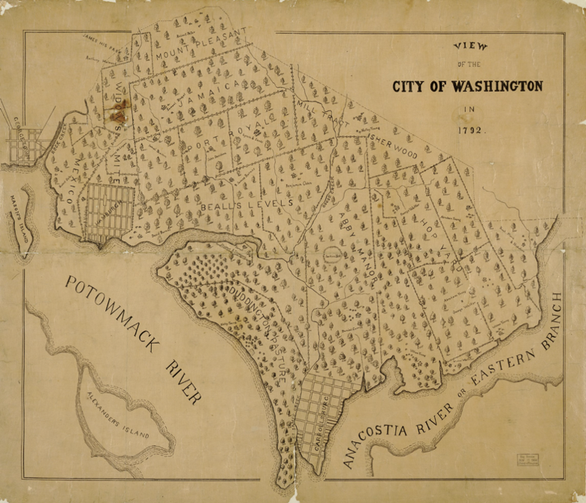
Long before it became the nation’s capital, the area now known as Washington, DC was valued for its natural abundance and strategic location. Due to the biodiversity, fertile land, and ample waterways, Washington, DC became a prime location for settlement. Prior to European contact, Southeast Washington was home to the Piscataway and Nacotchtank nations. Several villages have been noted across the whole of the Anacostia River, although most largely fall within the modern boundaries of Southeast, Washington, DC. The area around the Anacostia River, including Greenleaf Point—also known as Buzzard Point—at the southern tip of Southwest DC, was home to early fishing and bird-hunting communities made up of both Indigenous peoples and early European settlers. The Piscataway, an Algonquian-speaking community, maintained land holdings in the southernmost Southwest, where modern-day Fort McNair is located. This village was most likely inhabited until the 1670s, when a majority of indigenous peoples fled the area following warfare and disease.
After European settlement early plots in Southwest were initially plotted to the Young and Carroll families for development. Little came of these early developments; however, some small farms and plantations sprang up across the quadrant. After the Residence Act of 1790, land development within the new District of Columbia was determined by a three-person commission selected by President George Washington. After the Residence Act, plots were purchased from one of the commissioners of the city of Washington by a development syndicate headed by James Greenleaf. Greenleaf promised to build upon and utilize the Southwest quadrant. One of Greenleaf’s most notable clients was Thomas Law. Greenleaf sold a swath of land adjacent to the Anacostia River to a famous friend and later adversary, Thomas Law. Law’s famous 1794 Georgian home was later constructed on this land. Law and his wife, Eliza Parke Custis, George Washington’s eldest grandchild, lived at the home for about two years. The Thomas Law House is still present today and is inhabited by private owners.
Figure 2 View of the City of Washington in 1792. Courtesy of the Library of Congress.

Only a few structures were erected by Greenleaf during the late 18th and into the early 19th century. This disappointed the early national government and disenfranchised Greenleaf from the Washington, DC community. Despite these early setbacks in development of Southwest as a residential community, a handful of significant structures still took root in the neighborhood. The enduring structures from this period have become iconic symbols of Southwest. Greenleaf was given a deal to build on the land but left the area before he would build the 80 structures, he had told the city’s government that he would. Landowners built sparse housing in the area, namely Wheat Row, built from 1794-1795. These four late-Georgian townhouses became the first housing developments in the area and the first townhouse style homes within the District of Columbia. By 1797 much of Buzzard or Greenleaf’s Point was acquired by the U.S. government. L’Enfant recognized Buzzard Point’s strategic location at the confluence of the Anacostia and Potomac rivers and proposed it as a potential site for military use. Eventually almost 90 acres was obtained for the US Arsenal at Greenleaf Point.
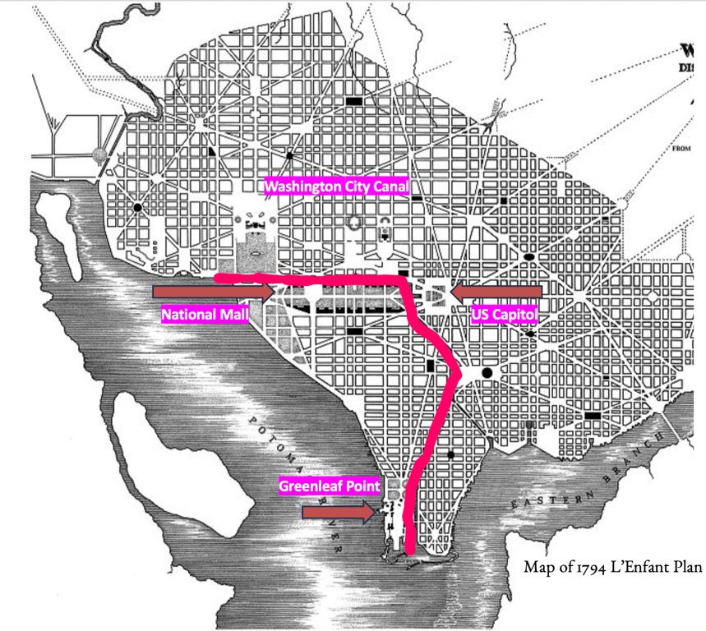
Upon the sale and eventual small-scale development of plots, Southwest became home to a number of small farms and just a few large plantations where landowners enslaved Black laborers. Tobacco quickly became the cash crop of modern-day Southwest, bringing in a small number of wealthy landowners to the area, the majority of planters were small-scale farmers. Southwest industrialized more slowly than its counter parts and was markedly more rural than the quickly progressing northern quadrants.
The 19th century brought a steady influx of Eastern European immigrants, industrial activities, and trade. Southwest was largely rural until the early 19th century when Eastern European immigrants, freed Black people and formerly enslaved individuals moved into the largely agricultural area. The first use of the moniker “The Island” became common in this era. Bound by the Potomac River to the south and west and the Washington City Canal to the north and east, Southwest Washington was, in more than one way, an island. This physical separation led to a social and cultural separation. The neighborhood separate from the rest of the city led the quadrant to develop as a self-contained community—one that experienced both voluntary and imposed isolation.
Figure 3 1794 Map of L'Enfant Plan expressing the location of the Washington City Canal. Via Library of Congress.
The mid-19th century brought great change to the city. In the 1850s the city’s population grew by 50% and a severe housing shortage ensued. Many neighborhoods across the district could not keep up with the high demand for housing. In Southwest the majority of homes were modest, largely one or two stories in height, aside from the few remaining plantation homes. Around this time alley dwellings, an inexpensive solution to a severe city-wide housing shortage, erupted. In Southwest a majority of the unskilled labor force lived within these poorly constructed units. Throughout the city alley homes sprang up to house the poorest of the population within the District of Columbia.
Housing was limited and often unaffordable and even with the construction of the Washington City Canal, Southwest was stunted economically separated from the rest of Washington, D.C. The canal became more of a nuisance than a help as it was unpredictable due to tidal movements with the Tiber and Anacostia. Thus, the canal became a stagnant center for waste and debris. The economy within Southwest began to form and wharves and docks sprang up across the Anacostia River. Small businesses were scattered throughout the Island and an economy in Southwest slowly started to attract immigrant and migrant populations.
The Island was now more accessible to and from other parts of the district and the foul odor accompanied with diseased water no longer posed a threat to the growing community. Southwest grew in mild popularity among the city’s low-income population. Tanneries, brickyards, and packing facilities offered jobs in the area. Low-paid and often unskilled workers trickled into the area to find jobs and inexpensive housing. The Island grew increasingly diverse post-Civil War partially due to the large influx of emancipated individuals. Because of the role that Southwest had played in the Underground Railroad, many formerly enslaved individuals found respite and some limited opportunity in the area. One of the prominent residents of Southwest in the post-Civil War era was Reverend Anthony Bowen, a former Underground Railroad conductor. Anthony Bowen, a household name within the district helped enslaved people escape and he founded St. Paul AME Church and the first Black YMCA in the district of Columbia to house and educate formerly enslaved individuals.
The American Civil War had brought a tide of change to Southwest. The Island experienced a short-lived economic surge during this period because of its role in the conflict. Used as a troop assembly area during the Civil War, Southwest’s ports were booming. A steady influx of soldiers and formerly enslaved Black Americans created a small workforce that labored in factories and at military outposts. The ports were staffed, and shipping supported a large portion of the neighborhood’s economic activity. This eventually stalled in the post-Civil War years when little traffic came through the area. Due to this stall, development also halted and any perceived potential for the area was never fully realized. Southwest slowly began to become socially scarred, and the city and government was quickly taking notice.
Post-war Southwest was a much different place than it had been in decades prior. Still relatively rural and unformed the Island experienced some improvements led by Alexander Shepherd, a storied yet divisive Southwest native. Though Shepherd opposed Black suffrage and civil rights, Shepherd was responsible for the vast improvement of infrastructure to Washington, DC. By the 1870s Congress pushed for the relocation of the nation’s capital and Shepherd worked to ensure this would not happen. Shepherd and his cronies completed a multitude of projects to modernize the city by outfitting neighborhoods with paved streets and gas, sewage and water lines. Shepherd shutdown and filled in the Washington City Canal in 1871. These improvements benefitted the Island and Southwest began to flourish in several small ways. Shipping and industrial fishing expanded the Island’s wharf area and created jobs within the quadrant.
With Washington remaining as the capital city, immigration continued at a rapid pace. With a large Irish immigrant population, diversity was at an all-time high in the city. The Island had a plethora of communities represented, as well as symbols of their identities. Irish Catholics, and German Jews were the most commonly represented non-Black communities in Southwest Post-War. Southwest boasted churches of several denominations as well as two synagogues. Even from north to south the Island’s population differed immensely. Fishermen lived and worked along the Potomac while government officers were employed just a mile north.
One of the most significant sites within the Island during the 19th century was known as. Island Hall became the neighborhood’s most significant stage for voicing important issues and concerns of the day. The three-story brick structure became a symbol of politics in the region. Prior to the Civil War Island Hall held community and church fairs, political meetings, and religious services. During the Civil War, Island Hall was repurposed as a Union hospital but post-war it became a staging ground for discussing topics such as Black suffrage, the temperance movement, Irish liberation, and the call for an eight-hour workday.
Health became a major concern in Washington. The lack of health infrastructure was largely to blame. In 1871 the first Washington City Board of Health was established. While the board only existed for a short period, it was impactful in its mission. The primary goal of this group was to condemn alley dwellings and remove their inhabitants for the sake of health. Over 300 alley homes were condemned and eventually demolished, a few hundred more were improved and finally deemed fit for human habitation. The Washington Board of Health took serious issue with these dwellings and rehabilitated some in an effort to keep people within their homes but also not create an even worse housing shortage. After the dissolution of the Board of Health, oversight of alley dwelling construction disappeared, leading to the rapid and unchecked rise of hundreds more throughout Washington, DC.
After the disbanding of the Board of Health the conditions of Southwest deteriorated once again. Wealthy residents of Southwest and their allies were concerned. Until the 1870s, alley dwellings were primarily home to Eastern European immigrants. However, by that time, the demographic moved from a 65% white majority to an 81% Black and population. By the 1880s nearly 10% of the Black population in Washington, D.C. lived on the Island. In the post-Civil War era, the city failed to address the housing needs of an increasingly diverse population, including emancipated peoples, leaving thousands without adequate accommodation.
Even though a public outcry demanded their demise, alley communities grew quickly into the late 19th century. In that era 231 named alleys within the city, housing nearly 19,000 residents. During this period brick usage in alley dwellings increased exponentially. This did not mean that a majority of alley houses had basic amenities such as plumbing or running water. Alley dwellings remained unsophisticated. Houses were also still becoming even further cramped, as families doubled up to keep up with the high rate of rent. Landlords continued to charge disproportionate rents, and more alleys exploded with residents. Dwelling construction continued to erupt. This boom is also reflected in records from the District of Columbia’s archive, with nearly 500 permits for new alley structures allotted in the first six months of 1892. This prompted a pause for alley dwelling permits in the latter half of that same year. This law prohibited the issuance of new permits for any structure built in an alley less than thirty feet wide. However, dwelling construction continued into the early 20th century. The Island’s housing, specifically alley dwellings, came under fire as the turn of the century approached. City officials saw not only an increase in alley residences but crime, disease and poverty rates as well. Smoke, debris, heat, garbage, and contaminated water deteriorated the already poor living conditions.
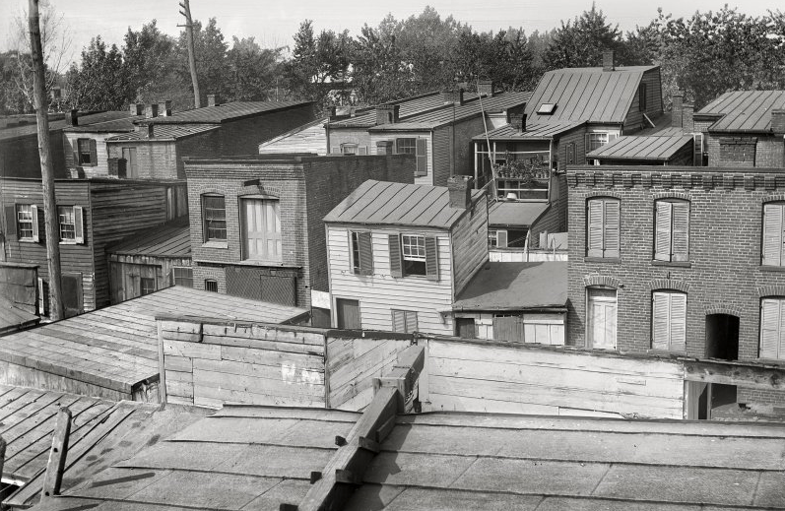
Established in 1897, the Washington Sanitary Improvement Company aimed to create improved housing alternatives for alley dwellers as part of a broader campaign to eliminate so-called “blighted” areas. Although initially envisioned as an investor-driven enterprise, the initiative gradually evolved into a philanthropic effort. Senator James McMillan—best known for the McMillan Plan—was an early advocate of the company’s mission, aligning with its goals to reshape the city’s built environment through socially motivated reform. WSIC efforts were largely unsuccessful in securing safer and clean housing to alley dwellers across the city but did address some health concerns and provided housing opportunities. From the late 19th to mid-20th century WSIC built almost 300 houses and flats within the Island, renting them for less than half of what slum landlords were charging in the same area. Among the 578 tenant families residing in WSIC housing on the Island the majority were white. This demographic distribution underscores the racial dynamics of early 20th-century housing initiatives, where efforts to improve living conditions often prioritized white residents.
Figure 4 View of Grace Alley S.W., between D & E and 8th & 9th streets, looking west, 1901. Via shorpy.com.
WSIC’s most significant contribution, however, was its reshaping of societal views, portraying the urban poor as deserving of dignified living conditions rather than as subjects of moral failing. By demonstrating that improved housing could lead to better public health outcomes and social stability, WSIC's efforts helped shift the narrative around poverty from one of individual blame to systemic responsibility.
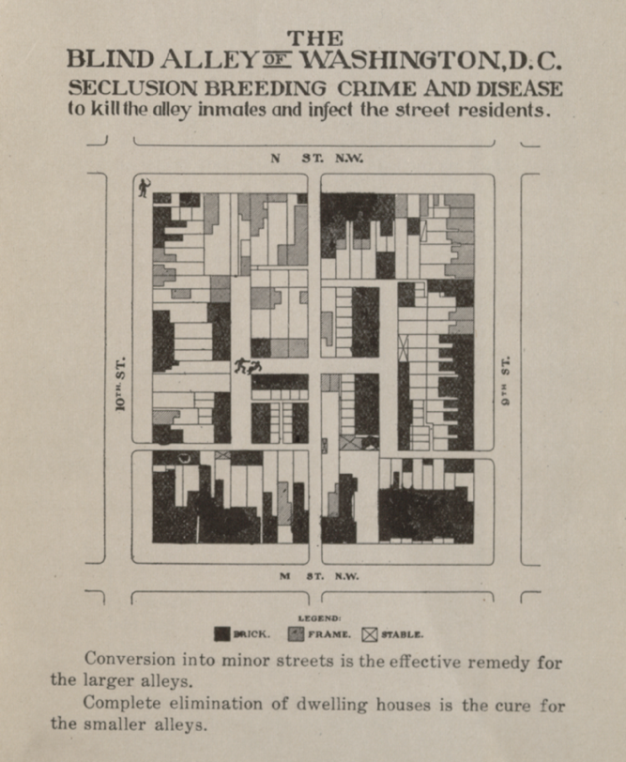
The City Beautiful movement gave city officials an outline and framework to look more closely at the state of Southwest. The City Beautiful Movement had a profound impact on the urban landscape of Washington, DC. Inspired by ideals of classical beauty, civic virtue, and social harmony, the movement sought to transform American cities through monumental architecture, formal planning, and beautification. In D.C., its principles were most visibly realized through the 1901 McMillan Plan, which reimagined the city’s core in alignment with Pierre L’Enfant’s original vision. While McMillan who was neither an urban planner nor an architect wielded immense power in the “beautification” of Washington, DC and impact Southwest in a number of ways. The plan emphasized symmetry, axial vistas, and cohesive neoclassical architecture, particularly around the National Mall and federal buildings. Owing to Southwest’s strategic and highly visible position relative to both the Capitol Building and the National Mall, McMillan’s city plan prioritized extensive efforts toward beautification and the transformation of the area’s physical and social landscape. McMillan’s plan and the urban renewal ethos of the time shaped iconic spaces such as Union Station, the Lincoln Memorial, and the surrounding parklands, reinforcing the capital's image as a dignified seat of government.
Figure 5 Excerpt from 1912 Alley Dwelling Survey. Via Library of Congress.
While the movements to beautify and sanitize Washington, DC advanced ideals of public order and civic pride, it also reflected and reinforced exclusionary ideas about whose histories and needs were represented in the urban fabric. This continued to raise ongoing questions about access, equity, and whose vision of "beauty" cities were designed to uphold. Throughout the remainder of the city, alley dwellings were being torn down or modernized for wealthier Washingtonians to reside in. Southwest’s reputation grew, and many people took notice. Southwest became further alienated and ostracized from the rest of the city.
First Lady Ellen Wilson intensified the campaign against alley life in the early 1910s, taking a strong public stance against what she viewed as deplorable living conditions. A vocal critic of alley dwellings, she advocated for their removal and envisioned their replacement with safer housing and public parks. However, her efforts lacked any concrete plan to provide affordable housing for the displaced alley dwellers, leaving many vulnerable residents without viable alternatives. She supported alley clearance legislation, and following her death, Congress passed the 1914 Alley Dwelling Act, which aimed to eliminate alley housing by 1918. This legislation ultimately stalled due to widespread housing shortages that affected major cities throughout the 1920s. The Great Depression only made alley life more popular as affordable housing grew increasingly scarce.
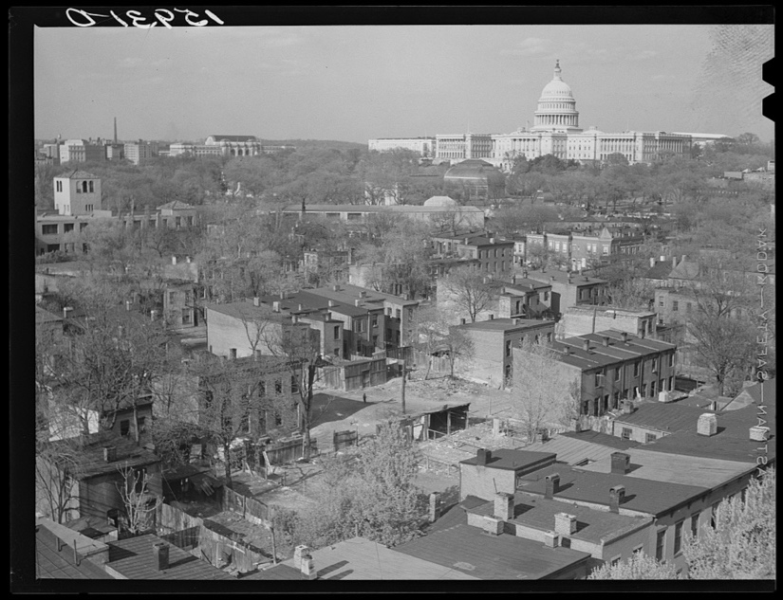
One of the biggest threats to alley life was the creation of the Alley Dwelling Authority under the first Roosevelt administration. Created to address growing concerns from professionals about the inability to totally rid the city of alley dwellings. The Alley Dwelling Authority (ADA) was formally established in 1934 as part of a New Deal push to address the substandard living conditions in Washington, D.C.'s alley dwelling communities. Their main goal was to reclaim the federally deemed “blighted” areas and provide alternative housing options for those who lived within alleys. Tasked with investigating and assessing living conditions in designated alleys, the agency held the authority to renovate, rehabilitate, or condemn structures—often justified by the promise of a safer, cleaner city. However, this did not translate into the redevelopment of cleared alleys for low-income housing; in fact, the Alley Dwelling Authority rarely, if ever, pursued that goal fully. Criticism of the ADA came from multiple directions—not just from alley residents, but also from neighboring landowners. White property owners often claimed that the government was overreaching in its involvement in the housing market, while alley dwellers defended their right to remain in their homes. The ADA was effective in its efforts to remove a majority of alley dwellings in certain areas of the city like the Northwest neighborhood Foggy Bottom. The ADA demolished 90 structures in St. Mary’s Court and on top of the land rebuilt new, higher rent, lesser occupancy homes. In Southwest, the ADA was less influential but still tore down a few dilapidated alley homes and replaced them with apartments and single family homes. The James Creek Dwellings, the ADA’s most successful project was completed in 1943 and predominantly housed war time workers. Much of the anti-alley legislation came to a halt during and immediately after World War II. A nationwide housing crisis spurred the creation of local and federal legislation in response. In 1944, a ten-year postponement was enacted for most anti-alley laws due to the housing shortage. However, rather than experiencing population growth, inhabited alleys saw their number of residents stagnate or decline slightly. A number of alley residents left the city at this time and moved to Anacostia and other parts of Southeast, Washington. Nonetheless, by the end of World War II nearly 24,000 people lived within Southwest’s alleys.
Figure 6 Southwest Washington, D.C., looking toward the Capitol, 1939. Via Library of Congress.

Living in the Margins: Daily Life within Alley Dwellings on the Island
The hasty and poor construction of alley dwellings was just one aspect of their broader story. Early alley dwellings varied in construction material and size, however, initially most alley dwellings were made of wooden boards and planks. Few alley homes would have windows and prior to the turn of the 20th century almost none would have indoor plumbing or heat. Many were modest, box-like structures, with some accounts describing them as measuring no more than 10 feet by 15 feet. This would have been a smaller example of alley dwellings; most would have measured at 16 feet wide and 32 feet in depth. The typography of most alley dwellings is as follows: two stories with a flat roof, almost always two bays in width.
Among the defining aspects of alley construction was their placement within hidden spaces. Often called “blind alleys,” these secluded passageways came to characterize the very nature of alley dwelling in Washington, D.C. These were narrow, enclosed passageways situated at the rear of city blocks, typically inaccessible from main streets and lacking through-access. Unlike standard roads, blind alleys were dead ends, making them largely invisible to the wider public. This physical isolation reinforced social marginalization, allowing substandard housing to proliferate out of sight and with little oversight or intervention.
Figure 7 Sanborn Map of Cow Alley, located within a blind alley at 4 and 1/2 and I Streets, Southwest, D.C. 1928. D.C. Public Library.
Almost all alley structures were built to substandard conditions. The wood framed houses were stable but offered little comfort outside of a simple shelter. After a larger availability of brick in the latter half of the 19th century dwellings were either reinforced or built using brick. On average alley homes provided shelter for an average of 4.8 persons per household but this varied across the city. Despite their limited space, many reports indicate that these homes sometimes housed a dozen people, leading to extremely cramped, unsanitary and generally challenging living conditions. The safety of air also became a major concern within dwellings. Alley homes rarely contained running water, toilets or adequate light. Outdoor spaces were minimal, often just small rear yards equipped with outhouses that were often shared.
Alley dwellings were typically built by white landowners, though they were not among the wealthiest in the city. Landowners saw an opportunity to generate extra income by developing the back plots of their properties. These dwellings were often built separately from the main house but could also be attached to the rear or side of the existing structure. Due to the haphazard and often sped up construction, alley houses often lacked basic amenities like running water and electricity.
While often fraught with illicit activity such as prostitution, gambling, and petty crime, many alley communities provided a certain level of protection to those who lived among them. The 19th century immigration period created the socio-cultural landscape that existed in Southwest for over a century. The waterfront economy thrived through trade, fishing, and shipbuilding, laying the foundation for its role as a key urban hub. The storied Municipal Fish Market, established in 1805, is considered to be the longest in-use fish market in the United States. Late in the 19th century, it was home to a mix of Black and white residents, including freed enslaved people who established a strong community.
A range of challenges deeply affected the Island, including rising crime rates, environmental overuse and neglect, as well as widespread disease—all shaped how the area was viewed both locally and across the city. Crime was considered especially high in alley dwelling communities, but this concern and fear was in part due to racism and classism. Propagandistic material was common and encouraged wealthy white landowners to worry. However, it is important to note that these issues were not unique to Southwest; crime was a citywide concern in Washington, DC.
The land itself was creating a problem for the Island’s inhabitants. Environmental factors from both the Anacostia and Potomac Rivers alongside, industrial activity incurred serious issues for residents of the Island. Due to the buildup of silt and other sediment from the Potomac River that would cause environmental issues for Southwest, many people who lived within Southwest moved more inland, away from the neighborhood and not within it. Human impact on the environment was also cause for many to relocate. The clearing of former agricultural land in Southwest for agricultural, infrastructure and other activity caused pollution and detritus overflow to the area. These factors deeply affected the transmission of disease. Overflow reached the banks of the Anacostia and spread into drinking water and would eventually reach individuals on a neighborhood level. Diseases such as malaria grew, particularly in hot summer months where the disease affected tens of thousands all within Southwest. Impoverished residents of the Island experienced disease at a much higher rate. This disproportionate impact underscored the deep inequalities in public health and infrastructure that defined life on the Island during this period.
Overcrowding, combined with the lack of basic resources like running water, led reformers to view alley dwellings as breeding grounds for vice and unsanitary living conditions—places that not only endangered their inhabitants but also posed moral and public health concerns for the broader city. Alley dwellings became symbols of debauchery within the city. Local white and wealthy citizens grew increasingly worried at the turn of the 20th century that alley communities would further disintegrate the city’s social status.
Despite the obvious issues with alley living, such as poor health and safety conditions, many alley dwellers found alley dwelling communities to be a place of refuge. While the physical conditions of alley dwellings were often dire, they also served as sites of social cohesion and resilience, where marginalized communities developed strong kinship networks and systems of mutual support despite systemic neglect. James Borchert, a well-known Washington, DC alley historian, often remarks about the not wholly negative environment within alleys. Borchert often describes alley communities as vast networks that housed people of all ages. Children played in the communally used street as adults worked, traded goods, and socialized. An important aspect of alley life was the ability for alley elders to warn one another about outsiders and other foes.
Alley communities in Washington, D.C., fostered resilient social networks that, in many cases, proved more cohesive than those in adjacent, white-dominated neighborhoods fronting main streets. The spatial marginalization of alleys paradoxically offered a measure of protection from racial hostility, enabling Black residents to cultivate spaces of relative safety and mutual support. Throughout the Jim Crow era, these enclaves functioned as vital sanctuaries for Black Americans navigating the pervasive realities of segregation and discrimination.
The lack of adequate municipal services, such as clean water and waste disposal, exacerbated the risk of infectious diseases like tuberculosis and cholera. Many died from these diseases and complications from them. In 1910, the mortality rate in alley communities was recorded at 30.1 deaths per 1,000 residents. Additionally, the dense population and substandard construction increased the danger of fires and structural collapses, posing significant risks to the health and safety of their residents. The living conditions within inhabited alleys was a major concern for local and national elites.
In 1952, mere months before urban renew efforts demolished over 400 total acres of the Island 43% of all households did not have indoor toilets and instead used outdoor facilities. 44% of residents did not have showers or baths, 70% had no heat withing their homes and 21% did not have electricity at all. These figures underscore the extent to which alley communities were neglected by public services, setting the stage for reformers and city officials to frame these spaces as unfit for habitation and in urgent need of intervention.

The Storm Hits: Urban Renewal Comes for the Island
By the early 1950s, the long-standing campaign to eliminate Southwest’s alley communities reached its final phase, as redevelopment plans shifted from rhetoric to action. Alleys within Southwest faced their final demise in the early 1950s when residents were given two years to relocate into street-fronting housing. Carl Cole, a former resident of Southwest during the time of urban renewal noted that the development movement came when “people were coming around taking a lot of pictures…” While city officials remained concerned about the poor living conditions, their bigger concern was high crime rates in alleys. Private and public advocates for urban renewal promoted a newer, cleaner, and safer Southwest to both the government and concerned citizens. Advocates used the promise of economic revitalization and the influx of middle and upper-class households to gentrify the area.
The rate of Black home and landownership in the Island was scattered and scarce. By the time urban renewal plans had been drawn up, Black ownership of dwellings totaled at 21%. While both Southeast and Southwest, DC were heavily considered for redevelopment, developers ran into issues in the approach to Southeast. Homeowners in Southeast, wary of forced removal, organized quickly and effectively. As a result, developers shifted their focus to Southwest, where homeownership was limited and the majority of residents were renters—making it a more vulnerable target for redevelopment. Southeast D.C. was home to a significantly larger and more sustained population of Black homeowners. This discrepancy reveals how geography, city planning, and federal development shaped the visibility and survival of early Black communities in D.C.—with those in SE forming a more extensive, though often less documented, foundation of Black homeownership in the city.
As one of the longest-lasting alley communities, the Island had resisted several social, cultural and political movements and federal attempts to cleanse and redesign the area. It was in the mid-20th century that urban renewal efforts fully descended on the neighborhood. Residents of the Island’s alleys were appalled at the rate at which their homes were destroyed, and the promise of new housing was never fulfilled. Local agencies use eminent domain as a tool to evict the thousands of people, hundreds of businesses and dozens of houses of worship to clear the area. Some alley residents were relocated while others were left with no place to go, the number of unhoused individuals increased dramatically.
The redevelopment of Southwest Washington, D.C., in the 1950s was one of the largest and most controversial projects of its kind in the United States. Driven by the federal government’s urban renewal policies under the Housing Act of 1949, and reinforced by its 1954 successor, the effort targeted the “slums” to entice a higher tax bracket into the neighborhood. The Housing Act of 1949 aimed to eliminate slums and promote urban development, providing federal funding to local governments for the clearance of “blighted” areas. At the time, the Island was a working-class, racially diverse neighborhood, home to thousands of people living in row houses, sanitary-era flats, and alley dwellings. Despite its strong sense of community, Southwest was characterized by deteriorating infrastructure, crime, disease, overcrowding, and a lack of city services—issues that city planners and private developers cited to justify the sweeping redevelopment.
Revitalization efforts did not proceed without resistance. These tensions between community preservation and redevelopment came to a head in the courts, most notably in the landmark 1954 case Berman v. Parker. Berman v. Parker (1954) illustrates how community pushback was often sidelined in the name of progress. While the decision upheld the government’s use of eminent domain to redevelop “blighted” areas, these agencies also ignored the voices of residents who opposed the destruction of their neighborhoods. On the Island many community members objected to being disconnected from long-standing homes, businesses, and cultural institutions. The Court’s ruling aligned with the government’s vision of rejuvenation and not the lived experiences and agency of affected communities, setting a precedent that diminished local resistance in future redevelopment projects. The Supreme Court decision in Berman v. Parker fundamentally reshaped the legal landscape for urban renewal, particularly through its endorsement of eminent domain. In this case, the Court upheld the District of Columbia Redevelopment Act of 1945, which allowed the government to seize private property in areas deemed “blighted,” even if individual properties were well-maintained. Justice William O. Douglas, writing for a unanimous Court, argued that public welfare encompasses aesthetic, economic, and social considerations—not just traditional notions of “public use.” This broadened interpretation of the law allotted federal agencies, local governments and, city planners sweeping authority to acquire land through eminent domain for neighborhood redevelopment purposes.
Congress, in collaboration with city planners, determined Southwest’s future, believing that urban renewal was the only viable path forward. The Southwest redevelopment plan, led by the D.C. Redevelopment Land Agency (RLA), involved the wholesale clearance of more than 500 acres of land. Planners envisioned replacing the densely packed row houses with futuristic architecture, wide boulevards, and open green spaces. The new plan emphasized open spaces and a greener landscape, which was markedly different from the current environment.
Initially, two types of redevelopment plan were proposed for the Island. The first favored preservation and stabilization of the existing structures, with some demolition, and the second encouraged a full-scale redevelopment project. The Redevelopment Land Agency and other stakeholders pushed for the total redevelopment in favor of a new Southwest that better fit the modern utopia vision the board had. Using principles from the City Beautiful movement, the main architects on the project emphasized palatial spaces and de-emphasized affordable houses. Beautification, in the eyes of planners, required a complete erasure of the existing landscape.
Driven by the National Capital Planning Commission (NCPC) and the District of Columbia Redevelopment Land Agency, the initiative sought to eliminate what planners considered blighted areas and replace them with modernist structures and open spaces. Slum clearance had been a longstanding priority, and by this point, developers finally had the means and authority to carry it out. Southwest soon became the blueprint and epicenter of urban renewal in the nation. As one of the first large-scale redevelopment projects, the area was given national attention. Other so-called blighted areas around the nation would follow suit. The Southwest redevelopment plan was heavily influenced by modernist architectural principles, particularly those advocated who promoted modern, high-rise living and large open spaces.
From the 1950s onward, several redevelopment plans were considered such as the Goodwille Plan as well as the Peets plan of 1951. The final iterations of the Island’s redevelopment was largely designed by Chloethiel Woodard Smith and Louis Justement. The so-called Justement-Smith plan was laid out in 1952 and described a new plan for a neighborhood consisting of superblocks and clear separation between residential and commercial zones. The Southwest redevelopment plan aimed to clear “blighted slums” and consolidate retail activity into a centralized shopping district, limiting the Island’s commerce to a few convenience shops for office workers and an entertainment area along the waterfront. The Justement-Smith plan instead stressed the importance of creating an atmosphere of wealth and luxury. The hope of both private developers and the federal government was to bring a higher tax bracket into the area and increase the economic development of the downtown area.
Alley dwellings and Victorian style row houses were demolished en masse to build these superblocks. The plan preserved very little of the built environment from the 19th century. Entire blocks were razed concurrently, leaving flat, lifeless plots of dirt and rubble. 5% of structures original to the Island remained, the rest were leveled. The few structural remnants of the Island remained. Some of the most notable sites saved were Wheat Row and the Thomas Law or Honeymoon House, both built in the late 18th century. St. Dominic’s Parish, established in 1806 and the Maine Avenue Fish Market. The Justement-Smith plan did not emphasize the wellbeing of the resources the neighborhood offered to residents, and did not include plans for low-income housing, existing businesses, residence or houses of prayer such as churches and synagogues.
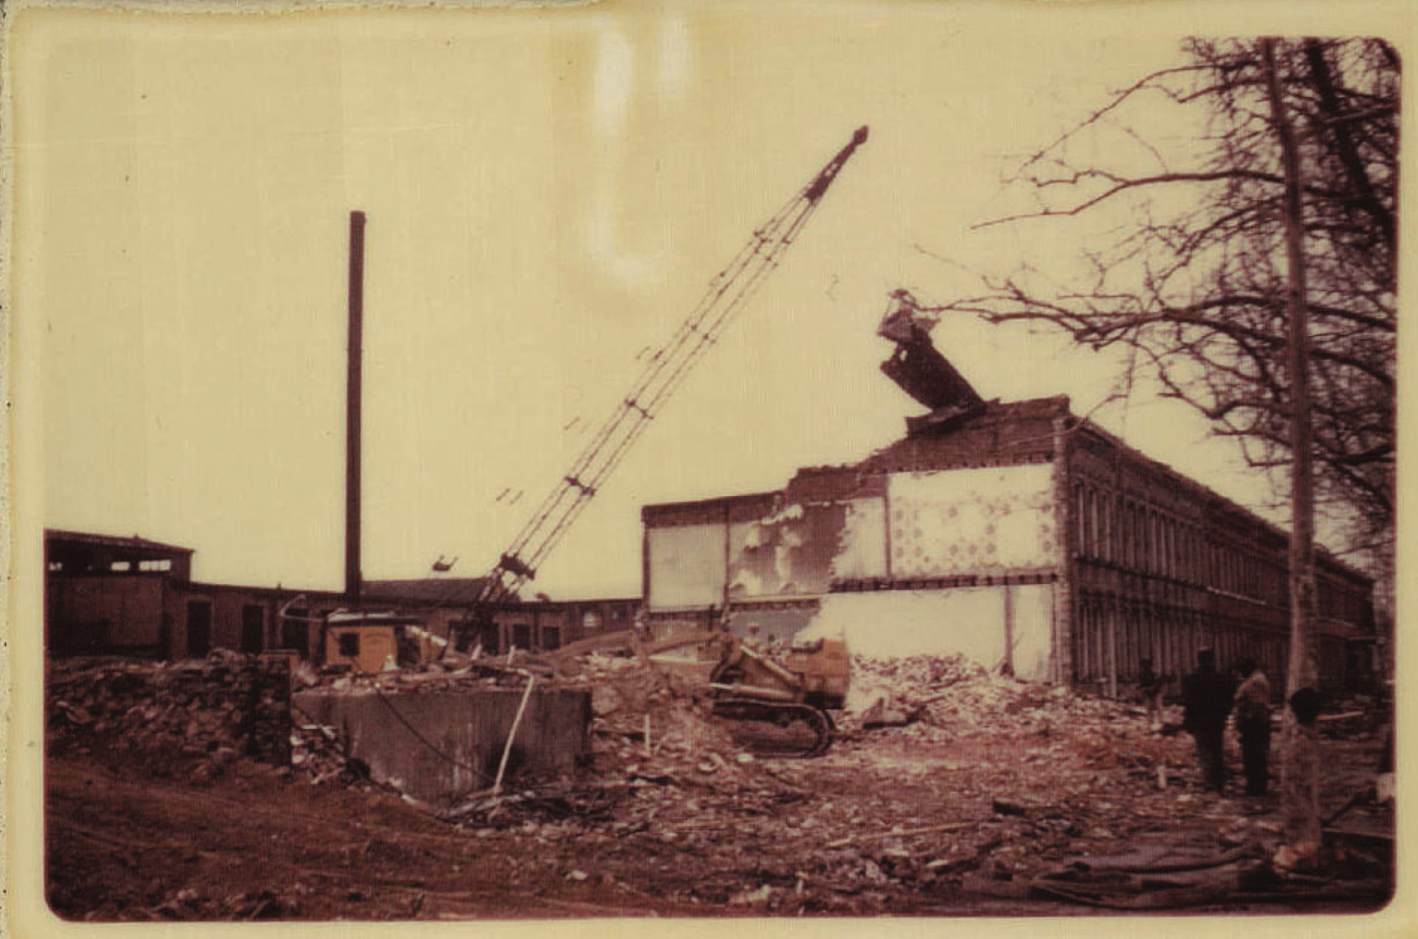
New structures such as upscale condos, townhomes and a newly refurbished waterfront area bandaged over what was originally mixed-use structures and developments. This reimagination left little room for the displaced residents to return, as much of the new housing was unaffordable to the former working-class population. Critics argued that the redevelopment prioritized aesthetics and economic revitalization over the needs of the existing community, effectively displacing the very people it claimed to help.
Figure 8 Demolition of alley homes on Water Street. Circa 1950s. Courtesy of St. Augustine’s Episcopal Church.
Many relocated to the Anacostia neighbor once again, which now caused tension between Southwest refugees and long-term residents of Southeast. Only some were relocated to public housing, such as Greenleaf Gardens, which had been completed in 1957. The construction of Greenleaf Gardens was highly contentious, and the head of the RLA, John Searles, fought to end its creation but failed. Little else was erected in terms of public housing during the redevelopment, and the alley residents suffered a fatal blow. Segregation continued to obstruct efforts to rehouse displaced alley dwellers, even after redevelopment. Many former alley dwellers, unable to afford housing elsewhere, faced homelessness at the hands of the DC Redevelopment Land Agency. Ultimately, segregation was the most significant factor preventing marginalized communities from ever returning to the area.
Today, out of more than 3,500 individual alley structures, only 108 alley structures exist today. They have withstood the impacts of urban renewal and gentrification efforts, preserving a unique aspect of Washington, D.C.’s architectural and social history. These dwellings, though, have become vehicles for gentrification. Primarily found in neighborhoods like Foggy Bottom, Capitol Hill, and Georgetown, many of these buildings were stabilized and adapted for modern use. While some continue to serve as residences, others have been transformed into shops, businesses, and community spaces, maintaining the historical character of the city's alleyways.
The area featured rowhouses, markets, and small businesses, fostering tight-knit communities despite widespread poverty. Unsafe drinking water, high infant mortality rates, rampant spread of disease, and constant crime significantly damaged the public’s view and understanding of Southwest. Despite these challenges, cultural life flourished. Churches, social clubs, and Black-owned businesses anchored the community, providing spaces for civic engagement and cultural expression. The neighborhood struggled with inadequate infrastructure and substandard housing, earning a reputation as a neglected urban area.
Residents, visitors, government officials, and urban planners called for reforms to the area. Both the City Beautiful and Sanitarian movements played significant roles in the federal government response to address the "blighted" conditions of Southwest D.C. Advocates for modernization and slum clearance viewed Southwest’s crowded, working-class neighborhoods as at odds with their vision for the city’s future. They promoted the development of wide boulevards, open green spaces, and monumental architecture to remake the area into a modern, orderly urban landscape—deliberately contrasting with the existing built environment.
The mid-20th century marked a transformative and turbulent period for Southwest due to urban renewal efforts. In the 1950s and 1960s, the federal government targeted the neighborhood as part of its plan to modernize Washington, D.C. Labeling much of Southwest, DC as socially and economically marred, authorities flattened large sections of the community, displacing thousands of residents—primarily Black tenants. This over 600-acre clearance made way for modernist architecture, including high-rise apartments, office buildings, and public housing projects. While these changes aimed to attract middle-class residents and businesses, they often disrupted existing social networks and exacerbated economic inequality in the city. In the process, approximately 23,000 residents—most of them Black—were displaced, often with little consultation or compensation. Even though the city’s plan aimed to create low and moderate income housing, the plans did not create housing for the masses that were evicted from their homes.
The redevelopment dramatically altered the neighborhood's physical and social fabric. Private developers were invited to construct large-scale apartment complexes, office buildings, and commercial spaces, catering to a middle- and upper-class demographic. The project was hailed by many as a huge success by advocates of urban renewal and The Capital Park apartments were honored with a design award by the American Institute of Architects. However, this creativity primarily benefited middle- and upper-class populations, who were the intended focus of the project.
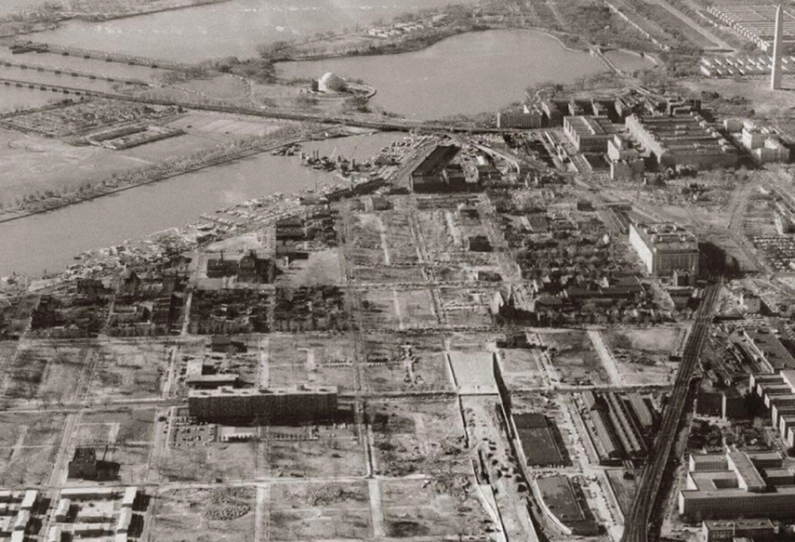
A once connected neighborhood was drastically different, the landscape was disrupted by the construction of the Southwest Freeway and L’Enfant Plaza. Even during the process of “revitalization” the project became a cautionary tale of urban redevelopment’s unintended consequences, exposing deep racial and economic inequalities embedded in mid-20th-century city planning.
Figure 9 Clearing of Southwest, DC, 1950s. National Capital Planning Commission.
By the time the project was completed in the 1970s, Southwest D.C. had been entirely transformed. The century old grid was replaced, and the Island was essentially erased from the physical environment. The project ultimately could not be considered a success.
In recent decades, Southwest’s latest redevelopment wave has centered on the Wharf, transforming its waterfront into a hub for dining and luxury living. This area became a focal point for revitalization while the interior part of the neighborhood was largely forgotten by this period of development. The Wharf project, which began in the 2010s, has transformed the wharf area for dining, entertainment, and luxury living. This redevelopment focused on more cultural icons of the last period of redevelopment with the redesign of Arena Stage, the Waterfront metro station, and the Wharf. However, this resurgence has sparked debates about gentrification and the displacement of long-time residents and businesses. While the redevelopment has brought economic investment and improved infrastructure, many advocate for preserving affordable housing and ensuring that the neighborhood’s history and cultural legacy are not erased.
The urban landscape that emerged from this transformation reflected not only modernist design but also evolving national ideals about housing, community, and social order. Southwest’s urban fabric reveals a layered narrative of national and international planning ideals, expressed through materials like brick, stone, aluminum, and concrete. Its built environment reflects the evolution of American architectural and social values, from well-crafted Sanitary-era housing with hardwood floors and garden plots to the landscaped superblocks of modernist condos and single family homes, marked by elevated porticos and glass-walled lobbies. These spaces embodied mid-century ideals of domesticity and gender roles, as seen in the contrast between large public-housing units—designed for working-class families—and the smaller, efficiency-oriented apartments characteristic of middle-class modernist design.
Even as mid-rise apartment blocks emerged in the postwar decades, the American preference for single-family living persisted in the rowhouses of Greenleaf and townhouse clusters developed during urban renewal. Rather than a static utopia or museum district, post-1960 Southwest functioned as a dynamic environment where layered social visions adapted to shifting urban needs. The waterfront served as a symbolic and functional link across time—its historic fish market coexisting with modern restaurants, structured parking, and promenades extending from the Titanic Memorial to Fort McNair. Superblocks created internal green courtyards that promoted a sense of small-scale community within the city’s growing transience. Wide roads accommodated automobiles, while car-free passages provided pedestrian access to the waterfront and M Street shopping, reflecting a modernist effort to reconcile mobility, density, and livability.
Criticism of the Southwest redevelopment project remains a key point in discussions of urban planning and gentrification. While it achieved the goal of modernizing the area, including eradicating some avoidable diseases, it also contributed to long-term racial and economic disparities in Washington, D.C. In recent years, historians and urban planners have revisited the Southwest case to draw lessons about the consequences of complete and large-scale urban revitalization, emphasizing the need for community-driven approaches to development. The area continues to experience cycles of displacement, particularly with new waterfront redevelopment efforts that further alter the social fabric of the neighborhood. The story of Southwest D.C. serves as a cautionary tale about the unintended consequences of urban renewal and the importance of equitable urban planning.

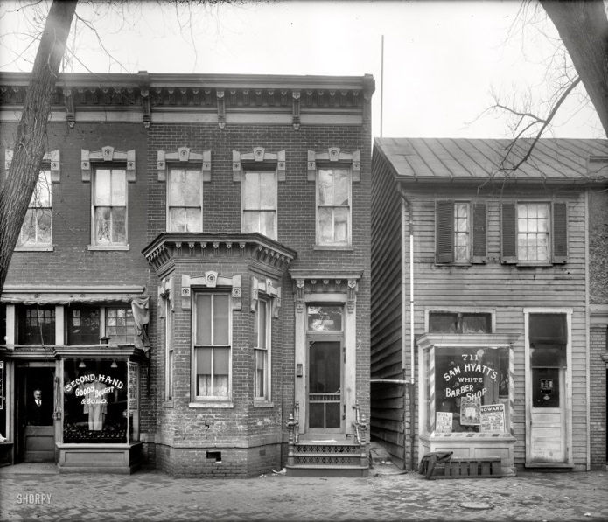
4 ½ Street SW: A Microhistory of Space, Community, and Displacement
4 ½ Street is one of the best examples of what is lost after 1950s urban revitalization efforts. The street was once considered to be the city’s commercial hub. The once cobblestone street was home to dozens of Jewish and Black owned businesses. The street was a vital part of the neighborhood before the RLA’s mid-20th century redevelopment. 4 ½ Street once stood as a powerful symbol of the vibrant, diverse life. Known as the commercial heart of the neighborhood, this cobblestone thoroughfare was home to a rich mix of Jewish- and Black-owned businesses that served as cornerstones of local economic and social life. During the late 19th and early 20th centuries, 4 ½ Street became a hub for Jewish-American enterprise following a wave of immigration in the 1880s. The street also functioned as a cultural and racial crossroads: Irish, Jewish, and Italian immigrant families lived to the west, while Black residents settled to the east. Here, in the daily life of the market and the play of children in the streets, communities met across lines of segregation, even as adults navigated the deeper inequities embedded in the built environment.
Figure 10 4 1/2 Street, Southwest. Circa 1950s. Via shorpy.com
Synagogues and churches sat upon the throughfare. Talmud Torah, established by Russian Jews fleeing Czarist Russia in 1886, became the epicenter for Jewish life on 4 ½ Street. Al Jolson, a famous Black and White movie star of the early 20th century once attended services at the congregation. His father was the cantor. Talmud Torah was located within the Island for nearly 50 years until the RLA forced the congregation to relocate.
Following widespread demolition during mid-century redevelopment, 4 ½ Street was renamed 4th Street—an act intended to symbolize a new beginning. The structures that replaced those formerly located on 4th Street represented a significant departure in both form and function. Capitol Park Apartments was the first structure realized under the Southwest Urban Renewal Plan, marking the beginning of Capitol Park—a model residential complex of apartments, townhouses, and landscaped open space. Heralded at the time as “the first step toward a new Washington,” the project embodied both architectural ambition and symbolic transformation. It was also a defining moment in the career of Chloethiel Woodard Smith, one of the few prominent female architects of the mid-20th century. Her success with Capitol Park led to further commissions and solidified her role in shaping the Southwest master plan. The award-winning design drew from avant-garde European modernism, incorporating innovative features for the city at the time, such as pilotis to raise the building and terra cotta brise-soleil for sun screening.
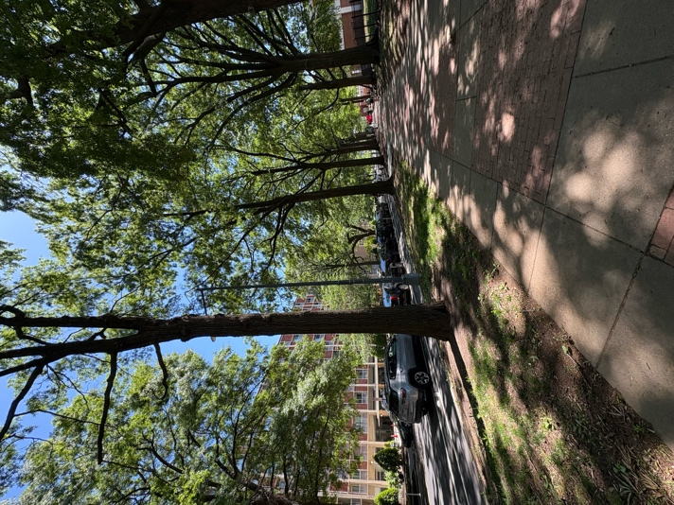
The site was formerly home to Dixon’s Court, a notorious alley community often cited as a symbol of urban blight. Photographs of its deteriorating conditions—framed by the distant U.S. Capitol dome—circulated widely and were even used in Soviet propaganda to critique American inequality. In response, President Eisenhower showcased the under-construction Capitol Park to Soviet Premier Nikita Khrushchev as evidence of national progress in housing and planning.
Figure 11 4th Street, 2025. Photo taken by author.
Capitol Park Apartments also holds legal significance. The land it occupies was central to Berman v. Parker, the landmark Supreme Court case that expanded the definition of “public welfare” under eminent domain to include aesthetic considerations and urban improvement. While Capitol Park was envisioned as a mixed-income community, it ultimately failed to achieve its social goals. Like much of Southwest’s redevelopment, it became a symbol of the social costs of urban renewal—costs disproportionately borne by displaced, primarily Black residents, and by a city that sacrificed cohesive communities for a modernist vision of progress. Yet this change also obscured the layered histories and cultures that once defined the area. Revisiting the story of 4 ½ Street calls into question dominant narratives of progress and invites us to ask whose lives are remembered in the remaking of the city.

Conclusion: What Comes Next?
The history of Southwest D.C.’s alley communities is a powerful entry point into a much larger, national story. Each alley and each alley community is distinct—shaped by its own geography, people, and patterns of life—but together, they tell an overarching story of strength, destruction, and the long consequences of policy-driven displacement. The demise of “The Island” destroyed communities and social networks that had existed for generations—woven over centuries through shared struggle, kinship, and cultural life. What was lost was not just housing, but a way of being in the city.
This erasure was not the result of any one malicious actor. The responsibility is shared across planners, developers, and government officials who, often with good intentions, enacted policies that prioritized modernization over community. These decisions reflected prevailing values of their time—values that viewed poverty as a problem to be cleared rather than a condition to be understood. But understanding this context does not absolve the harm. Instead, it deepens our responsibility to do better.
The destruction of alley cultures across the country reminds us that planning and preservation must evolve. When preservation privileges buildings over people, and when planning advances without historical memory, both fields fall short. A reparative approach recognizes that history lives not only in structures, but in stories, relationships, and place-based identities. Preservationists must expand their tools to include oral histories, community programming, and memory work. Planners must anchor development in equity, inclusion, and accountability for past harms.
The story of the Island shows that cities are not just physical spaces but also are archives of belonging, displacement, and opportunity. This project serves as both reflection and call to action: to remember what was lost, to value what remains, and to build a future where preservation and planning work together to sustain justice, memory, and community.
Preserving the memory and legacy of alley culture in Southwest D.C. is an ongoing challenge. Though the neighborhood’s history is steeped in stories of injustice but also cultural richness, much of its physical past has been erased under the guise of urban renewal. Generations of alley dwellers and working-class families built lives in these overlooked spaces—places rich with memory, meaning, and identity—only to see them wiped from the map by legislation that preferred modernization instead of community. The sleek developments that now define the area offer a sanitized version of history, burying lived experiences beneath glass and concrete.
Many important scholars have come before, and many more will follow. That is the hope for those who study erased places. Each contribution adds to a growing body of work that strengthens the collective narrative and brings us closer to justice. My contribution—a walking tour—invites both audiences and preservationists to reimagine the built environment and embrace progressive, community-rooted approaches to preservation. By retracing the paths of named alleys and revisiting surviving landmarks, the tour reclaims narratives once silenced and brings them back into public view. Juxtaposing the current landscape with its historical form encourages participants to see the neighborhood not just what stands, but what has been lost.
Yet no tour can fully capture the weight of what was lost. The broader implications of Southwest’s story require deeper reflection—on preservation, memory, and justice. True reparative preservation requires more: sustained community engagement, investment in remaining cultural assets, and planning processes that amplify historically marginalized voices. The goal is not nostalgia, but justice—and a more inclusive vision that centers those long excluded from dominant narratives.
The absence of physical structures does not preclude preservation. Memory, meaning, and narrative can still be safeguarded even when buildings are gone. Architectural details like trim, materials, and ornamentation matter—but the stories of those erased must carry equal weight. Preservationists must innovate. Storytelling, interpretive signage, oral histories, and immersive public programming are essential tools of justice. When adapted thoughtfully to each community, these methods help rebuild erased landscapes with care and integrity. They also bridge the gap between preservation and planning—two disciplines that, when aligned, can build cities that remember even as they grow.
City planners have a critical role in this work. Future redevelopment in Southwest must be rooted in community input, historical understanding, and accountability for past harms. Long-term planning strategies should embed preservation at their core, ensuring that growth does not come at the cost of cultural erasure. This includes honoring community heritage, protecting spaces of memory, and investing in affordable housing that supports belonging.
Alley communities offer powerful lessons. Their stories reveal how inequality is built into the landscape—and how memory, culture, and identity endure despite displacement. By studying these histories, planners and preservationists alike can work toward a practice grounded in equity, care, and justice. In doing so, they won’t just preserve the past—they’ll help shape a more truthful and inclusive urban future.

Appendix and Tour
When traditional analysis falls short of accessibility and equity, what approaches will truly serve the community's needs and honor their narratives? As preservationists, we have a responsibility to engage communities in history by developing innovative and equitable methods for placemaking and storytelling. Communities must be kept in mind when devising plans for preservation. Academic approaches to understanding and interpreting history often lack equity, frequently excluding the voices and stories of marginalized communities. This programming focuses on creating an educational experience that encourages awareness, understanding, and reflection of public history.
Tours are powerful tools for discovery and education, offering unique opportunities to engage with history and culture. They can reshape public perceptions, deepen understanding, and foster connections to the stories and spaces that define communities. The ability to observe and physically engage with the spaces where history and culture take place is essential in preserving the voice and memory of marginalized communities. Sharing these stories in spaces that have undergone significant transformation poses a unique challenge, making the creation of spaces for these narratives even more essential. Despite the social and physical isolation experienced by many of Washington's residents, this tour seeks to restore their right to the city.
Southwest’s the Island offers a unique opportunity for physical exploration for three key reasons. First, the neighborhood once housed a predominantly low-income population living in unsafe conditions, making the task of telling their nuanced and complex stories essential. Telling the stories of the people who lived in these alley dwellings can illuminate a previously overlooked population. While alley residents often faced hardship and poverty, they also built resilient, vibrant communities that provided mutual support and solidarity. These communities have an important role to play in the sharing of this history but also in the future of the city.
Second, the physical structures that once defined this community have been erased adding layers of complexity to preserving and interpreting its history. Without formal architectural or structural records, alley dwellings and their residents are often denied legitimacy, yet their stories are vital to the city's history. Discussing these spaces and walking through the built environment that was vastly different is a key component of this programming.
Southwest's complex relationship with gentrification underscores the importance of this programming. This tour highlights the necessity of preserving and sharing the area's history, ensuring that the stories of displaced communities are not forgotten in the face of ongoing development and change. Even though urban renewal initiatives aimed to provide safe food and water, sanitary streets, and protection from crime, the outcomes often diverged from these intentions. Though improved living conditions and cleanliness were achieved, the process dismantled a community that had taken over a century to build.
Preservation should serve as both a recognition and celebration of the past, honoring the history that has shaped the present. How can the stories of people and places that no longer exist in the area be told? What influence has gentrification had on shaping this narrative? How can we continue to share these important histories while acknowledging both their positive and negative aspects?

Why a Tour?
To make this history more accessible and bring erased narratives back into public view, this project turns to public history through the creation of a walking tour. Designed to foster connection and dialogue, the tour serves as a bridge between past and present communities. Engaging the public in this way is one of the most effective means of safeguarding historical and cultural resources. At its core, the project aims to establish a lasting and accessible educational tool—one that presents a complex, often solemn history in a way that is both comprehensible and meaningful. It offers a modest gesture toward reconciliation, inviting reflection, recognition, and continued conversation.
Active participation in shared historical storytelling is one of the most powerful tools for building appreciation and support for important historical and cultural resources—even those that are no longer physically present. By bringing history to the public in an interactive, personable and immersive way, we encourage a deeper connection between people and the spaces they inhabit, ensuring that these narratives are not only preserved but also remain relevant to future generations.
Establishing an accessible and enduring piece of educational programming became the foremost objective of this project. A tour provides an opportunity for direct engagement, allowing participants to experience history in situ—walking the same paths, seeing the same landmarks, and contextualizing historical events within the physical environment where they unfolded. By doing so, the tour transforms historical interpretation from static text into a dynamic, lived experience.
In examining redevelopment’s effects this project aims to weave public history with a nuanced and often solemn narrative, ensuring that stories that have long been overlooked or misunderstood are brought to the forefront of our collective memory. It seeks to strike a balance between accessibility and depth, making complex histories comprehensible while honoring the emotional weight they carry. By presenting history in a way that is engaging yet responsible, the tour serves as both an educational tool and a small gesture of reconciliation—acknowledging the past, fostering dialogue, and inspiring a more informed and empathetic understanding of our shared heritage.
While planning this tour, two key challenges emerged: organizing it without a traditional chronological structure and narrating the history of places that no longer physically exist. Addressing these required a creative, public history–driven approach that ensures the tour is both engaging and meaningful for audiences. Rather than following a linear timeline, the tour is structured thematically around concepts like community resilience, displacement, and the impact of public policy. This approach encourages participants to connect past injustices to present urban realities, highlighting the agency and cultural life of alley-dwelling communities. By engaging the public in reflective interpretation, the tour exemplifies how history preservation can adopt new methods to deepen scholarship and create more inclusive, participatory experiences.
Because demolition and urban renewal have erased most physical traces of the alley communities, the tour draws on historical photographs, oral histories, and archival records to reconstruct a sense of place within the new neighborhood. Participants are invited to contrast the present-day built environment with what once existed, using the landscape as a prompt for memory and imaginative reflection.
Tour Script and Outline
Overview of tour: These often-overlooked spaces were once home to vibrant communities, shaped by resilience, creativity, and resourcefulness despite significant social and economic challenges as well as systemic racism. Alley dwellings became an important aspect of DC heritage and culture. This tour invites you to step into the story of these spaces and the people who called them home, navigating the intricate intersections of community, marginalization, and urban transformation. While many of the physical alley dwellings have disappeared due to redevelopment and gentrification, their legacy remains integral to understanding the evolution of Washington, D.C., and the broader narratives of urban American life.

Stops:
- Huntoon Court and Wheat Row (Today known as Wheat Row) 1315 4th St SW, Washington, DC 20024 Theme: Early Architectural DC History and Setting the Stage for Blind Alleys.
When Washington, D.C. was founded in 1790, Pierre Charles L’Enfant envisioned a capital city that embodied democratic ideals through grand boulevards, sweeping vistas, and monumental architecture. His design prioritized broad avenues and public squares to accommodate future growth and grandeur—but in doing so, left the interiors of city blocks largely undefined. Over time, these overlooked spaces became home to the city’s network of alleys, which would later evolve into densely populated residential areas, especially in Southwest.
Early architecture in the city drew heavily from European influences, particularly the refined Federal style, known for its symmetry, classical detailing, and balanced proportions. A prime example of this era is Wheat Row, built in 1794, which remains one of the oldest surviving residential blocks in Washington. These four townhouses were originally constructed for merchants and professionals, reflecting a vision of Southwest as a desirable, economically active community centered around its bustling port.
Today, Wheat Row stands as a rare relic of 18th-century Washington, its brick façades and restrained elegance sharply contrasting with the glass, steel, and concrete structures that surround it. This juxtaposition offers more than aesthetic interest—it underscores the city’s layered history, and the shifting values embedded in urban development. While Wheat Row has been preserved as a touchstone of early American urban life, its survival prompts deeper questions: Why was this particular piece of the neighborhood saved, and what does its preservation suggest about whose histories are deemed valuable?
- Thomas Law House Theme: Southwest’s Early History
Southwest D.C. holds a deep and layered history that stretches back long before the founding of the federal city. This land was originally inhabited by the Anacostan people and later the Piscataway, whose presence shaped the region’s early identity. Once part of Maryland, the area was incorporated into the District of Columbia in 1791 through Pierre L’Enfant’s ambitious plan to create a capital city that reflected the ideals of a young republic.
In the years following the city's formation, Southwest remained largely agricultural, home to plantations and gardens. But by the early 19th century, its economy began to shift—driven by its proximity to the waterfront. Shipbuilding, fishing, and wharf-related industries took root, giving rise to a diverse and active community. The neighborhood became home to free African Americans, working-class immigrants, and a small number of wealthy landowners, all shaped by the rhythms of a port city.
Yet despite its vibrancy, Southwest struggled with poor infrastructure and systemic inequality. Limited access to public services and growing economic disparities created conditions that hindered long-term stability. Housing segregation and uneven investment deepened social divides. These foundational challenges laid the groundwork for the sweeping urban renewal efforts of the mid-20th century—projects that would drastically reshape the neighborhood’s built environment and displace many of its residents.
Understanding Southwest’s early development—and the obstacles it faced—reveals how structural inequities can drive both decline and transformation. It also reminds us that behind every redevelopment plan lies a deeper story about the people and communities who came before.
- Island Hall Theme: Post Civil War history of Southwest (D Street and Virginia Ave)
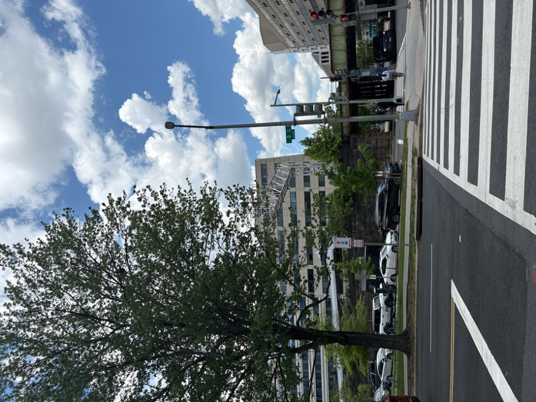
In the 19th century, Island Hall stood as one of the most prominent civic landmarks in Washington, D.C. This now-lost three-story brick building was more than just an architectural fixture—it was a vital gathering space that anchored political, social, and community life in post–Civil War Southwest. Named after the neighborhood it served, Island Hall reflected the identity and autonomy of a community that operated, in many ways, apart from the rest of the city.
Figure 12 D Street and Virginia Ave, SW. Formerly the site of Island Hall, 2025. Photo taken by author.
That identity was shaped in part by Southwest’s infamous inaccessibility. Surrounded by the Washington City Canal to the north and east and the Baltimore and Ohio Railroad to the west, the neighborhood became known as “The Island”—a name that captured both its physical separation and its social exclusion. Even after the hazardous canal was filled in, the nickname endured, symbolizing the enduring distinctiveness of the community that had taken shape within these boundaries. Over decades, Southwest developed a culture all its own—tight-knit, resilient, and rooted in shared experience.
Today, the site where Island Hall once stood is little more than a quiet block of grass, overshadowed by the concrete geometry of federal office buildings. It stands as a subtle but powerful reminder of what was lost—of the institutions and spaces that gave this community voice, coherence, and visibility.
Southwest’s legacy includes many notable figures whose lives shaped not just the neighborhood but the nation. From Anthony Bowen, a conductor on the Underground Railroad, to Marvin Gaye, Al Jolson, and Thurgood Marshall, the area has long been home to individuals whose contributions spanned civil rights, culture, and the arts. Island Hall may be gone, but its story—and those of the people who once gathered there—remain central to understanding the layered history of Southwest.
- O’Neils’ Court (Capitol Park Tower: G St SW & 3rd St SW) Theme: Creation of Alley Dwelling Communities
A convergence of inequality, unaffordable housing, and rapid population growth created a shelter crisis in 19th-century Washington, D.C. As traditional housing proved inaccessible to many, alley communities began to emerge as a workaround to the city’s housing shortage. Built behind existing rowhouses and tucked away from the public eye, these alleys offered quick and inexpensive shelter for the working-class poor. Developers seized the opportunity, constructing cramped, substandard dwellings within blind alleys—often without plumbing, ventilation, or safety considerations—while charging high rents. Though these structures were never meant to be permanent, many endured for decades; on the Island, some stood for over a century.
Most early alley dwellings were simple wood-frame buildings, though some were later replaced with more permanent brick structures. Early residents were predominantly white, including European immigrants drawn by jobs in the city’s growing economy. Following the Civil War, the demographic makeup of these communities shifted dramatically. Freed Black residents, often excluded from other parts of the city through segregation and discriminatory housing policies, found refuge in the alleys. What began as marginal shelter grew into enduring neighborhoods—tight-knit, resourceful, and defined by mutual aid.
Despite the harsh conditions, alley communities became spaces of resilience. They housed churches, small businesses, and extended families, creating vibrant if hidden ecosystems of urban life. Yet these communities were frequently stigmatized by outsiders, blamed for the poverty and overcrowding they endured, and targeted for removal in later reform efforts. Today, this site is home to Capitol Park Towers—now known as Potomac Place—designed by modernist architect Chloethiel Woodard Smith during the mid-century urban renewal of Southwest. The complex was envisioned as a safe and orderly refuge within a neighborhood undergoing massive clearance. Its shared green space and central fountain offered residents a sense of serenity and enclosure, in contrast to the surrounding streets still labeled as blighted. The design reflects the ideals of the time: clean lines, controlled space, and separation from what had been. Yet beneath this carefully curated landscape lies the memory of alley communities—wiped from the map but central to the neighborhood’s social history.

- Willowtree Alley and Clark Alley (Currently Tiber Island Homes) 68 houses. Theme: Cultural and Social History of Alley Dwellings.
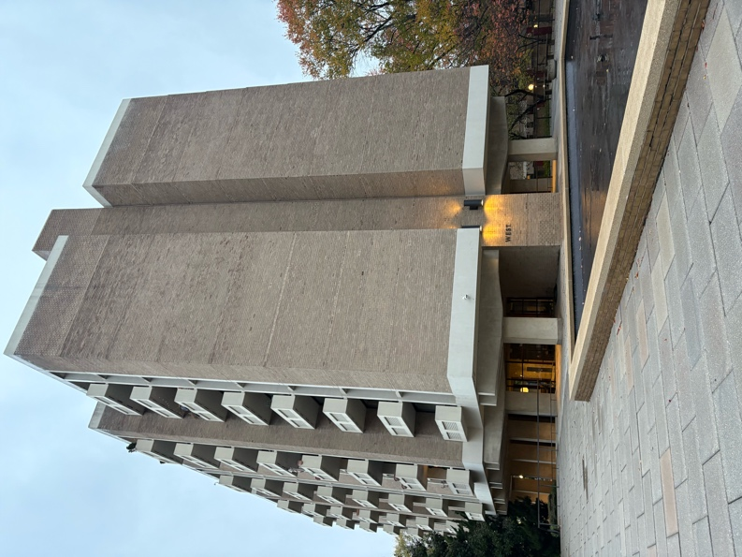
Built between 1963 and 1965, Tiber Island Homes became a landmark of Southwest D.C.’s urban renewal. Recognized with a design award from the American Institute of Architects in 1966, the development symbolized modern living and architectural ambition. Yet beneath its clean lines and landscaped courtyards lies a more complex history—one rooted in displacement and erasure.
Figure 13 Tiber Island Cooperative Homes, 2025. Photo taken by author.
Tiber Island sits on the former site of several named alleys, including Willow Tree Alley, once one of the largest and most stigmatized in the city. Known for overcrowding, high crime, and public health crises, it became a focal point for reformers who viewed alley life as a problem to be eliminated. These judgments were often shaped by racial and class biases. Residents faced intense scrutiny and harsh treatment from officials. In one raid, police found fifteen men in a single 11-by-15-foot room—a story used to justify clearance rather than reform.
Willow Tree Alley was among the first to be cleared in Southwest, reflecting First Lady Ellen Wilson’s national campaign to eliminate alley dwellings. Her efforts led to the 1914 Alley Dwelling Act, marking the start of federally supported clearance efforts. Today, Tiber Island’s modern design conceals the layered histories of those who once lived here. Remembering these lost communities helps us see past the architecture—and better understand the social forces that shaped what replaced them.

- Temple Court, Capitol Courts and Parker Row (Currently the Rubell Museum @ Delaware Ave & 1st St SW) Theme: Alley Dwellings & Representation in Public Eye, Safety and Health Concerns
The Rubell Museum now occupies the site where Temple Court, Capitol Courts, and Parker Row once stood—an area that, according to the 1912 Alley Directory, contained 29 alley dwellings. Compiled by Dr. Thomas Jesse Jones of the Monday Evening Club, the directory served as a powerful tool of advocacy, aimed at rallying reform-minded elites and federal officials to eliminate what they labeled as urban “slums.”
By the early 20th century, nearly 300 blocks in Washington, D.C. included inhabited alleys. Around 3,400 alley dwellings housed close to 24,000 residents. The directory reported an average of 58 people living in a single blind alley, often with inadequate sanitation and outdoor plumbing. These crowded and unsanitary conditions sparked fear among middle- and upper-class Washingtonians and fueled a wave of reform—ranging from grassroots advocacy to sweeping legislation.
Despite decades of pressure to dismantle alley life, Southwest’s alley communities endured for nearly a century. Their eventual erasure was not inevitable, but the result of a long campaign that reshaped the city—physically and socially—through persistent public and political intervention.

- 4 ½ Street, SW. (Currently 4th Street, Southwest. Theme: The Island as a center of Black and Jewish Life in Washington, DC.
The fight to preserve Southwest’s community identity reached the Supreme Court in the pivotal 1954 case Berman v. Parker. Max Morris, the plaintiff, owned a well-maintained department store that was slated for demolition—not because it was blighted, but because it sat within a larger area targeted for redevelopment. Morris argued that seizing functional private property for aesthetic or economic improvement violated the Fifth Amendment’s "public use" clause. While a lower court initially agreed, warning against the broad use of eminent domain for neighborhood beautification, the Supreme Court ultimately overturned that ruling. The Court held that comprehensive urban renewal served a legitimate public purpose, thus granting the government wide latitude to reshape entire districts—even if that meant displacing viable businesses and homes.
Before the ruling, 4½ Street SW was a vibrant artery of commercial and residential life. It was not only a central hub for local activity but also a symbol of the Island’s diversity and social divisions. The street marked a racial and cultural boundary—Black residents primarily lived to the east, while Jewish families settled to the west. Landmarks such as the Talmud Torah synagogue reflected the deep roots and community presence of Jewish Washingtonians in the area.
Today, no trace remains of the once-bustling 4½ Street. Once lined with cobblestones, shaded by elm trees, and lit by carbon lamps, it was home to grocery stores, doctors’ offices, and a local movie theater. A 1985 Washington Post article remembered it fondly for its lively games, busy storefronts, and abundance of bars—offering a glimpse into a street that was once full of life but ultimately lost to the sweeping hand of urban renewal.

- Christian Alley, Nolans and Pierce Court (Currently Syphax School & Gardens)
Theme: Segregation and the Syphax School’s Legacy
Alley dwellings were not originally conceived as segregated spaces, but over time they became strongly associated with Black Washingtonians—particularly by the early 20th century. Economic exclusion, discriminatory zoning, and racially restrictive covenants prevented many Black residents from accessing housing in more affluent or predominantly white neighborhoods. As a result, alley communities became both a refuge and a constraint, reinforcing cycles of poverty while limiting access to public services, education, and opportunity.
The area now known as Syphax Gardens once included several of these alley communities—Christian Alley, Nolan’s Alley, and Pierce Court—home to a total of 68 houses. At the center stood the Syphax School, named for the city’s first Board of Trustees of Colored Schools. Built in 1901, the school is a notable example of the Colonial Revival style and played a vital role in educating Black students in Southwest. Today, the building remains part of the Syphax Gardens public housing complex and stands as one of the few historic structures in the neighborhood to survive both waves of urban renewal. It offers a rare, tangible link to the legacy of Southwest’s Black communities and the institutions that sustained them.

- Dixons Court, Allen Court, Syphax Court, Pleasant Alley and Van Alley (Currently Southwest Library @ 3rd & K St) Theme: Demise of Alley Dwellings in SW
Today, the site of the Southwest Library was once home to Dixon’s Court, Syphax Court, and Pleasant Alley—three densely populated alley communities. Nearly 100 alley dwellings were concentrated within this five-block area. When Congress and local public safety officials condemned much of Southwest, it gave city leaders the authority and political momentum to pursue a sweeping redevelopment plan. The clearance of the Island proceeded rapidly, striking swift and irreversible blows to the neighborhood.
By the mid-1950s, much of Southwest had been reduced to rubble, with only a handful of historic structures left standing. The demolition was far-reaching in both physical and human terms. Approximately 24,000 households were displaced, many of whom had lived in alley communities for generations. There were no comprehensive relocation strategies in place, and the removal of residents was often abrupt and impersonal. What emerged in place of a long-standing, if underserved, community was a new vision of urban order—one that left behind few traces of the lives and histories that once filled these streets.
- Burkes Alley, Pig Alley, (Currently Town Square Towers 6th & 7th G Street) Theme: Gentrification and Urban Renewal
After more than a century of continuous existence, Southwest’s alley dwellings were erased with little resistance. In April 1954, bulldozers moved in, marking the beginning of a transformation with devastating consequences. Civic and federal leaders called for the demolition of alley housing, framing it as a public safety necessity and a step toward eliminating “blight.” In reality, the clearances paved the way for developments aimed at wealthier residents, often at the direct expense of long-standing, low-income communities.
What had once been a diverse, mixed-use neighborhood was rapidly replaced by a landscape of concrete and modernist design. New construction methods and planning ideologies favored uniformity and control over the organic vibrancy that had defined the area. Superblocks—large, enclosed housing complexes—came to dominate the urban fabric. This model of redevelopment would become the blueprint for large-scale urban renewal across the country in the decades that followed, with Southwest serving as both a prototype and a warning.

- Brothers Alley, Desmond Alley, Porksteak Alley, Riley’s Court (Currently Benjamin Banneker Park) Theme: The Legacy of Alley Dwellings in Southwest
Today, almost no physical evidence of alley dwellings remains in Southwest Washington, D.C. In contrast, neighborhoods like Georgetown and Capitol Hill have preserved portions of their historic alley infrastructure—such as Blagden Alley and Naylor Court—which now serve as vibrant cultural and historic destinations. These spaces have evolved into celebrated landmarks, drawing both locals and visitors for their architectural character and layered histories. Unlike the gradual transformations seen in other parts of the city, the erasure of Southwest’s alley communities was swift and total, largely due to aggressive urban renewal tactics. Despite their physical disappearance in Southwest, the legacy of alley dwellings continues to shape the district’s urban landscape—offering critical insights into housing inequality, community resilience, and the lasting impact of planning decisions on marginalized populations.
If we want to preserve this history, erased from the physical landscape we must look beyond what is built and confront what no longer exists and why it no longer stands in front of us.

Appendix of other important landmarks:
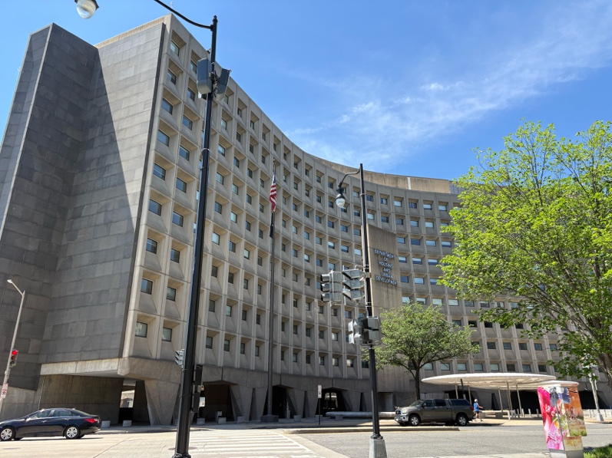
- St. Dominic Church: Built in 1875 in the English Gothic Style, this structure was the 2nd iteration of the church after a small chapel on the property was destroyed. The parish was established in 1852, and the original chapel was built in 1806. The location of this structure was deeply entrenched in alley dwelling communities, and an alley was even named after St. Dominic Church. The church is the only structure to survive the redevelopment of the area- the priory, school, and convent were demolished.
Figure 14 Department of Housing and Urban Development, 2025. Photo taken by author.
- Buzzard Point Power Plant: Designed in the Art Deco style and built in 1932, this structure was erected to accommodate the growing population of the city and supply power. Prior to the 1930s several interested parties wished to make the land a canal, a landfill and even a factory. Today this facility serves as a Pepco plant.
- Municipal Fish Market: Southwest D.C.’s Municipal Fish Market, established in 1805, is one of the oldest continuously operating open-air fish markets in the United States. Located along the Washington Channel, the market has long served as a vital commercial and cultural anchor for the community, connecting generations of Washingtonians to the city’s maritime heritage. Despite decades of redevelopment and urban renewal in the surrounding area, the Fish Market has endured, however, the fish market is a fraction of its original size.
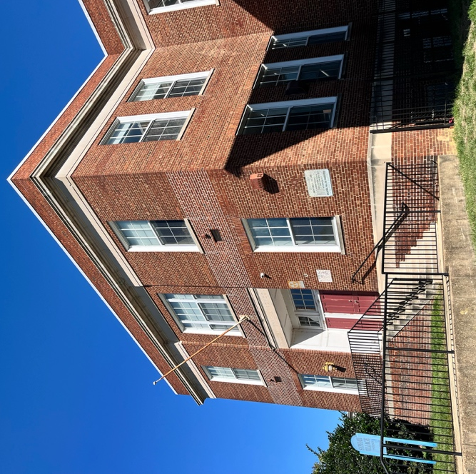
- Syphax Village: Built in 1901 the former school but now contains condominiums. The school was named after William Syphax, the first president of the Board of Trustees of Colored Schools of Washington and Georgetown. The colonial revival style structure historically educated Black Washingtonians. Syphax was a champion of a unified school system as well as equal education standards for students of color.
Figure 15 William Syphax School, 2024. Photo taken by author.

- Elizabeth G. Randall Junior High School: The Randall School, originally established in 1906 as Cardozo Elementary School, transitioned into a junior high school by 1927 and underwent multiple expansions to serve the growing educational needs of Southwest’s African American community. Its original structure and subsequent additions reflect the broader evolution of public-school architecture in Washington, D.C., during the early 20th century—showcasing work from both private architects and the Municipal Architect’s office. As one of the few community landmarks to survive the sweeping changes of urban renewal, the Randall School stands as a significant and enduring symbol of Southwest’s social and educational history.

Bibliography
- “A Bulldozer Isn't Always Needed,” Washington Post, April 4, 1964, E11.
- “A Redevelopment Plan for Southwest Washington, DC.” NCPC.gov, April 5, 1956. https://centennial.ncpc.gov/pdf/1956_A_Redevelopment_plan_for_Southwest_DC.pdf.
- “About Us: St. Paul AME Church DC.” St Paul AME Church. Accessed February 7, 2025. https://www.stpaulamedc.org/aboutus.
- “American Institute of Architects Honor Awards 1960 - 1969.” American Institute of Architects, n.d. https://web.archive.org/web/20080412214600/http://www.aia.org/library_honorawards_60_69.
- “DCHA Public Housing Properties.” District of Columbia Housing Authority. Accessed October 28, 2024. https://www.dchousing.org/vue/customer/properties_view.aspx?AspxAutoDetectCookieSupport=
- “District of Columbia Inventory of Historic Sites.” DC Office of Planning, 2009. https://planning.dc.gov/sites/default/files/dc/sites/op/publication/attachments/Inventory%202009%200%20Alpha%20Version%2003%2011.pdf.
- “Ellen Wilson.” Miller Center, August 28, 2023. https://millercenter.org/president/wilson/essays/wilson-ellen-1913-firstlady.
- “Guides: Washington, D.C., History Resources: Timeline.” Timeline - Washington, D.C., History Resources - Guides at Georgetown University. Accessed April 2025. https://guides.library.georgetown.edu/c.php?g=1096877&p=8002816#:~:text=1910%20The%20population%20of%20the,of%20alley%20housing%20by%201918.
- “History.” History - Ohev Sholom Congregation. Accessed May 10, 2025. https://www.ohevdc.org/history.
- “James Creek Dwellings – Washington DC.” Living New Deal, October 16, 2020. https://livingnewdeal.org/sites/james-creek-dwellings-washington-dc/.
- “Land Rich to Dirt Poor James Greenleaf Gambled and Lost in Early D.C.” The Morning Call, October 4, 2021. https://www.mcall.com/1999/07/04/land-rich-to-dirt-poor-james-greenleaf-gambled-and-lost-in-early-dc/.
- Ammon, Francesca. Southwest Washington, D.C., Urban Renewal Area, Historic American Buildings Survey (HABS No. DC-856) (Washington, DC: Historic American Buildings Survey, National Park Service, U.S. Department of the Interior, 2004).
- Antoinette J. “Southwest Quadrant,” in Pamela Scott and Antoinette J. Lee, Buildings of the District of Columbia (New York: Oxford University Press, 1993).
- Apartments Rehabilitated for Low-Income Families,” Washington Post, Aug. 5, 1967, C7.
- Asch, Chris Myers, and George Derek Musgrove. Chocolate city: A history of race and democracy in the nation’s capital. Chapel Hill: University of North Carolina Press, 2019.
- ​​Auslin, Michael. 2024. “Under Your Shoes: Washington’s Unique Geology.” Substack.com. THE PATOWMACK PACKET. April 7, 2024. https://patowmackpacket.substack.com/p/what-rocks-how-washingtons-geography.
- Beauchamp, Tanya E. “National Register Nomination for the William Syphax School” (Unpublished study, 2003).
- Berman v. Parker, 348 U.S. 26 (1954)
- Billingham, Chase M. “THE BROADENING CONCEPTION OF GENTRIFICATION: RECENT DEVELOPMENTS AND AVENUES FOR FUTURE INQUIRY IN THE SOCIOLOGICAL STUDY OF URBAN CHANGE.” Michigan Sociological Review 29 (2015): 75–102. http://www.jstor.org/stable/43630965.
- Borchert, James. “Builders and Owners of Alley Dwellings in Washington, D. C., 1877-1892.” Records of the Columbia Historical Society, Washington, D.C. 50 (1980): 345–58.
- Borchert, James. “The Rise and Fall of Washington’s Inhabited Alleys: 1852-1972.” Records of the Columbia Historical Society, Washington, D.C. 71/72 (1971): 267–88. http://www.jstor.org/stable/40067777.
- Borchert, James. “Urban Neighborhood and Community: Informal Group Life, 1850-1970.” The Journal of Interdisciplinary History 11, no. 4 (1981): 607–31. https://doi.org/10.2307/203145.
- Borchert, James. Alley Life in Washington: Family, Community, Religion, and Folklife in the City, 1850-1970. Chicago: University of Illinois Press, 1980. Blacks in the New World Series. Pp. Xiv, 317. Tables, Maps, Photographs. 1981. Urban History Review / Revue d’histoire urbaine.
- Boyd’s District of Columbia Directory for 1920, 1786.
- Brown, Letitia W. “Residence Patterns of Negroes in the District of Columbia, 1800-1860.” Records of the Columbia Historical Society, Washington, D.C. 69/70 (1969): 66–79. http://www.jstor.org/stable/40067705.
- Cantwell, Thomas J. “Anacostia: Strength in Adversity.” Records of the Columbia Historical Society, Washington, D.C.49 (1973): 330–70. http://www.jstor.org/stable/40067747.
- Clark-Lewis, Elizabeth. Living In, Living Out: African-American Domestics in Washington, D.C., 1910-1940 (Washington, DC: Smithsonian Institution Press, 1994).
- Clark, Alan Culling. Greenleaf and Law in the Federal City (Washington, DC: W.C. Roberts, 1901).
- Clement, Bell. “Wagner-Steagall and the DC Alley Dwelling Authority: A Bid for Housing-Centered Redevelopment 1934-1946,” Journal of the American Planning Association, 7 (2012), 438-48.
- Clephane, Walter C. “The Local Aspect of Slavery in the District of Columbia,” Records of the Columbia Historical Society, 3 (1900), 239-24.
- Cosby, Robert L. Gentrification and the History of Power and Oppression of African Americans in Washington DC., December 2023.
- DC Public Library. “Southwest Library,” http://dclibrary.org/southwest/history, accessed January 2025.
- Deborah Rubenstein and Stuart Speaker, with Joan C. Chase, “Historic Context,” in Archaeological Survey, 87.
- District of Columbia Office of Planning, and Kim Protho Williams, The DC Historic Alley Buildings Survey District of Columbia Office of Planning (2014).
- EHT Traceries, Inc. “National Register Nomination for Randall Junior High School” (Unpublished study, 2009).
- Feeley, Connie. “3 Housing Projects to Be Constructed,” Washington Post, Aug. 5, 1958, B8.
- Flanagan, Neil. “Inflection Point.” Washington City Paper, October 25, 2021. https://washingtoncitypaper.com/article/1400/inflection-point/.
- Fletcher, Patsy. “Ward 6 Heritage Guide - DC Office of Planning.” District of Columbia Historic Preservation Office, 2018.
- Groves, Paul A. “The Development of a Black Residential Community in Southwest Washington: 1860-1897.” Records of the Columbia Historical Society, Washington, D.C. 49 (1973): 260–75. http://www.jstor.org/stable/40067744.
- Hannold, Elizabeth. “‘Comfort and Respectability’: Washington’s Philanthropic Housing Movement.” Washington History 4, no. 2 (1992): 20–39. http://www.jstor.org/stable/40073068.
- Hannold, Elizabeth. “Comfort and Respectability: Washington's Philanthropic Housing Movement,” Washington History, 4, 2 (Fall/Winter, 1992/1993).
- Harris, Gabriela. Historic Schools in Washington, D.C.: Preserving a Rich Heritage (Unpublished manuscript submitted to the faculty of the Graduate Program in Historic Preservation School of Architecture, Planning, and Preservation, University of Maryland, College Park, Spring 2008).
- Heard, Sandra R. “Making Slums and Suburbia in Black Washington During the Great Depression.” American Studies 57, no. 4 (2019): 5–22. http://www.jstor.org/stable/45217855.
- Heine, Cornelius W. “The Washington City Canal.” Records of the Columbia Historical Society, Washington, D.C. 53/56 (1953): 1–27. http://www.jstor.org/stable/40067664.
- Herrala, Cory, Renee Novak, Rosemary Prola, and Hillori Schenker. Rep. The Old Southwest Historic Resource Documentation and Preservation Plan, December 2005.
- HINES, THOMAS S. “The Imperial Mall: The City Beautiful Movement and the Washington Plan of 1901-1902.” Studies in the History of Art 30 (1991): 78–99. http://www.jstor.org/stable/42620453.
- Huddleson, Sarah M. “The Sunny Southwest.” Records of the Columbia Historical Society, Washington, D.C. 26 (1924): 157–87. http://www.jstor.org/stable/40067387.
- Jones, Thomas Jess. Directory of Inhabited Alleys of Washington D.C. Washington, DC: Monday Evening Club, 1912.
- Kramer, Howard D. “Effect of the Civil War on the Public Health Movement.” The Mississippi Valley Historical Review35, no. 3 (1948): 449–62. https://doi.org/10.2307/1897696.
- Lavine, Amy. “Urban Renewal and the Story of Berman v. Parker.” The Urban Lawyer 42, no. 2 (2010): 423–75. http://www.jstor.org/stable/27895791.
- Longstreth, Richard, ed. 2010. Housing Washington: Two Centuries of Residential Development and Planning in the National Capitol Area. 1st ed. Center for American Places.
- Longstreth, Richard. “Brave New World,” in Richard Longstreth, ed., Housing Washington (Chicago: Columbia College, 2010).
- MacCord, Howard A. “Archeology of the Anacostia Valley of Washington, D. C., and Maryland.” Journal of the Washington Academy of Sciences 47, no. 12 (1957): 393–97. http://www.jstor.org/stable/24533610.
- National Park Service, HISTORIC AMERICAN BUILDING SURVEY SOUTHWEST WASHINGTON, D.C., URBAN RENEWAL AREA § (2004).
- Preston, Emmett D. “The Development of Negro Education in the District of Columbia.” The Journal of Negro Education 9, no. 4 (1940): 595–603. https://doi.org/10.2307/2292805.
- QED Associates. “Historical Context Study.” Southwest Histories and Studies, 2014. https://swna.org/wp-content/uploads/2020/06/P02-of-6-Historical-Analysis.pdf.
- Rothstein, Arthur, photographer. Alley dwellings in the southwest section. Washington, D.C. District of Columbia Washington D.C. Washington D.C. United States, 1937. Nov. Photograph. https://www.loc.gov/item/2017776356/. Images of Alley Dwellings in SW, DC.
- Russello Ammon, Francesca. 2009. “Commemoration Amid Criticism: The Mixed Legacy of Urban Renewal in Southwest Washington, D.C.” Journal of Planning History 8 (3): 175–220. https://doi.org/10.1177/1538513209340630.
- Simpson, Drew, and Carl Cole. Carl Cole. Other, October 4, 2005.
- Smith, Brendan L. “Smithsonian Insider – How Washingtonians Have Shaped and Reshaped One Neighborhood Over More than Five Decades | Smithsonian Insider.” Smithsonian Insider, June 2018. https://insider.si.edu/2018/06/how-washingtonians-have-shaped-and-reshaped-one-neighborhood-over-more-than-five-decades/.
- Summer, R. (2022). Comparing Mid-century Historic Preservation and Urban Renewal through Washington, D.C.’s Alley Dwellings. Journal of Planning History, 21(2), 132-158. https://doi.org/10.1177/1538513221997797
- Summer, Rebecca. 2021. “Writing out Black History in Washington, D.C.: How Historical Narratives Support a Performance of Progressiveness in Gentrifying Urban Spaces.” Urban Geography 43 (7): 1108–27. doi:10.1080/02723638.2021.1902141.
- Susaneck, Adam Paul. “Segregation by Design.” TU Delft Centre for the Just City, 2024. https://www.segregationbydesign.com/
- Swope, Carolyn B. “The Spatial Configuration of Segregation, Elite Fears of Disease, and Housing Reform in Washington, D.C.’s Inhabited Alleys.” Social Science History 48, no. 2 (2024): 173–201. https://doi.org/10.1017/ssh.2023.19
- Swope, Carolyn. “The Problematic Role of Public Health in Washington, DC’s, Urban Renewal.” Public Health Reports (1974-) 133, no. 6 (2018): 707–14. https://www.jstor.org/stable/26539883.
- TORREY, BARBARA BOYLE, and CLARA MYRICK GREEN. “Free Black People of Washington County, D.C. George Pointer and His Descendants.” Washington History 28, no. 1 (2016): 16–31. http://www.jstor.org/stable/43799315.
- Walton, William. “GUIDE to the LANDSCAPE ARCHITECTURE of WASHINGTON, D.C.” Landscape Architecture60, no. 3 (1970): 177–92. http://www.jstor.org/stable/44679906.
- Wennersten, John R. The Historic Waterfront of Washington, D.C. Charleston, SC: The History Press, 2014.
- Williams, Brett. “A River Runs Through Us.” American Anthropologist 103, nFo. 2 (2001): 409–31. http://www.jstor.org/stable/683474.
- WILLIAMS, KIM PROTHRO. “The Surviving Cultural Landscape of Washington’s Alleys.” Washington History 27, no. 2 (2015): 40–52. http://www.jstor.org/stable/43588158.

Asch, Chris Myers, and George Derek Musgrove. Chocolate City: A History of Race and Democracy in the Nation’s Capital, 320–54. University of North Carolina Press, 2017.
District of Columbia Office of Planning, and Kim Protho Williams, The DC Historic Alley Buildings Survey District of Columbia Office of Planning (2014).
​​WILLIAMS, KIM PROTHRO. “The Surviving Cultural Landscape of Washington’s Alleys.” Washington History 27, no. 2 (2015): 40–52. http://www.jstor.org/stable/43588158.
Longstreth, Richard, ed. 2010. Housing Washington: Two Centuries of Residential Development and Planning in the National Capitol Area. 1st ed. Center for American Places.
Summer, R. (2021). Comparing Mid-century Historic Preservation and Urban Renewal through Washington, D.C.’s Alley Dwellings. Journal of Planning History, 21(2), 132-158.
Ibid.
Cosby, Robert L. Gentrification and the History of Power and Oppression of African Americans in Washington DC., December 2023.
Summer, Rebecca. 2021. “Writing out Black History in Washington, D.C.: How Historical Narratives Support a Performance of Progressiveness in Gentrifying Urban Spaces.” Urban Geography 43 (7): 1108–27.
Billingham, Chase M. “THE BROADENING CONCEPTION OF GENTRIFICATION: RECENT DEVELOPMENTS AND AVENUES FOR FUTURE INQUIRY IN THE SOCIOLOGICAL STUDY OF URBAN CHANGE.” Michigan Sociological Review 29 (2015): 75–102.
Smith, Brendan L. “Smithsonian Insider – How Washingtonians Have Shaped and Reshaped One Neighborhood Over More than Five Decades | Smithsonian Insider.” Smithsonian Insider, June 2018.
Deborah Rubenstein and Stuart Speaker, with Joan C. Chase, “Historic Context,” in Archaeological Survey, 87
MacCord, Howard A. “Archeology of the Anacostia Valley of Washington, D. C., and Maryland.” Journal of the Washington Academy of Sciences 47, no. 12 (1957): 393–97.
Fletcher, Patsy. “Ward 6 Heritage Guide - DC Office of Planning.” District of Columbia Historic Preservation Office, 2018.
QED Associates. “Historical Context Study.” Southwest Histories and Studies, 2014.
“Land Rich to Dirt Poor James Greenleaf Gambled and Lost in Early D.C.” The Morning Call, October 4, 2021.
Wennersten, John R. The Historic Waterfront of Washington, D.C. Charleston, SC: The History Press, 2014.
Flanagan, Neil. “Inflection Point.” Washington City Paper, October 25, 2021. https://washingtoncitypaper.com/article/1400/inflection-point/.
Asch, Chris Myers, and George Derek Musgrove. Chocolate city: A history of race and democracy in the nation’s capital. Chapel Hill: University of North Carolina Press, 2019.
Summer, R. (2021). Comparing Mid-century Historic Preservation and Urban Renewal through Washington, D.C.’s Alley Dwellings. Journal of Planning History, 21(2), 132-158.
Asch, Chris Myers, and George Derek Musgrove. Chocolate city: A history of race and democracy in the nation’s capital. Chapel Hill: University of North Carolina Press, 2019.
QED Associates. “Historical Context Study.” Southwest Histories and Studies, 2014.
Summer, R. (2021). Comparing Mid-century Historic Preservation and Urban Renewal through Washington, D.C.’s Alley Dwellings. Journal of Planning History, 21(2), 132-158.
QED Associates. “Historical Context Study.” Southwest Histories and Studies, 2014.
“About Us: St. Paul AME Church DC.” St Paul AME Church. Accessed February 7, 2025. https://www.stpaulamedc.org/aboutus.
Asch, Chris Myers, and George Derek Musgrove. “Incapable of Self-Government: The Retreat from Democracy, 1869–1890.” In Chocolate City: A History of Race and Democracy in the Nation’s Capital, 152–84. University of North Carolina Press, 2017.
Asch, Chris Myers, and George Derek Musgrove. “Slavery Must Die: The Turbulent End to Human Bondage in Washington, 1836–1862.” In Chocolate City: A History of Race and Democracy in the Nation’s Capital, 84–118. University of North Carolina Press, 2017.
Ibid.
QED Associates. “Historical Context Study.” Southwest Histories and Studies, 2014.
District of Columbia Office of Planning, and Kim Protho Williams, The DC Historic Alley Buildings Survey District of Columbia Office of Planning (2014).
Ibid.
Borchert, James. “The Rise and Fall of Washington’s Inhabited Alleys: 1852-1972.” Records of the Columbia Historical Society, Washington, D.C. 71/72 (1971): 267–88.
Groves, Paul A. “The Development of a Black Residential Community in Southwest Washington: 1860-1897.” Records of the Columbia Historical Society, Washington, D.C. 49 (1973): 260–75. http://www.jstor.org/stable/40067744.
Asch, Chris Myers, and George Derek Musgrove. “Incapable of Self-Government: The Retreat from Democracy, 1869–1890.” In Chocolate City: A History of Race and Democracy in the Nation’s Capital, 152–84. University of North Carolina Press, 2017.
Summer, R. (2021). Comparing Mid-century Historic Preservation and Urban Renewal through Washington, D.C.’s Alley Dwellings. Journal of Planning History, 21(2), 132-158.
Borchert, James. Alley Life in Washington: Family, Community, Religion, and Folklife in the City, 1850-1970. Chicago: University of Illinois Press, 1980. Blacks in the New World Series. Pp. Xiv, 317. Tables, Maps, Photographs. 1981. Urban History Review.
Hannold, Elizabeth. “‘Comfort and Respectability’: Washington’s Philanthropic Housing Movement.” Washington History 4, no. 2 (1992): 20–39. http://www.jstor.org/stable/40073068.
QED Associates. “Historical Context Study.” Southwest Histories and Studies, 2014.
HINES, THOMAS S. “The Imperial Mall: The City Beautiful Movement and the Washington Plan of 1901-1902.” Studies in the History of Art 30 (1991): 78–99. http://www.jstor.org/stable/42620453.
Asch, Chris Myers, and George Derek Musgrove. “National Show Town: Building a Modern, Prosperous, and Segregated Capital, 1890–1912.” In Chocolate City: A History of Race and Democracy in the Nation’s Capital, 185–216. University of North Carolina Press, 2017.
Heard, Sandra R. “Making Slums and Suburbia in Black Washington During the Great Depression.” American Studies 57, no. 4 (2019): 5–22. http://www.jstor.org/stable/45217855.
“Ellen Wilson.” Miller Center, August 28, 2023. https://millercenter.org/president/wilson/essays/wilson-ellen-1913-firstlady.
“Guides: Washington, D.C., History Resources: Timeline.” Timeline - Washington, D.C., History Resources - Guides at Georgetown University. Accessed April 2025.
Williams, Kimberly Prothro. 2023. Hidden Alleyways of Washington, DC: A History. Washington, DC: Georgetown University Press.
Hannold, Elizabeth. “‘Comfort and Respectability’: Washington’s Philanthropic Housing Movement.” Washington History 4, no. 2 (1992): 20–39. http://www.jstor.org/stable/40073068.
Asch, Chris Myers, and Musgrove, George Derek. 2017. Chocolate City: A History of Race and Democracy in the Nation's Capital. Chapel Hill: University of North Carolina Press.
“James Creek Dwellings – Washington DC.” Living New Deal, October 16, 2020. https://livingnewdeal.org/sites/james-creek-dwellings-washington-dc/.
Cantwell, Thomas J. “Anacostia: Strength in Adversity.” Records of the Columbia Historical Society, Washington, D.C.49 (1973): 330–70. http://www.jstor.org/stable/40067747.
Asch, Chris Myers, and George Derek Musgrove. Chocolate city: A history of race and democracy in the nation’s capital. Chapel Hill: University of North Carolina Press, 2019.
Jones, Thomas Jess. Directory of Inhabited Alleys of Washington D.C. Washington, DC: Monday Evening Club, 1912.
Borchert, James. Alley Life in Washington: Family, Community, Religion, and Folklife in the City, 1850-1970. Chicago: University of Illinois Press, 1980. Blacks in the New World Series. Pp. Xiv, 317.
​​Borchert, James. “Builders and Owners of Alley Dwellings in Washington, D. C., 1877-1892.” Records of the Columbia Historical Society, Washington, D.C. 50 (1980): 345–58.
Borchert, James. Alley Life in Washington: Family, Community, Religion, and Folklife in the City, 1850-1970. Chicago: University of Illinois Press, 1980. Blacks in the New World Series. Pp. Xiv, 317.
QED Associates. “Historical Context Study.” Southwest Histories and Studies, 2014.
Borchert, James. “Urban Neighborhood and Community: Informal Group Life, 1850-1970.” The Journal of Interdisciplinary History 11, no. 4 (1981): 607–31.
Ibid.
Auslin, Michael. 2024. “Under Your Shoes: Washington’s Unique Geology.” Substack.com. THE PATOWMACK PACKET. April 7, 2024.
Swope, Carolyn. “The Problematic Role of Public Health in Washington, DC’s, Urban Renewal.” Public Health Reports (1974-) 133, no. 6 (2018): 707–14.
QED Associates. “Historical Context Study.” Southwest Histories and Studies, 2014.
Borchert, James. “Urban Neighborhood and Community: Informal Group Life, 1850-1970.” The Journal of Interdisciplinary History 11, no. 4 (1981): 607–31.
Swope, Carolyn. “The Problematic Role of Public Health in Washington, DC’s, Urban Renewal.” Public Health Reports (1974-) 133, no. 6 (2018): 707–14.
Lavine, Amy. “Urban Renewal and the Story of Berman v. Parker.” The Urban Lawyer 42, no. 2 (2010): 423–75. http://www.jstor.org/stable/27895791.
Simpson, Drew, and Carl Cole. Carl Cole. Other, October 4, 2005.
“A Redevelopment Plan for Southwest Washington, DC.” NCPC.gov, April 5, 1956.
Asch, Chris Myers, and George Derek Musgrove. “How Long? How Long? Mounting Frustration within the Black Majority, 1956–1968.” In Chocolate City: A History of Race and Democracy in the Nation’s Capital, 320–54. University of North Carolina Press, 2017.
Brown, Letitia W. “Residence Patterns of Negroes in the District of Columbia, 1800-1860.” Records of the Columbia Historical Society, Washington, D.C. 69/70 (1969): 66–79.
Williams, Brett. “A River Runs Through Us.” American Anthropologist 103, no. 2 (2001): 409–31.
Longstreth, Richard W., ed. Housing Washington: Two Centuries of Residential Development and Planning in the National Capitol SIC Area.
“‘Alley’ Is Out: D.C. Housing Unit Changes Its Name,” Washington Post, May 25, 1943, B1.
Berman v. Parker, 348 U.S. 26 (1954).
Lavine, Amy. “Urban Renewal and the Story of Berman v. Parker.” The Urban Lawyer 42, no. 2 (2010): 423–75.
Berman v. Parker, 348 U.S. 26 (1954).
QED Associates. “Historical Context Study.” Southwest Histories and Studies, 2014.
Barthelmes, Wes. “Razing Begins on S.W. Slums,” Washington Post, Sept. 17, 1957, A23.
Lavine, Amy. “Urban Renewal and the Story of Berman v. Parker.” The Urban Lawyer 42, no. 2 (2010): 423–75.
“A Redevelopment Plan for Southwest Washington, DC.” Centennial of the National Capital Planning Commission, April 1956. https://centennial.ncpc.gov/pdf/1956_A_Redevelopment_plan_for_Southwest_DC.pdf.
Longstreth, Richard W., ed. Housing Washington: Two Centuries of Residential Development and Planning in the National Capitol SIC Area.
“Historcial Context Study Southwest Washington, DC.” Southwest Neighborhood Association, 2014.
“A Redevelopment Plan for Southwest Washington, DC.” NCPC.gov, April 5, 1956.
Swope, Carolyn. “The Problematic Role of Public Health in Washington, DC’s, Urban Renewal.” Public Health Reports (1974-) 133, no. 6 (2018): 707–14.
Susaneck, Adam Paul. “Segregation by Design.” Delft Centre for the Just City, 2024.
QED Associates LLC. “Midcentury Modern Churches of Southwest Washington.” Southwest Neighborhood Association, 2014.
Summer, Rebecca. 2021. “Writing out Black History in Washington, D.C.: How Historical Narratives Support a Performance of Progressiveness in Gentrifying Urban Spaces.” Urban Geography 43 (7).
Smith, Brendan L. “Smithsonian Insider – How Washingtonians Have Shaped and Reshaped One Neighborhood Over More than Five Decades | Smithsonian Insider.” Smithsonian Insider, June 2018.
Swope, Carolyn. “The Problematic Role of Public Health in Washington, DC’s, Urban Renewal.” Public Health Reports (1974-) 133, no. 6 (2018): 707–14.
District of Columbia Office of Planning, and Kim Protho Williams, The DC Historic Alley Buildings Survey District of Columbia Office of Planning (2014).
Borchert, James. Alley Life in Washington: Family, Community, Religion, and Folklife in the City, 1850-1970. Chicago: University of Illinois Press, 1980. Blacks in the New World Series. Pp. Xiv, 317. Tables, Maps, Photographs. 1981. Urban History Review / Revue d’histoire urbaine.
Kramer, Howard D. “Effect of the Civil War on the Public Health Movement.” The Mississippi Valley Historical Review35, no. 3 (1948): 449–62.
Groves, Paul A. “The Development of a Black Residential Community in Southwest Washington: 1860-1897.” Records of the Columbia Historical Society, Washington, D.C. 49 (1973): 260–75.
“Apartments Rehabilitated for Low-Income Families,” Washington Post, Aug. 5, 1967, C7.
“American Institute of Architects Honor Awards 1960 - 1969.” American Institute of Architects, n.d. https://web.archive.org/web/20080412214600/http://www.aia.org/library_honorawards_60_69.
“History of the Wharf: About the Wharf.” The Wharf DC. Accessed October 1, 2024.
“District of Columbia Inventory of Historic Sites.” DC Office of Planning, 2009.

