ABSTRACT

Title of Document: | THE FUTURE OF HISTORIC DISTRICTS: A MODEL FOR PROTECTING OUR PAST FROM CLIMATE CHANGE
 | Amee Dea Ann Bearne, Dual Masters in Community Planning and Historic Preservation, 2016
Directed By: | Dennis J. Pogue, PhD, Adjunct Associate Professor

Historic places across the globe are experiencing the effects of climate change, particularly those within close proximity to coastal plains. Sea level rise, increased storm surge height and frequency, and unstable landmass are urgent threats to built environments; yet, where many communities can rebuild, historic neighborhoods and districts are irreplaceable. Due to integrity issues surrounding historic buildings, streets, and designated areas, contemporary innovations – ones that create sustainable efficiencies as well as protect heritage assets – are difficult to implement as they can damage both the materials as well as the character of a site or structure. This paper is an examination of the role of historic districts and ecodistricts in three cities, and how two generally separate ideas – heritage and climate change – can effectively intersect to create historic, environmentally friendly, and climate-change-ready places, to be called Eco/Historic Districts. This paper also gives recommendations for creating a base-model Eco/Historic District.

ECO/HISTORIC DISTRICTS:
A MODEL FOR PROTECTING OUR PAST FROM CLIMATE CHANGE

By

Amee Dea Ann Bearne

Dissertation submitted to the Faculty of the Graduate School of the
University of Maryland, College Park, in partial fulfillment
of the requirements for the degree of
Dual Masters in Community Planning and Historic Preservation
2016

Advisory Committee:
Dennis J. Pogue, PhD, Chair
Jim Cohen, PhD, Urban Studies Director

© Copyright by
Amee Dean Ann Bearne, University of Maryland
2016

Dedication
To my best friend and husband Adam, who for three years supported me perfectly; making me feel the necessary amount of guilt when I procrastinated my schoolwork, yet always willing to swoop me off to foreign lands whenever my feet got too itchy.
My perfect partner-in-crime, there to always aid and abet.
He is my favorite person, place, and thing: “my favorite noun” without whom this paper would never have been completed.

Acknowledgements
It is imperative that I recognize my advisor, Dennis Pogue, who was dedicated to my success until the very last moment. Through his ever-present patience, his encouragement, and his ability to spur on inspiration with a simple conversation, I am incredibly thankful. Without his guidance and support I would have been lost in both this paper, and historic preservation education as a whole.

To Jim Cohen, my community planning advisor, and fellow sustainability geek, I owe my gratitude. His door always open for a chat to solve a problem, to encourage me forward in my pursuits, or to share the latest and greatest innovations or literature on sustainable development, Jim made my time at the University of Maryland significant. For his tutelage, friendship, and kindness am extraordinarily grateful.

To Katherine Russell who saw in me the ability to make sustainability a top priority at the University of Maryland, giving me the amazing opportunity to continue my research and goals through professional work. By giving me a job in sustainability, and supporting my ideas and programs, Katherine cemented the work of sustainability into my career path, no matter where I go. I have never had a more supportive boss.

To Uri Avin, who gave me the opportunities to apply my knowledge of community planning and sustainability both in practice and on paper. The skills I acquired because of his dedication to active and practical learning will help me throughout my life and career.

To my students in the BSOS Sustainability Task Force; I have never been more proud or impressed by a group of 20-somethings as I am of all of you. There is no doubt in my mind that you will all achieve great heights and move the world toward a more sustainable future. I am incredibly grateful for all you have taught me, and for giving me the opportunity to impart my research and lessons learned to aid you in your academic and professional goals.

Finally, to the University of Maryland Planning and Preservation programs. My three years spent here have been irreplaceable. Thank you for the flexibility that allowed me to build my own emphasis in the area I find most compelling and important: sustainability. Even more, though, thank you for requiring me to learn about things in which I initially had no interest. Those topics broadened my scope and now force me to keep both an open mind and open heart when working in communities that need the services you have trained me to provide.

Table of Contents

ABSTRACT ii
Dedication v
Acknowledgements vi
Table of Contents vii
List of Tables ix
List of Figures x
Chapter 1: Introduction 1
1.1. Overview: 1
1.2: Methodology 4
1.2.a. Case studies 4
1.2.b. Boundaries 6
1.2.c. Data Collection 10
Chapter 2: Previous Research and Discovery 12
2.1. Background 13
2.1.a. Climate Change Effects on Coastal Cities 13
2.1.b. What is an Historic District? 15
2.1.c. What is an Ecodistrict? 21
2.2. The Intersection 28
2.2.a. Quality of Life 29
2.2.b. Land Values and Local Economy 31
2.2.c. Obstacles 36
2.2.d. The Model Indicators 40
Chapter 3: Holy Cross Historic District 44
3.1. Location 44
3.2. History and Inventory 47
3.3. Local Climate Change 49
3.4. What is currently being done? 51
3.5. Eco/Historic District 55
Chapter 4: HafenCity 57
4.1. Location 58
4.2. History and Inventory 59
4.3. Local Climate Change 61
4.4. What is currently being done? 63
4.5. Eco/Historic District 66
Chapter 5: Leith 67
5.1. Location 67
5.2 History and Inventory 68
5.3. Local Climate Change 70
5.4. What is currently being done? 73
5.5. Eco/Historic District 78
Chapter 6: Recommendations for Eco/Historic District 80
6.1. Social 80
6.2. Policy 80
6.3. Implementation 81
6.3.a. Stages Defining Capacity 82
Conclusion 85
Glossary 86
Works Cited 87

List of Tables

Table 1. How each district adds benefit through quality of life indicators 40
Table 2. Requirements for implementation of each district 42
Table 3. Stages of capacity for developing an Eco/Historic District 83

List of Figures
Figure 1. Boundary of Holy Cross Historic District. 7
Figure 2. Boundaries of HafenCity, Hamburg. 8
Figure 3. Current Leith Conservation Area Boundary. 10
Figure 4. Map of Ward 9 boundary, with Holy Cross Historic District in yellow. 46
Figure 5. Current inventory of National Historic Landmark properties in Holy Cross. 48
Figure 6. Climate Central's Surging Seas interactive scenario builder showing the Holy Cross Historic District at 2050 with current sea level projections. 50
Figure 7. Climate Central's Surging Seas interactive scenario builder showing the Holy Cross Historic District at 2100 with current sea level projections. 51
Figure 8. Boroughs of Hamburg city-state with HafenCity marked. 59
Figure 9. UNESCO World Heritage Site Map of Speicherstadt. 60
Figure 10. Climate Central's Surging Seas interactive scenario builder showing HafenCity and Speicherstadt at 2050 with current sea level projections 63
Figure 11. Climate Central's Surging Seas interactive scenario builder showing HafenCity and Speicherstadt at 2100 with current sea level projections. 63
Figure 12. Census 2011 Neighborhood Partnership Areas with Leith in yellow 68
Figure 13. Leith conservation area with listed buildings in red and notable landmarks in yellow 70
Figure 14. Climate Central's Surging Seas interactive scenario builder showing the Leith conservation area and significant monuments at 2050 with current sea level projections 72
Figure 15. Climate Central's Surging Seas interactive scenario builder showing the Leith conservation area and significant monuments at 2100 with current sea level projections 72

Chapter 1: Introduction

1.1. Overview:

Every day a new environmental threat related to climate change affects a human settlement. In the past decade coastal settlements have seen an uptick in storm surge intensity, height, and frequency while sea levels are rising incrementally. Recently climate scientists have reevaluated their projections for sea level rise suggesting that the rate of rise is more rapid than previously thought. Cities around the world will witness sea coastal creep as roads, bridges, homes, businesses, and recreational areas are flooded. For those cities – particularly along the coast – that carry long histories and maintain historic assets, climate change is an urgent threat. It is in those same historic places and cities, however, where climate change threat is most difficult to address.
Historic districts, conservation areas, and other types of protected places are bound both culturally and statutorily in keeping with the historic character, aesthetic, and integrity of the site. While modern advancements such as electricity, fiber cable, and waste water management have been added to the infrastructure in these places over the years, strict adherence to implementation procedure and processes are put in place to have the least amount of visible impact on the building or site. Thus, 21st century innovations considered invasive such as solar panels, green roofs, and floodable development are in constant conflict with preservation. While there are preservation organizations that are beginning to identify opportunities for environmentally friendly upgrades, the upgrades focus on individual building energy efficiency and reducing carbon emissions. Currently these organizations have conducted only limited research into climate change adaptation advancements for historic sites and structures. These innovations are, however, found in a new type of development scheme with climate change at its forefront, called ecodistricts.
Ecodistricts embody the future of urban built environments adapting to climate change effects. Generally only found in new development plans or in built-up areas that are not designated historic, the most successful ecodistricts allow residents to live harmoniously with the natural ecosystem of an area while simultaneously reducing or mitigating their carbon contribution to anthropogenic climate change. Most promising about the growing popularity of this development strategy is the ability to continually adapt to the new vulnerabilities brought on by climate change. Finding a possible intersection between the needs of historic districts – focusing on the most vulnerable at the coastlines – and ecodistricts may hold the key to protecting historic places from the projected perils of climate change events. This paper argues that those vulnerable historic places should make a priority of integrating the elements of an ecodistrict into an historic district. In doing so, this paper asserts that the historic district will save money, preserve cultural resources, increase social equity, and reduce their carbon footprint. By using this paper to determine the base requirements for an Eco/Historic District model, cities may begin investigating how they too can conserve their places of the past for future generations.
This paper asks three important questions: First, are there similarities between historic districts and ecodistricts such that the two can converge? Second, what changes need to be made to accommodate an integrated model? Third, what would such a model look like in reality? Beginning with a background overview of the definitions and examples of both historic districts and ecodistricts (or development strategies similar to ecodistricts), this paper offers a basic understanding of the legislative parameters and history for each case study’s country, namely the United States, Germany, and the United Kingdom (Scotland). Moving on to methodology, this paper discusses why each case study was selected, defines each case study’s boundary, and explores how the boundaries were determined. A literature review then follows, first establishing basic climate change threats at a global scale, then considering the history and necessary traits of both historic districts and ecodistricts as they are currently understood. An examination of the literature that analyzes the intersection of both districts will also be included. Subsequent chapters will analyze each case study for its history with climate change and environmental events, and evaluate its inventory of historic assets while considering the historic nature of the district. Each case study will be compared to the literature and data presented, and conclude with place-specific recommendations for ensuring the integrity and significance of the historic sites, with a focus on preserving their contributing buildings in the face of 21st century innovations and necessary climate change adaptation measures. The paper will then end with recommendations for a broad, base model Eco/Historic District.

1.2: Methodology

1.2.a. Case studies

The case studies in this paper were selected based on their proximity to large bodies of water, recent events or environmental factors that illustrate a need for climate change innovation, designation of an historic district or conservation area, implementation of green or sustainable practices in the historic area, and considering the stages in which they are individually working toward historic preservation protection against climate change events. The cities containing historic or protected areas as case studies are New Orleans, United States; Hamburg, Germany; and Edinburgh, Scotland.
In New Orleans, Louisiana, the focus will be on the Holy Cross historic district and its adjacent Lower 9th Ward; in Germany, the HafenCity district in the city of Hamburg; and in Scotland the historic community of Leith in the city of Edinburgh. These particular areas were selected because they each represent a different stage of development toward a climate change adapted historic district, roughly categorized the way Goldilocks would, as the “too small,” “too big,” and “just right” sustainably developed historic areas. The three represent opportunities for application of the proposed model. As will be explained in later chapters, New Orleans reflects the “too small” case study as there are still significant obstacles that require reconciliation before the model can be properly applied. Hamburg is the “too big” case study because while the city has created a distinct and innovative ecodistrict, the expense to historic buildings was too high. Implementing the model would prove somewhat problematic as there were only a few historic buildings saved. Edinburgh is the “just right” case study as the model could be feasibly implemented in its current state.
Having witnessed significant destruction over several decades from storm surge, the citizens of New Orleans are beginning to organize and engage in community discussions that have thus far produced plans for sustainable historic districts. Due to several devastating events in the recent past, New Orleans is in urgent need of stable restoration and revitalization, but can only make plans as funds for rebuilding and rehabilitation are scarce. Historic preservation is a priority for New Orleans, but sustainable development is currently its main focus. Attention will be paid to those instances where the City and neighborhood advocacy organizations have found intersections between preservation and climate change. New Orleans presents both the opportunities and obstacles that come with the urgent necessity of planning for climate change mitigation and of prioritizing the preservation of historic resources, and represents the “too small” case study.
Hamburg, Germany, on the other hand, has had extensive development in their port district of HafenCity; development that demonstrates some of the most innovative climate change adaptation measures in the world. Yet, the port district includes a UNESCO World Heritage Site, which is one of Hamburg’s most important historic districts. While some might see Hamburg as an example successfully implementing a sustainable historic district, their integration of historic aspects seems like an afterthought, a happy consequence to rubber-stamped modernization. From the preservation perspective, Hamburg has made several missteps in their creation of an ecodistrict with respect to their built heritage. Examining Hamburg’s choices between 21st century modernizations and preservation enables a perspective on the imbalance between history and the future, representing the “too big” case study.
Edinburgh presents a place in the middle, in which capacity for progress and funding for mitigation measures are in place and the historic inventory is extensive, and yet little is planned to protect the historic district against inevitable climate change events. The historic community of Leith, the case study that will be the central focus of this paper, was selected because it is in the “just right” stage. The interest of elected officials, wide community support, and policies that are already in place puts Leith in an optimal position to stand-in as a model for the many possibilities available to, or required of, an Eco/Historic District. Leith is the case study in which a balance between historic areas and ecodistricts can come together.

1.2.b. Boundaries

Determining the boundaries for each case study proved problematic – particularly in the European cities, as both are several centuries old – as the fluidity of borders based on history and cultural significance were muddled with contemporary neighborhood identification from residents and political precincts. Additional layers of complexity stemming from the designated United Nations Educational, Scientific, and Cultural Organization (UNESCO) World Heritage Sites further confuse the matter, as these site boundaries often overlap adjacent neighborhoods defined by political wards or residential community identifications.
In New Orleans, choosing the district was straightforward. Designated as a local historic district by the New Orleans Historic Landmarks Commission and listed on the National Register of Historic Places since 1986, the Holy Cross historic district has specific boundary lines. The district is located within the Lower 9th Ward for the New Orleans municipality; the disastrous effects of climate change that have occurred within the past 20 will be included in case study examination. (Appendix A includes a map of the New Orleans wards and a map of the Lower 9th Ward; Figure 1 shows the historic district boundaries for examination).
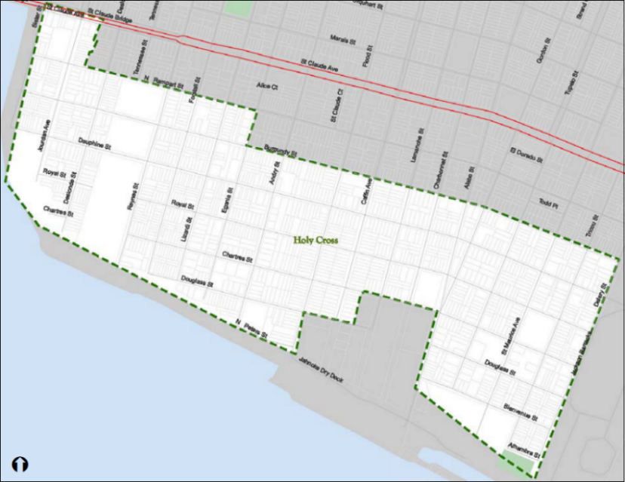
Figure 1. Boundary of Holy Cross Historic District.

A large fraction of HafenCity in Hamburg is not considered a protected historic area, making the choice of historic areas more difficult. Although HafenCity has a long history dating back to 1189, its urban fabric is not considered historic. HafenCity’s demarcation changed in 2008, when the historic district of Speicherstadt was added, and which was designated a UNESCO World Heritage Site in 2015. It is because of the vital integration of the Speicherstadt historic district into HafenCity’s sustainable development plans that this paper will use the boundary of HafenCity defined in the 2008 demarcation. (Appendix B includes a map of the entire city of Hamburg with demarcated neighborhoods and districts; Figure 2 shows the entirety of HafenCity in green, and the historic district, Speicherstadt, in yellow).
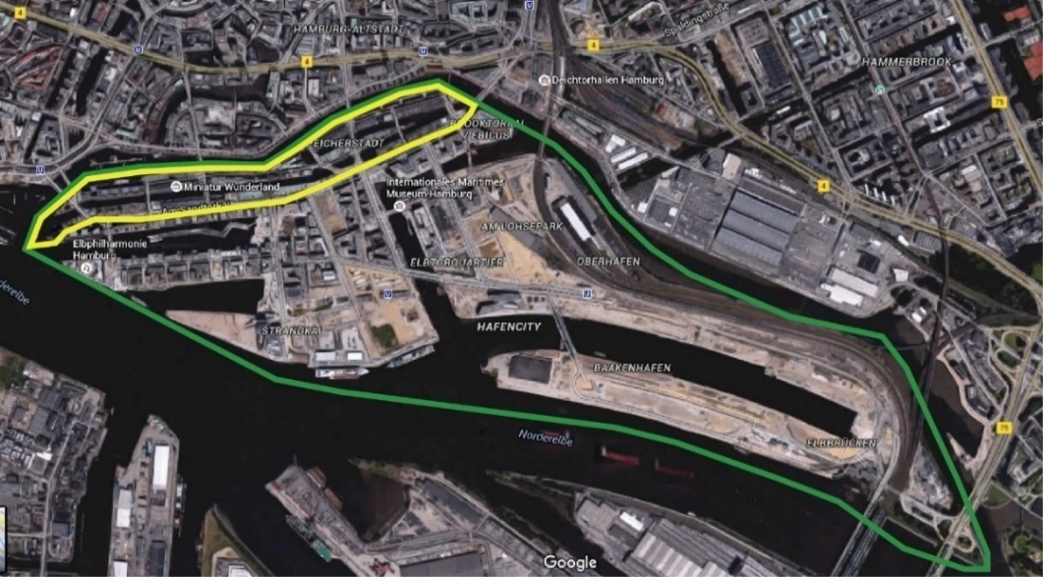
Figure 2. Boundaries of HafenCity, Hamburg.

The Leith community was the most difficult of the three case studies to define. Leith was an independent community before it was annexed by Edinburgh in 1920. Merging with Edinburgh effectively changed Leith’s traditional boundaries. In the last century the borders of Leith as a district have changed drastically, narrowing as the built environment became denser. Since the 2011 Census, Edinburgh has drawn four different but simultaneously current maps that identify as Leith, each highlighting different populations or uses. Thus, the boundaries of Leith changed based on the very factors that are the subject of this analysis. Exacerbating the conundrum is that each map overlaps with Edinburgh’s only UNESCO World Heritage Site, “Old and New Towns of Edinburgh,” making data collection on inventory, demographics, and site heritage difficult to disaggregate. To keep with the consistency of the first two case studies, using the political precinct – a ward – was considered. However, the conservation area defining Leith extends outside of the boundaries of the ward, while it is still included inside the neighborhood partnership area map by the organizations which oversee community identity and planning. In an attempt to keep things simple and consistent, the conservation area boundary will be the primary source, while the neighborhood partnership area and the UNESCO World Heritage Site will be used as supplementary information. (All maps acknowledged can be found in Appendix C; Figure 3 shows the map of the Leith conservation area.)
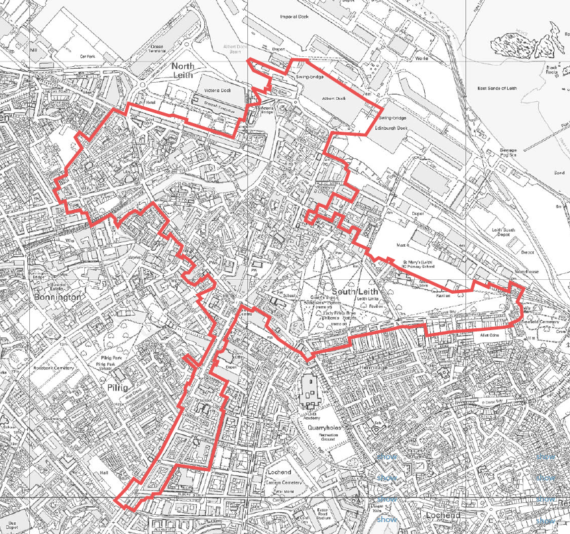
Figure 3. Current Leith Conservation Area Boundary.

1.2.c. Data Collection

For a complete analysis of the potential effects on historic districts and assets within the selected case studies, data was collected on climate change events, historic inventories, and demographics of each study area. Historic asset inventory data was retrieved directly from the municipalities and governing bodies controlling or protecting the heritage sites and structures. Climate change impact data were accumulated (including global and site-specific seal level rise, linear data on storm surge height, frequency and severity) through utilizing interactive sites projections of climate change events on land masses designed by government agencies such as NOAA and academic institutions such as Portland State University. Scientific journals and nongovernmental, climate organizations were also included to ensure reliability of climate data. Also collected were the demographics of the residents within the boundaries specified above. These demographics include age, gender, socio-economic status, level of poverty, race and ethnicity, and residential housing stock. This data was collected through censuses from each country.

Chapter 2: Previous Research and Discovery
While historic districts have been around informally for centuries, designation of historic areas is a construct of the 20th century. Countries around the world that have identified historic districts have also passed legislation protecting the delineated areas. There has been significant research surrounding the effects of historic districts on the local economy and land values, as well as the psychological and behavioral outcomes of creating and living in an historic district, the obstacles and challenges a community faces in having an historic district, and the effects on local history appreciation, understanding, and character of the area. This information on historic districts is important when looking for similarities between historic and ecodistricts. Moreover, determining how the local economy and the character of the district would change if not prepared for environmental threats is imperative for removing obstacles or making amendments to historic district legislations.
Ecodistricts are a recent development strategy and thus have few statutory protections or regulations. Serving more as a lens through which developers make plans, an ecodistrict helps determine how people will interact with their built environment. While not as lengthy in comparison to historic districts, the list of research for ecodistricts – and other ways developers and planners are bringing sustainability and resiliency to a built environment – is still substantial. Evaluating land values, behavior, and obstacles will also be discussed alongside the evaluation of historic districts on these same topics.
While it is important to identify the issues where ecodistricts and historic districts naturally intersect (local economy, psychological and mental benefits, healthy design, access to amenities, pride of place), as well as acknowledging the obstacles that make such intersections difficult, there is only a limited body of published research that combines these two area types.

2.1. Background

2.1.a. Climate Change Effects on Coastal Cities

Climate change effects on the built environment has been evident to scientists for several decades. Beginning in 1993, NASA began measuring sea level rise. With a rate of change at 3.42 millimeters per year, NASA has documented an increase of 74.48 millimeters since 1993; using coastal tide gauge data, the sea level change has been nearly 200 millimeters since 1870. While these increases may not sound threatening, because they are at a global scale there are drastic differences when narrowing in on particular coastlines. All across the United States coastal cities are being affected differently by sea level rise. From 1963 to 2012, Los Angeles and San Francisco only saw around 3 inches in permanent sea level rise, while Galveston, Texas, saw an increase of 12.5 inches. Worse still, sea level is rising at an increasing rate, meaning that the rate of change documented by NASA at a global scale will be much larger as time goes on, with increases between 6 and 16 inches by 2050, and between 12 and 48 inches projected by 2100.
The effect of climate change events on coastal cities will be catastrophic. Already five reef islands in the Solomon Islands group have been completely lost due to sea level rise and coastal erosion, with an additional six projected to be lost in the near future. While these islands were uninhabited, the sister island of Nuatambu is home to 25 families and has lost over half of its habitable area, with 11 houses submerged and washed away since 2011. There is an urgent and direct threat to the current way of life and the commemoration of the past as it relates to historic assets. Currently 44% of the world’s population lives in coastal areas. As a means for sustenance, fortification, travel, industry, and recreation the proximity to water affords for greater conveniences, efficiencies, and opportunities in life, and humans have historically attempted to settle as close to water as possible. For those cities where arresting or controlling water was a main factor in building up the urban form, water will become the main element for disaster. Acknowledging this problem, planners, landscape architects, architects, and engineers alike from around the globe are beginning to make plans for the future of cities and their neighboring waters. Utilizing ecodistricts as systemic strategic plans for neighborhood sustainable development, communities around the world are becoming more prepared for environmental eventualities. The most compelling problem that comes from these solutions to cities, however, are how to save the historic assets of cultural significance from the future of climate change.

2.1.b. What is an Historic District?

Countries around the world call them by different names; in the United States they are historic conservation districts (colloquially referred to simply as “historic districts”); in the United Kingdom, conservation areas. Germany has coined the term “städtebauliche denkmalschutz” translating to “urban conservation area,” which constitutes the idea of area preservation. Globally, the United Nations calls historic neighborhoods or areas “cultural heritage sites”. The broadest purpose behind each of these terms is to legally protect neighborhoods or communities of cultural, historical, or architectural significance. Yet, each country or organization has a nuanced definition and implementation style embedded within their legislation or policies.
According to the United States National Historic Preservation Act of 1966 (NHPA), historic conservation districts are defined as “an area which contains - (A) historic properties, (B) buildings having similar or related architectural characteristics, (C) cultural cohesiveness, or (D) any combination of the foregoing”. These places may be placed on the National Register for Historic Places allowing for tax incentive opportunities and nominal security. While the Act protects historic places from unabated government intrusion, it does not protect the area from alterations made by private citizens. State Historic Preservation Offices, enabled by the NHPA legislation, may also set up a state register for historic places, but is not required to do so. Those areas listed on state registers may qualify for different incentives or protections based on state-determined guidelines. Both types of registers, the federal and the state, have little legal teeth. Local historic districts are passed by local municipalities and the guidelines for their administration are created through the participation process of community residents. The local districts are vested with the greatest legal power to protect historic resources.
The creation of a district at any level of governance does not necessarily mean it is included on any of the other two levels. In New Orleans, the Holy Cross historic district is both locally designated and listed on the National Register. Therefore, changes made to the district and its contributing buildings are approved or denied through the New Orleans Historic District Landmarks Commission (changes made are not protected by the Federal Section 106 process), and are also subject to federal process under the Section 106 review. Section 106 is a procedural process that requires assessment of impacts before any federal funding or permitting is allowed with regards to construction or changes to the district.
In the United Kingdom, historic preservation is referred to as heritage conservation. The identification of protected conservation areas was introduced with the Civic Amenities Act of 1967, an act that also gave local planning authroities the sole responsibility of identifying conservation areas; superseded 23 years later by the Planning (Listed Buildings and Conservation Areas) Act of 1990. The 1990 Act allows for the Secretary of State for Communities and Local Government to also designate conservation areas with consultation from the local planning authority. In this Act, conservation areas are defined as “areas of special architectural or historic interest the character or appearance of which it is desirable to preserve or enhance,” and any development proposals or changes within the conservation area are required to be submitted and debated before the local planning authority public before permitting approval. Any demolition of buildings within the conservation area must go through “conservation area consent,” an application process through the local planning authority and the Secretary of State for Communities and Local Government. The Scottish government established S.61 Planning (Listed Buildings and Conservation Areas) (Scotland) Act 1997. This legislation continues the responsibility of designation to local planning authorities. However, Scotland’s legislation gives more finely detailed guidelines for what is protected in a conservation area and how the area is safeguarded. Conservation areas legislation,
“[defines] the character that merits protection, including the space between buildings; use of appropriate controls over development, demolition and advertising; financial assistance, where appropriate, for works of repair or restoration; protection of trees; interpretation schemes, through leaflets or signage; the implementation of enhancement schemes based upon Conservation Area Appraisals. Designation as a conservation area does not place a ban upon all new development within its boundaries. However, new development will normally only be granted planning permission if it can be demonstrated that it will not harm the character or appearance of the area.”

Unlike the United States, in Scotland it is national legislation that guides local decisions, but the local authority defines the conservation area that will be subject to national law.
Germany’s laws for protection of cultural heritage are devolved to each of its 16 states, as was the case before German reunification in 1990. The national government has little responsibility for heritage protection other than that found within the Federal Building Code outlining the practices that must be considered when states begin urban planning and development procedures. In this legislation the federal government outlines where grant funding may be utilized, when development permission may be refused, and reinforces that federal law does not supersede federal state law on matters of historic protection. Such hierarchy of law – federal versus federal state – is explicitly laid out in Germany’s constitution enabling states to maintain authority over planning and preservation practices at state and municipal levels. Legislation for city heritage protection, therefore, is locale-specific and made and implemented at the state level. In the case of the city-state of Hamburg, Denkmalschutzgesetz (DSchG) (translates to “Conservation Law”) established in 2013, it is the conservation law that protects the state’s historic assets. The law identifies and protects monuments, ensembles, garden monuments, archaeological sites/monuments, and moveable monuments that are deemed important due to their history with respect to science and art, or preserving the city’s image for public interest. The Denkmalrat, or Monument Council, is made up of 12 experts who advise the Senate of Hamburg to designate a monument by an administrative act. While “städtebauliche denkmalschutz” is the idea surrounding conserving areas in an urban setting, an “ensemble” is the name of the of place that is physically preserved. An ensemble is “a majority of constructed facilities, including their associated roads and squares and parks and indoor and outdoor water surfaces, whose preservation is made… in the public interest, even if… not each individual [structure] of the ensemble is a monument. An ensemble includes the accessories and equipment of its components, as far as they form a unit of cultural significance with the constituents of the ensemble”. Thus the ensemble is essentially in direct comparison to the U.S. historic district and the UK conservation area. The Monument Council maintains a list of monuments and ensembles for the city-state of Hamburg, in association with the Heritage Institute Hamburg.
The UNESCO definition of an historic district is “cultural heritage… sites: works of man or the combined works of nature and man, and areas including archaeological sites which are of outstanding universal value from the historical, aesthetic, ethnological or anthropological point of view”. Those countries that have signed on to the UNESCO World Heritage Site funding scheme are in charge of submitting possible sites for listing. Each country must define the boundaries and make a case for universal historic value in their application to UNESCO. Once added to the World Heritage List the historic restrictions to site or structure alterations as well as development of the buffer zone around the site must be approved by the World Heritage Committee, thus requiring extreme international protections over sites.
From the definitions above it can be asserted that the objective of historic site protection is similar from country to country, and that the following broad rules are required for the identification of an historic district:
- Collection of buildings, roads, and public spaces that can have a defined boundary;
- Local civic engagement acknowledging and supporting conservation of historic value;
- Area-specific identity based on architecture, events, or cultural significance;
- Design guidelines steering future enhancements toward a particular aesthetic;
- Centralized authority to ensure legitimization of the designation and associated design guidelines; and
- Funding source to upkeep the authority and future administrative planning requirements.
While the political systems and societal priorities determine nuanced differences between their preserved areas, the similarities are close enough to draw parallels that allow for a sustainability model to influence the protection of these designated districts. Finding ways to integrate already established sustainability models into historic districts requires an understanding of the development strategy that most closely resembles the size of an historic district, an ecodistrict.

2.1.c. What is an Ecodistrict?

Cities account for 70% of global greenhouse gas emissions while only taking up 2% of the world’s land mass, making these dense human settlements prime locations for tackling climate change. Furthermore, 54% of the world’s population live in urban areas with a projection of 66% by 2050. Because cities show the greatest income disparities among populations many city-dwellers do not have access to quality of life amenities that are assumed to come with urban living. The confluence of need to decrease the carbon footprint of cities while increasing quality of life, at the same time maintaining the business resources that make cities so valuable to national economies, produces an opportunity for tangible sustainable development action.
First introduced in the 1980s, sustainable development has become an all-encompassing term for development strategies that satisfy the needs of present generations without putting in danger the possibility for future generations to satisfy their own needs. Many experts and practitioners since the mid-1980s have agreed that change at the small, local scale is the most effective way to approach systematic sustainable development in cities. The most recent and revolutionary approach is the concept of the ecodistrict, while not always in coastal plains, for the purposes of this paper the main focus on ecodistrict innovation will be for those cities where water is part of the cultural identity. The physical outcome of a sustainable development strategy that affects the urban fabric, an ecodistrict also encourages approaches for energy efficiency and carbon footprint reduction in buildings and resident behavior. Site specific with defined boundaries, ecodistricts are most often found in urban settings due to the naturally built-in density and walkability. When implemented successfully, ecodistricts increase quality of life by addressing issues of healthy access, encouraging community building among residents and business owners.
For the past three decades, sustainable development – the notion that all areas of development must satisfy increased social equity and civic participation and a decrease in environmental damages, all while maintaining a resilient economy – has been increasing across planning sectors. Seen sometimes as an idea “too large,” the creation of an ecodistrict localizes sustainable development and crystalizes tangible tactics. From the United States, to Europe, to Asia, and beyond, ecodistricts are used to prioritize the local ecological and natural resources that were once an obstacle to settlement, while continuing to develop access to healthy housing, jobs, and other amenities without increasing carbon footprints. For several years, experts have attempted to define ecodistricts, but due to their hyper-localized nature creating a hard-and-fast rubric is difficult. In an attempt to define ecodistricts broadly, the city of Washington, DC’s Sustainable DC department – currently in the implementation stages of creating an ecodistrict in Ward 8’s Saint Elizabeth’s-Congress Heights neighborhood – defines an ecodistrict as,
Equitable, environmental, and economic sustainability applied at the neighborhood scale. EcoDistricts provide a framework for realizing a healthier and greener neighborhood– increasing efficiencies, reducing pollution, restoring ecosystems, and improving communities – through behavior change, building design, and infrastructure investments. EcoDistricts commit to achieving ambitious sustainability performance goals, guiding public investments and community action, and tracking the results over time. Fundamentally, EcoDistricts are an effort to deploy high-impact, or larger-scale sustainable projects that drive experimentation and innovation.

Examples of ecodistricts come from many organizations that have made sustainable development their mission. In the United States, for example, The Portland Sustainability Institute (PoSI) launched the nonprofit EcoDistricts.org, one of the world’s foremost think tanks on issues of sustainable, neighborhood-scale development. Since June 2014, EcoDistricts.org has been working with nine cities on 11 ecodistrict projects. Construction and rehabilitation of buildings to LEED standards with green roofs and solar panels are just some of the development opportunities for housing and buildings, the main highlight of the EcoDistrict.org model. These projects also attempt to address connectivity issues in transportation focusing on public transit, pedestrian friendly streets, trails, and bike lanes; opportunities that increase healthy options for access to amenities while decreasing greenhouse gas emissions. They work on environmental cleanups for the area watersheds and streams, looking for recreation and economic opportunities relating to water. Further environmental efforts include soil remediation to increase public green-open space and prioritizing green infrastructure from stormwater management projects, to gardens, to urban farming. What distinguishes these efforts from any other master plan is the environmental lens through which all opportunities are visualized, placed in a local scale for greater feasibility. Most important to this model is hyper-localism; the model must be adaptable to the needs of each neighborhood and depends on incrementalism. A major critique of this model is the slow pace associated with its implementation and larger focus on energy efficient buildings. The “continued efforts to go after the low-hanging building efficiency fruit often reduces the bigger gains from deeper innovation because once an investment is made in efficiency, it reduces the viability of a subsequent, larger-scale initiative”. That bigger opportunity is the holistic formation of an ecodistrict.
In Europe, ecodistricts hold opportunities for edgier green infrastructure that form the built environment. Being built around a theme, similar to the idea behind Ebenezer Howard’s Garden-City, Europe’s ecodistricts are further along in contributing to an ecodistrict model that is considered sustainable development, but also ecologically minded, allowing for an iterative process that adapts to climate change. This is due in part because European governments have increased control over city development projects. The European Union’s laws surrounding protection of natural landscapes also aids in fast-tracking adaptation measures including biodiversity and climate change mitigation, which are high priority targets when creating ecodistricts. In Germany the district of Vauban has been developed as completely car-free, while solarCity in Linz, Austria, is a renewable energy intensive community using a mix of 1/3 to 2/3 solar and district heating. Both examples offer a step further in sustainable development of ecodistricts than what is found in the United States: a neighborhood that does not depend on finite resources.
France has cemented the importance of this model by creating legislation prioritizing ecodistricts. ÉcoQuartiers are now part of the government’s overall development plan, included in the Ministry of Ecology, Sustainable Development and Energy’s national “Sustainable City” (Plan Ville Durable) program. It is due to this legislation and France’s dedication toward sustainability that the first smart grid ecodistrict, IssyGrid, was created in the city of Issy-les-Moulineaux. Microgrid technology is used to bring solar generated electricity to more than 1000 square meters of the city with greater efficiency as the energy doesn’t have to expend itself traveling long distances to its destination. Connected to a cloud-based service, the residents could track their carbon efficiency and connect them to the charging points around the district for electric vehicles. These services create buy-in from community members while reducing costs associated with purchasing electricity at the municipal level. The district is a resilient one that is now resistant to power outages while simultaneously keeping carbon emissions down. In short, European countries are working to create communities that are self-sufficient and resilient, not just green.
Most promising, however, are not the models of green neighborhoods, or biodiverse neighborhoods, but rather the models for ecodistricts coming predominantly out of developing countries. (This model is also similar to in concept to the one used in HafenCity, Hamburg which is discussed later at length.) Instead of working or mitigating against environmental factors, ecodistricts in places like Haiti are where we see a more holistic paradigm that considers synergies between several problems. While only in research phases, two examples from the development model in Léogâne, Haiti, deal with water and waste. Léogâne is a coastal city under continual threat of flooding. Where other cities might build floodwalls or use other short term tactics, researchers propose Léogâne use “colocation and coupling of complementary components” to solve energy crises and reduce flooding. Instead of stopping flooding, researchers call for Léogâne to redirect the waters to generate electricity, irrigate crops, and improve water quality. An equally synergistic option for waste comes through organic and solid waste drop-off at service plants or “nodes” strategically placed in public space areas for community gathering such as plazas or markets. These service plants allow residents to mingle while accessing clean drinking water, charging personal electronics, and disposing of their organic or solid waste, which is then used as augmentation to the power supply through biodigestion. This closed-loop model serves as a way for places to be truly sustainable while protecting biodiversity and allowing climate change mitigation measures to solve more than one problem.
For ecodistricts to be properly implemented there must be more than government oversight or development strategy from the private sector. Because an overarching objective of the formation of an ecodistrict is to produce greater social equity and empower local residents, each ecodistrict has a participatory process as an initial stage. For EcoDistricts.org, the organization targets neighborhoods that have an internal network of support already established due to it being a community of high need. High rates of poverty and low rates of job opportunities are where they seek out future project sites. It is in these places where neighborhood organizations have been working to create community-driven efforts for enhancement, but have fallen short due to funding or other policy-related obstacles. The planning stages for both Vauban in Germany and solarCity in Austria included extensive feedback from community members, and inclusion of ecodistricts into French legislation was based on the residents’ desires for cities to become more efficient. As resident buy-in is required for systemic implementation of green behaviors and mentality shifts that lead a resident to walk versus drive, or recycle versus throwing an item away, it is imperative that resident participation be included in the ecodistrict process.
Clearly ecodistricts can take many forms, from being a major theme to simply cleaning and greening a neighborhood, to developing smart technologies for greater efficiencies. While there is no set model for an ecodistrict, the cursory survey of successful ecodistricts illustrates that there are some required necessities for enactment:
- A boundary demarcating the neighborhood in which the ecodistrict will be applied;
- Centralized committee for making decisions that engage residents and reflect the desires of the community;
- A participatory process with residents and stakeholders;
- Inventory of opportunities and threats to be addressed;
- Determination of ecodistrict model (e.g. theme, closed loop, green action);
- Indicators that evaluate successful execution; and
- Funding and supportive policies that encourage ecodistrict formation.
Ecodistricts offer prime opportunities to fight against climate change on behalf of historic preservation, as well as mitigate against and adapt to impending climate change events to protect historic assets. Acknowledging the many harmonizing facets of both historic districts and ecodistricts is next required to understand fully how protecting historic buildings, monuments, roads, and greenspaces bolsters the sustainable movement. Aside from the parallels of scale and civic engagement, ecodistricts, like historic districts, increase land values, improve quality of life, and encourage healthier environments.

2.2. The Intersection

Several characteristics of both historic districts and ecodistricts align. The most complementary is the very nature of sustainability at the foundation of historic preservation, particularly for historic districts. Because sustainability deals not only with the environment, but also with social equity and resilient economies, historic districts at their core have quantifiable benefits directly related to the goals of sustainable development. Research around the effects of historic districts and sustainable development on communities in a variety of areas is substantial. Research with empirical evidence of the social impacts of ecodistricts is minimal, however similar development strategies at the neighborhood scale, such as New Urbanism, is extensive. While New Urbanism’s focus is on walkability and housing, and Smart Growth is on dense development near transit, the urban fabric and outcomes are often similar to that of ecodistricts. Thus, research surrounding social outcomes for ecodistricts will be substituted by that research done for New Urbanism and Smart Growth communities when necessary. Quality of life, land values and local economy, as well as obstacles surrounding property rights, and historic integrity are the topics that will be discussed.
Unfortunately, these same aspects of a strong community are negatively impacted by climate change. Thus by evaluating these same topics as ones that will be impacted by climate change events, hierarchies between historic preservation requirements and ecodistrict characteristics can be reconciled for a recommended Eco/Historic District model.

2.2.a. Quality of Life

Historic districts improve the quality of life for residents and evoke better individual behavior, overall, by residents. The urban fabric of historic districts, which often pre-date substantial automobile use, lends itself to compact, walkable design with close access to amenities, the same characteristics that are promoted and striven for when implementing ecodistricts. While no research has determined whether historic districts provoke a sense of friendliness, healthy living, and civic mindedness, or whether people who have already acquired such attributes seek out living opportunities in historic districts, the outcome is the same: historic district residents have better socially-conscious behavior, overall, than their non-historic counterparts.
One study determined that the overall success of historic districts was due to the local nature of the district. Using a “subdistrict” or local approach, cities can acknowledge specific needs, histories, and communities that draw together greater sense of unity. The intellectual and emotional connections between memory and our built environment is what allows old buildings and places to conjure a sense of wonder, to document the past and give meaning to community connections or political progress. Ecodistricts, too, are an outcome of local advocacy in which community members come together when the nexus of problems converges. Totnes, a town in England, created their own ecodistrict after recognizing they were,
Disillusioned with the failure of elected officials or governments to listen to their worries about the effects of ecological issues, especially climate change, environmental destruction, and the inevitable problems that they envisaged being caused by higher oil costs and shortages. [Ecodistrict workshops] provided a focus for many previously unrelated people to share their concerns and search for ways of ensuring a better future, not simply as individuals, or within their groups, but linking with existing organizations.

The advocacy and social cohesion required to implement historic districts and ecodistricts are not the only quality of life benefits that come from these two area-protection strategies. The psychological effects that accrue from protecting places that are designed for community interaction, easy access to amenities, close proximity to jobs, and walkability for all other aspects of life including recreation, encourage community togetherness and a desire to be among nature. Historic districts are generally already designed to be dense and walkable, with public spaces, and are perfect opportunities for ecodistricts to thrive. Ecodistricts can bring to historic districts efficient energy and mitigation of climate change effects while simultaneously creating community and business opportunities, and make places more green and pleasant. Ecodistricts, and similar development strategies, can also increase land values and boost local economies, as is also seen with historic district analysis.

2.2.b. Land Values and Local Economy
Opponents of historic districts often claim the designation decreases land values of the properties included due to increased regulation, which makes changing and upgrading homes difficult. Such difficulties are presumed to effectively dis-incentivize new ownership and decrease market demand. Yet research shows this to be an inaccurate assertion. In fact, historic districts not only increase land values of contributing and non-contributing properties within the district, but also increases the land values of those properties that are adjacent to the district. The hallmark of the historic district – design guidelines and rules that ensure property maintenance – prompts aspects of aesthetic desirability; the areas are more beautifully kept and conform to a particular time and character that elicits nostalgia and pride of place. Sustainable development strategies also boast an increase in land values while boosting local economies through tourism. The cost of constructing ecodistricts is substantially more than non-ecodistrict counterparts. Yet with savings to each resident for annual homeowner costs ranging from $250 to $1,200, and the internal rates of return ranging from 18 to 30%, residents break even between three and five years, and with the added benefit of environmental sustainability, social cohesion, and pleasant community design and surroundings. Ecodistricts also increase the likelihood that ecotourism will expand to include those places designed for environmentally friendly travelers, or tourists interested in the future of cities. When a place becomes more aesthetically desirable tourism begins to play a major role in the local economy. On the state level, heritage tourism in the U.S. generates $1.2 billion to as much as $10.3 billion in revenue per year, depending on the size and historic inventory of the state.
The designation of an historic district increases the awareness of a place, regardless of whether it is on the National Register of Historic Places or is a locally designated historic district. The creation of an historic district provides people with otherwise unavailable information about housing stock. “This information also appears to have a positive value to potential buyers. Creation of an historic district would, then appear to be a potentially valuable tool for helping potential buyers identify an additional portion of the housing stock in which they might be interested”.
With greater interest and awareness of historic districts comes greater investment both commercially and in residential housing. Furthermore, the desirability of living in an historic district ensures a stability of place that is not often found in non-designated areas. According to the findings of one recent study,
Local historic district designation has proven to insulate property values from wild swings in the housing market, including both downturns tied to larger economic trends, and “bubbles” caused by cycles of real estate speculation. This stability is related to investor confidence that, because there are explicit design limits in the zoning code, home investments in historic districts will not be adversely affected by construction of an inappropriate, out-of-scale building next door. It is also due to the fact that neighborhoods with stable values do not offer opportunities for “flipping” (purchase followed by quick resale at a high profit margin). In these ways, local historic district designation reduces the uncertainty facing the buyer regarding the future value of the investment.

Another study focused on the city of Philadelphia found that housing value decreased 24% within a newly created historic district, citing confiscatory regulation rather than use of incentives as the reason for the discount. But the weight of evidence from research that examined a total of 37 case studies nation-wide found substantial land value increases from between 5% to 8% per year, and as much as 35% over the course of a decade.
The opportunity that arises from merging historic districts and ecodistricts is in the adaptive reuse of the current building stock for residential and commercial use. Constructing ecodistricts faces a two-fold disadvantage: the cost, and the environmental impacts of building brand new, which together are not particularly sustainable. As an example, a 1,145-acre ecodistrict project in Tucson, Arizona cost $20 million more to develop than a similarly sized, conventionally planned community. When building new ecodistricts, the costs can be astronomical, even if the payback is substantial. This problem of upfront capital costs makes creating ecodistricts difficult for many cities around the world. However, by merging ecodistricts into historic districts, the costs decrease significantly as the urban grid and buildings are already standing, and the environmental benefit of retaining and reusing historic structures is readily apparent.
The “green building” movement focuses on the annual energy use of a building. But energy embodied in the construction of a building is 15 to 30 times the annual energy use. Razing historic buildings results in a triple hit on scarce resources. First, we are throwing away thousands of dollars of embodied energy. Second, we are replacing it with materials vastly more consumptive of energy. What are most historic houses built from? Brick, plaster, concrete and timber. What are among the least energy consumptive of materials? Brick, plaster, concrete and timber. What are major components of new buildings? Plastic, steel, vinyl and aluminum. What are among the most energy consumptive of materials? Plastic, steel, vinyl and aluminum. Third, recurring embodied energy savings increase dramatically as a building life stretches over fifty years. You’re a fool or a fraud if you say you are an environmentally conscious builder and yet are throwing away historic buildings, and their components.

The positive environmental and financial benefits of merging historic districts and ecodistricts indicate that ecodistrict models can help save historic assets from climate change events that are inevitable in many coastal cities. Climate change events can have a significant impact on property values and tourism, particularly as sea level rise and frequent storm surges threaten these historic areas. Recent studies have concluded that climate change will negatively impact those areas with historically high flows of tourism due to poorer weather conditions or extreme events. Aside from the obvious fact that pleasant weather increases the likelihood of receiving out-of-town visitors, with rising sea levels, the cultural resources that entice tourists could be damaged or destroyed by extreme weather that was not predicted when the resources were constructed, thus exacerbating the impending decrease in tourism. By acknowledging the economic benefit derived from historic districts it can also be recognized that there is a real possibility of substantial economic loss without mitigation measures that protect historic places and their included assets. "A large share of the world population lives in coastal regions… In the light of limited funds for adaptation it is an asset to provide comparable cost assessments. While mitigation remains of vital importance to keep climate impacts on a still manageable scale, an adaptation perspective can help to limit damage costs in the right places". With a recognition of the cost to our economies when climate actions damage or destroy the built environment and irreplaceable historic assets, measures to identify those places and assets under threat will be prioritized.

2.2.c. Obstacles

Although obvious parallels exist between historic districts and ecodistricts, the merging of the two comes with distinct obstacles that cannot be overlooked. Questions of integrity and the vagaries of legislation create problems when discussing changes to historic district guidelines.
At the heart of every historic preservation asset is the notion of integrity, or the features or characteristics that are retained on a property relating to its significance. In the United States, there are seven aspects of integrity: location, design, setting, materials, workmanship, feeling, and association. In some way, all of these aspects of integrity are associated with historic districts. The location of the district often plays a role in its significance; for all three of the case studies their significance relates to the history of industrial ports. For those districts that encompass particular architectural elements that make the district significant, design would also be relevant. In all three areas architecture plays a major role in the history of the districts. Setting, closely tied to location, is important in all three because of their proximity to water and how those conditions shaped the character of the cities. Materials are particularly important when a period of significance is determined. Buildings that contribute to the period of significance of the district will have special considerations for restoration or maintenance materials. In each area there are specified periods of significance and materials used for the contributing buildings that are part of the significance of the area. Workmanship is the evidence of the crafts of a particular culture. Again, due to the proximity to water and the industrial ports in each case study, workmanship will also be a consideration for significance and integrity. Feeling is the expression of the aesthetic particular to a period of time, most often the period of significance. In the case of both HafenCity and Leith, feeling through aesthetic will play a major role in integrity. However, due to the significant damage to Holy Cross from several natural disasters, this feeling will have less of a physical manifestation and may take on a more intangible nature. And finally, association, which is the direct link between the place and an important event or person in history. While all three sites have probably seen many interesting people and important events, association will be the least important aspect of their relative significance.
Once listed on the National Register of Historic Places owner is not subject to any restrictions on his use of the property unless tax credits are sought as a consequence of his rehabilitation of the resource. In the case of National Registered districts, there are no requirements for permitting changes; the district simply has given a certain level of protection against any future government intervention. In New Orleans, the local historic districts are governed by extensive and strict design guidelines that, like most historic districts in the United States, determine whether alterations or additions are in keeping with the historic character of the current culture and neighborhood aesthetic.
Hamburg’s laws require monuments or assets to fulfill two conditions: the ability to be protected due to its importance, and its worthiness to be protected due to its rarity or authenticity. Once these requirements are met the building is automatically added to the list for possible designation. Unless an owner actively requests that the building be removed from designation consideration, it will be added automatically. After inclusion on the list, Hamburg’s owners must maintain the structure. If there is evidence of neglect the owner may be compelled to sell their other properties to acquire the necessary funds to maintain the historic building. Because ensembles are a protected grouping of buildings and other structures that denote historic value as a grouping, the acknowledgment of duties required for individual buildings is necessary.
Scotland also has conditions for integrity, but they are substantially more subjective due to the country’s extensive historic inventory and recognition of the inevitability of changeover centuries. Nevertheless, in some cases Scotland is stricter than the United States. The owner of any building that is listed must receive permission for any repair, addition, or alteration of any kind on the exterior and the interior of the structure. Any intervention made to any monument must be at a minimum due to the risk involved, and guarding against any treatment that will irreversibly modify an asset’s character and negatively impact its special interest or features that made the asset important in the first place. Furthermore, when considering demolition of unlisted buildings in a conservation area, permission must be sought and is generally discouraged, as is the construction of new buildings in conservation areas as such could result in harm to the character of the place.
These issues of integrity and the legislation defining integrity creates obstacles for forming an Eco/Historic District. For historic buildings to be protected by climate change events, particularly permanent sea level rise, certain concessions will have to be made concerning any one or a combination of the seven outlined aspects of integrity. As constraining as each case study’s legislation and definition of integrity may appear, Scotland is the only country in the three case studies with legislation that has built-in allowances for 21st century issues of climate change threat and damage, the likes of which will be discussed further in chapter 5. It is also important to note that though UNESCO World Heritage rules for listed sites are very strict, the Committee makes special arrangements for those sites or artifacts of universal value that are threatened due to myriad dangers, including climate change related events such as sea level rise, floods and tidal waves, and landslides. Perhaps it is time for other places with policy protected historic sites and structures to follow suit.

2.2.d. The Model Indicators

Based on the literature above, there are numerous benefits to creating an historic district or an ecodistrict. Table 1 below illustrates the benefits of each district type.
Table 1. How each district adds benefit through quality of life indicators
 | Historic Districts | Ecodistricts
Community cohesion | Dense urban fabric lends to walkability allowing for opportunities for residents to mingle outside of their homes. | Bringing natural environment where possible back to urban form, particularly green public space. Increase in pedestrian safety and bicycle opportunities.
Social equity | Civic participation is prioritized, and affordable housing is preserved using the existing building stock. Resident participation is a pre-requisite to implementation. | Civic participation is a pre-requisite to implementation. Large changes in urban form and need for resident behavioral shift requires resident buy-in.
Economic prosperity | Land values and adjacent land values increase due to stability of residents, recognition of otherwise unknown housing stock, and aesthetic appeal. Local economy is helped through heritage tourism. | Land values increase quickly, while energy and waste costs decrease substantially. The aesthetics of nature create visual community desirability.
Environmental protection | Embodied energy in buildings reduces carbon emissions when choosing adaptive reuse. Measures for energy efficiency in historic buildings also reduces carbon emissions. Typically, narrow streets result in less cars on the road. Trees, green spaces, and water with historic value are protected. | Reducing automobile use, increasing renewable energy resources, focusing on local production for local outcomes. Design measures to use green space and tree canopy for heating and cooling, and requiring all buildings to be energy efficient.
Cultural identity | Preservation of history and identity of area is safeguarded. | Identity of both historic, current, and natural resources are key. Additional focus on natural resources based on proximity to certain ecological sites and their relation to built environment.
Innovation | Innovation must be aesthetically pleasing and within the character of the area, or must be least intrusive so as to not be visually disturbing. | Innovation can be vast or small. From using technology to track energy, to creating a closed-loop dualistic system, to capturing rain water for irrigation or organic waste for energy. If it saves money, creates community value, and decreases waste and greenhouse gases it is possible.
Climate change measures | Policy can allow climate change measures such as lifting structures above projected sea level, or moving structure to safe area. Visually unintrusive measures such as stormwater management in green space, bike lanes, trail connections, permeable pavement, and safeguarding existing biodiversity. | Living with the natural environment, rather than building up against it; adaptation. Identifying all feasible opportunities to reduce damage from storm, floods, erosion, and storm surge height and intensity.

Similarly, several aspects of planning and preservation are required to create both an historic district and an ecodistrict, individually. The table below shows the necessities for creating each district.
Table 2. Requirements for implementation of each district
 | Historic Districts | Ecodistricts
Community input | Determining contributing sites and structures, as well as periods of significance, and types of significance. | Determining innovative opportunities and needs, as well as strategy for community buy-in.
Identification of boundary | District must have boundary for consideration as a historic place. | District should have boundary to keep project viable and at neighborhood scale.
Policy support | At the local, state, or national level, support must be granted for designation. | Required at local level to enact changes to urban fabric.
Community buy-in | Without contributing buildings, which must be agreed to by owners, there would be no district. | Residents must understand and agree to the systemic behavioral shifts expected of them, as well as possible changes to services such as waste and water.
Central authority | With or without design guidelines, a central authority must preside over the maintenance of and enhancements to the district. | Not required but helpful. Public private partnerships are best approach in the absence of outside factors.
Funding | Comes from municipality or federal grants. Needed for support staff, and continued maintenance and compliance of historic district. | Private funding is often required as development costs are substantial. Funding from public incentives or tax credits are encouraged.
Guidelines | Design guidelines are generally necessary to keep the character of the district intact. However, only required at the local level. | Design guidelines are required before implementation begins. Substantial planning to keep with the character of the district is necessary.
Inventory of needs | District must have an understanding of sites and structures needing protection as well as places that may need future enhancement. | An inventory must be created of all project areas and possibilities whether viable for development or not. Knowledge of and planning for current and future needs is essential.

These tables will be used as a reference for consideration when determining recommendations for each case study, as well as finalizing the base requirements for an Eco/Historic District.

Chapter 3: Holy Cross Historic District

Listed on the National Register of Historic Places in 1986, and designated a local historic district in 1990, the Holy Cross historic district has a long history of farming and subsequent industrialization. One of the areas most damaged by the 1965 Hurricane Betsy, and the 2005 Hurricane Katrina, the neighborhood is fighting a continuing battle to create a firm foundation in community and business. Home to many nonprofits working to restore and rebuild after the 2005 disaster, the Holy Cross historic district and its political boundary of Ward 9 are working hard to make sustainability the first option when rebuilding, ensuring that energy is consistent, homes are sturdy, and the economy is thriving. Due to the lack of resources many actions taken toward sustainable development have only been planned with little actual work in the pipeline. Exacerbating the issue is the immediate need for basic necessities, which draws resources and time away from long-term development that could fundamentally change the area for the better. It is because of the intense community support, but little capacity for action outside of planning, that the Holy Cross historic district represents the “too small” case study because the recommended Eco/Historic District model requires more capacity to be successfully implemented.

3.1. Location

The Holy Cross historic district is part of the Lower 9th Ward. The 9th Ward voting district spans the largest expanse of land in New Orleans, as shown in Figure 4. However, the community was divided in the 1920s by the dredging of the Inner Harbor Navigation Canal, now commonly known as the Industrial Canal, which created lower and upper areas of the ward. With only one boundary on land, the neighborhood is bounded by water to the west and north at the Industrial Canal and Florida Canal (with their associated levees and floodwalls), and the Mississippi River to the south. Due to the water being held back by manmade structures, the area is often threatened when storm surge, heavy rain, and any other natural disasters cause the levees to overflow. The Holy Cross historic district is on the Mississippi River side of the Lower 9th Ward, making the district particularly vulnerable to flooding. The effect on the population is significant; in the 2000 census, the Holy Cross district had a population of 5,507, with 1,982 households, and 1,315 family households, more than twice the totals recorded only 10 years later. The area had the highest rate of African American homeownership in the country, with 41.8% of all housing units occupied and 67.2% of those in single family homes having a mortgage. The community was made up of 87.3% of African Americans and 9.4% Caucasian. In 2010, the population had fallen to 2,714, reflecting a reduction of 942 households. The owner occupied percentage grew to 55.5%, but the mortgage rate dropped to 48.5%, suggesting that either the houses owned free-and-clear were destroyed in the events of Hurricane Katrina, or the people who had owned the homes were part of the nearly 50% of people who moved in the wake of the storm.

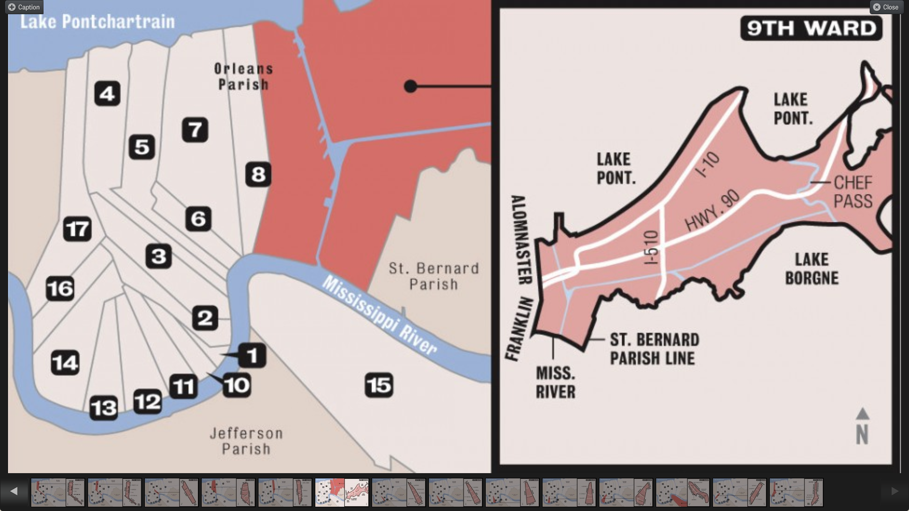
Figure 4. Map of Ward 9 boundary, with Holy Cross Historic District in yellow.

Whether specifically related to climate change events, these figures show a high rate of community instability, with low land values, and deepening financial dependence. Drinkable water did not return to Holy Cross until nearly a year after the hurricane. Few businesses and services have returned to the area, creating a void for jobs and amenities for those locals who have returned. This damages the neighborhood’s sense of community, the economy, and the district’s overall identity and roots in history. While the two nationally registered buildings are miraculously still standing, those residents who have moved back are working hard to reclaim and enliven the history of the area as the district has a significant cultural history that makes it valuable for saving and preserving.

3.2. History and Inventory

Historically the area has been home to blue collar workers made up of Irish immigrants and African Americans. Before the dredging of the Industrial Canal the area was mostly farmland with little infrastructure. Sugar was the dominant crop with several plantations dotting the landscape in a rural layout. Once the canal work began, bisecting the 9th Ward, development of services and businesses began in the upper 9th, while dock and canal workers began building their own residences in the lower district. It was during this time that Milton and Mary Doullut, husband and wife riverboat pilots, decided to build a home in the style of “steamboat gothic,” illustrated in Figure 5, in what is now the Holy Cross area. Just a few years later their son Paul built his own, architecturally significant home. The two were designated as National Historic Landmarks in 1977.
In the 1940s, the area began seeing a steady influx of predominantly African American artists and musicians. Throughout the 40s and 50s a new style of music emerged from the community: rhythm and blues. A musician called Fats Domino became the most famous of the local musicians, creating a music standard that many, including the singer Little Richard, wanted to take part in, whether just through recording in the area, or reflecting the culture through lyrics.
The area continued to grow, but with little infrastructure and political advocacy, as it was literally cut off from the rest of the city. Many of the plantation buildings were gone and the dominant architecture in the Lower 9th Ward consisted of one-story shotgun houses. However, a sufficient number of architecturally significant homes, coupled with the area’s cultural significance, made the community deserving of designation. In 1986 the district was added to the National Register of Historic Places under the criterion of “Architecture/Engineering Bungalow Craftsman.” Its area of significance is “Architecture” and the periods of significance are as follows: 1850-1874, 1875-1899, 1900-1924, 1925-1949.
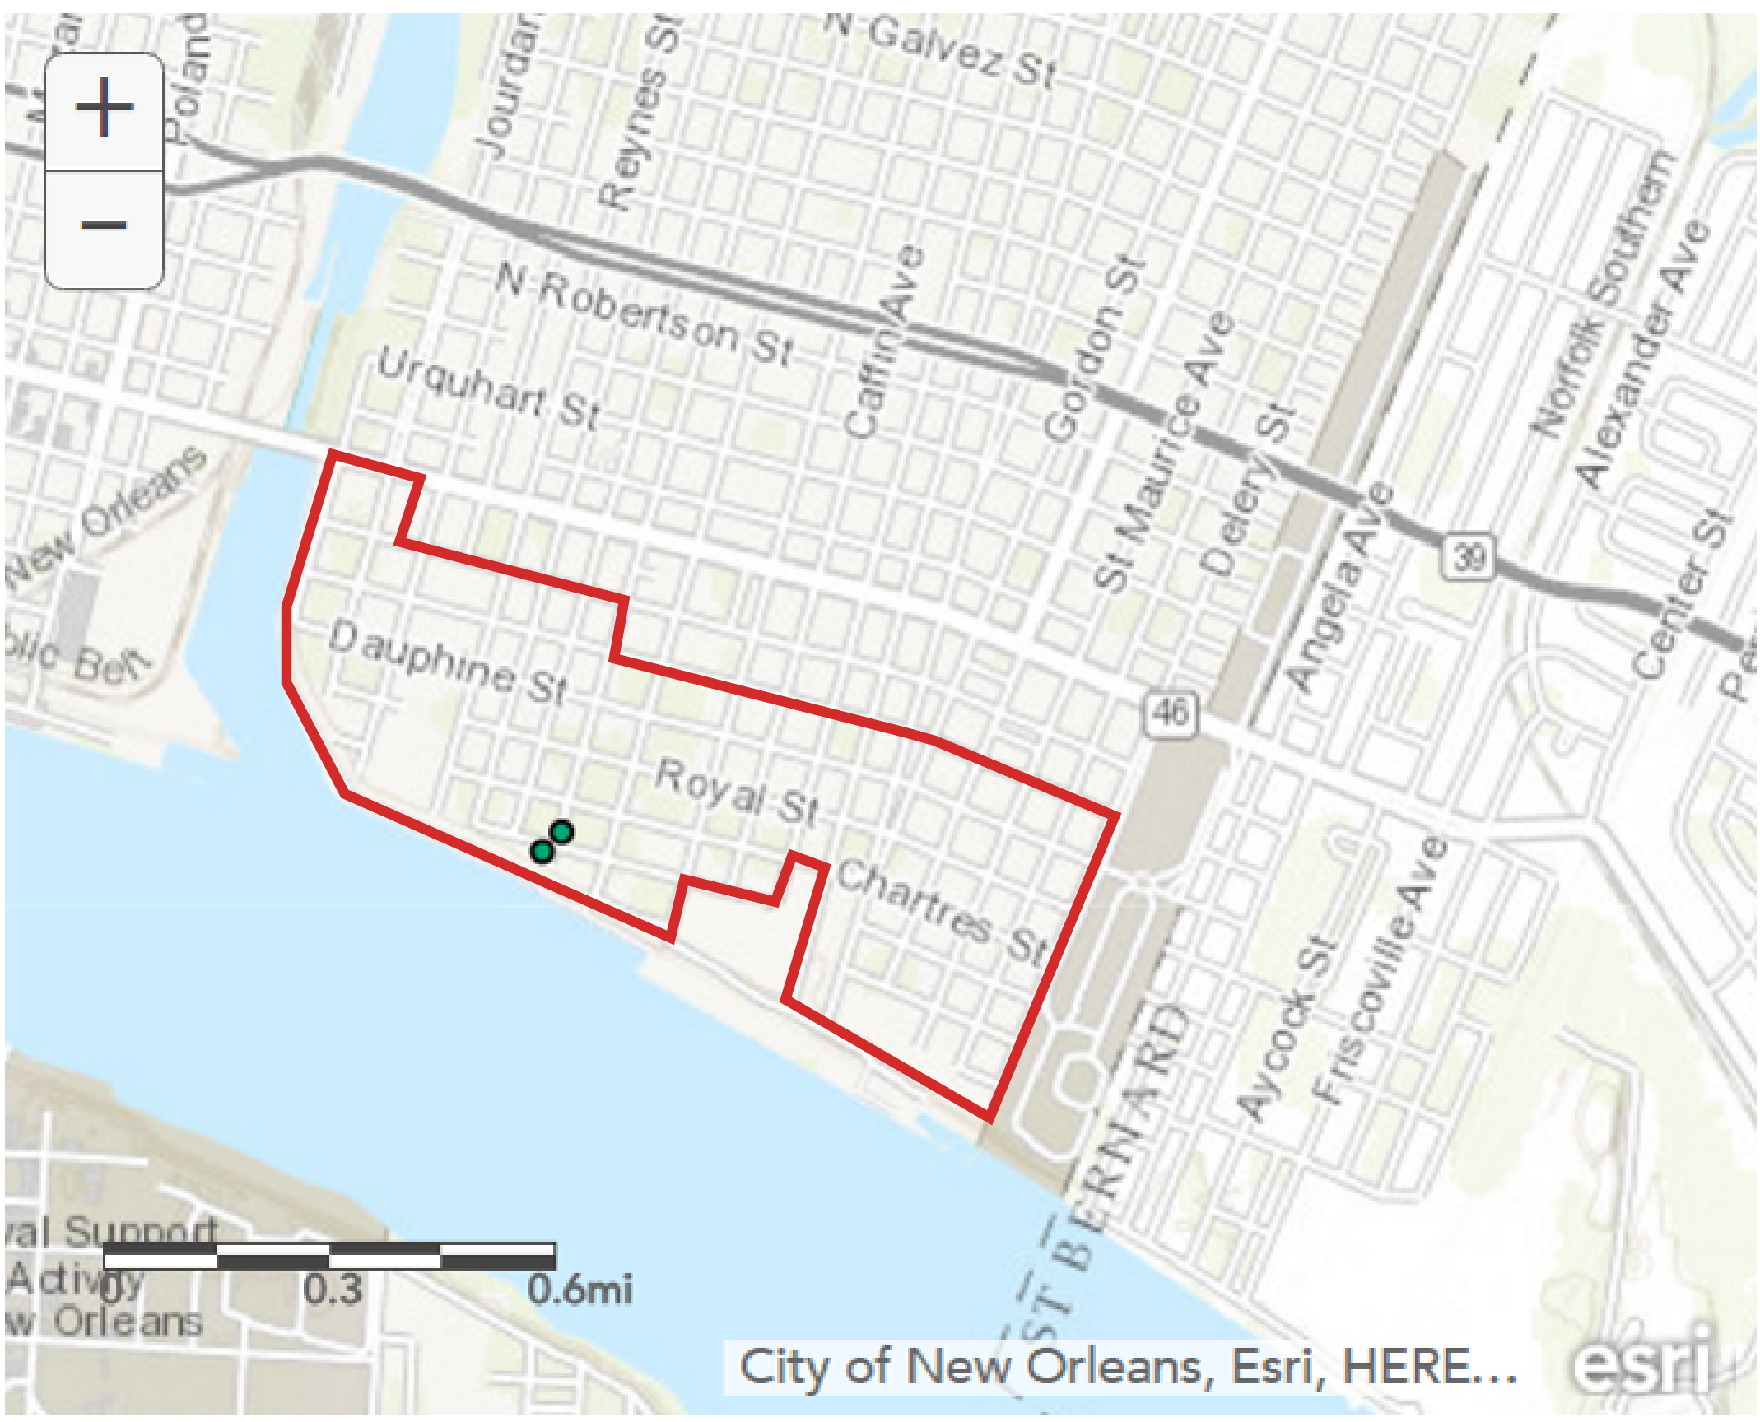
Figure 5. Current inventory of National Historic Landmark properties in Holy Cross.

Up until the 2005 hurricane events, the area was described as a tight-knit community where everyone knew each other, and even without many amenities the neighborhood was filled with people who looked out for each other and enjoyed their lives.

3.3. Local Climate Change

When New Orleans was hit by Hurricane Katrina in 2005, the Lower 9th Ward received the greatest share of damage due to its proximity to a deep-draft shipping channel called the Mississippi River Gulf Outlet. The channel had been built by the Army Corps of Engineers in the 1950s to increase connectivity to the Mississippi River. Surge waters from overloaded canals and broken levees literally swept homes off their foundations and left behind a swath of destruction in the community overall and in the Holy Cross historic district in particular. New Orleans and this area are prone to storms of this nature, although not necessarily the magnitude.
In 1965 Hurricane Betsy also had caused significant damage to the Lower 9th Ward, killing 81 people and causing millions of dollars in damage. Intense storms and erratic weather are not the only threats to this coastal area. Already scientists are seeing permanent sea level rise in New Orleans. In reaction, Louisiana’s Comprehensive Master Plan for a Sustainable Coast accounts for 10.63 inches of sea level rise at the coastline over the next 50 years. However, many experts suggest that, given recent findings of exponential increase of the rate of sea level rise, this consideration is not sufficient, and that Louisiana should plan for at least a 17 inch rise in sea levels over that same time period.
Projected sea level rise scenarios back up this assertion. Figures 7 and 8 show the projected sea level creep on the Holy Cross historic district as of 2050 and 2100, respectively. The scenario in Figure 7 shows that on the left (west) side, with unchecked pollution (status quo), in 2050 New Orleans and its Lower 9th Ward will be inundated with water aside from a small strip of land (gray/white areas) along the coastline. With extreme carbon cuts, reflected in the scenario on the right, there is still unprecedented permanent sea level rise, with only a small amount of land showing. Under this scenario, the historic houses will also be under water along with most of the historic district.
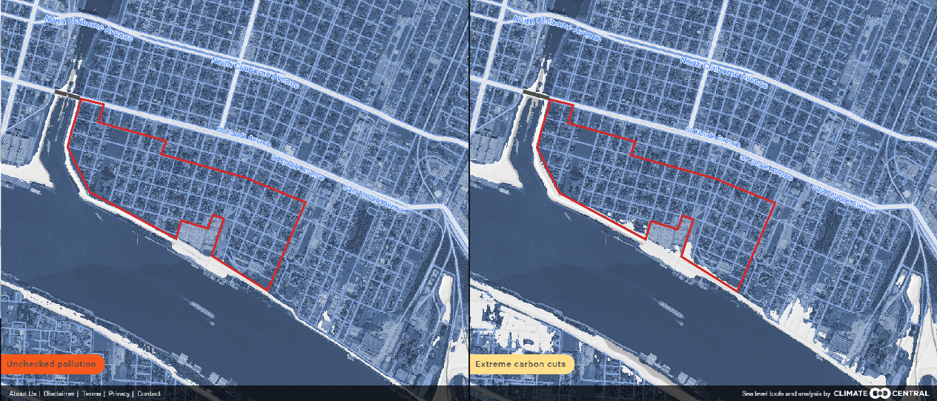
Figure 6. Climate Central's Surging Seas interactive scenario builder showing the Holy Cross Historic District at 2050 with current sea level projections.

By 2100, with unchecked pollution, there will no longer be any unsubmerged land showing in the Holy Cross historic district. In the scenario of extreme carbon cuts, there is a small amount of dry land, but the historic houses would still under water (Figure 7). Conditions seen during Katrina will be the constant in the lives of Holy Cross historic district residents and the rest of the Lower 9th Ward.
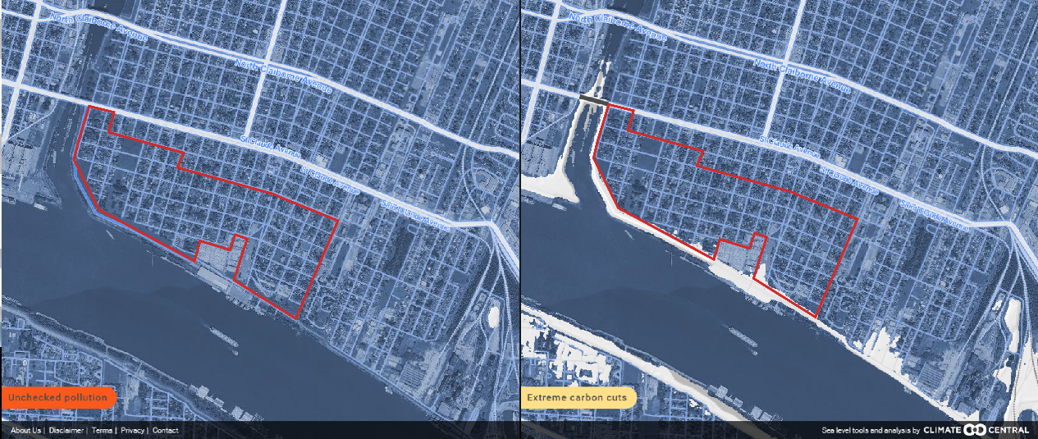
Figure 7. Climate Central's Surging Seas interactive scenario builder showing the Holy Cross Historic District at 2100 with current sea level projections.

These figures illustrate the importance of both climate change mitigation and adaptation. If the conditions illustrated in the scenarios progress as projected, significant changes must be made to the area, whether they be through complete relocation and retreat, or extensive measures that will change the built environment in the district as it is currently known. Historic assets and the cultural identity of the area will have to adapt to the new changes while attempting to remain rooted in their past.

3.4. What is currently being done?

With nationally registered historic structures like the Doullut Steamboat Houses damaged and threatened with demolition, along with immediate needs of food, shelter, and energy for the residents, it became evident that the Holy Cross community and communities throughout the rest of the Lower 9th Ward needed to both save their past and safeguard their futures. Already with a history as a low-income, disenfranchised neighborhood many community members sought out opportunities to make their voices heard, even in the face of proposals made at the local government levels to bulldoze and simply start again. However, some leaders were not convinced and fought for the right of the community to be heard and for history to be preserved. “There is a built-in incentive to demolish,” said Richard Moe, president of the National Trust for Historic Preservation, and “The first instinct after natural disasters is almost always to demolish buildings. It is almost always wrong.” While still the “too small” of the three case studies, there is much to be learned from the projects and programs that are planned to make change in the historic district and adjacent communities. Through grassroots efforts community organizations began to emerge in the neighborhoods, leaning heavily on public meetings to increase awareness of residential needs and desires. These meetings subsequently produced a document, Sustainable Restoration: Holy Cross Historic District & Lower 9th Ward, showing strong local support to prioritize sustainability during the substantial rebuild.
The “Sustainable Restoration” plan, produced a mere eight months after the destruction of the storm, lays out many substantial and important ideas for rebuilding the historic and non-historic communities of the 9th Ward. By bringing preservation concerns to the table, the community was able to ensure that old buildings should be considered in the inevitable new construction. According to the report, “Residents said they want to achieve historic preservation while maintaining a ‘living and diverse neighborhood’. They said historic preservation should apply to buildings at least 50 years old as well as to properties officially designated as historic; should preserve the continuity and integrity of building styles and types; and should assure consistency in the scale of structures”. Also prioritized was how those buildings should be revitalized: with energy efficiency and recycled/sustainable materials. There was even the recognition that change must come from the ground up, not just from the outside; the community created a “no blight” pact that would mean supporting each other to maintain new and old buildings as well as to find and utilize incentives for low-income families to either restore existing structures or build new buildings in the empty lots in the ward.
The study also recognized that communal renewable energy sources will not only decrease costs to each household, but will allow for energy when traditional sources are not available. They cited the possibility of sharing geothermal cooling and water heating, and installing solar photovoltaic, river water cooling/heating, and wind and water turbines. Most of these measures, aside from the solar PV systems, do not interfere with the aesthetics of a historic structure or place and are thus excellent opportunities for energy efficiency cooperatives. Solar power, while difficult to use on historic homes, has become the standard in residential renewable energy systems. This is problematic due to local regulations that generally make solar PV an impossibility. However, in the case of the 9th Ward the overabundance of vacant lots may allow the easiest and most accessible renewable resource to become an option for all residents, whether they live in a historic home or not. By acknowledging the many state-sponsored opportunities for renewable energy and new housing in low-income areas, the Lower 9th Ward can become more equitable, accessible, and sustainable while preserving its long history.
Opportunities lay also with the non-for-profit organizations working to restore historic homes in New Orleans, including the Holy Cross historic district. The Preservation Resource Center of New Orleans’ Operation Comeback is in the process of renovating several blighted properties. Their Home Again program, a joint effort with the National Trust, is working on renovating historic neighborhoods. A significant amount of work is being done to revive the area and bring properties back to habitable conditions. To date, there are nearly 60 properties under this program in Holy Cross. The missing link in the resource center’s work is the recognition that sustainable change must happen to save these buildings from their inevitable future. That is where the Sustain the Nine organization fills the gap.
Sustain the Nine grew out of the community work that took place to create the sustainable restoration plan. Through a series of sustainability-related programs, Sustain the Nine hopes to create a more sustainable community from the ground up. Where there is an opportunity to build, they want it to be built with energy-efficiency and resiliency in mind. Where there are existing buildings, they argue for retrofits that are in keeping with the historic character while making them last for as long as possible, and without contributing further to carbon emissions. Through their Built Environment program, they hope to provide, “New ideas for energy efficiency, water, comfort and building materials that respect [the] historic streets, homes and businesses”.
Outside of Holy Cross and the Lower 9th Ward, New Orleans has published a plan projecting to 2030 in which they outline flexible planning that uses a science-based and place-based approach to becoming an adaptable water city. The plan highlights desires to restructure river flow diversions to restore shore biodiversity. It also acknowledges the need for historic preservation to be a key consideration when planning and implementing sustainable measures and looking to reinvigorate neighborhoods.

3.5. Eco/Historic District

There are several opportunities available to New Orleans, the Lower 9th Ward, and the Holy Cross historic district when seeking ecological solutions for historic preservation problems caused by climate change. Because Holy Cross has already acknowledged the community’s desire to create a sustainable neighborhood while also respecting preserved properties and historic culture, they are already strengthening their community networks, a prerequisite to creating an ecodistrict, and often an outcome of having an historic district. Residents are taking action by cleaning up the vacant lots where houses once stood, and ensuring that they can soon be places for rebuilding. For those structures still standing, there are city-wide organizations that are working to preserve and restore them.
A recommended plan of action would be to ensure that the City take a formal stance on becoming a “water city,” a theme that allows them to live with the water rather than fighting against it to their own peril. Planning boardwalks and other elevated walkways around the area incentivize healthy lifestyles while also preparing for the eventuality of sea level rise. Furthermore, by utilizing their already-planned river flow diversions as a dualistic opportunity for complementary problem solving, such as renewable energy, poorer areas that suffer from unreliable electricity could subsidize already high costs of energy while reducing the carbon footprint. Plans should also be made to raise the steamboat houses or move them, as they will certainly be flooded in the coming decades. Any further development plans should have formal requirements for floodable development construction, as will be discussed in chapter 4. Finally, advocating for budget items to be shifted from social programs for housing and small business support to historic preservation for the same purposes can increase the likelihood that buildings, homes, and other character defining structures in the area will be saved and used for purposes of community building and cohesion.

Chapter 4: HafenCity
In 1997, the Senate of the federal state of Hamburg made the decision to create HafenCity on the man-made port island. The newest and most ambitious development in the history of the Free and Hanseatic City of Hamburg, HafenCity is made up of 10 quarters. The foundation of the district island was built up in the 1800s on docks and port installations, making shifts in sea level over the past century manageable for the constructed buildings. In recent years, however, areas of HafenCity have been subjected to annual flooding. While the potential for flooding was recognized before construction began, it forced developers to become increasingly innovative with architectural concepts that adapted to the watery conditions. Beginning in 1998, nearly all of the industrial buildings on the island were razed, making way for a new kind of “floodable” development. Although the industrial facades of some important buildings remain, behind them were built offices of businesses in the creative industries, marketing, and culture-related organizations. These businesses along with many new residents of the island are attracted by the large expanses of water surrounding the district, with quay walls being restored to their former glory.
Despite HafenCity consisting of mainly new buildings, historic references can still be seen; these modern developments breathe new life into the options for climate change adaptation for the built environment. The double-edged sword to this new life is the sad truth about the unnecessary demise of many historic buildings; buildings that could have added to the sustainable inventory of the district. The lost structures may yet be a catalyst for a positive future outcome, however, positioned against the backdrop of the island’s only remaining historic place: the industrial building ensemble of Speicherstadt. The fact that the island is constructed rather than a natural landscape allows for changes to the foundation that would otherwise be difficult. This also allows for easier engineering of the island to account for sea level rise and opportunities for renewable energies or river diversions. , Aside from the massive new construction that failed to utilize the already-standing historic industrial buildings on the island, HafenCity is a nearly successful example of an Eco/Historic District. While HafenCity has found great success through innovation, it has created numerous life-cycle problems with increased pollution, carbon emissions, and unnecessary waste. It is because of these problems that HafenCity is the “too big” case study when attempting to fit the Eco/Historic District model.

4.1. Location
HafenCity is located in the southern area of the Free and Hanseatic City of Hamburg’s Mitte borough. Hamburg lies in the northern region of Germany, landlocked by two neighboring federal states, but near both the North and Baltic Seas. HafenCity is bordered by the Norderelbe tributary that feeds into the larger Elbe river making its way to the North Sea. As mentioned, HafenCity is a free-standing island built on docks and man-made port structures. The community has access to the mainland of the city by bridges and boats. The location has ingrained in the history of Hamburg and thus should remain as an island. There is the potential for view shed obstacles as there is land across the river from HafenCity.

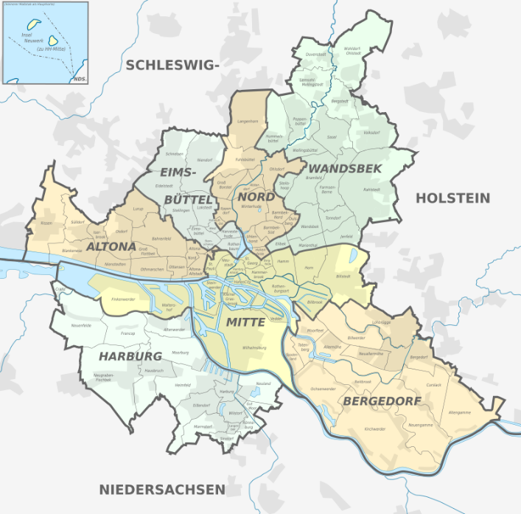
Figure 8. Boroughs of Hamburg city-state with HafenCity marked.

4.2. History and Inventory

HafenCity springs from an early tradition of river ports in Hamburg. The first was established soon after Holy Roman Emperor Barbarossa granted Hamburg, then a young town, exemption from custom duties in 1189. The port was the key factor in establishing Hamburg as a major city. Even up until the 19th century, port buildings and residential buildings were often one in the same, combining business, storage and residential quarters. The first modern harbor opened in 1866 and allowed for large steam ships to sail into the city and unload on the quayside by crane. It was the most modern system in Europe and Hamburg quickly earned a reputation as a fast and efficient port. Just as HafenCity is today, new ports that opened in the area were built on land raised many meters above sea level. These new ports would influence the future shape of HafenCity. World War II saw the area heavily damaged by Allied bombing, with over 70% of the structures destroyed. The area's significance as a port also declined with the advent of the shipping container. That part of the River Elbe was not deep enough for the massive new container ships, and new docks were built elsewhere.
Due to the intensive construction of a city-within-a-city, and the mass razing of nearly all existing buildings, the remaining historically significant buildings with intact integrity are concentrated in the district of Speicherstadt. In 2015, Speicherstadt was added to UNESCO’s list of World Heritage Site. Figure 11 shows the protected buildings in red, as well as the buffer zone, in gray, that must also have certain protections applied to ensure the character of the site remain both intact and with integrity.
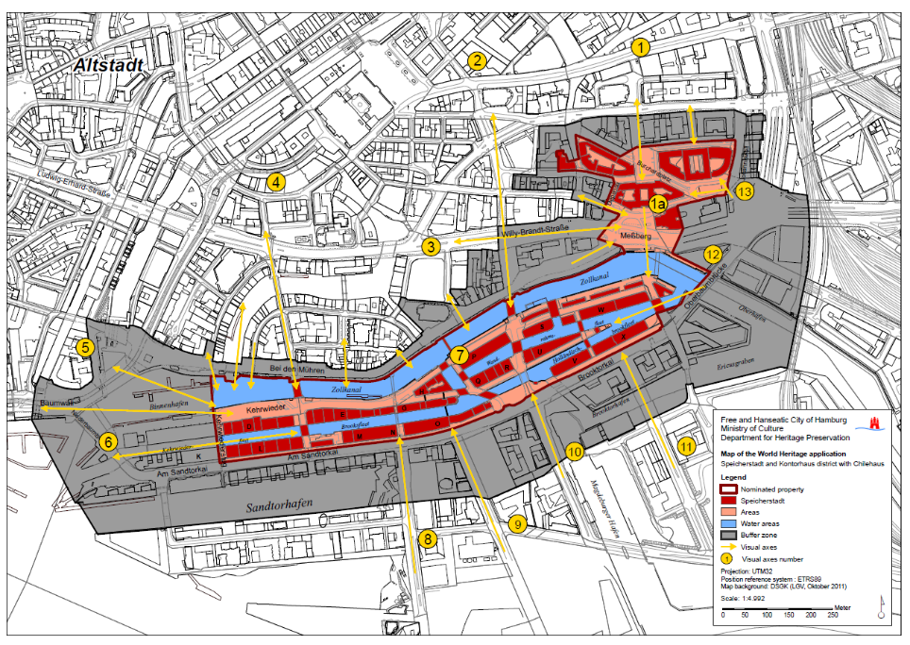
Figure 9. UNESCO World Heritage Site Map of Speicherstadt.

More than the others in HafenCity, Speicherstadt will require additional retrofits, engineering, and overall support, as it is the only remaining historic building ensemble in the district. Nevertheless, due to the extensive engineering of the new HafenCity ecodistrict (a term used by the author as a description of the area even though Hamburg has never used equivalent terminology when discussing HafenCity), Speicherstadt has directly and indirectly received several support systems that will ultimately protect it in a longer term than many other historic districts around the world.

4.3. Local Climate Change

In 2007, a gale from the North Sea produced a tide nearly 18 feet above typical levels on the German coast. The gale sent water 56 miles inland, reaching the city of Hamburg and washing over its neighborhoods. The only area of the city that withstood the event without any damage was HafenCity due to the innovative construction of the area. Flooding of the Elbe river happens often; the flood in 2002 was considered the worst since the Middle Ages, with catastrophic consequences in Germany. Again in 2013, the river flooded and caused mass evacuations throughout the country. HafenCity remained undisturbed, however. Due to the successes of HafenCity’s construction, the district’s residents describe the flooding as ‘events’ rather than disasters. There are limitations to the achievements of the ecodistrict, however, as these flooding events are not permanent, as sea level rise will. While engineering of the island will allow for easier adaptation measures as sea level rises, that does not suggest that current scenarios should be ignored.
Using the same scenario builder as was used to analyze the Holy Cross historic district, Figures10 and 11 illustrate the projected sea level inundation in HafenCity as of 2050 and 2100, respectively (the conditions reflecting unchecked pollution are on the left, and for extreme carbon cuts on the right). As depicted in Figure 10, the scenario for 2050 shows limited sea level creep on the HafenCity and Hamburg coastline. However, Figure 11 illustrates that with unchecked pollution, by 2100 HafenCity will be nearly completely inundated by the waters of the Norderelbe tributary. Furthermore, nearly one-third of the Speicherstadt ensemble is also projected to be under water. With the amount of funds put in to the design and construction of the HafenCity district and its integrated historic site, it is important to take into consideration the projections of sea level rise and continue adapting for new events or issues that may occur.
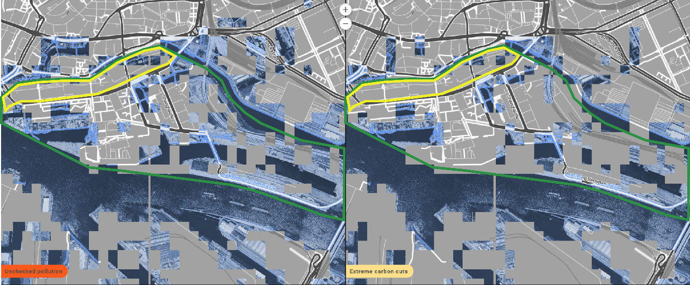
Figure 10. Climate Central's Surging Seas interactive scenario builder showing HafenCity and Speicherstadt at 2050 with current sea level projections

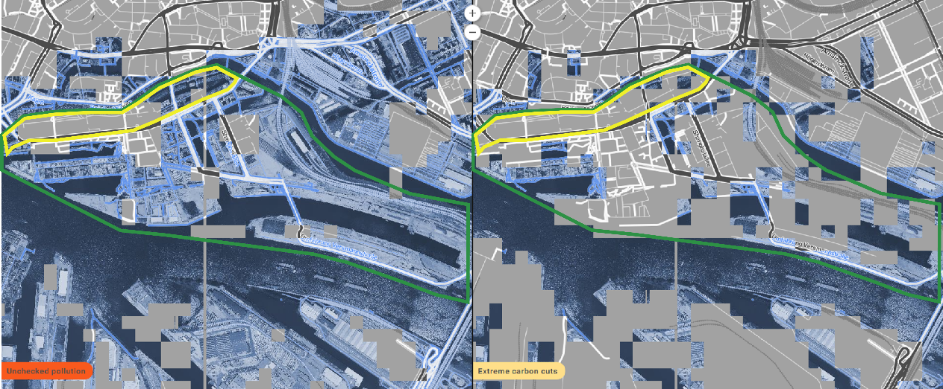
Figure 11. Climate Central's Surging Seas interactive scenario builder showing HafenCity and Speicherstadt at 2100 with current sea level projections.

4.4. What is currently being done?

HafenCity is a wholly-owned and operated subsidiary of the City of Hamburg, meaning that the City controls all decisions related to development, permitting, and construction. This control allows the City to ensure that a holistic approach to the needs of all Hamburg residents are taken into consideration. Although Hamburg does not use a similar term, HafenCity is effectively an ecodistrict. It addresses all the suggested requirements of sustainable development – environmental sustainability, social equity and civic participation, and economic resilience – and has a defined boundary through which it can focus on community identity.
Residents of all ages, classes, and familial and non-familial types live in the housing of HafenCity. This social diversity is the result of the “expressions of interest procedure,” in which a developer does not bid on the price of the land but rather on the proposed usage. Whichever developer creates the best socially useful proposal wins the right to build, and purchases the land for a pre-determined price. This forces developers to find those options that will be most beneficial in the long term for the city as a whole, rather than simply for their own bottom line. Furthermore, access to public amenities and transportation are prioritized by the City. In the most recent master plan, buildings are required to have a 20-meter setback from the quayside to ensure the island’s stability. The 20 meters are earmarked for public space and amenities, with elevated walkways to allow residents the ability to get from one place to another even in the event of flooding. The plan also requires elevated roadways so that vehicles will have access to and from the island in the event of a flood.
Most impressive of all the innovations from HafenCity is derived from the overall desire to live with the current flood and water problems that arise rather than retreating.
The urban spaces mainly extend over two levels. All buildings and roads are built on artificially raised, flood-protected bases at around 8 m above sea level, but embankment promenades remain at 4–5.5 m above sea level. The difference in height is particularly noticeable to the north of Sandtorkai. There unusually, in consideration of the adjacent Speicherstadt, the road (Am Sandtorkai) lies at the low level of the Speicherstadt, and the newly built basement foundations on the other side resemble a wall.

This floodable development means that while integrating the historic area of the city, the newly constructed buildings will be protected from all floods that are less than 8 meters in height above sea level. These areas will be used for storage and car garages for community members who reside in the apartments built above. The expectation is that the residents will have enough warning to move their cars from the streets to the garages, and then simply live with the water for as long as it stays.
There are some potential issues that come with HafenCity’s ambitious work in climate change adaptation, however: embodied energy and the lifecycle of building materials. Embodied energy is the total expenditure of energy involved in the creation of the building and its constituent materials. When buildings are destroyed in an effort to create more energy efficient structures, the embodied energy wasted represents a life-cycle of materials that contribute to climate change and pollution. Particularly in this current construction time when using the most energy consumptive materials is now the norm, a historic building that would have lasted 100 years could use 25% more energy annually and still have less lifetime embodied energy use than a contemporary building that lasts 40 years. Consequently, the construction of the “green” HafenCity did significantly more damage to the environment than was necessary. By retrofitting the historic structures already on the island the city would have added to their carbon footprint reduction portfolio, as well as created a stronger tie to the history of the area and greater cultural significance which could bring in heritage tourism. The unfortunate choice to raze the buildings turns the climate-ready city into one that contributed to the problem it was built to withstand. Nevertheless, given the current infrastructure in HafenCity – with an historic ensemble and an extensive green and smart district – there are still a few recommendations that can be given to this area that brings it more in line with the proposed eco/historic model.

4.5. Eco/Historic District

It is recommended that HafenCity first protect-in-place the Speicherstadt ensemble by reinforcing the island and raising it above the current sea level – taking into account the usual wave height of three meters, as well as raising it above the projected levels in 2050 as a result of extreme carbon cuts. Without the carbon cuts, sea level rise will be significantly higher, which will require further measures such as water-proofing the buildings in the ensemble to resemble the floodable development of the contemporary buildings in HafenCity. An opportunity to aid carbon cuts is to increase energy efficiency in the ensemble buildings and require all new buildings to be energy efficient. Lastly, in acknowledging that sea level rise is inevitable and the island can only be raised so high before it begins to lose its connection with the rest of the city of Hamburg, it is important to consider transportation options in the wake of a natural disaster or permanent flood. Opportunities such as boat trails, pedestrian highways, or elevated bike paths can increase social cohesion and equity for the residents of HafenCity.

Chapter 5: Leith

Edinburgh has a long history of wet weather. It adds to the magical perception of the city’s myths and legends, stories that are memorialized often through built structures or protected sites. However, like many other places in the world, Edinburgh’s climate is changing: rainfall is increasing, storm surges are becoming more intense and frequent, and sea levels are rising. The well-documented increase in water levels (and the projection of even further rises) means the assets of historic significance in the Leith conservation area are vulnerable to damage and deterioration far beyond what was considered normal when they were initially built. It is fortunate, then, that there are the means necessary to address these issues in Leith.
With policy and funding support from the Scottish government, a well-informed national agency – Historic Scotland – that has prioritized climate change mitigation to protect historic assets, and significant community education and engagement on issues of the environment both built and natural, the conservation area of Leith is the “just right” case study to fully reflect the potential of the Eco/Historic District model.

5.1. Location

The Leith conservation area is located at the port of Leith and runs inland along the Water of Leith river that flows through much of the northern Edinburgh neighborhoods. The entire community of Leith extends farther southeast and northwest of the conservation area, however, the boundary of the historically significant portion of Leith only makes up a portion of what locals consider to be Leith as a whole. Figure 12 shows the community of Leith as defined in the formation of a Neighborhood Partnership (a community cohesion organization that increases understanding of the needs of each community and conveys that information to the City Council) in yellow within the whole of Edinburgh.
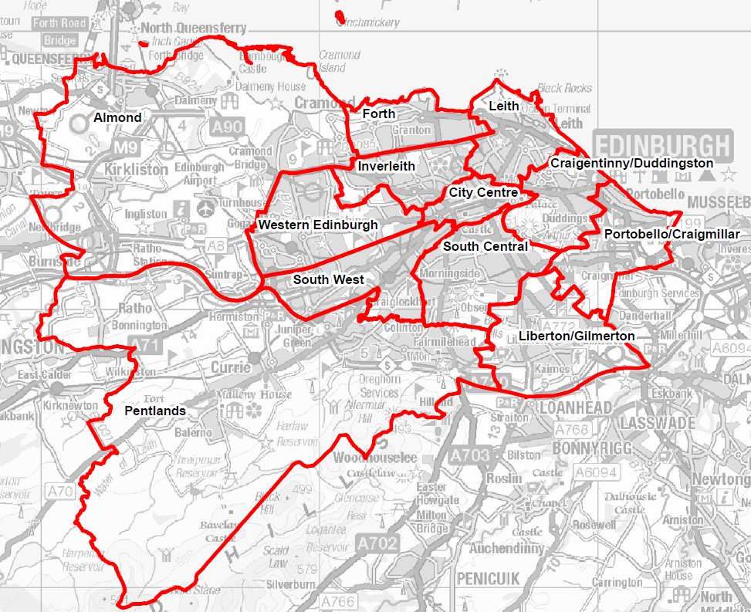
Figure 12. Census 2011 Neighborhood Partnership Areas with Leith in yellow

5.2 History and Inventory

The first mention of Leith can be traced back to 1128, in a document that founded Holyrood Abbey on the other side of the river. Its development has always been tied to its proximity to the Scottish capital, Edinburgh. After the loss of the town of Berwick to England, Leith became the country's main port. In 1560, a joint Scottish and English force laid siege to the town as it was occupied by the French.
Ship building became a major industry in the town, with Leith Docks becoming known as the Port of Edinburgh as the city expanded. Some of the 19th century shipyard buildings are still standing, as does the Leith Nautical College building, which opened in 1903. The aftermath of World War II saw Leith degenerate into an undesirable area rife with poverty.
Historic Scotland – the agency that provides guidance and support for historic properties in the country – has documented a large inventory of historic structures and places since 1991 when the agency was established. In the Leith conservation area, there are 476 listed buildings, 32 of which are considered locally as notable historic landmarks. Figure 13 shows that area with the listed buildings in red and the notable landmarks in yellow.
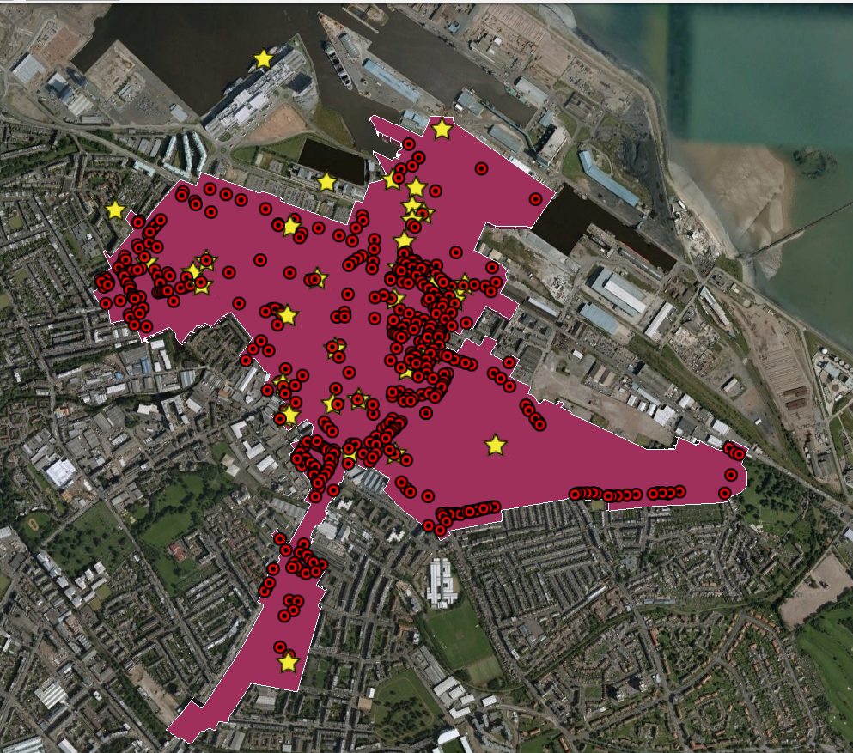
Figure 13. Leith conservation area with listed buildings in red and
notable landmarks in yellow

5.3. Local Climate Change

The average temperature for all seasons in all regions of Scotland has increased between 1.0 and 1.6º C since 1961; the average rainfall has increased 27% across Scotland, and snow cover has significantly decreased. All of these conditions are projected to worsen with visually evident effects by 2050. Historic materials on buildings – regardless of regional placement – will be adversely affected as they were built and tested against existing climates and preclude adaptive strategies currently being used for climate-related mitigation; the increased precipitation will add maintenance issues.
Even more concerning are those historic assets located on Scotland’s coastal borders where a net sea-level rise has already occurred and is projected to accelerate to visually evident proportions by 2080; “All of Scotland is now experiencing relative sea-level rise and all of the future projections expect accelerations in the rate of this rise”. These buildings are not only vulnerable to moisture degradation, but also severe flooding, storm surges, and erosion and falling away of the coastal walls, threatening total destruction.
In Leith, specifically, river flooding from the Water of Leith – shown in Figure 14 as the blue line running through the conservation area – regularly floods, damaging numerous listed buildings and historic monuments. The flood walls do not structurally support the increasing rainfall and storms the city has been experiencing over the past decade. The river flooding is a far more urgent crisis than the current sea level rise and its projected creep. Like the previous case studies, a sea level rise scenario for 2050 (Figure 14) and 2100 (Figure 15) with both unchecked pollution and extreme carbon cuts shows significant loss of land mass.

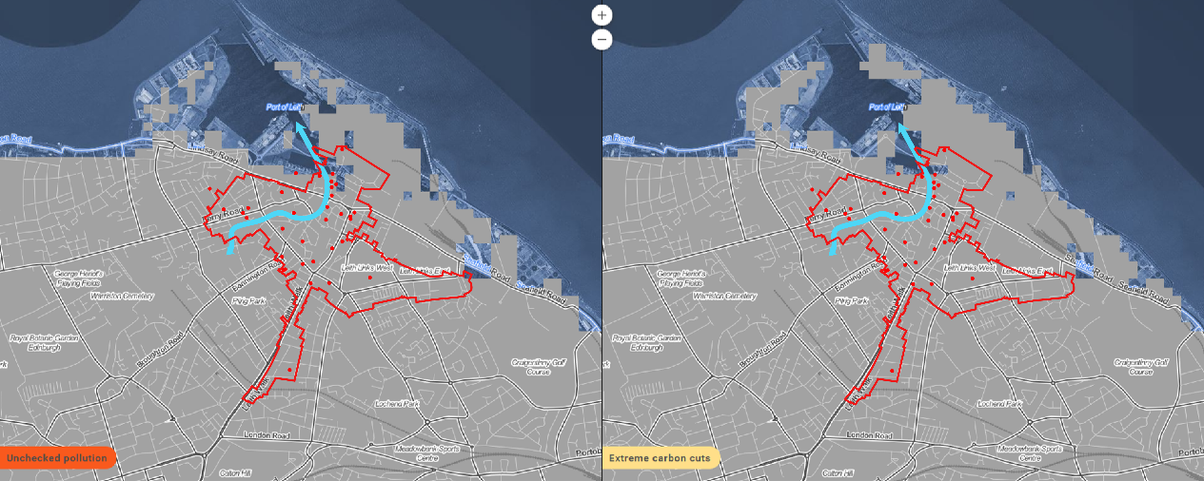
Figure 14. Climate Central's Surging Seas interactive scenario builder showing the Leith conservation area and significant monuments at 2050 with current sea level projections

In 2050 it is projected that some monuments and buildings will be at risk, but in 2100 nearly the entire Port of Leith is inundated with water.
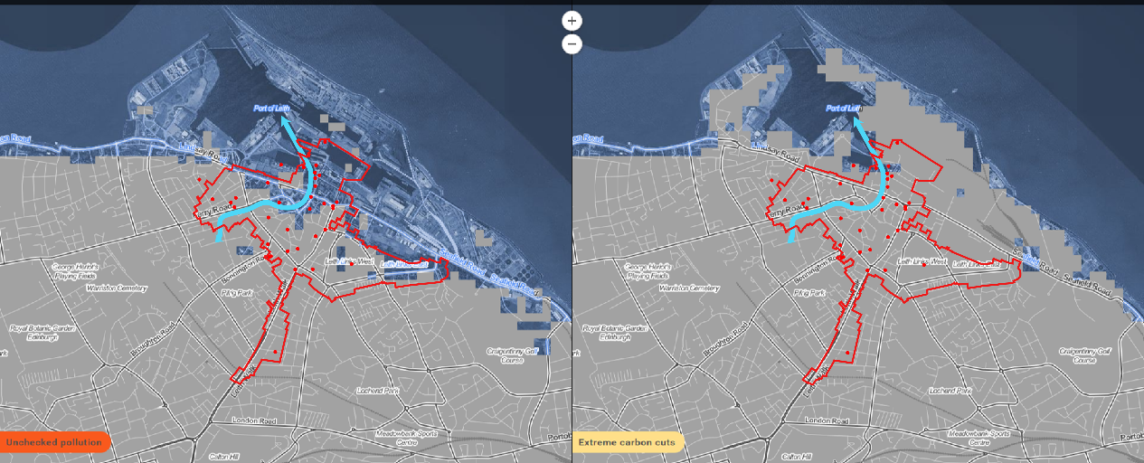
Figure 15. Climate Central's Surging Seas interactive scenario builder showing the Leith conservation area and significant monuments at 2100 with current sea level projections

Regardless of the crisis, it is evident that Leith is in need of climate change mitigation and adaptation measures.

5.4. What is currently being done?

The contrast between the historic Leith and the one that is found now is remarkable. Decades of regeneration have seen areas of Leith such as The Shore and The Waterfront become highly desirable. A number of high-end restaurants can be found in the area, as can the Royal Yacht Britannia, which is moored there. One recent disappointment for the area was the failure of the much-maligned Edinburgh Tram project, which only reached the city center due to budget problems, despite the initial plan calling for the route to run all the way down to Leith. Unfortunately, there have been very little in the way of climate change measures required in the construction of these developments. That is not to say that there is no supporting legislation for heritage preservation that considers the effects of climate change.
First, the government’s agency for historic preservation, Historic Scotland, identifies nine important principles behind their desire for preserving their historic environment:
- “Enhancing our quality of life,
- Knowing ourselves,
- Place-making,
- Sustainability,
- Environmental regeneration,
- Employment and economic success,
- An educational resource,
- Recreation and access, and
- Our broader environment.”

It is clear – through the broad definition of heritage prioritization – that Scotland places a high priority on those assets that represent its long history. As acknowledged in the principles, pride and rooting in history are not the only reasons for preserving historic places; there is also a significant economic interest for the country. Scotland’s historic environment is estimated to generate more than £2.3 billion and accounts for 2.5% of the country’s total employment annually. With over 14 million visitors each year, Scotland boasts 47,672 listed buildings, 8,205 scheduled monuments, 390 designed gardens and landscapes, 645 conservation areas, 39 historic battlefields, and six UNESCO World Heritage Sites. The country’s importance to the world’s history is unrefuted. With the increasing threat to these assets through changing climate and severe weather patterns, many of these structures and sites could face irreparable harm, causing lasting changes to culture and the economy.
Secondly, the Scottish Government has already proved to be a trailblazer for climate change action. With the passing of Climate Change (Scotland) Act 2009, the country set goals to reduce greenhouse gas emissions (GHG) by 80% by 2050 covering all gases recognized by the United Nations Framework Convention on Climate Change, Scotland created the standard for other European countries to follow. Eight further pieces of climate change legislation followed from 2010 to 2015, each clarifying and narrowing the field to smaller sectors and creating more specific goals. Unfortunately, none of the legislation surrounding climate change mentioned cultural heritage or historic preservation. With a focus heavy on GHG emissions reduction, the government has made the job of Historic Scotland – to find adaptation and mitigation interventions for their Properties in Care as well as the rest of their inventory – difficult. It was because of this omission that in 2011, the Scottish government updated their 2009 Scottish Historic Environment Policy (SHEP). In the updated document “flooding” is mentioned twice, “erosion” three times, and “climate change” is discussed five times. There is evidence of leniency in the definition of integrity as the government wants to ensure that buildings and monuments can be saved, even at the expense of the traditional concept of significance.
Subsequently, in 2012, Historic Scotland developed a climate action plan spanning five years, as allowed by the Climate Ready Scotland: Scottish Climate Change Adaptation Programme. The plan’s main focus is reducing carbon emissions from the agency’s day-to-day operations and in the buildings in their care, while educating others about possible climate-action innovations for buildings and places for which Historic Scotland have no direct control. Nevertheless, the lack of regulatory teeth has not stopped Historic Scotland from finding ways to utilize already implemented programs to their advantage.
In 1990, Historic Scotland created a subset agency called Buildings at Risk Register (BARR). Initially the register was implemented to inventory buildings deemed under threat through neglect. However, Historic Scotland has begun the process of expanding the inventory to include those buildings under threat due to climate change events. With this, along with their 10% allocation of all archeology funds to be used for coastal erosion projects, Historic Scotland has continued to demonstrate value for money in evolving with the changing needs of Scotland’s historic assets without much legislative support.
Scottish Planning Policy, which has regulatory teeth, also takes into account much of the work needed for historic preservation. Primary legislation surrounding the comingling of planning and preservation began in 1979, jumping to 1997 and continuing on to 2015. The major principles from Scottish Planning Policy state that “The planning system should: promote the care and protection of the designated and non-designated historic environment (including individual assets, related settings and the wider cultural landscape) and its contribution to sense of place, cultural identity, social well-being, economic growth, civic participation and lifelong learning; and enable positive change in the historic environment which is informed by a clear understanding of the importance of the heritage assets affected and ensure their future use.” With this statement it is clear that planning places high priority on preserving of historic assets and ensuring their place in the future plans of the country’s urban and rural places. As is evident, the most powerful work happening in Scotland is at the policy level, which enables and requires all historic places and structures, including Leith, to consider and prioritize climate change when repairing or protecting historic resources.
In Leith specifically, there is further capacity for implementation of an Eco/Historic District at the social level. More than any other place in Scotland, Edinburgh has an extensive community engagement infrastructure. Outside of voting districts, there are two different delineations that make up community organizations in the Leith area, the Leith Community Council and the Leith Neighborhood Partnership. The Community Council is a volunteer board that brings formal policy desires and concerns to the City Council. There are 12 Neighborhood Partnerships in Edinburgh and each are made up of a variety of stakeholders from the local community. They help form local community plans (similar to sector plans) and take on the responsibility of gathering community input and support through meetings, events, and other community activities. Because of the many data collection points, forums, and events that encourage neighbors to voice their concerns and needs for their community, and that the information is then passed on to the City Council for review and integration into local policy, Leith has impressive social and political capacity to create an Eco/Historic District.

5.5. Eco/Historic District

The key area missing from heritage protection policy is the funding prioritization that incentivizes private owners to begin a conditions assessment on their building based on projected climate change events. This added policy should acknowledge costs involved with maintenance and restoration, identify the low-hanging-fruit of conservation options, and ensure proper education of climate change threats to the individual property owner. Historic Scotland, along with Scottish Natural Heritage, should receive funding under such legislation to create priority tiers based on level of vulnerability of the site or structure, taking into account the number of structures in a particular area and the value of the structures to the historic inventory. Tax incentives should be included to aid owners in the preparation of their properties for restoration and climate change mitigation interventions, the likes of which should be determined by Historic Scotland. Furthermore, floodable development retrofits, like what is seen in HafenCity, should be considered as possible modifications for those assets in high-vulnerability areas. It is also recommended that those monuments within the Leith conservation area that are noncontributing to the historic character of the district, but that are also vulnerable to damage or destruction based on sea level rise projections, be relocated to a more inland area.
Under this same legislation, funds should be allocated to parallel the purposes already implemented by Historic Scotland through its archeology fund. Ensuring that vulnerable coastal zones are properly identified and funds are available for adaptation and mitigation is imperative.
Edinburgh’s planning should discourage adding infrastructure that will do more harm and contribute to climate change, such as adding overpasses and bypasses that increase both car use and pollution, and decrease the historic character of the area. Instead the planning staff should look for opportunities to live with the water, as what has been seen in New Orleans through plans, and in HafenCity in implementation. Planning out canals or pedestrian highways can create opportunities for interesting vistas as well as ways to control the water such that it causes little to no harm.
Finally, finding those places between the buildings that are not from the period of significance in the Leith conservation area and utilizing stormwater management strategies like bioswales and permeable pavement are highly recommended for greening measures to the area.

Chapter 6: Recommendations for Eco/Historic District
After an examination of the three case studies with respect to those quality of life indicators that will be negatively impacted by climate change, along with the historic assets that are vulnerable to damage or destruction, there are social, policy, and implementation measures that are required when implementing this new Eco/Historic District model. This chapter also covers a Stages of Capacity table that qualifies the capacity of cities to move from one phase of implementation to the next, with the end result being an Eco/Historic District.

6.1. Social

The requirements for social impacts of Eco/Historic Districts are simple in theory: involve the community every step of the way and work toward maintaining the cultural identity of the area throughout each implementation step. It is helpful to already have the networks in place, like what is seen in Leith. However, the Holy Cross neighborhood proved that building up the networks, even during time of desperate need, is very possible. The community must be consulted and made to feel as though their needs in both historic ties and environmental progress are being addressed.

6.2. Policy

Sustainability as a lens through which a historic district is maintained or rebuilt is advantageous for the local economy and for local residents. Approaching impediments with the perspective of creating long-term solutions provides governmental agencies with the reassurance that their economic tools for rebuilding and restoring historic structures and neighborhoods will produce lasting results and allow for further financial support. Creating policies that acknowledge the cost savings in prevention and mitigation versus repair after the fact are highly recommended.
Also recommended is policy that recognizes climate change effects on historic monuments and considers a case-by-case leniency of the integrity standards. Such policy should also incentivize through grants or tax credits, or simply require adaptive reuse of historic buildings in the event of development in the area. Alongside this requirement should also be new construction requirements that take into account the climate change projections of the area and standardize building practices to ensure the buildings will remain undamaged in the face of climate change eventualities.
Finally, funding for social programs that support affordable housing and small business should be restructured so that funds are earmarked for historic preservation adaptive reuse, when the building and housing stock already exists in historic places or structures. This can aid the social equity diversity of an historic district.

6.3. Implementation

Implementation of an ecodistrict inside of an historic place can be aided when those involved identify the character defining features of the district, and recognize those streets and places between buildings that are not contributing to the character of the district as malleable. This allows for opportunities for quick greening strategies. All features that do not contribute to character should be considered up for ecological conversion under adaptation or rehabilitation definitions.
However, it is always first and foremost important to innovate for the aesthetics of the place, regardless of the contributing or noncontributing status of the sites and structures found therein. There is also a need to cease further harm that contributes to climate change; cities must begin prioritizing carbon neutral activities such as walking and biking, or low-carbon opportunities such as public transit, and stop building infrastructure for automobiles.
Local participation can help in this effort, as planners generally plan for the current and projected needs of the population. When residents support carbon neutral or low carbon activities, the supporting infrastructure will be prioritized. This is why local support from the resident population is key. Community members can also help with inventorying vulnerabilities, another implementation requirement. Through crowdsourcing experiences of residents, assets that are vulnerable are certain to be inventoried.
Finally, creating a themed district, like what is seen in several European examples, that also draws upon the cultural and natural characteristics of the place, such that historic districts in more arid regions could become solar cities, rural areas could become microgrid districts, and coastal cities could become water cities. Furthermore, finding the closed-loop options that solve more than one problem, like what was proposed for Haiti, are a requirement for the implementation of this model.

6.3.a. Stages Defining Capacity

After considering all the actions that lead to successful ecodistricts, and those actions that failed the process, the following stages for historic district capacity to become an Eco/Historic District are as follows:
Table 3. Stages of capacity for developing an Eco/Historic District
 | 1 | Investigation | The formal acknowledgement and desire for an historic district to become an Eco/Historic District, but neighborhood may have several obstacles impeding progress.
 | 2 | Organizing Plans | Community members have formed groups to advocate for sustainable innovations in their existing historic neighborhood, but lack of funding or innovative best-practices encumber advancement.
 | 3 | Innovation | Elected officials and community members have collaborated to document needs, desires, and vulnerabilities. Movement toward policy changes that result in funding support for modern mitigation and adaptation measures are next steps.
 | 4 | Implementation | Policy and funding changes support tangible modifications to the historic district toward creating an Eco/Historic District.
 | 5 | Adaptive Maintenance | Changes have been made. Maintenance is required on a continual basis while reevaluating new threats and opportunities for innovation. Adapt to new problems or crises as they are discovered.

The process of creating an Eco/Historic District begins at the local level in which residents acknowledge the desire to create such a district in their own communities. To move from the Investigation stage to the Organizing Plans stage, stakeholders hoping to implement an Eco/Historic District should first identify the obstacles that keep them from beginning advocacy and public education, and form appropriate committees or groups who can build a network of support. Whether that’s through use of listservs, talking to neighbors or people on the street, or bringing the issue up during public comment portions of council meetings, without the dedicated networks, it is impossible to move to the Organizing Plans stage.
Once in the Organizing Plans stage, the groups formed should identify experts to provide guidance for best practices and begin formulating the required mission statements. They should also begin looking for partnerships with established organizations in the private, public, and nonprofit sectors. It is through this engagement that trust can be built and legitimization of missions can be recognized at political levels.
Moving into the Innovation stage requires collaboration by elected officials with the community network already formed in the second stage. The collaboration should document and begin formalizing community needs, desires, and vulnerabilities that include both historic assets, cultural identity, economic vitality, and environmental innovation. Elected officials should investigate opportunities for policy and funding support, while the community organization should, with consultation from experts, begin creating a cost/benefit analysis to support mitigation and adaptation strategies in the face of climate change event damage. This action moves the project into the Implementation stage.
In the Implementation stage policy support and funding from elected officials allow for real changes to be made to the area while establishing a formal boundary for the eco/historic district. This would involve formally adopting guidelines for the aesthetics and other environmental systems that encourage continuation of cultural and architectural heritage while creating environmental modifications to adapt to climate change eventualities. To move into the fifth and final stage, the city must prioritize those areas and assets where climate change creates the most vulnerabilities.
In the final stage, Adaptive Maintenance, the necessary changes have been made and the Eco/Historic District has been established. This stage requires vigilant reassessment of current and future threats while maintaining the new infrastructure. When new crises arise, new adaptation measures should be prioritized.

Conclusion

While there is no doubt that historic places and assets will be affected by climate change in the coming years, there are many opportunities to innovate against their damage or destruction while also creating livable, technologically-savvy, and environmentally-friendly places for people to live in harmony with nature. This Eco/Historic District model is just the beginning of research for what, the author predicts, will one day be the normal implementation strategies for all human settlements, both historic and contemporary, around the world.

Glossary

- Adaptation - Adjustment in natural or human systems in response to actual or expected climatic stimuli or their effects, which moderates harm or exploits beneficial opportunities.
- Mitigation - An anthropogenic intervention to reduce the anthropogenic forcing of the climate system; it includes strategies to reduce greenhouse gas sources and emissions and enhancing greenhouse gas sinks.
- Sustainability – The convergence of environmental, equity, and economic issues that create vital resilience.
- Sustainable development - meets the cultural, social, political and economic needs of the present generation without compromising the ability of future generations to meet their own needs.
- Resilience - The ability of a social or ecological system to absorb disturbances while retaining the same basic structure and ways of functioning, the capacity for self-organisation, and the capacity to adapt to stress and change.

Works Cited

Ahlfeldt, Gabriel M., and Wolfgang Maennig. 2010. "Substitutability and Complementarity of Urban Amenities: External Effects of Built Heritage in Berlin." Real Estate Economics 38 (2): 285-323.
Albert, Simon, Javier X Leon, Alistair R Grinham, John A Church, Badin R Gibbes, and Colin D Woodroffe. 2016. "Interactions between sea-level rise and wave exposure on reef island dynamics in the Solomon Islands." Environmental Research Letters (IOP Science) 11 (5). http://iopscience.iop.org/article/10.1088/1748-9326/11/5/054011.
Asabere, Paul K., Forrest E. Huffman, and Seyed Mehdian. 1994. "The Adverse Impacts of Local Historic Designation: The Case of Small Apartment Buildings in Philadelphia." Journal of Real Estate Finance and Economics 8: Kluwer Academic Publishers.
BBC News. 2005. Marooned Marble Arch may be moved. London, February 28. http://news.bbc.co.uk/2/hi/uk_news/england/london/4303919.stm.
Behrens, Kristian, and Frédéric Robert-Nicoud. 2014. Do cities widen the gap between rich and poor? World Economic Forum. July 24. https://www.weforum.org/agenda/2014/07/cities-urbanization-rich-poor-inequality/.
Bigano, Andrea, Alessandra Goria, Jacqueline Hamilton, and Richard S.J. Tol. 2005. "The Effect of Climate Change and Extreme Weather Events on Tourism." Fondazione Eni Enrico Mattei (FEEM) CCMP – Climate Change Modelling and Policy 2-33.
Bouton, Shannon, David Newsome, and Jonathan Woetzel. 2015. "Building the cities of the future with green districts." McKinsey & Company: Business Functions, May. http://www.mckinsey.com/business-functions/sustainability-and-resource-productivity/our-insights/building-the-cities-of-the-future-with-green-districts.
Brown, Hillary, and Miriam N. Ward. 2014. "A Haitian ‘ecodistrict:’ conceptual design for integrated, basic infrastructure for the commune of Léogâne." Earth Perspectives 1 (4): 1-11. http://www.earth-perspectives.com/1/1/4.
Bruns-Berentelg, Jürgen. 2006. HafenCity Hamburg Der Masterplan. PDF, HafenCity, Hamburg: HafenCity Hamburg GmbH.
Budds, Michael, Erin Reome, Dan Schauer, and Aaron Wilson. 2010. "Gateway EcoDistrict Pilot Study." Master of Urban and. http://pdxscholar.library.pdx.edu/usp_murp/3.
Bullivant, Lucy. 2012. Masterplanning Futures. New York, New York: Routledge.
C40 cities: delta connecting cities. 2016. Climate change adaptation. http://www.deltacities.com/cities/new-orleans/climate-change-adaptation.
Cidlowski, Laine. 2015. WHAT IS THE SAINT ELIZABETHS-CONGRESS HEIGHTS ECODISTRICT? Washington, D.C.: DC Office of Planning.
City of Edinburgh. 2014. "Community Council Area Profiles." Census 2011 - The Results for Edinburgh. January. Accessed February 20, 2016. http://www.edinburgh.gov.uk/downloads/file/2937/census_2011_-_community_councils.
—. 2014. "Conservation Area Profiles." Census 2011 - The Results for Edinburgh. April. Accessed February 20, 2016. http://www.edinburgh.gov.uk/downloads/file/3059/census_2011_-_conservation_areas.
—. 2014. "Council Ward Profiles." Census 2011 - The Results for Edinburgh. January. Accessed February 20, 2016. http://www.edinburgh.gov.uk/downloads/file/2945/census_2011_-_edinburgh_wards.
City of Edinburgh. 2015. "Leith Conservation Area Character Appraisal." http://www.edinburgh.gov.uk/downloads/file/1099/leith_conservation_area_character_appraisalpdf.
—. 2014. "Neighbourhood Partnership Area Profiles." Census 2011 - The Results for Edinburgh. January. Accessed February 20, 2016. http://www.edinburgh.gov.uk/downloads/file/2940/census_2011_-_neighbourhood_partnership_areas.
—. 2013. "Population distribution and density in Edinburgh : Recent trends and comparisons with other cities across Scotland and the UK." Census 2011 - The Results for Edinburgh. October. Accessed February 20, 2016. http://www.edinburgh.gov.uk/downloads/file/2942/census_2011_-_population_distribution_and_density.
City of Edinburgh. 2011. State of the Environment Audit: Water Quality and Flooding, Coastal Flooding. Edinburgh: City of Edinburgh Council.
—. 2014. "World Site ProfileWorld Heritage Profile." Census 2011 - The Results for Edinburgh. April. Accessed February 20, 2016. http://www.edinburgh.gov.uk/downloads/file/3060/census_2011_-_world_heritage_site.
City of New Orleans. 2015. Design Guidelines. April 29. Accessed November 20, 2016. http://www.nola.gov/hdlc/design-guidelines/.
—. 2015. Design Guidelines. April 19. http://www.nola.gov/hdlc/design-guidelines/.
—. 2016. Historic Landmarks. April 12. http://www.nola.gov/hdlc/historic-landmarks/.
—. 2016. Master Plan. March 3. http://www.nola.gov/city-planning/master-plan/.
Climate Central. 2013. Risk Finder: New Orleans. Accessed January 10, 2016. http://ssrf.climatecentral.org/#location=LA_City_2255000&state=Louisiana&level=6&geo=City&pt=t&target=&p=P&stn=8761724&setting=NCA_inthi&protection=tidelcontiglevees&stLoc=LA_City_2255000&proj=Total.
—. 2012. Surging Seas Risk Zone Map. Accessed January 8, 2016. http://ss2.climatecentral.org/index.html#14/53.5370/10.0046?show=satellite&projections=0-RCP85-SLR&level=10&unit=feet&pois=hide.
Co, Allan V., and Mary Roderick. 2013. "HafenCity, Hamburg." University of Washington. August 11. Accessed April 17, 2016. https://courses.washington.edu/gehlstud/gehl-studio/wp-content/themes/gehl-studio/downloads/Autumn2010/HafenCity.pdf.
Coffin, Donald A. 1989. "The Impact of Historic Districts on Residential Property Values." Eastern Economic Journal, 15 (3): 221-228.
Colorado Historical Foundation. 2011. The Economic Power of Heritage and Place: How Historic Preservation is Building a Sustainable Future in Colorado. State Historical Fund grant from History Colorado.
Connelly, Ceci. 2005. 9th Ward: History, Yes, but a Future? The Washington Post. October 3. http://www.washingtonpost.com/wp-dyn/content/article/2005/10/02/AR2005100201320_2.html.
Coulson, Edward N., and Michael L. Lahr. 2005. "Gracing the Land of Elvis and Beale Street: Historic Designation and Property Values in Memphis." Real Estate Economics 33 (3): 487-507.
Council of Europe. 2014. "Germany." Herein System, European Heritage Policies. Accessed April 20, 2016. http://www.herein-system.eu/germany-country-profile.
—. 2013. "Germany/ 3. Competence, decision-making and administration." Compendium: Cultural Policies and Trends in Europe. 4 9. http://www.culturalpolicies.net/web/germany.php?aid=32.
—. 2015. "Germany/ 4.2 Specific policy issues and recent debates." Cultural Policies. July 2. Accessed April 26, 2016. http://www.culturalpolicies.net/web/germany.php?aid=422.
—. 2013. "United Kingdom." Herein System, European Heritage Policies. Accessed April 20, 2016. http://www.herein-system.eu/united_kingdom-country-profile.
D. J. Wagenaar, K. M. de Bruijn, L. M. Bouwer, H. de Moel. 2016. "Uncertainty in flood damage estimates and its potential effect on investment decisions." Natural Hazards and Earth System Sciences 16 (1). https://www.sciencedaily.com/releases/2016/02/160229082014.htm.
Davies, Wayne K. D., and Ivan J. Townshend. 2015. "Chapter 2: New Urbanisms: From Neo-Traditional Neighbourhoods to New Regionalism." In Theme Cities: Solutions for Urban Problems, edited by Wayne K. D. Davies, 17-26. Springer.
Davies, Wayne K.D. 2015. "Chapter 7: Transition Towns and EcoDistricts: Local Sustainable Initiatives." In Theme Cities: Solutions for Urban Problems, edited by Wayne K.D. Davies. Springer.
—. 2015. Theme Cities: Solutions for Urban Problems. Springer. https://books.google.com/books?id=xZWkBwAAQBAJ&printsec=frontcover&source=gbs_ViewAPI#v=onepage&q&f=false.
Deutsches Institut fur Urbanistik. 2001. "Preservation in Germany and the Studyon Cultural Assets in Europe." Difu.de. Accessed April 2016. http://www.difu.de/dokument/preservation-in-germany-and-the-study-on-cultural-assets-in.html.
EcoDistricts. 2015. "Target Cities." EcoDistricts.org. https://ecodistricts.org/target-cities/about-target-cities/.
EcoDistricts. 2013. The EcoDistricts(TM) Framework: Building Blocks of Sustainable Cities. Portland, OR: EcoDistricts.
Edinburgh Neighborhood Partnerships. 2016. What is a Neighbourhood Partnership? http://www.edinburghnp.org.uk/about-nps/.
Ellison, Garret. 2016. "Why Meijer executive is thumbs down on Michigan historic districts." MLive Media Group. East Grand Rapids, MI, March 1. http://www.mlive.com/news/index.ssf/2016/03/meijer_murray_historic_distric.html.
EUR-Lex. 2016. "Environment and climate change." EUR-Lex: Access to European Union Law. http://eur-lex.europa.eu/summary/chapter/environment.html?root_default=SUM_1_CODED%3D20.
Federal Republic of Germany. 2012. Basic Law for the Federal Republic of Germany. Constitution, Berlin: German Bundestag.
—. 1997. Federal Building Code (Baugesetzbuch, BauGB). August 18. http://germanlawarchive.iuscomp.org/?p=649.
Felce, David, and Jonathan Perry. 1995. "Quality of Life: Its Definition and Measurement." Research in Developmental Disabilities 16 (1): 51-74.
Floodsite Project. 2008. Elbe flood in 2002. http://www.floodsite.net/juniorfloodsite/html/en/student/thingstoknow/geography/elbeflood2002.html, FLOODsite Consortium.
Frank, Karolin. 2013. Historic Preservation in the USA. Hamburg: Springer Science & Business Media. https://books.google.com/books?id=K5ooBgAAQBAJ&pg=PT242&lpg=PT242&dq=germany+historic+preservation+policy&source=bl&ots=X9HiX6Ht7g&sig=nRuhze1aQCsHuaQd3mi6UDs5MAE&hl=en&sa=X&ved=0ahUKEwjc2deC-6zMAhWEpx4KHQvMD-0Q6AEIUTAH#v=onepage&q=germany%20historic%20pr.
Fu, Bo-Jie, Guo-Hua Liu, Yi-He Lü, Li-Ding Chen, and Ke-Ming Ma. 2009. "Ecoregions and ecosystem management in China." International Journal of Sustainable Development & World Ecology 11 (4): 397- 409. http://dx.doi.org/10.1080/13504500409469842.
Gilderbloom, John I., Matthew J. Hanka, and Joshua D. Ambrosius. 2009. "Historic preservation’s impact on job creation, property values, and environmental sustainability." Journal of Urbanism: International Research on Placemaking and Urban Sustainability 2 (2): 83-101.
Google Earth Pro. 2016. Leith Conservation Area and Listed Buildings.
Government of Scotland. 2014. Scotland's Climate Trends Handbook. Comp. 2006-2014 Sniffer and Met Office. Edinburgh. www.environment.scotland.gov.uk/climate_trends_handbook/index.html.
Greater New Orleans Community Data Center. 2002. Holy Cross Neighborhood Snapshot. October 10. http://www.datacenterresearch.org/pre-katrina/orleans/8/20/snapshot.html.
Grossman, Daniel. 2015. "A Tale of Two Northern European Cities: Meeting the Challenges of Sea Level Rise." E360 Report, November 3. http://e360.yale.edu/feature/a_tale_of_two_northern_european_cities_meeting_the_challenges_of_sea_level_rise/2926/.
HafenCity Hamburg. 2016. "Essentials Quarters Projects." Hamburg. http://www.hafencity.com/upload/files/artikel/HafenCity_Projects_March_2016.pdf.
—. 2016. "Facts and Figures on HafenCity Hamburg." HafenCity. March. Accessed April 18, 2016. http://www.hafencity.com/upload/files/artikel/Fact_Sheet.pdf.
—. 2012. On historic ground. Accessed April 17, 2016. http://www.hafencity.com/en/overview/on-historic-ground.html.
—. 2005. Revision of the Masterplan: Taking the HafenCity Concept Further. Accessed April 18, 2016. http://www.hafencity.com/en/revision-of-the-master-plan/revision-of-the-masterplan-taking-the-hafencity-concept-further.html.
—. 2013. "The HafenCity project." HafenCity Hamburg. Accessed April 18, 2016. http://www.hafencity.com/en/overview/the-hafencity-project.html.
Hagan, Susannah. 2014. Ecological Urbanism: The Nature of the City. New York, NY: Routledge. https://books.google.com/books?id=VTSDBAAAQBAJ&pg=PA116&lpg=PA116&dq=HafenCity+Hamburg+Der+Masterplan+2006&source=bl&ots=133JMWC-o0&sig=PbIBActcpoOFGeViGaRUL1LCDRo&hl=en&sa=X&ved=0ahUKEwiT-L_Xx6_MAhUKlh4KHbWbDKIQ6AEILTAC#v=onepage&q=HafenCity%20Hamburg%20.
Hamburg.de. 2016. "Culture Authority: Heritage Monument List." Hamburg.de Politics & Administration. 4 18. http://www.hamburg.de/kulturbehoerde/denkmalliste/.
Hawkins, Dominique M. 2011. "City of New Orleans: Historic District Landmarks Commission, Holy Cross Historic District." City of New Orleans. May. Accessed November 19, 2015. http://www.nola.gov/nola/media/HDLC/Historic%20Districts/HolyCross.pdf.
Heritage Preservation: The National Institute for Conservation. 1990. Conservation Assessment Program: Handbook for Assessors. Washington, DC. https://www.heritagepreservation.org/CAP/docs/Handbook4Assessors.pdf.
Hickman, Amy. 2008. Waterfront Regeneration in the Historic Port of Leith: the Challenges of Maintaining Authenticity on an Urban Scale. Thesis, Edinburgh: University of Edinburgh.
Hill, Kristina. 2014. "Hybrid Edges: A Typology of Coastal Adaptation Strategies." Edited by MIT Sea Grant. Cambridge, MA: MIT Sea Grant. Accessed January 9, 2016. https://www.youtube.com/watch?v=6tH0zfvpGNs.
Historic Scotland. 2012. A Climate Change Action Plan for Historic Scotland 2012-2017. Edinburgh. http://www.historic-scotland.gov.uk/climate-change-plan-2012.pdf.
Historic Scotland. 2014. Adapting to Change. Edinburgh. http://www.historic-scotland.gov.uk/index/heritage/climatechange/adaptingtochange.htm.
Historic Scotland. 2011. Buildings at Risk Register. Edinburgh. http://www.historic-scotland.gov.uk/index/heritage/barr.htm.
Historic Scotland. 2015. Scottish Historic Environment Policy. Edinburgh. http://www.historic-scotland.gov.uk/index/heritage/policy/shep.htm.
Historic Scotland. 2013. Why is the Historic Environment Important. Edinburgh. www.historic-scotland.gov.uk/index/heritage/valuingourheritage/why-is-the-historic-environment-important.htm.
Intergovernmental Panel on Climate Change. 2007. Glossary. https://www.ipcc.ch/publications_and_data/ar4/wg2/en/annexessglossary-a-d.html.
Klijn, Frans, Rein W. De Waal, and Jan H. Oude Voshaar. 1995. "Ecoregions and Ecodistricts: Ecological Regionalizations for The Netherlands' Environmental Policy." Environmental Management 19 (6): 797-813.
Kopp, Robert E., Andrew C. Kemp, Klaus Bittermann, Benjamin P. Horton, Jeffrey P. Donnelly, W. Roland Gehrels, Carling C. Hay, Jerry X. Mitrovica, Eric DD. Morrow, and Stefan Rohmstorf. 2016. "Temperature-driven global sea-level variability in the Common Era." Proceedings of the National Academy of Sciences of the United States of America 113 (11).
Koshar, Rudy. 2000. From Monuments to Traces: Artifacts of German Memory, 1870-1990 (Weimar and Now: German Cultural Criticism). Berkeley and Los Angeles, California: University of California Press. https://books.google.com/books?id=rQbuKpqTZ7QC&pg=PA52&lpg=PA52&dq=germany+historic+preservation+policy&source=bl&ots=Yl6x09B5AE&sig=fRj4sYt2_iwNrnnDJ99W9SSv2t4&hl=en&sa=X&ved=0ahUKEwjc2deC-6zMAhWEpx4KHQvMD-0Q6AEIVDAI#v=onepage&q=germany%20historic%20pres.
Kreutz, Stefan. 2012. Transnational Assessment of Practice | Case study report: HafenCity, Hamburg. December 19. Accessed April 19, 2016. http://archive.northsearegion.eu/files/repository/20121219103527_HafenCity-Hamburg-Germany[1].pdf.
Landesrecht Hamburg. 2013. "Judicial Authority." Hamburg: Politics & Administration. April 5. http://www.landesrecht-hamburg.de/jportal/portal/page/bshaprod.psml?nid=0&showdoccase=1&doc.id=jlr-DSchGHA2013rahmen&st=null.
Lautenschlager, R. A. 1998. "Using Specific Environmental Concerns to Identify Critical Sustainability Issues." Ecosystems, Mar. - Apr.: 176-182. http://www.jstor.org/stable/3658585.
Lee, Sohyun Park. 2001. "Conflicting élites and changing values: designing two historic districts in downtown Seattle, 1958–73." Planning Perspectives 16 (3): 243-268.
Leith Local History Society. 2012. Timeline: Some milestones in the history of Leith. Accessed February 11, 2016. http://www.leithlocalhistorysociety.org.uk/timeline/timeline.htm.
Linz Life. 2016. solarCity Pichling. http://www.linz.at/english/life/3199.asp.
Mabry, Jonathan. 2007. "Benefits of Residential Historic District Designation for Property Owners." City of Tucson: Department of Urban Planning and Design, July 6.
MacCash, Doug. 2010. "Unusual flood-resistant 'steamboat house' helped keep neighborhood afloat." NOLA.com, August 28. http://www.nola.com/homegarden/index.ssf/2010/08/unusual_flood-resistant_steamb.html.
Martı´n, Ma Bele´n Go´mez. 2005. "WEATHER, CLIMATE AND TOURISM A Geographical Perspective." Annals of Tourism Research, 32 (3): 571-591.
Mason, Randall. 2004. "Fixing Historic Preservation: A Constructive Critique of "Signficance"." Places 16 (1): 64-71.
McClearly, Rebecca L. 2005. "Financial Incentives for Historic Preservation: An International View." University of Pennsylvania Scholarly Commons (University of Pennsylvania). http://repository.upenn.edu/hp_theses/35.
Meehl, G.A., T.F. Stocker, W.D. Collins, P. Friedlingstein, A.T. Gaye, J.M. Gregory, A. Kitoh, R. Knutti, J.M. Murphy, A. Noda, S.C.B. Raper, I.G. Watterson, A.J. Weaver and Z.-C. Zhao. 2007. Global Climate Projections In: Climate Change 2007: The Physical Science Basis. Intergovernmental Panel on Climate Change, Cambridge, United Kingdom and New York, NY, USA.: Cambridge University Press. http://www.ipcc.ch/publications_and_data/ar4/wg1/en/ch10.html.
Morris, Mimi. 2012. The Economic Impact of Historic Resource Preservation. California Culture & Historical Endowment.
Moser, Caroline. 2005. "Has gender mainstreaming failed?" International Feminist Journal of Politics. Vol. 7. no. 4. 576-590.
NASA: Earth Observatory. 2013. Images. http://earthobservatory.nasa.gov/IOTD/view.php?id=81368.
NASA: Global Climate Change. 2016. Sea Level. January. http://climate.nasa.gov/vital-signs/sea-level/.
National Aeronautics and Space Administration. 2015. Sea Level Change. Accessed 15 January, 2016. https://sealevel.nasa.gov/.
National Oceanic and Atmospheric Administration. 2015. Global vs. Local Sea Level. January 23. Accessed January 9, 2016. http://oceantoday.noaa.gov/globalvslocalsealevel/.
—. 2015. Sea Level Rise and Coastal Flooding Impacts. January 31. Accessed January 8, 2016. https://coast.noaa.gov/slr/.
National Park Service. n.d. Moving the Cape Hatteras Lighthouse. 2015. https://www.nps.gov/caha/learn/historyculture/movingthelighthouse.htm.
—. 2013. National Register of Historic Places. November 3. http://focus.nps.gov/nrhp/AssetDetail?assetID=80cdeb60-6d48-494b-8fe0-71a81aa2020a.
National Trust for Historic Preservation. 2013. "Creating Sustainable Communities." Preservation Green Lab. Accessed January 8, 2017. http://www.preservationnation.org/information-center/sustainable-communities/creating/#.VyD4I0dLXnN.
—. 2011. "Historic Districts." Preservation Nation. Accessed February 5, 2016. http://www.preservationnation.org/information-center/saving-a-place/historic-districts/#.VyD9N0dLXnN.
—. 2014. "Sustainable Communities." Preservation Green Lab. Accessed January 8, 2016. http://www.preservationnation.org/information-center/sustainable-communities/#.Vx7OGEdLXnM.
—. 2010. "The Role of District Energy in Greening Existing Neighborhoods ." Preservation Green Lab. September. Accessed January 8, 2016. http://www.preservationnation.org/information-center/sustainable-communities/green-lab/additional-resources/District-Energy-Long-Paper.pdf.
NOLA.com | The Times-Picayune. 2013. 9th Ward map. February 25. http://photos.nola.com/tpphotos/2013/02/ward-mapszip_33.html.
Nowacki, Caroline. 2013. The French Approach to EcoDistricts. November 8. http://www.m-group.us/m-lab/blog/2013/11/8/the-french-approach-to-ecodistricts.
Port of Hamburg. 2015. "History." Hafen-Hamburg. Accessed April 26, 2016. https://www.hafen-hamburg.de/en/history.
Portland Sustainability Institute. 2012. "The EcoDistricts Toolkit: Action Guide, How to Create an EcoDistrict." Portand State University.
Portland Sustainability Institute. 2011. The EcoDistricts Toolkit: Assessment, Prioritizing Projects in an EcoDistrict. Toolkit, Portland: Portland State University.
Preservation Resource Center of New Orleans. 2016. PRCNO Projects. http://www.prcno.org/neighborhoods/projects.php.
Public Law 102-575. 1992. National Historic Preservation Act of 1966, as amended through 1992. Washington, DC: United States of America.
Royal Institution of Chartered Surveyors. 2007. Preserving Germany’s cultural heritage through legislation. Royal Institution of Chartered Surveyors. http://www.dc-asia.com.sg/resources/content/files/PreservingGermanyCulturalHeritageFIBRE2007.pdf.
Rypkema, Donovan D. 2008. "Historic Preservation and Sustainable Development." New Brunswick. http://nj.gov/dep/hpo/4sustain/Conference2008/Rypkema.pdf.
Schleifstein, Mark. 2015. "Rising sea level threatens coastal restoration, New Orleans levees, scientists say." NOLA.com, August 27. http://www.nola.com/futureofneworleans/2015/08/rapidly_rising_sea_level_threa.html.
Schmitt, Laurent, Jayant Kumar, David Sun, Said Kayal, and S.S. (Mani) Venkata. 2013. "Ecocity Upon a Hill." IEEE power & energy magazine, June 10: 59-70.
Scotland's Environment -- Government of Scotland. 2014. Historic Environment. Edinburgh, June 5. www.environment.scotland.gov.uk/media/54393/People-and-the-environment-Historic-environment.pdf.
Scottish Housing Condition Survey - Scottish Government. 2011. Key Findings 2011. Edinburgh. http://www.gov.scot/Resource/0041/00410389.pdf.
Scottish Natural Heritage -- Government of Scotland. 2015. Climate change at the coast. Edinburgh, December 14. www.snh.gov.uk/about-scotlands-nature/rocks-soils-and-landforms/coasts/climate-change/.
Selzter, Ethan, Tim Smith, Joe Cortright, Ellen M. Bassett, and Vivek Shandas. 2010. Making EcoDistricts: Concepts & Methods for Advancing Sustainability in Neighborhoods. Portland: Portland Sustainability Institute (PoSI).
Shappard, Stephen R. J., Alison Shaw, David Flanders, and Sarah Burch. 2008. "Can Visualisation Save the World? – Lessons for Landscape Architects from Visualizing Local Climate Change." Digital Design in Landscape Architecture, 9th International Conf. 1-23. https://www.researchgate.net/publication/255570495_Can_Visualisation_Save_the_World_-_Lessons_for_Landscape_Architects_from_Visualizing_Local_Climate_Change.
Shaw, Alison, Stephen Sheppard, Sarah Burch, David Flanders, Arnim Wiek, Jeff Carmichael, John Robinson, and Stewart Cohen. 2009. "Making local futures tangible—Synthesizing, downscaling, and visualizing climate change scenarios for participatory capacity building." Global Environmental Change 19: 447-463.
State of Louisiana. 2012. Louisiana's Comprehensive Master Plan for a Sustainable Coast. Master Plan, New Orleans: State of Louisiana. https://issuu.com/coastalmasterplan/docs/coastal_master_plan-v2?layout=http://coastalmasterplan.la.gov/issuu/mpmar2012/layout.xml&e=3722998/2447530.
Stubblefield, Jo Anne P. 2008. Embracing New Urbanism: Representing Developers in a Changing Development Climate. Hyatt & Stubblefield, P.C.
Sustain the Nine. 2012. Lower 9th Ward: Hurricanes Katrina & Rita. April 22. http://www.sustainthenine.org/lower-9th-ward/hurricanes-katrina-rita.
Sustain the Nine. 2006. Sustainable Restoration: Holy Cross Historic District & Lower 9Th Ward. New Orleans: Sustain the Nine.
Świerczewska-Pietras, Katarzyna. 2015. "Restoring the riverside in a city: an examination of best practices for port revitalisation." BULLETIN OF GEOGRAPHY. SOCIO–ECONOMIC SERIES (29): 137-143.
The Data Center. 2015. Holy Cross Statistical Area. http://www.datacenterresearch.org/data-resources/neighborhood-data/district-8/Holy-Cross/.
The Edinburgh Partnership. 2014. Resilient Edinburgh: Climate Change Adaptation Framework For Edinburgh 2014 – 2020. Edinburgh: The City of Edinburgh Council.
The Heritage Portal. 2013. "Germany." Heritage Portal. May 9. Accessed April 20, 2016. http://www.heritageportal.eu/Resources/EU-Countries/Germany.html.
The Scottish Government. 2005. A Guide to Conservation Areas in Scotland. March 29. http://www.gov.scot/Publications/2005/03/29141519/15200.
The Scottish Government. 2014. Climate Ready Scotland: Scottish Climate Change Adaptation Programme. Edinburgh, May. http://www.gov.scot/Resource/0045/00451392.pdf.
The Scottish Government. 2010. Environment - Climate Change - Climate Change Act - Targets. Edinburgh, December 17. http://www.gov.scot/Topics/Environment/climatechange/scotlands-action/climatechangeact/targets.
The Scottish Government. 2011. Scottish Historic Environment Policy. Legislation, Edinburgh: Historic Scotland.
The Scottish Government. 2014. Scottish Planning Policy. Edinburgh. http://www.gov.scot/Resource/0045/00453827.pdf.
TUBS. 2016. "Boroughs of Hamburg." May 12. https://commons.wikimedia.org/w/index.php?curid=10440486.
Turtle, Michael. 2014. Why are these warehouses so important? April 25. Accessed February 3, 2016. http://www.timetravelturtle.com/2014/04/speicherstadt-hamburg-germany/.
U.S. General Services Administration. 2016. Section 106. January 13. http://www.gsa.gov/portal/category/20993.
UN Atlas of the Oceans. 2004. Human Settlements on the Coast. http://www.oceansatlas.org/servlet/CDSServlet?status=ND0xODc3JjY9ZW4mMzM9KiYzNz1rb3M~.
UNESCO World Heritage Convention. 2011. "Old and New Towns of Edinburgh." World Heritage List. Accessed January 11, 2016. http://whc.unesco.org/en/list/728.
—. 2015. "Speicherstadt and Kontorhaus District with Chilehaus: "Speicherstadt and Kontorhaus District with Chilehaus - map of inscribed property"." World Heritage List. July. Accessed April 17http://whc.unesco.org/en/list/1467/multiple=1&unique_number=2028, 2016.
—. 2015. "Speicherstadt and Kontorhaus District with Chilehaus: Description." World Heritage List. July. Accessed April 17, 2016. http://whc.unesco.org/en/list/1467/.
Union of Concerned Scientists. 2014. Science Connections: Sea Level Rise & Global Warming. http://www.ucsusa.org/global_warming/science_and_impacts/impacts/infographic-sea-level-rise-global-warming.html#.VzKYLIQrLRY.
United Nations Educational, Scientific and Cultural Organization. 2005. Basic Texts of the 1972 World Heritage Convention. Paris: UNESCO World Heritage Center.
United Nations Habitat. 2011. Hot Cities: battle-ground for climate change. Nairobi: United Nations.
United Nations. 2014. World’s population increasingly urban with more than half living in urban areas. http://www.un.org/en/development/desa/news/population/world-urbanization-prospects-2014.html.
United States National Park Service. 2001. VIII. HOW TO EVALUATE THE INTEGRITY OF A PROPERTY. November 28. https://www.nps.gov/nr/publications/bulletins/nrb15/nrb15_8.htm#seven%20aspects.
US Green Building Council. 2016. LEED. http://www.usgbc.org/leed.
Verband der Landesarchäologen in der Bundesrepublik Deutschland. 2014. "The conservation laws of the Länder." Landesarchaeologen.de. Verband der Landesarchäologen in der Bundesrepublik Deutschland. Accessed April 26 2016. http://www.landesarchaeologen.de/denkmalschutzgesetze/.
Zahirovic-Herbert, Velma, and Swarn Chatterjee. 2011. "Historic Preservation and Residential Property Values: Evidence from Quantile Regression." Urban Studies 49 (2): 396-382.

National Aeronautics and Space Administration. 2015. Sea Level Change. Accessed 15 January, 2016. https://sealevel.nasa.gov/.
Kopp, Robert E., Andrew C. Kemp, Klaus Bittermann, Benjamin P. Horton, Jeffrey P. Donnelly, W. Roland Gehrels, Carling C. Hay, Jerry X. Mitrovica, Eric DD. Morrow, and Stefan Rohmstorf. 2016. "Temperature-driven global sea-level variability in the Common Era." Proceedings of the National Academy of Sciences of the United States of America 113 (11).
Examples are discussed in Chapter 2.
National Trust for Historic Preservation. 2010. "The Role of District Energy in Greening Existing Neighborhoods ." Preservation Green Lab. September. Accessed January 8, 2016.
EcoDistricts. 2013. The EcoDistricts(TM) Framework: Building Blocks of Sustainable Cities. Portland, OR: EcoDistricts.
“Anthropogenic climate change” is the term used to define those changes to the planet’s environment caused by humans, most predominantly through omitting CO₂ and other greenhouse gases (GHGs)
Portland Sustainability Institute. 2011. The EcoDistricts Toolkit: Assessment, Prioritizing Projects in an EcoDistrict. Toolkit, Portland: Portland State University.
Sustain the Nine. 2006. Sustainable Restoration: Holy Cross Historic District & Lower 9Th Ward. New Orleans: Sustain the Nine.
National Park Service. 2013. National Register of Historic Places. November 3. http://focus.nps.gov/nrhp/AssetDetail?assetID=80cdeb60-6d48-494b-8fe0-71a81aa2020a.
Hawkins, Dominique M. 2011. "City of New Orleans: Historic District Landmarks Commission, Holy Cross Historic District." City of New Orleans. May. Accessed November 19, 2015.
HafenCity Hamburg. 2012. On historic ground. Accessed April 17, 2016. http://www.hafencity.com/en/overview/on-historic-ground.html.
Law Concerning the Spatial Division of the Free and Hanseatic City of Hamburg
UNESCO World Heritage Convention. 2015. "Speicherstadt and Kontorhaus District with Chilehaus: "Speicherstadt and Kontorhaus District with Chilehaus - map of inscribed property"." World Heritage List. July. Accessed Apri l7. http://whc.unesco.org/en/list/1467/multiple=1&unique_number=2028, 2016.
Google Maps. 2016. Accessed April 25 2016. https://www.google.com/maps/place/HafenCity,+20457+Hamburg,+Germany/@53.5432727,9.9994509,2575m/data=!3m1!1e3!4m2!3m1!1s0x47b18efec9b6a027:0x1f8fb91a27e1be57
Leith Local History Society. 2012. Timeline: Some milestones in the history of Leith. Accessed February 11, 2016. http://www.leithlocalhistorysociety.org.uk/timeline/timeline.htm.
City of Edinburgh. 2014 & 2015. Conservation Area Profile; Ward Council Profile; Neighborhood Partnership; and Community Council Profile.
UNESCO World Heritage Convention. 2011. "Old and New Towns of Edinburgh." World Heritage List. Accessed January 11, 2016. http://whc.unesco.org/en/list/728.
Conservation Area in the United Kingdom is the equivalent to a historic district in the United States.
City of Edinburgh. 2015. "Leith Conservation Area Character Appraisal." http://www.edinburgh.gov.uk/downloads/file/1099/leith_conservation_area_character_appraisalpdf. p.3
NASA: Global Climate Change. 2016. Sea Level. January. http://climate.nasa.gov/vital-signs/sea-level/.
Union of Concerned Scientists. 2014. Science Connections: Sea Level Rise & Global Warming. http://www.ucsusa.org/global_warming/science_and_impacts/impacts/infographic-sea-level-rise-global-warming.html#.VzKYLIQrLRY.
Ibid.
Albert, Simon, Javier X Leon, Alistair R Grinham, John A Church, Badin R Gibbes, and Colin D Woodroffe. 2016. "Interactions between sea-level rise and wave exposure on reef island dynamics in the Solomon Islands." Environmental Research Letters (IOP Science) 11 (5).
UN Atlas of the Oceans. 2004. Human Settlements on the Coast. http://www.oceansatlas.org/servlet/CDSServlet?status=ND0xODc3JjY9ZW4mMzM9KiYzNz1rb3M~.
United Nations Educational, Scientific and Cultural Organization. 2005. Basic Texts of the 1972 World Heritage Convention. Paris: UNESCO World Heritage Center.
Public Law 102-575. 1992. National Historic Preservation Act of 1966, as amended through 1992. Washington, DC: United States of America. Sec. 301, para. 10.
U.S. General Services Administration. 2016. Section 106. January 13. http://www.gsa.gov/portal/category/20993.
The Scottish Government. 2005. A Guide to Conservation Areas in Scotland. March 29. http://www.gov.scot/Publications/2005/03/29141519/15200.
Federal Republic of Germany. 1997. Federal Building Code (Baugesetzbuch, BauGB). August 18. http://germanlawarchive.iuscomp.org/?p=649.
Ibid. Sec. 164a (3).
Ibid. Sec. 172 (3).
Federal Republic of Germany. 2012. Basic Law for the Federal Republic of Germany. Constitution, Berlin: German Bundestag.
The Heritage Portal. 2013. "Germany." Heritage Portal. May 9. Accessed April 20, 2016. http://www.heritageportal.eu/Resources/EU-Countries/Germany.html.
Council of Europe. 2013. "Germany/ 3. Competence, decision-making and administration." Compendium: Cultural Policies and Trends in Europe. 4 9. http://www.culturalpolicies.net/web/germany.php?aid=32.
Landesrecht Hamburg. 2013. "Judicial Authority." Hamburg: Politics & Administration. April 5. http://www.landesrecht-hamburg.de/jportal/portal/page/bshaprod.psml?nid=0&showdoccase=1&doc.id=jlr-DSchGHA2013rahmen&st=null.
Ibid. § 4. Subject of preservation.
Ibid. § 3. Monument Council
Ibid. § 4. Subject of preservation. Paragraph 3. “Ein Ensemble ist eine Mehrheit baulicher Anlagen einschließlich der mit ihnen verbundenen Straßen und Plätze sowie Grünanlagen und Frei- und Wasserflächen, deren Erhaltung aus in Absatz 2 genannten Gründen im öffentlichen Interesse liegt, und zwar auch dann, wenn kein oder nicht jeder einzelne Teil des Ensembles ein Denkmal darstellt.”
Hamburg.de. 2016. "Culture Authority: Heritage Monument List." Hamburg.de Politics & Administration. 4 18. http://www.hamburg.de/kulturbehoerde/denkmalliste/.
United Nations Educational, Scientific and Cultural Organization. 2005. Basic Texts of the 1972 World Heritage Convention. Paris: UNESCO World Heritage Center. Article 1, subsection 3.
Ibid. Section II.F. 103 - 107
United Nations Habitat. 2011. Hot Cities: battle-ground for climate change. Nairobi: United Nations.
United Nations. 2014. World’s population increasingly urban with more than half living in urban areas. http://www.un.org/en/development/desa/news/population/world-urbanization-prospects-2014.html.
Behrens, Kristian, and Frédéric Robert-Nicoud. 2014. Do cities widen the gap between rich and poor? World Economic Forum. July 24. https://www.weforum.org/agenda/2014/07/cities-urbanization-rich-poor-inequality/.
Cidlowski, Laine. 2015. WHAT IS THE SAINT ELIZABETHS-CONGRESS HEIGHTS ECODISTRICT? Washington, D.C.: DC Office of Planning.
Three projects are within the District of Columbia. EcoDistricts. 2015. "Target Cities." EcoDistricts.org. https://ecodistricts.org/target-cities/about-target-cities/.
US Green Building Council. 2016. LEED. http://www.usgbc.org/leed.
Wells, Llewellyn. 2011. EcoDistrict 2011. Living City Block..
EUR-Lex. 2016. "Environment and climate change." EUR-Lex: Access to European Union Law. http://eur-lex.europa.eu/summary/chapter/environment.html?root_default=SUM_1_CODED%3D20.
Linz Life. 2016. solarCity Pichling. http://www.linz.at/english/life/3199.asp.
Moser, Caroline. 2005. "Has gender mainstreaming failed?" International Feminist Journal of Politics. Vol. 7. no. 4. 576-590.
Schmitt, Laurent, Jayant Kumar, David Sun, Said Kayal, and S.S. (Mani) Venkata. 2013. "Ecocity Upon a Hill." IEEE power & energy magazine, June 10: 59-70. p.64-65
Brown, Hillary, and Miriam N. Ward. 2014. "A Haitian ‘ecodistrict:’ conceptual design for integrated, basic infrastructure for the commune of Léogâne." Earth Perspectives 1 (4): 1-11. http://www.earth-perspectives.com/1/1/4. p.4
Ibid. p.5
Felce, David, and Jonathan Perry. 1995. "Quality of Life: Its Definition and Measurement." Research in Developmental Disabilities 16 (1): 51-74. P.61
Gilderbloom, John I., Matthew J. Hanka, and Joshua D. Ambrosius. 2009. "Historic preservation’s impact on job creation, property values, and environmental sustainability." Journal of Urbanism: International Research on Placemaking and Urban Sustainability 2 (2): 83-101.
Lee, Sohyun Park. 2001. "Conflicting élites and changing values: designing two historic districts in downtown Seattle, 1958–73." Planning Perspectives 16 (3): 243-268.
Mason, Randall. 2004. "Fixing Historic Preservation: A Constructive Critique of "Signficance"." Places 16 (1): 64-71.
Davies, Wayne K.D. 2015. "Chapter 7: Transition Towns and EcoDistricts: Local Sustainable Initiatives." In Theme Cities: Solutions for Urban Problems, edited by Wayne K.D. Davies. Springer.
Stubblefield, Jo Anne P. 2008. Embracing New Urbanism: Representing Developers in a Changing Development Climate. Hyatt & Stubblefield, P.C. p.3
Ellison, Garret. 2016. "Why Meijer executive is thumbs down on Michigan historic districts." MLive Media Group. East Grand Rapids, MI, March 1. http://www.mlive.com/news/index.ssf/2016/03/meijer_murray_historic_distric.html.
Coulson, Edward N., and Michael L. Lahr. 2005. "Gracing the Land of Elvis and Beale Street: Historic Designation and Property Values in Memphis." Real Estate Economics 33 (3): 487-507.
Ahlfeldt, Gabriel M., and Wolfgang Maennig. 2010. "Substitutability and Complementarity of Urban Amenities: External Effects of Built Heritage in Berlin." Real Estate Economics 38 (2): 285-323.
Colorado Historical Foundation. 2011. The Economic Power of Heritage and Place: How Historic Preservation is Building a Sustainable Future in Colorado. State Historical Fund grant from History Colorado. P.22
Stubblefield, Jo Anne P. 2008. p. 2
Bouton, Shannon, David Newsome, and Jonathan Woetzel. 2015. "Building the cities of the future with green districts." McKinsey & Company: Business Functions, May. http://www.mckinsey.com/business-functions/sustainability-and-resource-productivity/our-insights/building-the-cities-of-the-future-with-green-districts.
Morris, Mimi. 2012. The Economic Impact of Historic Resource Preservation. California Culture & Historical Endowment. P.20
Coffin, Donald A. 1989. "The Impact of Historic Districts on Residential Property Values." Eastern Economic Journal, 15 (3): 221-228.
Mabry, Jonathan. 2007. "Benefits of Residential Historic District Designation for Property Owners." City of Tucson: Department of Urban Planning and Design, July 6.
Ibid.
Asabere, Paul K., Forrest E. Huffman, and Seyed Mehdian. 1994. "The Adverse Impacts of Local Historic Designation: The Case of Small Apartment Buildings in Philadelphia." Journal of Real Estate Finance and Economics 8: Kluwer Academic Publishers.
Zahirovic-Herbert, Velma, and Swarn Chatterjee. 2011. "Historic Preservation and Residential Property Values: Evidence from Quantile Regression." Urban Studies 49 (2): 396-382. P.380
Jonathan Mabry. P.5
Bouton, Shannon, David Newsome, and Jonathan Woetzel. 2015
Rypkema, Donovan D. 2008. "Historic Preservation and Sustainable Development." New Brunswick. http://nj.gov/dep/hpo/4sustain/Conference2008/Rypkema.pdf.
Bigano, Andrea, Alessandra Goria, Jacqueline Hamilton, and Richard S.J. Tol. 2005. "The Effect of Climate Change and Extreme Weather Events on Tourism." Fondazione Eni Enrico Mattei (FEEM) CCMP – Climate Change Modelling and Policy 2-33.
Martı´n, Ma Bele´n Go´mez. 2005. "WEATHER, CLIMATE AND TOURISM A Geographical Perspective." Annals of Tourism Research, 32 (3): 571-591. P.581
D. J. Wagenaar, K. M. de Bruijn, L. M. Bouwer, H. de Moel. 2016. "Uncertainty in flood damage estimates and its potential effect on investment decisions." Natural Hazards and Earth System Sciences 16 (1). https://www.sciencedaily.com/releases/2016/02/160229082014.htm.
United States National Park Service. 2001. VIII. HOW TO EVALUATE THE INTEGRITY OF A PROPERTY. November 28. https://www.nps.gov/nr/publications/bulletins/nrb15/nrb15_8.htm#seven%20aspects.
City of New Orleans. 2015. Design Guidelines. April 29. Accessed November 20, 2016. http://www.nola.gov/hdlc/design-guidelines/.
Royal Institution of Chartered Surveyors. 2007. Preserving Germany’s cultural heritage through legislation. Royal Institution of Chartered Surveyors. http://www.dc-asia.com.sg/resources/content/files/PreservingGermanyCulturalHeritageFIBRE2007.pdf.
Ibid.
The Scottish Government. 2011. Scottish Historic Environment Policy. Legislation, Edinburgh: Historic Scotland.
Ibid. 3.15.
Ibid. 3.58.
Ibid. Article 11, paragraph 4.
The Data Center. 2015. Holy Cross Statistical Area. http://www.datacenterresearch.org/data-resources/neighborhood-data/district-8/Holy-Cross/.
Ibid.
NOLA.com | The Times-Picayune. 2013. 9th Ward map. February 25. http://photos.nola.com/tpphotos/2013/02/ward-mapszip_33.html.
MacCash, Doug. 2010. "Unusual flood-resistant 'steamboat house' helped keep neighborhood afloat." NOLA.com, August 28. http://www.nola.com/homegarden/index.ssf/2010/08/unusual_flood-resistant_steamb.html.
Greater New Orleans Community Data Center. 2002. Holy Cross Neighborhood Snapshot. October 10. http://www.datacenterresearch.org/pre-katrina/orleans/8/20/snapshot.html.
National Park Service. 2013. National Register of Historic Places. November 3. http://focus.nps.gov/nrhp/AssetDetail?assetID=80cdeb60-6d48-494b-8fe0-71a81aa2020a.
City of New Orleans. 2016. Historic Landmarks. April 12. http://www.nola.gov/hdlc/historic-landmarks/.
Sustain the Nine. 2012. Lower 9th Ward: Hurricanes Katrina & Rita. April 22. http://www.sustainthenine.org/lower-9th-ward/hurricanes-katrina-rita.
State of Louisiana. 2012. Louisiana's Comprehensive Master Plan for a Sustainable Coast. Master Plan, New Orleans: State of Louisiana. https://issuu.com/coastalmasterplan/docs/coastal_master_plan-v2?layout=http://coastalmasterplan.la.gov/issuu/mpmar2012/layout.xml&e=3722998/2447530. p.83
Schleifstein, Mark. 2015. "Rising sea level threatens coastal restoration, New Orleans levees, scientists say." NOLA.com, August 27. http://www.nola.com/futureofneworleans/2015/08/rapidly_rising_sea_level_threa.html.
Climate Central. 2012. Surging Seas Risk Zone Map. Accessed January 8, 2016. http://ss2.climatecentral.org/index.html#14/53.5370/10.0046?show=satellite&projections=0-RCP85-SLR&level=10&unit=feet&pois=hide.
Ibid.
Connelly, Ceci. 9th Ward: History, Yes, but a Future? The Washington Post. 3 October 2005. http://www.washingtonpost.com/wp-dyn/content/article/2005/10/02/AR2005100201320_2.html
Sustain the Nine. 2006. Sustainable Restoration: Holy Cross Historic District & Lower 9Th Ward. New Orleans: Sustain the Nine.
Ibid. p. 6
Ibid. p. 9
Preservation Resource Center of New Orleans. 2016. PRCNO Projects. http://www.prcno.org/neighborhoods/projects.php.
Sustain the Nine. 2012. Lower 9th Ward: Hurricanes Katrina & Rita.
C40 cities: delta connecting cities. 2016. Climate change adaptation. http://www.deltacities.com/cities/new-orleans/climate-change-adaptation.
City of New Orleans. 2016. Master Plan. March 3. http://www.nola.gov/city-planning/master-plan/.
HafenCity Hamburg. 2012. On historic ground. Accessed April 17, 2016. http://www.hafencity.com/en/overview/on-historic-ground.html.
TUBS. 2016. "Boroughs of Hamburg." May 12. https://commons.wikimedia.org/w/index.php?curid=10440486.
HafenCity Hamburg. 2012. On historic ground. Accessed April 17, 2016. http://www.hafencity.com/en/overview/on-historic-ground.html.
UNESCO World Heritage Convention. 2015. "Speicherstadt and Kontorhaus District with Chilehaus: "Speicherstadt and Kontorhaus District with Chilehaus - map of inscribed property"." World Heritage List. July. Accessed April 17http://whc.unesco.org/en/list/1467/multiple=1&unique_number=2028, 2016.
Grossman, Daniel. 2015. "A Tale of Two Northern European Cities: Meeting the Challenges of Sea Level Rise." E360 Report, November 3. http://e360.yale.edu/feature/a_tale_of_two_northern_european_cities_meeting_the_challenges_of_sea_level_rise/2926/.
Floodsite Project. 2008. Elbe flood in 2002. http://www.floodsite.net/juniorfloodsite/html/en/student/thingstoknow/geography/elbeflood2002.html, FLOODsite Consortium.
NASA: Earth Observatory. 2013. Images. http://earthobservatory.nasa.gov/IOTD/view.php?id=81368.
Grossman, Daniel. 2015. "A Tale of Two Northern European Cities: Meeting the Challenges of Sea Level Rise."
Climate Central. 2012. Surging Seas Risk Zone Map.
Ibid.
HafenCity Hamburg. 2016. "Essentials Quarters Projects." Hamburg. http://www.hafencity.com/upload/files/artikel/HafenCity_Projects_March_2016.pdf. P.19
Ibid.
Bruns-Berentelg, Jürgen. 2006. HafenCity Hamburg Der Masterplan. PDF, HafenCity, Hamburg: HafenCity Hamburg GmbH. p.73-76
HafenCity Hamburg. 2016. "Essentials Quarters Projects." Hamburg. http://www.hafencity.com/upload/files/artikel/HafenCity_Projects_March_2016.pdf. P.18
Rypkema, Donovan D. 2008. "Historic Preservation and Sustainable Development."
Government of Scotland. 2014. Scotland's Climate Trends Handbook. Comp. 2006-2014 Sniffer and Met Office. Edinburgh. www.environment.scotland.gov.uk/climate_trends_handbook/index.html.
City of Edinburgh. 2014. "Neighbourhood Partnership Area Profiles." Census 2011 - The Results for Edinburgh. January. Accessed February 20, 2016. http://www.edinburgh.gov.uk/downloads/file/2940/census_2011_-_neighbourhood_partnership_areas.
Leith Local History Society. 2012. Timeline: Some milestones in the history of Leith. Accessed February 11, 2016. http://www.leithlocalhistorysociety.org.uk/timeline/timeline.htm.
Leith Local History Society. 2014. Explore Historic Leith. Guidebook, Edinburgh: City of Edinburgh Council.
Google Earth Pro. 2016. Leith Conservation Area and Listed Buildings.
Government of Scotland. 2014. Scotland's Climate Trends Handbook
Scottish Natural Heritage -- Government of Scotland. 2015. Climate change at the coast. Edinburgh, December 14. www.snh.gov.uk/about-scotlands-nature/rocks-soils-and-landforms/coasts/climate-change/.
Climate Central. 2012. Surging Seas Risk Zone Map.
Ibid.
Hickman, Amy. 2008. Waterfront Regeneration in the Historic Port of Leith: the Challenges of Maintaining Authenticity on an Urban Scale. Thesis, Edinburgh: University of Edinburgh.
Historic Scotland. 2013. Why is the Historic Environment Important. Edinburgh. www.historic-scotland.gov.uk/index/heritage/valuingourheritage/why-is-the-historic-environment-important.htm.
Scotland's Environment -- Government of Scotland. 2014. Historic Environment. Edinburgh, June 5. www.environment.scotland.gov.uk/media/54393/People-and-the-environment-Historic-environment.pdf.
The Scottish Government. 2010. Environment - Climate Change - Climate Change Act - Targets. Edinburgh, December 17. http://www.gov.scot/Topics/Environment/climatechange/scotlands-action/climatechangeact/targets.
Ibid.
The Scottish Government. 2011. Scottish Historic Environment Policy.
Ibid. p. 23, 36
Ibid. p. 7, 8, 38
Ibid. p. 7, 14, 61
Ibid. Sections 3.21., 3.33, 3.35, 3.39, 3.40, 3.41
The Scottish Government. 2014. Scottish Planning Policy. Edinburgh. http://www.gov.scot/Resource/0045/00453827.pdf. p.72
Historic Scotland. 2012. A Climate Change Action Plan for Historic Scotland 2012-2017. Edinburgh. http://www.historic-scotland.gov.uk/climate-change-plan-2012.pdf.
Historic Scotland. 2011. Buildings at Risk Register. Edinburgh. http://www.historic-scotland.gov.uk/index/heritage/barr.htm.
Historic Scotland. 2014. Adapting to Change. Edinburgh. http://www.historic-scotland.gov.uk/index/heritage/climatechange/adaptingtochange.htm.
Historic Scotland. 2015. Scottish Historic Environment Policy. Edinburgh. http://www.historic-scotland.gov.uk/index/heritage/policy/shep.htm.
The Scottish Government. 2014. Scottish Planning Policy. Edinburgh. http://www.gov.scot/Resource/0045/00453827.pdf. Principle 137. p.33
Edinburgh Neighborhood Partnerships. 2016. What is a Neighbourhood Partnership? http://www.edinburghnp.org.uk/about-nps/.
Intergovernmental Panel on Climate Change. 2007. Glossary. https://www.ipcc.ch/publications_and_data/ar4/wg2/en/annexessglossary-a-d.html.
Ibid.
Ibid.
Ibid.

