Parents’ Perspectives on AAE use and how they Communicate those Perspectives to their Children

Sierra Hall

UMD Hearing and Speech Department Undergraduate Honors Thesis Proposal

Advisor:
Dr. Yi Ting Huang, PhD

Committee member:
Dr. Jared Novick, PhD

Graduate Student mentor:
Arynn Byrd, M.A. CCC-SLP

Table of Contents
CONTENTS

1. INTRODUCTION ........................................................................................................ 3
African American views on AAE use............................................................................ 3
Parent influence on language and dialect use............................................................... 4
Research Question……………………………………………........................................ 5
Hypotheses……………………………………….............................................................5
2. METHODS ................................................................................................................... 6
Participants........................................................................................ 6
Procedure .................................................................................. 7
Results............................................................................................................... 9
Discussion............................................................................................................... 15
3. REFERENCES……………………………………………. 19

INTRODUCTION
Language is a vital signal of group membership and holds a major role in how both children and adults view each other in society (Glasco, 2022; Ogbu, 1999). For children, they primarily learn about the social implications of language from their parents and other adults around them. For example, children learn from their parents when to code-switch two different languages or dialects based on where or who they observe their parents speaking to (Clayton, 2015; Díaz-Campos 2001, 2005). Children are also learning how to view the dialects they speak based on the feedback they get from the communities and adults around them. For example, students that receive negative feedback in schools or from their parents would be prone to becoming ashamed or ridiculed for oral or written output in non-mainstream dialects (Glasco, 2022; Clayton, 2018; Craig, 2014).
The views children learn about the dialect they speak and dialects they hear has the ability to shape their self-identity and how they view or want to connect with their peers. Thus it is important to understand how adults, such as parents, view and communicate with their children about mainstream and non-mainstream dialects of American English in order to understand how parents’ views of dialect use influence and impact the way children view languages/dialects. In the future, this will allow us to understand how children decide what language/ dialect they deem appropriate to use and to socialize with given their experiences. The remainder of this proposal will explore how adults who speak African American English, view their dialect, and describe a study that will investigate how parents talk about dialect use with their children.
African American views on AAE use.
African American English (AAE) is a variety of American English spoken by many but not all African Americans and has a unique historical, cultural, and linguistic system (Baker-Bell, 2013; Green, 2002; Gupta, 2010; Hankerson, 2022; Lanehart, 2015). AAE can be classified as an idiolect, which means it can signify group membership and is used to unify the community (Ogbu,1999 pg. 17,18). The use of AAE depends on several factors, including the speaker’s age, gender, socioeconomic status, and whether or not a speaker grew up hearing or speaking AAE in their community (Craig & Grogger, 2012, Gupta, 2010; Horton-Ikard & Miller, 2004; Lanehart, 2015; Rickford & Price 2013; Speicher and McMahon, 1992; Van Hofwegen & Wolfram 2010; Weldon, 2021).
African American adults have many varying views on AAE depending on their personal experiences and beliefs. For some African American adults who were encouraged to speak AAE within their households, they developed positive views towards AAE which resulted in them feeling pride in speaking that dialect as their own sense of identity and as a way to preserve their culture. Their experiences resulted in them having strong resistance to code-shifting, or using dialects that were considered mainstream in professional or educational spaces (Clayton, 2015; Ogbu, 1999). While there are some adults with positive attitudes towards AAE, there are some adults who have had negative experiences that discouraged them from using AAE. Many of the adults who were discouraged from using AAE learned from adults around them that AAE was an inferior dialect spoken by unintelligent people (Speicher and McMahon, 1992). For example, some African American adults reported being ridiculed and mocked in school for using AAE and others reported watching their educators inflict physical harm on children who used AAE (Ogbu, 1999; Speicher and McMahon, 1992). These experiences led to those adults avoiding the use of AAE entirely and instead use dialects of American English that were considered to be “standard” to provide them the most academic and social benefits (Craig, 2014; Glasco, 2022).
The immense pressure that African American adults continuously face in regards to the dialects they speak can cause the internalization of the stigmatization that AAE is only appropriate for certain settings, such as at home, in their communities, or with their family and friends (Clayton, 2015; Clayton, 2018; Glasco, 2022; Hoover, 1978; Ogbu, 1999; Speicher and McMahon, 1992). Recognizing individual attitudes of African American adults towards AAE use is important because African Americans are not a monolithic group and the varying opinions they hold toward AAE are shaped by their own experiences. The experiences these adults have with AAE may shape the beliefs and societal views they communicate to their children.
Parent influence on language and dialect use.
The literature discusses varying attitudes of African American adults towards AAE use. However, there is still a lack of research regarding how African American parents specifically view AAE use in their children and how they communicate those attitudes with them. The literature that does exist on how parents shape language use in children is mostly based on literature about bilingual parents.
In the bilingual literature, parents are constantly modeling language for their children and providing implicit and explicit models of how language is used in social environments. For example, some bilingual parents encourage the use of the native language at home to promote cultural identity in their children (Arua & Magocha, 2002; Mosty & Ragnarsdóttir, 2013; Worthy & Rodríguez-Galindo, 2006). In contrast, other parents spend time teaching words of the dominant language, like English, in their home language to ensure proficiency (Mosty & Ragnarsdóttir, 2013). In addition, some parents prefer for their children to be bilingual in the United States because it allows for academic and economic gain as it increases cognitive ability and job security. It can give individuals multiple purposes and increase their qualifications for employment and allow for their children to still communicate to family members who still may be in their home country (Arua & Magocha, 2002; Miller & Gerber, 2018; Mosty & Ragnarsdóttir, 2013; Worthy & Rodríguez-Galindo, 2006). Research has also shown that parents who are bilingual also urge their children to use their discretion on when to speak the native language and when to speak English depending on the domain the children are in, such as at school or at home (Arua & Magocha, 2002; Miller & Gerber, 2018; Mosty & Ragnarsdóttir, 2013; Worthy & Rodríguez-Galindo, 2006).
It is possible that bidialectal parents would share similar views to bilingual parents, but there is less information on the perspectives and methods used to communicate beliefs regarding language use in parents who speak non-mainstream dialects of English, such as AAE. The one study that evaluated the perspectives of AAE speaking parents found that parents and children who spoke AAE desired to learn GAE and code-switch from AAE to GAE to ensure a stronger education and better jobs (Ogbu, 1999). However, in that same study, an African American parent reported that schools should not limit the use of AAE in classrooms and allow students to have a voice (Ogbu, 1999). Since there has been little to no work on how African American parents view dialect use since then, there is a significant gap in the literature. The gap in the literature may exist because the literature surrounding AAE has primarily focused on how teachers can support AAE students in mastering GAE and the educational outcomes of speaking AAE. However, it is important to examine African American parents' perspectives on dialect use because parents directly influence the type of dialect their children use, and influence their children's attitude towards the dialects they speak. Therefore, their voices and opinions should be more prominent to understand better how AAE-speaking children learn the social implications of speaking a non-mainstream dialect.
The proposed study
To understand parents’ perspectives on the use of AAE, and how they communicate these perspectives to their children, the proposed study will utilize language surveys to examine the dialects parents speak, identify parents' views on non-mainstream vs mainstream dialects, and assess how these views are shared with their children. My research questions are: “What are parents’ perspectives on the use of non-mainstream dialects, particularly AAE, and how do they communicate these perspectives to their children?”
I hypothesize that a parent who identifies as speaking AAE will be more likely to have a positive perspective on AAE than parents who identify as speaking GAE. This hypothesis is based on the literature that states that children and adults who were taught to develop positive views towards AAE, can result in them feeling proud of their dialect and preserve their cultural identity (Clayton, 2015; Ogbu, 1999). An alternative hypothesis is that a parent who identifies as speaking AAE will be more likely to have a negative perspective on AAE than parents who identify as speaking GAE. In the literature, it has been documented that certain African American adults have experienced ridicule and mockery in educational settings for their use of AAE. Additionally, some individuals have reported witnessing instances where educators resorted to physical punishment against children who spoke AAE (Ogbu, 1999; Speicher and McMahon, 1992). These experiences led to those adults avoiding the use of AAE entirely and they would encourage their children to solely use GAE instead.
I also hypothesize that African American parents would want their children to be bidialectal. Parents may realize that the advantages of being bidialectal allows for academic and social advancement and allows for speaking to a wider range of audiences (Arua & Magocha, 2002; Miller & Gerber, 2018; Mosty & Ragnarsdóttir, 2013; Worthy & Rodríguez-Galindo, 2006). An alternative hypothesis is that African American parents would prefer their children to speak only AAE because they want their children to be proficient in their native dialect in order to form strong community and cultural connections (Arua & Magocha, 2002; Mosty & Ragnarsdóttir, 2013; Worthy & Rodríguez-Galindo, 2006).
To test these hypotheses, I plan to use a language survey to identify the dialects parents speak, identify parents' views on non-mainstream vs mainstream dialects, specifically AAE and GAE, and assess how these views are shared with their children. Specifically, I plan to use a survey created by Byrd et al. (2022) which is a modified version of a typical survey that includes audio samples of different dialects, allows for parents to identify their own dialect that they speak, and includes questions on their experiences with different dialects. The findings from this study will allow us to better understand African American parents’ perspectives on AAE may shape how their children view the dialect in the future. This will also allow us to understand how children decide what language/ dialect they deem appropriate to use and to socialize with given their experiences.

METHOD
Participants
This study recruited 31 parents from the Washington D.C., Maryland, and Virginia area to participate. Parents were recruited from two local elementary schools in Maryland as well as a recruitment database. I advertised my study to parents by attending back-to-school nights and emailing interested parents. I recruited families from a variety of racial backgrounds with varying socioeconomic statuses (SES) because SES can influence the type and frequency of AAE features that a speaker produces (Horton-Ikard & Miller 2004). Therefore, recruiting parents from different SES would allow me to capture a wider variety of perspectives towards AAE use and how these views about AAE use are communicated to their children. The only exclusionary criterion for the study was that all participants should speak English. All participants completed a consent form and were compensated for their participation through Tango.

Table 1.
Demographic information of participants

 | Non-AAE | AAE
n | 22 | 7
Age Range
25-34 years old | 3 | 0
35-44 years old | 13 | 7
45-54 years old | 5 | 0
Declined to report | 1 | 0
Race
Asian | 1 | 0
Black | 10 | 6
White | 8 | 1
Multi-racial | 2 | 0
Declined to report | 1 | 0
Education
High School Diploma | 3 | 0
Some College | 1 | 1
Associate Degree | 2 | 0
College Degree | 4 | 1
Graduate Degree | 11 | 5
Declined to report | 1 | 0
Family Income
$20,000-40,000 | 2 | 0
$41,000-60,000 | 0 | 1
$61,000-100,000 | 5 | 2
$100,000-200,000 | 9 | 3
More than $200,000 | 4 | 0
Declined to report | 2 | 1

Procedure and materials
Interested parents were emailed a link to the survey for them to complete at a time that is convenient for them. The survey assessed 1) the dialect that the parent identified as speaking, 2) the parents’ perspectives towards non-mainstream dialect use, such as AAE, 3) how parents communicated their views of AAE use to their children in an explicit measure, and 4) general demographic information about the parent and their families. The beginning of the survey had a digital consent form, and parents were paid for their participation following the notification I received regarding completion of the survey. The survey took approximately 15-20 minutes.
The survey was created using Qualtrics and used Likert scale questions, with the scale very unlikely to very likely or very unintelligent to very intelligent for gauging the parents’ perspectives towards both AAE and GAE. In addition, open response questions were used as an explicit measure for gauging how parents communicated these views that they had of both dialects to their children.
Identifying parent dialect. To allow the parent to self-identify their dialect that they speak, language samples from databases were used. The language samples that represented AAE use were taken from Corpus of Regional African American Language (CORAAL) and specifically used samples that represented the Maryland and Washington DC areas. As for obtaining GAE language samples, the podcasts “Perceptual Blackness Pilot”' and “HappyScribe: Armchair Expert with Dax Shepard. For both dialects, a female and male voice were used. This method was used to eliminate gender bias because historically gender is known to influence dialect feature prominence since males are known to use dialect features stronger than women use which would appear to be more subtle.
The participants were presented two 20 second audios of each dialect labeled “Dialect 1” and “Dialect 2”. Instead of informing the participants that they were listening to AAE or GAE, they were instructed to listen to both dialects and ignore the content of what was being said. They were instructed to listen solely to the styles of speech. This was done to eliminate pre-existing stereotypes of each dialect and to avoid bias. They were also given the option to choose “prefer not to answer” so these were all voluntary responses. After listening to each dialect, the participants would choose whether or not they identified with speaking that dialect. In the survey, if the parents answered “yes” to identifying as speaking both AAE and GAE, they were deemed bidialectal, but categorized as an AAE-speakers. However, if a parent answered “no” to both they were deemed as neither, but categorized as a Non-AAE speaker. Any parents who reported speaking only GAE were also categorized as Non-AAE speakers. After the data was collected, there were 22 Non-AAE speaking parents and 7 AAE-speaking parents. There were also no parents who identified as speaking only AAE so bidialectal self-reported parents were categorized as AAE-speaking parents, but parents who answered "prefer not to answer" were not included for further analysis. This was because it was unclear which dialect those parents identified as speaking, which could affect their responses to the dialect questions.
Perspectives towards dialect use. To gauge the parents' views towards each of the dialects, participants were provided with audio samples to listen to before responding to Likert scale questions. The Likert scale ratings used in the survey were adapted from Byrd et al., (2022), as well as from studies by McCullough (2019) and Dossey (2020). These questions aimed to assess various aspects of their attitudes and likelihood of using each dialect in different contexts. For instance, one question asked participants, "How likely are you to use this dialect in the workplace?" Participants were instructed to rate their responses on a scale from 1 to 5, with 1 indicating "very unlikely" and 5 indicating "very likely," with the option to select "prefer not to answer." This approach allowed for insights into the participants' attitudes towards the dialects and their potential usage in various social and professional settings.
Qualitative Survey on parents' communication with their children. To gauge how these views were communicated to their children, participants were asked to respond to open-ended questions. This method was used as an explicit measure of what words parents would use to describe each dialect to their children or what words they would use to deem what dialect was more appropriate for their child to use and why. The open-ended survey questions are based on Mosty and Ragnarsdóttir’s 2013 article, “Parents’ Perspectives towards home language and bilingual development of preschool children,” and Speicher and McMahon’s 1992 article, “Some African-American Perspectives on Black English Vernacular.”
Participants were asked binary questions such as, “Would you let your child become friends with someone who speaks this way?” Following those questions, participants were provided an open field to elaborate on their responses. There were also two open response questions at the end that asked, “Between dialect 1 and dialect 2, which dialect would you want your child to use and why?” or “Between dialect 1 and dialect 2, which dialect do you think is more appropriate for your child to use and why?”. Dialect 1 represented AAE and dialect 2 represented GAE. These questions focused on parents’ perspectives and preferences for their children using AAE or GAE in both academic and social environments.

RESULTS
This study utilized a mixed methods approach to assess whether the dialect spoken by a parent predicts their perspectives of AAE and GAE and how they may communicate these perspectives to their children. Inferential and descriptive statistics were used to evaluate: 1) parents' potential use of AAE or GAE, 2) their encouragement of their children to use AAE or GAE, and 3) their perception of the intelligence of an AAE or GAE speaker. The data was collected through Likert-scale questions in the survey, which ranged from "very unlikely" to "very likely" for the likelihood questions and from "very unintelligent" to "very intelligent" for the perceived intelligence of the speaker. Likert scale numbers were transformed to ordinal values where 1 represented “very unlikely” and 5 represented “very likely”. Additionally, parents’ open-ended responses were coded for any overall patterns using qualitative analyses.

Research Question 1 – Quantitative analysis.
Research question 1 asks “What are parent perspectives on non-mainstream dialects, particularly African American English?” To address this question, the responses from the questions regarding the target dialect AAE and the responses from the GAE portion were used to compute a ratio of mean response. If the mean response was less than 1 that implies the rating for GAE was greater. If it was greater than 1, that implied that the rating for AAE questions were higher. The averages per survey question for all the participants were calculated to determine the overall rating across dialect groups for each question.

All parents. A visual representation of the results was created (Figure 1) showing the mean responses per survey question. The results showed that for all the questions there was a GAE preference. Overall parents’ average ratings were less than one implying that they rated AAE lower than GAE. For the question regarding intelligence, while the average rating was less than 1, it was 0.93 which was close to 1. This is indicative of parents rating each of the dialect speakers they heard similarly. This might have occurred since parents could not determine intelligence based solely on how the person sounds. Also for the question regarding the participants’ likelihood of using the dialect in their communities, while the average rating was less than 1, it was 0.85. This shows that the participants rated their likelihood of using AAE or GAE in the community, similarly.
A one sample t-test was conducted to test for any significant differences between the dialect preference of the parents in the sample based on their mean responses compared to the dialect preference of parents in the population based on their mean responses. For all the questions that they were asked, multiple independent t-tests were conducted to compare parents’ preferences for GAE compared to AAE based on their mean responses. The results revealed significant differences across several questions: for question 1: “How likely are you to use this dialect in your community?”, t(27) = -2.49, p = 0.019; for question 2: “How likely are you to encourage your child to use the dialect at home?”, t(27) = -7.05, p < 0.001; for question 3: “How likely are you to encourage your child to use this dialect at school?” , t(27) = -8.38, p < 0.001; for question 4: “How intelligent do you believe this speaker is?”, t(27) = -2.55, p = 0.017; for question 5: “How likely are you to encourage your child to speak this dialect with their teachers?”, t(27) = -7.88, p < 0.001; for question 6: “How likely are you to use this dialect with others?”, t(27) = -10.19, p < 0.001; for question 7: “How likely are you to use this dialect in the workplace?”, t(27) = -10.19, p < 0.001 (all p-values < 0.05).

Figure 1. Average Ratings of Participants Overall
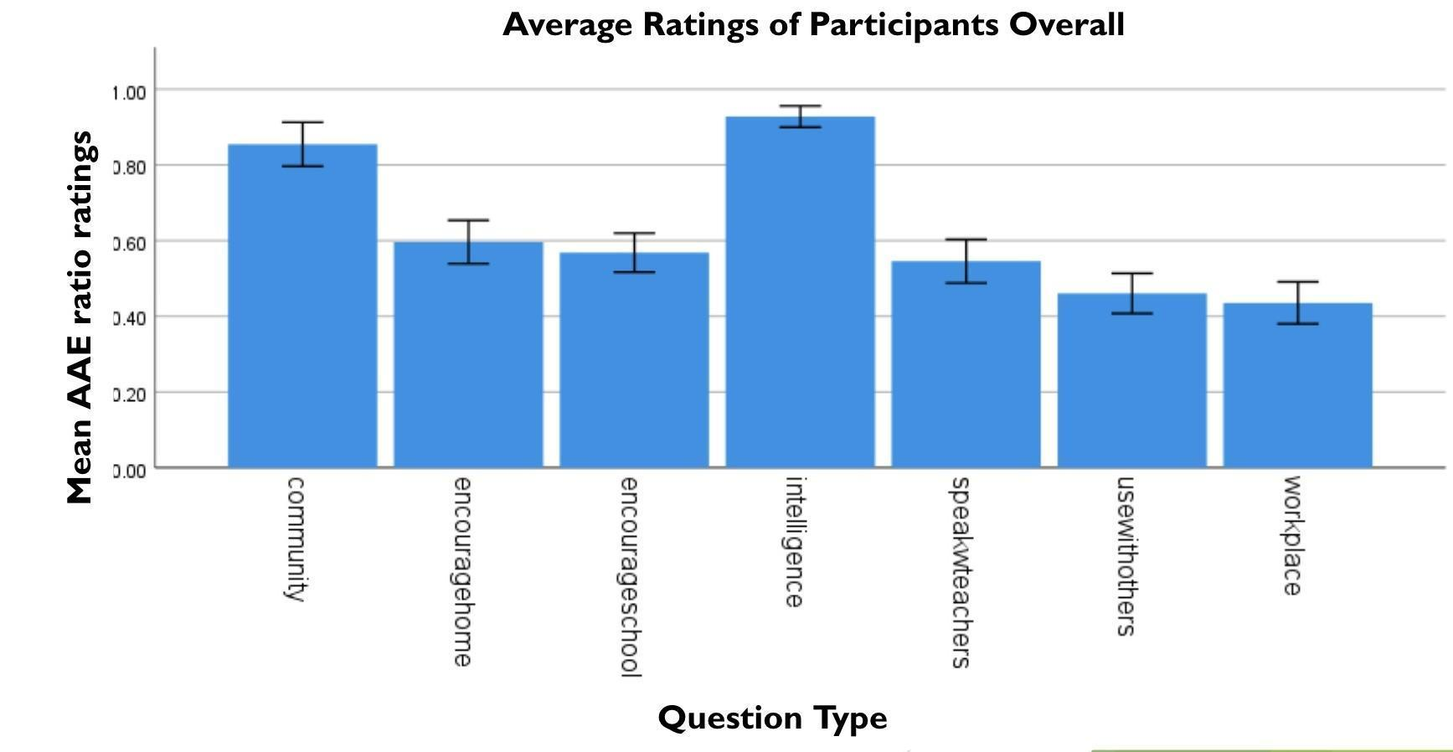

By race. A visual representation of the results was created (Figure 2) showing the mean responses per survey question for both groups. For both Black and non-Black participants, the average ratings were less than one, which implies that on average the ratings for GAE were higher than AAE. Even though there was no significant difference (see below), for all the questions Black participants rated AAE a little higher than non-Black participants. For example, for the question regarding intelligence of the speaker, while the ratios for both groups were less than 1, it was still close to 1 with the ratio for Black participants at 0.94 and non-Black participants at 0.91. Compared to non-Black participants, Black participants were significantly more likely to use AAE with others and in the workplace. In addition, both Black and non-Black participants nearly rated the likelihood of encouraging their child to speak AAE at school the same way, with Black participants having a mean of 0.571 and non-Black participants having a mean of 0.565. Since both ratios of the ratings are less than 1, both groups would almost equally encourage their child to speak GAE more at school. Overall the ratios of the ratings were less than 1, so both groups rated GAE higher than AAE.
To test for any significant differences in ratings of target dialects between the participants who identified as Black and those who were deemed non-Black based on their responses, a one-tailed Analysis of Variance (ANOVA) was conducted. When the independent variable was race, the results showed that for the majority of the questions, there was not a statistically significant difference between the two groups on how they rated each target dialect. The results revealed: for question 1: “How likely are you to use this dialect in your community?”, F(1, 26) = 0.14, p = 0.71; for question 2: “How likely are you to encourage your child to use the dialect at home?”, F(1, 26) = 0.47, p = 0.50; for question 3: “How likely are you to encourage your child to use this dialect at school?”, F(1, 26) = 0.003, p = 0.96; for question 4: “How intelligent do you believe this speaker is?”, F(1, 26) = 0.28, p = 0.60; for question 5: “How likely are you to encourage your child to speak this dialect with their teachers?”, F(1, 26) = 0.04, p = 0.85; question 6: “How likely are you to use this dialect with others?”, F(1, 26) = 3.54, p = 0.07; question 7: “How likely are you to use this dialect in the workplace?”, F(1, 26) = 2.39, p = 0.13 (all p-values > 0.05).

Figure 2. Average Rating of Participants by Race
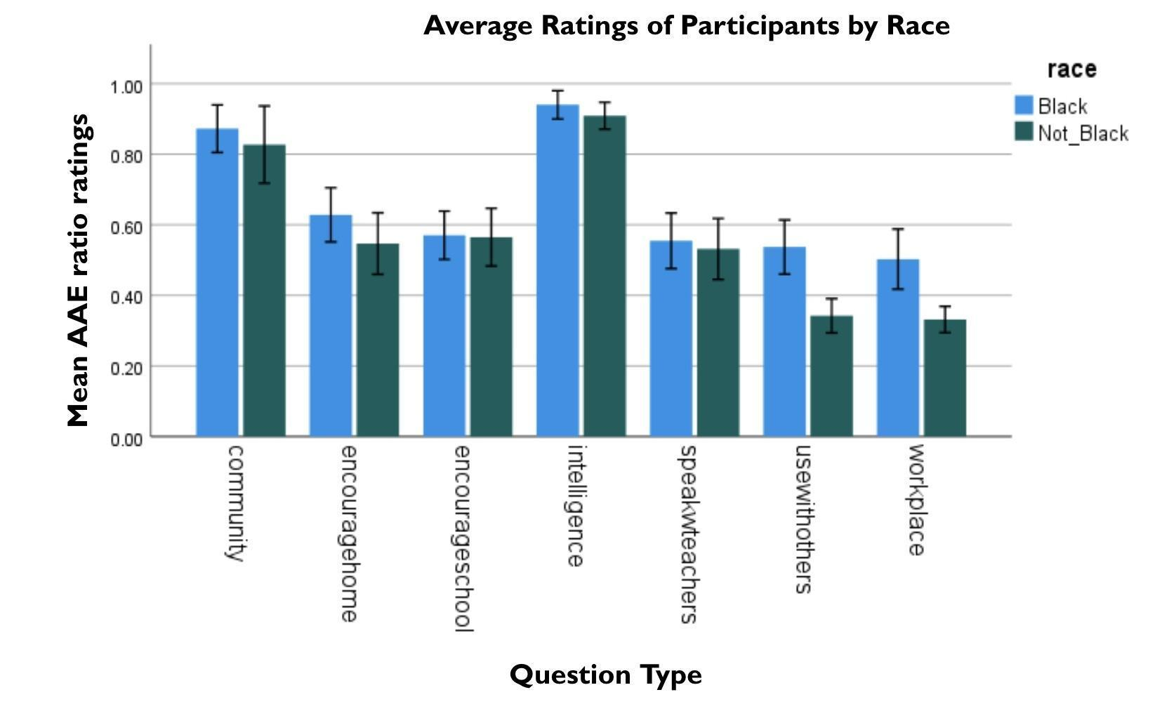

By dialect. A visual representation of the results was created (Figure 3) showing the mean responses per survey question for each group. For both AAE and non-AAE speaking participants, the average ratings were less than one, which implies that on average the ratings for GAE were higher than AAE for parents in both dialect groups. Even though for the majority of the questions there was no significant difference (see below), unlike the results when the independent variable was race, in this test for the majority of the questions non-AAE speakers rated AAE higher than AAE speakers. For example, for the question regarding likelihood of using AAE in the community, non-AAE speakers were more likely to use AAE in the community than AAE speakers. In addition, for the question regarding intelligence of the AAE-speakers, non-AAE speakers rated the AAE speaker’s intelligence higher than the AAE-speaking participants. While the ratios for both groups were less than 1, it was still close to 1 with the ratio for AAE participants at 0.84 and non-AAE participants at 0.96. For the questions regarding the likelihood of using AAE with others and in the workplace, AAE-speakers rated AAE higher than non-AAE speakers, indicating that AAE-speakers would be more likely to use AAE with others and in their workplace.
To test for significant differences in ratings of target dialects between the participants who identified as AAE-speaking and those who identified as non-AAE speaking, another one-tailed ANOVA was run. When the independent variable was ‘self-identifying dialect group’, the results showed that for all of the questions, there was not a statistically significant difference between the two groups on how they rated each target dialect. The results revealed: for question 1: “How likely are you to use this dialect in your community?”, F(1, 26) = 0.31, p = 0.58; for question 2: “How likely are you to encourage your child to use the dialect at home?”, F(1, 26) = 0.21, p = 0.65; for question 3: “How likely are you to encourage your child to use this dialect at school?”, F(1, 26) = 0.19, p = 0.66; for question 4: “How intelligent do you believe this speaker is?”, F(1, 26) = 3.28, p = 0.08; for question 5: “How likely are you to encourage your child to speak this dialect with their teachers?”, F(1, 26) = 1.07, p = 0.31; question 6: “How likely are you to use this dialect with others?”, F(1, 26) = 2.43, p = 0.13; question 7: “How likely are you to use this dialect in the workplace?”, F(1, 26) = 0.05, p = 0.83 (all p-values > 0.05).

Figure 3. Average Ratings of Participants by Dialect

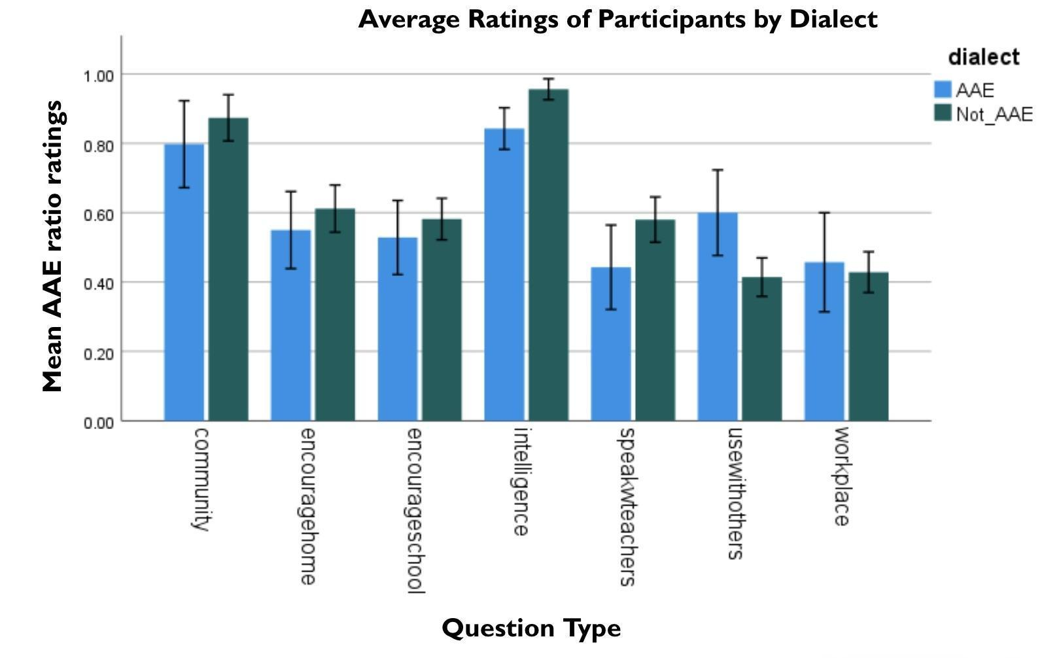

Research Question 2 – Qualitative analysis.
To address the second research question, “How do parents communicate their perspectives of AAE or GAE to their children?”, I coded parents' responses for relevant themes. Parents were asked four types of open-response questions: 1) how they would describe AAE or GAE to their child, 2) which dialect would they want their child to speak and why, 3) which dialect they feel is more appropriate for their child to speak, and 4) discuss whether they would want their child to be friends with an AAE or GAE speaker.
When parents were asked how they would describe GAE to their children, many parents described it as a professional and articulate dialect to use socially. For instance, one participant said “More of an educated dialect. Proper American English.” This is indicative of parents conveying more positive views of GAE to their children. However, this differed from how parents described AAE. Many parents described AAE as a dialect that should be used in informal settings due to its slang or country-like features. In particular, one parent said, “That is not really proper English, more of a slang”. It appears based on their descriptions that both Bidialectal and GAE only speaking parents describe AAE and GAE to their children similarly. This is aligned with their ratings of the dialect as the average ratings for perspectives towards AAE were mostly “unlikely” to use, whereas the average ratings for perspectives towards GAE were mostly “likely” to use.
When parents were asked which dialect they would want their child to speak and why, many parents reported preferring for their child to speak GAE. When asked to explain why, parents used words like “proper” and “clear” to justify their child speaking GAE. For instance, one participant said:

“#2 (GAE). This sounds proper and clear and I would want my children to speak clearly, so others could understand them.”

This is indicative of parents having more positive views of GAE to the point of preferring their children to use this dialect. Most parents said GAE was more appropriate because the use of it allowed for stronger communication and better reception from society. One participant said:

“Dialect 2 (GAE). There will be better reception from mainstream society with using this tone and enunciating words rather than slang and slurred speech. This is more formal to use with the public. The other you may use with your friends the same age. Dialect 1 (AAE) may seem disrespectful and threatening to people who do not talk that way.”

While most parents felt this way, there were few parents who reported preferring their child to be bidialectal. One participant said:

“I would want my child to be able to use both dialects depending on their surroundings.”

However, this does not align with their response to what dialect they would want their child to use which they indicated as GAE (dialect 2).
When parents were asked to discuss whether they would want their child to be friends with an AAE speaker, almost all the participants, regardless of what dialect they identified with speaking, encouraged their children to be friends with children of a variety of backgrounds. One participant said, “The Bible says by their fruits you will know them, it’s not about how you speak. The way you speak may indicate where you come from and not whether or not they would be a good friend.” This is indicative of parents not wanting to limit who their children’s friends are based solely on the way they speak. However, when parents were asked to discuss whether they would want their child to be friends with a GAE speaker, they were not as ambiguous or focused on ceasing judgment towards others. Many parents explained that they would want their child to be friends with GAE speakers because of how “clear” and “articulate” it sounds. A bidialectal participant said her reasoning for this choice is because her child would have “Exposure to proper formal speech.” This reasoning aligns with the ratings towards child use of GAE, but the reasoning that parents provided regarding AAE, does not align with their ratings towards child use of AAE.

Discussion
The study aimed to explore parent perspectives on a non-mainstream dialect, particularly AAE, and how these perspectives are communicated to their children. This discussion section addresses each research question in turn, evaluates the hypotheses, interprets the findings, and discusses their broader implications.
The first research question that this study addressed was, “What are parent perspectives on a non-mainstream dialect, particularly AAE?” It was hypothesized that the identifying dialect of the parent is predictive of the perspectives towards that dialect. This means that if a parent identifies as an AAE-speaker, they will be more likely to have a positive attitude towards AAE than a parent who identifies as a GAE-speaker. Contrary to our prediction, the results indicate that the identifying dialect of a parent was not predictive of their perspectives towards AAE. Despite identifying as AAE-speakers themselves, many parents expressed a preference for GAE over AAE for their children, citing perceptions of clarity, articulateness, and social acceptance associated with GAE. This preference for GAE over AAE suggests that AAE may be perceived as informal or less prestigious, leading parents to prioritize GAE for their children.
The results diverge from previous research, which has suggested a direct link between parental dialect identity and attitudes towards AAE, with some studies highlighting the role of cultural pride in shaping positive attitudes towards AAE among African American adults. These adults were encouraged to speak AAE within their households causing them to develop positive views towards AAE. This resulted in them feeling pride in speaking that dialect as their own sense of identity and as a way to preserve their culture (Clayton, 2015; Ogbu, 1999). In addition, these findings shed light on the impact of societal pressures and educational experiences on parental language preferences and practices. Previous literature showed that some African American adults reported being ridiculed and mocked in school for using AAE and others reported watching their educators inflict physical harm on children who used AAE (Ogbu, 1999; Speicher and McMahon, 1992). The discrepancy between parental dialect identity and preferences for their children's language use may reflect broader societal attitudes towards AAE and GAE. Parents' preference for GAE over AAE for their children may stem from perceptions of AAE as informal or less prestigious, reflecting broader patterns of linguistic discrimination and social inequality. Additionally, the desire for social acceptance and academic success may motivate parents to prioritize GAE, despite their own identification as AAE-speakers.
The second research question that this study addressed was, “How do parents communicate their perspectives of AAE or GAE to their children?” It was hypothesized that there was no difference between how parents communicate their views of AAE or GAE with their children. Our hypothesis was supported by the findings that indicated a preference for GAE over AAE. This finding was consistent with our initial hypothesis and aligns with previous research suggesting a societal preference for GAE over AAE in educational and professional settings. Adults who were discouraged from using AAE learned from those around them that AAE was an inferior dialect spoken by unintelligent people (Speicher and McMahon, 1992).
This finding was surprising because when parents were asked if they would let their child be friends with an AAE speaker, most parents stated they didn’t mind their kids being friends with AAE speakers and explained how they would encourage their child to have friends of a variety of backgrounds. However, these parents’ ways of thinking were contradicted when they were asked how they would describe AAE to their children. Parents generally used negative terms like slang or informal language to describe AAE, which are often how media and society describes AAE (Craig, 2014; Glasco, 2022). Meanwhile, parents described GAE as more articulate and professional. This finding may have occurred due to the social stigma of AAE and the negative implications it brings regarding job security and academic gain. Studies have shown that adults have experienced adverse responses to their use of non-mainstream dialects in school, resulting in ridicule or sometimes physical punishment (Ogbu, 1999; Speicher and McMahon, 1992). These results reflect parents’ desires for their child to be positioned in the best light to excel academically, financially, and in all aspects of their life with ease.
Understanding the dynamics between parents’ perspective on dialects and how they communicate them with their children is crucial for addressing biases and promoting inclusive attitudes towards all dialects and languages. This is important to investigate because the opinions that parents have towards languages and dialects shape the values that children learn about their own identities and linguistic diversity (Clayton, 2015; Díaz-Campos 2001, 2005). By recognizing the significance of parental perspectives on language, parents can foster a more inclusive linguistic environment for their children. They can actively challenge stereotypes and biases by embracing linguistic diversity and encourage open-mindedness towards different dialects. In addition, parents can promote language acceptance and pride in cultural heritage by providing opportunities for their children to learn and appreciate diverse linguistic traditions. Through these actions, parents can empower their children to navigate multiple social settings with confidence and respect, ultimately contributing to a more equitable society.
Limitations
There were two major limitations in this study. The first limitation was the sample size, which reduced our statistical power and limited the perspectives our survey captured. The patterns did not reach statistical significance because the smaller sample size increased the variability of the data. This could have led to a higher probability of chance instead of genuine effects within the data. Another limitation is that the participants that were recruited were from the Washington, DC, Maryland and Virginia area which typically is more affluent. This is shown in the majority of the participants being in the $100,000 - $200,000 income range. Since the use of non-mainstream dialects can be closely tied to SES (Horton-Ikard & Miller 2004), this may have limited the perspectives gathered from my sample. Only interviewing parents with a higher SES provided an issue for generalizability because it fails to capture linguistic behaviors from individuals with more diverse SES backgrounds. For example, the study does not gauge the perspectives of AAE from individuals that have lower incomes.
Lastly, our interview was only administered to families in the Washington, D.C., Maryland, and Virginia (DMV) area. Surveying parents from other regions of the United States may add more diversity to the thoughts and perspectives captured in the survey. To address these limitations future studies should use a larger and more diverse sample of parents across the nation to test if the same claims from this study hold true. Given that the survey exclusively interviewed parents from the DMV, it fails to capture linguistic attitudes from parents in other geographical locations. This limitation impedes the generalizability of the results, as regional differences, such as those in the southern region of America, may create varied perspectives on AAE due to diverse personal experiences and exposures.
Conclusion
This study sheds light on the interaction between parents' perspective, language attitudes, and cultural identity. By looking at how parents’ perspectives align with how they discuss AAE and GAE, we were able to highlight the potential power that familial conversations may have in shaping language attitudes and cultural identity. Future research should interview young adults about their experiences with non-mainstream dialects, current language ideologies, and explore what their parents and teachers taught them about dialect use. This will provide direct insight on how parents' ideals on linguistic diversity shape what their child thinks. In the future, researchers should also consider asking parents whether or not they code-switch after explaining that concept and also consider providing an additional response of “both” for the question regarding which dialect they feel is more appropriate for their child to speak and why. This would expose how parents navigate between different linguistic contexts and may provide insights into their attitudes towards linguistic diversity and cultural identity. Additionally, incorporating a "both" response option for the preference question would allow parents to express their support for bidialectalism, acknowledging the value of both AAE and GAE in different settings. This nuanced approach could offer a more comprehensive understanding of parental perspectives on dialects and their implications for children's language development and social interactions.
The results of this study highlight the urgent need to explore how societal stereotypes and biases of non-mainstream dialects not only impact adults, but also impact how these ideals are passed down to their children. Changes in societal views occur incrementally with each generation; therefore, if our goal as a society is to embrace linguistic diversity, we have to start by changing the ideals we teach our children. By teaching children to embrace dialect variation, it furthers the work of challenging the stereotypes and biases that fuel language stigmas, and works towards a society where all languages and dialects are not just tolerated, but celebrated.

References
- Arua, A. E., & Magocha, K. (2002). Patterns of language use and language preference of some children and their parents in Botswana. Journal of multilingual and multicultural development, 23(6), 449-461.
- Baker-Bell, A. (2013). “I never really knew the history behind African American language”: Critical language pedagogy in an advanced placement English language arts class. Equity & Excellence in Education, 46(3), 355-370.
- Baker-Bell, A. (2020). Linguistic justice: Black language, literacy, identity, and pedagogy. Routledge.
- Ball, A. F. (1996). Expository writing patterns of African American students. The English Journal, 85(1), 27-36.
- Becker, C., Davidov. E., Cieciuch, J., Algesheimer, R., Kindschi, M. (2020). Measuring school children’s attitudes toward immigrants in Switzerland and Poland. Journal of Measurement Instruments for the Social Sciences, 9(2), 1-14.
- Becker, K. (2014). Linguistic repertoire and ethnic identity in New York City. Language & Communication, 35, 43-54.
- Behizadeh, N. (2017). " Everybody Have Their Own Ways of Talking": Designing Writing Instruction That Honors Linguistic Diversity. Voices from the Middle, 24(3), 56.
- Beneke, M., & Cheatham, G. A. (2015). Speaking up for African American English: Equity and inclusion in early childhood settings. Early Childhood Education Journal, 43, 127-134.
- Brown, M. C., Sibley, D. E., Washington, J. A., Rogers, T. T., Edwards, J. R., MacDonald, M. C., & Seidenberg, M. S. (2015). Impact of dialect use on a basic component of learning to read.Frontiers in Psychology, 6(196), 1–17. https://doi.org/10.3389/fpsyg.2015.00196
- Bühler, J. C., Waßmann, F., Buser, D., Zumberi, F., & Maurer, U. (2017). Neural processes associated with vocabulary and vowel-length differences in a dialect: An ERP study in pre-literate children. Brain topography, 30, 610-628.
- Byrd, A. S., & Brown, J. A. (2021). An interprofessional approach to dialect-shifting instruction for early elementary school students. Language, Speech, and Hearing Services in Schools, 52(1), 139-148.
- Byrd, A.S., Maher, Z., Hunag, YT, Edwards, J, (2022). Development and Evaluation of a Dialect Experience Questionnaire. Poster presentation at Linguistic Society of America.
- Charity, A. H., Scarborough, H. S., & Griffin, D. (2004). Familiarity with “school English” in African-American children and its relation to early reading achievement. Child Development, 75(5), 1340–1356. https://doi.org/10.1111/j.1467-8624.2004.00744.x
- Clayton, D. (2015). The negotiation of language in college settings.
- Clayton, D. M. (2018). Language, race and space: What it means to be a speaker of African American English in higher education spaces.
- Craig, C. (2014). Speaking from Different Positions: Framing African American College Male Literacies as Institutional Critique. In Composition Forum (Vol. 30). Association of Teachers of Advanced Composition.
- Craig, H. K., & Grogger, J. T. (2012). Influences of social and style variables on adult usage of African American English features.
- Craig, H. K., & Washington, J. A. (2006). Malik goes to school:Examining the language skills of African American students from preschool–5th grade. Psychology Press. https://doi.org/10.4324/9781410615602
- Craig, H. K., Zhang, L., Hensel, S., & Quinn, E. (2009). African American English-speaking students: An examination of the relationship between dialect shifting and reading outcomes. Journal of Speech, Language, and Hearing Research, 52(4), 839–839. https://doi.org/10.1044/1092-4388(2009/08-0056)
- Díaz-Campos MA. 2001. Acquisition of phonological structure and sociolinguistic variables: a quantitative analysis of Spanish consonant weakening in Venezuelan children's speech. PhD Diss., Ohio State Univ., Columbus
- Díaz-Campos MA. 2005. The emergence of adult-like command of sociolinguistic variables: a study of consonant weakening in Spanish-speaking children. In Selected Proceedings of the 6th Conference on the Acquisition of Spanish and Portuguese as First and Second Languages, ed. D Eddington, pp. 56–65. Somerville, MA: Cascadilla
- Diehm, E. A., & Hendricks, A. E. (2021). Teachers' content knowledge and pedagogical beliefs regarding the use of African American English. Language, Speech, and Hearing Services in Schools, 52(1), 100-117.
- Dossey, E., Clopper, C.G., Wagner, L. (2020). The Development of Sociolinguistic Competence across the Lifespan: Three Domains of Regional Dialect Perception. Journal of Language Learning and Development, 1-22
- Edwards, J. R., & Rosin, P. (2016). A prekindergarten curriculum supplement for enhancing mainstream American English knowledge in non-mainstream American English speakers. Language,Speech, and Hearing Services in Schools, 47(2), 113–122. https:// doi.org/10.1044/2015_LSHSS-15-0011
- Flores, N., & Rosa, J. (2015). Undoing appropriateness: Raciolinguistic ideologies and language diversity in education. Harvard educational review, 85(2), 149-171.
- Foster, M., & Peele, T. (1999). Teaching and learning in the contexts of African American English and culture. Education and Urban Society, 31(2), 177-189.
- Friend, C. A., Hunter, A. G., & Fletcher, A. C. (2011). Parental racial socialization and the academic achievement of African American children: A cultural-ecological approach. Journal of African American Studies, 15, 40-57.
- Glasco, G. L. (2022). African American English as a Predictor of Ethnic and Ethnolinguistic Identity in Adolescence.
- Green, L. (2002). Speech events and rules of interaction in AAE. African American English: A linguistic introduction.
- Gupta, A. (2010). African-American English: Teacher beliefs, teacher needs and teacher preparation programs. Reading Matrix: An International Online Journal, 10(2).
- Hankerson, S. (2022). “Why can’t writing courses be taught like this fo real”: Leveraging critical language awareness to promote African American Language speakers’ writing skills. Journal of Second Language Writing, 58, 100919.
- Hankerson, S. (2023). “The World Has to Stop Discriminating Against African American Language”(AAL): Exploring the Language Ideologies of AAL-Speaking Students in College Writing. Written Communication, 40(2), 587-619.
- Hoover, M. R. (1978). Community attitudes toward black english. Language in Society, 7(1), 65-87.
- Horton-Ikard, R., & Miller, J. F. (2004). It is not just the poor kids: The use of AAE forms by African-American school-aged children from middle SES communities. Journal of communication disorders, 37(6), 467-487.
- Johnson EK, White KS. 2020. Developmental sociolinguistics: children's acquisition of language variation. WIREs Cogn. Sci. 11(1):e1515
- Jonsberg, S. D. (2001). What's a (White) teacher to do about Black English?. The English Journal, 90(4), 51-53.
- Koch, L. M., & Gross, A. (1997). Children's perceptions of Black English as a variable in intraracial perception. Journal of Black Psychology, 23(3), 215-226.
- Lanehart, S. (Ed.). (2015). The Oxford Handbook of African American Language. Oxford University Press.
- Lewis, T. L. (2015). Exploring Children's Perceptions of African American English.
- McCullough, E.A., Clopper, C.G., Wagner, L. (2019). The Development of Regional Dialect Locality Judgments and Language Attitudes Across the Life Span. Journal of Child Development, 90(4), 1080-1096.
- Molett, M. (2013). Academic and cultural bias in the classroom: A qualitative examination of the overrepresentation of African American students in special education. McNair scholars research journal, 6(1), 8.
- Mosty, N. L., Lefever, S., & Ragnarsdóttir, H. (2013). Parents’ perspectives towards home language and bilingual development of preschool children.
- Murdock-Perriera, L. A. (2019). How Teacher-Student Interactions about Language Use Shape Elementary Students’ Experiences of Belonging. Stanford University.
- Ogbu, J. U. (1999). Beyond language: Ebonics, proper English, and identity in a Black-American speech community. American Educational Research Journal, 36(2), 147-184.
- Piller, I., & Gerber, L. (2018). Family language policy between the bilingual advantage and the monolingual mindset. International Journal of Bilingual Education and Bilingualism.
- Smith J, Durham M, Fortune L. 2007. “Mam, my trousers is fa'in doon!”: Community, caregiver, and child in the acquisition of variation in a Scottish dialect. Lang. Var. Change 19(1):63–99
- Smith J, Durham M, Richards H. 2013. The social and linguistic in the acquisition of sociolinguistic norms: caregivers, children, and variation. Linguistics 51(2):285–324
- Speicher, B. L., & McMahon, S. M. (1992). Some African-American perspectives on Black English vernacular1. Language in Society, 21(3), 383-407.
- Rickford, J., & Price, M. (2013). Girlz II women: Age‐grading, language change and stylistic variation. Journal of Sociolinguistics, 17(2), 143-179.
- ​​Van Hofwegen, J., & Wolfram, W. (2010). Coming of age in African American English: A longitudinal study 1. Journal of Sociolinguistics, 14(4), 427-455.
- Washington, J. A., Branum-Martin, L., Sun, C., & Lee-James, R.(2018). The impact of dialect density on the growth of language and reading in African American children. Language, Speech,and Hearing Services in Schools, 49(2), 232–247. https://doi.org/10.1044/2018_LSHSS-17-0063
- Weldon, T. L. (2021). Middle-class African American English. Cambridge University Press.
- Worthy, J., & Rodríguez-Galindo, A. (2006). “Mi hija vale dos personas”: Latino immigrant parents' perspectives about their children's bilingualism. Bilingual Research Journal, 30(2), 579-601.

