Relations between Memory Measures and Hippocampal Volumes in Early Childhood
Carli Fine
University of Maryland, College Park
Psychology Honors Thesis

Advisory Committee:
Dr. Tracy Riggins
Dr. Anna Li
Dr. Elizabeth Redcay

Author Note: Special thanks to Kelsey Canada for editing and assistance.
Abstract
The phenomenon of childhood amnesia, in which only a mere fraction of childhood experiences is remembered, may be due to changes in the underlying neural mechanisms supporting memory. However, this assumption is largely based on measures of memory from lab-based tasks, which show relations with specific brain areas. It is unclear whether tasks in the lab used to measure childhood memory skills map onto children’s memory for experiences in everyday life. This study aimed to address this gap by investigating the potential relation between two different tasks completed by 200 4- to 8-year-old children. Specifically, children completed both a rich, open-ended autobiographical interview examining children’s recall for real-world events, and a controlled, laboratory-based assessment that examines children’s memory for temporal order. This study assessed whether both/either tasks show 1) age-related differences, 2) relations to each other, and 3) relations to the volume of the hippocampus, a neural structure thought to be critical for memory. Results indicated that performance on both tasks show positive age-related differences, and relations to each other. However, neither task was related to the hippocampus. Overall, this work contributes new knowledge regarding memory development by examining the extent to which naturalistic versus laboratory-based tasks similarly measure children’s developing memory abilities, and suggests important avenues of future research.

Relations between Memory Measures and Hippocampal Volumes in Early Childhood
Memory creates a narrative sense of self, which provides continuity for an individual’s conscious experience. However, most individuals’ first memories from before the ages of 3 or 4 years old are completely inaccessible, a phenomenon known as childhood amnesia. It was initially thought that children were incapable of forming new memories before the age of around five years, but research in the lab and experiences in the real-world have proven that this is simply not true (i.e. Pillemer & White, 1989). Rather, children’s newly formed memories are less stable than those of adults over time, with memories formed earlier in development more easily forgotten (Peterson, Hallett, and Compton-Gillingham, 2017). As a period of dramatic improvement in the durability of memory, early childhood is a key stage of interest for studying memory development.
Memory is not monolithic. Instead, there are different forms of conscious mnemonic experience: short-term working memory (repeating an address to remember it), episodic memory (memory for events, like a birthday party), and semantic memory (memory for facts, like a capital city). Episodic details, in particular, require mental time travel and undergo the greatest developmental change (Bauer & Larkina, 2016). In addition to the re-experiencing of events through mental time travel, called autonoetic recall, episodic memory encompasses the contextual background of such experiences (i.e. spatiotemporal details) (Tulving, 2002). In early childhood, substantial improvement is observed both in the ability to think in an autonoetic way as well as to retrieve contextual details (Perner & Ruffman, 1995).
On account of its heterogeneity, a variety of paradigms have been employed to measure episodic memory throughout the lifespan. The approach of using different tasks is, in part, intended to provide measurement specificity. Additionally, various memory constructs may be supported by different structures, and in some contexts, multiple measures may assist in probing different brain regions implicated in supporting memory (Bauer, Pathman, Inman, Campanella, & Hamann, 2017). Moreover, different tasks each have their benefits and drawbacks; while lab-based tasks are easier to control, administer, and score, open-ended paradigms including interviews for autobiographical memory are richer and real-world oriented. However, studies are typically conducted using a single task, meaning different tasks are typically examined separately, and little is known about the relation between performances on various tasks undertaken by the same participants. It is unknown the extent to which tasks used to measure childhood episodic memory development in the lab map onto what children experience in everyday life. Consequently, a gap exists in our understanding of the extent to which naturalistic versus laboratory-based paradigms similarly measure the critical ability of episodic memory. This is particularly consequential in early childhood given that this is when memory subtypes are each developing, and, likely, specializing.
The current study aimed to address this gap through an investigation of two different episodic memory tasks in a large sample of typically-developing children during early- to mid-childhood. One task is a rich, open-ended autobiographical interview examining children’s recall for real-world events; the other a controlled, laboratory-based assessment that examines children’s memory for temporal order using a series of child-appropriate pictures. To further examine similarities and differences between the tasks, we thought it was important to probe their underlying biological bases. Thus, we examined whether either or both related to hippocampal volume, the most likely structure implicated in supporting performance of episodic memory on both tasks.

Autobiographical Memory
Autobiographical memory refers to recollections of personal experiences and events and has been shown to improve dramatically across early childhood. There are several possible conceptualizations of the relation between autobiographical memory and episodic memory. Some explain episodic memory as an umbrella ability supporting the recall of past events, and describe autobiographical memories as specific events that are highly emotional and personal (e.g. Pathman, Samson, Dugas, Cabeza & Bauer, 2011). Others think of autobiographical memory as the umbrella ability for experiences related to the self, comprised of details involving semantic knowledge and episodic time-travel (e.g. Willoughby, Desroacher, Levine, & Rovet, 2012). In general, although the distinction between episodic and autobiographical memory is rather complicated, for the purposes of event-retelling, this report will use language more closely aligned with the latter: autobiographical events contain both episodic and semantic memory details.
The field of declarative memory research has long sought to understand and characterize the phenomena of childhood amnesia, starting with establishing the average age of one’s first memory (Rubin, 2000). As investigation turned to the content of those memories, it became evident that autobiographical retellings grow richer and more detailed as they become more stabilized for the long-term (Pillemer & White, 1989). Changes in the autobiographical memory system have also been shown to be linked to the maturation of the physical brain, in regions such as the hippocampus (i.e. Willoughby et al., 2012; Bauer et al., 2017).
Autobiographical memory is tested through open-ended paradigms that enable rich, personal experiences. Though the interviews are harder to standardize across subjects, they bring a personal element to the laboratory setting, which aligns more closely to real-life experience. Autobiographical memory interviews differ from many other laboratory memory tasks because they allow for personalization (i.e. asking a child about a specific past event in their life), but are also more difficult to control. For example, the nature of the testing paradigm necessarily introduces the element of verbal development and language exposure (Fivush & Nelson, 2004), creating some barriers to interpreting the absence of a memory, as opposed to a mere inability to verbally express one’s memory. Though little research bridges the extremes of personalization versus control (see Cabeza et al., 2004), autobiographical memory is uniquely positioned for making such comparison with other episodic paradigms.
Temporal Order Memory
Memory for temporal order is the ability to place items in the correct chronological sequence, and is central to contextualizing when events take place within a memory (Tulving, 2002). The NIH Toolbox, which is intended to serve as a comprehensive battery of low-cost yet highly reliable testing materials for widespread diagnostic use of neurological and behavioral functions, has even included a paradigm for testing temporal ordering in the lab as a measure of episodic memory (Bauer et al., 2013). Memory for temporal order underlies the ability to sequence events within a narrative, and is therefore strongly related to memory storytelling.
This type of memory also displays age-related improvements, which are related to the brain. Although infants exhibit the capacity to remember the ordering of actions (Bauer et al., 2000), it is well-known that temporal memory capacities improve during development and especially early childhood (Canada, Pathman, & Riggins, 2020). Moreover, the hippocampus is thought to contribute to memory for sequence information in adults (DeVito & Eichenbaum, 2011).
Temporal order memory is tested via close-ended paradigms that provide clear, specific parameters for children to demonstrate their skills nonverbally. Since the resulting data is immediately produced in the form of numerical output (counts and percentages as opposed to autobiographical interview transcripts that must next undergo scoring), temporal order memory is widely applicable and facilitates comparison across subjects of different age groups and stages of verbal development. In addition to simple primacy tasks, in which children are asked which of two events happened first, temporal order memory can also be tested for sequences of multiple events. This ability to generate the sequence of events may underlie storytelling skills required in the recollection of real-life narratives (Bauer et al., 2000). However, the specific relations between temporal order and autobiographical memory remain largely uncharted.
Hippocampus

The hippocampus is a brain structure named for its constitutional resemblance to a seahorse and is well-known for its relations to learning and memory. The hippocampus is a likely candidate brain structure underlying behavioral changes in episodic memory during early childhood because it is shown to support memory in school-aged children and adults (Ghetti & Bunge, 2012) and undergoes significant development during early childhood (Gogtay et al., 2006; Lavenex & Banta Lavenex, 2013). This bilateral structure in the medial temporal lobe is functionally heterogeneous and comprised of various subfields (e.g. dentate gyrus, thought to be one of the few sites of adult neurogenesis). The hippocampus can also be viewed as consisting of three anatomical subregions along its longitudinal axis: the head, body, and tail (e.g. Poppenk, Evensmoen, Moscovitch, & Nadel, 2013). Theories regarding specialization along the longitudinal axis of the hippocampus suggest that both structural connections between hippocampal subregions and the cortex, and the uneven distribution of subfields within each subregion likely facilitate the differing contributions of the subregions to learning and memory. For example, it has been proposed that the anterior hippocampus (i.e. head) supports coarse, global relations, while the posterior hippocampus (i.e. body/tail) supports fine-grained, local representations (Poppenk et al., 2013). As noted above, the hippocampus undergoes protracted development, and is later developing than many other neural structures. Further, hippocampal subregions mature at differing rates (Gogtay et al., 2006; Riggins et al., 2018). Therefore, this study explores the potential relations between memory tasks and hippocampal subregions: head, body, tail.
Goals and Hypotheses
This study asked whether both the autobiographical memory and temporal ordering tasks show 1) age-related differences, 2) relations between tasks, and 3) relations to the hippocampus, a neural structure thought to be critical for memory. Firstly, it was hypothesized that both the real-world autobiographical memory task and the lab-based temporal order task would show age-related differences in performance, such that older children would outperform younger children on both tasks. Secondly, it was hypothesized that the lab-based and real-world memory task performance would relate to each other, such that children who performed well on the temporal order task would also perform well on the autobiographical memory task. Finally, it was hypothesized that lab-based and real-world measures of memory would relate to the volume of the hippocampus, likely to the same subregions.
Methods
Participants
Subjects participated in a larger NIH-funded research project examining the development of hippocampal memory networks, which included a battery of cognitive tasks and neuroimaging measures. All methods administered by the Neurocognitive Development Lab were approved by the Institutional Review Board at the University of Maryland prior to data collection. This report examines relations between age and memory scores for two different behavioral tasks and neural data derived from structural MRI scans.
Subjects were 4- to 8-year-old children recruited through the Infant and Child Studies Consortium, a university-maintained database of local families, as well as through flyers in local schools. Preliminary exclusion criteria included screening for a history of developmental disabilities, developmental delays, or neurological conditions as reported by parents. Subjects were all native English speakers, had normal or corrected-to-normal vision, and were born full-term. Since subjects were below 18 years of age, informed consent was obtained from parents or legal guardians. Additionally, written assent was also obtained from children 7 years of age and older, and oral assent from younger children. Families received monetary compensation and a small prize at each visit for their study participation.
A total of 200 participants aged 4-8 years old were recruited for the study. Of these, 191 participants contributed data for autobiographical interviews, 199 participants for the temporal order task, and 177 participants for MRI scans. One subject (n = 1) did not provide usable data for any task due to uncooperativeness. Thus, this report includes data from 199 total participants (100 reported females, M = 6.17 years, SD = 1.52 years). For the autobiographical memory task, additional data were excluded due to failure to complete the autobiographical memory task (n = 3) or lack of task audio recordings (n = 5), which were due to a combination of uncooperativeness and experimenter error. There was also an outlier (n = 1) who scored well over 3 SDs above the mean and was also excluded. For neural analyses, additional data were excluded due to children not completing an MRI scan (n = 9), because of shyness or claustrophobia, or due to unusable scans, typically on account of too much motion in the scanner (n = 22).
Materials and Procedures
Subjects participated in three different sessions that occurred in approximately one-week intervals. Behavioral performance for both memory tasks was recorded at participants’ first visit. Age refers to participants’ age at this first visit. Neural data were collected from the second visit approximately one week later.
Autobiographical Memory Interviews. Subjects underwent an Autobiographical Memory Interview (AMI) with three phases of questioning on recent events in their life: Free Recall, Prompted Recall, and Specific Probes (adapted from Levine, Svoboda, Hay, Winocur, & Moscovitch, 2002; Figure 1). Parents provided two recent events in their child’s life that were unique, discrete occurrences (i.e. your last birthday party, trip to Disney World, Girl Scouts’ bridging ceremony). For each event, two prompting details were also provided.

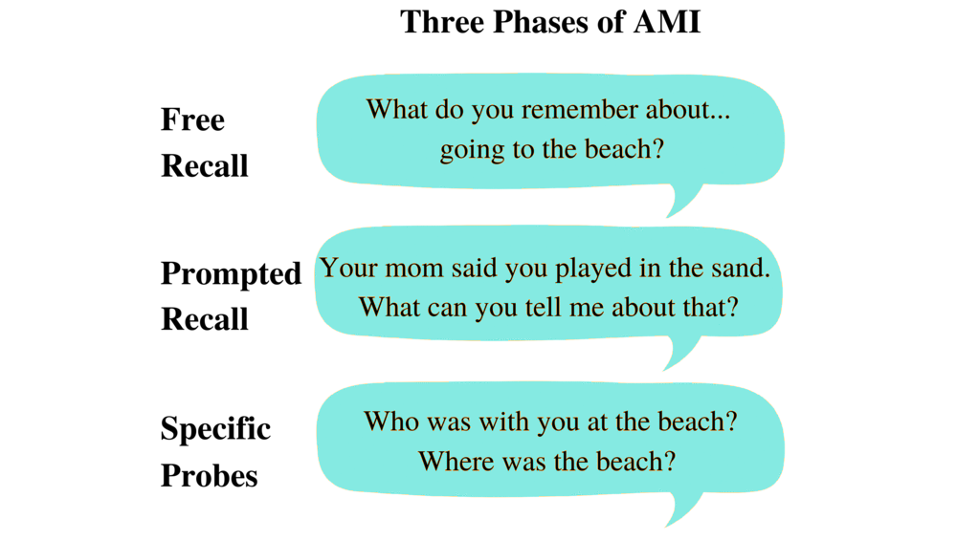
Figure 1. Example of the experimental format for the AMI, with three distinct phases.

Autobiographical memory reports were collected using standard AMI procedures. First, children were presented with the event title and asked to recall their memories using a general prompt (i.e. “What do you remember about going to the beach? Can you tell me everything you can remember about going to the beach?”). If children could not identify the event from the title alone, one of the two prompting details was delivered as an event clarifier. During the Free Recall section, experimenters were instructed to provide as little detail as possible and to demonstrate active listening skills through the concise repetition or summarization of the information given and encouragement (i.e. “You said you went in the ocean. What else?”, “Can you tell me more about that?”). After the child expressed an inability to remember any further details, the experimenter would commence the Prompted Recall section by delivering one of the two prompting details (i.e. “Your mom also told me that when you went to the beach, you played in the sand. Do you remember playing in the sand? What can you tell me about that?”). The Prompted Recall section was skipped if both details were already used by the experimenter as event clarifiers or spontaneously produced by the child. After expressing an inability to remember any further details, the experimenter would commence the Specific Probes section by asking a series of “Wh-” questions about the overall event, including Who, When, Where, Why, and How (i.e. “Who all was there with you at the beach? When did you go to the beach? Where was the beach? Why did you go to the beach? How did you feel when you went to the beach?”). This progressive questioning method served to minimize disparities in memory recall due to factors other than not remembering. Before moving onto the next event, the experimenter would once again affirm whether the child had any other details that they would like to add. Then, the procedure was repeated with the second event.
Prior research has indicated that the Mean Length of Utterance (MLU) is significantly related to age and can be used as a measure of grammatical development (Miller & Chapman, 1981). Thus, in this study, this measure of the number of speech units per phrase served as a proxy for verbal production skills. Child Language Analysis (CLAN) software was used to transcribe AMI audio records, and to calculate MLU (MacWhinney, 2000). MLU was calculated as the average of the number of morphemes per utterance for measuring linguistic productivity.
Details were scored used a modified version of the Autobiographical Interview Scoring Manual (Levine et al., 2002). This scoring is characterized by the division of event internal (episodic) from event external (semantic) details. Event internal details are those that necessarily require autonoetic mental time travel to access, such as events/actions, emotions/thoughts, perceptions, times, and places. Event external details are those that do not necessarily require the use of mental time travel to access, such as facts, repetitions, and comments on the recollection process. A key modification to the coding procedure included an additional classification of episodic time and place details as fine- or course-grained, and semantic time details as generally semantic or a date/time, due to hypotheses of hippocampal longitudinal axis specialization (Poppenk et al., 2013), which will be explored in future research. Thus, coding of time details entailed four different classes: Episodic time details internal to the event included course-grained event placements (i.e., the month of the event, recently versus a long time ago) and/or fine-grained details such as ordering or duration of details within the event (i.e., first/next/then, “we stood in line for X minutes”). Semantic time details included coarse-grained events such as general holidays (i.e., Christmas) or fine-grained details such as dates, days of the week, and clock numbers (i.e., March 16th, Monday, 10:05 am).

Table 1.
Difference between Episodic and Semantic Details
Examples of  Memory Details | Episodic  (Event Internal) | Semantic  (Event External)
Course-grained | month of the event,  recently versus a long time ago | Christmas
Fine-grained | first/next/then,  “we stood in line for X minutes” | March 16th, Monday, 10:05 am
Note. Event internal details necessarily require mental time travel.

Transcripts were coded using General Architecture for Text Engineering (GATE) software to tag and tally details in a more visual and automated manner (Cunningham, Maynard, & Bontcheva, 2011; Cunningham, et al., 2011; Figure 2). Event-internal details from all categories were summed across the three interview phases for both events to obtain a measure of total episodic details. This was done to operationalize general episodic memory abilities during autobiographical recall, providing children with maximum opportunity to demonstrate their capabilities. Event-internal time-related details were collapsed across the course- and fine-grained details and summed across all interview phases for both events to obtain a measure of total temporal details. This was done to explore the smaller subset of temporal details that have the potential to be more conceptually related to temporal order. Semantic time details were excluded to derive a measure of episodic skill rather than general time knowledge.

Free Recall Start
Event
Location (Coarse-Grained)
Emotion
Repetition

*RSR: what can you tell me about
your first rock concert ?
*CHI: I saw Heart .
*CHI: it was at Wolftrap .
*CHI: really &-um really far away .
*CHI: but it was fun .
*CHI: a lot of fun .

Figure 2. Example of the detail tagging scheme in GATE. RSR = Researcher, CHI = Child.

Temporal order task. Subjects completed a behavioral task for temporal order, in which they ordered sequences of child-appropriate illustrations on laminated index cards. Illustration sets contained three different settings (Park, Fair, Pet Shop), each with nine thematically relevant images, plus one practice setting (Yard) with four thematically relevant images. Children were first presented with the practice set and then presented with two out of three randomly assigned experimental sets in counter-balanced order.
First, before viewing the cards, children were presented with the event theme (i.e. “Now I’m going to show you what I do at the fair.”). Next, the experimenter named each card (i.e. “ride the pony”) while laying it out in a V shape across from the child (Figure 3A). Besides picture order, experimenters did not provide any temporal aids, such as verbalizing sequential language (i.e. “first/next/then”). Before shuffling the cards and asking the child to recreate the sequence, the experimenter repeated the event theme (i.e. “That’s what I do at the fair.”). Then, children were asked to take the cards and place them into the correct sequence order to the best of their ability (Figure 3B).

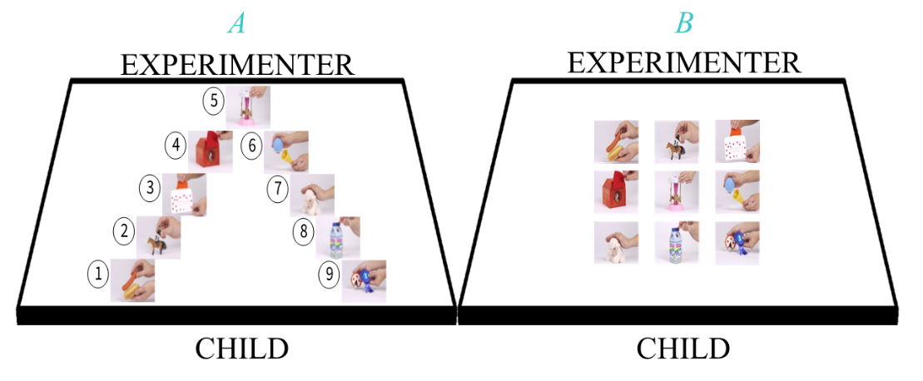
Figure 3. Depiction of the experimental set-up of one of the 9-item sequences (Fair). A) The set-up at the time of encoding, as the experimenter discussed the order. Notably, children were not shown any numbers. B) Example of the set-up at the time of retrieval, after being shuffled and placed in random order face-up for children to reproduce the sequence. Reprinted from Canada et al., 2020 with permission.

Notably, for one of the lists for each subject, an age-appropriate distractor (i.e. tic-tac-toe) was employed randomly for approximately one-minute before the delayed recall. This was performed to investigate the effects of working memory on task performance. This manipulation did not impact performance (Canada, Pathman, & Riggins, 2020), and thus was not considered further.
Scoring was determined by the proportion of sequentially adjacent pairs reconstructed, meaning items were both next to each other in the initial sequence and in the correct order (i.e. Item 3 before Item 4). There were 8 possible pairs in each list, and scores were collapsed across the two lists for all adjacent pairs, a proportion correct out of 16, listed in decimal form to the nearest hundredths place.
MRI acquisition. Participants underwent training in a mock MRI scanner, and then real-time motion feedback in an MRI machine before structural image scanning took place. A Siemens 3.0-T scanner (MAGNETOM Trio Tim System, Siemens Medical Solutions, Malvern, PA) with a 32-channel coil was used to acquire T-1 weighted structural MRI scans with standard parameters (.9 mm³). T1 images were reconstructed and segmented using Freesurfer version 5.1 (FSL; surfer.nmr.mgh.harvard.edu) and Automatic Segmentation Adapter Tool (ASAT; PA, 2011), which are standard automatization programs tantamount to manual segmentation (Fischl, 2012). The hippocampus was divided into head, body, and tail subregions using standard anatomical landmarks (Riggins et al., 2018; Weiss, Dewitt, Goff, Ditman, & Heckers, 2005) (Figure 4). Hippocampal volumes were all adjusted for Intracranial Volume (ICV) derived from Freesurfer and adjusted with ASAT to account for age-related overall head size and total volumetric differences (Raz et al., 2005; see Riggins et al., 2018). Various manual quality assurance checks were performed, such as the exclusion of skull and dura mater from the inside the pial boundary for intracranial volume calculations. In this study, ICV-adjusted subregion hippocampal volumes were collapsed across the left and right hemispheres in initial analyses of bilateral subregion relations to memory performance. Subsequently, exploratory analyses examined potential hemispheric-specific relations between memory performance and ICV-adjusted hippocampal subregion volumes.

Figure 4. Depiction of the divisions of hippocampal anatomical subregions along the long-axis. Reprinted with permission from Riggins, Blankenship, Mulligan, Rice, & Redcay, 2015.
Statistical Analyses
Transformations. Tasks were initially scored with different scales. Specifically, the AMI was scored using unlimited counts and the ordering task using proportions. Consequently, because of the different initial scales, scores on both tasks were standardized using Z-score transformations. To test the relations between naturalistic and laboratory-based memory task performance in early childhood, all correlations with age and neural data were computed using Z-scores to produce reports with scales that might be more directly comparable.
Analyses. Bivariate correlations were used to investigate the relations between age and performance on the memory tasks, and task performance against each other.
Previous results have indicated that sex differences may affect volumetric differences in neural data, beyond sex differences in skull circumference in early childhood. Although sex differences in behavioral performance was not a main question of interest, preliminary bivariate correlations between sex and total memory scores were examined to determine whether to control for sex in statistics with memory task data. If these correlations were significant, partial correlations followed, examining relations between tasks and age, with sex controlled.
Previous reports have indicated that verbal productivity is related to AMI recall scores, over and above the effects of age. Therefore, bivariate correlations between MLU and autobiographical memory scores were examined to determine whether to control for MLU in subsequent analyses examining autobiographical memory performance. If these correlations were significant, partial correlations followed, examining relations between autobiographical memory and age with MLU controlled.
Partial correlations were used to individually examine the relations between each hippocampal subregion and each respective memory task, controlling for age and sex. Multiple linear regressions were used to predict memory performance using all hippocampal subregions, age, and sex within a single analysis. Based on seeing the initial data, post hoc analyses were conducted 1) to explore the potential for hemispheric specialization via further divisions into left versus right hippocampal regions, and 2) to explore a potential age interaction for older and younger children via a median age split.
Statistical analyses were performed in a combination of SPSS and RStudio 3.5.2 (https://www.r-project.org) for educational and learning purposes, with the R package ggplot2 (Wickham, 2016) used for plotting figures.
Results
Preliminary Analyses
Distribution of variables. The distribution of autobiographical memory total episodic and total temporal details, the related covariate MLU, and temporal ordering proportions can be seen in Table 2. Distributions of raw scores were examined for normality and performance proficiency before Z-score transformations were applied. The distributions of both total episodic detail and total temporal detail raw scores before Z-scoring were unimodal and skewed right (See Appendix for Figures A1, A2). The distribution of scores before Z-scoring was approximately bell-shaped and centered below 50% (Figure A3).

Table 2.
Distribution of Variables of Interest and Related Covariates
Variable |  | N | Mean | SD | Range
AMI | Total Episodic Details | 190 | 54.46 | 30.51 | 6-173
AMI | Total Temporal Details | 190 | 7.610 | 7.742 | 0-38
AMI | Morphemes/Utterances  (MLU) | 191 | 6.292 | 1.933 | 2.37-11.91
Ordering Task | All Adjacent Pairs | 199 | .4742 | .2355 | .00-1.00

Investigation of covariates. Sex was considered as a potential covariate, but not found to be significantly related to standardized variables of total episodic details or standardized total temporal details and was thus not considered further in analyses considering autobiographical memory recall and age. Sex was found to be significantly related to the standardized variable of all adjacent pairs performance from the lab-based task, such that females performed better than males, r(199) = -.157, p = .026. As a result, sex was controlled for in further analyses of temporal order memory and age through partial correlations.
MLU was also considered as a potential covariate in analyses of autobiographical memory recall and found to be significantly related to standardized total episodic details above age, r(187) = .676, p < .001, and also standardized total temporal details, r(187) = .557, p < .001. Thus, MLU was retained in further analyses considering autobiographical memory recall and age.
Do both memory tasks show age-related differences?
AMI. The bivariate correlation between age and standardized total episodic details showed age-related variations (Figure 5). Age was positively related, wherein older age was associated with more details recalled, r(190) = .446, p < .001. However, this relation did not hold when controlling for MLU, r(187) = .047, p = .525.

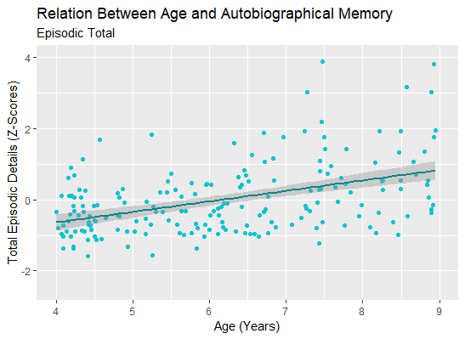
Figure 5. Relations between age and total episodic details on the autobiographical memory task.

Similarly, the bivariate correlation showed age-related variations, wherein older age was associated with more details recalled, r(190) = .426, p < .001 (Figure 6). This relation also did not hold above and beyond the development of verbal fluency when controlling for MLU, r(187) = .094, p = .199.

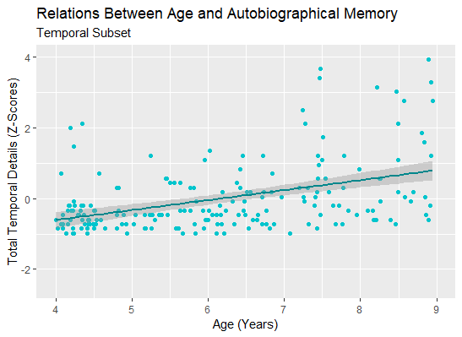
Figure 6. Relations between age and total temporal details on the autobiographical memory task.

Ordering Task. The bivariate correlation showed age-related variations in standardized scores of temporal order memory, wherein older age was associated with more adjacent pairs recalled, r(199) = .559, p < .001 (Figure 7). Results were similar when controlling for sex, r(196) = .552, p < .001.

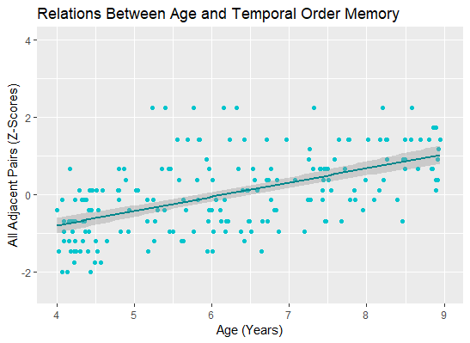
Figure 7. Relations between age and memory for temporal order.

Does performance on both memory tasks relate to each other?
Standardized total episodic details and all adjacent pairs were positively related, r(190) = .270, p < .001, such that the same children who scored well on one task also scored well on the other task (Figure 8A). However, this relation appeared to be primarily driven by age, as it did not hold over and above the effect of age, r(187) = .023, p = .753. The relation between standardized all adjacent pairs and total temporal details was explored and also found to be a significant positive relation, r(190) = .212, p = .003 (Figure 8B). This relation also did not hold over and above the effect of age, r(187) = -.039, p = .597.

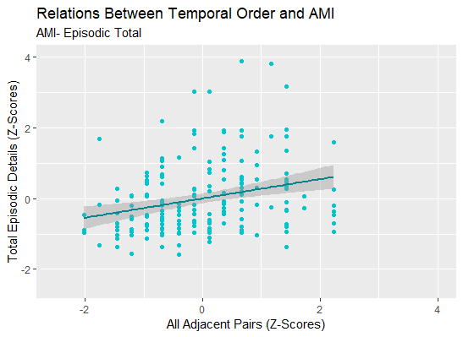
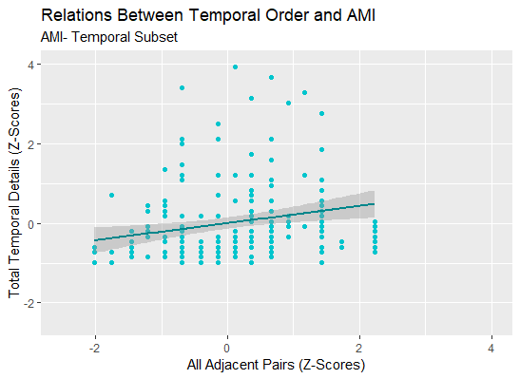
Figures 8A and 8B. Relations between total episodic details and all adjacent pairs (8A), and total temporal details and all adjacent pairs (8B).

Were either or both of the memory tasks related to hippocampal volume?
Autobiographical memory. Bilateral hippocampal volume did not significantly relate to either standardized total episodic details or total temporal details when controlling for age effects. Although post hoc analyses explored hemispheric differences (left versus right hippocampus) and age effects (median age split), no significance was found in neural regions.
Temporal order memory. Bilateral hippocampal volume did not significantly relate to standardized all adjacent pairs scores when controlling for age effects. A significant linear regression accounted for 30.6% of variance, but only age emerged as a significant predictor of temporal order memory (Table 3). Post-hoc analyses explored hemispheric differences (left versus right hippocampal volumes) and age effects (median age split), but no robust relations emerged with any hippocampal subregion.

Table 3.
Relations between temporal order memory and hippocampal volumes
Predictor Variables | B | p
Age | .577 | .000*
Sex | -.080 | .222
Hippocampal Head | -.044 | .566
Hippocampal Body | -.056 | .425
Hippocampal Tail | -.029 | .661
Adj. R² | .306
F(5,171) | 16.52 | <.001
Note. Linear regression with multiple predictors of standardized all adjacent pairs, indicates that only age shows a robust relation with memory scores.

Discussion
This study explored the relations between 1) age-related differences, 2) relations between tasks, and 3) relations to the hippocampus for real-world autobiographical memory and lab-based temporal order memory. Findings showed significance related to the first two behavioral goals, but not in the third biological goal.
Do both memory tasks show age-related differences?
AMI. Results showed that consistent with my hypothesis, older children outperform younger children in autobiographical recall. This finding supports previous research documenting improvements in the durability and stability of memories, and autonoetic skills in early childhood (Pillemer & White, 1989). However, the covariate of MLU greatly affected outcomes in an unanticipated way.
After taking verbal development on the autobiographical interview task into account, the relation for either the total episodic or temporal variable with age was no longer significant. This finding suggests that age-related differences in performance did not account for variations in children’s autobiographical memory recall beyond variations in verbal fluency. Prior research suggests that coincident language development plays a role in the narrative retelling of memories (Fivush & Nelson, 2004). For this reason, it was decided a priori that language would be important to control for during analyses. However, that the relevance of language might surpass or usurp the role of memory in its relations to age was unanticipated. While it was expected that the autobiographical paradigm would contain cognitive noise (e.g. searching for words to articulate experiences), this invokes the “process impurity” problem, which asks how to manage or resolve the fact that most cognitive tasks involve multiple cognitive functions (Sörqvist, 2014). The consideration of language-dependent memory paradigms, which involve competing demand for memory and language skills, frames this dilemma in a new context.
Ordering task. Results were consistent with hypotheses, finding that older children outperform younger children on memory for temporal order. This aligns with research validating this measure of temporal order memory as a reliable and consistent tool for episodic memory characterization (Bauer et al., 2013).
As with analyses of autobiographical memory, a covariate relation affected analyses. Performance on the temporal order task showed sex differences, wherein females outperformed males. Though not a primary analysis of interest, this finding was surprising and unexpected. Sex differences have been documented in studies of autobiographical recall and on a neural level, but usually explained as resulting from sex differences in cognitive styles, such as females showing a greater reliance on language skills in memory recollection (Young, Bellgowan, Bodurka, & Drevets, 2012). Sex differences in temporal order memory may exist, but alternatively this may represent Type I error given the relatively weak proportion of variance it explained as compared to other analyses. Further, a longitudinal analysis sample including the subsample used in the current study reported a lack of sex differences in memory for temporal order (Canada, Pathman, & Riggins, 2020).
Does performance on both memory tasks relate to each other?
Performance on the two tasks was positively related, such that children with better autobiographical memory also showed better temporal order memory. This finding was consistent across variables, as analyses revealed the same relations for all adjacent pairs with total episodic details as for the subset of total temporal details. Though, given the amount of variance explained by the relation, and visual inspection of the graphs, it appears that the relation with autobiographical temporal details is perhaps less related to temporal order memory compared to episodic details. Since the temporal details are also less normally distributed, this could be a product of using a portion of the data requiring the explicit mentioning of time, though “when” context might underlie the ability to recount events at a higher level. In either case of using total episodic details or the temporal subset, episodic details involving mental time travel corresponded with timing context, aligning with developmental indications about the importance of the capacity to remember the order of events and actions (Bauer et al., 2000). This finding also suggests that memory performance on lab-based tasks relates to performance on real-world memory.
Interestingly, after controlling for age-related differences, the relation between task performances were non-significant. Thus, although episodic memory improves as children develop, it is not the only important factor within development. Perhaps in this investigation, it is not possible to tease apart the differences between the pure memory construct versus other factors contributing to performance.
Were either or both of the memory tasks related to hippocampal volume?
We thought that task relations may be due to a common underlying neural mechanism, and that biological foundations might aid in an understanding of the similarities or differences between memory measures. However, no significant relations were found between tasks and hippocampal subregion volume when controlling for age and sex. The absence of significant findings relating brain to behavior was particularly surprising given the breadth of prior research documenting relations between the hippocampus and episodic memory (Ramsaran, Schlichting, & Frankland, 2019). It may be that there is no relation in the age group; however, this may be a Type 2 error and a false negative. Past findings with this particular dataset sample have indicated that when accounting for MLU in statistical analyses, there is a potential relationship between the hippocampus and autobiographical memory, such that a smaller volume in the right hippocampal body predicts better scores on memory performance (Fine, Amin, Cox, & Riggins, 2019). Smaller sizing aligns with theories about specialization along the hippocampal axis, as well as the idea that ‘bigger’ does not always mean ‘better’ during development (Poppenk et al., 2013; Demaster, Pathman, Lee, & Ghetti, 2013). In a sense, absence of size relations also supports the notion that larger structures are not fundamentally responsible for supporting higher-level skills.
Limitations and Future Directions
Autobiographical memory. Autobiographical memory tasks beget greater ecological validity and a wider variety of interesting responses, at the potential cost of greater subjectivity and experimental error. As such, undertaking research with participants in early childhood can be difficult to navigate the balance between following rules and keeping children comfortable and engaged in experimental tasks. The AMI paradigm necessarily requires young children to share details about their life with a stranger. Trying to build rapport and maintain the flow of naturalistic conversation during interviews sometimes necessitated protocol deviation in this sample. For example, there were many transcripts where experimenters shared a common interest with participants or asked if events were fun, deviating from the protocol script. There were also many instances in which children did not remember the correct event and needed to use their prompting detail for identification, and when experimenters forgot to provide a prompted recall detail due to time restraints or because children were wearing out. In sum, the richness of the open-ended paradigm lends itself to increased opportunity for experimental error which is exacerbated by implementation with a young subject population.
Because it is a real-world event, autobiographical memories were also subject to parental accuracy. Many studies of autobiographical memories choose to prospectively track events, such that parents prepare for the experimental session in the leading months or weeks by writing down salient events as they take place. For the AMI task, parents had to retrospectively think of events that might have been significant enough for their children to remember. Although prior research indicates that children might not be able to supply events of their own on the spot (Peterson, Warren, & Short, 2011), this does highlight the differences between what adults and children understand and remember about their lives. For instance, one parent provided an event about their car breaking down during a road trip, and the child was unable to identify the scenario without probing detail that this was the time they played with frogs on the side of the road. In this example, the child did not suffer from retrieval failures and memory fragility, they simply encoded the scenario from a different perspective because they lacked an understanding of what was happening around them at the time of the event. Thus, even though the differences in account accuracy might be negligible, maturity may lead to differences in perspective and relevance of details during real-world scenarios, which might cause underestimation of childhood memory capacity.
Open-ended, naturalistic recall is particularly vulnerable to other developmental variables. Other latent variables underlying the developmental trajectory could mature alongside episodic skills or be precursors to the ability to articulate memory recollection. In this study, it seems as though verbal development explained a great deal of the variance in memory. Although prior research has indicated that parental support for language production facilitates reminiscing (Wu & Jobsen, 2019), it is unclear whether children’s language skills actually prevent the expression of non-verbal autonoetic experience. Furthermore, theory of mind is the ability to understand that others have differing perspectives from oneself, and also shows age- and brain-related improvements (Xiao, Geng, Riggins, Chen, & Redcay, 2019). Young children have a hard time with the idea that others’ frame of reference differs from theirs, and especially as scientists and authority figures, who do possess answers for all the laboratory-based tests, researchers might seem all-knowing. If it is difficult to understand what researchers might assume about their experience, it could prevent children from adequately describing event details. Children cannot receive credit for implied details, only the things that they actually tell researchers. For instance, in the coding scheme, children receive points for each individual that they can remember was present at a past event, such that when a child says “my whole family,” researchers typically inquire who all that entails. Future linguistic research should be focused on teasing apart the developmental trajectories of language acquisition and other cognitive skills such as theory of mind, and quintessentially whether verbosity precedes or follows the development of memory formation ability.
Temporal order memory. Though intended to assess temporality and episodic memory, the time course of the temporal ordering task is notable. While autobiographical memories deteriorate over time, the temporal ordering task was assessed minutes after encoding. Insignificant differences with the use of a distractor task (Canada, Pathman, & Riggins, 2020) provide evidence that these details are stored in a long-term system rather than a short-term, attention-driven working memory system. However, episodic memories are thought to deteriorate over time (Pillemer & White, 1989), and the short timescale of this assessment may fail to properly account for such a curve even if immediate relations are evidenced. Additionally, even on this short timescale, most subjects did not reach ceiling and the mean score was below 50% accuracy. This suggests that many children did struggle to initially encode the material.
Another limitation of temporal order memory is the presentation of the event sequences as hypothetical activities in which the experimenter engages. As laboratory-provided information in visual form, this means it lacks experiential cues that facilitate recall.
Memory Relations. One primary difference between the autobiographical memory and temporal ordering tasks is the occurrence of incidental versus intentional encoding. Memorization of the temporal ordering task requires deliberate concentration on material that children expected to be tested on, whereas real-life memories occur more passively. Since encoding strategies improve with age along with actual memory skills (Pathman et al., 2011), it is difficult to tease apart the extent to which laboratory-based measures reflect real-life experiences.
This gap between the intentional and incidental bridges over to the personal and impersonal (see Cabeza et al., 2004; Pathman et al, 2011). That is, while autobiographical memories are personally relevant to oneself, laboratory-provided experiences are not. Since episodic memories might necessarily require emotional, personal significance (Pathman et al., 2011), this could hinder the ability to understand event recollection, and more work should be done to address this unintended consequence.
Additionally, in operationalizing autobiographical memory through the use of total episodic variables, the provision of two events more directly paralleled the use of two 9-item sequences used for temporal order memory. However, unlike temporal order, the two events in autobiographical memory interviews were not always equally remembered. Children who completely forgot one event or who had recording issues that interfered with the scoring of one event might have had differences that artificially lower their scores. Inequality was assumed to even out with individual differences given the power of the sample size. However, if one’s goal is to indicate the richness possible in memory encoding, then future paradigms might choose the best memory out of two for each child or task.
Finally, the measures used in this study were drawn from a larger battery of tasks, in which tasks were not assigned in a randomized order in an attempt to equate demand across children. That is, temporal order memory testing always preceded autobiographical memory testing. Although children were offered regular breaks and snacks, this introduces the possibility of cross-over effects and fatigue, and lower stamina or time of day differences might translate to performance effects.
Although autobiographical memory and temporal order might conceptually diverge on real-life context, personal relevance, verbal dependency, and encoding strategy, ultimately, memory performance still related to each other. Even though age was a driving factor, such cross-construct validation is so interesting and compelling on account of, rather than despite, all these differences, because it indicates cross-over in the mechanisms underlying all episodic memory measures.
Hippocampus
The current study focused on relations between measures of memory and hippocampal subregion volume. Changes in hippocampal subregion volumes are often modest and therefore difficult to detect. Future investigation should consider reframing this work through different anatomical variables. For example, long-axis specialization lends itself to an investigation of the hippocampus through the subfields (dentate gyrus, cornu ammonis, and subiculum). These functional subfields also mature at different trajectories (Lavenex & Banta Lavenex, 2013), and are a presumable alternative to the anatomical division of the longitudinal axis itself.
Additionally, though thought to be critical, the hippocampus is not the only brain region developing during childhood and does not function in isolation. Future work should investigate the relations between episodic memory and other neural correlates such as cortical thickness, which also exhibits maturation in early childhood (Lyall et al., 2015) and is thought to contribute to memory alongside the hippocampus in children and adolescents (Østby, Tamnes, Fjell, & Walhovd, 2012).
Moreover, future analyses of this memory data should consider a longitudinal approach. Although this particular investigation and subsample was cross-sectional, this overall study involved an accelerated longitudinal design, such that a portion of subjects came back for testing after one and two years. A longitudinal investigation of the changes in memory across paradigms might be fruitful in understanding the nature of their relationship and the circuitry that motivates behavioral performance.
Conclusion
In summary, this investigation examined the relations between two measures of memory, autobiographical and temporal order, and potential underlying neural substrates in early childhood. Both autobiographical narratives and temporal order sequences require episodic time-travel skills and the ability to think about past experience in an autonoetic way. But the measures diverge based on testing method and the extent to which they may represent memory in the real world. Although these findings suggest both measures of memory are related to each other, why that may be (i.e. general age, cognitive function, verbal ability, and brain development) remains an area opportune for future research. Despite this, the present findings contribute to new knowledge about the extent to which naturalistic versus lab-based tasks similarly measure memory abilities.

References
Bauer, P., Dikmen, S., Heaton, R., Mungas, D., Slotkin, J., & Beaumont, J. (2013). III. NIH TOOLBOX COGNITION BATTERY (CB): MEASURING EPISODIC MEMORY. Monographs of the Society for Research in Child Development, 78(4), 34-48. DOI: 10.1111/mono.12033
Bauer, P. J., & Larkina, M. (2016). Predicting remembering and forgetting of autobiographical memories in children and adults: a 4-year prospective study. Memory (Hove, England), 24(10), 1345–68. https://doi.org/10.1080/09658211.2015.1110595
Bauer, P. J., Pathman, T., Inman, C., Campanella, C., & Hamann, S. (2017). Neural correlates of autobiographical memory retrieval in children and adults. Memory (Hove, England), 25(4), 450–466. https://doi.org/10.1080/09658211.2016.1186699
Bauer, P. J., Wenner, J. A., Dropik, P., & Wewerka, S. S. (2000). Parameters of remembering and forgetting in the transition from infancy to early childhood. Monographs for the Society for Research in Child Development, 65 (4, Serial No. 263).
Cabeza, R., Prince, S. E., Daselaar, S. M., Greenberg, D. L., Budde, M., Dolcos, F., … Rubin, D. C. (2004). Brain activity during episodic retrieval of autobiographical and laboratory events: an fMRI study using a novel photo paradigm. Journal of Cognitive Neuroscience, 16, 1583–1594.
Canada, K. L., Pathman, T., & Riggins, T. (2020). Longitudinal Development of Memory for Temporal Order in Early to Middle Childhood. The Journal of Genetic Psychology, 1–18. DOI: 10.1080/00221325.2020.1741504
Cunningham, H., Maynard, D., & Bontcheva, K. (2011). Text processing with gate. Gateway Press, CA.
Cunningham, H., Maynard, D., Bontcheva, K., Tablan, V., Aswani, N., Roberts, I., ... & Heitz, T. (2011). Developing language processing components with gate version 6 (a user guide). University of Sheffield, Department of Computer Science
DeMaster, D., Pathman, T., Lee, J. K., & Ghetti, S. (2013). Structural development of the hippocampus and episodic memory: developmental differences along the anterior/posterior axis. Cerebral cortex, 24(11), 3036-3045
DeVito, L. M., & Eichenbaum, H. (2011). Memory for the order of events in specific sequences: Contributions of the hippocampus and medial prefrontal cortex. Journal of Neuroscience, 31(9), 3169–3175. DOI:10.1523/JNEUROSCI.4202-10.2011
Fine, C., Amin, S., Cox, L., & Riggins, T. (2019, October). Relations between autobiographical memory and hippocampal subregion volumes in early childhood. Poster presented at the biennial meeting of the Cognitive Development Society, Louisville, KY.
Fischl, B. (2012). FreeSurfer. NeuroImage, 62(2) 774–781. DOI:10.1016/j.neuroimage.2012.01.021
Fivush, R., & Nelson, K. (2004). Culture and language in the emergence of autobiographical memory. Psychological Science, 15(9), 573–577.
Ghetti, S., & Bunge, S. A. (2012). Neural changes underlying the development of episodic memory during middle childhood. Developmental Cognitive Neuroscience, 2(4), 381–395. https://doi.org/10.1016/j.dcn.2012.05.002
Gogtay, N., Nugent, T. F., Herman, D. H., Ordonez, A., Greenstein, D., Hayashi, K. M., … Thompson, P. M. (2006). Dynamic mapping of normal human hippocampal development. Hippocampus, 16(8), 664–672. http://doi.org/10.1002/hipo. 20193.
Lavenex, P., & Banta Lavenex, P. (2013). Building hippocampal circuits to learn and remember: Insights into the development of human memory. Behavioural Brain Research, 254, 8–21. https://doi.org/10.1016/j.bbr.2013.02.007
Levine, B., Svoboda, E., Hay, J., Winocur, G., &; Moscovitch, M. (2002). Aging and autobiographical memory: dissociating episodic from semantic retrieval. Psychology and Aging, 17, 677-689.
Lyall, A., Shi, F., Geng, X., Woolson, S., Li, G., & Wang, L. et al. (2014). Dynamic Development of Regional Cortical Thickness and Surface Area in Early Childhood. Cerebral Cortex, 25(8), 2204-2212. DOI: 10.1093/cercor/bhu027
MacWhinney, B. (2000). The CHILDES Project: Tools for Analyzing Talk. 3rd Edition. Mahwah, NJ: Lawrence Erlbaum Associates.
Miller, J. F., & Chapman, R. S. (1981). The Relation between Age and Mean Length of Utterance in Morphemes. Journal of Speech, Language, and Hearing Research, 24(2), 154–161. https://doi.org/10.1044/jshr.2402.154
Østby, Y., Tamnes, C., Fjell, A., & Walhovd, K. (2011). Dissociating Memory Processes in the Developing Brain: The Role of Hippocampal Volume and Cortical Thickness in Recall after Minutes versus Days. Cerebral Cortex, 22(2), 381-390. DOI: 10.1093/cercor/bhr116
PA (2011): A learning-based wrapper method to correct systematic errors in automatic image segmentation: Consistently improved performance in hippocampus, cortex and brain segmentation. NeuroImage, 55, 968–985.
Pathman, T., Samson, Z., Dugas, K., Cabeza, R., & Bauer, P. J. (2011). A “snapshot” of declarative memory: differing developmental trajectories in episodic and autobiographical memory. Memory, 19(8), 825–835. https://doi.org/10.1080/09658211.2011.613839
Perner, J., & Ruffman, T. (1995). Episodic Memory and Autonoetic Consciousness: Developmental Evidence and a Theory of Childhood Amnesia. Journal of Experimental Child Psychology, 59(3), 516-548. DOI: 10.1006/jecp.1995.1024
Peterson, C., Warren, K. L., & Short, M. M. (2011). Infantile amnesia across the years: A 2-year follow-up of children’s earliest memories. Child Development, 82(4), 1092–1105. https://doi.org/10.1111/j.1467-8624.2011.01597.
Peterson, C., Hallett, D., & Compton-Gillingham, C. (2017). Childhood Amnesia in Children: A Prospective Study across Eight Years. Child Development, 89(6), e520-e534. DOI: 10.1111/cdev.12972
Pillemer, D., & White, S. (1989). Childhood Events Recalled by Children and Adults. Advances in Child Development and Behavior Volume 21, 297-340. DOI: 10.1016/s0065-2407(08)60291-8
Poppenk, J., Evensmoen, H. R., Moscovitch, M., & Nadel, L. (2013). Long-axis specialization of the human hippocampus. Trends in cognitive sciences, 17(5), 230-24
Ramsaran, A. I., Schlichting, M. L., & Frankland, P. W. (2019). The ontogeny of memory persistence and specificity. In Developmental Cognitive Neuroscience (Vol. 36). Elsevier Ltd. https://doi.org/10.1016/j.dcn.2018.09.002
Raz, N., Lindenberger, U., Rodrigue, K. M., Kennedy, K. M., Head, D., Williamson, A., . . . Acker, J. D. (2005). Regional brain changes in aging healthy adults: General trends, individual differences and modifiers. Cerebral Cortex, 15, 1676–1689. DOI:10.1093/cercor/bhi044
Riggins, T., Blankenship, S. L., Mulligan, E., Rice, K., & Redcay, E. (2015). Developmental differences in relations between episodic memory and hippocampal subregion volume during early childhood. Child Development, 86(6), 1710-1718.
Riggins, T., Geng, F., Botdorf, M., Canada, K., Cox, L., & Hancock, G. (2018). Protracted hippocampal development is associated with age-related improvements in memory during early childhood. NeuroImage, 174, 127-137. DOI: 10.1016/j.neuroimage.2018.03.009.
Rubin, D. C. (2000). The distribution of early childhood memories. Memory, 8, 265-269. Rybash, J. M., & Colilla, J. L. (1994). Source memory deficits and frontal lobe functioning in children. Developmental Neuropsychology, 10, 67-73.
Sörqvist, P. (2014). On interpretation and task selection in studies on the effects of noise on cognitive performance. Frontiers in Psychology, 5. DOI: 10.3389/fpsyg.2014.01249
Tulving, E. (2002). Episodic memory: from mind to brain. Annual Review of Psychology, 53(1), 1–25. https://doi.org/10.1146/annurev.psych.53.100901.135114
Weiss, A. P., Dewitt, I., Goff, D., Ditman, T., & Heckers, S. (2005). Anterior and posterior hippocampal volumes in schizophrenia. Schizophrenia Research, 73, 103–112. DOI:10.1016/j.schres.2004.05.01
Wickham, H. (2016). ggplot2: Elegant graphics for data analysis. New York: Springer.
Willoughby, K., Desrocher, M., Levine, B., & Rovet, J. (2012). Episodic and Semantic Autobiographical Memory and Everyday Memory during Late Childhood and Early Adolescence. Frontiers in Psychology, 3. DOI: 10.3389/fpsyg.2012.00053
Wu, Y., & Jobson, L. (2019). Maternal Reminiscing and Child Autobiographical Memory Elaboration: A Meta-Analytic Review. Developmental Psychology. https://doi.org/10.1037/dev0000821
Xiao, Y., Geng, F., Riggins, T., Chen, G., & Redcay, E. (2019). Neural correlates of developing theory of mind competence in early childhood. Neuroimage, 184, 707-716. DOI: 10.1016/j.neuroimage.2018.09.079
Young, K., Bellgowan, P., Bodurka, J., & Drevets, W. (2012). Functional neuroimaging of sex differences in autobiographical memory recall. Human Brain Mapping, 34(12), 3320-3332. DOI: 10.1002/hbm.22144

Appendix

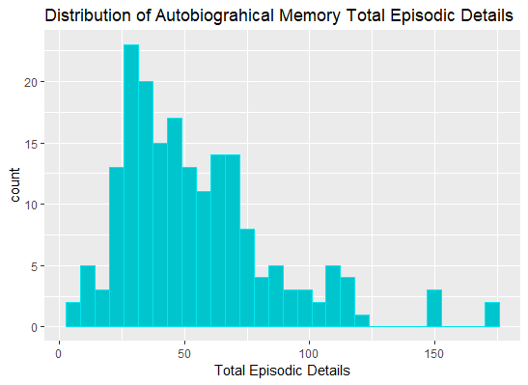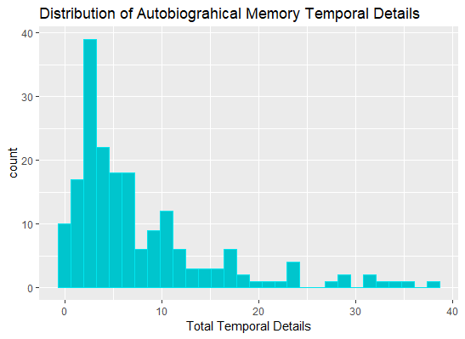
Figures A1 and A2. Distribution of raw total episodic details and total temporal details on the autobiographical memory task.

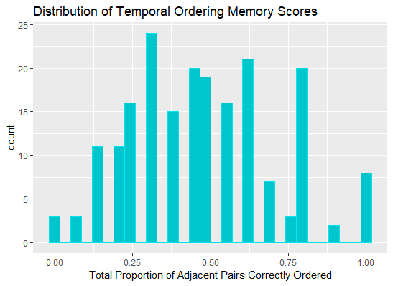
Figure A3. Distribution of raw scores on the temporal order memory task.

