Gating Tegucigalpa, Honduras: The paradoxical effects of “Safer Barrios”

Cristina Handal & Clara Irazábal

Gating Tegucigalpa, Honduras: The paradoxical effects of “Safer Barrios”

Cristina Handal and Clara Irazábal
aThe New School; bUniversity of Missouri

ABSTRACT
This paper analyzes the paradoxical political and socio-spatial dynamics cre- ated by “Safer Barrios,” a security program that redefines notions of citizenship, governance, participation, and space in Tegucigalpa, Honduras. The rapid proliferation of street gates sanctioned by the state under this program is producing understudied effects both within and outside the gates throughout the city, a phenomenon that this study qualitatively analyzes. The findings reveal that these newly gated residential areas demand a more nuanced analysis than that which traditional gated communities have received in the past; this stems from their different constitution and consequences, particu- larly the program’s unique relationship to and sponsorship by the local gov- ernment. The program paradoxically fosters a greater sense of community and safety for participants while negatively affecting mobility and sociability for the rest of city residents. The findings hold critical implications for city design, planning, and policymaking.

Introduction
Gates and guards dominate the new and rapidly expanding neighborhood security infrastructure in the capital city of Tegucigalpa, Honduras. As such, they also constitute the new delineators of usable public space. The program Safer Barrios was conceived in 2011 and institutionalized in 2012 in Tegucigalpa. Legalized by the mayor’s office, it denotes a security initiative instigated by some city residents that allows for the gating of existing streets and neighborhoods. This new infrastructure is requested, managed, and, for the most part, applauded by the initiating street residents. Today, more than 30%¹ of Tegucigalpa’s population is living inside gates. A blue sign over these gates reads, “Barrios Más Seguros, Proyecto AMDC,” which means “Safer Barrios,² Project of the Central District’s Mayoral Office.” We refer to this process as urban gating and draw comparisons between this program and conventional gated communities, with the latter serving as a critical point of departure from which to understand Safer Barrios.
This gating security program includes profound political and socio-spatial implications, both physically visible and socially experienced, that manifest themselves in contradictory ways. On one hand, Safer Barrios stands out as advancing new positive spaces that foster opportunities for neighbors to meet and interact with one another within their residential streets—a cultural practice that had been incrementally lost in the city for many years. On the other hand, they simultaneously create greater segregation and lack of connectivity for the larger city.
Decades of research and work on gated communities have shown the negative consequences they have on a city, marking divisions and encouraging a type of privatization that exacerbates socio- spatial segregation (Blakely & Snyder, 1997; Low, 2001). However, the aim of this study is to analyze a new typology of urban gating that stands distinct from the traditional gated community and

continues to grow and gain momentum in Tegucigalpa and other Latin American cities. We analyze the significance of urban gating—its benefits and downfalls—which includes a qualitative assessment of its contradictory processes and effects and an exploration of implications for city design, planning, and policymaking.
The first section of this article addresses the context in which this case study flourished: the incremental loss of public space in Tegucigalpa and crime in Honduras and Central America. The second presents how public space has paradoxically been found again through gating, discussing gated communities in general and Safer Barrios in particular. The third section details the research methodology and findings, followed by the fourth section’s consideration of the paradoxical effects and implications of these new spatial configurations.

Lost public space
Tegucigalpa’s streets
The city of Tegucigalpa was founded in 1578 with the ubiquitous traits of a Spanish colonial settlement. It was characterized by an orthogonal urban grid, a central plaza with a cathedral, and downtown density and walkability. Activities of work and rest co-existed in the same physical city spaces. The plaza and surrounding streets supported the publicness of city life. A culture of sociability, combined with the temperate year-round climate, further encouraged practices of social sharing on the street.
In the 1960s, this colonial design was slowly abandoned as the city started to spread outward onto the hills that surrounded the downtown area, thus breaking and curving the grid. “The growth of the city was done in an unorganized way, evidenced by the traffic congestions, abandonment of historic buildings, environmental threats, especially after Hurricane Mitch, misuse of public spaces, and the growing violence and insecurity” (Ochoa, 2009, p. 25). Commercial and residential activities were woven together almost seamlessly in the urban fabric, but density and walkability began to unravel. The growing availability of the car made way for larger vehicular streets and smaller sidewalks, and as the city continued to expand, the spaces of sociability continued to shrink. “The unregulated urban sprawl of Tegucigalpa is best explained by frozen laws and fixed mindsets, unable to grapple with the influx of people. The problem has been exacerbated by an asymmetrical distribution of power and responsibility” (Angel et al., 2004, p. 28).
Parks and plazas were designed and constructed along the way, but their lack of accessibility and disconnection from one another contributed to their fading use. Thus, the sidewalks and streets right outside people’s homes and businesses became evermore important as the primary public spaces. Throughout the whole city, particularly in the spaces planned and regulated by the authorities and in the self-built places under their radar, these streets emerged critical as clusters and networks of socialization. However, in the late 1990s and early 2000s, public space—and more specifically, the use of the sidewalks and streets as public space—increasingly dwindled and lost vitality. Factors contributing to the loss of public space and the increasingly introverted behaviors on the part of most of the population included suburbanization; an increased separation of commercial, residential, and other uses; a rise of private automobile ridership; deficiencies of public transit; and most importantly
in Honduras, increasing violence and crime on the streets (Cálix, 2008; Fernández, 1987).

The criminality context and perceptions of safety and fear
Latin America has experienced a steady growth in criminal violence in the last 20 years. According to 2014 data from the United Nations Office of Drugs and Crime (UNODC), this region harbors the highest rate of criminal violence in the world, accounting for one in three global homicides. Although the region’s population stood at only 8% of the worldwide total, it accounted for 36% of homicides in 2012. In fact, Honduras claimed the highest homicide rate in Latin America and in the

world (UNODC) in 2011. In 2009, two years prior to the implementation of Safer Barrios, the homicide rate in the Central District was 79.2 per 100,000 inhabitants, with an average of 66 homicides monthly, including at least two daily (Observatorio Nacional de la Violencia, 2010). These numbers were continuing to escalate.
Researchers and analysts offer many reasons to explain crime in Honduras and Central America. These include a thriving, global, illegal drug trade market that has led to growing structures of organized crime and that has turned transit nations such as Honduras into crime hubs, a flourishing growth in youth violence and gangs, the availability of firearms, weak law enforcement institutions subjugated by corruption and lack of capacity of local governments, and a legacy of conflict and civil wars (InSight Crime, 2016; Luhnow, 2014; Olson, 2015; Renwick, 2016). Across the region, govern- ments and communities have adopted different measures to combat violence, some attempting to attack it at its multiple roots and others using palliative measures to alleviate the crime on the streets and the resulting palpable fear. These take various forms and scales, including international plans, national policies, local programs, and grassroots efforts. They range from international interventions given the transnational scope of the drug trade to policies of city militarization (Cajina & Orozco, 2015) and neighborhood strategies of community policing (Olson, 2015). In the most recent years as the crime and violence escalated to record-high statistics, a series of strategies and policies were diffused across the Central American borders.
Guatemala, Honduras, and El Salvador have formed security initiatives and an alliance known as “The Northern Triangle of Central America (NTCA),” through which they receive help from the United States in the extradition of drug traffickers. “This assistance, rooted primarily in the U.S. ‘war on drugs,’ includes extensive support for the region’s police and military forces, despite abundant reports of [these forces’] involvement in extrajudicial killings and other serious human rights violations” (Carlsen, 2015, para.11). These countries also seek to advance enforcement of punitive justice to guilty drug traffickers and other criminals and strengthen criminal judicial institutions. Based on the analysis of newspaper articles from the three “Northern Triangle” countries as well as reports from nonprofit organizations and multilateral organizations,³ regular transnational meetings and forums confirm the three countries’ joint efforts and commitments from others such as the United States and South American countries, but the results render too slow, and sometimes even conterproductive, to materialize on the ground.
In the meantime, the desperation of citizens affected by the escalating day-to-day crime continues to expand. The general distrust of the national police, stemming from many known cases of police corruption and links with organized crime, coupled with a disbelief in the judicial institutional power, has left people with a growing feeling of despair and institutional distrust. Consequently, in Honduras, El Salvador and Guatemala, people increasingly take matters into their own hands. Examples include the upsurge in civilians carrying firearms for personal protection; the increase in hiring of private security guards; the installation of home and business alarm systems; and the strengthening of homes’ physical structures through the use of iron fences, barbed wire, or stronger building materials in the facades (Coy & Pohler, 2002). This militarization at the residential level has yielded a shared typology of introverted residential architecture encountered across Latin American countries. “This sense for security is part of the culture. They build the gates, walls, and fences before they build the house” (Henfling, 2017, para. 10).
Recently, this type of escalating securitization is manifesting also through the closings of streets, whose ultimate and most formalized expression is found in Safer Barrios. While built under other names, urban gating practices modeled like Safer Barrios are also flourishing in the capital cities of San Salvador and Guatemala City. Inevitably, however, gates that physically and visually scale down the publicness of streets also cause social disengagement from public space. Streets enjoyed as once lively public realms display frequent emptiness now. A person’s experience of walking next to a solid wall or high, guarded fence, revealing decreased physical and visual street porosity and connectivity, contributes to a heightened sense of insecurity and alienation from the once bustling streets.

Lost-and-found public space
Gated communities
One of the mechanisms communities have used to recover the use of streets as safe, populated spaces has included the abandoning of old streets and the creation of new ones within planned gated communities (hereafter referred to as GCs). As in many examples around the world, the GCs in Tegucigalpa stand traditional in purpose, location, and physical characteristics. They provide new subdivisions in the city and most commonly reside outside the city center, with new streets and green areas designated as semi- public, social spaces within the enclosed communities. Just as in other parts of the region and world, the GCs in Tegucigalpa primarily serve a high-income or middle-high income population. In these tradi- tional, planned developments, “political and spatial practices represent the hegemonic means by which urban elites construct status, exercise economic and symbolic power over societies, and develop exclu- sionary ways to redefine and reconstruct their communities” (Irazábal, 2006, p. 74).
Gated communities represent one of the fastest growing real estate phenomena in Latin America. Former studies on GCs demonstrate that they result from increasing crime, perceptions of insecurity, and fear of crime (Caldeira, 1996, 2000; Coy & Pohler, 2002; García Ellín, 2009). However, the self- induced isolation of GCs results in segregating and homogenizing populations while not necessarily producing the security effects sought (Low, 2001). Also, this leads gated residents to disengage from the broader local community and become involved in issues pertinent only to their immediate community (Lang & Danielsen, 1997). Private developers most often design and construct these GCs in a top-down fashion (Libertun de Duren, 2006). Several studies report problems and disputes with neighbors and general levels of “neighborliness” perceived as low, reflecting that gated community residents do not necessarily want to know their neighbors (Blandy, Lister, Atkinson, & Flint, 2003). This confirms that GCs do not prove synonymous with a form of communitarian living.
Traditional GCs were limited to high-income, elite groups who decided to live in “fortified enclaves” (Caldeira, 1996) as well as remain in their “ghettos for the rich” (Charmes, 2012; Paquot, 2009). Yet, studies since 2000 have exposed the increasing reach of gated communities, including to different ethnic groups and income populations (Anacker, 2009; Dinzey-Flores, 2006; Grant & Mittelsteadt, 2004; Sánchez, Lang, & Dhavale, 2002; Vesselinov, Cazessus, & Falk, 2007; Wilson-Doenges, 2000). Some versions of gated communities after 1970 reveal typological changes in some Latin American countries; yet this proves not the case in Honduras, where analysts deem the planned gated communities expensive and exclusive to high income groups. Now, however, in other parts of the world, GCs are more commonly occurring in neighborhoods with people earning low to middle incomes (Plöger, 2010, 2012). Some studies have found additional motivations for moving to GCs developed in lower-income neighborhoods, aside from security and prestige, such as for provision of better housing and more amenities (Elhadary, 2014). While developers still design and build them from scratch as well as master plan them in a top-down fashion, many GCs do recreate a sense of community, however exclusionary and paradoxical (Irazábal, 2006, 2009).

Urban gating through Safer Barrios
Honduras has experienced rapidly increasing crime and homicide rates from 2006 onward, reaching a record-breaking peak in 2011.⁴ Reacting to the state’s failure in providing security to its citizens, some neighbors began searching for their own solutions. They started gathering informally to close off their streets from public access with gates, thus restricting non-residents from entering as a way to alleviate neighborhood crime. Initially, the municipal authorities reacted by bringing down the gates; because the gates infringed upon the rights of others to access the streets, the rightful property of the state, municipal authorities viewed the gates as illegal and a hindrance to free traffic.
Thereafter, through a series of negotiations with neighborhood representatives, the mayor’s office eventually backed down and presented the program “Safer Barrios” in 2011. Safer Barrios required

neighbors to form associations, gather signatures from 80% of residents in favor,⁵ and provide the solicited documentation⁶ for the city to review and decide on the gates’ approval. For the most part, the approval decision was based on considering intrusions on the traffic around the neighborhood. Once the neighborhood gates were approved, the neighbors self-organized to decide on the security infrastructure they could collectively afford and moved forward with their project, making sure to identify their gates with the assigned, blue city sign and to abide by the rules of the Safer Barrios program.
These gates became popular and proliferated the city quickly. In the first months of its institu- tionalization, the program created approximately 6,000 “beneficiaries,” as the mayor’s office refers to the Safer Barrios residents. Today, over 300,000 people in 230 neighborhoods⁷ live inside gates with blue signs, representing 30% of the total population in the city of Tegucigalpa.
As the program has continued to grow, the new mayor has added additional regulations. The pre- existence of planned GCs and their prestige have facilitated the cultural acceptance of neighbors in traditional streets wanting to close themselves off. Meanwhile, this program has caused Tegucigalpa to physically change in a myriad of ways. An aerial plan view (Figures 1 and 2) reveals a multiplicity of bubbles, sometimes next to one another or one within another; this means that a pre-existing gated community may lie within a recently enclosed Safer Barrios community. Most strikingly, the experiences of pedestrians and drivers now remain clouded by spaces of vehicular congestion and pedestrian inaccessibility, a reverberation caused by gating structures that restrict or prohibit access (Figure 3). However, additional impacts underlie this program’s effects, as those who live inside reveal. This study’s subsequent sections discuss these impacts in detail.
In literature analyzing the benefits and repercussions of gated communities, some authors high- light the reasons why the state favors this typology, pointing to the fact that developers pay for the urban infrastructure, with the cost then passed onto homebuyers (Carrasquillo, 2011). Later, the residents form their own types of internal governance structures that ensure their heightened

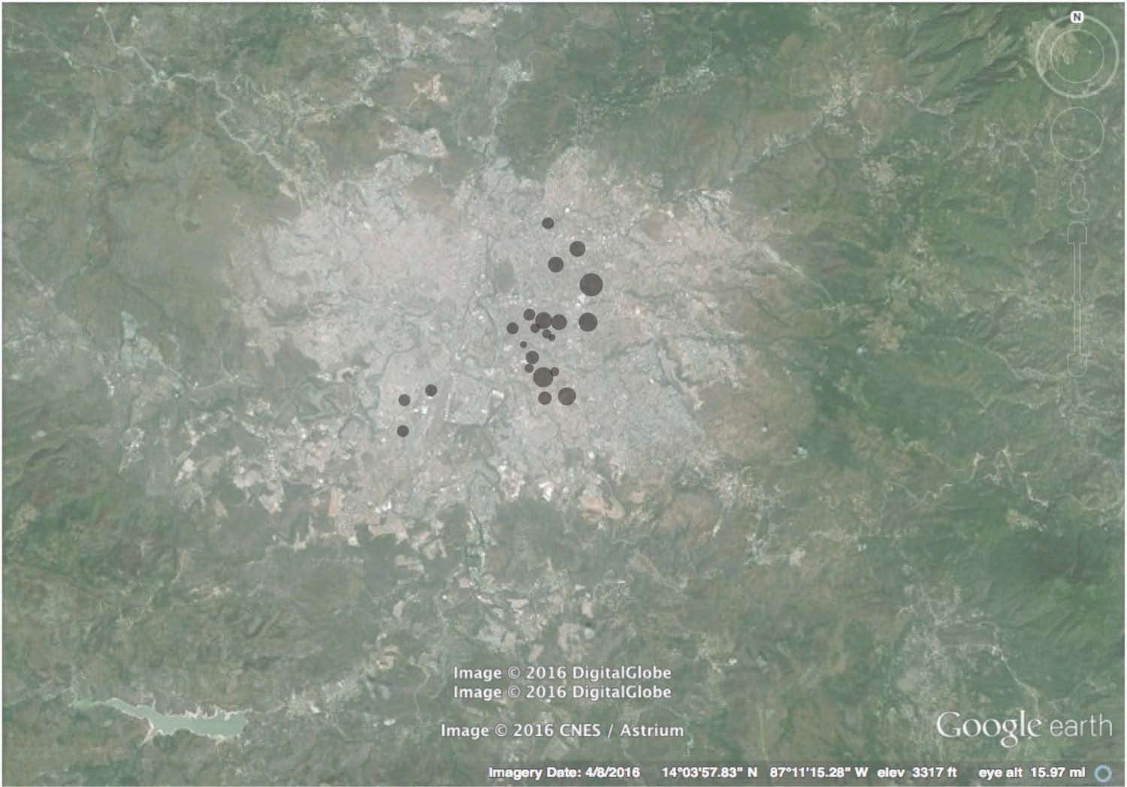

Figure 1. Aerial map of location and dissemination of “Safer Barrios” gates in Tegucigalpa, Honduras between 2011–2013 (6,000 people in Safer Barrios).
Sources: Data from KMZ file provided by city program officials, maps created by authors, background map from Google Earth.

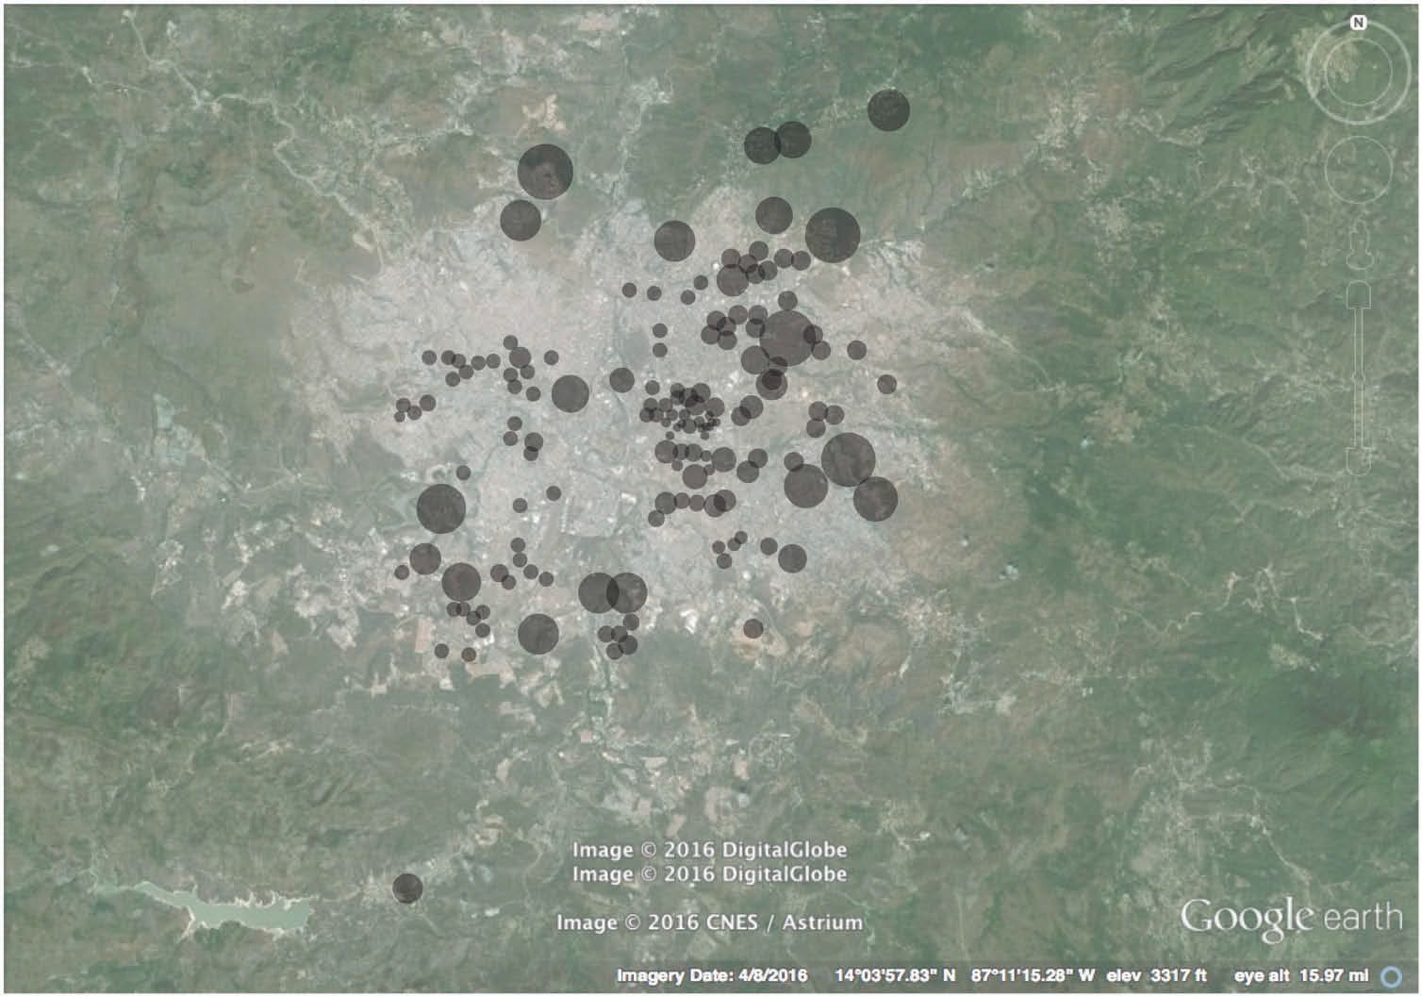

Figure 2. Aerial map of location and dissemination of “Safer Barrios” gates in Tegucigalpa, Honduras between 2015–2016 (300,000 people in Safer Barrios).
Sources: Data from KMZ file provided by city program officials, maps created by authors, background map from Google Earth.

expectation of services is met (McKenzie, 1994; Nelson, 2005). In a similar way to GCs in other countries, Safer Barrios became a financial and political strategy of a cash-strapped local govern- ment. One can see the institutionalization of the program, both as a state’s failure to provide citizen security and as a way to deal with public fear and insecurity through a palliative measure that transfers responsibility to the public. Safer Barrios also represents a new marketing tool that effectually increases property values. A program official from the mayor’s office shared that “the property values of households in Barrios más Seguros have increased, and people that visit the city for work or vacation are preferring rentals in these locations.”
At the local level, important political elements aligned in helping Safer Barrios to flourish. First, the mayor of Tegucigalpa who created the program was serving his second 4-year term in office and was also running for the nation’s presidency. At that time, citizens’ main concern lay in their safety, and the presidential candidates were championing campaigns that emphasized their crime-fighting agendas. From the mayor’s perspective, the Tegucigalpa citizens had discovered a solution that apparently worked, and opposing it would have incurred heavy political costs. Thus, not only did he approve and legalize their solution—Safer Barrios—but he also leveraged its benefits to prove he was providing safety to Hondurans in the capital.
The mayor announced his campaign slogan as “The Poor First” (Primero los Pobres), aligning his programs with correlating names as he prepared his presidential platform from his seat in the Mayor’s Office. Therefore, the selection of the word barrios, which encompasses all income levels, even the poorest (as opposed to colonias, which refers to formal, usually higher-income neighborhoods) proved an important campaign move. However, the campaign of the opposing candidate, the congressional president, seemed even tougher on crime than did his, and the mayor lost his presidential bid.
In addition to political intentions, strong economic motives were entrenched behind the pro- gram’s support. Growing quickly in Honduras, this type of so-called public-private partnership

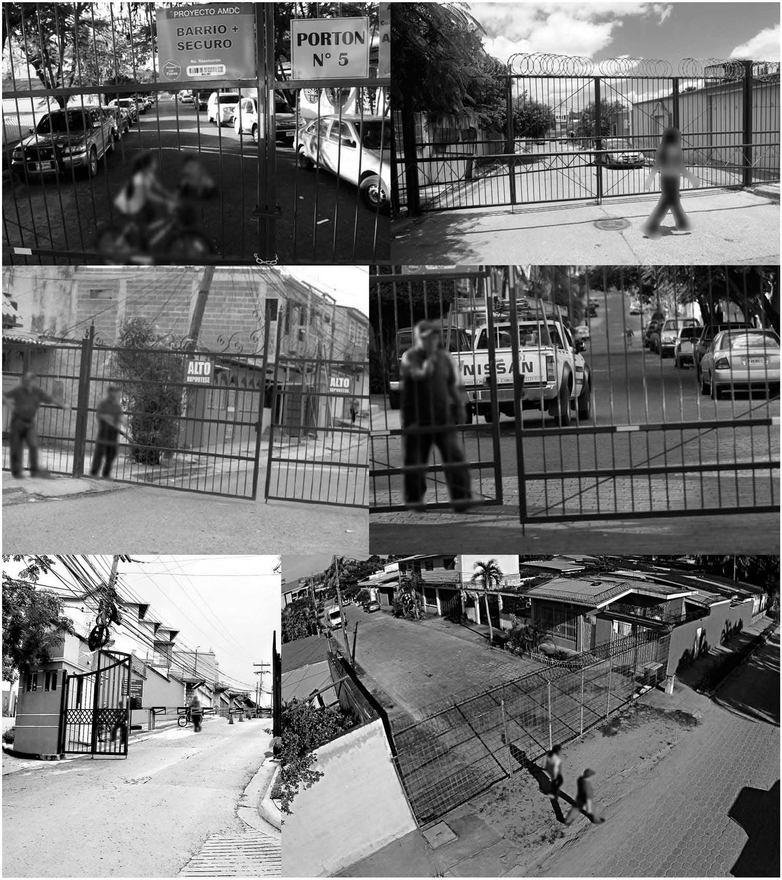

Figure 3. Photographs of “Safer Barrios” Gates in Tegucigalpa, 2012–2015.
Sources: El Heraldo, La Tribuna, La Prensa (access through newspapers’ online platforms).

(Irazábal, 2016) meant that the citizens were bearing all the costs of security; the city had allocated no funds for its development. A review of the city’s annual operational plans and budgets from 2007 to 2012 revealed that no item for security existed, besides a nominal amount related to the operational costs of the National Police.
Thus, these political-economic motivations prove critical in the inception and flourishing of the urban gating program. The governing regime that effectually formed in Tegucigalpa instigated a “gating machine,” whereby, according to Vesselinov et al. (2007, p. 109), “the combination of the interests and actions of local governments, real estate developers, the media, and consumers suggest that prevailing structural conditions assure the future proliferation of gated communities”; in this case, it means the proliferation of Safer Barrios.

Methodology and findings
Methodology
This study’s research stems from fieldwork performed in Tegucigalpa, Honduras, from 2011 to 2016, with follow-up interviews and participant observations occurring in 2019. The aim of the study was to understand this recent phenomenon through its causes and enabling conditions, the motivations of parties involved, the effects of the program, and the evolving implications at various scales. Research focused on recruiting, interviewing, and making observations of people living in streets that were participating in the Safer Barrios program. To complement these findings, we also interviewed people living outside Safer Barrios, including some not in favor of the program. The neighborhoods selected and people interviewed were recruited through common acquaintances that facilitated their access. These parameters present their own limitations and, for a more balanced and thorough analysis, a continuation of this research work should focus more on other stakeholders and opinions. Specifically, the research methods consisted of 14 semi-structured interviews, three focus groups, an online survey, and on-site observations in three Safer Barrios sites. Content analysis of media included government reports and laws that pertained to security within and outside Safer Barrios, plus approximately 30 local newspapers dating from 2011 or later that captured the development of Safer Barrios cases as journalists were recording them. Statistical information, albeit scarce due to unavailability, was obtained from the National Observatory of Violence at the Universidad Nacional
Autónoma de Honduras and from the Central District’s mayoral office.
We selected three neighborhoods on which to focus, referred to as neighborhoods A, B, and
C. Although similar in terms of middle- and middle-high income levels, the three neighborhoods presented very different conditions. The following table (Table 1) includes the factors we used for their selection: their standing in the permit process; our accessibility to the neighborhood; location and size; relation to other geographic factors or unique characteristics; income of the residents; and participant information.
We conducted the first two focus groups face-to-face in these neighborhoods, with most of the neighborhood leadership from each Safer Barrio. The third focus group was conducted online through the formation of a group in the messaging service WhatsApp, and included six (6) women between the ages of 21 and 32 who live in Tegucigalpa in different locations, including Safer Barrios, private gated communities, and other non-gated neighborhoods.
We distributed an online survey (n = 99) via Twitter and Facebook from a young political candi- date’s account; running for congresswoman, she had social media followers from across income levels and neighborhoods. This allowed us to access a population that was otherwise inaccessible.⁸ While 41% of respondents lived in a Safer Barrio, 59% did not.
The purpose of the interviews to different stakeholders, including city official and residents of Safer Barrios, gated communities, and other areas, was to understand the Safer Barrios program from as many perspectives as possible. We conducted three of the interviews with the two city officials who work on the Safer Barrios program, and we have maintained ongoing communication with some interviewees for various years to learn of program updates and consequences. Although all useful in understanding the program’s impacts so far, this work presents preliminary findings with potential self-selection bias, and thus further research proves warranted to thoroughly analyze this ongoing, urban gating practice.

Findings
The published document that legalizes Safer Barrios presents the outward-facing justification for the program. The bylaws found in the Agreement on the Regulations on Security for Safer Barrios (Acuerdo Reglamento de Seguridad Barrios y Colonias más Seguros) states the following:

Table 1. Characterization of neighborhoods studied for Safer Barrios.
Neighborhood A Neighborhood B Neighborhood C

Permit Process
(for Safer Barrios)
Forming neighborhood association to begin gate permit process, thus we could study and compare dynamics and space before gate, during process, and after gate
Had recently obtained their permit At initial neighborhood meetings evaluating if
gating was a common goal; by the end of the elaboration of this article neighbors installed two gates

Accessibility and Contact
(with neighborhood)
One of us grew up and lived there, giving us complete access to neighbors
Acquaintances have their office in this residential neighborhood, connecting us with the association
Acquaintances live here, and others send their children to the neighborhood’s daycare

Location and size Southeast of downtown; 10 hectares; around 224
houses
South of downtown; 9 hectares; around 160 houses East of downtown; 1.85 hectares; around 40
houses

Unique Characteristics Serves as an important connection between two main
boulevards and was used heavily as an auxiliary road or short cut; had one office building in construction and one residential tower, which were halted in the process of Safer Barrios
Multiple streets to close for neighborhood; adjacent to significant new road constructions; one of the first residential areas of Tegucigalpa, formerly destroyed by 1998 Hurricane Mitch, with significant displacements and reconstructions; has office spaces in houses
Has commercial locations (a daycare and
a school for learning English, a bar, and barber shop), which have caused challenges in the Safer Barrios process

Income Level of Residents Middle-High Income Middle Income Middle and Middle-High Income

Research Participants (interviewees or focus group participants)
Interview with two members of the neighborhood association; interview with domestic live-in employee; online focus group with 20 neighbors in their neighborhood WhatsApp group; interview with developer, whose project was halted here; interview with person who uses this street for commute to work
Focus group with the five-person neighborhood association; interview with one person whose office is located there; interview with State company employee whose route is in this neighborhood
Interviews with two neighbors involved in the meetings but not part of the neighborhood association; interview with one person who works in the neighborhood as a driver

the current levels of insecurity in the capital city and their increasing nature are characterized by a large number of household robberies organized in neighborhoods, generating uncertainty in the capital’s residents from all sectors.
This reveals the clearest and most dominant catalyst behind Safer Barrios: security.
The program’s bylaws also state that a neighborhood needed to attain a minimum of 80% of household votes, signifying agreement with the streets’ enclosure. Residents shared this mandates’ problematic nature as up to 20% of households could disagree with the street closures, oftentimes because they did not want to pay extra fees for security. This created difficulties between neighbors, with resentments ensuing. Conversely, the signature requirements and document preparation forced neighbors to interact with one another, and thus become “united for a same cause.”⁹ When the current mayor took office in 2014, the government mandated a 90% agreeing body, due to the complaints voiced from the first implementation period. Yet, based on our interviews with residents and the mayor’s office, neighbors inside Safer Barrios have most often expressed positive remarks about the program.
To form the neighbors’ association and be in agreement to apply to Safer Barrios we had meetings in different houses. I hosted the meeting twice in my house. It was a real pleasure. I don’t remember the last time I had seen and spoken to so many of my neighbors.¹⁰

We talk to our neighbors again, as we don’t rush in and out of the house. We used to stay inside our four walls, behind the house gate. Now we can be outside again.¹¹
Another interviewee, whose office is located in a Safer Barrios neighborhood, told us she had received flyer invitations under her office door for outdoor weekend barbeques and cycling lessons for kids. She added:
I am surprised and happy to know this is happening and that kids are playing outside again, just like in our times and that of our children.
The city employee who handles the permits at the municipal office stated:
People like it very much and they are in favor of the program. We don’t have a thorough study on this, but I hear it on a daily basis from people that come to renew their neighborhood permits.¹²
However, since many Safer Barrios are centrally located, daily activities for those living outside the gates prove different. One of our interviewees was a local driver, and his perspective reflected one of the two most common complaints that the mayor’s office claimed to have received, which is also the most prevalent issue:
The program is out of control. It has gotten out of the mayor’s hands. It’s causing tremendous traffic congestion, and the city is now made up of mini-prisons.¹³
The second most common complaint the mayor’s office has received is that it violates the right of free circulation. In a local newspaper article, we learned of lawyers who were against the program, claiming that, according to Honduran legislation, the streets are property of the state and are thus national goods for public use.¹⁴
In our online survey (n = 99) of December 2013, in the first years of implementation when the program was relatively new, 49% of responders considered that Safer Barrios fostered social segregation while 51% said it did not.
According to an interview with city officials, the Safer Barrios program has claimed four major achievements:

- Crime reduction¹⁵
- Employee benefits for the local job industries of welders, painters, construction workers, gate manufacturers, electricians, and security companies and their employees

- Zoning compliance, as residential zones restrict the proliferation of commercial and manufac- turing uses
- Improvement of the quality of life through empowerment of neighbors in a participatory and democratic manner

The stories collected from the three selected neighborhoods reveal spatial changes caused by Safer Barrios.

- The decrease in the number of vehicles and the overall vehicular slowdown has allowed for social activity on the street. In Figure 4, a street is now known to neighbors as “the block” (la cuadra), where all outdoor gatherings have occurred; this offers an example of neighborhood landmark- ing, which residents of neighborhood B have also experienced. The blocks selected for these are typically the quieter and less frequented streets because they are safer for pedestrian use.
- Attention is being paid to the physical conditions of the street and sidewalks because of the increased pedestrian use; they had been neglected for many years before. Neighbors raise complaints to the municipal office or fix these themselves.
- The time for drivers to navigate vehicular routes in some cases doubled, either because of slowdowns at the gate for identification and/or because of overuse of alternative routes; from this traffic congestion has come new road construction projects, especially those of overpasses. Among other repercussions stands the increasing prevalence of some roads now markedly more used than others and in need of repairs more often; city authorities have reported difficulty keeping up with this faster-paced maintenance.
- The excessive presence of gates is rendering a new mental image of the city for many people, creating some sense of disorientation and frustration.
- Cars parked on sidewalks in Safer Barrios are typically those of residents or visitors of residents. Thus, the streets lying outside Safer Barrios are oversaturated with parked vehicles. This load, formerly diffused, is now concentrated in a fewer number of streets.

Unfavorable effects
One of the most obvious adverse consequences of Safer Barrios, which the citizens affected by the gates’ proliferation around the city emphasize, is the inconvenience and restriction of the new urban mobility patterns. Personal observations as well as interviews with drivers and the online focus group point to evidence of these mobility pattern restrictions and frustrations. An employee of a state office next to a Safer Barrio shared his experience and discontent with the restrictions and control:
First of all, my commute is much longer now if I avoid the Safer Barrios street since I must go around two heavy boulevards instead. I have used this street to get to the office since I started working here, because frankly, this is a main road. Those of us that use this road are not invading any privacy; it’s a main road! Now, the problem is that my privacy is compromised every day. Whenever I decide to use this street to get to work they (guards) record my license plate number and my ID card number. It’s like I’m being monitored all the time.
Urban gating on already existing, centrally located streets that serve critical functions for pedestrian and vehicular systems of the city results in newly concentrated areas of traffic congestion and inconvenience for vehicles and pedestrians as well as longer travel times. Findings from studies on how car traffic deteriorates living conditions and increases urban segregation (Fotel, 2006) can now show potential, direct links to these gates’ effects, which worsen traffic outside of them.
It has become more challenging for companies delivering services to perform their functions. An employee from the Honduran water company noted:
It takes us much longer to complete jobs in a single day. Before [Safer Barrios], we could accomplish getting to eight to ten households, but now we can get to six on a very good day …. This is because of the slowdowns to enter Safer Barrios and because of the congestions on the boulevards that have resulted from the closed streets.

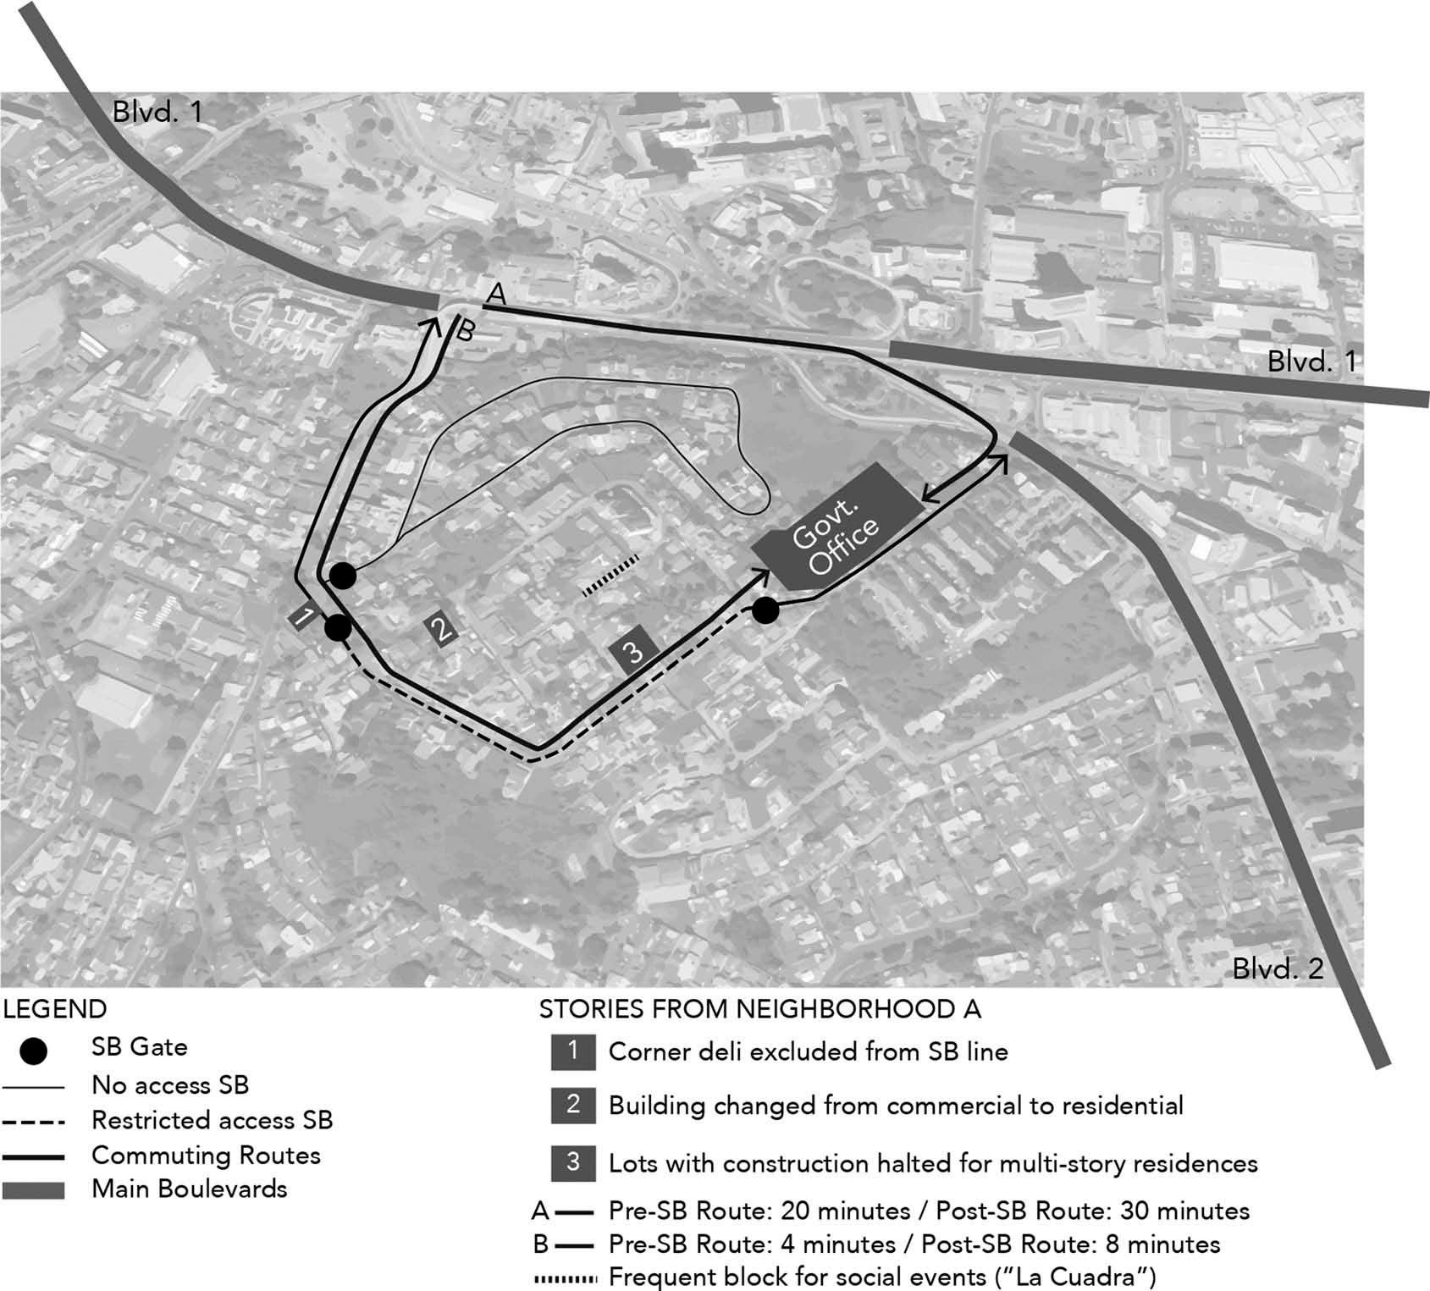

Figure 4. Spatial considerations in Safer Barrio “A”.
Sources: Map illustration created by authors, background map from Google Earth.

These commuting delays cause stress and exhaust people’s energy and productivity.
Based on our observations and regardless of location, Safer Barrios also fosters exclusive and excluding communities, cultivates socio-economic homogeneity within, and limits the interaction of heterogeneous groups of people. This is predicated upon divisions between the inside and the outside, the “us” and the “them.” On the outside of the Safer Barrios, there is a physical loss of the public realm—and of the sense of place and belonging—through the subtraction of previously public streets and sidewalks. On the inside, the generation of a new governmentality includes self- imposed and peer-imposed disciplining (Foucault, 1991), which has manifested in unfriendly coer- cive measures such as publicly displaying names of neighbors who have not paid their monthly dues for the new security service.
In the process of formation of Safer Barrios, neighbors co-produce a document of rules and regulations, which is then authorized by city officials. In this form of public-private partnership between the citizens and the state, a heavy financial cost ensues that the citizens are bearing—that of their own security. Additionally, the government is encouraging traditional privatization methods,¹⁶ fracturing the public realm and subtracting part of it for the exclusive use of a selected group of people.

What started in Tegucigalpa has now sent reverberations beyond Honduras’ borders. The neighboring capital cities of Guatemala and San Salvador have instigated very similar practices of urban gating due to their increasing crime rates as well. What we have found there, according to three local newspapers¹⁷ and three residents is much more division and animosity between neigh- bors in the enclosed streets.

Favorable effects
That same enclosure of public streets for a select few paradoxically recreates the opportunity for newly found conviviality amongst neighbors who had lost a sense of community. The initial and more explicit intent for the use of guards and gates lies in safety—they are designed to exclude and keep people out who are perceived as heightening risks for the residents. Simultaneously though, residents inside Safer Barrios are benefiting from the re-engagement with one another.
Residents have experienced new elements of sociability that they previously had forgone. They are strengthening their ties with one another, not only by “being outside again”¹⁸ but also through email groups and electronic text messaging services such as WhatsApp. To foster these new opportunities, they create neighborhood groups to communicate with one another—not only to manage the program (e.g., share information about upcoming meetings and program updates), but also to share other neighborly experiences, jokes, and social events.¹⁹ Occasionally, these offer platforms for altruism beyond the gates. For example, upon a volcanic eruption in neighboring Guatemala, the residents in Safer Barrios Neighborhood B quickly joined efforts through their messaging group to make one of the homes a collection center for relief donations to send to Guatemala. Paradoxically, expressing solidarity and caring for distant others who pose no perceivable risk to residents are made easier by the new socio-spatial arrangement created by the gates; while in contrast, the gates simultaneously impose added costs (less accessibility and mobility, longer commuting times, greater segregation, housing unaffordability, and diminished citizenship rights) for the immediate neighbors.
The most prominent positive effects of the new gates that city officials have used to their marketing advantage are job creation and crime reduction. The effectiveness of the crime reduction remains questionable,²⁰ but the perception of safety does not. For example, a domestic employee in a Safer Barrios home expresses a common sentiment among residents:
Oh yeah! I’m not scared anymore. I used to have a very hard time sleeping here, thinking anyone could get in the house despite the tall fence and solid gate, and I would get very nervous each time the doorbell rang, knowing of too many cases of thieves entering houses in this manner. I think many of my stomach and high- [blood] pressure problems stem from that—the fear. But no, not anymore.
This benefit along with job creation remain the strongest selling points that the mayor’s office utilize. They market Safer Barrios as an achievement, even though they do not back up its success with hard numbers. In our interviews, for example, we learned they work with rough estimates; in this case, they calculated about 500 current employees who work as guards, the majority from small businesses or self-employed. They also claim that many new jobs exist for all those involved in making and servicing the gates. Although they have not surveyed this in a systematic way, the high and increasing number of gates that have guards proves very apparent, based on our observations. New jobs for gate manufacturers, welders, painters, construction workers, electricians, and security companies are now filled. The construction and security industries may thus be experiencing growth. These favorable effects of job increase and crime reduction, even if limited or transient, are used to justify the existence of the program and increase its demand, thus reproducing the practice and raising the gates’ proliferation.
When asked whether she thought the program should continue, the same domestic employee responded, “Well, if there’s insecurity, we must keep ourselves locked up in the neighborhoods.”
Another consideration that proves more favorable than not is a newfound respect for zoning designations. One Safer Barrios neighbor shared that they “now have a strong voice to confront unwanted changes in the neighborhood and to communicate with the municipal authorities.” This

person shared two instances in which the neighborhood stopped what was considered “illegal construction”: a new building that would have commercial office spaces although this area had a residential designation only (labeled as 2 in Figure 4), and a plan for a residential building of 49 housing units on two lots meant for single family homes (labeled as 2 in Figure 4).
We have opposed this project because of the FAR (floor area ratio) violation, which will also cause privacy invasion to the adjacent homes and will disrupt the neighborhood character. On top of that, the sewage, wastewater, and energy capacities will be exceeded and will undoubtedly cause ongoing physical damages. Additionally, the traffic and on-street parking for 49 new vehicles and their visitors is something we do not need to accept.
The developer, on the other hand, remains upset and is pursuing legal action against this Safer Barrios group.
I have already invested a lot of money on this project. I had the building and environmental permits. How can a neighborhood group override the lawful permitting process?
What we see from this case is that citizens are now exercising more power over responsibilities typically assumed by the government, such as provision of security and enforcement of planning regulations. The strength of the Safer Barrios group to protect its neighborhood can have positive implications.

Safer Barrios’ paradoxes and implications
Many have tagged gated communities as significant contributors to urban inequality (Morgan, 2013; Vesselinov et al., 2007). One can perceive Safer Barrios in the same way. However, this study offers a more nuanced analysis of Safer Barrios as introducing new, paradoxical socio-spatial and political reconfigurations that problematize conventional understandings of GCs, responses to crime, and public space. Through Safer Barrios, some people are selectively rediscovering the use of streets as socializing spaces, a benefit simultaneously further lost to many. This signifies the public space paradox: the program’s positive effects within the gates are predatorily built on the backs of its negative effects outside the gates. In other words, the beneficial community-building, relationship- enhancement with municipal leaders, and facilitation and open use of shared semi-public spaces are all paradoxically creating segregation; the alienation of state authorities’ mandate to preserve the public interests; restricted mobility; and prohibited access to public land.
The following section provides an analysis of the paradoxes that Safer Barrios causes as they relate to citizenship, governance and participation, physical space, and program cooptation and subversion.

The urban space paradox
The clearest paradox of this urban gating practice is socio-spatial: through Safer Barrios, public space is constrained to many for the refound benefits of a few.

Citizenship, governance, and participation paradoxes
The process of approval and maintenance of Safer Barrios reveals a new way of conceiving citizen- ship with new rights and responsibilities. For many residents, legalizing their Safer Barrios may be their first experience of direct contact with the state, which is a moment of recognition and thus of citizenship (Akrich, 1992). The Safer Barrios program requirements, which include an association formation with its dedicated leadership and a certain number of accrued signatures, creates a recognition of existence, of membership, and of a new form of relationship between neighbors as well as vis-à-vis the state. The process of application for the gates creates another form of

recognition and inclusion. One can see the initial process of gate-building as participatory and democratic since it consists of neighbors coming together for a shared cause. However, both the act of gating public space and the associated fees of more expensive elements of security infrastructure put democracy in conflict with equity, as the rule of the majority trumps minorities who have moral and/or economic objections to the street gating. In some of the observed cases, this has resulted in coercive measures and relationship ruptures between neighbors. This creates power asymmetries within and without the enclave participants as some neighbors may have value conflicts or challen- ging economic conditions and consequently disagree on the fees; in addition, imbalances of citizen- ship rights between those inside and outside the gates also create significant power struggles.
These issues show evidence that decisions of infrastructures and their unique or specific structure in society usually create unequal opportunities of participation and distribution of costs and benefits. For Winner (1980, p. 128), “[t]he issues that divide or unite people in society are settled not only in the institutions and practices of politics proper, but also, and less obviously, in tangible arrangements of steel and concrete, wires and transistors, nuts and bolts,” and here, of gates and guards. Furthermore, according to Chiodelli and Moroni’s (2014) typology of spaces in connection with property rights and management, Safer Barrios could be categorized as a privately-run public space. This perversely affects citizenship—distinguishing the rights between the ones within and outside the gates.
The adoption of a technical system requires the existence of a socio-political infrastructure that supports, operates, and maintains that system (Winner, 1980). This means that by accepting and welcoming the idea of street gating, the neighbors are also accepting and welcoming its governing bodies—the city’s regulations and the internal neighborhood structures and leaderships. Safer Barrios works legally under centralized and hierarchical governmental structures, both at the city and neighborhood levels. In this way, both hard and soft infrastructures are used to “enhance the power, authority, and privilege of some over others” and “act like laws” (Winner, 1980, p. 125). “They create both opportunities and limits; they promote some interests at the expense of others. To live within the multiple, interlocking infrastructures of modern societies is to know one’s place in gigantic systems that both enable and constrain us” (Edwards, 2004, p. 191). From the outset, the requirement of having to go through the mayor’s office to obtain a permit for a gate enforces a direct hierarchical relationship between city residents and the municipal government. Then, the require- ment of having to form an association with a leadership structure from the pool of neighborhood residents means there would be levels of authority and disciplinary rules amongst the neighbors, where formerly none existed.
In other areas, for example, neighbors may organize to share keys of a vehicular or pedestrian gate that bypasses the legal program; this illustrates the development of citizen control by residents uniting to take actions together for the benefit of their immediate community. These types of actions are caused and fueled by government distrust and a shared feeling of abandonment, whereby citizens feel the need to act on their own to protect themselves. Yet, these sentiments may also spark lively citizen participation among previously passive and apathetic communities. In actuality, these governance processes are supposed to serve and safeguard the public interests, not benefit just some (usually the most enfranchised already) at the expense of others (usually the least enfran- chised). When government decides to serve private interests, as in this case—favoring a few street residents who gate themselves and, in the process, upset mobility and shrink public space for the rest of city residents—it proves not to serve and safeguard the public interests. Furthermore, it is not treating all residents equally as designed to do, thus segmenting citizenship (i.e., first-class vs. second-class citizens). These cases reveal that participatory processes within cities may not necessarily foster cooperation and coexistence, but rather cultivate more seclusion and self-interest (Irazábal, 2009). A fragmented public exercising segmented, grassroots democracy leads to a “splintered urbanism” (Graham & Marvin, 2001) that exacerbates urban inequities. Additionally, the neighborhoods’ focus on their own governance structures can be examples of “shoestring democracy,” which “encompasses a broad range of behaviors utilized to insulate residents from

local conflicts and disagreements, and limits rather than promotes political participation” (Low, Donovan, & Gieseking, 2012, p. 279).

The safety paradox of program cooptation and subversion
A mirroring practice of Safer Barrios works illegally in Tegucigalpa on the sidelines of government. In neighborhoods that have a strong criminal gang presence or that gangs consider part of their territory, the delineations of their space have usually been immaterial, known only by neighbors and competing gangs, except for the occasional use of sandbags or other like objects. Recently, however, gang members are mimicking the physical cues that the Safer Barrios program uses, such as the mechanical arms, gates, and fake signs that imitate the legal program’s signs.
The program cooptation by gang members is something that the city officials know about anecdotally but have not wanted to formally verify or address. Although it can be dangerous to live in a neighborhood where gang members also reside, in some instances it can paradoxically prove safer since the gang members have control over their territory and know its residents. A program official we interviewed explained, “They know who goes in and out of their neighborhood; this does not affect the neighbors because they are ‘protected’ by the gang, but it does affect the police and other entities of the state.” The gangs’ use of Safer Barrios’ tactics further establishes their power over the gated areas and reinforces their practices of intimidation through visible and tangible pieces of infrastructure, demonstrating the effectiveness of these physical borders as segregating and power- accruing technologies.

Table 2. Paradoxes and implications for practice of Safer Barrios.
 | Paradox | Implications for Design | Implications for Planning | Implications for Policymaking
Citizenship | Perversion of | Universal and | Universal and | New forms of
 | citizenship based | equitable access to | equitable access to | citizenship
 | on inside/outside, | public space | the right to the | recognition or
 | exclusion/inclusion |  | city | discrimination
Governance and | Participation can | Dissimilar and | New governance | Dissimilar and
Participation | cultivate | sometimes | structures; | sometimes
 | segregation | participatory | dissimilar and | participatory
 |  | design processes; | sometimes | policy-making
 |  | improved | collaborative | process
 |  | communication | enforcement of
 |  | structures between | planning
 |  | residents and | regulations
 |  | authorities on
 |  | spatial stewardship
Space | Public space | Design for crime | Zoning, traffic, | New forms of
 | constrained to | prevention at | public | conception and
 | many for the | domestic and | transportation, | regulation of the
 | refound benefits of | urban scale | pedestrian | commons,
 | a few |  | accessibility and | ownership, and
 |  |  | mobility, public | what is public,
 |  |  | space planning | semi-public, and
 |  |  | and management | private
Program | Criminal gangs | Design for crime | Planning for crime | In conjunction
Cooptation | expanding their | prevention | prevention | with planning,
and Subversion | repertoires of |  |  | a holistic
 | territorial control |  |  | approach to
 | by mimicking Safer |  |  | address the root
 | Barrios’ techniques |  |  | causes of
 |  |  |  | violence (poverty,
 |  |  |  | inequality,
 |  |  |  | community and
 |  |  |  | economic
 |  |  |  | development,
 |  |  |  | gun control, etc.)

The Safer Barrios program renders implications for the fields of design, planning, and policy. As shown in the summary on Table 2, the practice-based implications are detailed below, followed by implications for research.

Spatial effects: Implications for design, planning, and policymaking practices
At the neighborhood scales, we observed in our research some immediate implications regarding participation; we found that people in neighborhoods B and C were taking better care of their streets and sidewalks since these entail newfound public spaces being used again. These neighbors have been in communication with the mayor’s office requesting both re-pavement of the pothole-ridden streets and extermination of disease-carrying mosquitoes. These new communication lines between the local authorities and neighbors have proved relatively successful and, although this places more pressure on the mayor’s office, it promotes more positive citizenry in the long run—with people and government working in tandem to improve their communities. The need for coming together for a common cause has rendered a successful method of community organizing within Safer Barrios that was not prevalent before in Tegucigalpa. Thus, the formation of new governance structures has transpired. In Safer Barrios, residents mostly expressed feeling supported by the local government, a sense of partnership and understanding that they are not alone in their fight against crime. This already offers a participatory design process, and the new governing bodies and improved relationships could help shape a new participatory policymaking process. Although often considered a short-sighted palliative solution to crime in residential streets, Safer Barrios has prompted eagerness in many people to participate, self- organize, and most importantly, interact and share street space with one another.
The program also holds both immediate and longer-term spatial implications. Implications at the city-wide scale exist for traffic and planning. For example, Safer Barrios has revealed some of the inefficiencies of Tegucigalpa’s ad-hoc planning. On one hand, people are suddenly complying with zoning designations since Safer Barrios restricts commercial and manufacturing activities in what are meant as exclusively residential zones; this positive implication is also shown in the favorable effect of citizens now enforcing planning regulations in their neighborhoods. At the same time, the road restrictions have made evident the importance of residential streets in the transportation network of the city, which has almost led to a vehicular collapse and worsening situation, where every day more cars are navigating with less available roads. This pushes an increased need for an efficient public transportation system and better planning. Also, immediate implications on business operations are arising; for example, closures are making deliveries more difficult, causing delays in service provisions.
Regarding design at the singular household scale, neighbors may find less of a need to have window guards and tall fences in their houses, which could, in the long run, change the visual appearance of the domestic architecture in Tegucigalpa, rendering more open and porous spaces. This could eventually instigate a redesign of the introverted Latin American house. New typologies could change the demands for existing materials and cause changes in the design and construction industry in the region.
Large-scale urban design implications also exist. Various schools of thought predominate on the practices of designing crime-deterrent built environments. Many seem extreme, and the language that describes their tactics tends to depict a harsh, defensive tone. However, in the city of Tegucigalpa, a no more extreme strategy exists than people physically gating themselves together to feel safer. In this context and in that of other cities where this is happening, some of the ideas of Newman’s “defensible space” (1973), Jeffery (1971) and Crowe and Fennelly’s (2013) “crime pre- vention through environmental design,” and Clarke and Mayhew’s “situational crime prevention” (1980) carry explanatory power and may even inform alternatives to Safer Barrios in the future. Of these three schools of thought, defensible space is perhaps the most segregative, with its focus on restricting places for people who belong in certain areas through territoriality, surveillance, building image, and proximity of residential to other uses. Crime prevention through environmental design

offers other urban design strategies that can help prevent crime, without adding more walls that are currently creating more fortresses. Finally, situational crime prevention builds on the two previous approaches, considering the social and economic strategies of the design as basis for healthy communities.
In conjunction with planning, there is need to use a holistic approach to address the root causes of violence, such as poverty, inequality, deficient community and economic development, and gun control, among others. This approach must follow principles of universal design and equitable access to public space and the right to the city. From the government level, this requires new forms of conception and regulation of the commons concerning ownership and what is deemed public, semi- public, and private.

Research implications
Urban gating, specifically for Safer Barrios, produces both short- and long-term effects; we recom- mend continuing research on these various implications. Potential risks from this program—whose full effects, given its youth, have not yet been realized—may instigate areas of study, including the following: (a) a high level of street fragmentation that increasingly compromises connectivity and mobility for the majority of the city’s population, including residents of Safer Barrios, that could potentially make some areas of the city practically inaccessible to many, thus violating their rights to the city and to democracy, and accruing socio-economic costs due to health and productivity impacts; (b) an increased privatization of open spaces for recreation, socialization, and contact with nature inside Safer Barrios, accelerating the withering and abandonment of public spaces outside Safer Barrios and inducing growing insecurity and sense thereof in them; and (c) accent- uating socio-spatial segregation between Safer Barrios’ residents and outsiders. Since Safer Barrios creates discontinuous spaces separated from each other, this would not necessarily induce socio- spatial class identification and solidarity among all Safer Barrios’ residents. Instead, it could induce street-by-street, balkanized processes of closed-up socio-spatial identification and solidarity, which could be very damaging and dangerous to any semblance of “social contract” that can keep the Honduran society together. This proves particularly worrisome given the unhealed wounds that a convoluted past and current political polarization have inflicted on Hondurans.
Given the high stakes for democracy, peace, and the right to the city for many, researchers should continue to examine the effects of Safer Barrios and alert the world community about their findings; this study does so only in a preliminary way, given its own limitations and the relatively recent implementation of Safer Barrios in Tegucigalpa. Future research can expand the samples and scopes of interviews and surveys presented here and use other qualitative and quantitative assessment tools to further reveal; measure; map; identify correlations and the extent of their causal effects; and offer recommendations to overcome the problems identified.

Conclusion
This new and increasingly popular typology of urban gating offers novel viewpoints on gated communities. Safer Barrios—with its implementation across various income levels and upon cen- trally located streets as opposed to peripheral, master-planned gated communities—causes fragmen- tation of the street layout and disruptions to its connectivity. Its legalization and government sponsorship represent a unique type of partnership between the people and the state, and its cooptation by criminal gangs significantly sets it apart from other examples of urban gating around the world. It produces large consequences in Tegucigalpa’s physical and functional settings, includ- ing effects on people’s everyday lives as well as on citizenship consciousness and practices.
Safer Barrios offers a clear example of the proliferation of urban programs reacting to the increasing crime and violence in Latin America that produce direct and contradictory socio-spatial effects on the urban built environment and people’s subjectivities and experiences. Although the

gates serve as tools of exclusion, they paradoxically also act as conduits of cordiality and trust amongst the neighbors in the newly created enclaves, thus producing new semi-public spaces in places where fear had been shaping an ever more introverted population and architecture. This includes the creation of community spirit, the integration of neighbors through new programs and activities—both physically and online—and their active participation in government concerns. Unfortunately, adverse side effects also arise regarding the increasing re-socialization and recovery of social spaces happening within these communities; these effects are akin but larger in scope than those caused by traditional gated communities.
Although we discuss the pros and cons of Safer Barrios, we are unequivocal in our assessment that the negative effects of Safer Barrios on the “public good” for all outweigh their positive effects within the gates. Even though objective conditions of insecurity exist in Tegucigalpa that fuel people’s need to protect themselves—and we empathize with their feelings, recognizing their security concerns—their right to protect themselves cannot encroach on other people’s right to the city, specifically their rights to free mobility and usage of public space, their rights to have the govern- ment defend their public interests, and ultimately their rights to defend their public interests themselves. Henri Lefebvre’s concept of “right to the city” (1968) and David Harvey’s contribution to this work (2003) not only refer to accessing space, but more critically include a right to take part in the decision-making processes of shaping the space (Irazábal, 2008).
Analyzing Safer Barrios through the events, motives, and circumstances at different scales (the local street, the neighborhood, the city, and the national and international contexts) helps explain the confluence of factors that made the program possible as well as the effects it induces at different levels. In its manifestation as security infrastructure, this program proves inherently political, selectively (dis)serving multiple stakeholders’ agendas. The gates and guards are political technolo- gies revelatory of local, national, and transnational processes. They offer an expression of the state’s failure to deliver and safeguard citizen rights to all; and reveal and exacerbate its selective response to people’s grievances. Under this scheme, people who collectivize their voices and take action to achieve citizen rights that should be available to all—such as the right to safety and neighborly conviviality—do so at the expense of the opportunity of others to access these rights as well.
It proves not solely unjust but also perverse that a new, engaged, and collaborative citizenry now exists with whom local authorities can work to strategize, design, and build new infrastructure, creating policies that are directly predicated on the detrimental exclusion of others from exactly those gains and opportunities afforded to Safer Barrios residents. Past a tipping point of street gating (when more streets in the city are gated than necessary to enable a relatively effective circulation), this “sálvese quien pueda” (every one for oneself) strategy devolves in a race to the bottom; the new- found peace and conviviality within the rapidly proliferating gates may feel good for a while for the few “privileged” enclosed within, but as the finite urban commons are increasingly lost, so the gates will deliver diminishing returns to the gated until the reality of entrapment for both people within and without the gates encircles all.
This analysis of Safer Barrios evokes critical implications for planning and policymaking. Crime and the fear of violence are rapidly changing social values, cultures, behaviors, and the socio-spatial layout of our cities; and the efforts to decrease them also have their undesired effects. These dynamics are shaping cities and how people interact with space and with one another, affecting people’s daily lives and the conceptions and practices of citizenship. The younger generations are already experiencing space in a radically different way than previous generations, due to the increased presence of programs, policies, reconfigured spatial arrangements, and gadgets targeting crime prevention. Methodological implications also arise, including the need for data mining and analysis to thoroughly evaluate the program and help make future decisions. Analysts and commu- nity leaders need to better connect the efforts to study security policies and practices as well as city- making design and planning. Many often treat these foci of urban planning and policy analysis as separate although they are intrinsically related. It is important to analyze the complex and contra- dictory effects of current strategies and learn from them to make informed and pertinent decisions

moving forward. Ultimately, only by tackling the root causes of violence, which the Safer Barrios program does not, will we truly have safer barrios.

Notes
- In 2016, the City officials tallied 300,000 people residing in the legalized gates.
- This name can be best understood as “Safer Neighborhoods” or “Safer Hoods.” However, we have kept it as “Safer Barrios” because of the intentional choice of using the word “Barrios” in Honduras. For more on the use of this word, please refer to this article’s third section titled “Lost-and-Found Public Space.”
- These include articles from La Prensa (2014, p. 2016) of Honduras, Prensa Libre (2018) from Guatemala, and El Diario de Hoy (2017) from El Salvador, as well as reports from the United Nations (2013) and the National Democratic Institute.
- 91.6 homicides per 100,000 inhabitants, according to the United Nations Office on Drugs and Crime (UNODC, 2014), which made it the highest in the world.
- Two years later, the requirement changed to require 90% of neighbors’ signatures.
- This included the program application, the agreeing neighbors’ identification documents, and the associated application fees.
- Officials in the Department of City Planning provided these numbers, which do not recognize the citizens living inside gates not legalized under the Safer Barrios program nor people living in private gated communities that are not required to be in the city’s program.
- Smartphone usage and internet coverage have rapidly expanded in Honduras, increasingly limiting potential bias in the samples related to the online surveys. Smartphones are one of the top products sent as remittances from the United States to Honduras. According to an article from the Honduran newspaper La Prensa (“Crece la demana de smartphones en Honduras”) in 2016, 72% of the population had a mobile device; 34% had a smartphone. The following year, 90% of the population had a mobile device and about 23% had internet access. According to an article from La Prensa (“Noventa de cada Cien Hondureños tienen un Teléfono Celular”) in 2018, 90% of Hondurans have a cell phone. Today, a government initiative called “Internet del Pueblo” (“the People’s Internet”) allows for free Wi-Fi connection in many highly used public areas.
- Shared by one resident of a Safer Barrios neighborhood in a focus group held in October 2015.
- Ibid.
- Shared by one resident in a Safer Barrios neighborhood in a 2015 interview.
- Stated during an interview with a program official in March 2018.
- Interviewed in 2015.
- Lawyers argued against Safer Barrios before the Supreme Court of Honduras (Proceso Digital, Jan. 4, 2012).
- Different sources show distinct numbers throughout the years, such as a 95% crime reduction from the Mayor’s Office after the first year, but more ambivalent numbers after the second year from the National Observatory of Violence.
- Privatization methods that reduce the responsibilities and overload for the government, such as transferring property rights from the state to individuals or from services to private corporations.
- From newspapers El Diario de Hoy (Choto, 2016) from El Salvador and Prensa Libre from Guatemala (2018).
- Shared by one resident in a Safer Barrio in a focus group in October 2015.
- Shared by residents in two different Safer Barrios in follow-up interviews in March and May 2016. Common communication topics include weekend and weeknight events, family news including someone’s passing, and invitations to celebrate holidays together such as a Mother’s Day lunch and a Christmas potluck dinner on their street or even locations outside their neighborhoods.
- Currently, there is a shortage of quantified data on actual crime reduction in the newly gated streets, although the interviews suggest that there is in fact a significant crime reduction. However, as other gated communities literature suggest (Helsley & Strange, 1999), gating diverts crime to other communities and may in some cases increase the overall levels of crime. City authorities or organizations that gather crime data in Tegucigalpa however, have not quantified this.

Disclosure statement
No potential conflict of interest was reported by the authors.

About the authors
Cristina Handal is an architect and urban designer, and has worked as a consultant and designer in Latin America, North America and Africa. She teaches courses in urban ecologies, urban design, architecture and graphic design at

Parsons New School for Design. She is a PhD Candidate of Public and Urban Policy at The Milano School of Policy, Management and Environment at The New School. She received her architecture degrees from Barnard College and the Graduate School of Architecture, Planning and Preservation at Columbia University, followed by a Master of Science in Design and Urban Ecologies at Parsons. In her research, she explores the intersections between physical space, social behavior and policy.
Clara Irazábal is the Director of the Latinx and Latin American Studies Program and Professor of Planning with tenure in the Department of Architecture, Urban Planning and Design (AUPD) at the University of Missouri, Kansas City (UMKC). Before joining UMKC in 2016, she was the Latin Lab Director and Associate Professor of Urban Planning in the Graduate School of Architecture, Planning and Preservation at Columbia University, New York City. She got her PhD from the University of California, Berkeley and has two master degrees. In her research and teaching, she explores the interactions of culture, politics, and placemaking, and their impact on community development and socio-spatial justice in Latin American cities and U.S. Latinx and immigrant communities. Irazábal has published academic work in English, Spanish, Portuguese, and Italian, and has worked as a consultant, researcher, and/or professor in multiple countries of the Americas, Europe, and Asia.

ORCID
Cristina Handal http://orcid.org/0000-0003-0046-1571 Clara Irazábal http://orcid.org/0000-0003-2312-9360

References
Akrich, M. (1992). De-scribing technologies. In W. E. Bijker & J. Law (Eds.), Shaping technology/building society: Studies in sociotechnical change (pp. 205–258). Cambridge, MA: The MIT Press.
Anacker, K. (2009). Gated communities: International perspectives. Journal of Urban Affairs, 31(4), 47–63. doi:10.1111/j.1467-9906.2009.00469.x
Angel, S., Bartley, K., Derr, M., Malur, A., Mejia, J., Nuka, P., … Vargas, M. (2004). Rapid urbanization in Tegucigalpa, Honduras: Preparing for the doubling of the city’s population in the next twenty-five years. Princeton, NJ: Woodrow Wilson School of Public and International Affairs.
Blakely, E. J., & Snyder, M. G. (1997). Fortress America: Gated communities in the United States. Washington, DC: Brookings Institute.
Blandy, S., Lister, D., Atkinson, R., & Flint, J. (2003). Gated communities: A systematic review of the research evidence.
Glasgow/Bristol: ESRC Centre for Neighbourhood Research.
Cajina, R., & Orozco, L. (2015). Relaciones Civiles-Militares en Centroamérica. Programa Estado de la Nacion/ Programa Estado de la Region, Costa Rica.
Caldeira, T. (1996). Fortified enclaves: The new urban segregation. Public Culture, 8(2), 303–328. doi:10.1215/ 08992363-8-2-303
Caldeira, T. (2000). City of walls: Crime, segregation and citizenship in Sao Paolo. Berkeley, CA: University of California Press.
Cálix, D. N. (2008). Tegucigalpa a pie: Guía histórica. Tegucigalpa, Honduras: Instituto Hondureño de Antropología e Historia.
Carlsen, L. (2015, March 31). Continuing the crackdown on kids. Foreign Policy in Focus. Retreived from http://fpif. org/continuing-the-crackdown-on-kids/
Carrasquillo, C. A. S. (2011). Gated communities and city marketing: Recent trends in Guaynabo, Puerto Rico. Cities, 28, 444–451. doi:10.1016/j.cities.2011.05.009
Charmes, E. (2012). Gated communities: Ghettos for the rich? Books and Ideas. Retrieved from http://www.book sandideas.net/Gated-Communities-Ghettos-for-the.html
Chiodelli, F., & Moroni, S. (2014). Typology of spaces and topology of toleration: City, pluralism, ownership. Journal of Urban Affairs, 36(2), 167–181. doi:10.1111/juaf.12028
Choto, D. (2016, May 16). Inseguridad cerca las colonias de San Salvador. El Diario de Hoy. Retrieved from https:// historico.elsalvador.com/188397/inseguridad-cerca-las-colonias-de-san-salvador.html
Clarke, P., & Mayhew, R. V. G. (1980). Designing out crime. London, UK: H.M.S.O.
Coy, M., & Pohler, M. (2002). Gated communities in Latin American megacities: Case studies in Brazil and Argentina.
Environment and Planning B: Planning and Design, 29, 355–370. doi:10.1068/b2772
Crowe, T., & Fennelly, J. (2013). Crime prevention through environmental design (3rd ed.). Amsterdam, The Netherlands: Elsevier.
Dinzey-Flores, Z. (2006, August 10). Public gated communities: The social impact of gates in private versus private housing. Paper presented at the Annual Meeting of the American Sociological Association, Montreal Convention Center, Montreal, Quebec, Canada.

Edwards, P. N. (2004). Infrastructure and modernity: Force, time, and social organisation in the history of socio- technical systems. In T. Misa, P. Brey, & A. Feenberg (Eds.), Modernity and technology (pp. 185–225). Cambridge, MA: MIT Press.
El Diario de Hoy. (2017, June 16). Estados Unidos urge a Triángulo Norte a combatir el crimen organizado. Retrieved from https://historico.elsalvador.com/363010/estados-unidos-urge-a-triangulo-norte-a-combatir-el-crimen- organizado.html
Elhadary, Y. A. (2014). Living behind the wall and socio-economic implications for those outside the wall: Gated communities in Malaysia. International Journal of Environment, Society and Space, 2(2), 1–9.
Fernández, A. (1987). Tegus, capital de Honduras. Américas, 39, 6.
Fotel, T. (2006). Space, power, and mobility: Car traffic as a controversial issue in neighbourhood regeneration.
Environment and Planning A: Economy and Space, 38(4), 733–748. https://doi.org/10.1068/a36111 Foucault, M. (1991). ‘Governmentality’(Trans. Rosi Braidotti and Revised by Colin Gordon). In G. Burchell, C. Gordon, &
P. Miller (Eds.), The Foucault effect: Studies in governmentality (pp. 87–104). Chicago, IL: University of Chicago Press. García-Ellín, J. C. (2009). Gated communities and housing projects: The control of public space in San Juan.
Southeastern Geographer, 49(4), 354-375.
Graham, S., & Marvin, S. (2001). Splintering urbanism: Networked infrastructure, technological mobilities & the urban condition. London, UK: Routledge.
Grant, J., & Mittelsteadt, L. (2004). Types of gated communities. Environment and Planning B: Planning and Design, 31, 913–930. doi:10.1068/b3165
Harvey, D. (2003). Paris, capital of modernity. New York, NY: Routledge.
Helsley, R., & Strange, W. (1999). Gated communities and the geography of crime. Journal of Urban Economics, 46, 80–105. doi:10.1006/juec.1998.2114
Henfling, I. (2017, May 15). Do you have to live with gates, walls and fences in Costa Rica? American European Costa Rica MLS. Retrieved from https://www.american-european.net/costa-rica-real-estate-blog/costa-rica-real-estate- topics/do-you-have-to-live-with-gates-walls-and-fences-in-costa-rica/
Insight Crime & Asociacion para una Sociedad mas Justa. (2016). Gangs in Honduras. Retrieved from https://www. insightcrime.org/images/PDFs/2015/HondurasGangs.pdf.
Irazábal, C. (2006). Localizing urban design traditions: Gated and edge cities in Curitiba. Journal of Urban Design, 11
(1), 73–96. doi:10.1080/13574800500297736
Irazábal, C. (2008). Citizenship, democracy, and public space in Latin America. In Ordinary places, extraordinary events: Democracy, citizenship, and public space in Latin America (pp. 11–34). London, UK: Routledge.
Irazábal, C. (2009). Revisiting urban planning in Latin America and the caribbean. Global Report on Human Settlements 2009: Regional Report Latina America and the Caribbean. Retrieved from https://unhabitat.org/wp- content/uploads/2010/07/GRHS2009RegionalLatinAmericaandtheCaribbean.pdf.
Irazábal, C. (2016). Public, private, people partnerships (PPPPs): Reflections from Latin American cases. In A. Lehavi (Ed.),
Private communities and urban governance: Theoretical and comparative perspectives (pp. 191–214). New York: Springer.
Jeffery, C. R. (1971). Crime prevention through environmental design. Beverly Hills, CA: Sage.
La Prensa. (2014, September 17). Honduras, segundo en Centroamerica, con mas inversion militar. Retrieved from https://www.laprensa.hn/honduras/apertura/748486-98/honduras-segundo-en-centroam%C3%A9rica-con-m%C3% A1s-inversi%C3%B3n-militar
La Prensa. (2016a, August 29). La violencia y el crimen organizado siguen desplazando a cientos de Hondureños. Retrieved from https://www.laprensa.hn/honduras/994627-410/la-violencia-y-el-crimen-organizado-siguen- desaplazando-a-cientos-de-hondure%C3%B1os
La Prensa. (2016b, January 29). Crece la demanda de Smartphones en Honduras. Retrieved from https://www.laprensa. hn/economia/dineroynegocios/924554-410/crece-la-demanda-de-smartphones-en-honduras
La Prensa. (2018, May 3). 90 de cada 100 Hondureños tienen un teléfono celular. Retrieved from https://www.laprensa. hn/economia/1174904-410/hondure%C3%B1os-tienen-telefono-celular-conatel
Lang, R., & Danielsen, K. (1997). Gated communities in America: Walling out the world? Housing Policy Debate, 8(4), 867–899. doi:10.1080/10511482.1997.9521281
Lefebvre, H. (1968). Le Droit à la ville (2nd ed.). Paris, France: Anthropos.
Libertun de Duren, N. (2006, July). Planning à la carte. The location patterns of gated communities around Buenos Aires in a decentralized planning context. International Journal of Urban and Regional Research, 30(2), 308–327. doi:10.1111/j.1468-2427.2006.00667.x
Low, S. (2001, March). The edge and the center: Gated communities and the discourse of urban fear. American Anthropologist, 103(1), 45–58. doi:10.1525/aa.2001.103.1.45
Low, S., Donovan, G., & Gieseking, J. (2012). Shoestring democracy: Gated condominiums and market-rate coopera- tives in New York. Journal of Urban Affairs, 34(3), 279–296. doi:10.1111/j.1467-9906.2011.00576.x
Luhnow, D. (2014, April). Latin America is world’s most violent region. The Wall Street Journal. Retrieved from https://www.wsj.com/articles/latin-america-is-worlds-most-violent-region-1397248932
McKenzie, E. (1994). Privatopia: Homeowner associations and the rise of residential private government. New Haven, CT: Yale University Press.

Morgan, L. J. (2013). Gated communities: Institutionalizing social stratification. The Geographical Bulletin, 54, 24–36. Nelson, R. H. (2005). Private neighborhoods and the transformation of local government. Washington, DC: Urban
Institute Press.
Newman, O. (1973). Defensible space; crime prevention through urban design. New York: Macmillan Publishing. Observatorio Nacional de la Violencia. (2010). Mortalidad y Otros: Boletin Enero-Diciembre 2009. Tegucigalpa,
Honduras: Instituto Universitario de Democracia, Paz y Seguridad.
Ochoa, M. Z. (2009). El Centro Historico del Distrito Central: La recuperacion de la Plaza Central, Tegucigalpa, Honduras. In F. Aguilar & M. Juan (Eds.), 1998. Tegucigalpa: Su trazo urbano (1578-1920) (pp. 5–35). Instituto Hondureño de Antropología e Historia. Tegucigalpa, Honduras: Artes Gráficas.
Olson, E. (2015). Crime and violence in central America’s northern triangle: How U.S. policy responses are helping, hurting, and can be improved. Washington, DC: Woodrow Wilson International Center for Scholars.
Paquot, T. (2009). Ghettos de Riches: Tour du monde des enclaves residentielles securisees. Paris, France: Perrin.
Plöger, J. (2010). Territory, local governance, and urban transformation in Latin America: The processes of residential enclave building in Lima, Peru. In P. Van Lindert & O. Verkoren (Eds.), Decentralized development in Latin America: Experiences in local governance and local development (pp. 35–48). GeoJournal Library. The Netherlands: Springer.
Plöger, J. (2012). Gated barriadas: Responses to urban insecurity in marginal settlements in Lima, Peru. Singapore Journal of Tropical Geography, 33, 212–225. doi:10.1111/sjtg.2012.33.issue-2
Prensa Libre. (2018, April 30). Cierre de Colonias es Aprovechado por Asociaciones de Vecinos para Cometer Abusos. Retrieved from https://www.prensalibre.com/ciudades/cierre-de-colonias-es-aprovechado-por-asociaciones-de-veci nos-para-cometer-abusos/
Proceso Digital. (2012, January 4). Abogados impugnaron “Barrios Seguros” ante la Corte Suprema. Retrieved from http://www.proceso.hn/component/k2/item/43089.html
Renwick, D. (2016, January). Central America’s violent northern triangle. Council on Foreign Relations. Retrieved from https://www.cfr.org/backgrounder/central-americas-violent-northern-triangle
Sánchez, T. W., Lang, R. E., & Dhavale, D. (2002). Security vs status? A first look at the census’s gated community data. Journal of Planning Education and Research, 24, 281–291. doi:10.1177/0739456X04270127
United Nations Human Rights Office of the High Commissioner. (2013, February 25). Private military and security companies in Honduras need robust and effective monitoring. Tegucigalpa/Geneva: Author. Retrieved from https:// newsarchive.ohchr.org/EN/NewsEvents/Pages/DisplayNews.aspx?NewsID=13032&LangID=E
United Nations Office on Drugs and Crime (UNODC). (2014). Global study on homicide. Vienna, Austria: Author. Vesselinov, E., Cazessus, M., & Falk, W. (2007). Gated communities and spatial inequality. Journal of Urban Affairs,
29, 109–127. doi:10.1111/j.1467-9906.2007.00330.x
Wilson-Doenges, G. (2000). An exploration of sense of community and fear of crime in gated communities.
Environment and Behavior, 32(5), 597–611. doi:10.1177/00139160021972694 Winner, L. (1980). Do artifacts have politics? Daedalus, 109, 121–136.

