FIGURES
*
*
*
*
*
*
*
*
Figure 1. Mean First Impressions Ratings by Stimulus Participant Race
Note: Awkward was reverse scored such that higher scores indicated lower ratings of awkwardness.
Error bars signify standard deviation of the mean
*p < .05
**p < .01

Figure 2. Mean First Impressions Ratings by Stimulus Participant Gender
*
*
*
*
*
*
Note: Awkward was reverse scored such that higher scores indicated lower ratings of awkwardness.
Error bars signify standard deviation of the mean
*p < .05
**p < .01
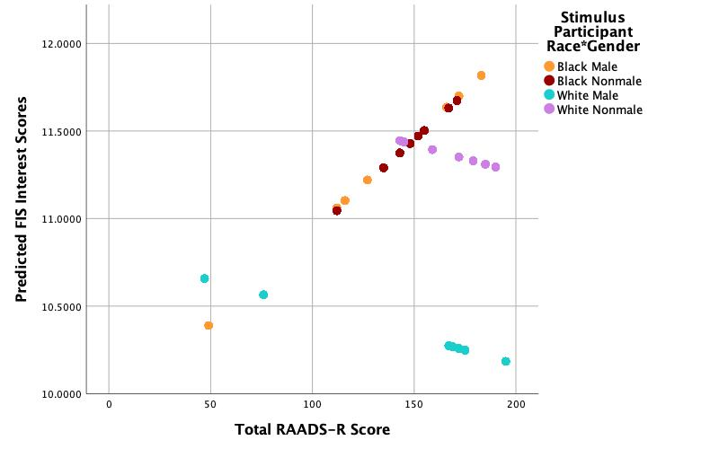
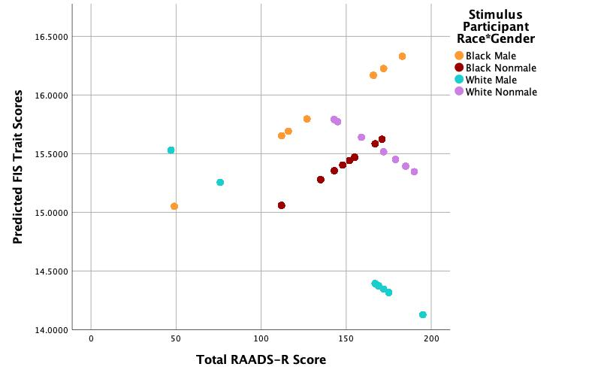
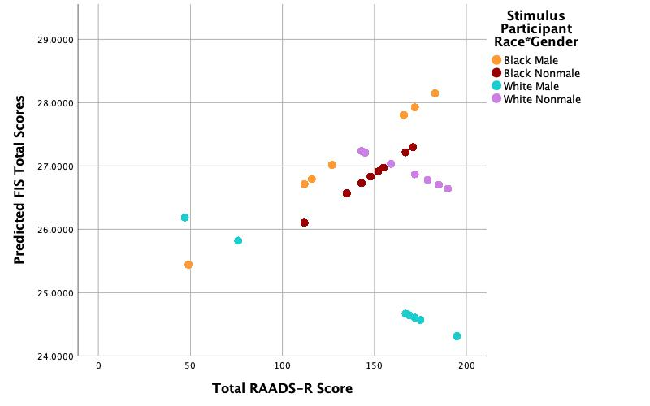
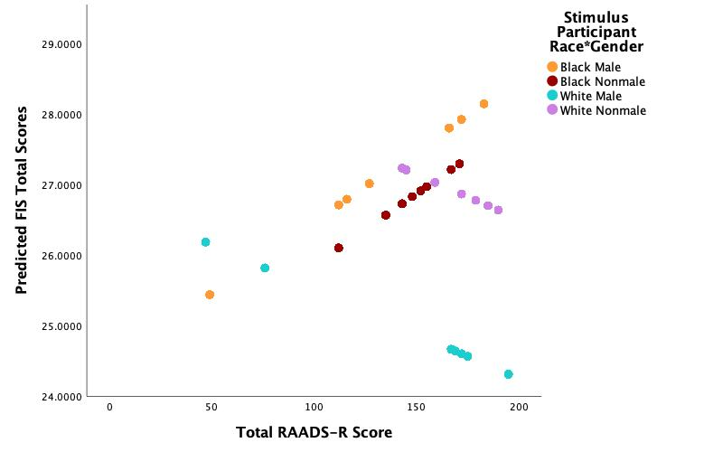
A
B
C
Figure 3. Predicted FIS Scores across RAADS-R Scores by Stimulus Participant Race and Gender
Each point represents a stimulus participant, and values are the model’s expected ratings for a typical rater. Panel A: FIS Total, Panel B: FIS Traits, and Panel C: FIS Interest.

FIS = First Impressions Scale
RAADS-R = Ritvo Autism Asperger Diagnostic Scale–Revised

*
*
*
*
*
*
*
*
*
*
*
*
*
*
*

Figure 4. Mean First Impressions Ratings by Rater Race
Note: Awkward was reverse scored such that higher scores indicated lower ratings of awkwardness.
Error bars signify standard error of the mean
*p < .05
**p < .01

*
*
*
*
*
*
*
*
*
*
*
*
*
*
*
*
Figure 5. Mean First Impressions Ratings by Rater Gender
Note: Awkward was reverse scored such that higher scores indicated lower ratings of awkwardness.
Error bars signify standard error of the mean
*p < .05
**p < .01

