teach for knowledge, mentor for success

preparing students to enter the workforce
Nedelina Tchangalova, Francy Stilwell
Engineering & Physical Sciences Library, University of Maryland, College Park, Maryland, United States
nedelina@umd.edu, fstilwel@umd.edu
Keywords: Honors programs, collaboration, emerging technologies, library instruction, subject guides, mentoring.
Abstract: The future well-being of any society arguably depends on the full knowledge potential students are able to transfer from academia to the workplace upon graduation. There are different mechanisms to transfer this knowledge, and at the University of Maryland, efforts are concentrated on establishing honors programs. These programs prepare students for the acquisition of lifelong skills such as research skills, team work and leadership skills by using emerging technologies in teaching and mentoring students through their course of study. The Gemstone program is one of the five honors programs on campus and its goal is “to give our students transferable skills that will be valuable for wherever life leads them.” This paper presents how campus collaboration may help with building the foundation of this academic knowledge and with transferring it later to the workplace.

1 INTRODUCTION
One of the goals of honors programs at the University of Maryland (UMD) is to prepare students to enter the workforce with confidence by developing a foundation of knowledge for career success. The Gemstone program is one of the five honors programs on campus that involves students in acquiring lifelong skills and expanding their knowledge potential. The first Gemstone class entered UMD in the fall of 1996 and finished the program in May of 2000. In this multidisciplinary four-year research program, under the guidance of faculty mentors and Gemstone staff, students work in teams on significant research projects, exploring the interdependence of science and technology with society. These students are digital natives, highly motivated and highly competitive; they are used to competing against their peers, even to the point of strain. They appreciate being challenged and do not feel it is a burden. Even more than just graduating and getting a diploma, these students want to obtain life-long skills from their college coursework. Below are selected testimonials encapsulating what students have learned throughout their research process:
- The Gemstone Team “Genes to Fuels,” which won the Library Award for Undergraduate Research (2011) this year from the UM Libraries, wrote in their application essay: “During the course of our research process, we picked up on some important lessons. We now have a sense of how quickly emergent scientific fields update and expand their knowledge. Like any other skill, researching literature needs practice to master, and we feel this project has given us plenty” (Gemstone Team “Genes to Fuels” 2011, p.2).
- Gemstone Team “Dietary Information and Evaluation Technologies” (DIET), another team competing for the same award learned that “the best way to further our learning is to utilize all available resources, and seek guidance with experts whenever possible. The ability to find scholarly support for an idea in a library is a key skill for any graduate school or job, and the skills we have been developing will surely help us in the future. Additionally, the critical analysis skills we have learned crosses over into other areas of life, not just for library research” (DIET 2011, p.2).
- Gemstone Team “Food Deserts” feels “more confident, adept and efficient in our research methods” (Gemstone Team “Food Deserts” 2011, p.2).

2 background
The University of Maryland, College Park, is a major public research university located on 1,250 acres of land in close proximity to Washington, D.C. UMD has 38 faculty members appointed to the National Academy of Sciences, the National Academy of Engineering, and the Institute of Medicine. Also, it has four current Nobel laureates in physics and economics. In the Fall of 2010, the total enrolment of students was 37,641 (UM Newsdesk n.d.). Within this academic institution, the Gemstone program provides a flexible environment for learning and conducting research while offering a rigorous curriculum to the selected students (Gemstone 2010). Each Gemstone team is assigned a team librarian to assist and guide them in their quest for information related to their research projects.
It is a well-known fact that companies today are willing to invest huge sums of money and time to encourage collaboration (Naimark 2004). Today, the sharing of ideas and information is considered to be more participatory and productive than lonely work in an office or in-class assignments. To meet these industry expectations and to prepare students to transfer seamlessly from academia to the corporate world, faculty mentors, Gemstone staff, and librarians provide an environment for students to work together in teams, either with others in the same building or same city, or even over long distances.

3 teaching
We find Gemstone students are interested in developing lifelong learning skills that will help them succeed. The same ambition that motivates these students academically is likely to bring them into the challenging world of corporate industry. It is important to adopt positive assumptions about their skills and create a mentoring environment that feeds their academic appetites, along with offering them opportunities for problem-solving and applying their skills.
3.1 Faculty members
Faculty members challenge and support the students in the development of research, teamwork, communication and leadership skills. To facilitate communication between team members, faculty professors use the Enterprise Learning Management System (ELMS), which is an online environment that supports teaching and learning at the University of Maryland (Figure 1).

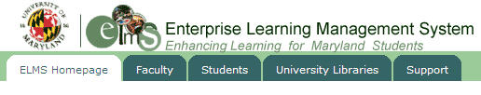
Figure 1: Enterprise Learning Management System

This system provides course materials, serves as a tool for exchanging ideas via a discussion board, and offers space for managing the students’ grades. Gemstone students are encouraged to explore other technologies to help facilitate the exchange of ideas, collect information for their projects, write their theses, and record all their activities. For example, the Gemstone Team “Genes to Fuels” created a web site to publicize their research process and findings (Gemstone “Team Genes to Fuels” 2009). To promote e-learning and teaching in a virtual classroom, some professors use the Wimba platform to communicate with their students without needing to be physically present in the classroom (Wimba 2009). Even more than this, the teaching faculty use the Wimba classroom as a virtual space to offer office hours for their students seeking help with their research.
In their fourth year, each team of students present their research, in the form of a thesis, to experts in the field. At the end of the program, students participate in a citation ceremony and enter the workplace with confidence and a great sense of accomplishment.
Finally, their research projects are archived in the Digital Repository at the University of Maryland (DRUM), thus making them accessible to future generations of researchers (Figure 2) (DRUM 2010).

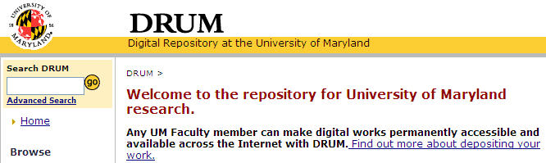
Figure 2: Digital Repository at the University of Maryland.

3.2 Librarians
The University of Maryland Libraries strive to provide quality orientations and literacy sessions to the students of the Gemstone program. Librarians volunteer to mentor one team or several teams at once. The librarians’ vision for the students is to become adept at determining the authority and accuracy of information, and analyzing and evaluating that information to synthesize new knowledge from multiple resources. Subject librarians model and teach these skills and strategies collaboratively with faculty instructors. They help students to formulate appropriate research questions, organize the search for data, analyze and evaluate the data found, and communicate the results. In this way students develop the skills and strategies needed to become independent, lifelong learners and to transfer this knowledge from academia to the workplace.
A variety of technological tools and services are used extensively during teaching to enhance the students learning experiences:
- Clickers and Laser Pointers. Librarians have begun to use classroom technology that allows students to respond and interact via small, hand-held, remote keypads, called "clickers." These classroom response systems enable subject librarians to collect student responses to a posted question, usually a multiple choice question. The answers are immediately collected and displayed on a classroom projection screen where both the students and the librarian can see and discuss them. Other low-cost innovative tools used by librarians at the Engineering & Physical Sciences Library (EPSL), are the laser pointers (Zdravkovska 2010). These devices “encourage interactivity and foster a sense of enjoyment as a result of the involvement and activity.” The use of these classroom teaching tools makes the library instruction session more interesting and fun for the students by engaging them in thinking about and initiating further discussions.
- Digital Reference. Outside of the classroom, librarians usually offer a “one-shot” library instruction at the beginning of the team’s program. Following this training, students seeking help are able to reach out to their librarians via chat or e-mail. Most librarians can be contacted via a chat window using the Meebo application or by using the chat service AskUsNow available 24 hours a day, 7 days a week.
- Subject Guides. Students rely on finding information using commonly used search engines like Google, Yahoo, etc. But an efficient way to introduce Gemstone students to scholarly publications within the library collections is to develop subject-specific guides using the CampusGuide platform. (Springshare 2011). Library subject guides, sometimes called research guides or pathfinders, are usually annotated bibliographies of books, reference materials, websites, databases, and journals within a specific discipline (Figure 3). Library resources that are selected and organized at the coursework level and in syllabi are more useful for students because these resources meet their specific research and information needs. (Adebonojo 2010, Hintz 2010).

4 mentoring
From the perspectives of the mentor and the mentee, both feel that building the mentoring relationship with the Gemstone teams plays an important role in the students’ professional growth. The benefits of such a mentoring relationship include socialization into the academic environment which can then segue to the corporate or academic workplace upon graduation. The mentoring relationship also helps students with the difficulties of decision-making throughout the research process and with the development of close collaborative relationships. Mentoring is a vital cog in the machinery of the Gemstone educational program, and faculty instructors, Gemstone staff and librarians take this relationship seriously. Every player in this relationship is rewarded for a job well done using different technologies.

Faculty members are proud of creating collaborative networks within an institution, disseminating their expertise and skills to the Gemstone teams, and building the next generation of scholars. They set an example for the students who can then bring what they have learned into the workplace. Instructors are acknowledged in the final theses that students archive into DRUM.
Our librarians gain a sense of personal satisfaction from seeing the team’s final theses, especially noting their use of library resources and scholarly works in their references.

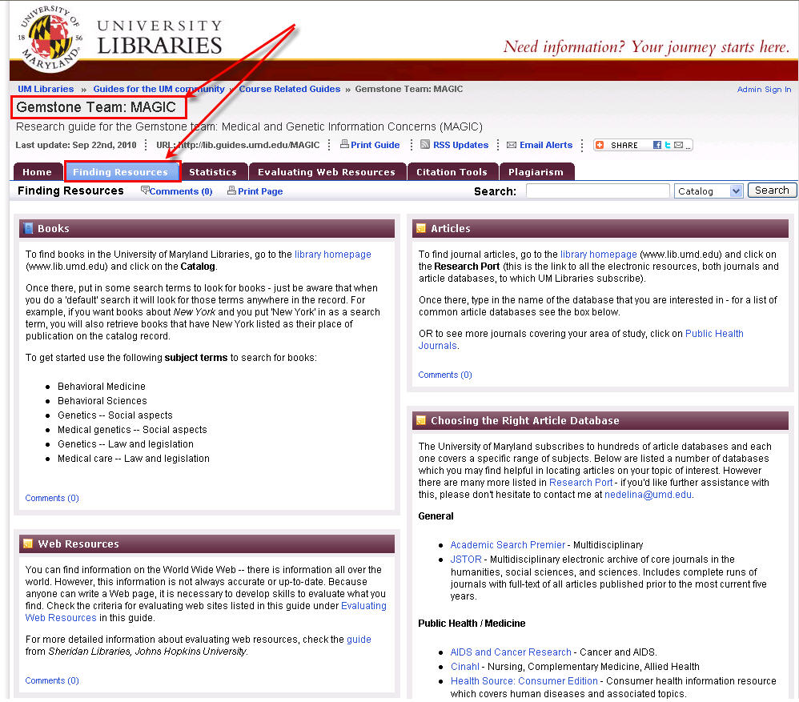
Finally, the students make headlines because of the mentoring program; the many successful grants awarded to these students speak well of their academic achievement (Figure 4) (Gemstone 2010).
Figure 3: Example of a subject guide created for a Gemstone team which include information resources

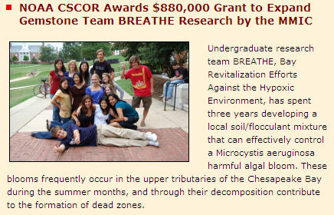
Figure 4: Grant awarded to a Gemstone team
Since the establishment of the Gemstone program, teams have received more than 30 grants from different institutions in the United States. The grant providing organizations range from small non-profits to multinational corporations and the total awarded thus far is approximately more than one million US dollars according to the data provided in an e-mail communication with Dr. Rebecca Thomas, Associate Director of the Gemstone Program, on May 11, 2011. In addition, they have received extra funding from the Gemstone program and various tangible donations, such as: mobile devices from Microsoft Inc., portable breath testers and PDAs from the Pacific Institute for Research and Evaluation (PIRE), and fire alarm control equipment. The teams have also benefited from complimentary services like free lab space and have received training from professional staff working in the corporate world.
5 Conclusions
There is a lot of pressure to improve university teaching and more and more faculty members are determined to better their own teaching practices through the use of technology. We are eager to move out of the established comfort zone of long-held beliefs and established teaching practices to try something innovative and different. We are motivated by the successes of our students and their thirst for knowledge; therefore, we aim to get away from the traditional “chalk and talk” mentality to help them enter seamlessly into the workforce. Our students pursue their career goals in various companies, including Google, IBM, Intel, and Microsoft to name a few (Gemstone 2010).
Acknowledgements
The authors thank Dr. Rebecca Thomas, Associate Director of the Gemstone Program, for her continued support of the UM Libraries and for her dedication in building a collaboration between Gemstone staff, instructors, mentors, students and librarians.
Thanks are also due to our library colleague, Bob Kackley, who tirelessly mentors new librarians and library graduate students, while simultaneously getting them involved with the Gemstone program.
References
Adebonojo, L. 2010. LibGuides: Customizing subject guides for individual courses. College & Undergraduate Libraries, 17(4), 398-412. doi:10.1080/10691316.2010.525426
Digital Repository at the University of Maryland (DRUM). 2010. [Internet] Available from: <http://drum.lib.umd.edu/> [Accessed 11 May 2011].
Gemstone. 2010. University of Maryland. [Internet] Available from: <http://www.gemstone.umd.edu/> [Accessed 11 May 2011].
Gemstone Team “Food Deserts”. 2011. University of Maryland. [Internet] Available from <http://hdl.handle.net/1903/11349> [Accessed 11 May 2011].
Gemstone Team “Dietary Information and Evaluation Technologies” (DIET). 2011. University of Maryland. [Internet] Available from <http://hdl.handle.net/1903/113544> [Accessed 11 May 2011].
Gemstone Team “Genes To Fuels”. 2011. University of Maryland. [Internet] Available from <http://hdl.handle.net/1903/11351> [Accessed 11 May 2011].
Gemstone Team Genes to Fuels. 2009. Home page. [Internet] Available from <http://www.genestofuels.com/index.php> [Accessed 11 May 2011].
Hintz, K., Farrar, P., Eshghi, S., Sobol, B., Naslund, J.A., Lee, T., Stephens, T., McCauley, A. 2010. Letting students take the lead: A user-centred approach to evaluating subject guides. Evidence Based Library and Information Practice, 5(4), 39-52.
Library Award for Undergraduate Research. 2011. University of Maryland. [Internet] Available from <http://libraries.umd.edu/libraryaward/> [Accessed 11 May 2011].
Naimark, A. 2004. Universities and industry in Canada: An evolving relationship. In Knowledge matters, Axelrod, P., ed. McGill-Queen’s University Press.
Springshare. 2011. [Internet] Available from: <http://www.springshare.com/> [Accessed 11 May 2011].
UM Newsdesk. N.d. Facts & Figures. University of Maryland. [Internet] Available from <http://www.newsdesk.umd.edu/facts/quickfacts.cfm>[Accessed 11 May 2011].
Wimba. 2009. Blackboard Collaborate. [Internet] Available from <http://www.wimba.com> [Accessed 11 May 2011].
Zdravkovska, N., Cech, M., Beygo, P., Kackley, B. 2010. Laser pointers: Low-cost, low-tech innovative, interactive instruction tool. Journal of Academic Librarianship, 36(5), 440-444.

