APA 6

SNAP Redemption at Farmers’ Markets: Assessing the Home Nutrition Environment and Healthy Food Accessibility for Maryland SNAP Families

Carolina Aguiar, Valerie Caplan, Emily Chang, Sophia Chang, Jennifer Kuo, Moses Lahey, Rutvij Pandya, Katherine Richard, Kelci Schexnayder, Monique Thornton, Rachel White
Team Food Deserts, Gemstone Program, University of Maryland

Table of Contents
Abstract……………………………………………………………3

Introduction…………………………………………………….….4

Literature Review…………………………………………………6

SNAP Case Studies and Successes..............................................7

Nutrition and Poverty …… ……………………………………......8

WIC Program Studies……………………………………………9

Education and Efficacy………………………………………….…11

Program Evaluations and Current Focus………………………….12

Theoretical Background……………………………………….......13

Methodology……………………………………………………..14

Market Analysis………………………………………….……….15

Cross-sectional Survey…………………………………….……..19

Intervention Analysis Survey...…….…………………………….25

Importance of Research………………………………………....30

Conclusion……………………………………………………...30

References………………………………………………………32

Appendices A-F………………..……………………………37-48
Abstract
Currently, 35.5 million Americans live in a state of food insecurity. To address this insecurity in impoverished households, the federal government has created programs to provide low-income citizens with monetary assistance to purchase food for their families, and achieve a more healthful diet. One such example is SNAP (Supplemental Nutrition Assistance Program). To better understand the effects SNAP availability in farmers’ markets, Team Food Deserts will conduct a mixed-methods research project in stages: first, a market analysis after the implementation of a SNAP redemption program in four area farmers’ markets; second, a cross-sectional survey of SNAP shoppers at the market investigating the relationship between self-efficacy and the home-nutrition environment; and third, evaluating a nutrition education program. At the conclusion of our study, we intend to establish a relationship between a parent’s self-efficacy to provide for their family and their home-nutrition environment, as well to show the economic feasibility of bringing SNAP to farmers’ markets on a wider scale.

INTRODUCTION
The United States Department of Agriculture’s Local Food Systems report defines food insecurity as the uncertain access to healthy and safe food, or limited means in acquiring food normally (Martinez et al., 2010). Today, there are 35.5 million people, including over 12 million children, in the United States living in a food insecure household (Yu, Lombe, & Nebbitt, 2010). A household with one or more children under age six is twice as likely to suffer from food insecurity (Yu et al., 2010). Many of these food insecure households may be located in food deserts, which are areas of limited access to or availability of healthy foods. Food deserts are usually characterized by segregation, poverty and an overall lack of the necessities of life, and, oftentimes, these areas of limited healthy food availability have higher rates of nutrition-related disease and health problems (Walker, Keane, & Burke, 2010). While these situations negatively impact the entire family, they are especially devastating to children, whose food availability and nutrition primarily relies on what a parent is able to provide.
The government has instituted a number of programs to relieve the burden of food insecurity and to increase healthy food access for families in food insecure households and in food deserts. One federal food supplement programs is the Supplemental Nutrition Assistance Program, formerly known as food stamps, which served over 33 million people in 2009 (USDA, 2010c). Households with a monthly income of 100 percent or less of Federal poverty guidelines are eligible and may redeem their SNAP benefits in most grocery stores to purchase almost any food item (USDA, 2010c). The Special Supplemental Nutrition Program for Women, Infants and Children (WIC) is a similar program designed for pregnant and post-partum women with children and infants under age five. WIC participants have more restrictions and limitations on what foods may be purchased with their benefits than do SNAP participants, as foods provided by WIC have been pre-selected for their nutritional value (USDA, 2010a).
To address the gaps in these programs, namely that fruit and vegetables are difficult to access due to limited availability in local stores and relatively higher prices per calorie, states and communities are turning to farmers’ markets (Drewnowski &Damon, 2005). Recently, farmers’ markets are being affiliated with food security programs because of the growing ease of accepting benefits from federal and state food and nutrition programs (Martinez et al., 2010). In fact, Congress established the Women, Infants, and Children Farmers’ Market Nutrition Program in 2002 to “provide fresh, nutritious, unprepared, locally grown fruits and vegetables through farmers’ markets to WIC participants.” This program has seen great success, and recently, similar efforts have been made on a smaller scale to implement comparable programs at farmers’ markets for SNAP benefits redemption (USDA, 2010a, FAQ section).
Team Food Deserts seeks to expand the body of research concerning the introduction of SNAP redemption programs to farmers’ markets through a multi-phased, mixed-methods research project that involves a market analysis, a cross-sectional survey, and a possible program evaluation assessing the results of an outside nutrition education program (see Appendix A). Through our market analysis, we aim to answer the question: what percentage of farmers’ market sales can be attributed to SNAP shoppers following the implementation of an EBT system? Our cross-sectional survey will seek to answer the question: What is the effect of parental self-efficacy on the home nutrition environment? We have defined the home nutrition environment as a combination of three variables: perceived barriers to food access, fruit and vegetable offerings in the home, and family health behavior. Finally, if there is a high retention rate throughout the nutrition education program run by our mentor and several partner organizations, we will administer a program evaluation to answer the question: What are the effects of two styles of a nutrition education program on parental self-efficacy and, therefore, on the home nutrition environment?
We hypothesize that implementing an EBT system in a farmers’ market will bring new SNAP shoppers to the market and therefore increase the market’s total sales. We also hypothesize that parental self-efficacy will be a significant predictor of the home nutrition environment quality. Lastly, we hypothesize that the outside nutrition education program will increase parental self-efficacy and improve the home nutrition environment.
The following sections of this paper will provide further information on the topics of our research, in addition to explaining how we will carry out our research. We include a defense of the purpose of our project, the effects we hope it to have on the local community, and the appendix is comprised of the tools we will use to complete our research.

LITERATURE REVIEW
Recently, there has been a significant push on both national and specifically local levels to target the issue of food insecurity and accessibility to fresh foods, especially for lower-income families and those on governmental assistance. Studies in the past few years have contributed substantial research to this topic, and the collection of literature on this subject is growing. Here, we overview relevant research pertaining to the following areas: SNAP case studies and successes of the program; the relationship between poverty and nutrition; an overview of similar projects based on the WIC program; education and parental self-efficacy; current focuses of national and local programs and finally a theoretical basis for our research. After a thorough compilation and analysis of these published research studies we have identified gaps that still exist in this field that we hope to address through our project. — specifically, how to successfully tie in the farmers’ market system to the SNAP program and evaluating factors affecting self-efficacy of program participants.

SNAP Case Study, a Success
Since its inception, the SNAP program has been embraced by low-income families across the nation and has received considerable support from community planners, vendors, and others closely connected to the national food environment. According Zedewski, Mon, and Yin (2009), an increasing number of low-income families are turning to SNAP as a feasible and comprehensive lifeline for nutritional sustenance. SNAP caseloads are at an all-time high not only because of the domestic economic stresses of the past few years, but also because of the decreasing stigma associated with receiving federal aid (Zedewski et al., 2009). We hope that this is reflected in the number of SNAP participants that start coming to the farmers' markets after the implementation of the EBT machines.
Federal guidelines state that SNAP-eligible families cannot have more than $2,000 in assets and must have gross incomes that fall below 130 percent of the federal poverty level (Zedewski et al., 2009). The majority of families enrolled in SNAP are single-parent households. The federal government pays for all SNAP benefits, with the exception of the administrative rates, which are covered by individual states. States also pay for SNAP if they offer eligibility to people outside of the federal government eligibility limitations listed above. According to one study, the program substantially reduces deep poverty incomes (defines as gross income below one-half of the poverty level) and moves many working families above the official federal poverty threshold. SNAP benefits cut the share of working families with children in deep poverty from 20 percent to four percent in 2007, and substantial increases were observed in the share of families with young children living at or above the official poverty level when SNAP benefits were added to cash income (Zedweski et al., 2009). These signs of SNAP's success are positive indicators, as we hope to further address the problem of food accessibility by working with the federal program.

Nutrition and Poverty
Studies have demonstrated a relationship between nutrition-related diseases and poverty. A fitting example of one of these studies was completed by Pickett et al. (2005), it sought and found a correlation between the obesity levels and lower incomes in developed countries. There are many factors that explain why people of lower socio-economic status tend to have poorer health outcomes, including limited availability of fresh fruits and vegetables. For example, lower income individuals often have difficulty accessing fresh produce because of the absence of supermarkets in impoverished areas (Bollen et al., 2008). A compilation of market analysis by Bollen et al. (2008) shows that the ability of farmers markets to accept SNAP benefits will greatly alter fresh produce availability to low-income groups.
Cultural norms, food accessibility, and individual preferences and characteristics influence an individual’s food purchases and eating habits (Steptoe et al., 2003). A study conducted by Steptoe and colleagues (2003) examined the relationship between the attitudes and shopping habits of consumers and their belief in health benefit, perceived barriers, self efficacy, nutritional knowledge and encouragement. Our proposed research also evaluates how self-efficacy plays a role in how individuals choose whether or not to buy fruits and vegetables. This study concluded that an individual’s knowledge about the recommended consumption of fruits and vegetables is the best predictor of fruit and vegetable intake. This information is useful in the development of our study because it suggests that nutritional knowledge is a determining factor in an individual’s food choice. This will be particularly important to our team if the participant retention rate in our study is high enough to enable the implementation of the second phase of our project. This phase includes a survey evaluating a nutrition education program aimed at informing SNAP shoppers about their health needs and how to fulfill them.

WIC Program Study
The WIC program has also seen much success over recent years. The WIC food package was recently modified in an effort to improve its nutritional quality and to increase partnerships with local farmers' markets and the SNAP program. Paralleling the implementation of SNAP benefits at farmers' markets through EBT machines, the installation of WIC redemption at markets has been piloted and research has shown that such supplemental support has had positive effects (Herman, Harrison, & Jenks, 2006). Though WIC targets a smaller, more specific population than SNAP, results of WIC redemption at farmers’ markets can be compared to SNAP redemption at farmers’ markets because they are similar programs. Thus, basing our research off of these findings, we have support to proceed with our project.
One study investigated the impact of providing supplemental financial support in the form of vouchers specifically to purchase fresh produce. The study was designed to test whether WIC participants would use the vouchers and, if so, how the vouchers would affect what foods were purchased by these individuals (Herman et al., 2006). The study results indicated frequent use by participants, and researchers concluded that the low-income women used almost all of the vouchers, and purchased a wide variety of healthy fruits and vegetables over the course of the study (Herman et al., 2006). Neither participants nor retail vendors reported any significant barriers to voucher redemption at any of the sites, and the retailers did not find the study burdensome to their operations, but rather, were positive about their participation. Overall, the researchers found that, provided a targeted subsidy, low-income consumers make wise, varied, and nutritious choices from available produce, and are cognizant of dietary improvement (Herman et al., 2006).
Providing the vouchers can be likened to the installation of EBT machines at markets for the SNAP program. The targeted population for this WIC study also serves as a basis for our selection of participants. As for the market analysis portion of this study, they worked in a very similar fashion to what we hope to do — they gathered sales data from the market manager and recorded the redemption of the vouchers. They also carried out in-depth interviews with participants to address further questions.

Education and Efficacy
Studies have been conducted to determine the effectiveness of educational nutrition programs in changing the eating habits of a population. A study conducted by Reger and colleagues (1998) aimed to determine whether educational information regarding health would promote the sale and consumption of low-fat milk. The team measured the effectiveness of their study by monitoring pre- and post- intervention sales of high- and low- fat milk and using a telephone survey to determine changes in individuals’ milk consumption habits. This study is similar to ours in that it examines the situation from both a market perspective and behavioral perspective. The study determined that educational programs providing nutrition information have been very effective in altering eating habits.
The Farmers’ Market Nutrition Program, an aspect of the WIC program, increases the availability of fruits and vegetables to all members of society in an effort to increase awareness and popularity of farmers markets (Just & Weninger, 1997). Just and Weninger(1997) concluded that farmers’ markets that accepted WIC coupons increased their profits by 8 percent. They also found that, as the amount of educational information regarding healthy eating habits increased, fruit and vegetable consumption increased. This study has important bearings in the current research because it suggests that healthy eating was increased by both the ability of shoppers to use their WIC benefits and the availability of nutritional information.

Program Evaluations and Current Focus
Food accessibility is now coming more into the national spotlight, aided by the successful onset of these nutritional programs and an increased awareness in general of food justice (especially on a federal level). As a result, program evaluation and monitoring efficiency of these programs is fast becoming an important area of research.
The Community Food Security Coalition reported the current status of individual state WIC program modifications to implement new produce packages, which provides opportunities for WIC clients to use their benefits at farmers’ markets (Fisher, et al. 2009). The report assessed the implementation of the recently established WIC Produce Package Rule. One aspect of the new package with particular significance for community food systems is the addition of fruit and vegetable vouchers. The interim rule includes cash value vouchers or checks to be used to purchase fresh fruits and vegetables. This aspect also allows states to authorize farmers at farmers’ markets to redeem cash-value vouchers for fresh produce. The research primarily evaluated the potential impact of linking the WIC program with farmers’ markets, and also addressed how the WIC program, alongside the Farmer’s Market Nutrition Program, could be further developed to incorporate the needs of both participants and vendors alike. The researchers found that discrepancies between cash-value vouchers, the technical difficulties of installing EBT systems, and the accessibility of farmers’ markets specifically for WIC participants are cited as the primary concerns on the state-level, as reported by vendors, participants and government officials/coordinators in the states that were observed in detail (New York, California, Texas, and Washington). Recently, researchers have made numerous policy recommendations at the local and national level, especially directed at the Food and Nutrition Service of the USDA. Including modifying WIC regulations and redemption systems to better incorporate farmers as vendors, planning early to coordinate the establishment of both WIC and SNAP EBT at the same market as to avoid duplication of resources and increasing efficiency for both consumers and vendors. This concern ties into our research, because, while we are not focusing on the WIC program, we hope to improve accessibility to fresh produce through the increased efficiency and representation of SNAP at farmers’ markets.

Theoretical Background
Using the Theory of Planned Behavior (TPB) as our guide, we expect to find a relationship between self-efficacy and the home nutrition environment. According to the theory, an individual’s attitudes, subjective norms, and perceived behavioral control contribute to that individual’s behavioral intentions (Ajzen, 1991). Azjen (1991) emphasizes the importance of perceived behavioral control and asserts that a person’s resources and opportunities must to some extent determine the likelihood of behavioral achievement. Perceived self-efficacy (people’s confidence in their ability to perform a behavior), as defined by Bandura et al. (1977, 1982) was identified as being interchangeable with perceived behavioral control by Azjen (1991), and has been shown to strongly influence behavior (1977, 1980).
With our cross-sectional survey, we expect to find that parents with lower self-efficacy scores also have lower home nutrition environments scores. Using TPB, parents with low self-efficacy have low perceived behavioral control, which indicates that these parents have more perceived barriers to healthy eating and food access, leaving them less inclined to improve or change family health behaviors and fruit and vegetable consumption in the home, and resulting in low home nutrition scores.
The nutrition education program will provide parents with the tools and strategies needed to improve the home nutrition environment (e.g. promoting home fruit and vegetable consumption), which should result in an increase in home nutrition environment scores. Conner et al. (2003) found that intentions were predicted by attitudes, perceived behavioral control, and perceived past behavior cross-sectionally when TPB was applied to healthy eating in 144 health promotion clinic attendees. These participants self-reported TPB measures after the clinic, six months later, and then six years later. Similar this to study, with a post-test—dependent on participant retention—we expect to find that the educational program increased parental self efficacy, which decreased perceived barriers to fruit and vegetable access, increased fruit and vegetable consumption in the home, and empowered parents to change negative family health behaviors. Higher self-efficacy should result in an increase in behavioral intention and an increase in the likelihood of a parent performing the desired behavior: improving home nutrition environment.
METHODOLOGY
The following portion of our proposal describes the methodology we will use to answer our research questions. The first section discusses the market analysis, explaining how we will identify the markets we are studying, the function of EBT machines, and how we will collect and analyze our market data. The second section describes the survey we will administer to SNAP recipients shopping at our chosen farmers’ markets, which will examine the relationship between parental self-efficacy and the home nutrition environment. The final section describes a possible post-test that we will administer to the SNAP recipients we have previously surveyed, which will examine the relationship between parental self-efficacy and the home nutrition environment following an education intervention. Each section also outlines confounding variables and limitations of the methodology.
Market Analysis
To address the question, what percentage of farmers’ market sales can be attributed to SNAP shoppers following the implementation of an EBT system, we will collect quantitative sales data from four farmers’ markets in the Prince George’s County Maryland, area during the 2011 market season. Our mentor, Dr. Stephanie Grutzmacher, has secured a partnership with several local organizations that deal with food and food access issues: Maryland Hunger Solutions, the Maryland Department of Agriculture, and the Prince George’s County Extension. These groups will identify four appropriate sites for research. Suitable markets are ones that do not already have EBT machines, are guaranteed to be open for the entire 2011 market season (June to November), and are close to a sizeable SNAP recipient population. These organizations will also have the responsibility of working with market coordinators, installing the EBT machines, ensuring that a market worker will be able to run the machine, and obtaining permission for our team to set up a table near the EBT machine to survey market customers. While our partner organizations will not have a final decision for several months, four potential options include markets in Cheverly, Hyattsville, Wheaton, and Greenbelt. Once markets have been identified and selected, EBT machines will be purchased with money from grants, and our partner organizations will install the EBT machines. These organizations will also conduct outreach in the areas around the markets to inform SNAP participants of the machines’ recent installation.
At the end of the market season, we plan to interview market vendors about their experiences accepting SNAP benefits. While we have not yet decided on our exact questions, we plan to ask about the vendors’ experiences with the scrip system described in the following paragraph. We will also be asking for their general impressions about having new SNAP shoppers in the market.
Data Collection and Analysis
The market sales analysis will be quantitative. Our independent variable is the presence of EBT machines, and our dependent variables are both the total volume of sales in the market and the sales in the market from SNAP shoppers. To see how the recently-added EBT machines influence the dependent variables, we will collect sales data from the EBT machines and from the market as a whole. Market coordinators will be able to provide sales data from the entire market. Markets that accept SNAP benefits use scrip systems and point-of-service (POS) terminals, where the EBT machines are located (USDA, 2010b). From the records kept by this system, we will be able to collect SNAP sales data. Since we will be providing one EBT machine per market, there will be one POS terminal at the market. SNAP participants can use their benefits by swiping their EBT card at the EBT machine located in the POS terminal. In exchange, they are given scrip (paper certificates or wooden tokens) that are given to individual farmers and vendors while shopping. At the end of the market day, vendors give the scrip back to the market coordinators and staff, and the market goes through its own procedures for paying back the vendors (USDA, 2010b).
Another potential set-up for EBT machines is for SNAP customers to receive receipts from the vendors and bring the receipts to the POS terminal where they swipe to pay for purchases, while leaving their goods at the individual vendors’ stands. Market coordinators are in charge of tracking receipts and making appropriate payments to the farmers and vendors after the market day ends (USDA, 2010b). Individual markets will determine which system to use, and details of operation will be worked out between the market coordinators and our partner organizations. Regardless of whether the markets use receipts or scrip systems, we will be able to obtain sales data for SNAP shoppers from the EBT machines.
In order to fully evaluate the market data, we must first set a standard of success for market revenue—which also incorporates the fraction of sales that can be attributed to EBT machines. There are significant costs to implementing an EBT program in a farmers’ market. An EBT machine has a one-time cost of approximately $1000, a wireless network connection fee of approximately $65 per month, and transaction fees of $0.10 for every time an EBT card is swiped (“Increasing Access,” 2009). If the new revenue brought in by SNAP sales for the entire summer market season covers these costs, we will classify the program as a success.
After obtaining consent, we will conduct our interviews with vendors at the market, during the market day at times that are convenient for the vendors. All interviews will be tape-recorded and transcribed. To analyze our interview data, we will use the tagging software ATLAS.ti (ATLAS.ti, 2010), which will allow us to code transcripts of our interviews and identify common themes.

Confounding and Extraneous Variables and Limitations
We decided to only look at market sales made in 2011 to eliminate several confounding variables. If we compared 2010 sales to 2011 sales, many significant factors could have changed, influencing our data. The economic climate of the entire area as well as individual families’ financial situations may not be the same; the vendors present at the market may vary from year to year; and the volume of shoppers may not remain consistent between the 2010 and 2011 seasons. However, we will have access to the 2010 total sales data if we decide later on that it will be helpful for an analysis. We are also considering obtaining sales data from another market in the area that does not use an EBT machine as a control group for comparison if one is available.
Another confounding variable is that SNAP shoppers could be purchasing baked goods instead of fruits and vegetables. While we presently only plan to look at the total SNAP shopper sales versus the total market sales, should this prove too great a limitation to our study, we have an alternative option. Each vendor at a farmers’ market has an individual number that is entered into the EBT machine at POS terminals (“Increasing Access,” 2009). Therefore, we could break down our data into specific vendors if we wish to do a more in-depth analysis of the foods that SNAP shoppers are buying at the markets.
Other extraneous variables include the variety of foods offered (some markets may simply have a wider selection of produce than others), shoppers’ individual tastes and preferences, and the four markets’ different customer compositions, hours of operation, and vendors. Variables such as these could affect the ability of SNAP recipients to shop at a specific market and could therefore result in our analysis finding that one market is more (or less) successful than the others.
Anticipated Results
We expect to find that installation of EBT machines increases the sales made at the four farmers’ markets, due to the presence of new SNAP shoppers. These sales will meet or exceed the standard of success defined above. We predict this outcome because of the relative success that previous EBT and SNAP implementation programs have had in other farmers’ markets. For example, the Greenmarket network in New York City, comprised of 57 markets, accepted $150,000 in food stamp benefits and $1,000,000 in benefits from the WIC Farmers’ Market Nutrition Program in 1998 (Payne, 2002). After implementing a wireless EBT SNAP redemption program, Greenmarket’s SNAP sales increased to $251,000 in 2009 (USDA, 2010b). In addition, the USDA reports that from 2008 to 2009, the “the total value of SNAP redemptions at farmers’ markets and farm stands nearly doubled, from over $2 million to over $4 million” (USDA, 2010b, para. 5). These numbers point not only to feasible but also financially successful EBT implementation programs.
The WIC Farmers’ Market Nutrition Program has also been widely regarded as a success, another indicator that supports our anticipated results. In 2009, 2.2 million people participated in the WIC Farmers’ Market Nutrition Program, generating “$20 million in revenue to farmers” (USDA, 2010a, para. 11).
Cross-Sectional Survey
The second half of our market analysis will address the second question, what is the effect of parents’ self-efficacy on the home nutrition environment, through the use of a cross-sectional survey. Specifically, the survey will evaluate the relationship between parent self-efficacy and, respectively, fruit and vegetable consumption in the home, perceived barriers to healthy eating and food access, and family health behavior.
Data Collection and Analysis
We will administer a survey to a convenience sample of two hundred SNAP shoppers at the four markets (fifty shoppers per market). To obtain our sample, we will set up a table near the EBT machine and advertise our survey. Each participant will be paid twenty dollars for their involvement in our study. To qualify for our survey, participants must be parents living with their children, and at least one of their children must be between five and ten years old. Also, neither the participants, nor anyone in the household, may suffer from any food allergies or serious dietary health conditions such as diabetes. Finally, only one member of each household may take the survey; one family or household will be considered our unit of analysis.
After obtaining consent from the participants, we will administer surveys individually. For those survey respondents who are illiterate, a team member will administer the survey orally and then record their answers. We may hire a student translator to translate our interview and other materials if the market locations determined by our partner organizations will likely serve a large population of non-English speakers. Interview protocol will include questions from several preexisting surveys that measure parent self-efficacy (Cullen et al., 2000), consumption of fruits and vegetables (Townsend & Metz, 2006) perceived barriers to food access, and the home nutrition environment (Ihmels, Eisenmann, & Myers, 2009) (see Appendices B-D).Through the survey responses, we can measure our dependent (consumption of fruits and vegetables, perceived barriers to food access, and the home nutrition environment) and independent variable (parental self-efficacy).
Our survey will also incorporate questions about demographics, including age, sex, income, race/ethnicity, education, and household composition. Several final survey questions will determine ease of access to the farmers’ market, including mode of transportation and distance traveled. The responses to all survey questions will be scored for later analysis. The exact questions have yet to be determined. For questions that involve children, respondents who have more than one child will be asked to select a “reference child” on whom they will base their answers. This “reference child” should be between five and ten years old. Finally, participants will be assigned a number for tracking purposes. They will fill out a document, separate from the survey, on which they will provide an address and contact information and the contact information for several friends or family members who would be able to get in touch with them should they move or change phone numbers for later use during the possible follow-up study (see Intervention Analysis Survey).
During our data collection period, we will conduct in-depth interviews with between twenty and thirty randomly chosen survey participants. Immediately after the participant has taken the survey and after obtaining consent for an interview, we will ask several open-ended questions to gauge their feelings about the market and why they choose to purchase what they purchased. The interviews will be conducted on-site, and will be tape-recorded and transcribed shortly following the interview to preserve the initial responses of the interviewed participant (Mobley, 2010).
To analyze our survey data, we will use the Statistical Package for the Social Sciences (SPSS Inc, 2009) program. After entering the data from our cross-sectional survey, we will go through the process of data cleaning by addressing missing data and data entry errors. After cleaning the data and creating and recording the necessary variables for analysis, we will use linear regression and the Pearson product-moment correlation to determine relationships between our variables. We are using the Pearson product-moment correlation method because our data will be score data as opposed to ordered data (Graziano & Raulin, 2010). Linear regression will be used to determine the extent to which parental self-efficacy will explain variance in the home nutrition environment outcomes of fruit and vegetable consumption in the home, perceived barriers to healthy eating and food access, and family health behavior. We will also determine any demographic trends among our key variables. We will use ATLAS.ti to analyze themes within the tape-recorded, in-depth interviews.
Confounding and Extraneous Variables and Limitations
As mentioned above, we intend to control for several confounding variables through our selection criteria and interview protocol. Some survey candidates will be eliminated from the outset because they are not the parents of or do not live with a child between the ages of five and ten. We are only surveying parents because one of our research goals is to determine not only the health habits of an adult individual, but also how these habits affect the household and, in particular, children within the household. Because of this, the participant must live with his or her child to ensure that the participant’s mentality and decisions directly affect the child.
We have set the minimum age as five years old for children with the assumption that, by age five, the majority of children eat the same foods as the older children and adults in their household. We chose ten years old as the maximum age for children with the assumption that, after age ten, children become more autonomous and may select foods outside the home and beyond what their parents provide. Because we are exploring parent self-efficacy, we strictly defined this age range to ensure that the participants are primarily responsible for feeding their child or children. Although family composition varies widely beyond the traditional parent-child household that we will present in our research, in limiting our participants to these criteria, we hope to control for as many external or otherwise influential factors as possible.
However, some extraneous variables cannot be controlled for using our research design. For instance, although our selection criteria should increase the likelihood that the respondent is responsible for grocery shopping and food preparation in the household, some participants may be less aware of the health habits of their families. Also, while the respondent will ideally be cognizant of his or her child’s eating habits, some respondents may not be sufficiently aware to answer questions regarding their child’s nutrition and health habits. Additionally, self-reporting bias might skew the results, as people may not be honest about reporting their health habits, particularly those health habits that may be viewed as undesirable (Subar et al., 2003). We also suspect that a mother’s education will play a key role in our results, as more educated mothers are more likely to have a stronger sense of self-efficacy (Coleman et al., 2000).
Because we are selecting a convenience sample, our results will not be representative of the entire population of SNAP participants; our results may only be applicable to SNAP users who shop in farmers’ markets in the targeted region. Finally, our results may be subject to volunteer bias, as those shoppers who volunteer for our survey may be more health-conscious than shoppers who did not volunteer. Because of the difficulties of obtaining volunteers, a small sample size may also be a limitation of our study. If we cannot obtain a large enough sample, our results may not be generalizable to the larger community (Graziano & Raulin, 2010). Also, our final results may not be generalizable to farmers’ markets outside of Maryland or to farmers’ markets in extremely rural or highly urbanized areas, as the farmers’ markets in our research will be primarily suburban.
The qualitative data that we obtain from our interviews will have similar limitations and confounding and extraneous variables. However, this qualitative data may also be subject to interviewer reactivity, as the interviewer may be inclined to react more to certain details than to others (Graziano & Raulin, 2010). Participants may also be less honest with face-to-face interviewers than they might be on a survey. Lastly, because of time constraints, we may not be able to go as in-depth with our interviews as we would like.
Anticipated Results
We anticipate that our analysis will demonstrate that parent self-efficacy is a significant predictor of fruit and vegetable consumption in the home, perceived barriers to healthy eating and food access, and family health behavior. We expect these results based on our review of TPB, which states that personal beliefs influence behavior (Ajzen, 1991). In our research, the belief in question is perceived self-efficacy, and the behavior is the individual’s health decisions, which impact his or her home nutrition environment. For our survey, we expect that, if an individual’s self-efficacy score is low, he or she will have a correspondingly low score for the home nutrition environment. Similarly, we expect that a high self-efficacy score will be a predictor of a strong home nutrition environment score.
Intervention Analysis Survey
The last portion of our research project focuses on the effects of a nutrition education program that will be carried out by our partner organizations. The nutrition education program will aim to improve participants’ sense of self-efficacy and better their home nutrition environments. Program participants will be recruited from survey respondents by our mentor and our partner organizations. The program participants will be split into two groups: a control group and an experimental group. The control group will only be presented with nutritional literature, whereas the experimental group will receive personalized one-on-one nutrition education and counseling. Following this nutrition education program, we will administer a post-test, our program evaluation, to answer our third question, what are the effects of two styles of a nutrition education program on parental self-efficacy and, therefore, on the home nutrition environment?
Data Collection and Analysis
After the nutrition education program has been carried out, our team will conduct a survey as part of a program evaluation regarding the effectiveness of the program in increasing parental self-efficacy. Program evaluations are used to determine if a specific social program is effective, well organized, efficiently delivered, and supported by the participants and community (Magill, 1993). In terms of our research project, the program evaluation will assist us in determining if the two types of education given have varying effects on parental self-efficacy, and consequently if and how this changed self-efficacy affects the home nutrition environment of the household.
As mentioned previously, our research takes on a mixed method approach, comprised of both quantitative and qualitative research. The quantitative aspect will provide a more concrete and reliable evaluation of the education programs (Magill, 1993). The first survey will be used a pre-test data and the second survey will be post-test data. Because program evaluations are applied research, after compiling the quantitative responses from participants of the two groups, we will be able to determine which intervention is most effective at increasing parental-self efficacy, and therefore the home nutrition environment, in these circumstances (Graziano & Raulin, 2010).
The participants surveyed in the nutrition education program post-test will be participants from both the cross-sectional survey and the nutrition education program. We will reach the participants using the tracking number and contact information collected during the pre-test. We will contact them upon the completion of the education intervention. Because the post-test is identical to the cross-sectional survey, with the addition of a few questions about the nutrition education program, we will be able to see if there has been any change in the variables we are measuring. First we will compare results from the pre-test to the post-test to see if parental self-efficacy increased during the nutrition education program. Next, we will determine whether the home nutrition environment improved during the nutrition education program. The additional questions will ask the respondent to reflect on his or her experience in the educational program.
As with the cross-sectional survey, we will use the SPSS program to analyze the quantitative data obtained from the post-test to compare with the pre-test. Before analyzing our data, we will once again clean our data and address missing variables. We will do an ANOVA, using an analysis of covariance to determine whether the nutrition education program resulted in significant changes on our key variables. This analysis will determine the relative effectiveness of two intervention approaches in improving parent self-efficacy and the home nutrition environment.
Confounding and Extraneous Variables and Limitations
We have designed our project in order to overcome many threats to validity, yet some confounding and extraneous variables remain. One issue concerning the actual intervention is that it may be considered unethical to randomly assign a group to a treatment that may not have as much of a beneficial effect as the other group’s treatment. Additionally, while a program may be effective, our pre- and post-test evaluation cannot determine the cause of its efficacy (Munck & Verkuilen, 2005). For our purpose, this is not necessarily a drawback, as we are primarily focused on determining the effects of two types education.
Our survey responses may be analyzed to determine some perceived advantages and disadvantages of the nutrition education program intervention and, as well as used to make suggestions for future programs. These advantages, disadvantages, and speculations may then be shared with the partner organizations that conduct the program, in order to make changes and improvements for the future, as well as models for other programs.
Measurement reactivity may cause participants to answer differently on a survey since they are aware that their results will be compiled and measured by researchers (Graziano & Raulin, 2010). Similarly, the experimenter effect refers to any preconceived notions that we may have as to results or conclusions an experiment should yield (Graziano & Raulin, 2010). Although we are using well-established surveys, it is possible that, in combining them, we may inadvertently bias our results. We plan to prepare our interview protocol in a manner that allows for open communication between interviewer and interviewee and encourages honesty in participant responses (Mobley, 2010). The surveys should counteract any experimenter effects since participants’ answers to questions yielding quantitative data will not have to be interpreted.
Maturation, history, and attrition all pose threats to our project’s validity due to the long period of time over which the research will take place. Maturation (any changes due to normal growth or predictable changes) can result in participants changing their behaviors despite the educational intervention (Graziano & Raulin, 2010). We have no way of knowing whether if the change in participant behavior is attributable to the educational intervention, simply their new access to farmers’ markets, or participants’ awareness that they are being monitored within a study focusing on nutrition. History is the chance that an event may occur during the study, yet completely independent of the study, that causes the participants to change their behaviors (Graziano & Raulin, 2010). Again, we have no way of accounting for this in our results. Attrition is the loss of participants during the intervention, which may leave us with an inadequate sample size to yield valid results (Graziano & Raulin, 2010). We will account for this by only continuing with the post-test if we have a 56% retention rate of participants that complete the intervention and agree to continue to the program evaluation. We have chosen this percentage based on a power calculation. The calculation takes into account our sample size and how precise we want our results to be. If our retention rate falls below the 56% threshold, our results may be less reliable because the sample size has decreased significantly. This could adversely impact our analysis because it may prevent us from accurately identifying trends within our sample. If the sample size is too small, it becomes more difficult to demonstrate that the trends observed in our data are relevant outside our research.
Anticipated Results
We predict that there will be a difference in participants’ survey responses before the nutrition education program compared to participants’ survey responses after the nutrition education program. The differences will suggest increased parental self-efficacy after the nutrition education program. We have based our hypothesis on the results of a WIC program introduced in 2001 that suggested positive effects that arose as a result of an educational intervention. This program evaluation of an educational intervention showed that, compared to participants in the control group, participants in the intervention increased their daily fruit and vegetable intake by more than one-half serving, on average (Herman, Harrison, Afifi & Jenks, 2008).
We also predict that the experimental group, the participants who receive a one-on-one individualized nutritional education, will have a greater increase in their sense of self-efficacy and therefore an improvement in their home nutrition environment than the control group, who are only presented with nutritional literature. It has been predicted by health professionals that the future of nutritional education will consist of a combination of curricula, nutrition education programs, and nutrition materials (Anderson, 1994). Based on these assumptions, we have higher expectations for the experimental group to experience increased self-efficacy than the control group. We believe that we can maximize the success of an educational intervention by including an in-person education in addition to literature.
Importance of Research
Our research and anticipated results will be an important contribution to the field because no market evaluation and cross-sectional study have been conducted on the farmers’ markets we will be studying, as no EBT machines currently exist in the farmers’ markets we will be evaluating. Furthermore, no similar study have yet been performed in Maryland. We hope to contribute valuable knowledge not only to the larger research community, but also to organizations seeking to improve nutrition in the home and food accessibility.
Because we are conducting a cross-sectional study in the first part of our study, our research cannot imply causality (Graziano & Raulin, 2010). However, our first study will demonstrate that a relationship does or does not exist between self-efficacy and our three dependent variables (reported barriers to food access, fruits and vegetables in the home, and family health behavior). If we are able to complete a program evaluation through our post-test, we can assess this type of intervention’s success, providing either a model or improvements to be made in similar programs in the future. Furthermore, both of our surveys may show whether there is a relationship between fruit and vegetable consumption and level of education.
CONCLUSION
Our research will determine whether or not the addition of EBT machines in farmers’ markets can increase the sales in a farmers’ market due to of the addition of SNAP shoppers, and if a relationship exists between parents’ self-efficacy and fruit and vegetable consumption in the home, perceived barriers to food access, and family health behavior in SNAP households. If participant retention rates are sufficient, our research may also determine which type of intervention is more effective in improving the home nutrition environment in SNAP households. Our research may help local SNAP households to increase their fruit and vegetable consumption and provide them with information on preparing healthful foods for their families, which may in turn lead to better health for these SNAP users.
This study will ultimately help local neighborhoods establish a framework to efficiently provide healthy foods to SNAP recipients, and consequently help improve parental self-efficacy. We will better grasp how parental self-efficacy affects the perception of barriers to food access, what foods are present in the home, and a family’s eating habits. This information will help us determine how to best address the problem of food intervention with nutritionally-at risk families. We hope that our research will benefit the community by not only directly introducing SNAP redemption machines to area farmers’ markets and affecting these local businesses, but also in evaluating how education impacts people’s eating habits. Through this project we will gain knowledge about eating habits in the home as well as information regarding fresh food accessibility for SNAP recipients. The significance of this research is far-reaching because it will contribute to the already established and still-growing lexicon of literature and research on food insecurity and the connection with the farmers’ market system.

References
Ajzen, I. (1991). Theory of Planned Behavior [Figure]. The Theory of Planned Behavior. Organizational Behavior And Human Decision Processes. 50, 180-185. Retrieved September 15, 2010, from www.courses.umass.edu/psyc661/pdf/tpb. obhdp.pdf
Anderson, J.E. (1994). What should be next for nutrition education? The Journal of Nutrition, 124(9), 1828-1832.
ATLAS.ti. (2010). ATLAS.ti Version 6.2. Berlin, Scientific Sofware Development.
Bollen, C., Vernez-Moudon, A., Kinney, K., Drewnowski, A. (2010). How
farmers can promote access to healthy food. University of Washington Center for Public Health Nutrition, 1-4. Retrieved November 1, 2010, from http://depts.washington.edu/uwcphn/reports/fm_brief.pdf.
Coleman, P. K., Karraker K. H. (2000) Parenting self-efficacy among mothers of school-age children; conceptualization, measurement, and correlates. Family Relations, 49(1), 13-24.
Cullen, K..M., et al. (2000). Socioenvironmental influences on children's fruit, juice
and vegetable consumption as reported by parents: reliability and validity of measures. Public Health Nutrition, 3(3), 345-356. Retrieved October 19, 2010, from the Cambridge University Press database.
The Food Trust. (2009, July 20). Increasing access: The Clark Park farmers market SNAP/food stamp pilot program. Retrieved October 25, 2010, from http://www.thefoodtrust.org/catalog/resource.detail.php?product_id=158
Fisher, A., & Tessman, N. (2009). State implementation of the new WIC produce package: opportunities and barriers for WIC clients to use their benefits at farmers’ markets. Community Food Security Coalition. Retrieved on November 12, 2010 from http://www.foodsecurity.org/pub/WIC-FarmesMarketReport.pdf
Graziano, A., & Raulin, M. Research methods: A process of inquiry (7 ed.). Boston, MA: Allyn & Bacon.
Herman, D., Harrison, G., Afifi, A., & Jenks, E. (2006). Choices made by low-income women provided with an economic supplement for fresh fruit and vegetable purchase. Journal of American Dietectic Association. 1065(1), 740-4. Retrieved on November 11, 2010 from http://healthpolicy.ucla.edu/pubs/flies/JADA.052006.pdf
Herman, D., Harrison, G., Afifi, A., & Jenks, E. (2008). Effect of a targeted subsidy on intake of fruits and vegetables among low-income women in the Special Supplemental Nutrition program for Women, Infants, and Children. American Journal of Public Health, 98(1), 98-105. Retrieved from Academic Search Premier database.
Ihmels, M. A., Eisenmann, J. C., & Myers, E. F. (2009). Prediction of BMI change in
young children with the Family Nutrition and Physical Activity (FNPA) screening
tool. Annals of Behavioral Medicine, 38, 60-68. Retrieved October 19, 2010, from the SpringerLink database.
Just, R, & Weninger, Q. (1997). Economic evaluation of the farmer’s market nutrition
program. American Journal of Agricultural Economics, 79(3), (304-307). Retrieved February 19, 2011 from http://www.jstor.org/stable/1244431
Magill, R. S. (1993). Focus groups, program evaluation, and the poor. Journal of Sociology and Social Welfare, 20, 103-115 (107-111). Retrieved from HeinOnline database.
Martinez, S., Hand, M., Da Pra, M., Pollack, S., Ralston, K., Smith, T., Newman, C. United States Department of Agriculture Economic Research Service. (2010, May). Local food systems: concepts, impacts, and issues. Retrieved November 14, 2010, from http://www.ers.usda.gov/publications/err97/
Mobley, S. (2010, October 14). Focus Groups, Interviews. Workshop presented at University of Maryland, College Park, Jimenez Hall.
Munck, G. L., & Verkuilen, J. (2005). Research Designs. In K. Kempf-Leonard (Ed.), Encyclopedia of Social Measurement (Vol. 3, pp. 385-395).
Payne, T. (2002). U.S. Farmers' Markets 2000: A study of emerging trends. Journal of Food Distribution Research, 33(1), 173-175.
Pickett, K., Kelly, S., Brunner, E. Lobstein, T., & Wilkinson, R. (2005). Wider income
gaps, wider waistbands? An ecological study of obesity and income inequality. Journal of Epidemiology and Community Health, 59(8), 670-674. Retrieved February 19, 2011, from http://www.jstor.org/stable/25570806
Reger, B., Wootan, M.G., Booth-Butterfield, S., & Smith, H. (1998). 1% or less: A
community-based nutrition campaign. Public Health Reports, 113(5), 410-419. Retrieved February 19, 2011, from http://www.jstor.org/stable/4598321
Steptoe, A., Perkins, L., McKay, C., Rink, E., Hilton, S., & Cappuccio, F. P. (2003). Psychological factors associated with fruit and vegetable intake and with biomarkers in adults from low-income neighborhoods. Health Psychology, 22(2), 148-153.
SPSS Inc. (2009). SPSS Base 15.0 for Windows User's Guide. SPSS Inc., Chicago
Subar, A. F., Kipnis, V., Troiano, R. P., Midthune, D., A., S. D., Bingham, S., et al. (2003). Using intake biomarkers to evaluate the extent of dietary misreporting in a large sample of adults: the OPEN study. American Journal of Epidemiology, 158(1), 1-13.
Townsend, S.K., & Metz, M. A.. Food Stamp Program. (2006). Fruit and Vegetable Checklist. Retrieved October 10, 2010, from http://townsendlab.ucdavis.edu/PDF_files/FV/FSP_FV_InstructGuide.pdf
United States Department of Agriculture. (2010a, April). WIC farmers’ market nutrition assistance program. Retrieved November 9, 2010 from http://www.fns.usda.gov/wic/fmnp/fmnpfaqs.htm
United States Department of Agriculture Agricultural Marketing Service & Nutrition Service. Project for Public Spaces, Inc. (2010b, June). Supplemental nutrition assistance program (SNAP) at farmers markets: A how-to handbook. Retrieved November 9, 2010, from http://www.ams.usda.gov/AMSv1.0/ams.fetchTemplateData.do?template=TemplateJ&page=WFMPublications
United States Department of Agriculture Food and Nutrition Service. (2010c, November 2). Supplemental nutrition assistance program: Frequently asked questions. Retrieved November 13 from http://www.fns.usda.gov/snap/faqs.htm
Walker, R. E., Keane, C. R., & Burke, J. G. (2010). Disparities and access to healthy food in the United States: A review of food deserts literature. Health & Place, 16 (5), 876-884. doi:10.1016/j.healthplace.2010.04.013
Yu, M., Lombe, M., & Nebbitt, V. E. (2010). Food stamp program participation, informal supports, household food security and child food security: A comparison of African-American and Caucasian households in poverty. Children and Youth Services Review, 32(5), 767-773. doi:10.1016/j.childyouth.2010.01.015
Zedewski, S. R. & Mon, E. (2009). Many low income working families turn
to the Supplemental Nutrition Assistance Program for help. The Urban Institute., (1-9). Retrieved October 15, 2010 from http://www.urban.org/uploadedpdf/411938_snapforhelp.pdf.
APPENDIX A: GLOSSARY
Attitude toward the behavior: refers to the degree to which a person has a favorable or unfavorable evaluation or appraisal of the behavior in question.
Electronic Benefit Transfer (EBT) Card: A plastic card that, in combination with a PIN (personal identification number), allows SNAP and other public assistance clients access to benefits issued by the State (USDA 2010).
Electronic Benefit Transfer (EBT) System: An electronic payments system that uses point of service technology (wired or wireless devices that process transactions through the use of EBT, debit, or credit cards to initiate electronic debits and credits of customer and retailer accounts) and electronic funds transfers for the delivery and control of food and public assistance benefits (USDA 2010).
Family health behavior: the diet and nutrition patterns (breakfast patterns, family eating, food choices, beverage choices, food restriction and rewards systems), television habits (television usage and screen time), and activity (family physical activity, child physical activity, and family route) of a household.
Home nutrition environment: the perceived barriers to fruit and vegetables, fruit and vegetable consumption in the home, and family health behavior
Perceived barriers: see perceived behavioral control
Perceived behavioral control: refers to the perceived ease or difficulty of performing the behavior and it is assumed to reflect past experience as well as anticipated impediments and obstacles.
Perceived self-efficacy: refers to the belief about what one can do under different sets of conditions with whatever skills one possesses
Subjective norms: refers to the perceived social pressure to perform or not to perform the behavior.
Supplemental Nutrition Assistance Program (SNAP): A Federal program operated in accordance with the Food and Nutrition Act of 2008 (7 USC 2011-2036), formerly known as the Food Stamp Program created by The Food Stamp Act of 1964, which was created to help low-income households obtain a healthier diet (USDA 2010).

APPENDIX B: PARENT SELF-EFFICACY
These tables show the questions in the Parent Self-Efficacy survey along with one research team’s results. We will not be looking at their numbers, simply their questions.
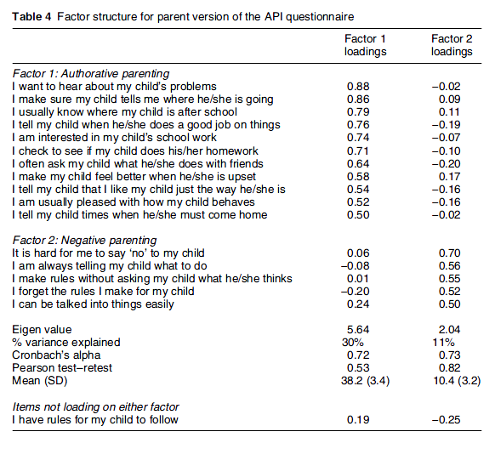

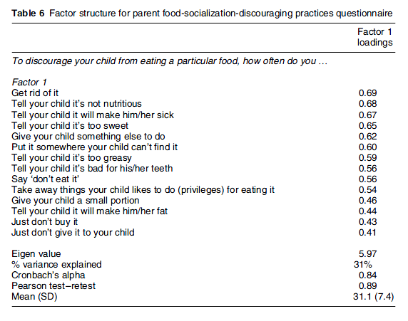
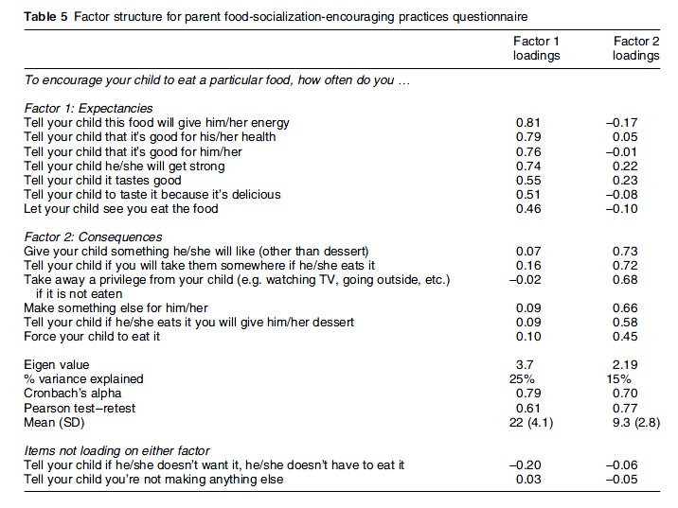
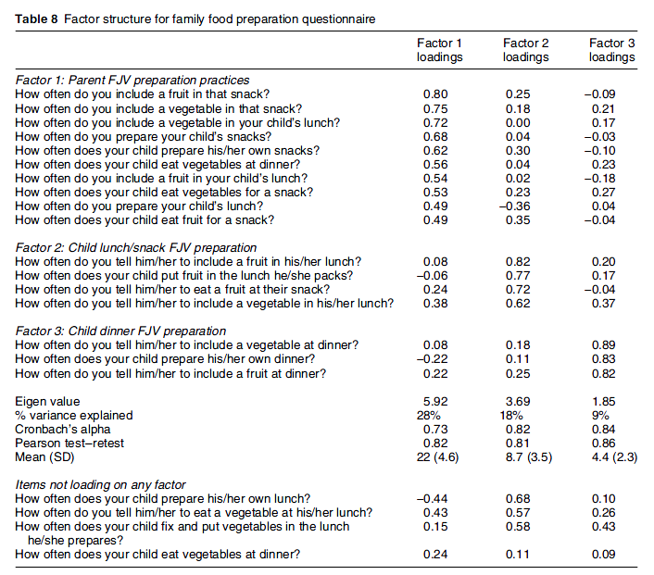
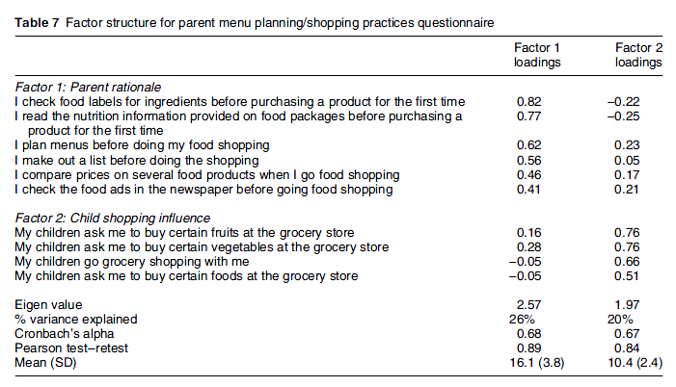
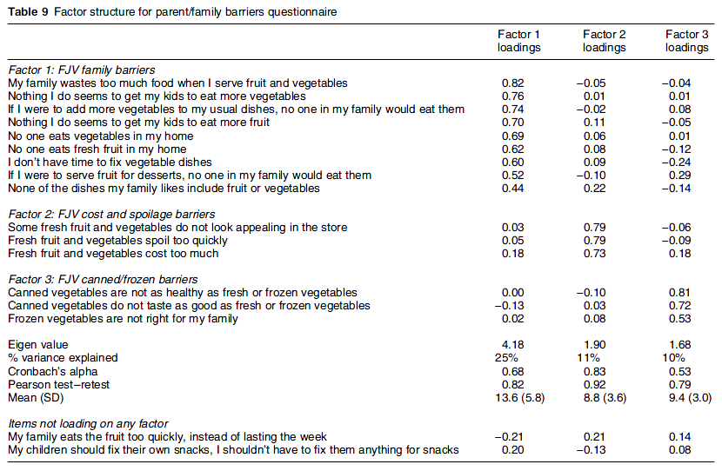
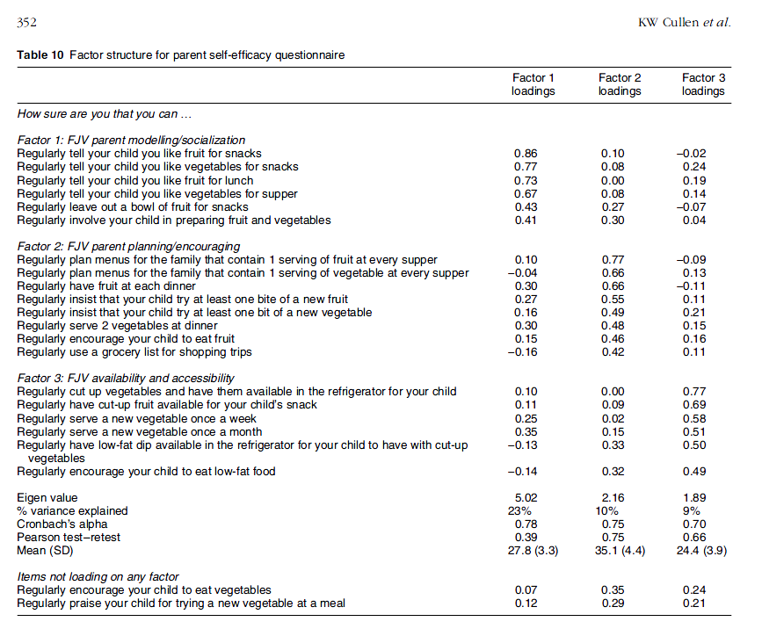
APPENDIX C: FRUIT AND VEGETABLE FOOD FREQUENCY QUESTIONNAIRE


columns for – where did you buy this food, do you like this food, does your reference child like this food?
APPENDIX D: FAMILY NUTRITION AND PHYSICAL ACTIVITY SCREENING TOOL
Welcome to the Family Nutrition and Physical Activity Screening Tool. This short and easy to complete assessment will allow you to evaluate your family's home environment with regard to nutrition and physical activity. The survey only takes about 5 minutes to fill out and will provide you and your family with valuable information and tips about promoting healthy lifestyles in your family.

Demographics
Child's Age
Child's Gender
Male

Female

Parent/Guardian's Age
Parent/Guardian's Gender
Male

Female

Diet and Nutrition
Instructions: For each category, select the description that best fits your child or your family. It is important to indicate the most common or typical pattern and not what you would like to happen.
Breakfast Patterns
My child rarely eats breakfast and we don't typically eat together as a family.

My child does not regularly eat breakfast but we eat together as a family on most days of the week.

My child eats breakfast on most days but we don't typically eat together as a family.

My child eats breakfast on most days and we typically eat together as a family.

Family Eating
Our family regularly eats fast food and we eat while watching TV.

Our family regularly eats fast food but we rarely eat while watching TV.

Our family rarely eats fast food but we eat while watching TV.

Our family rarely eats fast food and we rarely eat while watching TV.

Food Choices
Our family uses prepackaged foods frequently and we usually do not eat fruits and vegetables with meals (or as snacks).

Our family uses prepackaged foods frequently but we regularly consume fruits and vegetables with meals (or as snacks).

Our family eats mostly freshly prepared meals but we usually do not eat fruits or vegetables with meals (or as snacks).

Our family eats mostly freshly prepared meals and we regularly consume fruits and vegetables with meals (or as snacks).

Beverage Choices
Our child frequently drinks soda pop or other sweetened drinks, and rarely drinks low fat milk with meals or at snacks.

Our child frequently drinks soda pop or other sweetened drinks but frequently drinks low fat milk with meals or at snacks.

Our child rarely drinks soda pop or other sweetened drinks, but rarely drinks low fat milk with meals or at snacks.

Our child rarely drinks soda pop or other sweetened drinks, and frequently drinks low fat milk with meals or at snacks.

Restriction and Reward
I don't monitor my child's snack food consumption and snack foods such as candy are frequently used as a reward for good behavior.

I don't monitor my child's snack food consumption but snack foods such as candy are not used as a reward for good behavior.

I monitor my child's snack food consumption but snack foods such as candy are used as a reward for good behavior.

I monitor my child's snack food consumption and snack foods such as candy are not used as a reward for good behavior.

Television Habits

Screen Time
My child watches television or plays on the computer (or with video games) for more than 4 hours each day.

My child watches little television but plays on the computer or with video games for 2-4 hours each day.

My child doesn't play on the computer (or with video games) but watches television for 2-4 hours each day.

My child watches television or plays on the computer (or with video games) less than 2 hours each day.

Television Usage
I rarely monitor the amount of TV my child watches and my child has access to a TV in his/her bedroom.

I monitor the amount of TV my child watches but my child has access to a TV in his/her bedroom.

I rarely monitor the amount of TV my child watches but my child does not have access to a TV in his/her bedroom.

I monitor the amount of TV my child watches and my child does not have access to a TV in his/her bedroom.

Other Activities

Family Activity
I rarely participate in physical activity (e.g. walking) and our family does not play games outside, ride bikes, or walk together very often.

I participate regularly in physical activity (e.g. walking) but our family does not play games outside, ride bikes, or walk together very often.

I rarely participate in physical activity (e.g. walking) but our family plays games outside, ride bikes, or walks together fairly frequently.

I participate regularly in physical activity (e.g. walking) and our family plays games outside, ride bikes, or walks together fairly frequently.

Child Activity
My child participates in almost no physical activity during his/her free time and is not enrolled in any organized sports or activities with a coach or leader.

My child participates in some physical activity a few days a week (2-3 days) in his/her free time but does not typically participate in any organized sports or activities with a coach or leader.

My child does not participate in physical activity in his/her free time but does participate in some organized sports or activities with a coach or leader a few days a week (2-3 days).

My child regularly participates (i.e. on most days) in physical activity in his/her free time and also participates in sports or activities with a coach or leader.

Family Routine
Our family does not have a daily routine or schedule for our child’s bedtime and our child gets less than 12 hours of sleep each night.

Our family does not have a daily routine or schedule for our child’s bedtime but our child typically gets at least 12 hours of sleep.

Our family follows a daily routine or schedule for our child’s bedtime but our child tends to get less than 12 hours of sleep a night.

Our family follows a daily routine or schedule for our child’s bedtime and our child typically gets at least 12 hours of sleep a night.

APPENDIX E: BUDGET

Item | Quantity | Cost | Subtotal:
Travel expenses
Gas: College Park - Farmer's Market Sites | 20 | $20.00 | $400.00
Printing expenses
Surveys | 400 | $0.80 | $320.00
EBT expenses
EBT machines | 4 | $1500.00 | $6000.00
Monthly fees and wireless costs | 6 | $60.00 | $360.00
Survey expenses
Compensation for survey participants | 200 | $25.00 | $5000.00
 |  |  | Total:
 |  |  | $12080.00

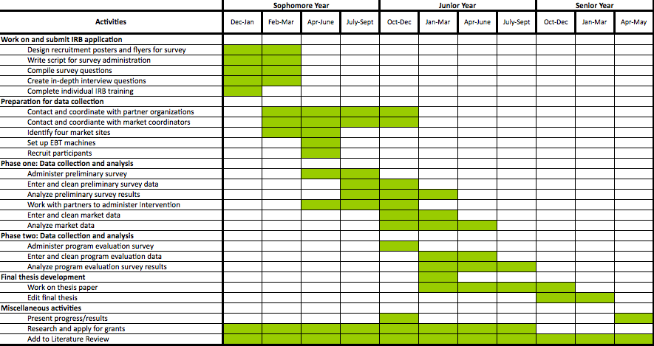
APPENDIX F: APPROXIMATE TIMELINE

