Teaching Social and Environmental Justice through the bande dessinée

Abstract:
This article provides concrete strategies for integrating discussions of colonialism and environmental justice in intermediate and advanced French language classes. It focuses on the graphic novel Tropiques toxiques (2020) by Franco-Guadeloupean author Jessica Oublié, which investigates the origins and ongoing impacts of the chlordecone pesticide scandal in Guadeloupe and Martinique using a first-person, documentary-style narrative. Through activities analyzing the interplay between text and image, along with addressing the historical context, this work can help students make connections between environmental and social justice issues faced by cultural groups across national boundaries while honing their linguistic skills and mastery of grammatical structures.

In recent years sales of graphic novels or bande dessinée (BD), as well as the study and adoption of these works in the French language classroom, have continually increased as the genre has come to be considered “an appropriate object of scholarly attention” (Grove 78; Groensteen; Miller). As textual-visual hybrids, these works can provide opportunities for language students at all levels—from elementary school through university courses, beginner through advanced learners—to practice and strengthen reading comprehension, lexical expansion (Koele), understanding of grammatical concepts, as well as critical thinking and intercultural competency (Jacquet and Côté). For these reasons, numerous studies from around the world have touted the merits of the bande dessinée as a pedagogical tool in the FLE classroom that can captivate students’ interest and motivate and engage learners (Bannier; Dekoke; Lochmanová; Măluţan; Sezer; Sylvand).
However, most existing studies focus on the use of BD targeted to younger audiences, such as Tintin, Les Schtroumpfs, Titeuf, and Astérix et Obélix. Many educators have also used more complex BD like the popular autobiographical series Persepolis (2000–2004) by Marjane Satrapi and the science-fiction series La Transperceneige (1982–2015) created by Jacques Lob, Jean-Marc Rochette, and Benjamin Legrand, to introduce themes of identity, political oppression, and climate change into the classroom while also helping students to develop and strengthen linguistic skills. This brief article suggests another resource that educators might use to focus specifically on themes of social and environmental justice.
In this essay, I propose methods for teaching the BD Tropiques toxiques, written by Jessica Oublié and illustrated by Nicola Gobb, which was published in 2020 by Steinkis. Oublié, born in 1983 in Paris, is an author and consultant whose parents hail from Martinique and Guadeloupe. Tropiques toxiques is Oublié’s second graphic novel, following the 2017 publication of Péyi an nou with illustrator Marie-Ange Rousseau, which recounts the story of the Bumidom (Bureau pour le développement des migrations dans les départements d’outre-mer), a government agency tasked with overseeing the migration of workers from the Caribbean to France from 1962 to 1983 (Wimbush). Péyi an nou was awarded the Prix BD du livre politique from France Culture in 2018.
Like Oublié’s first BD, Tropiques toxiques can be categorized as a “reportage,” a non-fictional genre of BD (Miller 57). The work takes a journalistic and historical approach to uncovering a phenomenon that has received little attention outside French-language media: the chlordecone scandal that has rocked Martinique and Guadeloupe. Tropiques toxiques documents Oublié’s discovery of the ongoing scandal and illustrates her journeys between the Antilles, France, the United States, and Africa as she recounts her subsequent investigations to better understand the historical, economic, and scientific roots of this disaster that continues to negatively impact the health and livelihood of people living in France’s regions in the Antilles and elsewhere.
The pesticide chlordecone, also known by the brand name Kepone, was primarily used in the 1960s and 1970s, and many tons were used on banana farms in Martinique and Guadeloupe from 1972 to 1993. However, in 1976 the product was banned in the United States through the Toxic Substances Control Act after authorities discovered that improper disposal and handling of Kepone by its manufacturer in Hopewell, Virginia sickened workers and community members and polluted the James River. Chlordecone has been linked to disruption of liver function and prostate, stomach, and pancreatic cancer in humans; the World Health Organization first recognized its carcinogenic properties in 1979. Due to these effects and chlordecone’s long afterlife—it can linger in soil and water for many decades—it is labeled as a persistent organic pollutant (POP). France banned chlordecone within the Hexagon in 1990, but an exception was made to allow remaining stocks to be used in the Antillean departments for an additional three years despite the product’s many known risks to public health and land-based and maritime ecosystems. Even after this official ban, the pesticide continued to be imported and used in the Caribbean departments for years under a different name (Curlone), according to a 2005 report prepared for the Assemblée nationale by the Commission des affairs économiques, de l’environnement et du territoire (“Rapport d’information”). It was only in May 2009 that the Stockholm Convention on Persistent Organic Pollutants banned chlordecone across the world (“Governments Unite”). Studies conducted by the French government suggest that chlordecone can be detected in the bodies of 95% of all Martinicans and Guadeloupeans alive today (Vincent).
In telling this story, the BD Tropiques toxiques can be a particularly useful resource for the FLE classroom for several reasons. First, it can complement and enhance thematic units on social and environmental justice that are often included in French language textbooks and curricula. Oublié’s BD exposes the history of the colonial domination and exploitation of people and the Earth in the Caribbean, and it vividly demonstrates the effects of this history and the resulting social, economic, and political inequalities that people in the Antilles continue to face today. In its efforts to “untangle the historical circumstances of such human-made ecological disaster,” the BD provides students a striking but accessible entry into this complex history (Boum Make 388–389).
Second, the BD is an authentic document that can help students develop intercultural competency. Through over one hundred interviews conducted with people directly affected by chlordecone, as well as those working in impacted industries like agriculture and fishing, Tropiques toxiques focuses on real voices and stories from diverse communities to provide what Oublié has called a polyphonic “cartographie composite des acteurs” (Oublié and Rolland). This work also exposes students to Martinican and Guadeloupean creole, which can be a valuable addition to intercultural education as these linguistic traditions are rarely included in French language curricula. Third, the text’s engagement with scientific and public health fields can interest a wide range of students. In addition to the interviews and data points included in the BD, Oublié and her colleagues developed a companion website where readers can engage with scientific research on chlordecone and learn about efforts to mitigate its effects. Finally, Oublié’s investigation into the pesticide’s history in the United States, particularly in the state of Virginia, forges a connection to an American context that can help students to grasp the simultaneously local and global nature of these issues of social and environmental justice.
As Boum Make points out, the BD thus “provides a site where knowledge can be accumulated and circulated” (393). In what follows, I briefly propose some ways to engage this circulation of intercultural, historical, and environmental knowledge by incorporating Tropiques toxiques into the FLE classroom at varying proficiency levels and discuss how these activities promoted student learning and engagement.
Advanced Language, Literature, and Culture Courses
I first taught this BD in an upper-level undergraduate French special topics course focused on the intersections of empire, racism, and environment with the goal of studying how Oublié’s work represents and contests the legacies of colonial ideologies, a topic explored in detail by Mark McKinney in The Colonial Heritage of French Comics (2011). Students read longer excerpts from Tropiques toxiques paired with critical readings in English, including Max Loboiron’s Pollution Is Colonialism (2021) and Rob Nixon’s Slow Violence and the Environmentalism of the Poor (2013). These works can help students deepen connections between the environmental justice issues faced by those in the Antilles and Indigenous communities in the United States. For a deeper understanding of the intertwining of racialization and economic systems in a global Francophone context, students read Françoise Vergès’s “Racial Capitalocene” (2017). Additionally, an episode of the podcast Kiffe ta race featuring Oublié, titled “Antilles empoisonnées: le scandale du chlordécone,” provided extra listening comprehension practice for students with advanced proficiency. (Full bibliographic information for these resources is included in the Appendix.)
Analyzing excerpts from Tropiques toxiques enhanced my students’ interest in class discussions about the political, environmental, and economic legacies of colonialism by giving them a visceral, concrete narrative they could approach at both textual and visual levels. The readings described above motivated my students to learn more about the specific history surrounding chlordecone as well as the broader context of the Antilles and French overseas regions, and several students then pursued these topics for their final research projects. The BD particularly appealed to learners who were not necessarily engaged by more traditional literary texts such as novels by giving them a different way to consume and relate to the content, which was especially important in my institution where most students major in international relations, politics, and public health rather than studying French as their main subject—a situation increasingly common in higher education (Fischer). Students commented that the BD’s documentary style, combining testimony from diverse sources with photos and scientific data, piqued their interest by showing them real people and their stories in a contemporary context. My students were also motivated to learn more about the connections with pesticide pollution in the United States, which allowed them to connect the work to their own lives and experiences.
While Tropiques toxiques thus lends itself well to advanced literature and culture courses, brief excerpts or individual panels from the BD can be used effectively in lessons adapted for students at lower proficiency levels, as discussed below.
Intermediate Language Courses
Many intermediate French textbooks—especially those used in higher-education courses like Horizons and Liaisons (Cengage) or Chez nous (Pearson)—include units or chapters centered on health, civic action, and/or the environment. Excerpts from Tropiques toxiques can complement these units with a focus on recognizing cognates and vocabulary. Often, these units also cover grammatical concepts like the subjunctive, which are well suited to discussing the action-oriented domains of environmental science and public health.
A lesson for an intermediate class (B1–B2 level) might start with a discussion or think-pair-share activity bringing students’ attention to preconceived notions about the Antilles and French overseas regions (for example, “Quels mots et quelles images associez-vous aux Antilles/aux Caraïbes?”). This would be a useful moment to introduce France’s overseas departments if such material has not previously been covered. After students share their responses, the instructor displays the striking cover image of Tropiques toxiques (figure 1), which features a partially submerged tropical island shaped like a human skull covered with verdant vegetation and surrounded by fish and coral in turquoise water.
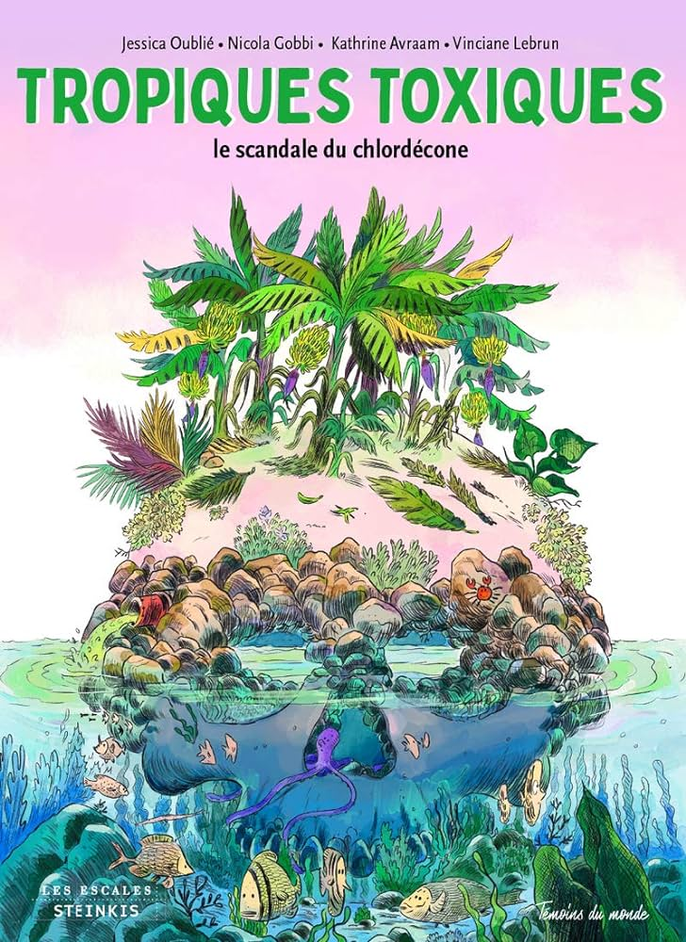
Figure 1. Cover image of Tropiques toxiques.
Students discuss what they see in the image and what it evokes, generating a word map on the board or with a digital tool such as Mentimeter and using the unit’s vocabulary (e.g. la pollution, polluer, etc.), adding new terms as needed. A small-group or “jigsaw”-style activity then focuses more closely on the BD: each group reads a different panel, identifying key words and discussing the images. Students also compare the images’ contents with the United Nations’ definition of “social justice” (see Appendix). Each group then shares their conclusions as the instructor highlights connections between them. In particular, the panels on pages 90–91, 106–107, 168–169, 178–179, and 180–181 are well suited to drawing students’ attention to environmental issues and activism. For example, photographs and drawings on page 180 (figure 2) document protests in Martinique from 2018 and 2019 raising awareness of chlordecone’s effects on the island.
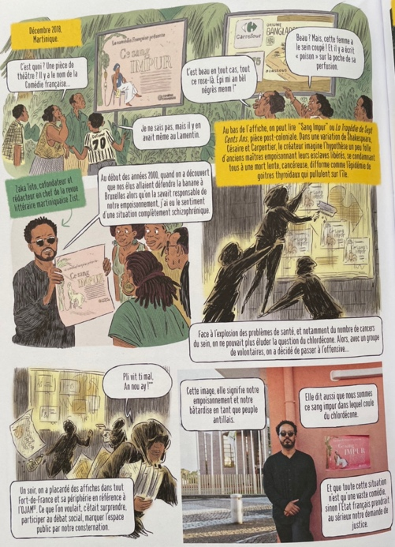
Figure 2. Tropiques toxiques, p. 180.
These panels include many cognates related to public health (problème, cancer, empoisonnement) as well as political and civic action (volontaire, défendre, responsable, conséquences, prendre au sérieux, demande de justice, participer au débat social, crime contre l’humanité, génocide, l’espace public, le boycott, désobéissance civile), giving students a lexicon for discussing complex social issues even at a low-intermediate proficiency level.
A follow-up activity demonstrating grammatical mastery concludes the session as students generate “guidelines” for social and/or environmental action using the subjunctive and/or impersonal infinitive expressions. This activity could be expanded to include sketching BD-style images to illustrate their guidelines or making (digital) posters promoting those actions, or students could conduct a research project related to environmental or public health concerns in their own communities. Such projects could even include a service component to take the lesson beyond the classroom.
Expansion activities might include watching interviews with Oublié, reading related news articles, and responding to comprehension questions (see the Appendix for possible resources). Alternatively, students might analyze posters for a fake play posted around Martinique in 2018, “Ce sang impur,” which critiqued racialized stereotypes linked to the chlordecone scandal, and make connections with the visual tropes used in nationalist discourses and in the BD (these posters are also referenced within Tropiques toxiques on page 180; see figure 2).
In intermediate language courses where I have used these activities, students expressed interest in learning about this subject of contemporary, “real-world” relevance through a genre many of them had not previously encountered in school settings. My intermediate students found the complexity of the BD’s language to be approachable while it pushed them to expand their lexicons. Students also remarked they were motivated by the opportunity to discuss environmental and social issues in the language classroom, which they found challenging but rewarding as it allowed them to use their burgeoning language skills in a new way, making connections with current events and going beyond the brief information about the Caribbean departments presented in our textbooks. The follow-up activities demonstrating mastery of the subjunctive through creating guidelines for environmental and social action also made for lively classroom discussions as students expressed their values and opinions and used their creativity and digital literacy skills in making brochures and posters with online resources like Canva. Teaching with Tropiques toxiques and using these activities stoked my students’ interest in the class, but more importantly, it inspired them to want to learn more about the Francophone world.
Though the length and complexity of the content presented in Tropiques toxiques may pose challenges to assigning the whole text in a typical FLE class, this essay has offered some ways that instructors at different levels can use excerpts from this BD to complement discussions of social and environmental justice, climate, health, and colonialism in their classes. As we seek ways to continually engage and motivate our students, BD like Tropiques toxiques can help to augment lexical, grammatical, and cultural content in an authentic and captivating way.

Appendix: Supplemental Resources
Boum Make, Jennifer, Charly Verstraet, and Jessica Oublié. “Interview with Jessica Oublié.” Kwazman vwa, 21 Mar. 2021. <https://kwazmanvwa.com/interview-with-jessica-oublie/>.
Diallo, Rokhaya, Grace Ly, and Jessica Oublié. “Antilles empoisonnées: le scandale du chlordécone.” Kiffe ta race, episode 56, Binge Audio, 24 Nov. 2020. <https://www.binge.audio/podcast/kiffetarace/antilles-empoisonnees-le-scandale-du-chlordecone>.
“Journée mondiale de la justice sociale: 20 février.” Nations Unies. <https://www.un.org/fr/observances/social-justice-day#:~:text=La%20justice%20sociale%20est%20fond%C3%A9e,et%20%C3%A0%20cr%C3%A9er%20des%20emplois>.
Loboiron, Max. Pollution Is Colonialism. Duke UP, 2021.
Nixon, Rob. Slow Violence and the Environmentalism of the Poor. Harvard UP, 2013.
Vergès, Françoise. “Racial Capitalocene.” Futures of Black Radicalism, edited by Gaye Theresa Johnson and Alex Lubin, Verso, 2017, pp. 72–82.

Works Cited
Bannier, Augustin. La bande dessinée en classe de FLE: Pourquoi n’est-elle pas étudiée pour elle-même? Masters Thesis, Université Angers, France, 2014.
Boum Make, Jennifer. “What the Chlordecone Pollution Says About Modes of Inhabiting the World: Examining the Intersection of Socio-Racial Inequality and Environmental Degradation in Tropiques Toxiques by Jessica Oublié et al.” Contemporary French and Francophone Studies, vol. 26, no. 4–5, 2022, pp. 387–395.
Dekoke, Taty Mbaki. Sémiotique de la bande dessinée et apprentissage du Français. Masters Thesis, University of Cape Town, 2005.
Fischer, Karin. “It’s a Bleak Climate for Foreign Languages as Enrollments Tumble.” Chronicle of Higher Education, 15 November 2023. <https://www.chronicle.com/article/its-a-bleak-climate-for-foreign-languages-as-enrollments-tumble>.
“Governments Unite to Step-up Reduction on Global DDT Reliance and Add Nine New Chemicals Under International Treaty.” Stockholm Convention, 8 May 2009. <https://chm.pops.int/Convention/Pressrelease/COP4Geneva8May2009/tabid/542/>. Press release.
Groensteen, Thierry. Un objet culturel non identifié. Éditions de l’An 2, 2006.
Grove, Laurence. “État présent: Bande dessinée Studies.” French Studies, vol. 68, no. 1, 2013, pp. 78–87.
Jacquet, Marianne, and Isabelle Côté. “L’utilisation de la bande dessinée en salle de classe: un outil de formation interculturelles critique.” La Revue de l’AQEFLS, vol. 31, no. 1, 2014, pp. 150–165.
Koele, Malefane Victor. “La bande dessinée au service de l’enseignement: l’apprentissage du lexique et de l’interculturel en classe de FLE.” Francisola: Revue indonésienne de la langue et la littérature françaises, vol. 5, no. 2, 2020, pp. 97–104.
Lochumanová, Zuzana. L’enseignement du FLE avec les bandes dessinées. Masters Thesis, University of West Bohemia, 2014.
Măluţan, Cristina-Ana. “Exploitation pédagogique et stylistique de la bande dessinée en classe de FLE.” Acta Technico Napocensis: Languages for Specific Purposes, vol. 2, 2017, pp. 71–78.
McKinney, Mark. The Colonial Heritage of French Comics. Liverpool UP, 2011.
Miller, Ann. Reading Bande Dessinée: Critical Approaches to French-Language Comic Strip. Intellect Books, 2008.
Oublié, Jessica, and Armelle Blin Rolland. “Réparer l’oubli: écrire l’histoire contemporaine des Antilles françaises en bande dessinée.” Interview, 19 July 2023. Bangor University.
“Rapport d’information sur l’utilisation du chlordécone et des autres pesticides dans l’agriculture martiniquaise et guadeloupéene.” Assemblée nationale, 30 June 2005. <https://www.assemblee-nationale.fr/12/rap-info/i2430.asp>.
Sezer, Pinar. La place de la bande dessinée dans les manuels de français. Thesis, Université de Marmara, 2022.
Sylvand, Benjamin. L’image pédagogique: Pour l’usage et la réalisation de productions pédagogiques audiovisuelles et multimédias. Editions des archives contemporaines, 2015.
Vincent, Faustine. “Chlordécone: les Antilles empoisonnées pour des générations.” Le Monde, 6 June 2018. <https://www.lemonde.fr/planete/article/2018/06/06/chlordecone-les-antilles-empoisonnees-pour-sept-siecles_5310192_3244.html>.
Wimbush, Antonia. “Depicting French Caribbean Migration Through Bande Dessinée.” International Journal of Francophone Studies, vol. 21, no. 1–2, 2018, pp. 9–29.

