ABSTRACT

Title of Document: THE APPLICATION OF AN EXOGENOUS LINEAR AND RADIAL ELECTRICAL FIELD TO AN IN VITRO CHRONIC DIABETIC ULCER MODEL FOR EVALUATION AS A POTENTIAL TREATMENT

Authors: Sagah Ahmed, Natalie Anzures, Zachary Bosley, Brendan Bui, Ariana Feizi, Sudi Jawahery, Courtney Koenig, Katherine Lakomy, Megan Lin, Poorna Natarajan, Eisha Nathan, Hiba Sayed, Eduardo Solano

Directed by: Dr. John Fisher

Chronic diabetic ulcers affect approximately 15% of patients with diabetes worldwide. Currently, applied electric fields are being investigated as a reliable and cost-effective treatment. This in vitro study aimed to determine the effects of a constant and spatially variable electric field on three factors: endothelial cell migration, proliferation, and angiogenic gene expression. Results for a constant electric field of 0.01 V demonstrated that migration at short time points increased 20-fold and proliferation at long time points increased by a factor of 1.40. Results for a spatially variable electric field did not increase directional migration, but increased proliferation by a factor of 1.39 and by a factor of 1.55 after application of 1.00 V and 0.01 V, respectively. Both constant and spatially variable applied fields increased angiogenic gene expression. Future research that explores a narrower range of intensity levels may more clearly identify the optimal design specifications of a spatially variable electric field.

THE APPLICATION OF AN EXOGENOUS LINEAR AND RADIAL ELECTRICAL FIELD TO AN IN VITRO CHRONIC DIABETIC ULCER MODEL FOR EVALUATION AS A POTENTIAL TREATMENT

By
Team ELECTRODE (Evaluating Linear-Radial Electrode Conformations for Tissue Repair and Organizing a Device for Experimentation)

Sagah Ahmed, Natalie Anzures, Zachary Bosley, Brendan Bui, Ariana Feizi, Sudi Jawahery, Courtney Koenig, Katherine Lakomy, Megan Lin, Poorna Natarajan, Eisha Nathan, Hiba Sayed, Eduardo Solano

Thesis submitted in partial fulfillment of the requirements of the Gemstone Program University of Maryland, College Park 2014

Advisory Committee:
Dr. John Fisher, Mentor
Dr. Mario Dagenais
Ms. Kimberly Ferlin
Dr. Amy Karlsson
Dr. Richard Payne
Dr. Jesse Placone

© Copyright by:
Sagah Ahmed, Natalie Anzures, Zachary Bosley, Brendan Bui, Ariana Feizi, Sudi Jawahery, Courtney Koenig, Katherine Lakomy, Megan Lin, Poorna Natarajan, Eisha Nathan, Hiba Sayed, Eduardo Solano

2014

Acknowledgements

We would like to thank Dr. John Fisher, our Gemstone mentor, for supporting us and providing us with the necessary materials and lab space to conduct our experiments. Over the past three years, he has guided us not only in our research, but also in our development as future professionals and we will be forever thankful for his endless encouragement. We would also like to thank Ms. Kimberly Ferlin, who has become an essential part of our team and who has overseen our laboratory work on a day-to-day basis. Additionally, we would like to thank other current and former members of Dr. Fisher’s laboratory: Bao-Ngoc Nguyen, Martha Wang, Anthony Melchiorri, Emily Coates, and Andrew Yeatts for their assistance in the laboratory experiments. We would also like to thank our electrical engineering consultants, Dr. Mario Dagenais and his graduate student Tiecheng Zhu, for the use of their equipment and their assistance in creating our devices. We would additionally like to thank the Howard Hughes Medical Institute for their financial assistance for this project; without their support, none of our research would have been possible. We would like to acknowledge our librarians, Mr. Jim Miller and Ms. Nevenka Zdravkovska, for their assistance in writing our grants and senior thesis. Finally, and most importantly, we would like to thank the entire Gemstone Honors Program staff, both old and new, for their unwavering support, interest, and guidance throughout the research process. The staff has truly made the Gemstone experience one to remember and we hope they continue to be an inspiration for all future young researchers in the Gemstone program.

Table of Contents

Acknowledgments i
Table of Contents ii
List of Figures iv
Abbreviations vi

Chapter 1: Introduction 1
1.1 Diabetes 1
1.2 Diabetic Ulcers 2
1.3 Current Treatments 4

Chapter 2: Literature Review 8
2.1 Natural Wound Healing 8
2.2 Chronic Wounds 11
2.3 Body’s Natural Bioelectric Field 13
2.4 Physiological Responses to Electrical Stimulation 17
2.5 Healing Wounds with Electrical Stimulation 18
2.5.1 In vitro 18
2.5.2 In vivo 20
2.5.3 Diabetic Ulcers 21
2.6 Investigation of Electrical Stimulation Techniques 22

Chapter 3: Experimental Questions 25

Chapter 4: Methodology 27
4.1 Device Design 27
4.1.1 Linear 27
4.1.2 Radial 28
4.2 Comparison of Devices 29
4.3 Cell Culture 31
4.4 Experimental Timeline 32
4.5 Electrical Stimulation 33
4.5.1 Linearly Applied Field 33
4.5.2 Radially Applied Field 34
4.6 Migration Assay 36
4.7 Live-Dead Viability Assay 43
4.8 qRT-PCR Assay 46
4.9 Statistical Analysis 49

Chapter 5: Results 50
5.1 Migration Assay 50
5.1.1 Linearly Applied Field 50
5.1.2 Radially Applied Field 54
5.1.3 Reverse Polarity Radially Applied Field 57
5.2 Live-Dead Viability Assay 58
5.2.1 Linearly Applied Field 58
5.2.2 Radially Applied Field 60
5.2.3 Reverse Polarity Radially Applied Field 63
5.3 qRT-PCR Assay 65
5.3.1 Linearly Applied Field 65
5.3.2 Radially Applied Field 67
5.3.3 Reverse Polarity Radially Applied Field 69
5.4 Ideal Voltage Selection 71

Chapter 6: Discussion 72
6.1 Experimental Question #1 72
6.2 Experimental Question #2 78
6.3 Recommendations 86
6.3.1 Double-Disc Radial Electrode Design 86
6.3.2 Prototype Design 88

Chapter 7: Conclusion 97
7.1 Overall Conclusions 97
7.2 Limitations 97
7.3 Future Research 99
7.4 Implications 100

References 102

List of Figures

Figure 1: Wagner Grade Classification System 4
Figure 2: Wound Healing Mechanisms 11
Figure 3: Membrane Potential 14
Figure 4: Electrical Potentials in Tissue 15
Figure 5: Types of Current 23
Figure 6: Linear Field Device 27
Figure 7: Radial Field Device 28
Figure 8: Coating Process of Radial Device 29
Figure 9: Direction of Linear Electric Field 29
Figure 10: Direction of Radial Electric Field 30
Figure 11: Direction of Reverse Polarity Radial Electric Field 31
Figure 12: Experimental Timeline 33
Figure 13: Linear Experimentation Set-Up 34
Figure 14: Radial Experimentation Set-Up 35
Figure 15: Reverse Polarity Radial Experimentation Set-Up 35
Figure 16: Linear Migration Assay 37
Figure 17: Radial Migration Assay 38
Figure 18: Linear Migration Analysis 39
Figure 19: Radial Migration Analysis with Positive r 40
Figure 20: Radial Migration Analysis with Negative r 41
Figure 21: Relation of R and r in Radial Migration Analysis 42
Figure 22: Linear Live-Dead Viability Assay Analysis 44
Figure 23: Radial Live-Dead Viability Assay Analysis 45
Figure 24: Representative Linear Migration Images 50
Figure 25: Linear Cell Migration Data 51/53
Figure 26: Representative Radial Migration Images 54
Figure 27: Radial Cell Migration Data 55/56
Figure 28: Reverse Polarity Cell Migration Data 57
Figure 29: Representative Linear Live-Dead Viability Images 58
Figure 30: Linear Live-Dead Viability Data 59
Figure 31: Representative Radial Live-Dead Viability Images 61
Figure 32: Radial Live-Dead Viability Data 62
Figure 33: Reverse Polarity Live-Dead Viability Data 64
Figure 34: Linear VEGF Gene Expression Data 65
Figure 35: Linear bFGF Gene Expression Data 66
Figure 36: Radial VEGF Gene Expression Data 67
Figure 37: Radial bFGF Gene Expression Data 68
Figure 38: Reverse Polarity VEGF Gene Expression Data 69
Figure 39: Reverse Polarity bFGF Gene Expression Data 70
Figure 40: Wound Healing and Experimental Time Points 77
Figure 41: Schematic of Radial Electrical Intensities 80
Figure 42: Proposed Radial Field Intensities 87
Figure 43: PSpice Circuit and Simulation Results 90
Figure 44: Final Circuit Values After Phase One 92
Figure 45: Example of Overshoot 93
Figure 46: Evaluation of 555 Timer ICs in Phase One 94
Figure 47: Image of Fully Functional Circuit Board 96
Figure 45: Example of Overshoot 92
Figure 46: Evaluation of 555 Timer ICs in Phase One 93
Figure 47: Image of Fully Functional Circuit Board 95

Abbreviations

AdCMV VEGF: Adenovirus-mediated vascular endothelial growth factor
aFGF: Acidic fibroblast growth factor
BAEC: Bovine aortic endothelial cells
bFGF: Basic fibroblast growth factor
cAM: Calcein acetoxymethyl ester
cAMP: Cyclic adenosine monophosphate
cDNA: Complementary DNA
DC: Direct current
EF: Electrical field
EGF: Epithelial growth factor
EH: Ethidium homodimer-1
ELISA: Enzyme-linked immunosorbent assay
FES: Functional electrical stimulation
G-CSF: Granulocyte colony-stimulating factor
GAPDH: Glyceraldehyde 3-phosphate dehydrogenase
GM-CSF: Granulocyte macrophage colony-stimulating factor
HUVEC: Human umbilical vein endothelial cell
IC: Integrated circuit
IDF: International diabetes foundation
IFN-γ: Interferon gamma
IL-1: Interleukin 1
IL-6: Interleukin 6
IL-8: Interleukin 8
KGF-2: Keratinocyte growth factor 2
LTB4: Leutrokine B4
MAP: Mean arterial pressure
MMP: Matrix metalloproteinase
mRNA: Messenger ribonucleic acid
NO: Nitric oxide
NWPT: Negative wound pressure therapy
PBS: Phosphate buffered saline
PCNA: Proliferating cell nuclear antigen
PDGF: Platelet-derived growth factor
PET: Positron emission tomography
PF4: Platelet factor 4
qRT-PCR: Quantitative reverse transcriptase polymerase chain reaction
RAOEC: Rat aortic endothelial cells
RMP: Resting membrane potential
RNA: Ribonucleic acid
ROS: Reactive oxygen species
SPECT: Single photon emission computed tomography
SWT: Standard wound treatment
TEP: Trans-epithelial potential
TGF-β: Transforming growth factor beta
TNF-α: Tumor necrosis factor alpha
TNF-β: Tumor necrosis factor beta
VEGF: Vascular endothelial growth factor
VNS: Vagus nerve stimulation

CHAPTER 1: INTRODUCTION

1.1 Diabetes
The term Diabetes mellitus describes a cluster of severe medical diseases with a characteristic pathology of abnormally high blood glucose levels ¹. According to the World Health Organization, approximately 171 million people had diabetes worldwide in 2000 ². By 2030, the number of people with diabetes is expected to be more than double the 2000 statistic at approximately 366 million people ². In 2011, the National Institute of Diabetes and Digestive and Kidney Diseases reported that diabetes affected 25.8 million people of all ages or 8.3 percent of the population in the United States ^{3,4}. In addition, diabetes was listed as either the underlying cause or contributing factor for a total of 231,404 deaths and is the seventh leading cause of death for Americans in 2007 ^{3,5}. If current trends continue, it is estimated that as many as 33%, or 1 in 3 American adults will have diabetes by 2050 ⁶.
Although there are several categories of diabetes, the most common forms are Type 1 and Type 2 diabetes. Type 1 diabetes is an autoimmune condition in which a person’s body attacks its own pancreatic beta cells that produce the hormone insulin ^{3,7}. Without sufficient amounts of insulin, the body is unable to properly regulate blood glucose levels ^{3,7}. Type 1, or juvenile-onset diabetes, typically affects children and young adults, while Type 2, or adult-onset diabetes develops later in life ^{3,7,8}. Type 2 diabetes is characterized as a condition of insulin-resistance, defined as the body’s inability to absorb glucose from the bloodstream ⁸. In association with diabetes is another condition known as prediabetes, which describes patients that have higher than normal blood sugar levels, but are not yet considered diabetic ^{3,7}. However, with prediabetes comes an increased risk of developing Type 2 diabetes in the future; in 2010, it was estimated that approximately 79 million Americans aged 20 years or older had prediabetes ³.
Due to an imbalanced metabolism, the disease leads to symptoms such as weight loss, fatigue, slow healing of cuts and bruises, frequent urination, and extreme hunger and thirst ⁹. Several complications are also associated with the presence of diabetes. In the United States, diabetes is the leading cause of kidney failure and new cases of blindness in adults aged 20-74 years ⁵. Cardiovascular complications also account for the deaths of 50% of diabetic patients ¹⁰. In addition, around 60% to 70% of diabetic patients have been reported to suffer from mild to severe forms of nervous system damage ⁵. Moreover, diabetes can lead to a number of debilitating complications of the lower extremities, such as peripheral arterial disease, neuropathy, chronic diabetic ulcers, and other non-healing wounds ¹¹⁻¹³.
Diabetes has significant impacts on not only health, but also on economic costs in the United States. From $174 billion in 2007 to $245 billion in 2012, the total estimated costs of diagnosed diabetes increased 41%, with hospital inpatient care and prescription medications representing the largest portion of these costs ¹⁴. More than 1 in 5 health care dollars in the United States is spent on the care of patients with diagnosed diabetes. Even further, diabetic patients spend about 2.3 times more in medical expenditures in comparison to those patients without diabetes ¹⁴.
1.2 Diabetic Ulcers
Diabetic patients are twice as likely to suffer from diseases that affect the lower extremities, such as foot ulceration, than non-diabetic patients ¹⁵. These diabetic ulcers are defined as any necrosis, gangrene, or full-thickness skin defect distal to the ankle in a diabetic patient ¹⁵. Foot ulcers affect approximately 15% of diabetic patients and often result in subsequent infections, amputations, and hospitalizations ¹⁶. Diabetic foot ulcers also account for more hospitalizations than any other complication of diabetes ^{17,18} and 80% of all leg amputations performed in the US are due to diabetic foot ulcers ¹³.
There are several different causes of diabetic foot ulceration and chief among them is peripheral neuropathy, a condition caused by poor circulation and vasoconstriction, the narrowing of blood vessels, in the foot or leg due to excessive inflammation ¹⁹. This neuropathy often reduces the body’s ability to feel pain and other sensations, which increases the likelihood of foot ulceration seven-fold ²⁰. Repetitive exposure to trauma, edema, calluses, and peripheral vascular disease are other causes of foot ulceration among diabetic patients ²¹.
The Wagner ulcer classification system, the most widely accepted of such organizational tools for diabetic ulcers, bases categorization of these ulcers largely on the extent of the ulcer’s penetration into the skin tissue of the foot and the presence of gangrene within the wound ²². The system assigns grades of 0-5 to diagnosed diabetic ulcers. At grade zero, there is no ulcer and the skin is at its normal, healthy stage. At grade one, there is evidence of a superficial skin ulcer and typical pathogens associated at grade one are gram-positive bacteria. When the ulcer has progressed to grade two, the ulcer can be described as deep and extending through the dermis, with possible exposure of tendon, ligaments, joint capsule, or bone. At grade three, the diabetic ulcer has evidence of polymicrobial infections and there is presence of abscess, osteomyelitis, or joint sepsis around the ulcer. When localized gangrene occurs at the forefoot or heel, the ulcer is at grade four. Gangrene of the whole foot indicates that the ulcer is grade five and will most likely require amputation ^{23,24}.

Grade | Description | Associated Symptoms
0 | At risk
1 | Superficial | Gram-positive bacterial infection
2 | Infiltrated dermal layer
3 | Deep with abscess, osteomyelitis, or joint sepsis | Polymicrobal infection
4 | Localized gangrene | Localized necrosis
5 | Gangrene of entire food | Systemic necrosis
Figure 1: Wagner Grade Classification System for Diabetic Ulcers. The grades of diabetic ulcers and their descriptions and associated symptoms.

Many ulcers in the lower extremities are resistant to treatment and thus require continuous medical care ²⁵⁻²⁹. The average treatment cost of a single ulcer is roughly $8,000, while an infected ulcer usually costs about $17,000 to treat ³⁰. Generally, treatment costs increase in proportion to ulcer severity ³¹. In the case of treatment failure, amputations are even more expensive costing approximately $45,000 ³¹.
1.3 Current Treatments
Medical professionals who treat patients afflicted with chronic diabetic ulcers must overcome several obstacles. These difficulties include, but are not limited to: risk of infection, harming healthy endothelial cells, patient discomfort, and a long recovery time ³². However, there are currently a number of experimental treatments that show promise for the improvement of methods of treating chronic diabetic ulcers.
The most common treatment for diabetic ulcers is debridement, the general removal of necrotic tissue from the ulcer ³³. Nearly all ulcer treatments begin with this preliminary step in addition to another subsequent treatment ³². The necrotic tissue can harbor pathogens and microorganisms resulting in infection, thus removal of this tissue is essential to long-term healing ^{33,34}. There are several methods to perform debridement for diabetic ulcers: mechanical, hydrosurgical, surgical, biological, enzymatic, and autolytic.
Perhaps the most generic of the debridement treatments is mechanical debridement, a process in which wet gauze is applied to the wound site and then allowed to dry ³². Afterwards, the gauze is removed, removing necrotic tissue along with it ³². This method has the negative consequences of possibly damaging healthy tissue and causing painful discomfort to the patient ³². Another generic treatment, hydrosurgical debridement, involves the application of a jet of sterile water or saline solution to the wound site ³⁵. This method allows for the simultaneous removal and evacuation of the necrotic tissue through a pressure effect ³⁵.
Other more invasive forms of debridement are also used when the wound requires a more aggressive approach. Surgical debridement includes the excision of necrotic tissue or callus tissue until healthy tissue is encountered, thus transforming a chronic ulcer into an acute ulcer and stimulating healing ³³. Biological debridement is the application of larva or maggots that secrete enzymes to break down necrotic tissue and dispose of the refuse ³⁶. This method is especially useful, because the treatment process occurs at a faster pace than many other treatments ³⁷. However, neither of these methods show any significant benefit to the recovery time of the ulcer nor any reduction in the bacterial load in the ulcer compared to more generic debridement treatments ^{33,36,38}. Enzymatic and chemical debridement are similar to biological debridement in that enzymes or chemical solutions, respectively, are used to dissolve the necrotic tissue ³². These methods, however, involve the direct application of such enzymes as collagenase or chemical solutions of calcium or sodium hypochlorite to the ulcer rather than using organisms as a delivery mechanism ³².
Autolytic debridement, the process of stimulating healthy cells to break down the necrotic tissue, is achievable using gels and dressings developed to promote this biological activity and is the most commonly used debridement method ³². Specifically, hydrogel or hydrocolloid dressings are used to activate the surrounding cells’ natural ability of phagocytosis to clear the area of necrotic tissue ³². Unfortunately, the disadvantage to this treatment is that the treatment process occurs at a slow pace compared to others listed above ³². On the other hand, an advantage of this method is that it traps moisture and can be used alongside antibiotics, which promote the re-epithelialization of the wound ³⁹.
Other treatments are typically used in conjunction with debridement and are continuously being re-evaluated by researchers. Gene therapy is the manipulation of cellular genetics with the goal of improving wound healing ⁴⁰. Two such genes have been studied extensively: p53 and the adenovirus-mediated vascular endothelial growth factor (AdCMV VEGF) gene. The p53 gene encodes a tumor suppressor protein that plays a major role in cell cycle control and becomes unregulated in diabetic ulcers. Silencing the p53 gene in the affected region is correlated with a significant increase in VEGF secretion in wounds, an increase in vasculogenic cytokine profile, and an increase in endothelial cell markers ⁴⁰. Manipulation of the AdCMV VEGF gene can also significantly accelerate wound closure by promoting angiogenesis at the wound site ⁴¹.
Growth factor therapy has been applied in studies involving diabetic ulcers and the acidic fibroblast growth factor (aFGF) ⁴². Studies have shown a significant increase in capillary and fibroblast levels in ulcer tissues after the application of aFGF to the wound site. aFGF causes affected cells to secrete greater amounts of transforming growth factor beta (TGF-β) and proliferating cell nuclear antigen (PCNA) proteins, which may be important in the wound healing process ⁴².
Cell therapy also shows potential in treating diabetic ulcers. Ulcers that are grade 3 and above can penetrate the bone. Bone marrow positively participates in the normal wound healing process, but requires medical stimulation in the treatment of chronic wounds ⁴³. Shaving the bone, exposing the bone marrow, and then grafting the epidermis reduces the rate of amputation and shortens treatment length ^{43,44}.
Negative pressure wound therapy (NPWT) is one of the most prevalent current treatments for diabetic ulcers. Lauded as one of the most important advancements in medical therapy since antimicrobial treatment, NPWT is now used to treat chronic and acute wounds and help anchor skin grafts ²⁸. Application of NPWT via vacuum creates a decreased amount of tissue pressure at the wound site, resulting in vasodilation, blood flow to the wound site, and perfusion ²⁸. NPWT also helps to decrease bacterial levels and deformation of cells ²⁹. Since NPWT decreases edema and increases vascularity and granulation tissue, it directly helps to shorten the healing process ²⁸. However, possible problems that may arise during NPWT application include difficulty in placing the vacuum system on the wound, an increase in necrotic tissue around edges of the wound, and ischemia following application ^{28,29}.
Even with the presence of these treatments, which can heal diabetic ulcers to an extent, the limits and inconsistencies of these treatments indicate the need for a promising field of research in wound healing using electrical stimulation ⁴⁵.
CHAPTER 2: LITERATURE REVIEW
2.1 Natural Wound Healing
Scientists traditionally separate natural wound healing into four phases: hemostasis, inflammation, proliferation, and remodeling ⁴⁶⁻⁴⁹. While the process of wound healing is not as linear as these classifications may suggest, the aforementioned phases will be used here as a guide to describe the natural healing of acute wounds.
Hemostasis
Hemostasis is the first step of the healing process and takes place directly after wound formation ^{47,50}. Immediately after the wound forms, endothelial cells at the site vasoconstrict, limiting blood flow to the wound site and thus avoiding excessive blood loss ⁵¹. Following vasoconstriction, platelets migrate to the site forming a temporary blockage ⁵⁰ and also activate the intrinsic coagulation pathway through the use of mediators ⁵¹. Platelets then release platelet-derived growth factor (PDGF), which is integral in various healing pathways ⁴⁸.
Inflammation
Inflammation takes place twenty-four hours after injury until approximately four to six days post-wounding ⁵¹. The COX-2 enzyme, a cyclooxygenase found in endothelial cells, is activated and causes the cells to produce prostaglandins. Prostaglandins cause vasodilatation and inflammation at the wound site while also increasing permeability of the vasculature to allow neutrophils, a type of white blood cell, to bind to the endothelial cells ⁵¹. When the neutrophils bind to the platelets, they stimulate the release of 12-lipoxygenase enzyme, which produces lipoxin A4 or lipoxin B5 ⁵¹. The purpose of these lipoxin molecules is to effectively shut down the inflammatory process so the wound can move on to the next step, proliferation ⁵¹. Finally, setting the stage for the next phase, the neutrophils which are bound to platelets release the growth factors PDGF, tumor necrosis factor beta (TNF-β), platelet factor 4 (PF4), leutrokine b4 (LTB4), and interleukin 1 (IL-1), all mediators that will active macrophage migration to the wound ^{48,49}. The inflammation stage primarily exists as a first line of defense to limit blood loss and to set the stage for proliferation by releasing certain mediators and summoning macrophages to the wound site ⁵¹.
Proliferation
The proliferation wound healing stage occurs four to fourteen days post-injury ⁵¹. Three cell types play a major role in this stage: endothelial cells, macrophages, and fibroblasts. Endothelial cells release IL-1 to call fibroblasts and macrophages to the wound ⁵¹. In turn, macrophages release the growth factors, PDGF, interleukin 6 (IL-6), keratinocyte growth factor 2 (KGF-2), tumor necrosis factor alpha (TNF-α), granulocyte macrophage colony-stimulating factor (GM-CSF), and granulocyte colony-stimulating factor (G-CSF) to further promote the migration of macrophages and fibroblasts to the wound site ⁵¹. Macrophages, a critical part of the immune system, also remove debris and harmful bacteria by phagocytosis ⁵¹. In addition, fibroblasts release additional chemical factors, such as interferon gamma (IFN-γ), which call monocytes to the wound and transform them into macrophages ⁵².
Different growth factors have varying effects at the wound site. IL-1 and TNF-α cause nitric oxide (NO) to be released, which prevents the growth of bacteria and causes matrix metalloproteinase (MMP) to be released, which has proteolytic properties ⁴⁹. IL-1 and KGF-2 promote epithelization and stimulate fibroblasts to make these same growth factors, which call keratinocytes to the wound ⁵¹.
Angiogenesis is one of the most important processes during the proliferation stage ^{53,54}. Angiogenesis helps mitigate hypoxia, aides in nutrient and matrix delivery to the wound site, and causes proliferation of cells ⁴⁹. Macrophages and fibroblasts use IL-1, TNF-α, KGF-2, and TNF-β to stimulate keratinocyte production of vascular endothelial growth factor (VEGF) ⁵¹, a sulfide-linked dimeric glycoprotein ^{55,56}. VEGF contributes to more than fifty-percent of all angiogenesis in wounds ⁵² . Keratinocytes and endothelial cells, in turn, produce additional VEGF, which stimulate angiogenesis and proliferation of endothelial cells. VEGF is classified as a mitogen ⁵⁶, which means it stimulates mitosis and is also an angiogenic factor ⁵⁷. Its receptors, tyrosine kinases such as Flk-1 and KDF (VEGFR-2) and Flt-1 (VEGFR-1), are found almost exclusively on endothelial cells ⁴⁹. Hypoxia also induces VEGF production due to the presence of NO. NO also protects the wound from ischemia and reperfusion of injury ⁵¹.
The proliferation phase ends with wound contraction ⁵¹. TNF-β and PDGF from fibroblasts transform these cells into myofibroblasts, which contract and close the wound ⁵¹.
Remodeling
The final and longest stage is remodeling, which takes place from eight days to up to one year post-injury ⁵¹. In this stage, fibroblasts releases TGF-β and PDGF, which stimulate the construction of a firm collagen matrix ⁴⁹. Fibroblasts also increase presence of tissues inhibitors, decrease presence of MMP, and increase the presence of tissue adhesion proteins ⁴⁹.
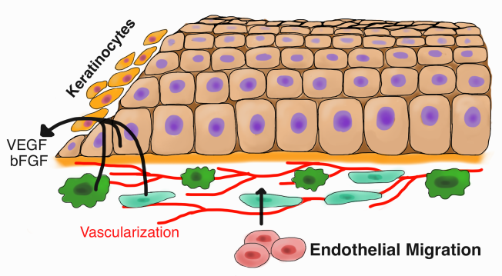
2.2 Chronic Wounds
Figure 2: Depiction of Epithelial Tissue After Injury and the Important Factors Involved in Wound Healing. The epithelial tissue is shown as a layer of cells with purple nuclei. Below the basal lining of the epithelial tissue, endothelial cells are shown migrating to the wound area and contributing to the vascularization beneath the wound bed, represented by the red lines. Other cells are shown releasing important growth factors such as VEGF and bFGF, which then travel towards the wound site. Finally, keratinocytes, another type of cell prominently involved in wound healing, are also shown migrating from the apical side of the epithelial tissue to the wound site. In chronic wounds, these factors are the ones most implicated. The dysfunction or lack of these crucial factors causes the wound to stay in a state of injury instead of healing.

In chronic wounds, such as diabetic ulcers, the healing process is severely impaired. The inability of these wounds to heal is due to a combination of over a hundred separate deficiencies, not limited to lack of growth factors, inhibited angiogenesis and bone healing, abnormal macrophages, lack of fibroblast migration and proliferation, and improperly formed collagen matrix ⁵⁸. These deficiencies manifest in a series of debilitating symptoms starting with neuropathy, or damage to the nerves of the peripheral nervous system ⁵⁸. This damage leads to an overactive inflammatory response, leaving the wound unable to heal ⁵⁸. Possible complications of these symptoms include infection, sepsis, and in the worst cases, amputation ⁵⁸. Previous research has pinpointed one of these important symptoms in the healing process– the excessive inflammatory response ^{51,59-63}. The extension of this phase leads to improper healing; thus many normal processes become accentuated and harmful to the body.
In a normal wound, the presence of NO aids in MMP production, degrades bacteria, and protects the wound site from ischemia ^{51,64}. In chronic wounds, however, the affected area enters a state of oxidative stress during the prolonged inflammatory period ⁵⁹. Oxidative stress is when reactive oxygen species (ROS) are rendered inactive due to an imbalance between the production of ROS and the counteracting protection by anti-oxidants ^{59,65}. Oxidative stress inhibits the endothelial cell enzyme NO synthase, interfering with the production of NO and also producing ROS superoxides, inactivating existing nitric oxide ⁶⁵. The resulting pathology is infection and ischemia. Oxidative stress also has a negative effect on the oxidative oxygen species. The excess oxidative species and the lack of protective anti-oxidants can lead to necrosis and apoptosis of cells in the wound site ⁵⁹.
In a normal wound, a steady blood supply is essential for delivery of oxygen, nutrients, and healing factors to the wound site as well as proliferation of cells ^{53,54}. In chronic wounds, however, the blood supply is impaired drastically ⁵⁷. Diabetic wounds have been known to have abnormally low concentrations of VEGF and TGF-β, growth factors that normally induce an angiogenic response ⁶¹. Even though some research has shown that in chronic wounds the production of growth factors such as VEGF and TGF-β is increased ^{57,60}, both the bioavailability and quantity are greatly decreased ⁶⁰. Thus, the angiogenic response is interrupted, making it extremely difficult for wound repair to continue.
In a normal wound, protease activity is controlled, only eliminating proteins that would interfere with the wound healing process ⁶⁶. In chronic wounds, protease activity is deregulated due to the presence of inactive protease inhibitors, causing detrimental effects on the ability of the wound to heal ^{48,60}. Proteases can breakdown essential growth factors such as VEGF, PDGF, and TGF-α and components of the extracellular matrix, which as discussed in normal wound healing, are both integral to the intracellular healing processes ^{48,60}.
Finally, in a normal wound, endothelial cells play an important role in the wound healing process ⁵¹. In chronic wounds, endothelial cell dysfunction is quite apparent. More specifically, the endothelial cells have difficulty with vasodilation, proliferation, and migration as well as inhibition of white blood cell activity ⁶⁷. Due to the severe limitations of the endothelial cells, neovascularization is impaired ⁵⁸. Without the essential blood supply to carry immune cells and oxygen to the affected site, the wound remains in a chronic, injured state.
2.3 Body’s Natural Bioelectric Field and Wounding
The formation of electrical fields in the human body was first studied over 150 years ago by German physiologist Emil Du-Bois Reymond ⁶⁸. Individual cells in the body maintain an electric potential across the plasma membrane (V_{m}) between -70 and -90 mV ⁶⁹. This potential is the result of the selective activity of sodium and potassium ion channels in the cell’s plasma membrane ⁶⁹. This selective ion transport results in an accumulation of negative charge inside the cell relative to extracellular space ⁶⁹.
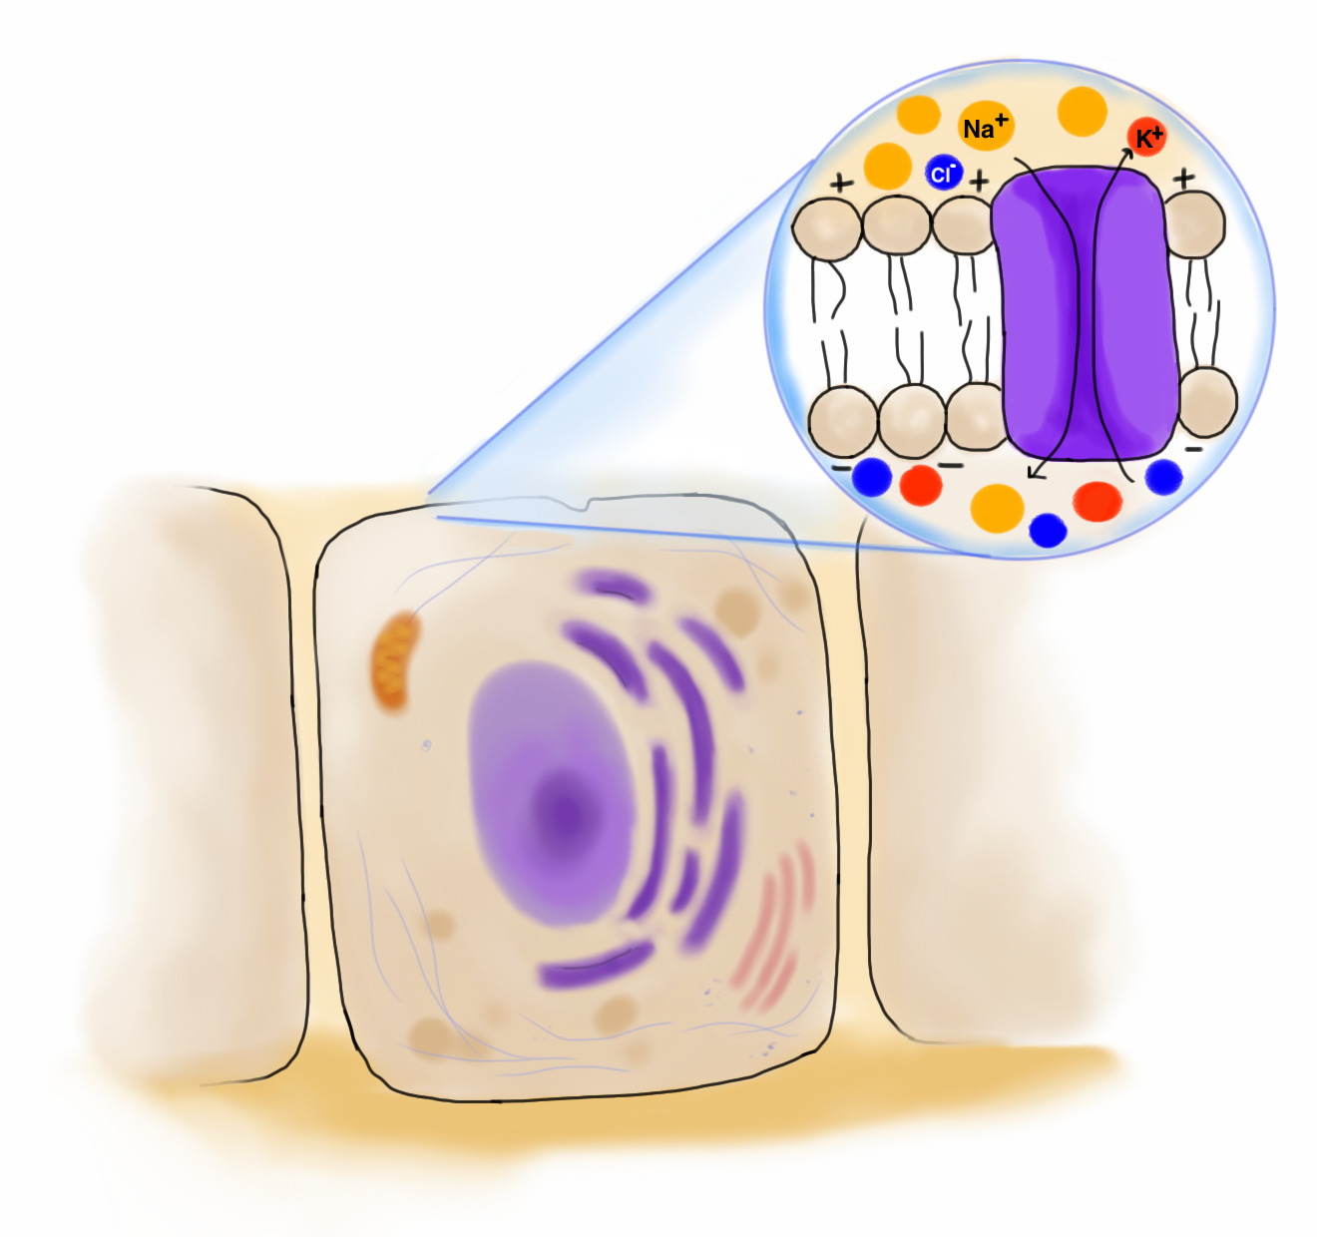
Figure 3: Membrane Potential. A typical cell is depicted with an outset of the plasma membrane. The phospholipids in the plasma membrane are shown with their hydrophobic tails on the inside and their hydrophilic heads facing outwards. An ion transport channel is shown as an integral protein in the plasma membrane. The distribution of sodium (orange), potassium (red) ions, chloride (blue) ions are shown with an excess of sodium ions on the outside of the cell and an excess of potassium and chloride ions on the inside of the cell. The outside of the cell is shown as being positively charged, while the inside is shown as being negatively charged.
Physiologically, changes in concentration of sodium and potassium ions play a key role in the function of excitable cells, such as neurons and muscle cells ^{70,71}. Similarly to excitable cells, cells in the human epithelium and endothelium exhibit selective ion transport across the plasma membrane, which also results in a significant electric potential difference across the skin ⁷²⁻⁷⁴. This naturally occurring trans-epithelial potential (TEP) is one of the driving forces responsible for the initiation of wound healing ⁷².
When the human epithelial layer is injured, a current leak is created at the wound site, which results in the collapse of the TEP and, subsequently, in the creation of lateral electric fields of 40-200 mV/mm directed toward the center of the wound ^{72,75} ⁷⁶. These lateral electric fields serve as the predominant signals responsible for the observed directional migration of epithelial cells into the wound center, a process known as galvanotaxis ⁷⁷⁻⁸⁰.
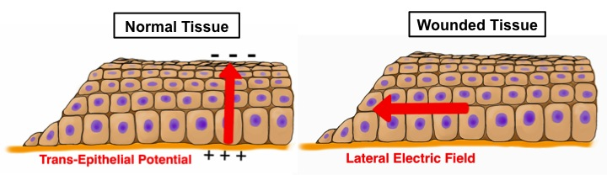
Figure 4: Electrical fields in normal tissue and wounded tissue. A layer of normal epithelial tissue is shown with the trans-epithelial potential on the left. The outer layer of the skin is collectively negatively charged, while the inner layer of the skin is collectively positively charged. When a wound occurs, the TEP is dissolved. A layer of wounded tissue is shown on the right. The red arrow shows the direction of the lateral electric field, which is created after the TEP is dissolved. The lateral electric field is in the direction of the wound and promotes cell migration to the wound site through galvanotaxis.
A study performed by Song et al. demonstrated that the lateral electric fields that are generated upon injury are also key regulators of the orientation and frequency of epithelial cell division at the wound site and, hence, the rate of wound healing in vivo ⁸¹. The same study also showed that the directed cellular migration in the same cell population is interrupted when the electric field polarity is reversed, which emphasizes the importance of the direction of the lateral electric fields in the direction of cellular movement and wound closure in vivo ⁸¹. Additional research has shown that directional migration based on polarity of the electric field is dependent on cell type and origin ⁷⁴. For example, corneal epithelial and metastatic breast cancer cells move towards the cathode of the electric field, or with the flow of electrons, ^{82,83} while human glioma, human induced pluripotent, and human umbilical vein endothelial cells move towards the anode of the electric field, or against the flow of electrons ⁸⁴⁻⁸⁶. A study on the directionality of endothelial cell migration under the influence of an applied electric field determined that cell morphology and alignment were altered such that migration parallel to the electric field (towards the anode) would be promoted ⁸⁷. In addition, the study found that while standard 2D in vitro models allowed for the observation of directional migration caused by galvanotaxis, an increase in cell migration velocity was only observed under spatial confinement conditions that mimic those found in physiological migratory channels ⁸⁷.
The precise mechanism by which electrical stimulation induces cell migration is currently under investigation. However, several important mechanistic details have been identified. First of all, it is known that the electric fields induced by the body’s natural wound-healing pathways occur at field strengths that are too low to mechanically push or pull on cells ⁸⁸. It can therefore safely be said that electrical stimulation does not apply a significant bulk force to cells ⁸⁸. However, results from a study that focused on the effects of electrical stimulation on keratinocyte migration suggest that applied and endogenous electric fields are strong enough to cause the electrophoretic migration of several cell membrane components ⁸⁹.
Cell membranes are composed of a variety of charged biomolecules, such as proteins, lipids and carbohydrates ⁸⁹. Therefore, in the presence of an extracellular electric field, some rearrangement of the cell membrane is expected ⁸⁹. Current scientific hypotheses point to the activation of a signaling pathway via a transmembrane protein sensor ^{88,89}. This polarization of membrane components is believed to interact downstream with a major signaling pathway such as the PI3K/AKT pathways ^{88,89}, which has already been shown to regulate cell migration in some strains of human epithelial cells ⁹⁰. At present, no single membrane component has been identified as being capable of sensing an external electric field ⁸⁹. However, further mechanistic research that identifies this biomolecule may provide insight on the question of why certain cell types migrate towards electrically charged anodes or cathodes.
The effect of electrical signals on the rate and direction of wound healing provides evidence for the use of electrical signals to modulate wound healing in patients with chronic injuries ⁸¹.
2.4 Physiological Responses to Electrical Stimulation
As previously mentioned, the body’s endogenous electric field has been linked to the directional control of endothelial cell migration, elongation, and alignment ⁹¹. Manipulation of this natural electric field, mainly by external electrical stimulus, has been proven to cause many positive cellular changes. Some different types of external electrical stimulation include neural stimulation, which influences overall heart rate, as well as mean arterial pressure (MAP) and functional electrical stimulation (FES), which can lead to improvements in exercise capacity and functional ability ⁹²⁻⁹⁶.
Due to the importance of electricity in signaling in neuronal pathways, it follows that electrical stimulation would cause the body to react just as if an action potential had been created. Vagus nerve stimulation (VNS) has long been used to prevent and treat seizures ⁹⁷. In a study by Henry et al., positron emission tomography (PET) scans during VNS treatment cycles has shown to alter blood flow by increasing activity in the right thalamus, right postcentral gyrus, and bilateral inferior cerebellum, while decreasing blood flow to the amygdala, hippocampus, and posterior cingulate gyrus, all of which are often involved in complex partial seizures ⁹⁸. In subsequent studies by Ring et al., Van Laere et al., and Vonck et al., single photon emission computed tomography (SPECT) showed contrasting results to those acquired via PET scan ⁹⁴⁻⁹⁶. Where the thalamic activity was found to increase with VNS in the PET studies, activity was seen to decrease in the SPECT studies ⁹⁴⁻⁹⁶. However, as VNS is an invasive treatment and tests cannot be readily performed on healthy individuals, differences in subjects and techniques could be the cause of these discrepancies. Nevertheless, consistent alteration of blood flow to other areas of the brain can be seen in both studies ⁹⁴⁻⁹⁶.
In another study by Lee et al., FES was applied to stroke patients that experienced paresis in their lower limbs ⁹³. The hemiparetic leg muscles – quadriceps, hamstring, gluteus maximus, and tibialis anterior – were electrically stimulated during assistive ergometer training ⁹³. Results showed significant improvement in exercise capacity and functional ability compared to control groups ⁹³. Other studies involving FES-induced cycling also showed large increases in lower extremity strength and functional ability due to the added electrical stimulation ⁹⁹.
2.5 Healing Wounds through Electrical Stimulation
2.5.1 In Vitro
As previously stated, the emergence of endogenous electric fields in wounded areas seems to determine the onset of the process of wound healing in humans ¹⁰⁰. In addition to neuronal and muscular activation, researchers have investigated the use of external electrical stimulation-based therapy to treat wounds. This method can be especially helpful for those injuries categorized as non-healing wounds, such as chronic diabetic foot ulcers. Foremost, studies have shown that electrical stimulation promotes directional fibroblast migration ^{101,102}, an essential step in the onset of the normal wound healing process. One study found that directional fibroblast migration occurred upon stimulation with a 100 mV/mm electric field in vitro ¹⁰¹. The electrically stimulated cells moved towards the cathode at a higher rate than non-stimulated cells ¹⁰¹. This study also explored potential mechanisms and determined that the intracellular communicating signal cyclic AMP (cAMP) was responsible for the observed directional migration ¹⁰¹.
Another study showed that the application of an externally applied electric field increases skin fibroblast proliferation, growth factor expression, and cell differentiation ¹⁰², all of which are critical steps for the onset of the wound-healing process. This study found that the cell growth rate in stimulated cells increased exponentially. This high cellular proliferation level was not only evident immediately after electrical stimulation, but was additionally maintained 24 and 48 hours post-stimulation. The study also demonstrated an increase in growth factor expression from the electrically stimulated fibroblasts ¹⁰². Higher VEGF, aFGF, and basic fibroblast growth factor (bFGF) cellular expression was observed after stimulation, regardless of the strength of the electric field; 50 mV/mm and 200 mV/mm fields showed similar results ¹⁰².
Electrical stimulation, when applied to wounds, can not only increase migration but also the production of vascular endothelial growth factor (VEGF) in the skin tissue surrounding the wound which directly correlates to wound repair ¹⁰³. It has been found that application of a direct-current electrical field to a wound will induce cell growth and migration of cells towards the wound perimeter ⁹¹. This is due to changes in membrane potentials of cells which release VEGF, and in turn cause changes in the cell’s Rho-ROCK and PI3K-Akt signal transduction pathways ⁹¹. Wound tissue is electrically polarized compared to surrounding healthy tissue as a result of the buildup of positive potassium ions in the tissue surrounding the wound ⁹¹. Activation of these pathways leads to cell reorientation and directional movement of cells towards the damaged tissue and speeds up the rate angiogenesis and wound repair ⁹¹. Moreover, it has been shown that electrical stimulation induces the migration of keratinocytes, which contribute to the skin’s first line of defense against pathogens, a key process in wound healing ¹⁰⁴⁻¹⁰⁶.
In addition to the significance of endothelial cells in wounds, previous literature has determined that an external electrical field can affect the behavior of endothelial cells. In a study by Bai, Forrester, and Zhao involving human umbilical vein endothelial cells (HUVEC), applied direct current electrical stimulation resulted in an up-regulation of VEGF and interleukin 8 (IL-8), two potent angiogenic factors ¹⁰⁷. In addition, pre-angiogenic responses were observed, including directional migration, elongation, and perpendicular orientation to the EF, while control cells that were not stimulated were randomly oriented ^{107,108}. In another study by Li and Kolega, the migration of bovine aortic endothelial cells (BAEC) was tested in the presence of an electric field ¹⁰⁹. An electric field between 1 V/cm and 2 V/cm affected the direction of cell migration without affecting the overall motor activity ¹⁰⁸. This observation supports the idea that since the natural wound healing process creates a negatively charged electrode in the center of the wound, the endothelial cells are drawn to migrate toward the center of the wound, promoting healing ^{110,111}.
2.5.2 In vivo
Similarly to the previously mentioned in vitro studies, there is a record for the use of electrical stimulation in vivo. Human trials show the greatest potential of the use of an electrical stimulation-based therapy to treat chronic wounds. Studies have shown that electrical stimulation increases perfusion, or blood flow, to the wound site. Increased perfusion is correlated with elevated oxygen levels, increased angiogenesis, and increased levels of VEGF ¹¹². In another study, it was found that the use of electrical stimulation up-regulated angiogenesis by increasing VEGF expression, down-regulated inflammation, increased expression of regulatory T-lymphocytes, and improved overall wound healing in human subjects ¹¹³. This series of studies show that electrical stimulation has the potential of not only improving wound healing parameters in vitro, but that it also has the ability to mimic the same results in human patients.
2.5.3 Diabetic Ulcers
Electrical stimulation also provides a viable therapy specifically for the treatment of chronic diabetic foot ulcers ^{77,114}. A series of clinical studies have found that the healing rate of wounds in diabetic patients, including foot ulcers, increases when the patient receives electrical stimulation.
In exploratory studies, medical researchers applied electrical stimulation therapy after warming of wounded patient tissue ^{115,116}. One study warmed the tissue by using a heat lamp before and immediately after stimulation and another study performed the whole stimulation in a warm room. Both trials saw increased blood flow to the wounded area and an overall increase in healing rates ^{115,116}. The use of heat in during the trials, however, did not cause more overall healing after stimulation therapy ^{115,116}. The trials found that the localized heat helped to dilate blood vessels in the wounded area so that the healing of the wounds would occur in a shorter time lapse ^{115,116}. Additional clinical trials have examined the effects of electrode type to stimulate non-healing wounds in patients with diabetes ¹¹⁷. Studies like these have shown that electrical stimulation penetrates deep into the wounded tissue and induces the onset of healing. These studies, however, have not examined the mechanisms by which electrical stimulation acts in the tissue nor have they measured the expression of angiogenic growth factors and other proteins, which are associated with healing. In addition, various electrode conformations have not been studied.
2.6 Investigation of Electrical Stimulation Techniques
Studies that involve an external electrical stimulus have also investigated the effects of various types of electrical stimulation on wound healing, specifically experimental changes in current. Current is the flow rate of electrons in an electrical circuit and is measured in amperes (A). Voltage is the potential difference between a negatively charged material (anode) and a positively charged material (cathode). If there is a potential difference, then current will flow between the cathode and anode. Voltage is measured in volts (V). Resistance, another related term, is a property of a material that resists the flow of electrons and is measured in ohms (Ω).
Direct current (DC) describes electrons continuously flowing in one direction, from one anode to one cathode, as opposed to alternating current where the position of the anode and cathode and the direction of electron flow continuously switch. Voltage can be applied continuously or in pulses. Even further, pulsed current may be split into monophasic and biphasic types. Monophasic currents are unidirectional, but have periods where there is no current flow. Pulsed biphasic current, unlike monophasic currents, have multiple phases; the positions of the anode and cathode switch, and electron flow is reversed. Figure 5 shows the different kinds of currents that can be applied.
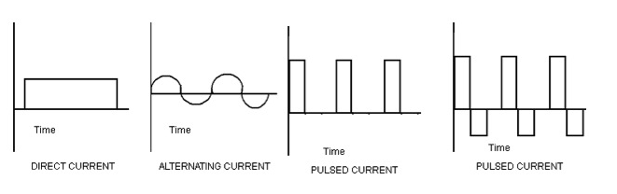
Figure 5: Different Types of Electrical Current (from Left to Right: Direct, Alternating, Pulsed Monophasic, Pulsed Biphasic). Graphical representations of the different types of current show differences in the time applied (continuous or non-continuous) and the direction of current. Direct current is applied continuously and in one direction. Alternating current, while applied continually, switches the direction of the current repeatedly. Pulsed monophasic current is non-continuous; the current is applied in a single direction at repeated intervals. Pulsed biphasic current is also non-continuous; current switches between two directions at repeated intervals.
Application of continuous microamperage DC is a plausible method of treatment for wound repair due to the endogenous potential difference between a wound and the surrounding tissue. External electrical stimulation devices delivering the current typically have an anodal and cathodal side. One study conducted tested to see which was more appropriate for wound repair: anodal or cathodal microamperage DC electrical stimulation. The distinction between anodal or cathodal electrical stimulation lies in which electrode is place on or near the wound site. In anodal electrical stimulation, the anode is placed on or near the wound site, whereas the opposite is true for cathodal electrical stimulation. This study concluded that the use of an anode rather than a cathode in delivering microamperage DC was more effective in healing skin wounds, because use of an anode decreased the wound surface area faster than use of a cathode ¹⁰⁰.
Another experiment by Zhao et al. used DC, specifically, low DC voltage current, and applied it to endothelial cell cultures to investigate the effects on wound healing. The experiment found that the cells migrated towards the anode. Cells also became increasingly elongated with the application of an electric field. After testing for other factors involved in wound healing, Zhao et al. concluded that the application of a low DC electric field would help facilitate wound healing, because of its effect on VEGF, migration, and other proteins ¹⁰⁷.
Pulsed current studies have also shown promise in the field of applied electrical stimulation for wound healing. High voltage pulsed current, in particular, is useful for the prevention of limb amputation that may occur as a result of diabetic ulcers of the lower extremity ¹¹⁸. Kloth et al. conducted a study on patients with diabetic ulcers who had been unsuccessfully treated with other medical methods. A high voltage pulsed monophasic electrical signal was applied to the wound for 45 minutes a day, 5 days a week for periods of 4, 5 or 16 weeks. They found that electrical stimulation dramatically increased the wound healing rate and decreased the surface area of diabetic ulcers, resulting in the healing of all ulcers in the study. The control group had no significant healing: ulcers either increased in area, though not significantly, or remained the same ¹¹⁹.
In addition, a pulsed electrical signal has been shown to increase the release of bFGF and decrease wound healing time. Pulsed electrical signals can also increase cell proliferation and impede diabetic wound necrosis ¹²⁰.

CHAPTER 3: EXPERIMENTAL QUESTIONS
This study aimed to postulate a chief cause of diabetic ulcer persistence and subsequently evaluate electrical stimulation as a potential treatment for diabetic ulcers.
Angiogenesis, or vascular tissue formation, is a crucial process in tissue repair and wound healing ⁵⁸. The angiogenic response is stimulated by an endogenous electric field that develops across tissue layers and triggers cellular pathways associated with wound healing ¹²¹. These pathways initiate both the production of intracellular growth factors, such as vascular endothelial growth factor (VEGF) and basic fibroblast growth factor (bFGF), and cell migration towards the wound site ^{62,122}. In a diabetic ulcer, the increased inflammatory response increases proteolytic activity, or the degradation of proteins ^{48,60}. This degradation inhibits the target angiogenic pathways and thereby reduces the production of intracellular growth factors including VEGF and bFGF ¹²³. We proposed the concept that the inflammation of damaged tissue is a major factor suppressing angiogenesis in diabetic ulcers, thus delaying the wound healing process ^{47,113,124}.
Our experiment used an external electrical stimulus to supplement the endogenous electrical field and trigger the implicated cellular pathways associated with tissue repair. These pathways, which are inhibited by excessive inflammation, would consequently be activated and promote the rapid healing of the ulcer. We believed that electrical stimulation would activate these cellular healing pathways, because previous studies have shown that applied current enhances ion transport through the wound and increases directed cell migration through galvanotaxis ¹²⁵. Other studies have also shown that sensory electrical stimulation is able to release more VEGF in skin, which improved the healing pathways in diabetic ulcers ¹²⁶.
Based upon these findings and our extensive literature review, we hypothesized that the application of an electrical stimulus would alleviate the effects of the inflammatory tissue response in wounds, and thus increase angiogenesis and reduce the healing time of chronic diabetic ulcers. Specifically, we proposed and investigated the following two hypotheses and their associated experimental questions:
- Growth factors that promote the proliferation of endothelial cells are highly correlated with angiogenesis ^{62,122}. The directed migration of these endothelial cells is of key importance ¹⁰⁷. Does the application of a unidirectional and homogenous applied electric field increase endothelial cell proliferation, VEGF and bFGF gene expression, and cell migration in an in vitro migration model?
- The intensity and direction of the applied electric field has been shown to change levels of angiogenesis and wound healing ¹²⁶. In contrast to a unidirectional and homogenous applied electric field, an electric field with a radial geometry would result in non-constant electric field intensities in different regions of the area of interest. The electric field gradient would align with the oxygen concentration gradient in the wound bed, applying more electrical stimulus to the center of the wound where oxygen concentration is lowest ¹¹⁹. Does the application of a radial electric field increase endothelial cell proliferation, VEGF and bFGF gene expression, and cell migration in an in vitro migration model? Even further, does the variable intensity field produce significantly larger differences in cell proliferation, VEGF and bFGF gene expression, and cell migration compared to a constant intensity field?

CHAPTER 4: METHODOLOGY
4.1 Device Design
4.1.1 Linear Conformation
In order to apply a linear and constant electric field to a cell population, a biocompatible parallel plate electrode device was constructed. Parallel plate electrodes were created by coating two microscopes slides with approximately 2,000 Å of conducting metal using a traditional electron-beam deposition set-up ¹²⁷. 99.99% pure titanium was chosen as the conducting metal, because of its frequent use as a component of medical devices and its biocompatibility ¹²⁸. The two electrodes were glued to a third microscope slide to stabilize the device and to ensure that the plates were uniformly 1.5 cm apart in all experiments as shown in Figure 6.
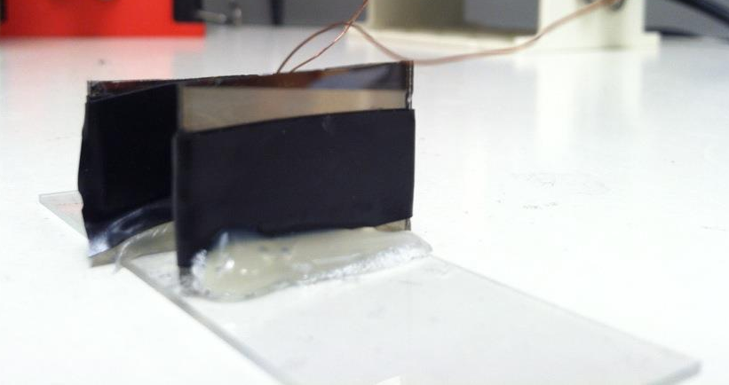
Figure 6: Linear Field Device. The two electrodes are placed 1.5 cm apart. The two electrodes were stabilized in the correct position by a microscope slide. The wires extended from each of the electrodes and were connected to a waveform generator.

4.1.2 Radial Conformation
In order to apply a radial and variable electric field to a cell population, a second biocompatible device was constructed. Unlike the previously created linear device, the radial device required two separate electrodes: an inner electrode and an outer electrode. The inner electrode was designed to be a solid circle placed inside an annulus acting as the outer electrode. The inner electrode was comprised of a solid titanium cylinder with a diameter of 0.3175 cm. The outer electrode was comprised of a hollow glass cylinder with a diameter of 3 cm and coated with titanium on the inner surface. The distance between the outer electrode and inner electrode was 1.5 cm and was equal to the distance between the electrodes in the linear field device for ease of comparison.
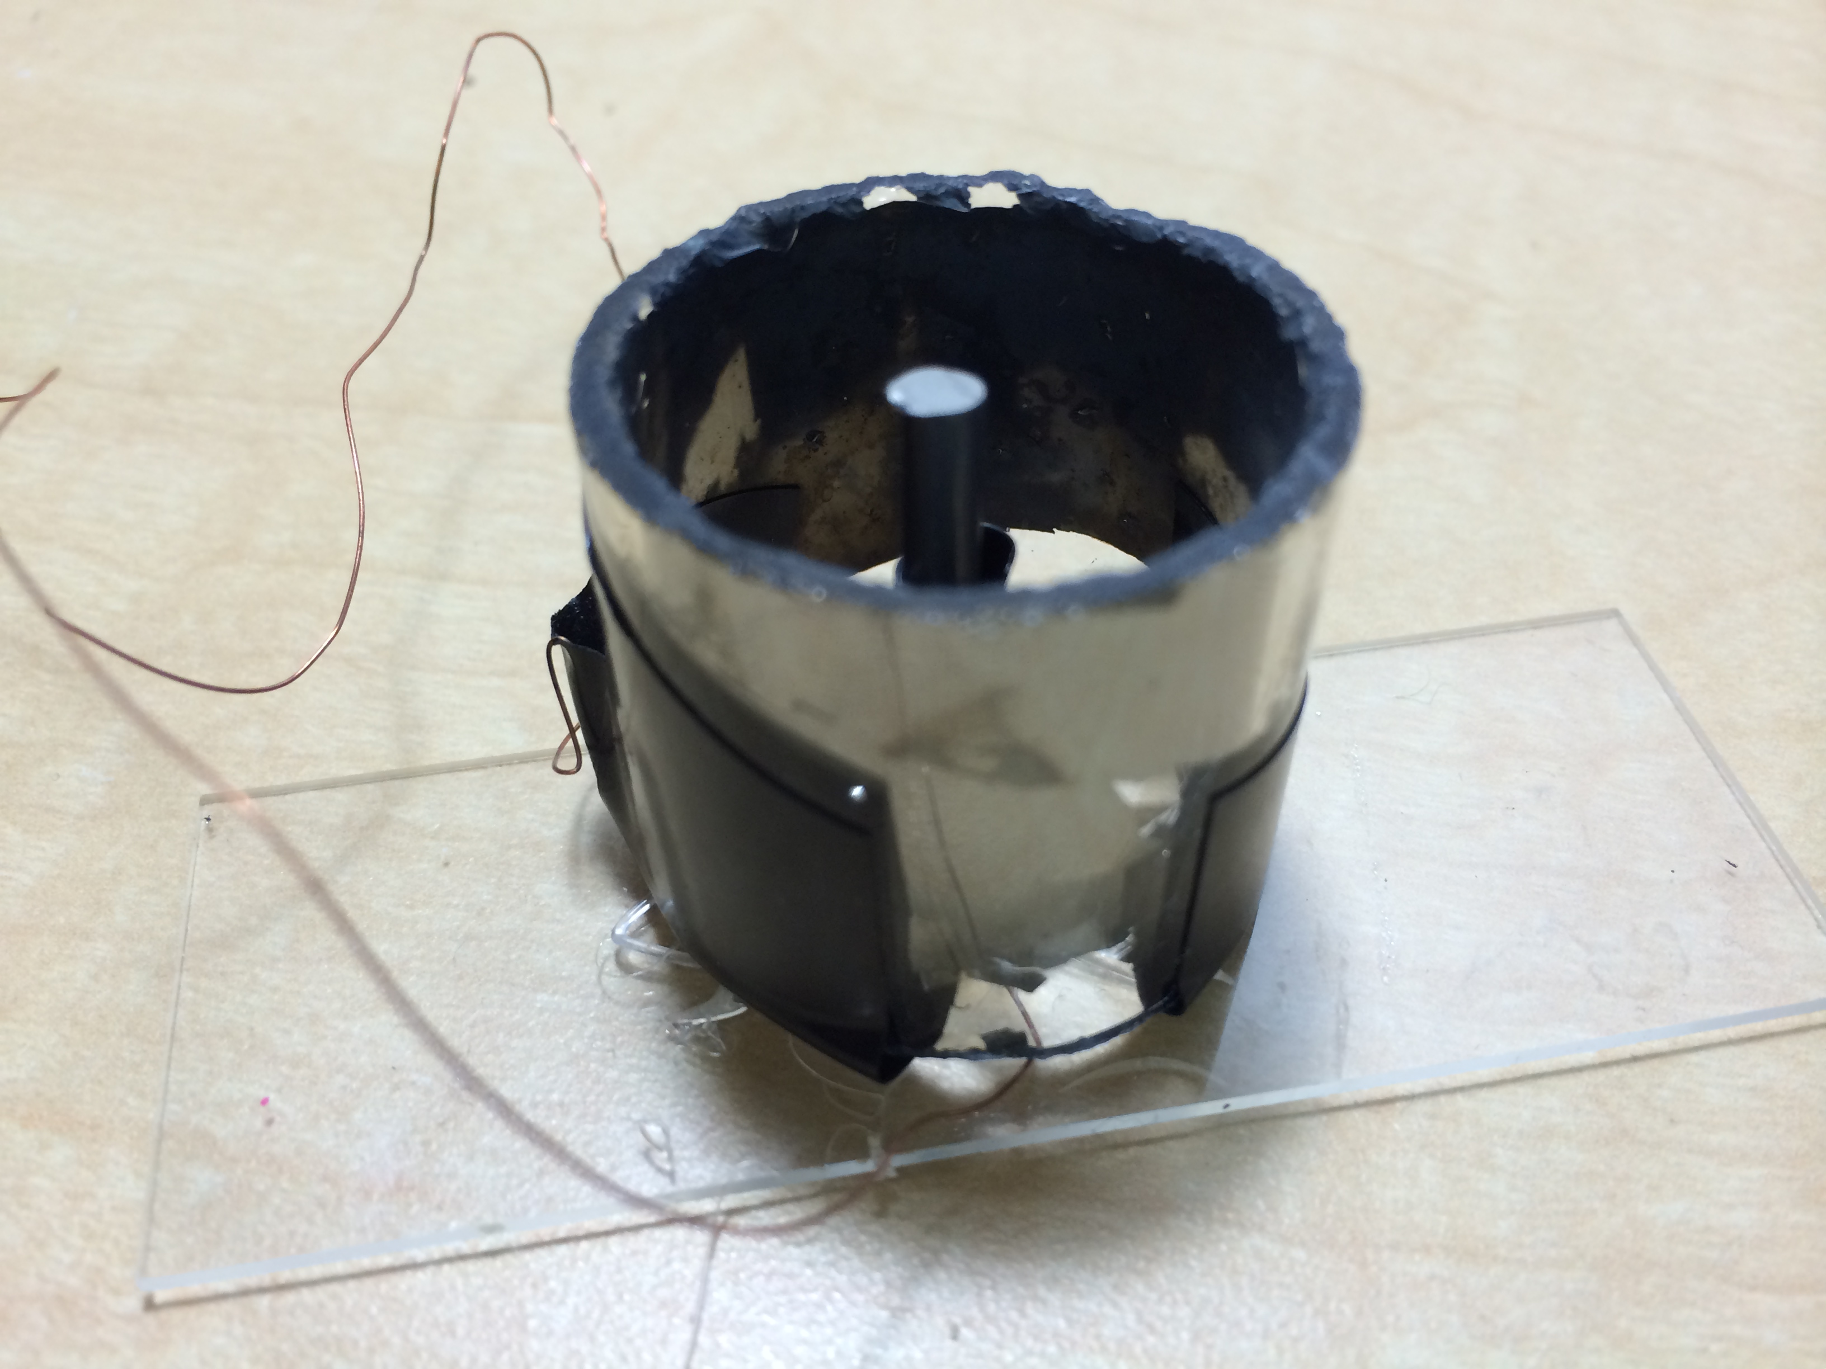
Figure 7: Radial Field Device. The outer electrode was a titanium-coated hollow cylinder while the inner electrode was a sold titanium cylinder. The two electrodes were stabilized in the correct position by a microscope slide. The wires extended from each of the electrodes and were connected to a waveform generator.
In order to coat the inner surface of the outer electrode with conducting metal, a custom thermal evaporation set-up was constructed in a vacuum chamber. A bar of pure titanium was suspended inside the glass cylinder. A high current was then applied to the metal bar, raising its temperature to the melting temperature of titanium. As the metal heated, titanium particles evaporated, traveled outwards, and settled on the inner surface of the glass cylinder. The set-up was designed to deposit approximately 2,000 Å of titanium on the inside of a Pyrex glass cylinder in accordance with the thickness of titanium on the linear device. The inner titanium electrode was then positioned inside the newly titanium-coated outer electrode as shown in Figure 8. Then, the radial device was assembled and stabilized on a microscope slide as seen in Figure 7.
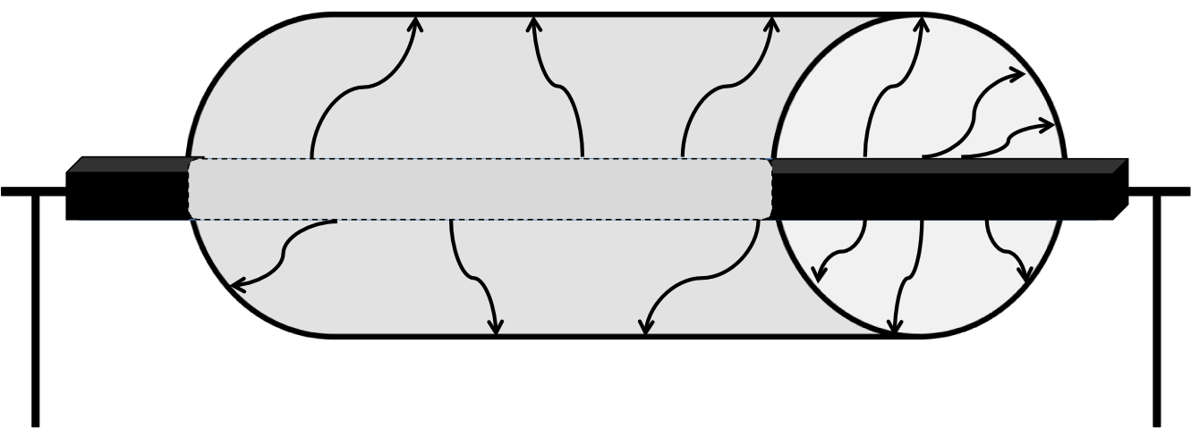
Figure 8: Coating Process of Outer Electrode in Radial Device. In our custom set-up, a bar of pure titanium was suspended inside the glass cylinder. A high current was then applied to the metal bar, raising its temperature to the melting temperature of titanium. As the metal heated up, evaporating particles traveled outwards and settled on the inner surface of the glass cylinder.

4.2 Comparison of the Electrical Fields
The linear electrode configuration creates a constant field between the two electrodes as seen in Figure 9 and is both unidirectional and homogeneous. Previous research has shown that this particular conformation stimulates angiogenesis and wound healing ¹²⁶. The proposed direction of cell migration is also shown in Figure 9. The cells were hypothesized to move to the right following lateral field lines.
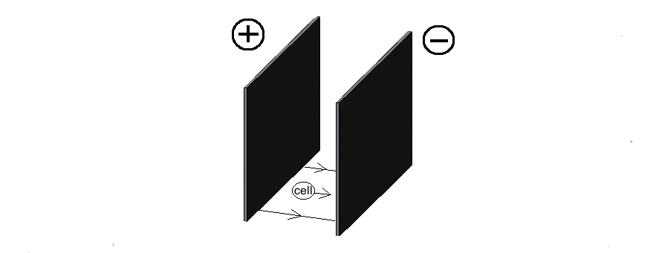
Figure 9: Direction of Electrical Field in Linear Set-Up. The two electrode plates are shown in the schematic with the positive electrode (cathode) on the left and the negative electrode (anode) on the right. The arrows between the electrode plates represent the direction of the electrical field, which customarily runs from the cathode to the anode, in this case from left to right. The supposed direction of the cells’ movement, from left to right, is also indicated. The cell moves from the cathode to the anode.

However, in contrast to the linear device, the radial device delivers an electrical field of variable intensity. The intensity of the electric field varies in space by a factor of (r²)⁻¹, where r is the radius of the field. Thus, as the radius of the field decreases, the intensity of the field increases and vice versa. In this particular conformation, the negatively charged inner electrode is placed in the center of the positively charged outer hoop electrode as seen in Figure 10. Therefore, the electrical field is the most intense at the center of the inner electrode and least intense at the edge of the outer electrode.
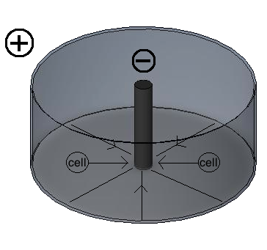
Figure 10: Direction of Electrical Field in Radial Set-Up. Two electrode plates are shown in the schematic as concentric circles. The inner circle is the negative electrode (anode) and the annulus is the positive electrode (cathode). The arrows between the electrode plates represent the direction of the electrical field, which customarily runs from the cathode to the anode, in this case towards the inner circle. The supposed direction of cell movement is also indicated. The cells move from the cathode to the anode, towards the inner circle.

The primary difference between the two devices is the intensity of the electric field. While the linear field provides a constant field and thus equal stimulation to the cell population within its range, the radial field provides a non-constant field and thus the cells closer to the inner electrode receive a stronger electrical stimulus than those on the edge of the outer electrode.
In addition to comparing the effects of a linear versus radial field, a reversed radial field as seen in Figure 11 was tested. The same radial device was used for this experiment; however, the positive and negative electrodes were interchanged. The purpose of this supplementary experiment was to further prove that the electrical field can be manipulated and hence is the cause for any differences between control and experimental groups.
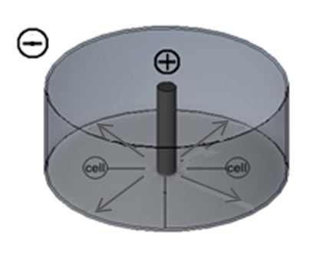
Figure 11: Direction of Electrical Field in Reverse Polarity Radial Set-Up. Two electrode plates are shown in the schematic as concentric circles. The inner circle is the positive electrode (cathode) and the annulus is the negative electrode (anode). The arrows between the electrode plates represent the direction of the electrical field, which customarily runs from the cathode to the anode, in this case towards the outside of the annulus. The predicted direction of cell movement is also indicated. The cells moves from the cathode to the anode.

4.3 Cell Culture

An in vitro diabetic ulcer model was developed for evaluation of the effects of an electrical stimulation treatment on cells in culture. Since endothelial cells play an important role in the proliferation stage of wound healing ^{49,56,129}, are severely damaged in a chronic wound such as diabetic ulcers ^{58,67}, and have electrical properties ^{73,75,107,108}, this cell type was a natural choice for the in vitro diabetic ulcer model. Even further, the in vitro model was originally designed such that it could be easily translated in vivo. Consistent with previous literature focusing on animal models of diabetic ulcers, the in vivo model consisted of Sprague-Dawley rats ^{130,131}. Therefore, the specific cell line chosen was rat aortic endothelial cells (RAOECs).
A vial containing greater than 500,000 cryopreserved RAOECs (Cat #:R304-05a) was purchased from Cell Applications, Inc. The cells were grown in Rat Endothelial Cell Growth Medium (Cat #: R211-500) until the third passage and then vials of the cells were frozen and stored at -80°C at low passage for subsequent experiments. Cells were thawed as needed. All cell culture was completed following the manufacturer’s protocols.
Prior to experimentation, 6-well plates were treated with Attachment Factor (Cat #: 123-100) before cell plating to increase cell adhesion to the polystyrene. The cells were plated at a seeding density of 150,000 cell per 9.5 cm². The cells were cultured and expanded at 37°C and 95% relative humidity and grown to confluence for testing. All cells examined were grown at less than the twelfth passage to ensure consistency between cell behavior and morphology.
4.4 Experimental Timeline
For ease of understanding, a complete experimental timeline is shown below in Figure 12. To distinguish between migration and proliferation, shorter time points, 4.5 and 9 hours, were chosen for the Cell Migration Assay, and longer time points, 24 and 48 hours, were chosen for the Live-Dead Viability Assay. The doubling time for RAOECs is approximately 36 hours, thus 24 and 48 hour time points are not suitable for migration data. The increase in the number of cells would trigger the cells to naturally disperse and obscure cell migration. Thus, time points of 4.5 and 9 hours were chosen, so that migration could be documented before cell proliferation encroached upon the edge of the cell population, or cell front. Gene expression time points were chosen to match proliferation time points and to allow cells to produce a sufficient amount of mRNA for qRT-PCR.

Figure 12: Graphic of Experimental Time with Assays and Associated Time Points in Relation to Time of Electrical Stimulation. Cells were plated 72 hours (3 days) before electrical stimulation in order to allow the cells to form a confluent monolayer in each well. 72 hours later, cells were scraped based on the type of device being used. Experimental wells were then stimulated for a one-time application of 30 minutes. 4.5 and 9 hours post-stimulation, migration images were taken with a camera attached to an inverted microscope. 24 and 48 hours post-stimulation, the Live-Dead Viability Assay and mRNA extraction were performed. Data analysis for the Migration Assay and Live-Dead Viability Assay were done after the experiment was completed. mRNA was converted to cDNA and then qRT-PCR was performed after the experiment was completed.
4.5 Electrical Stimulation
4.5.1 Linearly Applied Electric Field
Immediately prior to electrical stimulation, the majority of cells were scraped from the well with a sterile cell scraper, leaving only a 1-cm wide strip of cells in the middle of the well as seen in Figure 13. The wells were marked prior to plating to ensure scraping consistency between each 1-cm strip of cells. The linear field device was soaked in ethanol for 30 minutes to sterilize the device. The device was then placed in an experimental well such that the distance between the cell strip and the nearest electrode was even on either side and so that there was contact between the growth medium and the electrodes. As seen in Figure 13, the electrode on the right side corresponded to the negative lead, while the electrode on the left side corresponded to the positive lead. The electrode wires were connected to a waveform generator. The generator applied a direct pulsed monophasic current at low voltages with a frequency of 50 Hz while all other electrical factors were kept constant ¹³². The device remained active in each experimental well for a single application of 30 minutes. The pulsed monophasic square wave was chosen due to research supporting its effectiveness in accelerating wound healing ¹¹⁹. The protocol was repeated to test voltages of 0.01 V, 0.10 V, and 1.00 V.
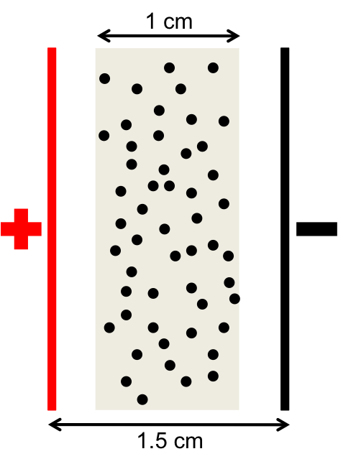

Figure 13: Schematic of Linear Experimentation Set-Up. The width of the cell strip after scraping is shown as 1 cm across. The distance between electrodes is shown as 1.5 cm across, equally distributed from the left and right sides of the cell population. Consistent with Figure 9, the cathode is shown on the left and the anode is shown on the right.

4.5.2 Radially Applied Electric Field
Immediately prior to electrical stimulation, a 1-cm diameter circle was scraped in the middle of each well, leaving ring of cells as shown in Figure 14. The wells were marked prior to plating to ensure scraping consistency between each 1-cm diameter of cells. The radial field device was soaked in ethanol for 30 minutes to sterilize the device. The device was then placed in an experimental well such that the inner radial electrode was in the center of the well and so that there was contact between the cell media and each electrode. As seen in Figure 14, the inner electrode corresponds to the negative lead, while the outer electrode corresponds to the positive lead. The electrode wires were connected to a waveform generator and a current was applied with the same specifications used in the linear experiments. The device remained active in each experimental well for a single application of 30 minutes. The protocol was repeated to test voltages of 0.01 V, 0.10 V, and 1.00 V.
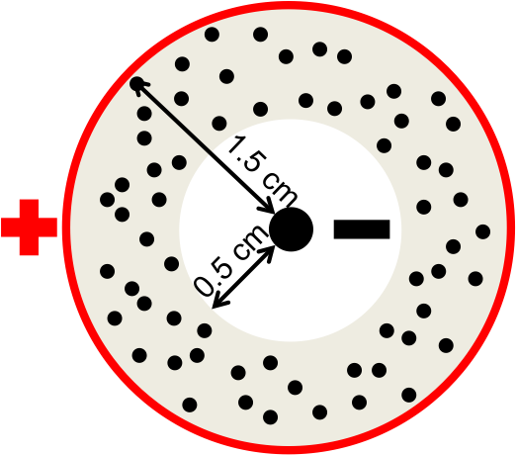

Figure 14: Schematic of Radial Experimentation Set-Up. The cells are scraped in a 0.5 cm radius from the center of the well. The remaining cell population is in the annulus. The total distance between the inner and outer electrode is indicated as 1.5 cm. The outer hoop represents the cathode and the inner circle represents the anode.

Additionally, a radial reverse polarity experimentation set-up was used for one trial of 1.00 V. As shown in Figure 15, the inner electrode corresponds to the positive lead, while the outer electrode corresponds to the negative lead. The protocol remained the same and the device remained active in each experimental well for a single application for a total of 30 minutes.
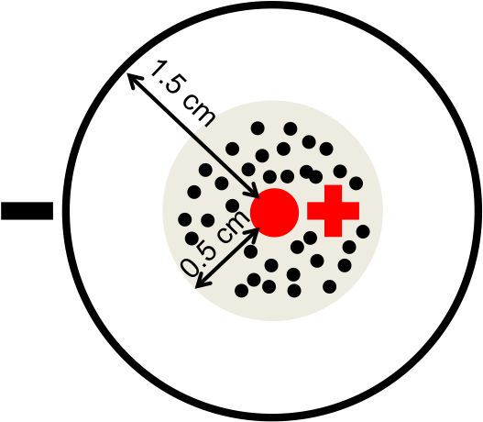

Figure 15: Schematic of Reverse Polarity Radial Experimentation Set-Up. The cells are scraped outside a 0.5 cm radius from the center of the well. The remaining cell population is in the center of the well. The total distance between the inner and outer electrode is indicated as 1.5 cm. The outer hoop represents the anode and the inner circle represents the cathode.

4.6 Migration Assay
Background
Endothelial cell migration was the first factor assessed to determine if an applied electrical stimulus had an effect on wound healing. Cell migration was measured using the principles of a scratch wound assay in combination with a wound-healing assay. These two assays require a scratch or scrape to be made in the middle of a confluent population of cells to allow for cell migration typically seen in wound healing ^{133,134}. Cells at the edge migrate into the empty space and the distance the cells migrate can be measured from images taken at specified intervals post-wounding. The location of the cells from one image to another are then compared and analyzed for cell migration ¹³³⁻¹³⁶. Since this experiment was evaluating directional migration, the cells were scraped in the opposite fashion of the typical scratch assay and thus the analysis technique had to be adjusted for both linear and radial experimental set-ups.
Procedure
To observe the effects of a linearly applied electric field on endothelial cell migration in this experiment, an inverted microscope (Zeiss Axiovert) equipped with a model 18.2 digital camera (Diagnostic Instruments) was used. Images of the cells were taken before electrical stimulation was applied and 4.5 and 9 hours post-stimulation using the SPOT Basic Imaging Software. Three images were taken along each side of the 1-cm line of cells as shown in Figure 16, for a total of 6 images per well. Measurements were recorded using the stage scale of the microscope in order to ensure that images were taken at the same place for every time point.

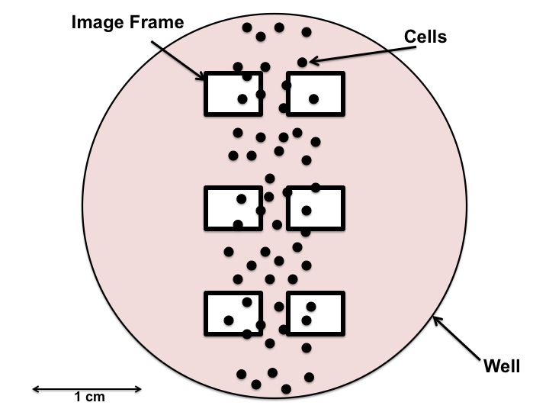
Figure 16: Schematic of the Cell Strip for the Linear Phase of Experimentation and the Position of Images Taken During the Migration Assay. The scattered dots represent the 1-cm line of cells that remain after scraping. The red background represents the cell culture media in the well. The white rectangles represent the placement of the Migration Assay images at the top, middle, and bottom of the well and on the left and right sides of the cell population. The image frames are distributed evenly in the vertical direction and are equal distances apart in the horizontal direction. The placements of the images were determined so that migration of cells from the original scraped 1-cm strip could be detected in the left or right direction.
For the radial electric field, images were also taken before electrical stimulation was applied and 4.5 and 9 hours post-stimulation. Before plating, two intersecting lines in the shape of a cross were drawn through the circle as shown in Figure 17, so that the circle was divided into four separate quadrants: top right, top left, bottom left, and bottom right. During migration analysis, four images were taken, one for each quadrant at the point where the linear line intersected the curve of the circle with a radius of 0.5 cm. To ensure the same location of image capture for each time point, measurements were recorded using the stage scale on the microscope.
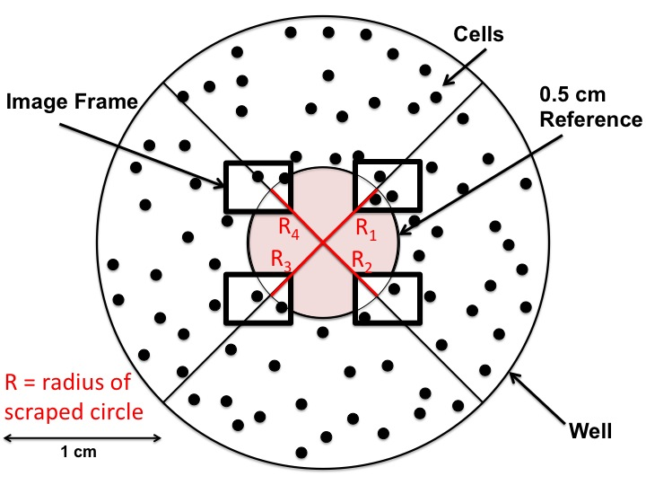
Figure 17: Schematic of the Cell Strip for the Radial Phase of Experimentation and the Position of Images Taken During the Migration Assay. The scattered dots represent the cells that remain after approximately scraping a reference circle with a 0.5 cm radius, R, from the middle of the well. The red background represents the portion of the well (reference circle) that was scraped prior to testing. The white rectangles represent the placement of the Migration Assay images at each of the four diagonal cross-sections of the reference circle. The diagonal lines were used as reference to make sure the placement of the four images was distributed evenly in the horizontal and vertical directions.
Analysis
To analyze the distance that the cells migrated in the linear model, the images were calibrated to the scale of the microscope’s objective (0.279 pixels/micron) with a Java-based image-processing program developed at the National Institutes of Health, ImageJ. ImageJ was used to draw straight lines and measure the distance in micrometers from the starting position of the cells to the edge of the cell population. For each image, five measurements at equal vertical intervals of 716 micrometers along the line of cells were recorded and the average of the distances was determined. Intervals were evenly divided based on the total length of the image. A representative image with the five measurements at equal distances on the y-axis is shown in Figure 18.
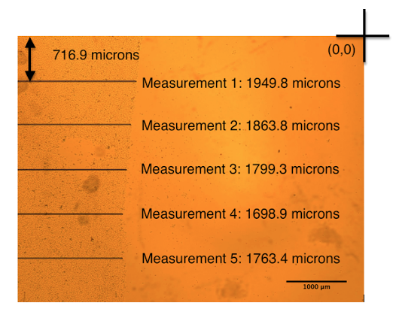

Figure 18: Example of Linear Migration Analysis Image Taken on the Right Side of the Scraped Line. For each image taken for the linear Migration Assay (See Figure 8), five lines were drawn from the edge of the cell population to the edge of the image. The five lines were equally distributed in the vertical direction, each 716.9 microns apart. Intervals were evenly divided based on the total length of the image. The lengths of the lines were measured in microns, indicating migration of cells to the right. The drawing of the lines and measurements were done in ImageJ.

These 5 measurements were taken for each image for the three time points: 0, 4.5, and 9 hours post-stimulation. The change in width of the cell population was calculated between each time point with the following equations:
Δ_{0hr to 4.5hr} = L_{4.5hr} – L_{0hr}
Δ_{4.5hr to 9hr} = L_{9hr} – L_{4.5hr}
where L represents the average width of the cell population for each picture. The average and the standard deviation of Δ_{0hr to 4.5hr} and Δ_{4.5hr to 9hr} values were then calculated for all control and experimental images. Average right side Δ_{0hr to 4.5hr} and Δ_{4.5hr to 9hr} and their accompanying standard deviations were then plotted for comparison. Only right side images were used because the anode was positioned on the right side of the scraped line (See Figures 9 and 10). The projected movement of cells was towards the anode due to the positively charged outside of the cell membrane. Measurements made on the left side of the scraped line did not demonstrate any difference in migration between control and experimental wells. Average length measurements for L_{0hr,} L_{4.5hr,} and L_{9hr} and their corresponding standard deviations were also plotted for each voltage to examine total distance traveled.
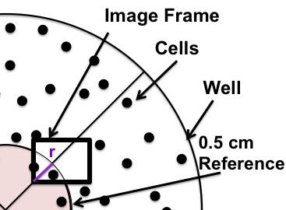
To analyze the distance that the cells migrated in the radial model, the ImageJ program was used to draw a straight line and measure the distance in micrometers from the intersection of the diagonal line and reference circle to the edge of the cell population. The distance from the inside of the reference to the edge of the cell population (r) was measured twice, once on each side of the diagonal line. If cells were observed to be inside the circle, the value obtained for the distance in micrometers was set as a positive number as seen in Figure 19.
Figure 19: Schematic and Example of the Measurement of r in the Radial Migration Assay (Inward Movement). For each image taken for the radial Migration Assay (See Figure 17), the distance of cell migration was measured. If the cells moved inwards of the reference circle, a distance r in microns was measured inside the circle. Two lines were drawn from either side of the diagonal reference line inwards from the reference line as indicated on the left in the schematic. Actual measurements are shown on the right in the example image. All lines and measurements were done with ImageJ.
If the cells were observed to be outside the circle, the value obtained for the distance was set as a negative number as seen in Figure 20. If the edge of the cell population was inside the markings and could not be seen, measurements were not taken for that well.
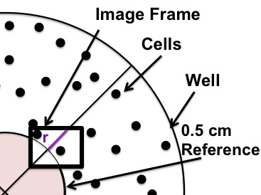
.

Figures 20: Schematic and Example of the Measurement of r in the Radial Migration Assay (Outward Movement). For each image taken for the radial Migration Assay (See Figure 17), the distance of cell migration was measured. If the cells moved outwards of the reference circle, a distance r in microns was measured outside the circle. Two lines were drawn from either side of the diagonal reference line outwards from the reference line as indicated on the left in the schematic. Actual measurements are shown on the right in the example images. All lines and measurements were done with ImageJ. Note that the measurements are negative since they are on the outside of the reference circle.

The r-value was then subtracted from 5000 microns, the reference circle radius, to calculate the radial distance from the center of the scraped circle to the edge of the cell population (R) using the equation:
R = 5000μm – r
Figure 21 below shows the distance that is represented by the calculation of R.
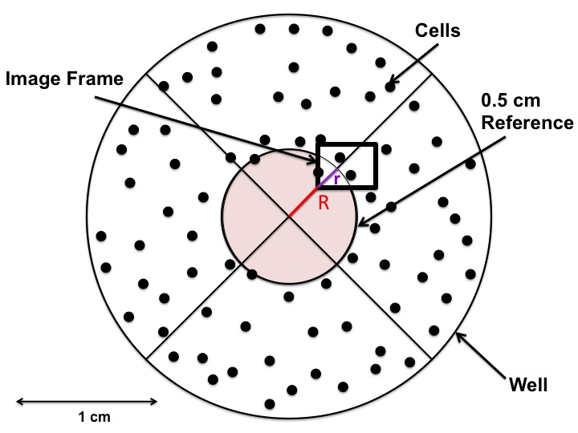
Figure 21: Schematic Representing the Calculation of R and the Measurement of r in the Radial Migration Assay. The red line represents R and the purple line represents r. After measuring the two r values on each side of the diagonal reference line, the distance R is calculated. R is calculated by subtracting the r-value from 0.5 cm (5000 microns) in order to calculate new radius of the inner circle.

The following equations were used to calculate the decrease in the radius of the scraped circle over time.
Δ_{0hr to 4.5hr} = R_{0hr} – R_{4.5hr}
Δ_{4.5hr to 9hr} = R_{4.5hr} – R_{9hr}
where R represents the average radius of the scraped circle for each picture. The average and the standard deviation of Δ_{0hr to 4.5hr} and Δ_{4.5hr to 9hr} values were then calculated for all control and experimental images and plotted for comparison. The projected movement of cells was towards the anode due to the positively charged outside of the cell membrane, thus the radius of the scraped circle was hypothesized to decrease. Average radius measurements for R_{0hr,} R_{4.5hr,} and R_{9hr} and their corresponding standard deviations were also plotted for each voltage to examine total distance traveled.

4.6 Live-Dead Viability Assay

Background

After completion of electrical stimulation, the fluorescence-based Live-Dead Assay was used to assess the viability of the cell monolayer. To perform this test, the LIVE/DEAD Viability Kit L3224 (Invitrogen) was used. The kit contained two fluorescent dyes: calcein AM (cAM C3099) and ethidium homodimer-1 (EH E3599). cAM is a fluorogenic esterase substrate that is hydrolyzed by nonspecific intracellular esterases into calcein, which is observed as a green-fluorescent product ¹³⁷. This green fluorescence indicates cells that have esterase activity as well as an intact membrane that can retain esterase products, both of which are distinguishing characteristics of live cells ¹³⁷. Conversely, EH is a red-fluorescent nucleic acid stain that can only pass through the membranes of dead cells ¹³⁷. Numerous published studies have indicated the validity of using the Live-Dead Viability Assay on mammalian cells ^{138,139}.

Procedure

To carry out the Live-Dead Viability Assay, the medium supernatant was removed and plates were rinsed with phosphate buffered saline (PBS) to remove the remainder of media and serum. EH and cAM were diluted in PBS and added to the cell monolayer. The cells were then incubated for 30 minutes in the dark at room temperature ¹³⁹. Following this incubation, the fluorescence of the cells was observed and analyzed using an inverted microscope (Zeiss Axiovert) with the Filter set 23 (Zeiss) and 11.2 Color Mosaic (Diagnostic Instruments).

For the linear phase of the experiment, the viability images were obtained using SPOT Basic Imaging Software. One live image and one dead image were taken at the top, middle, and bottom region of each well as seen in Figure 22. All images were obtained at 20X magnification. Live images were taken using the green filter, with excitation/emission spectrum 485/530 nm, while dead images were taken using the red filter, with excitation/emission spectrum 530/645 nm.
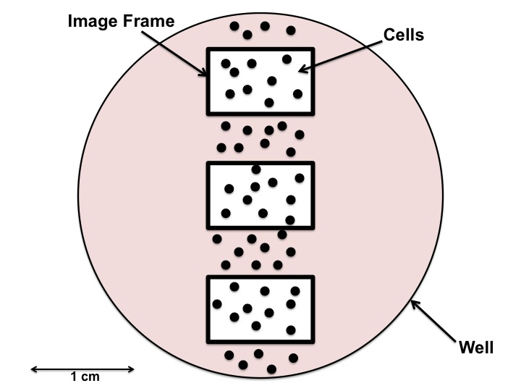
Figure 22: Diagram of the Cell Strip for the Linear Phase of Experimentation and the Position of Images Taken During the Live/Dead Viability Assay. The scattered dots represent the 1-cm line of cells left after scraping. The red background represents the cell culture media in the well. The white rectangles represent the placement of the Live/Dead Viability Assay images at the top, middle, and bottom of the well, distributed evenly in the vertical direction. Each image was taken with the cell population in the middle.

For the radial phase of the experiment, one live image and one dead image were taken at the top, right, bottom, and left of each well as seen in Figure 23 following the same procedures used in the linear phase of the experiment.

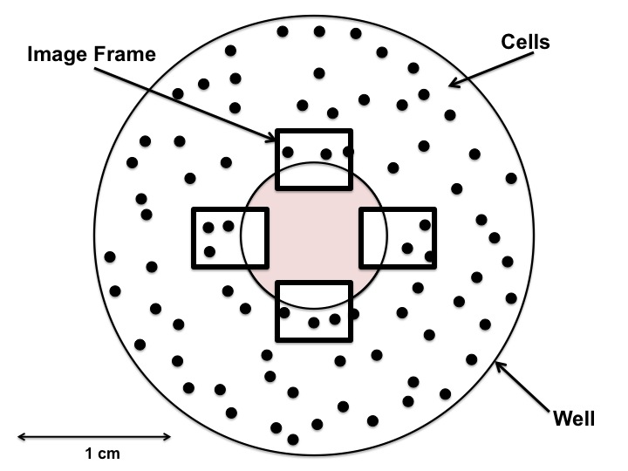

Figure 23: Schematic of the Cell Annulus for the Radial Phase of Experimentation and the Position of Images Taken During the Live/Dead Viability Assay. The scattered dots represent the cells left after scraping a reference circle with a 0.5 cm radius from the middle of the well. The red background represents the portion of the well (reference circle) that was scraped prior to testing. The white rectangles represent the placement of the Live/Dead Viability Assay pictures at the top, bottom, left, and right sections of the reference circle, distributed evenly in the vertical and horizontal directions.

Analysis
While the Live-Dead Viability Assay is primarily employed to assess the viability of cells post-electrical stimulation, the images from this experiment were used also to analyze the change in cell population size at two time points: 24 and 48 hours after electrical stimulation. The images were calibrated using SPOT Advanced Modular Imaging Software for Microscopy and the total area of the field of view was calculated in ImageJ. A total count of the number of viable cells in each image, represented by cells fluorescing green in color, was acquired from manual counting with the aid of the Cell Counter plugin available with ImageJ. The same was done for the nonviable cells, which fluoresce red.
Density of cells was calculated by dividing the number of cells in the image by the total area of the field of view. Thereafter, the cell density was normalized to the seeding density at the time of plating. The values of live cells in each of the images from the three control wells were then averaged and the standard deviation was calculated. Similarly, the values of the dead cells in each of the images from the three control wells were averaged and the standard deviation was calculated. The same calculations were performed for the live and dead cells in the images taken from the three experimental wells. Averaged data was then plotted with the accompanying standard deviations. It is important to note that our 24 and 48 hour time points refer to time elapsed after stimulation, not time elapsed after cell plating as shown in Figure 12.
4.8 qRT-PCR Assay
Background
The mRNA expression of angiogenic genes post-stimulation was also measured. The genes of interest, vascular Endothelial Growth Factor (VEGF) and basic Fibroblast Growth Factor (bFGF), were measured at the gene level by extracting the protein-specific messenger RNA (mRNA) from both the control and experimental cells. Quantitative Reverse-Transcriptase Polymerase Chain Reaction (qRT-PCR) was used with both control and experimental cDNA samples. Analysis of the expression of genes encoding for VEGF and bFGF is widely accepted as a measurement of in vitro angiogenic response ¹⁴⁰⁻¹⁴³. A housekeeping gene, glyceraldehyde 3-phosphate dehydrogenase (GAPDH), was chosen for comparison ^{141,144-147}.
Procedure
I. RNA Isolation
Before performing the gene-specific expression assay (qRT PCR), RNA was isolated from the cell populations. The RNeasy Plus Mini Kit (Qiagen) was used to extract the total RNA. The total RNA was eluted in RNase free water and detected with a NanoDrop spectrophotometer (NanoDrop2000/2000c, Thermo Scientific). Any concentration above 20 ng/μL was considered suitable for each sample. Samples with higher nucleic acid concentrations were diluted to match concentration of the majority of the samples.
II. cDNA conversion
The isolated RNA was reverse transcribed using a High Capacity cDNA Reverse Transcription Kit (Applied Biosystems; Cat #: 4368813). Specifically, the RNA was combined with a solution of 10x RT buffer, 10x RT random primers, 25x dNTP mix (100mM) and MultiScribe Reverse Transcriptase (50U/L). All samples were exposed to a thermal cycle of 25°C for 10 minutes, 37°C for 120 minutes, and then 85°C for 5 minutes. The cDNA was then stored at -20°C until use.
III. qRT-PCR
A TaqMan Gene Expression Assay (Life Technologies) containing pre-designed mixtures of primers and probes specific to the rat species Rattus norvegicus were used to target cDNA of vascular endothelial growth factor (VEGF, TaqMan Assay ID: Rn01511601_m1) and basic fibroblast growth factor (bFGF, TaqMan Assay ID: Rn00570809_m1). Primers for the housekeeping gene, glyceraldehyde 3-phosphate dehydrogenase, were also obtained (GAPDH, TaqMan Assay ID: Rn01775763_g1). The reaction volume was 20 μL and each sample was run in triplicate. The reaction was run for 2 minutes at 5°C, 10 min at 95°C, 40 cycles of 15 seconds at 95°C, and 1 minute at 60°C with a 7900HT Fast Real-time PCR System Prism 7000 sequence detector (Applied Biosystems) ¹⁴⁸.
Analysis
In order to understand the significance of the VEGF and bFGF values obtained from the qRT-PCR experiment, the 2^{−ΔΔC}_{T} method was used to analyze the relative changes in VEGF and bFGF gene expression ¹⁴⁹. The qRT-PCR data was analyzed using relative quantification, which refers to comparing the expression of target genes relative to an untreated control group ¹⁴⁹. Performing the 2^{−ΔΔC}_{T} method first requires the C_{T} values of each sample from the qRT-PCR experiment; the C_{T} values represent a cycle number where the amount of amplified target gene reaches a threshold¹⁴⁹. Then, the ΔC_{T} value, or the difference in threshold cycles for the target gene and a reference gene is calculated. The reference gene used in this experiment was GAPDH, a housekeeping gene that is present in all cells and used as an internal PCR control. The ΔC_{T} value is calculated using the equation below:
ΔC_{T} = C_{T, target} - C_{T, GAPDH}
Then, the ΔΔC_{T} value is calculated using the equation below ¹⁴⁹:
ΔΔC_{T} = (C_{T, target} - C_{T, GAPDH})_{Time x} -(C_{T, target} - C_{T, GAPDH})_{Time 0}
Time x refers to any time point and Time 0 refers to the 1X expression of the target gene normalized to the reference gene, GAPDH. The final step is to calculate the fold change, or difference in change of target gene expression relative to the control GAPDH gene expression.
This fold change is calculated using the equation below:
Fold change= 2^{-ΔΔC}_{T}
The resulting value can be averaged and reported as mean RQ values. The means and associated propagated error can be plotted to compare gene expression of genes of interest in the control and experimental groups. .
4.9 Statistical Analysis
Data was analyzed using one-way ANOVA and Tukey’s multiple-comparison test to determine statistically significant findings. A confidence interval of 95% was used with the alpha-value set at 0.05 for all analyses. Means and associated standard deviations are shown in the figures with the exception of qRT-PCR results, which were reported as means and associated propagated error.

CHAPTER 5: RESULTS
5.1 Migration Assay
5.1.1 Linearly Applied Electric Field
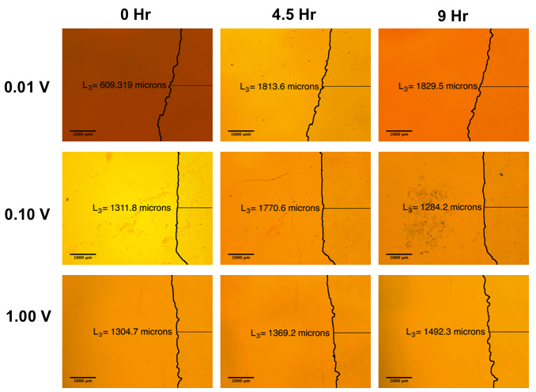
In order to quantify cell migration, the distance from the edge of the image frame to the cell front was measured before stimulation and then again at 4.5 and 9 hours post-stimulation across 3 voltages: 0.01 V, 0.10 V, and 1.00 V. In Figure 24, the edge of the cell population is shown at multiple time points. Across all voltages, the cell front migrated to the left of the frame with the exception of 0.10 V between 4.5 and 9 hours. The images were taken on the right side of the 1-cm cell strip and represent migration towards the right electrode or anode. Note that the images are inverted due to the camera attachment, which explains why the cells appear to be migrating towards the left.
Figure 24: Representative Images of Linear Cell Migration at All Experimental Voltages and Time Points. All images were taken on the right-hand side of the 1-cm cell population line and represent cell population migration towards the negative electrode or anode. The black line represents the border of the cell population. The borders of the experimental cell populations generally migrate towards the anode between time points.
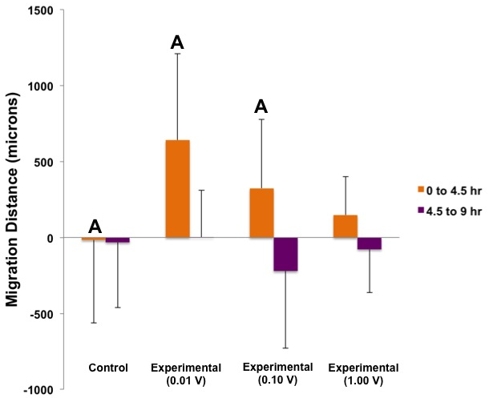
A graphical analysis of migration, shown in Figures 25a and 25b, demonstrates whether or not the experimental cell population migrated a significantly greater distance towards the anode than the control cell population after the application of a linear electrical stimulus.
A
Figure 25: Cell Migration of Rat Aortic Endothelial Cells When Exposed to Linear Electric Fields. Figure 25a (above) represents the distance migrated between 0 and 4.5 hr and between 4.5 and 9 hr on the right side of the cell population. Negative migration represents cells that migrated in the opposite direction than intended. The 0.01 V and 0.10 V experimental groups between 0 and 4.5 hr were statistically different from the control between 0 and 4.5 hr (p<0.05). Specifically, the migration distances for 0.01 V and 0.10 V were significantly greater than the control between 0 and 4.5 hr (p<0.05) as indicated by “A.” None of migration distances for experimental groups were statistically different from the control between 4.5 and 9 hour (p>0.05). Data represents means ± standard deviation; n(control)=109 and n(experimental)=31-45. Figure 25b (Page 52) represents the distance measured from the original cell population line at all three time points: 0 hr, 4.5 hr, and 9 hr. Trends are represented, but none of the data was statistically significant (p>0.05).

Initial analysis measured migration on the left and right sides of the cell strip, where the left side represents migration towards the cathode and the right side represents migration towards the anode. Significant migration was only observed on the right side of the strip, thus only data from the right side is represented in Figures 25a and 25b. Negative migration distance in Figure 25a represents migration opposite of the intended direction, towards the cathode rather than the anode.
Between 0 and 4.5 hours, the control population migrated 15.98 ± 546.0 μm opposite of the intended direction. Between 4.5 and 9 hours, the control population migrated 31.98 ± 429.7 μm opposite of the intended direction. Between 0 and 4.5 hours, the 0.01 V, 0.10 V, and 1.00 V populations migrated 641.6 ± 569.1, 324.7 ± 452.5, and 147.8 ± 253.7 μm, respectively, in the intended direction. Between 4.5 and 9 hours, the 0.01 V population migrated in the intended direction an additional 1.955 ± 308.2 μm, while the 0.01 V and 1.00 V populations migrated opposite of the intended direction an additional 221.3 ± 507.2 μm and 77.84 ± 284.8 μm, respectively.
The migration of cells after 4.5 hours is largest after stimulation of 0.01 V, followed by 0.10 V, then 1.00 V. After 9 hours, the migration of cells was largest at 0.10 V, albeit in the opposite direction, followed by 1.00 V in the opposite direction, then 0.01 V in the intended direction. Overall, as stimulation voltage increases from 0.01 V to 1.00 V, migration distance between 0 and 4.5 hours decreases. A similar trend cannot be observed for migration distance between 4.5 and 9 hours. The control group migrated a smaller distance when compared to all experimental groups between 0 and 4.5 hours and between 4.5 and 9 hours, except when compared to the experimental group between 4.5 and 9 hours after 0.01 V stimulation.
Statistical analysis results are represented on Figure 25a by the letter “A” to indicate a significant increase in migration distance between 0 and 4.5 hours compared to the control cell population. Between 0 and 4.5 hours, the cell population significantly migrated a larger distance after stimulation with 0.01 V and 0.10 V (p<0.05), but not with 1.00 V (p>0.05) as compared to the control. At 9 hours, none of the experimental populations experienced a significant increase in migration compared to the control (p>0.05).
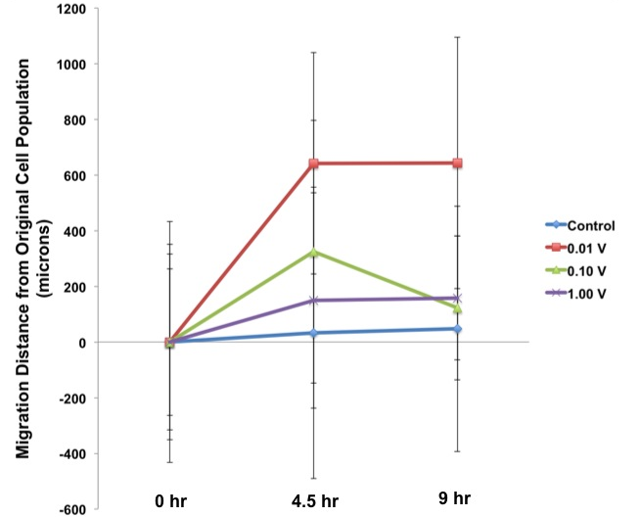
In the trend graph shown below in Figure 25b, the distance as compared to the original cell population is plotted. General trends show that 0.01 V migrated the greatest distance, which is followed by 1.00 V and then 0.10 V. The control population migrated the smallest distance. However, none of the trend data was statistically significant (p>0.05).
B
5.1.2 Radially Applied Electric Field
Figure 26 represents images and measurements of cell migration after application of a radial electrical stimulus. In general, when a radial electrical stimulus was applied, the cell front migrated inwards, towards the upper-right hand corner of the image, representing migration towards the negative electrode or anode.
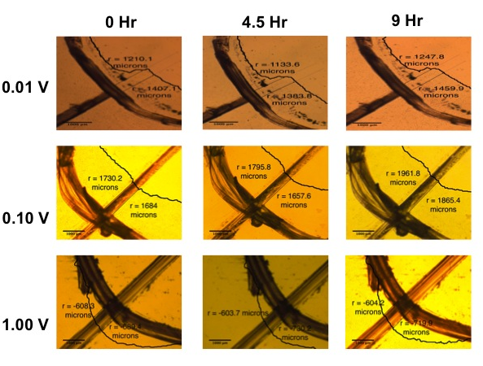
Figure 26: Representative Images of Radial Cell Migration at All Experimental Voltages and Time Points. All images were taken at the inner radius of the 1-cm wide cell population and represent cell population migration towards the negative electrode or anode. The thin, curved black line represents the border of the cell population. The borders of the experimental cell populations generally migrate inwards towards the upper right-hand corner of the image, the intended direction of migration.

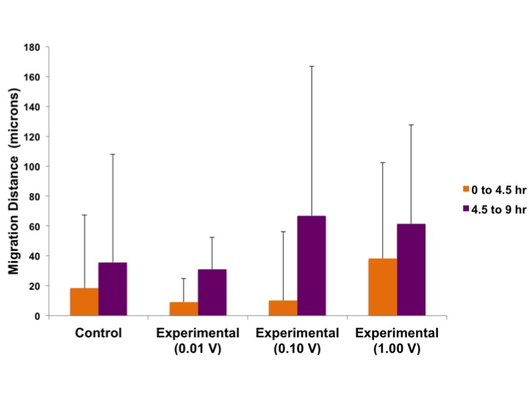
Figures 26a and 26b represent decreases in the radii of the cell populations after application of radial electrical stimulus. A greater decrease in the radius of the cell population is analogous to greater cell migration towards the negative electrode or anode. Between 0 and 4.5 hours, the radius of the control cell population decreased 18.32 ± 49.04 μm. Between 4.5 and 9 hours, the radius decreased 35.58 ± 72.33 μm. Between 0 and 4.5 hours, the radii of the cell populations after application of 0.01 V, 0.10 V, and 1.00 V decreased 9.103 ± 15.75, 10.14 ± 45.93, and 38.10 ± 64.25 μm, respectively. Between 4.5 and 9 hours, the radii of the cell populations after application of 0.01 V, 0.10 V, and 1.00 V decreased 31.05 ± 21.21, 66.88 ± 99.94, and 61.54 ± 66.21 μm, respectively. Statistical analysis revealed no significant differences between the decreases in the experimental cell population radii as compared to the control (p>0.05).
A

Figure 27: Cell Migration of Rat Aortic Endothelial Cells When Exposed to Radial Electric Fields. Figure 27a (above) represents the distance migrated between 0 and 4.5 hr and between 4.5 and 9 hr on the right side of the cell population. Negative migration represents cell migration opposite of the intended direction of migration. The experimental groups between 0 and 4.5 hr were not statistically different from the control between 0 to 4.5 hr (p>0.05). The experimental groups between 4.5 and 9 hr were also not statistically different from the control between 4.5 and 9 hr (p>0.05). Data represents means ± standard deviation; n(control)=45-50 and n(experimental)=14-18. Figure 27b (below) represents the distance measured from the original cell population border at all three time points: 0 hr, 4.5 hr, and 9 hr. Trends are represented, but none of the data was statistically significant (p>0.05).
The trend graph below demonstrates the distance of the experimental cell population from the original cell population. At 4.5 hours, this distance is largest when stimulated with 1.00 V, followed by 0.10 V, and then closely followed by 0.01 V. The distance of the experimental cell population from the original cell population measured at 9 hours is largest when stimulated with 0.01 V, followed by 1.00 V and then 0.01 V. Overall, as stimulation voltage increases from 0.01 V to 1.00 V, distance from the original cell population increases at 4.5 hours. However, no such trend can be observed at 9 hours. None of the total cell migration distance data shown in Figure 27b is statistically significant (p>0.05).
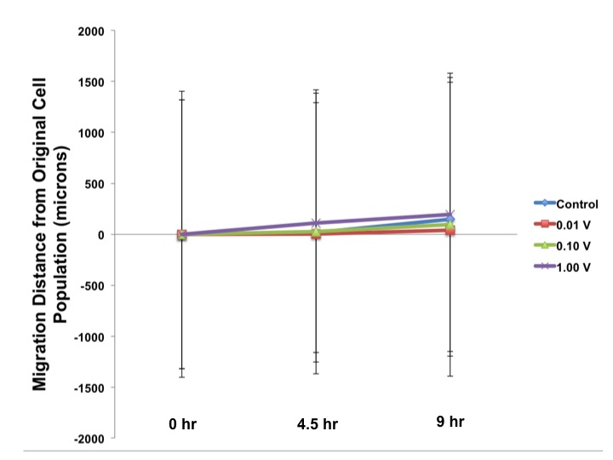
B

5.1.3 Reverse Polarity Radially Applied Electric Field
Under radial experimental conditions with an applied voltage of 1.00 V in which the locations of the anode and the cathode were switched, migration, proliferation and angiogenic gene expression data were collected. Figure 28 shows cell migration in response to a reverse radially applied electric field.
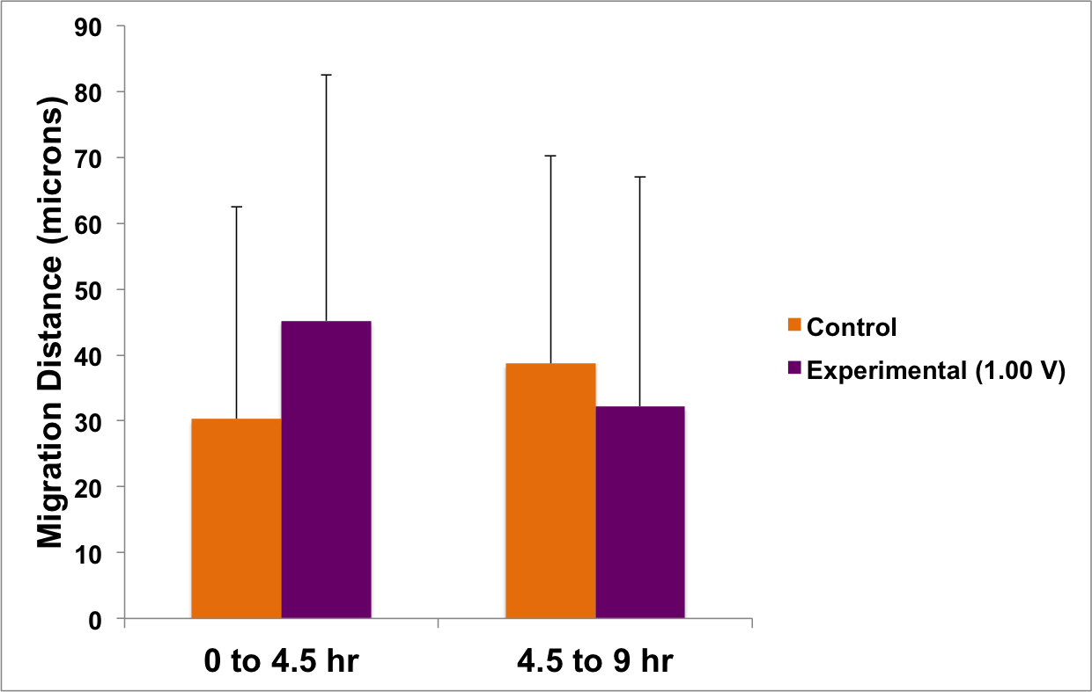
Figure 28: Cell Migration of Rat Aortic Endothelial Cells When Exposed to Reverse Radial Electric Fields. The migration distance of the reverse polarity cell population was not statistically different from the migration distance of the control cell population between 0 and 4.5 hr and between 4.5 and 9 hr (p>0.05). Data represents means ± standard deviation; n(control)=23 and n(experimental)=20.
Under reverse polarity conditions, positive cell migration was defined as migration outwards towards the negatively charged electrode or anode. Figure 28 shows the change in the radius of the cell population between 0 and 4.5 hours and between 4.5 and 9 hours. The control cell population migrated 30.27 ± 32.22 and 38.69 ± 31.60 μm between 0 and 4.5 hours and between 4.5 and 9 hours, respectively. The reverse polarity cell population migrated 47.77 ± 36.39 and 33.00 ± 35.52 μm between 0 and 4.5 hours and between 4.5 and 9 hours, respectively. Both control and experimental populations migrated in the intended direction towards the anode. No reverse polarity experimental migration data was statistically different from the control (p>0.05).
5.2 Live-Dead Viability Assay
5.2.1 Linearly Applied Electric Field
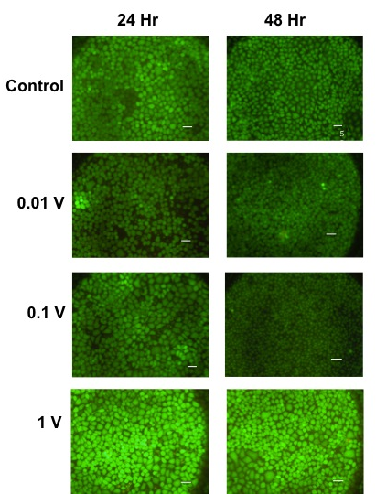
In order to quantify cell proliferation, a Live-Dead Viability Assay was performed. A compilation of representative pictures including a control group along with the three experimental voltages after both 24 and 48 hour time points is shown in Figure 29 below. All images were taken at 20x magnification.

Figure 29: Representative Images of Linear Cell Proliferation at All Experimental Voltages and Time Points. Examples of cell proliferation data in a linear setting at all experimental voltages and time points, as well as under control conditions. Live cells appear in green, while red cells (undetectable) appear in red.
After 24 hours, the experimental groups appear to display a greater density of cells compared to the control. After 48 hours, it is harder to discern differences between the control and the experimental groups. Red regions, or dead cells, are non-existent or undetectable across all images.
Figure 30 below shows the ratio of the experimental and control cell densities to the seeding density 24 and 48 hours after the application of a linear electrical stimulus to the experimental group.
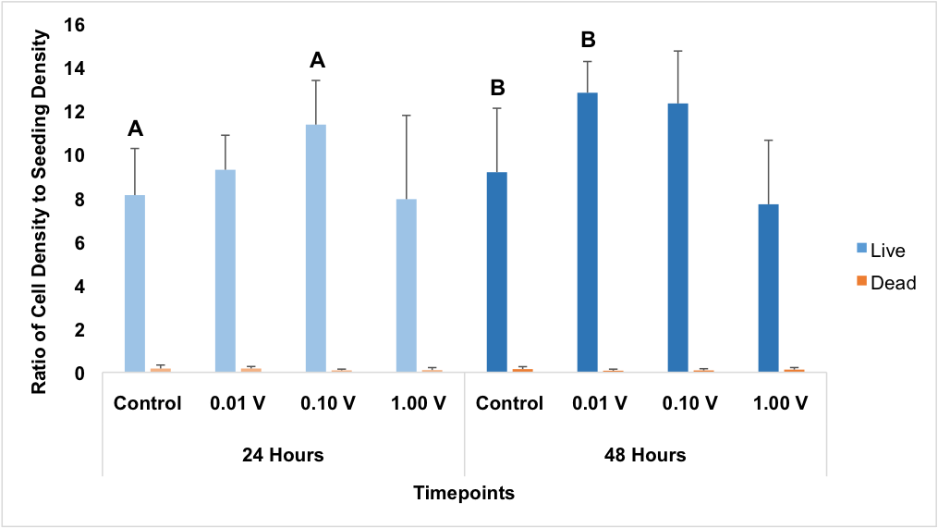
Figure 30: Cell Proliferation of Rat Aortic Endothelial Cells When Exposed to Linear Electric Fields. At 24 hr, the ratio of live cell density to seeding density at 0.10 V was significantly greater than that of the control (p<0.05), as indicated by “A.” At 48 hr, the ratio of live cell density to seeding density at 0.01 V was significantly greater than that of the control, as indicated by “B” (p<0.05). The live cell density at 24 hr was not statistically different from the live cell density at 48 hr at all tested experimental voltages (p>0.05). None of the dead cell density data was statistically significant (p>0.05). Data represented means + standard deviation; n(control)=36 and n(experimental)=12.

The live cell density ratio is graphed in blue. After 24 hours, the control live cell density was 8.12 ± 2.14 times the seeding density. In comparison, the experimental live cell densities after application of 0.01 V, 0.10 V and 1.00 V were 9.28 ± 1.58, 11.35 ± 2.02, and 7.93 ± 3.84 times the seeding density, respectively. After 48 hours, the control live cell density was 9.17 ± 2.93 times the seeding density. In comparison, the experimental live cell densities after application of 0.01 V, 0.10 V and 1.00 V were 12.80 ± 1.43, 12.31 ± 2.40, and 7.70 ± 2.93 times the seeding density, respectively.
The dead cell density ratio is graphed in red. After 24 hours, the control dead cell density was 0.17 ± 0.159 times the seeding density. In comparison, experimental dead cell densities after the application of 0.01 V, 0.10 V and 1.00 V were 0.18 ± 0.09, 0.09 ± 0.05, and 0.10 ± 0.11 times the seeding density, respectively. After 48 hours, the control dead cell density was 0.15 ± 0.11 times the seeding density. In comparison, the experimental dead cell densities after the application of 0.01 V, 0.10 V and 1.00 V were 0.08 ± 0.07, 0.09 ± 0.08, and 0.13 ± 0.09 times the seeding density, respectively.
Statistical analysis results are represented on Figure 30 by the letters “A” and “B” to indicate a significant increase in proliferation compared to the control after 24 and 48 hours, respectively. After application of a linear electrical field, a statistically significant difference between experimental and control dead cell densities was not observed (p>0.05). After 24 hours, only an applied voltage of 0.10 V caused a significant increase in live cell density or proliferation compared to the control (p<0.05). After 48 hours, only an applied voltage of 0.01 V caused a significant increase in live cell density or proliferation compared to the control (p<0.05).
5.2.2 Radially Applied Electric Field
The same Live-Dead Viability Assay was performed for all radial experiments with the modifications for the placement of the images. In Figure 31, a compilation of representative pictures across voltages and time points is shown.
Upon observation, it is extremely difficult to discern between voltages and time points. The application of 0.10 V seems to cause the lowest amount of proliferation, but this may be also due to the fact that these pictures were taken on a different microscope after a fluorescent bulb issue with the regular microscope.
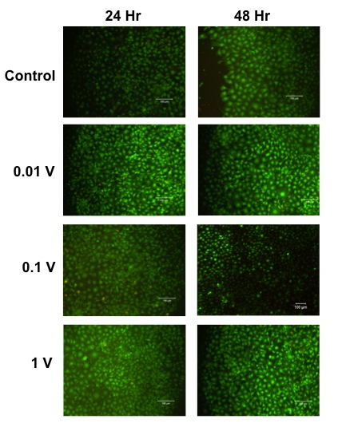
Figure 31: Representative Images of Radial Cell Proliferation at All Experimental Voltages and Time Points. Examples of cell proliferation data in a radial setting at all experimental voltages and time points, as well as under control conditions. Live cells appear in green, while red cells (undetectable) appear in red. Patches of black represent portions of the image devoid of cells.

Figure 32 below shows the ratio of the experimental and control cell densities to the seeding density 24 and 48 hours after applying a radial electrical stimulus to the experimental group.
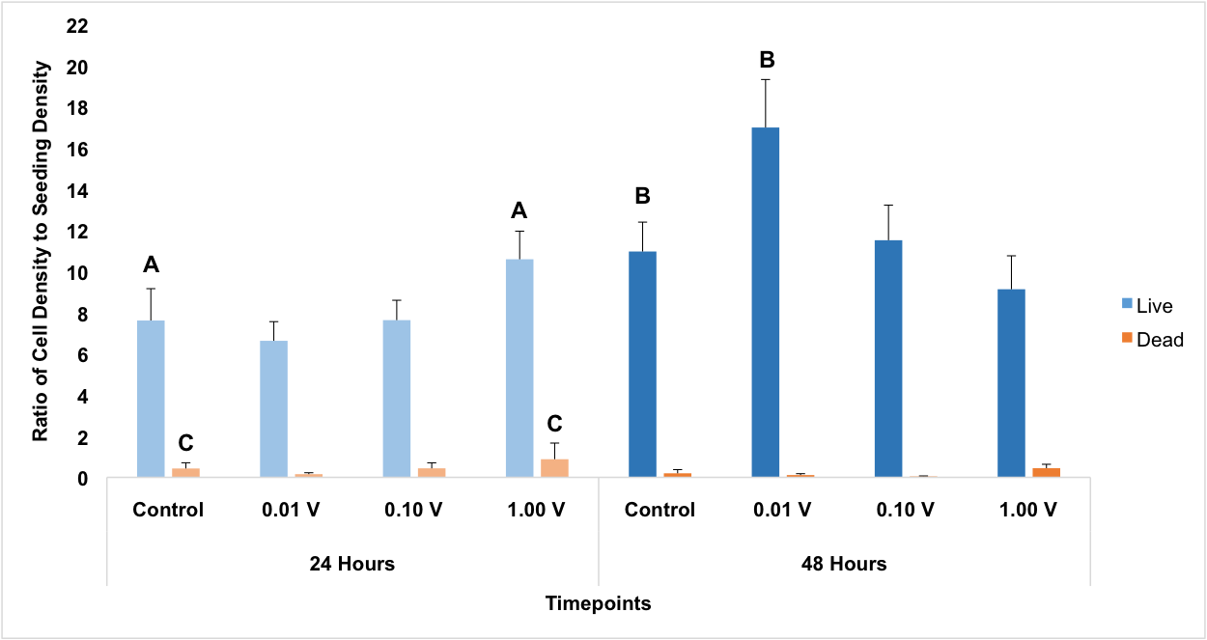
Figure 32: Cell Proliferation of Rat Aortic Endothelial Cells When Exposed to Radial Electric Fields. At 24 hr, the ratio of live cell density to seeding density at 1.00 V was significantly greater than that of the control (p<0.05), as indicated by “A.” At 48 hr, the ratio of live cell density to seeding density at 0.01 V was significantly greater than that of the control, as indicated by “B,” while the ratio of live cell density to seeding density at 1.00 V was significantly less than that of the control (p<0.05). At 24 hr, the ratio dead of cell density to seeding density at 1.00 V at 24 hr was significantly greater than that of the control, as indicated by “C.” The live cell density at 48 hr was significantly greater than the live cell density at 24 hr at both 0.01 V and 0.10V (p<0.05). Data represented means + standard deviation; n(control)=36 and n(experimental)=12.
The live cell density ratio is graphed in blue. After 24 hours, the control live cell density was 7.62 ± 1.54 times the seeding density. In comparison, the experimental live cell densities after the application of 0.01 V, 0.10 V and 1.00 V were 6.63 ± 0.93, 7.63 ± 0.96 and 10.59 ± 1.36 times the seeding density, respectively. After 48 hours, the control live cell density was 10.96 ± 1.43 times the seeding density. In comparison, the experimental live cell densities 48 hours after the application of 0.01 V, 0.10 V and 1.00 V were 16.98 ± 2.33, 11.51 ± 1.70 and 9.13 ± 1.62 times the seeding density, respectively.
The dead cell density ratio is graphed in red. After 24 hours, the control dead cell density was 0.43 ± 0.28 times the seeding density. In comparison, the experimental dead cell densities after the application of 0.01 V, 0.10 V and 1.00 V were 0.16±0.07, 0.44 ± 0.27 and 0.88 ± 0.78 times the seeding density, respectively. After 48 hours, the control dead cell density was 0.20 ± 0.18 times the seeding density. In comparison, the experimental dead cell densities after the application of 0.01 V, 0.10 V and 1.00 V were 0.11 ± 0.07, 0.04 ± 0.03 and 0.04 ± 0.19 times the seeding density, respectively.
Statistical analysis results are represented on Figure 32 by the letters “A”, “B,” and “C” to indicate a significant increase in live cell density after 24 and 48 hours and a significant increase in dead cell density after 24 hours, respectively, as compared to the control. After 24 hours, an applied voltage of 1.00 V caused a significant increase in live cell density or proliferation (p<0.05) and also caused a significant increase in dead cell density (p<0.05) compared to the control. After 48 hours, only an applied voltage of 0.01 V caused a significant increase in live cell density or proliferation (p<0.05). After 48 hours, radial electrical stimulation did not cause a statistically significant difference between experimental and control dead cell densities p>0.05). No general trends between voltage and proliferation can be identified from this data.
5.2.3 Reverse Polarity Radially Applied Electric Field
Figure 33 shows the ratio of the experimental and control cell densities to the seeding density 24 and 48 hours after applying a reverse polarity electrical stimulus to experimental wells
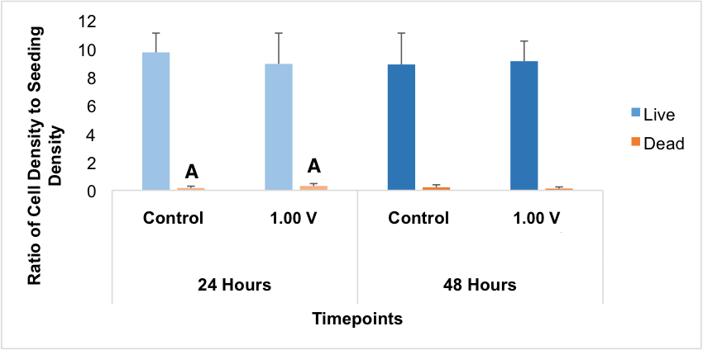
Figure 33: Cell Proliferation of Rat Aortic Endothelial Cells When Exposed to Reverse Polarity Radial Electric Fields. At 24 hr, the ratio of dead cell density to seeding density under reverse polarity conditions was significantly greater than that of the control (p<0.05), as indicated by “A.” Data represented means + standard deviation; n(control)=12 and n(experimental)=12.
The live cell density ratio is graphed in blue. After 24 hours, the control live cell density was 9.729 ± 1.359 times the original seeding density. In comparison, the live cell density after the application of 1.00 V was 8.916 ± 2.171 times the seeding density. After 48 hours, the control live cell density was 8.876 ± 2.212 times the seeding density. In comparison, the live cell density after the application of 1.00 V was 9.108 ± 1.417 times the seeding density.
The dead cell density ratio is graphed in red. After 24 hours, the control dead cell density was 0.1685 ± 0.1270 times the seeding density. In comparison, the dead cell density after the application of 1.00 V was 0.3126 ± 0.1632 times the seeding density. After 48 hours, the control dead cell density was 0.2174 ± 0.1754 times the seeding density. In comparison, the dead cell density after the application of 1.00 V was 0.1248 ± 0.1158 times the seeding density.
Statistical analysis results are represented in Figure 33 by the letter “A” to indicate a significant increase in dead cell density of the experimental cell population as compared to the control cell population 24 hours post-stimulation (p<0.05). Reverse radial electrical stimulation did not cause a significant difference between experimental and control dead cell densities after 48 hours (p>0.05). Reverse polarity did not significantly increase live cell density either 24 or 48 hours post-stimulation (p>0.05).
5.3 qRT-PCR Assay
5.3.1 Linearly Applied Electric Field
The qRT-PCR gene expression data was analyzed and expressed as fold change following the procedure detailed in the methodology. Angiogenic gene expression in response to a linearly applied electric field is shown below. VEGF gene expression is shown in Figure 34 and the bFGF gene expression is shown in Figure 35.
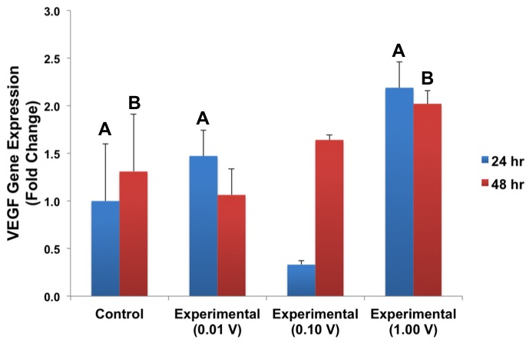
Figure 34: VEGF Expression of Rat Aortic Endothelial Cells When Exposed to Linear Electric Fields. All experimental groups at 24 hr were statistically different from the control at 24 hr (p<0.05). Specifically, the fold changes for 0.01 V and 1.00 V were significantly greater than the control (p<0.05) as indicated by “A”, while the fold change for 0.10 V was significantly less than the control (p<0.05). All experimental groups at 48 hr were also statistically different from the control at 48 hr (p<0.05). The fold change for 1.00 V was significantly greater than the control (p<0.05) as indicated by “B” and the fold changes for 0.01 V and 0.10 V were significantly less than the control (p<0.05). Data represents means ± propagated error; n=3.

All fold changes were normalized to the fold change of the control group after 24 hours, which has a fold change of 1. Under control conditions, the VEGF fold change at 48 hours was 1.31 ± 0.60. After 24 hours, the VEGF fold changes of the 0.01 V, 0.10 V and 1.00 V populations were 1.47 ± 0.2, 0.33 ± 0.04 and 2.19 ± 0.27, respectively. After 48 hours, the VEGF fold changes of the 0.01 V, 0.1 V and 1 V populations were 1.06 ± 0.27, 1.64 ± 0.05 and 2.02 ± 0.14, respectively.
After 24 hours, the experimental VEGF fold changes at 0.01 V and 1.00 V were significantly greater than the control (p<0.05). The experimental VEGF fold change at 0.10 V was significantly less than the control (p<0.05). After 48 hours, the experimental VEGF fold change 1.00 V was significantly greater than the control (p<0.05).
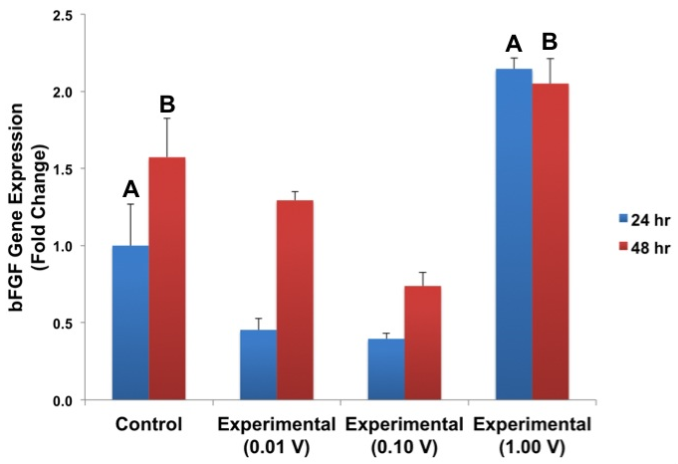
Figure 35 shows the bFGF gene expression after application of a linear electric field.
Figure 35: bFGF Expression of Rat Aortic Endothelial Cells When Exposed to Linear Electric Fields. All experimental groups at 24 hr were statistically different from the control at 24 hr (p<0.05). Specifically, the fold change for 1.00 V was significantly greater than the control (p<0.05) as indicated by “A”, while the fold changes for 0.01 V and 0.10 V were significantly less than the control (p<0.05). All experimental groups at 48 hr were also statistically different from the control at 48 hr (p<0.05). Specifically, the fold change for 1.00 V was significantly greater than the control (p<0.05) as indicated by “B”, while the fold changes for 0.01 V and 0.10 V were significantly less than the control (p<0.05). Data represents means ± propagated error; n=3.

All fold changes are normalized to the fold change of the control group after 24 hours, which has a fold change of 1. Under control conditions, bFGF fold change after 48 hours was 1.66 ± 0.76. After 24 hours, the bFGF fold changes of the 0.01 V, 0.10 V and 1.00 V populations were 1.36 ± 0.24, 0.58 ± 0.07 and 1.80 ± 0.06, respectively. After 48 hours, the bFGF fold changes of the 0.01V, 0.10 V and 1.00 V populations were 0.97 ± 0.24, 1.34 ± 0.06 and 1.72 ± 0.13, respectively.
Figure 33: bFGF Expression of Rat Aortic Endothelial Cells When Exposed to Linear Electric Fields. All experimental groups at 24 hr were statistically different from the control at 24 hr (p<0.05). Specifically, the fold change for 1.00 V was significantly greater than the control (p<0.05) as indicated by “A”, while the fold changes for 0.01 V and 0.10 V were significantly less than the control (p<0.05). All experimental groups at 48 hr were also statistically different from the control at 48 hr (p<0.05). Specifically, the fold change for 1.00 V was significantly greater than the control (p<0.05) as indicated by “B”, while the fold changes for 0.01 V and 0.10 V were significantly less than the control (p<0.05) Data represents means ± propagated error; n=3.
After 24 hours, the experimental bFGF fold changes at 0.01 V and 0.10 V were significantly less than the control (p<0.05). The experimental bFGF fold changes at both 24 and 48 hours after an applied voltage of 1.00 V were significantly greater than the control (p<0.05). After 48 hours, the experimental bFGF fold change at 0.01 V was significantly less than the control (p<0.05).
5.3.2 Radially Applied Electric Field
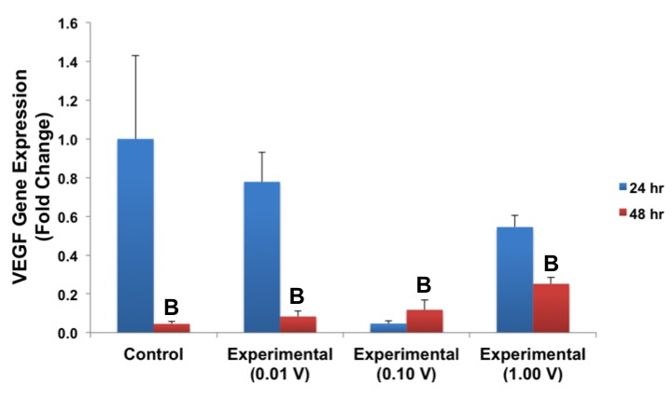
Figure 36 shows VEGF gene expression after application of a radial electric field.
Figure 36: VEGF Expression of Rat Aortic Endothelial Cells When Exposed to Radial Electric Fields. All experimental groups at 24 hr were statistically different from the control at 24 hr (p<0.05). However, none of the fold changes from these experimental groups were significantly greater than the control at 24 hr (p>0.05). All experimental groups at 48 hr were also statistically different from the control at 48 hr (p<0.05). Specifically, the fold changes for 0.01 V, 0.10 V, and 1.00 V were significantly greater than the control (p<0.05) as indicated by “B.” Data represents means ± propagated error; n=3.
All fold changes were normalized to the fold change of the control group after 24 hours, which has a fold change of 1. Under control conditions, the VEGF fold change after 48 hours was 0.04 ± 0.01. After 24 hours, the VEGF fold changes of the 0.01 V, 0.10 V and 1.00 V populations were 0.78 ± 0.15, 0.05 ± 0.01 and 0.54 ± 0.06, respectively. After 48 hours, the VEGF fold changes of the 0.01 V, 0.10 V and 1.00 V populations were 0.08 ± 0.03, 0.12 ± 0.05 and 0.25 ± 0.03, respectively.
After 24 hours, the experimental VEGF fold changes at 0.01 V, 0.10 V and 1.00 V were significantly less than the control (p<0.05). After 48 hours, the experimental VEGF fold changes at 0.01 V, 0.10 V and 1.00 V were significantly greater than the control (p<0.05).
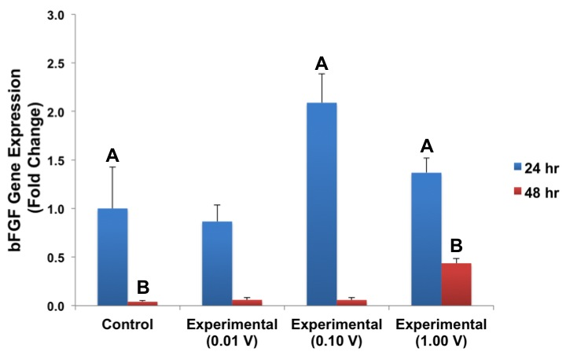
Figure 37 shows bFGF gene expression after application of a radial electric field.
Figure 37: bFGF Expression by Rat Aortic Endothelial Cells When Exposed to Radial Electric Fields. The 0.10 V and 1.00 V experimental groups at 24 hr were statistically different from the control at 24 hr (p<0.05). Specifically, the fold changes at 0.10 V and 1.00 V were significantly greater than the control (p>0.05) as indicated by “A.” The 1.00 V experiment group at 48 hr was also statistically different from the control at 48 hr (p<0.05). Specifically, the fold change for 1.00 V was significantly greater than the control (p<0.05) as indicated by “B.” Data represents means ± propagated error; n=3.

All fold changes were normalized to the fold change of the control group after 24 hours, which is 1. Under control conditions, bFGF fold change at 48 hours was 0.04 ± 0.01. After 24 hours, the bFGF fold changes of 0.01 V, 0.10 V and 1.00 V were 0.86 ± 0.17, 2.09 ± 0.30, and 1.37 ± 0.15, respectively. After 48 hours, the bFGF fold changes of 0.01V, 0.10 V and 1.00 V were 0.06 ± 0.02, 0.06 ± 0.02 and 0.44 ± 0.05.
After 24 hours, the experimental bFGF fold changes at 0.10 V and 1.00 V were significantly greater than the control (p<0.05). After 48 hours, the experimental VEGF fold change at 1.00 V was significantly greater than the control (p<0.05).
5.3.3 Reverse Polarity Radially Applied Electric Field
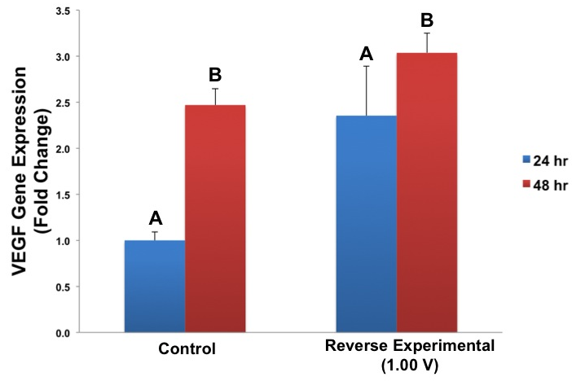
Figure 38 shows VEGF gene expression after the application of a reverse polarity radial electrical field.
Figure 38: VEGF Expression of Rat Aortic Endothelial Cells When Exposed to Reverse Polarity Radial Electric Fields. The fold change for the reverse polarity group was significantly greater than the control at 24 hours (p<0.05) as indicated by “A.” The fold change for the reverse polarity group was also significantly greater than the control at 48 hours (p<0.05) as indicated by “B.” Data represents means ± propagated error; n=3.

All fold changes were normalized to the fold change of the control group at 24 hours post-stimulation, which has fold change of 1. After 48 hours, VEGF fold change of the control was 2.47 ± 0.09. The VEGF fold change of the reverse polarity population was 2.37 ± 0.36 24 hours post-stimulation and 3.04 ± 0.08 48 hours post-stimulation. After both 24 and 48 hours, the reverse polarity VEGF fold changes were significantly greater than the control (p<0.05).
Figure 39 shows bFGF gene expression after the application of a reverse polarity radial electrical field.
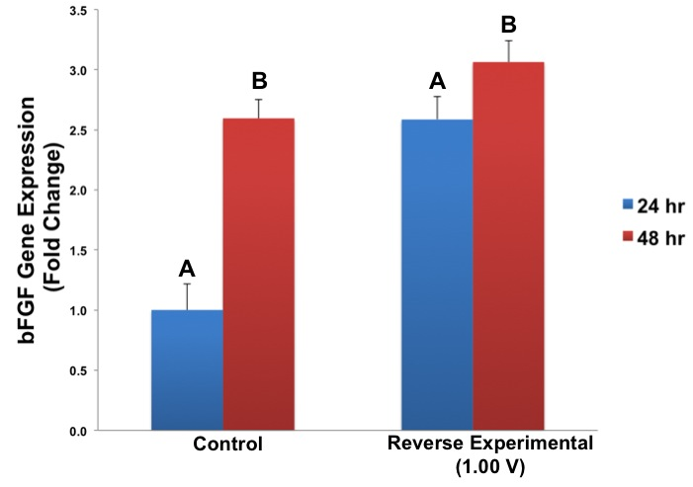
Figure 39: bFGF Expression of Rat Aortic Endothelial Cells When Exposed to Reverse Polarity Radial Electric Fields. The fold change for the reverse polarity group was significantly greater than the control at 24 hours (p<0.05) as indicated by “A.” The fold change for the reverse polarity group was also significantly greater than the control at 48 hours (p<0.05) as indicated by “B.” Data represents means ± propagated error; n=3.

All fold changes were normalized to the control at 24 hours post-stimulation, which has a fold change of 1. After 48 hours, the bFGF fold change of the control was 2.59 ± 0.05. The bFGF fold change of the reverse polarity population was 2.60 ± 0.07 24 hours post-stimulation and 3.06 ± 0.01 48 hours post-stimulation. After both 24 and 48 hours, the reverse polarity bFGF fold changes were significantly greater than their respective controls (p<0.05).
5.4 Ideal Voltage Selection
Under linear experimental conditions, cell migration in the intended direction was significantly greater than the control at 0.01 V and 0.10 V, exclusively between 0 to 4.5 hours post-stimulation. At 0.10 V, cell proliferation was significantly greater than the control 24 hours post-stimulation. At 0.01 V, cell proliferation was significantly greater than the control 48 hours post-stimulation. The VEGF gene expression was significantly greater than the control at 24 hours at 0.01 V. The VEGF and bFGF gene expression were significantly greater than the control at 24 hours and 48 hours at 1.00 V. Therefore, 0.01 V promoted all three factors essential to wound healing: proliferation after 48 hours, migration between 0 and 4.5 hours, and VEGF gene expression after 24 hours. bFGF gene expression was not affected. As a result, 0.01 V was selected as the ideal voltage for the linear configuration. Note that not all voltages possible were tested and the selection of 0.01 V only indicates that the application of a linear electric field at 0.01 V was the best out of the three voltages tested.
For the radial configuration, no significant cell migration was observed and no voltage trends were observed from the proliferation data. Therefore, the data is inconclusive in regards to an ideal voltage for the radial configuration.

CHAPTER 6: DISCUSSION

6.1 Experimental Question #1

Experimental Question #1 examined the effects of a linearly applied electric field on rat aortic endothelial cell proliferation, migration, VEGF gene expression, and bFGF gene expression. Additionally, these parameters of wound healing were measured at multiple voltages, 0.01 V, 0.10 V, and 1.00 V, to determine an ideal voltage of this linearly applied electric field.
The results demonstrated that the cell front migrated a significantly greater distance compared to the control 4.5 hours post-stimulation at the lower voltages, 0.01 V and 0.10 V. However, no significant trends in the distance of cell migration were observed 9 hours post-stimulation. Additionally, the ratio of live cell density to the seeding density significantly increased in comparison to the control 24 hours post-stimulation with an application of 0.10 V and 48 hours post-stimulation with an application of 0.10 V. VEGF and bFGF gene expression were significantly greater than the control at 24 hours and 48 hours post-stimulation with the application of 1.00 V. Only VEGF expression was significantly greater 24 hours post-stimulation with the application of 0.01 V.
Directional Migration After Application of Low Voltages
Directional migration was observed in response to a linearly applied electric field of low voltages. The observed cell front migrated a significantly greater distance towards the anode than the control 4.5 hours post-stimulation at lower voltages, 0.01 V and 0.10 V. A study conducted by Zhao et al. also examined the effects of electrical stimulation on human umbilical vein endothelial cells (HUVECs) and found similar migration patterns to the results found in our study. With an application of 150 mV/mm of pulsed DC electrical stimulation, the researchers found that endothelial cells migrated toward the anode after a period of four hours ⁸⁴. Zhao et al. also observed pseudopodia of the cells extending toward the anode. In another study, Chang et al. observed a similar directed migration response in rabbit corneal endothelial cells after the application of low voltage DC electric fields ¹⁵⁰. The researchers visualized development of pseudopodia and ruffled membranes on the anodal side and a withdrawal of these structures on the cathodal side of the rabbit corneal endothelial cells ¹⁵⁰. Since these cellular projections are extending toward the anode, there is greater net movement in the direction of the anode, suggesting a link between the development of new cellular projections and unidirectional migration ^{91,150}.
Zhao et al. also suggested that directional migration can also be induced at electric field intensities below 100 mV/mm ⁸⁴. This recommendation is noteworthy since our study demonstrated the same directional migration response toward the anode with intensities also significantly lower than 100 mV/mm. The electrical voltages we used were 0.01 V, 0.10 V, and 1.00, which correlate to electric field intensities of 0.66 mV/mm, 6.66 mV/mm, and 66.66 mV/mm, respectively. While differences were observed at 0.01 V and 0.10 V, no significant directional cell migration was observed at 1.00 V. The cause of this discrepancy is unknown, but suggests the mechanism for cell migration in response to an applied electric field is more intricate than previously thought.
Both the Zhao and Chang studies confirm that endothelial cells of different origin migrate towards the anode during an application of an electrical stimulus. The same effect was observed in the RAOECs, significant migration was only seen towards the anode and not towards the cathode. All data shown represents migration towards the anode.
Selective Upregulation of Angiogenic Gene Expression
Direct electrical stimulation also selectively upregulates transcription of certain growth factors. The gene expression of the first angiogenic growth factor examined in our study, VEGF, increased significantly at 0.01 V and 1.00 V. The second factor, bFGF, was only significantly increased after a treatment of 1.00 V.
A second study conducted by Bai et al. discovered that after electrical stimulation VEGF gene and protein expression in human endothelial cells was upregulated in comparison to a control population that was not subject to an exogenous electric field ¹⁰⁷. Increases in VEGF and interleukin-8 (IL-8) were observed after an application of 200 mV/mm electric field due to increased activity of VEGF receptor-1 ¹⁰⁷. The increase in activity of this receptor triggers signaling pathways, such as MAP kinase and protein kinase C. These proteins bind to DNA response elements that regulate transcription of specific genes, a possible mechanism for the increased VEGF gene expression seen in the RAEOCs as well ¹⁰⁷. VEGF production is responsible for the majority of angiogenesis in wounds ⁵². In addition, VEGF stimulates cell division, which can increase cell proliferation in the wound site ⁵⁷.
Our results demonstrated a significant increase in bFGF gene expression 24 and 48 hours post-stimulation after exposure to a field of 1.00 V, but exhibited no significant increase in bFGF gene expression at any of the lower voltages. This discrepancy may be due to the fact that bFGF is not regulated by the VEGF receptor-1 signal transduction pathway, but that is is actually upstream of this pathway ¹⁵¹⁻¹⁵³. bFGF activation can augment VEGF expression; however, VEGF activation is not contingent on bFGF activation ¹⁵⁴. It is possible electrical stimulation may not activate the bFGF receptors, which are highly specific, but may act somewhere downstream to activate VEGF ¹⁵². Research has shown that although the pathways overlap, they also have distinct angiogenic inhibitors and inducers, which regulate one growth factor or the other, but not both ¹⁵⁵. Analysis of this intracellular pathway suggests that low bFGF gene expression levels are plausible despite the significant increases in VEGF gene expression at two different voltages, 0.01 V and 1.00 V, in our study.
Although the electric field intensities tested in our study were lower than those of Bai et al., who used an intensity of 200 mV/mm, our most intense electric field at 66.6 mV/mm yielded maximum VEGF expression 24 and 48 hours post-stimulation, which coincides with Bai et al. Bai et al. also observed fluctuations in VEGF expression between 30 minutes and 4 hours post-stimulation, suggesting that our 24 and 48 hour time points may have omitted significant oscillations of VEGF expression levels at shorter time points ¹⁰⁷.
Proliferation and Gene Expression Trade-Off
In our study, proliferation increased significantly at lower voltages, 0.01 V and 0.10 V, while gene expression of both VEGF and bFGF increased significantly at the highest tested voltage, 1.00 V. Previous research done by Wang et al. demonstrates this trade-off; weak electrical fields tended to enhance cell proliferation, while stronger electrical fields enhanced transcription ¹⁵⁶. Wang et al. observed electrical fields of 200 mV/mm significantly inhibited proliferation of endothelial cells by arresting the cell cycle in the G1 phase during which cells grow in size and transcribe mRNA ^{156,157}. Cells were arrested in the G1 phase through the downregulation of cyclin E and the upregulation of p27^{Kip1}, which together inhibit the progression of the cell into the S phase, during which cells replicate DNA to prepare for mitosis ^{156,157}. This research supports our observation that gene expression at high voltages, 1.00 V, is inversely correlated to proliferation and migration under the same parameter. Conversely, proliferation and migration are highest at lower voltages, 0.01 V and 0.10 V, while gene expression is primarily insignificant at these parameters with the sole exception of the application of 0.01 V after 24 hours. This data suggests that an optimal voltage within the tested range exists that will significantly increase both cell proliferation and angiogenic gene expression.
Wound Healing Process and Experimental Timeline
The entire wound healing process is more intricate than the markers of cell proliferation, directional migration, and angiogenic gene expression. The wound healing process spans the sequential stages of hemostasis, inflammation, proliferation, and remodeling ⁴⁶⁻⁴⁹. Our study primarily examined endothelial cells’ transition into the third stage, proliferation, during which the endothelial cells release angiogenic growth factors and undergo replication ⁵¹. Diabetic ulcers are arrested in the inflammation phase ^{59,60}, thus our study hypothesized that an application of an exogenous electrical stimulation would drive the cells into the proliferation phase of healing. Our study demonstrated significant increases in cell proliferation after application of 0.01 V and 0.10 V and significant increases in VEGF gene expression at 0.01 V and 1.00 V. bFGF gene expression was only increased after application of a 1.00 V stimulus. Both significant increases in cell proliferation and VEGF expression suggest a progression into the proliferation phase of wound healing if applied to a more complex model, a promising and important advancement in the healing of chronic wounds.

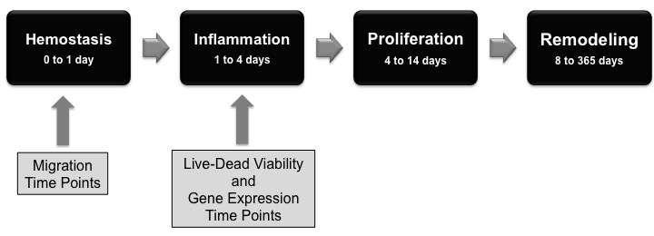
Figure 40: Wound Healing Process and Associated Experimental Time Points. The wound healing process spans four phases: hemostasis, inflammation, proliferation, and remodeling. The stages may overlap, but are loosely defined into ranges of time. Hemostasis lasts for the first 24 hours and inflammation continues from the end of hemostasis until the fourth day. The proliferation phase is 4 to 14 days post-wounding and remodeling occurs 8 to 365 days post-wounding. The experimental time points took place during the first two phases: migration time points were during hemostasis and live-dead viability and gene expression time points were during inflammation.
Determination of Suitable Voltage
Although the cell migration, cell proliferation, and VEGF gene expression significantly increased at different voltages, we conclude that 0.01 V provides the most effective linear electrical field for wound healing compared to the other voltages tested since 0.01 V significantly increased all three aspects of wound healing examined. This voltage is different than the optimal voltage determined by previous research, which has seen healing effects in ischaemic rat skeletal muscle at the optimal voltage of 0.10 V ¹⁵⁸. The use of a suitable voltage when applying an external electrical stimulus is extremely important as electrical stimulation acts on many different pathways including, but not limited to expression of angiogenic genes, cell migration, and cell proliferation ^{84,159,160}. In order to activate as many wound healing pathways as possible and to maximize treatment effects, the most suitable voltage must be determined. For rat aortic endothelial cells, the suitable voltage for a linearly applied stimulus was determined to be 0.01 V.
6.2 Experimental Question #2
In comparison to Experimental Question #1, Experimental Question #2 focused on determining the effects of a radially applied electric field on rat aortic endothelial cell proliferation, cell migration, VEGF gene expression, and bFGF gene expression. Whether a radial electric field would be more efficient than a linear electric field in promoting cell proliferation, migration rates, VEGF gene expression, and bFGF gene expression was also investigated.
Analysis of data provided the following important results. Cell proliferation increased significantly as compared to the control 24 hours post-stimulation at 1.00 V and after 48 hours at 0.01 V, while a significant increase in cell death was also observed after 24 hours at 1.00 V. For cell migration, stimulation with a radial electric field did not result in any statistical significance with respect to the control. VEGF gene expression was increased significantly with respect to the control across all voltages 48 hours post-stimulation. bFGF gene expression was increased significantly with respect to the control 24 hours post-stimulation for 0.10 V and 1.00 V and 48 hours post-stimulation for 1.00 V. However, there were no clear voltage trends observed in the statistical significance of cell proliferation, migration, and angiogenic gene expression data.
Delay in Proliferation is Related to Gradient Voltage Intensity
As observed in the linear study, angiogenic gene expression and cell proliferation appear to be competitively upregulated by radial electrical stimulation such that proliferation and angiogenic gene expression peak under different experimental voltages. Cell proliferation is most significantly increased 48 hours after 0.01 V stimulation and 24 hours after 1.00 V stimulation. At 48 hours after 0.01 V, VEGF gene expression is significantly increased with respect to the control and at 24 hours after 1.00 V, bFGF gene expression is significantly increased with respect to the control. However, neither VEGF nor bFGF gene expression are at their highest levels at these voltages and time points. This data therefore suggests that radial electrical stimulation may impose limits on the extent to which electrical stimulation can promote proliferation and angiogenic gene expression.
In addition to competing with angiogenic gene expression for the favorable effects of radial electrical stimulation, cell proliferation at 0.01 V and 0.10 V appears to sharply increase between the 24 and 48 hour time points. While cell proliferation at the 48 hour time point of both 0.01 V and 0.10 V is not significantly greater than the associated control value, cell proliferation at the 48 hour time point of both voltages is statistically greater than the associated 24 hour time point values. This trend is different from the results observed in the linear study, in which cell proliferation may have been statistically different from control values, but there were generally no significant differences in proliferation data between time points. This evidence may indicate that radially applied electric fields cause a spike in cell proliferation that begins at least 24 hours post-stimulation. This spike in proliferation may be related to an initial lag in mitosis, which could explain the overall lack of significant increases in experimental proliferation as compared to the control population. Therefore, this evidence points to a delay in cell growth caused uniquely by radial electrical stimulation.
The key difference between radial electrical stimulation and linear electrical stimulation is the shape and properties of the resulting electric field. Figure 41 shows graphical representations of all experimental electric field intensities (an applied voltage difference of 0.01 V, 0.10 V and 1.00 V in both linear and radial configurations).
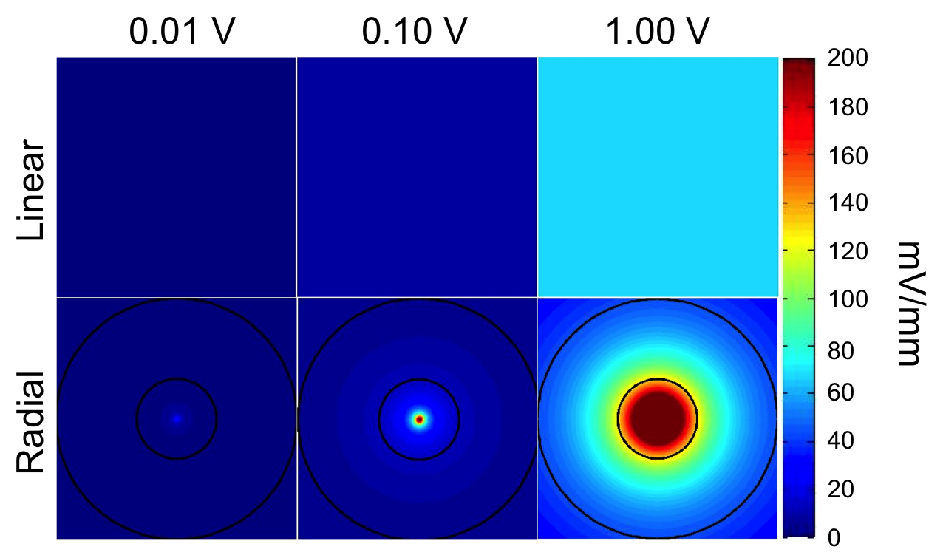
Under radial stimulation conditions, the border of the cell population closest to inner electrode or anode is almost two times the constant electric field intensity under the corresponding linear stimulation conditions. The maximum electric field intensities applied to the cell population in the 0.01 V, 0.10 V and 1.00 V radial experiments were 1.288 mV/mm, 12.88 mV/mm and 128.8 mV/mm, respectively. The constant electric field intensities in the linear experiments were 0.66 mV/mm, 6.66 mV/mm and 66.6 mV/mm, respectively. Previous work on the response of cultured fibroblast cells to applied electric fields has established the existence of a threshold field intensity, beyond which a detrimental effect on cell density is observed ¹⁶⁰. It is possible that the electric field applied to some cells under radial stimulation conditions has surpassed an undetermined threshold field intensity. The possibility of exceeding this threshold field intensity raises two important questions: 1) what is the underlying cause of decreased cell proliferation past the threshold field intensity and 2) can this underlying cause be linked to the delay in cell proliferation observed in our radial experiments?
Figure 41: Electric Field Intensity in All Experiments. Electric field intensity in linear experiments is constant in all parts of the cell population, whereas the intensity in the radial experiments is intentionally non-constant. In the radial diagrams, the outer black circle represents the outer border of the experimental cell population, and the inner black circle represents the inner border of the experimental cell population.
A time delay in cell proliferation after the application of electrical stimulation has previously been observed in a study conducted on cultured erythroleukemia cells after the application of a pulsed stimulus with an amplitude of up to 7 V ¹⁶¹. In this study, a potential cause of this delay in cell growth was the presence and production of hydrogen peroxide in the cell media as a result of the applied electrical stimulus ¹⁶¹. Hydrogen peroxide and other chemically active compounds can be produced in water-based solvents after the application of an electrical stimulus, especially at high voltages ¹⁶². Elevated concentrations of hydrogen peroxide can damage DNA and oxidize proteins, fatty acids, and biological co-factors leading to cell damage ¹⁶². Sunka et al. were able to establish that the application of electrical stimulation had an effect on the cell media as well as the cultured cell population. Therefore, they hypothesized that the delay in cell growth observed in their experiment was related to cell damage caused by reactive peroxide species ¹⁶². It is therefore possible that high electric field intensities, especially those applied in the 1.00 V experiments, may have caused reactive peroxide species to be produced in our experiments, thereby damaging cells and delaying or suppressing cell proliferation.
The hypothesis of cell damage at high electric field intensities is supported by the increase in cell death in the 1.00 V radial experiment and by the fact that the magnitude of cell proliferation at the highest voltage in the linear experiment decreased with respect to the control. The cell population did not experience an increase in proliferation between 24 and 48 hours after a radial application of 1.00 V. Thus, it is possible that the extent of cell damage inflicted on this population has caused an even longer delay in cell growth and has suppressed proliferation during the allotted time of the experiment.
The lack of increased proliferation observed in the reverse polarity population can also potentially be explained by cell damage. In the reverse polarity experiment, the area closest to the inner electrode was populated by cells and experienced the highest electric field strengths. In addition, the reverse polarity experiment was conducted at 1.00 V, which means that the electric field strengths are comparable to those of the 1.00 V standard polarity experiment. A significant increase in cell death 24 hours after electrical stimulation also supports the hypothesis of cell damage under the reverse polarity experimental conditions.
While all radial experiments caused a delay or suppression of cell proliferation, only the maximum electric field intensity induced by the application of 1.00 V exceeded those applied in the linear experiments. The delay of cell proliferation observed at 0.01 V and 0.10 V can potentially be explained by the reduced electric field strength in the bulk of the cell population. While the electric field intensity is greater at the center of the radial cell population than that of the comparable linear cell population, approximately two-thirds of the radial cell population experiences an electric field intensity that is less than that of the comparable linear cell population. A study of the effects of electrical stimulation on rat calvarial bone cells determined that cell proliferation was not affected below a threshold experimental voltage ¹⁶³. If a similar lower limit threshold exists for rat aortic endothelial cells, it is possible that the electric field intensity in the bulk cell population approaches or falls below it, thereby reducing or delaying the observed effect on cell proliferation.
The above speculation regarding the lack of increased cell proliferation due to electric field intensities that were both too extreme and too mild indicates that the range of voltages tested in this experiment may have been too broad. The voltage range tested has been studied previously in experiments using linear electric fields and may not be appropriate for use in radial electric fields. Decreased variability of the magnitude of electric field values present in the cell population by finer control of the voltage difference applied between the two electrodes may be necessary.
Delays in VEGF and bFGF Gene After 1.00 V Application of a Radial Electric Field

After 24 hours, VEGF gene expression for all experimental groups was not significantly greater than the control. However, after 48 hours, VEGF gene expression for all experimental groups was significantly greater than the control. There was a significant increasing trend in VEGF gene expression as voltage increased; the cell population to which 1.00 V stimulation was applied displayed the most VEGF gene expression. This data signifies that similar to the results obtained for proliferation, there may be a time delay in the expression of angiogenic gene expression. Previous research has shown that there can be a relationship between cell damage and a decrease in growth factor gene expression; for example, tubular epithelial cells that are damaged during diabetes may lead to reduced epithelial growth factor (EGF) synthesis ¹⁶⁴. The previously introduced hypothesis of cell damage at high electric field intensities is therefore a possible explanation for the decreased VEGF expression observed after 24 hours at 1.00 V and the subsequent increase in VEGF expression after 48 hours. Prior research also provides support for a general gene expression delay, since it has been found that maximal VEGF mRNA levels are typically found between 3 and 7 days after full-thickness wounding and significant bFGF expression does not begin until approximately 8 days after full thickness wounding ¹⁶⁵. Based on the fact that VEGF and bFGF expression significantly increased both 24 and 48 hours after the reverse polarity experiment, it does not appear that field direction governs the gene expression response of endothelial cells to electrical stimulation.
Lack of Increased Cell Migration in the Presence of an Applied Radial Electric Field
Cell migration did not significantly increase with respect to the control at any experimental time points or voltages when studied in response to radial electrical stimulation. Based on the delay of effects observed in cell proliferation and angiogenic gene expression, a similar delay of cell migration is possible. A study on the migratory response of fibroblasts to electrical stimulation determined that directional cell migration did not begin until at least 1 hour post-stimulation ¹⁶⁶. This confirms that there can be a time delay between the end of electrical stimulation and the beginning of directional cell migration. The delay would also be dependent on the strength and intensity of the electrical field, which could explain why even though our time points were taken more than 1 hour after stimulation, no trends were observed. It is therefore possible that cell migration effects did not begin until after the observed time interval, 4.5 hours post-stimulation and 9 hours post-stimulation.
Additionally, endothelial cells have been shown to migrate towards a chemotaxic gradient of VEGF and other proteins ¹⁶⁷. A recent study investigated the mechanism of chemotaxic cell migration in neural crest cells and found that a “chase-and-run” mechanism exists ¹⁶⁸: cells do not only migrate with the lateral electrical field, but also follow other cells secreting a chemotaxic substance ¹⁶⁸. In our radial experiments, the border of the cell population that moves directionally inwards lies along a radius that is close to the inner electrode. As a result, the border of the cell population has the smallest perimeter in the bulk cell population. Assuming that the density of cells at the start of the experiment is relatively constant, more cells need to follow fewer cells inward towards the inner electrode. If endothelial cells migrate via the same “chase-and-run” mechanism as neural crest cells, the migration of the cell population in our radial experiments could be hindered by the disparity in the number of follower and leader cells. This disparity and the challenges it presents could account for the lack of cell migration observed under radial experimental conditions.
Reverse polarity migration results show a similar lack of trends between control and experimental groups. However, in the case of the reverse polarity experiment, the border of the cell population experiences the lowest intensity electric field present in the cell population and therefore may limit the bulk movement of the cell population.
The results obtained from studying the effects of a radial electric field on cell proliferation, migration, and gene expression can be summarized as follows. For cell proliferation and gene expression, there could be an increased delay between stimulation and observed effects. This delay would prevent accurate comparison with the control, since there were no causes for delay in the control population. For cell migration, although there were no significant effects, differences between the radial and linear experimental setups and scraping patterns could most likely account for the lack of increase in migration.
Delays in cell proliferation, migration, and gene expression are not ideal for promoting rapid wound healing in vivo. Therefore, based on the radial and linear electrical stimulation results obtained from using the aforementioned experimental setups and voltages, radial electrical stimulation is not likely to be superior to linear electrical stimulation.
6.3 Recommendations
6.3.1 Double-Disc Radial Electrode Design
As mentioned previously, extremely high electric field intensities can be linked to delays in cell proliferation and angiogenic gene expression. In our radial experiments, the radius of the inner electrode was designed to be as small as possible. Since radius of the electrode and electric field intensity are inversely related, an extremely high intensity electric field was created near the inner electrode. This phenomenon is demonstrated graphically in Figure 41 on Page 79. Unfortunately, the presence of this high intensity electric field seemed to be correlated to delays in cell proliferation and angiogenic gene expression.
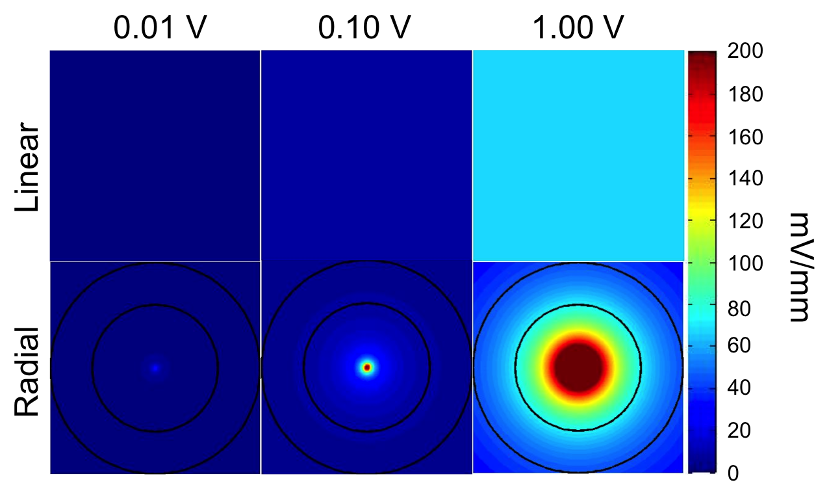
In order to study the potential positive effects of radial electrical stimulation, the scale of the radial electrode set-up should be increased. This reconfiguration would avoid applying an extremely high intensity electric field to the cell population. However, the original electrode distance relationship must be maintained in order to compare radial and linear electrical stimulation data. Thus, both the outer and inner electrode size should be increased, but the difference between the radii must be equal to 1.5 cm. This change will result in milder electric field intensities within the cell population. Regrettably, this change may eliminate the use of 6-well plates for in vitro experiments, as the dimensions of the new radial device may exceed the size of a well in a 6-well plate. Figure 42 is a graphical representation of the intensities of our existing linear electric fields and recommended radial electric fields.
Figure 42: Electric Field Intensity in Linear and Proposed Radial Experiments. Electric field intensity in linear experiments is constant in all parts of the cell population. In the radial diagrams, the outer black circle represents the outer border of the experimental cell population, and the inner black circle represents the inner border of the experimental cell population. The electric field intensity in the proposed radial experiments is intentionally non-constant, but is milder inside the cell population than the electric field intensity applied in the radial experiments that were conducted in this study. Example dimensions are as follows: outer electrode radius = 0.025 m, inner radius = 0.010 m, cell border radius = 0.015 m.

The application of high electric field intensities to cell populations can be linked to cell damage. Thus, applying a milder radial electric field will allow for a better assessment of the potential of radial electrical stimulation to effectively increase cell proliferation and angiogenic gene expression.

6.3.2 Prototype Design
In our previously described experiment, the electrical stimulus, a square wave signal, was generated with a function generator. A function generator is a piece of electronic test equipment that can generate many types of waveforms. However, function generators are expensive, cumbersome, and not very portable. Therefore, they are not suitable for permanent use in a medical device. As an alternative, we sought to design a simple and inexpensive electrical circuit to replace the function generator in a potential prototype for our device. To replicate the function generator signal, we designed a circuit using a 555 timer. A 555 timer is an integrated circuit (IC) that is designed to generate square pulses with varying parameters. ICs are prefabricated, preassembled combinations of electrical parts. They are designed to exhibit particular characteristics and generate certain electrical signals. 555 timers are ICs that are inexpensive, easy to trouble-shoot, and require only simple design work. Implementing such a design also enables our potential prototype to be small in size, significantly smaller than a function generator, as well as lighter and more portable. Another factor that adds to the practicality of this design is the use of a battery source instead of a wall outlet as a power source.
In order to operate a 555 timer, a DC source of at least 5 V is required. If 4 new AA batteries are placed in series, the voltage produced is 6.5 V. Most commercially available batteries have a voltage of 1.5 V. However, since new batteries begin with a higher voltage than 1.5 V, the resulting voltage is 6.5 V instead of 6 V. The 4 AA battery source allows the minimum voltage requirement to be meet easily with little cost and allows the user to replace the batteries without needing to order specialized parts. Thus, the design used 4 AA batteries as a DC source.
In order to successfully design and optimize the circuit, testing was conducted in two phases. The first phase involved testing three different 555 timer ICs to determine the best model for the circuit. The LM555CN, NE555P, and TCL555CP were used in this test because they are common, easy to locate, and purchase. In addition to testing these parts, the first phase of testing was used to determine the correct values for the circuit components in the design. The first phase evaluates the effect of these components on the duty cycle and frequency. In a square wave, with the exception of transient states, applied voltage jumps from a high value to a low value; duty cycle is the percentage of time the voltage is at the high value. A 50% duty cycle means the voltage is at the high voltage for half the time and at the low voltage for the rest of the time. Frequency is the rate per second that the waveform takes to travel one period. To achieve our desired duty cycle, 50%, and frequency, 60 Hz, the correct values for the circuit components needed to be determined. The second phase of testing was contingent on the results of the first phase.
The circuit design used for the first phase of testing is present in Figure 43a. In Figure 43a the values denoted R1 and R2 are resistors and the values denoted C1 and C2 are capacitors. The battery source is also displayed in the right side of the figure. The large block near the center is the representation of the 555 timer. The numbers around the block indicate the pin numbers of the IC. Pins are the metal attachments on the sides of ICs that are connected to the internal components of the IC. Pin numbers denote the identity of each pin. Figure 43b show the simulation results generated by PSpice. The simulation spans from 10 μs to 40 μs. The image is a graph of voltage versus time. However, PSpice employs a "on"/"off" approach to simulating this circuit, meaning it does not provide an amplitude, but rather a logic '1' or '0'. The signal approximately has a duty cycle of 50%, and a frequency of 60 kHz. Originally, there was a unit miscalculation with frequency resulting in incorrect starting values. The frequency simulated is too high by a factor of 1000. However, this error does not affect the eventual results or conclusions of our design, because final circuit design values were evaluated by inspection of the circuit output.

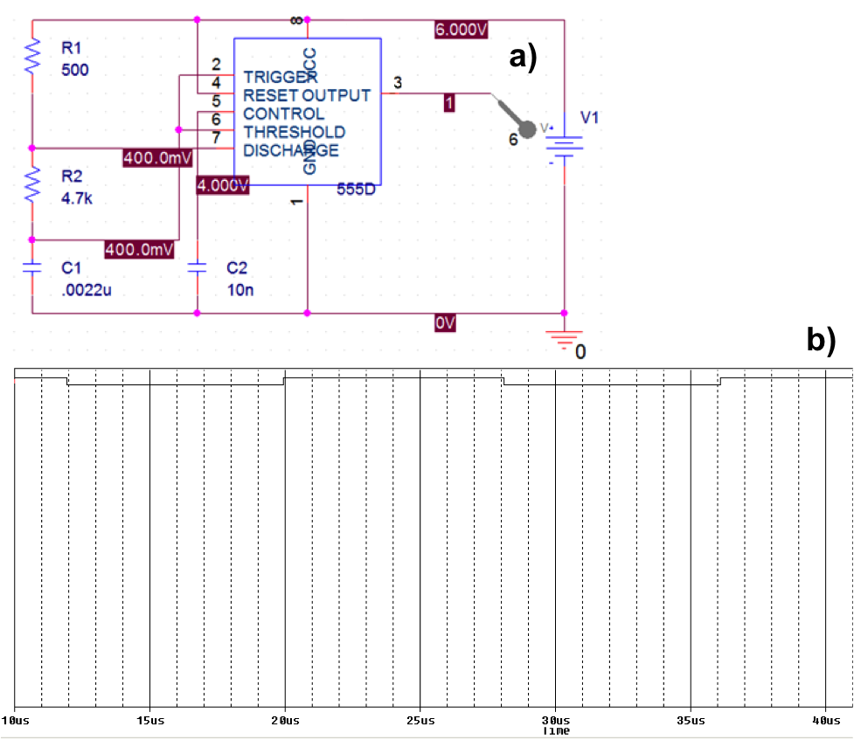
Figure 43: PSpice Circuit and Simulation Results. In Figure 42a, the values denoted R1 and R2 are resistors and the values denoted C1 and C2 are capacitors. R1=500 Ω, R2=4.7 kΩ, C1=0.0022 uF, and C2=10 nF. The battery source of 6 V is also displayed in the right side of the figure. The large block near the center is the representation of the 555 timer. The numbers around the block indicate the pin numbers of the IC. Pins are the metal attachments on the sides of ICs that are connected to the internal components of the IC. Pin numbers denote the identity of each pin. The third pin is the output of the circuit. The gray pointer at the end of the third pin shows what is being measured in the simulation. The white numbers surrounded by maroon are the voltage values carried by the wires they are positioned next to. These values are generated during simulation. Figure 42b represents simulation results generated by PSpice. The simulation spans from 10 us to 40 us. The image is a graph of voltage versus time. However, PSpice employs an "on"/"off" approach to simulating this circuit, meaning it does not provide an amplitude, but rather a logic '1' or '0'. The signal approximately has a duty cycle of 50%, and a frequency of 60 kHz. There was a unit miscalculation with frequency resulting in incorrect starting values. The frequency simulated is too high by a factor of 1000.

To obtain starting component values for our model, the design was simulated using PSpice software by Cadence. The starting values were: a source of 6 V, R1=500 Ω, R2=4.7 kΩ, C1=0.0022 μF, and C2=10 nF shown in Figure 43a. Using the values we obtained, the circuit was constructed on a solder-less breadboard. Breadboards allow electrical circuits to be tested without physically fusing them together. This is a standard method for realizing circuit designs. An oscilloscope, a tool for viewing electrical signals, was used to examine the signal produced by the circuit. The purpose of this phase of testing was to fine-tune the components to obtain a frequency of approximately 60 Hz and a duty cycle of approximately 50%. To achieve the desired values, we changed components based on trends determined from governing equations.
The governing equations employed were ¹⁶⁸:

Fortunately, the behavior of the 555 timer ICs is similar enough that the value of the components did not need to be altered for each IC. The resulting adjusted values were: R1=10 kΩ, R2=2.22 MΩ, C1=0.0054 μF, and C2=10 nF. This can be seen in Figure 44.

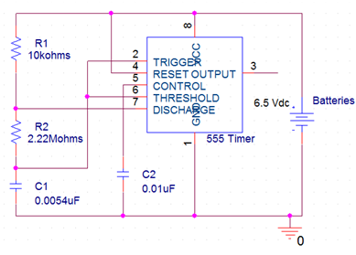
Figure 44: Final Circuit Component Values after Phase One of Testing. The values denoted R1 and R2 are resistors and the values denoted C1 and C2 are capacitors. R1=10 kΩ, R2=2.22 MΩ, C1=0.0054 uF, and C2=0.01 uF. The battery source of 6.5 V is also displayed in the right side of the figure. The large block near the center is the representation of the 555 timer. The numbers around the block indicate the pin numbers of the IC. Pins are the metal attachments on the sides of ICs that are connected to the internal components of the IC. Pin numbers denote the identity of each pin. The third pin is the output of the circuit.

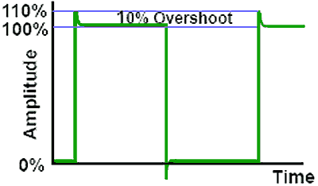
Figure 46a displays the results of the NE555P implementation output. The amplitude of the signal is 5.81 V. The frequency of the signal is 59.2 Hz. The duty cycle of the signal is 50%. A phenomenon named overshoot appears in this signal around 8 ms and again around 42 ms. When a basic circuit generates a square wave, the voltage sometimes goes above the top of the square wave at the point where the voltage increases from the lowest point to the highest point. The voltage above the top of the square wave is refered to as overshoot. An example of this principle is shown in Figure 45. Overshoot is due to the non-ideal nature of circuits and a square wave is very difficult to generate accurately without this characteristic ¹⁷⁰. However, function generators, due to their internal complexity, have neglible overshoot.
Figure 45: Example of Overshoot. When a basic circuit generates a square wave, the voltage sometimes goes above the top of the square wave at the point where the voltage increases from the lowest point, to the highest point. The voltage above the top of the square wave is refered to as overshoot. Overshoot is due to the non-ideal nature of circuits and a square wave is very difficult to generate accurately without this characteristic.

The desired signal behavior has no overshoot, so this is an undesireable quality in our results. All overshoot values have been graphically estimated. The overshoot of the NE555P IC is about 1.9 V, spanning from 5.81 V to approximately 7.7 V.
Figure 46b displays the results of the TLC555CP implementation output. The amplitude of the signal is 6.5 V. The frequency of the signal is 58.5 Hz. The duty cycle of the signal is 50%. Overshoot occurs at 8 ms and 42 ms. The overshoot of the TLC555CP IC is about 0.5V, spaning from 6.5 V to approximately 7 V.
Figure 46c displays the results of the LM555CN implementation output. The amplitude of the signal is 5.88 V. The frequency of the signal is 59.2 Hz. The duty cycle of the signal is 50%. There is no visible overshoot of this signal.
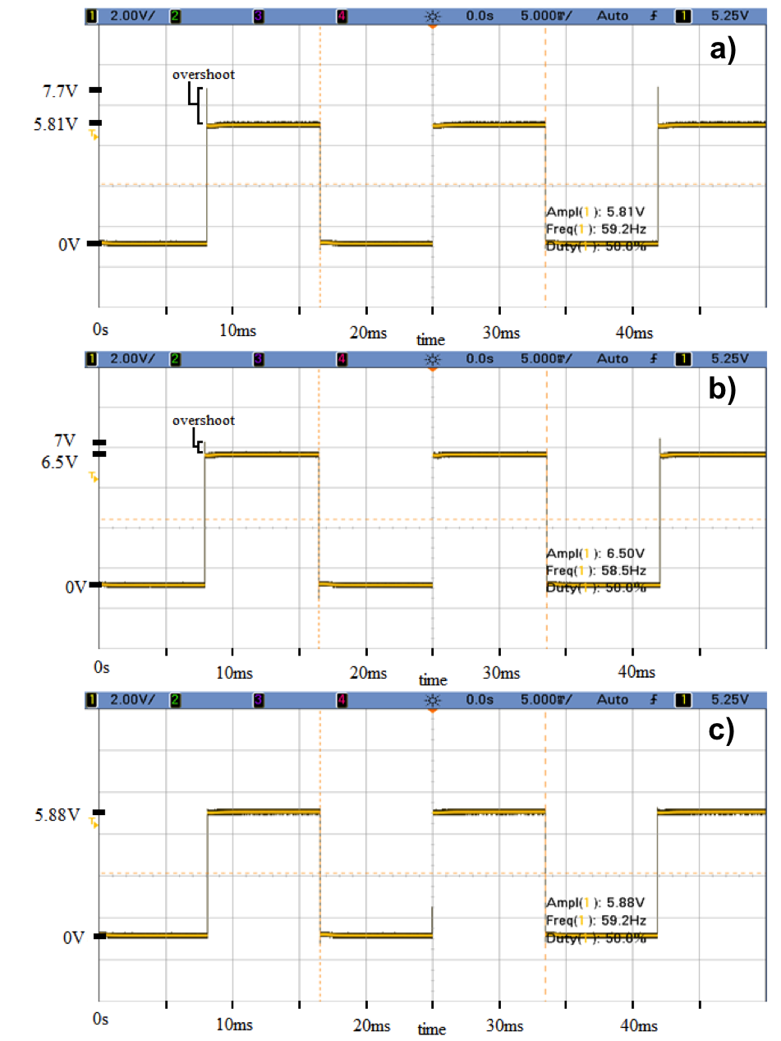
Figure 46: Evaluation of Different 555 timer ICs in the First Phase of Testing. The results of testing each IC are shown above. These images were captured with an oscilloscope and show the voltage versus time behavior of the circuit output. The scale of each image is 2V per y-axis division and 5ms per x-axis division. A phenomenon named overshoot appears in each signal around 8ms and again around 42ms. All overshoot values have been graphically estimated. Figure 46a displays the results of the NE555P implementation output. The amplitude of the signal is 5.81V. The frequency of the signal is 59.2Hz. The duty cycle of the signal is 50%. The overshoot of the NE555P IC is about 1.9V, spaning from 5.81V to approximately 7.7V. Figure 46b displays the results of the TLC555CP implementation output. The amplitude of the signal is 6.5V. The frequency of the signal is 58.5Hz. The duty cycle of the signal is 50%. The overshoot of the TLC555CP IC is about 0.5V, spaning from 6.5V to approximately 7V. Figure 46c displays the results of the LM555CN implementation output. The amplitude of the signal is 5.88V. The frequency of the signal is 59.2Hz. The duty cycle of the signal is 50%. There is no visible overshoot of this signal.
The output of the NE555P IC significantly overshot the amplitude of the square wave. The output of the TCL555CP IC also overshot the amplitude at the same time as the NE555P IC. However, the overshoot is not as significant. Finally, the LM555CN IC exhibits no visible overshoot. Since overshoot is not a desirable characteristic, the LM555CN IC most accurately replicates the function generator signal. In addition, the LM555CN has a more desirable frequency value than the TCL555CP IC. Therefore, the LM555CN was selected as the IC component.
The second phase of testing used the circuit from the first phase of testing. The output of the circuit in phase one was connected to a resistor and the signal after the resistor became the new output that was evaluated. The goal of the second phase of testing was to determine the resistor value that would decrease the output voltage amplitude to 0.10 V. Amplitude is the measure of the difference between the maximum voltage and the minimum voltage of a signal. During this phase of testing only amplitude was evaluated, because the addition of a resistor in this location will not change the duty cycle, or frequency of the signal, which was determined in phase one.
The determination of this resistor value was based on the trend exhibited by Ohm's Law: V=IR, where V is voltage drop, I is current, and R is resistance. If R is increased, then V will increase, meaning the output of the signal is lower. Measurements in this phase of testing were made with a multimeter, a basic electrical tool designed to measure voltage. In order to determine the resistor value, the resistance was increased until the desired output voltage was obtained. The resistance required to reach a signal amplitude of 0.1 V was 58 MΩ.
In summary, the circuit board generates a signal in an inexpensive, more compact, portable fashion than the function generator used in our previous experiments. To accomplish this we implemented a 555 timer circuit. While the circuit design was successful and effectively replicated the desired signal, it is far from efficient. 555 timers require a minimum of 5 V to operate. However, only a final signal amplitude of only 0.10 V is desired, thus most of the energy input is lost to heat dissipation in the high resistor values. Note that originally the most suitable voltage for the linear electrical device was determined to be 0.10 V but after further analysis of the data, 0.01 V was determined as the most suitable voltage. The procedure for outputting an electrical stimulus of 0.01 V would be similar to this procedure.
It may not be necessary to use the 555 IC that requires 6.5 V to generate such a low output. However, for this study, the LM555CN model is sufficient. This experiment demonstrates that the signal required can be generated at a lower cost with a simple integrated circuit as seen in Figure 47. Further work should be done to design a more efficient circuit that implements a smaller source voltage.
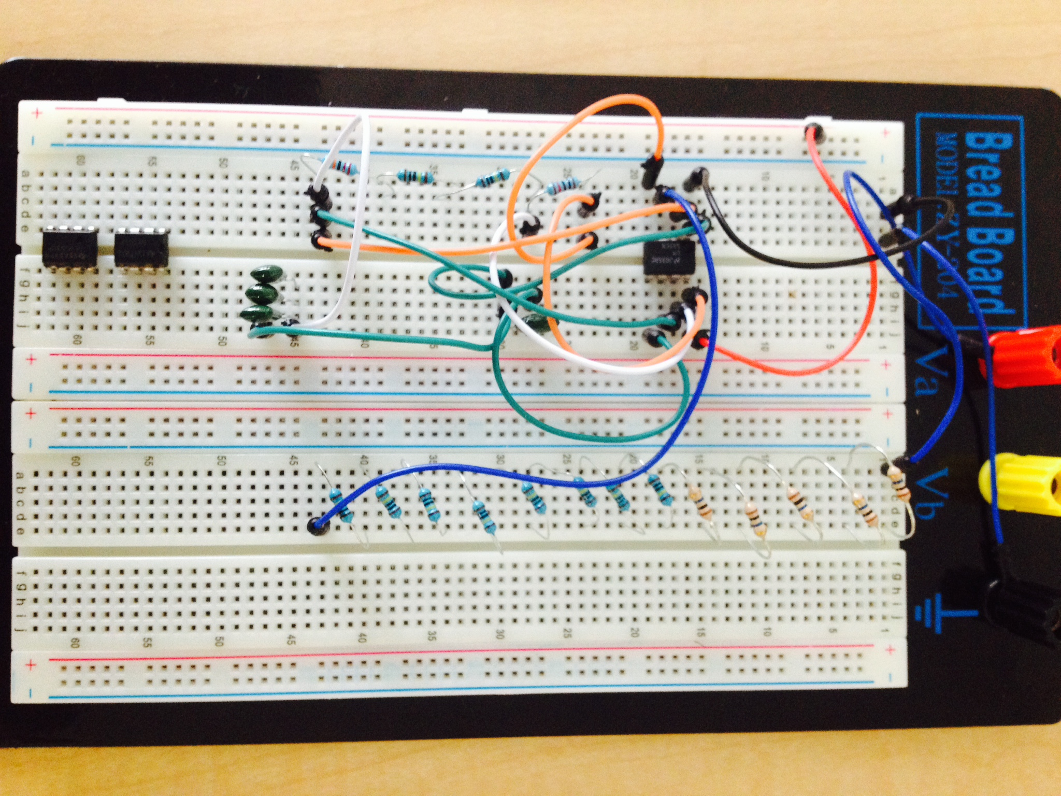
Figure 47: Image of Fully Functional Circuit Board. The circuit board with a LM55CM model and a 58 MΩ resistor outputs a pulsed monophasic square wave at 0.10 V. The creation of this model demonstrates that a functional, portable, and easy-to-use device can be created for both healthcare professionals and patient use in the future, once an optimal voltage and electrode conformation is determined.
CHAPTER 7: CONCLUSIONS

7.1 Overall Conclusions

The effect of an applied electrical stimulus on rat aortic endothelial cell migration, cell proliferation, and angiogenic gene expression was not consistent between the linear and radial model. Following the application of a linear electric field, cell migration, cell proliferation, and angiogenic gene expression all increased significantly at varying time points and voltages. Cell migration and cell proliferation increased significantly at lower voltages and gene expression of VEGF and bFGF increased most significantly at higher voltages. An analysis of the results suggests that a voltage of 0.01 V for a linearly applied field is the most suitable for the purposes of healing diabetic ulcers.
The overall effects of electrical stimulation on cell migration, proliferation, and angiogenic gene expression using a radial electric field set-up showed no clear significant voltage trends due to varying electric field intensities and a potential delay in the wound healing process. Thus, unfortunately, no single voltage was better than the other voltages for a radially applied field.
In conclusion, based on these results, the linear electrical field has a larger potential to treat diabetic ulcers. Using a voltage of 0.01 V can also maximize the effects of a linearly applied electrical field as compared to 0.10 V and 1.00 V. The radial electric field results did not yield a single voltage appropriate for wound healing.
7.2 Limitations
Our study has several limitations. The first limitation involves the in vitro migration model used for our study. The in vitro model consisted solely of healthy rat aortic endothelial cells. These cells were not taken from tissue samples from diabetic ulcer patients and thus results seen in the normal cells may not be the same if the study was performed on diabetic tissue ¹⁷¹. In addition, our model was 2-D, rather than 3-D, thus angiogenesis could not be observed directly ¹⁷².
Additionally, we were not able to progress into in vivo testing. While results indicate that electric fields have positive effects on cell migration, cell proliferation, and gene expression in vitro, these positive effects may not translate into an in vivo model. In vivo testing is required to prove that these beneficial effects will be observed in a living organism with a more complicated and orchestrated wound healing process. Furthermore, in vivo testing could determine if the electric fields have any harmful effects on living organisms before translating the apparatus into human trials.
Another limitation of the study is the creation of our own Migration Assay. The migration data was more varied than the proliferation and gene expression data, possibly indicating low precision in the data. Throughout the implementation of the Migration Assay, it was a challenge to ensure the same cell population was captured in all images across time points. Although the microscope stage scale and coordinate system was used to position the well plate and the pictures were visually compared for similar cell population edges, small differences on a micron scale can translated into large differences between migration data points. In addition, the Migration Assay protocols were not identical between the linear and radial model, which makes comparison of the migration effects of the two fields difficult.
The final limitation of the study is that only gene expression, but not protein expression was measured. Gene expression is the transcription of mRNA from DNA, while protein expression is the translation of mRNA to protein. While mRNA levels can be indicative of protein levels, they are not necessarily correlated, as there are many steps between the creation of mRNA to the production of the actual protein. mRNA degradation and stability are two factors that can influence production of the protein production. The protein product of the angiogenic growth factor is required for the wound healing process.
7.3 Future Research
Future research is needed to confirm our results and to thoroughly prove our hypothesis. Firstly, any additional research must address the limitations of our study protocol. Since our study was not done on a diabetic model it is imperative that our results are replicated in an in vitro diabetic model. In vitro diabetic models can be achieved several ways, but in order to parallel our study, we recommend an endothelial monolayer treated with streptozotocin to mimic the effects of diabetes ¹⁷³. Then, both linear and double-disc radial electric fields can be tested on the diabetic in vitro model. However, it is important that both linear and radial Migration Assay protocols are similar and use the same reference markings on the bottom of the well plate in order to ensure Migration Assay images are taken in the exactly same location between time points and between experimental treatments. An additional Enzyme-Linked Immunosorbent Assay (ELISA) should be also done in order to evaluate both gene and protein expression.
After further in vitro studies, testing on in vivo diabetic models would be necessary to demonstrate that electric fields produce the same effects in vivo as in vitro. The safety of this experimental treatment would also be evaluated with in vivo testing. During this phase of testing, the efficiency and practicality of different adhesives for attaching the electrodes as well as identifying ideal placement of electrodes relative to the wound could be investigated. In addition, the influence of initial wound size and severity on the outcome of the electric field treatment and time of application of the electrical stimulus could also be studied. These studies could be completed on a variety of different animal models. Several studies have used rat models that were induced with diabetes with the drug, streptozotocin ¹³¹. Genetically modified diabetic rats can be used as well ¹⁷⁴. Several studies have also demonstrated different ways of inducing the artificial diabetic ulcers in vivo. One study induced the ulcer using a round iron and removing the subsequent scald three days later ⁴² and another study used pressure induced wounds ¹⁷⁵.
Once in vivo studies were completed and if the same treatment effects were observed and safety was confirmed, clinical studies will need to be completed to further verify safety and to confirm our results on a human model. An interesting avenue of research would be to evaluate the possibility of different effects of treatment between patients with Type I and Type II diabetes. Clinical studies could also show the practicality of our device for use by nurses or the patients themselves.
Finally, once the prototype has passed clinical trials, it will be important to test the ease with which the device can be used by the patient or caregivers in their daily routines and environments. Our intent was for the device to be easy-to-use and portable, thus we would want to ensure that it is functional in practice.
7.4 Implications
Based on the results of our in vitro studies, as well as the design of our prototype, a small, portable electrical stimulation device for treating diabetic ulcers is feasible. Recent research has stated that improvements in diabetic ulcer treatments will only come from combination therapy targeting numerous biochemical causes of diabetic ulcers, rather than just one ¹⁷⁶. Our device targets multiple biochemical functions, as seen through increases in cell migration, cell proliferation, and angiogenic gene expression. Additionally, it is easily combined with other treatments such as debridement offering maximum therapy potential.
Our device should be considered as a next-generation form of treatment, since it can target multiple growth factors and other biochemical functions that are underlying causes of diabetic ulcers. Other normal routes of delivering and affecting multiple growth factors in the treatment of diabetic ulcers are expensive due to recombination production ¹⁷⁶. Our device would have the potential to deliver similar effects in a more cost-effective, portable, and feasible manner.

REFERENCES

1. Diabetes [Internet]. Rochester (MN): Mayo Clinic: c2013 [cited 26 Mar 2014].
Available from http://www.mayoclinic.com/health/diabetes/DS01121%3E.
2. International Diabetes Federation and World Health Organization. Diabetes Action Now, Switzerland, 2004. Available from National Library of Medicine, Bethesda, MD; WK 815.
3. Centers for Disease Control and Prevention. National diabetes fact sheet: national estimates and general information on diabetes and prediabetes in the United States, 2011. Available from U.S. Department of Health and Human Services, Centers for Disease Control and Prevention, Atlanta, GA; CS217080A.
4. Statistics About Diabetes [Internet]. Alexandria (VA): American Diabetes Association: c2014 [cited 26 Mar 2014]. Available from http://www.diabetes.org/diabetes-basics/statistics/.
5. Fast Facts: Data and Statistics about Diabetes [Internet]. Alexandria (VA): American Diabetes Association: c2014 [cited 26 Mar 2013]. Available from http://professional.diabetes.org/admin/UserFiles/0%20-%20Sean/FastFacts%20March%202013.pdf.
6. Boyle JP, Thompson TJ, Gregg EW, Barker LE, Williamson DF. Projection of the year 2050 burden of diabetes in the US adult population: dynamic modeling of incidence, mortality, and prediabetes prevalence. Popul Health Metr 2010;8:29.
7. National Diabetes Statistics [Internet]. Bethesda (MD): National Institute of Diabetes and Digestive and Kidney Diseases, National Institutes of Health: c2013 [cited 26 Mar 2014]. Available from http://diabetes.niddk.nih.gov/dm/pubs/statistics/#dd.
8. Boulton AJ, Kirsner RS, Vileikyte L. Clinical practice. Neuropathic diabetic foot ulcers. N Engl J Med 2004;351(1):48-55.
9. Symptoms [Internet]. Alexandria (VA): American Diabetes Association: c2014 [cited 26 Mar 2014]. Available from http://www.diabetes.org/diabetes-basics/symptoms/.
10. Morrish NJ, Wang SL, Stevens LK, Fuller JH, Keen H. Mortality and causes of death in the WHO Multinational Study of Vascular Disease in Diabetes. Diabetologia 2001;44 Suppl 2:S14-21.
11. Boulton AJ. The diabetic foot. The Medical clinics of North America 1988;72(6):1513-1530.
12. Claxton MJ, Armstrong DG, Boulton AJ. Healing the diabetic wound and keeping it healed: modalities for the early 21st century. Curr Diab Rep 2002;2(6):510-8.
13. Pecoraro RE, Reiber GE, Burgess EM. Pathways to diabetic limb amputation. Basis for prevention. Diabetes Care 1990;13(5):513-21.
14. Association AD. Economic costs of diabetes in the U.S. in 2012. Diabetes Care 2013;36(4):1033-46.
15. Barshes NR, Sigireddi M, Wrobel JS, Mahankali A, Robbins JM, Kougias P, Armstrong DG. The system of care for the diabetic foot: objectives, outcomes, and opportunities. Diabet Foot Ankle 2013;4.
16. Foot Complications [Internet]. Alexandria (VA): American Diabetes Association: c2014 [cited 26 Mar 2014]. Available from http://www.diabetes.org/living-with-diabetes/complications/foot-complications/
17. Norwood, Diane Voyatzis. Diabetic Foot Ulcers [Internet]. New York(NY): NYU Langone Medical Center: c2013 [cited 26 Mar 2013]. Available from http://www.med.nyu.edu/content?ChunkIID=102704.
18. Rowe, Vincent Lopez, MD. Diabetic Ulcers [Internet]. Los Angeles(CA): University of Southern California: c2011 [cited 26 Mar 2013]. Availabe from http://emedicine.medscape.com/article/460282-overview.
19. Veves A, Falanga V, Armstrong DG, Sabolinski ML, Study ADFU. Graftskin, a human skin equivalent, is effective in the management of noninfected neuropathic diabetic foot ulcers: a prospective randomized multicenter clinical trial. Diabetes Care 2001;24(2):290-5.
20. Singh N, Armstrong DG, Lipsky BA. Preventing foot ulcers in patients with diabetes. JAMA 2005;293(2):217-228.
21. Reiber GE, Vileikyte L, Boyko EJ, del Aguila M, Smith DG, Lavery LA, Boulton AJ. Causal pathways for incident lower-extremity ulcers in patients with diabetes from two settings. Diabetes Care 1999;22(1):157-62.
22. Frykberg R. Diabetic Foot Ulcers: Pathogenesis and Management. Des Moines, Iowa: Am Pham Physician; 2002. p 1655-1663.
23. Adams CA, Deitch EA. Diabetic foot infections. In: Holzheimer R, Mannick J, editors. Surgical Treatment: Evidence-Based and Problem-Oriented. Munich: Zuckschwerdt; 2001.
24. Oyibo SO, Jude EB, Tarawneh I, Nguyen HC, Harkless LB, Boulton AJM. A Comparison of Two Diabetic Foot Ulcer Classification Systems: The Wagner and the University of Texas wound classification systems. Diabetes Care 2001;24(1):84-88.
25. McIntosh A, Peters J, Young R, Hutchinson A, Chiverton R, Clarkson S, Foster A, Gadsby R O'Conner M, Rayman G, Feder G. Prevention and Management of Foot Problems in Type 2 diabetes: Clinical Guidelines and Evidence. Sheffield: University of Sheffield; 2003.
26. Frykberg RG, Zgonis T, Armstrong DG, Driver VR, Giurini JM, Kravitz SR, Landsman AS, Lavery LA, Moore JC, Schuberth JM and others. Diabetic foot disorders. A clinical practice guideline (2006 revision). J Foot Ankle Surg 2006;45(5 Suppl):S1-66.
27. Li S, Zhao J, Liu J, Xiang F, Lu D, Liu B, Xu J, Zhang H, Zhang Q, Li X and others. Prospective randomized controlled study of a Chinese herbal medicine compound Tangzu Yuyang Ointment for chronic diabetic foot ulcers: a preliminary report. J Ethnopharmacol 2011;133(2):543-50.
28. Kasai Y, Nemoto H, Kimura N, Ito Y, Sumiya N. Application of low-pressure negative pressure wound therapy to ischaemic wounds. J Plast Reconstr Aesthet Surg 2011.
29. Kairinos N, Solomons M, Hudson DA. The paradox of negative pressure wound therapy--in vitro studies. J Plast Reconstr Aesthet Surg 2010;63(1):174-9.
30. Mulder G, Armstrong D, Seaman S. Standard, appropriate, and advanced care and medical-legal considerations: Part one-diabetic foot ulcerations. Wounds 2003;15:92-106.
31. Ngan, Vanessa. Leg Ulcers [Internet]. New Zealand: DermNet New Zealand Trust: c2004 [cited 26 Mar 2014]. Available from http://dermnetnz.org/site-age-specific/leg-ulcers.html.
32. Haycocks S, Chadwick P. Debridement of diabetic foot wounds. Nurs Stand 2012;26(24):51-2, 54, 56 passim.
33. Lebrun E, Tomic-Canic M, Kirsner RS. The role of surgical debridement in healing of diabetic foot ulcers. Wound Repair Regen 2010;18(5):433-8.
34. Kirshen C, Woo K, Ayello EA, Sibbald RG. Debridement: a vital component of wound bed preparation. Adv Skin Wound Care 2006;19(9):506-17; quiz 517-9.
35. Granick M, Boykin J, Gamelli R, Schultz G, Tenenhaus M. Toward a common language: surgical wound bed preparation and debridement. Wound Repair Regen 2006;14 Suppl 1:S1-10.
36. Bradley M, Cullum N, Sheldon T. The debridement of chronic wounds: a systematic review. Health Technol Assess 1999;3(17 Pt 1):iii-iv, 1-78.
37. Dumville JC, Worthy G, Bland JM, Cullum N, Dowson C, Iglesias C, Mitchell JL, Nelson EA, Soares MO, Torgerson DJ and others. Larval therapy for leg ulcers (VenUS II): randomised controlled trial. BMJ 2009;338:b773.
38. Smith J. Debridement of diabetic foot ulcers. Cochrane Database Syst Rev 2002(4):CD003556.
39. Bell DP. Diabetic foot ulcers: current treatment options and new developments. Surg Technol Int 2010;20:97-105.
40. Nguyen PD, Tutela JP, Thanik VD, Knobel D, Allen RJ, Chang CC, Levine JP, Warren SM, Saadeh PB. Improved diabetic wound healing through topical silencing of p53 is associated with augmented vasculogenic mediators. Wound Repair Regen 2010;18(6):553-9.
41. Di Peppe SR, Mangoni A, Zambruno G, Spinetti G, Melillo G, Napolitano M. Adenovirus-mediated VEGF₁₆₅ gene transfer enhances wound healing by promoting angiogenesis in CD1 diabetic mice. Volume 9. Gene Therapy: Nature Publishing Group; 2002. p 1271-1277.
42. Xie L, Zhang M, Dong B, Guan M, Lu M, Huang Z, Gao H, Li X. Improved refractory wound healing with administration of acidic fibroblast growth factor in diabetic rats. Diabetes Res Clin Pract 2011;93(3):396-403.
43. Badiavas EV, Abedi M, Butmarc J, Falanga V, Quesenberry P. Participation of bone marrow derived cells in cutaneous wound healing. J Cell Physiol 2003;196(2):245-50.
44. Yamaguchi Y, Yoshida S, Sumikawa Y, Kubo T, Hosokawa K, Ozawa K, Hearing VJ, Yoshikawa K, Itami S. Rapid healing of intractable diabetic foot ulcers with exposed bones following a novel therapy of exposing bone marrow cells and then grafting epidermal sheets. Br J Dermatol 2004;151(5):1019-28.
45. Reid B, Song B, McCaig CD, Zhao M. Wound healing in rat cornea: the role of electric currents. FASEB J 2005;19(3):379-86.
46. Velnar T, Bailey T, Smrkolj V. The wound healing process: an overview of the cellular and molecular mechanisms. J Int Med Res 2009;37(5):1528-42.
47. Diegelmann RF, Evans MC. Wound healing: an overview of acute, fibrotic and delayed healing. Front Biosci 2004;9:283-9.
48. Shah JM, Omar E, Pai DR, Sood S. Cellular events and biomarkers of wound healing. Indian J Plast Surg 2012;45(2):220-8.
49. Li WW, Li VW. Angiogenesis in Wound Healing. Supplement to Contemporary Surgery 2003:2-33.
50. McFadyen JD, Jackson SP. Differentiating haemostasis from thrombosis for therapeutic benefit. Thromb Haemost 2013;110(5).
51. Broughton G, Janis JE, Attinger CE. Wound healing: an overview. Plast Reconstr Surg 2006;117(7 Suppl):1e-S-32e-S.
52. Koh TJ, DiPietro LA. Inflammation and wound healing: the role of the macrophage. Expert Rev Mol Med 2011;13:e23.
53. Tonnesen MG, Feng X, Clark RAF. Angiogenesis in Wound Healing. Journal of Investigative Dermatology Symposium Proceedings 2000;5:40-46.
54. Nissen NN, Polverini PJ, Koch AE, Volin MV, Gamelli RL, DiPietro LA. Vascular endothelial growth factor mediates angiogenic activity during the proliferative phase of wound healing. Am J Pathol 1998;152(6):1445-52.
55. Nogami M, Hoshi T, Kinoshita M, Arai T, Takama M, Takahashi I. Vascular endothelial growth factor expression in rat skin incision wound. Med Mol Morphol 2007;40(2):82-7.
56. Breier G, Risau W. The role of vascular endothelial growth factor in blood vessel formation. Trends Cell Biol 1996;6(12):454-6.
57. Zhang F, Lei MP, Oswald TM, Pang Y, Blain B, Cai ZW, Lineaweaver WC. The effect of vascular endothelial growth factor on the healing of ischaemic skin wounds. Br J Plast Surg 2003;56(4):334-41.
58. Brem H, Tomic-Canic M. Cellular and molecular basis of wound healing in diabetes. J Clin Invest 2007;117(5):1219-22.
59. Ebaid H, Ahmed OM, Mahmoud AM, Ahmed RR. Limiting prolonged inflammation during proliferation and remodeling phases of wound healing in streptozotocin-induced diabetic rats supplemented with camel undenatured whey protein. BMC Immunol 2013;14:31.
60. Demidova-Rice TN, Hamblin MR, Herman IM. Acute and impaired wound healing: pathophysiology and current methods for drug delivery, part 1: normal and chronic wounds: biology, causes, and approaches to care. Adv Skin Wound Care 2012;25(7):304-14.
61. Kota SK, Meher LK, Jammula S, Krishna SV, Modi KD. Aberrant angiogenesis: The gateway to diabetic complications. Indian J Endocrinol Metab 2012;16(6):918-30.
62. Eming SA, Krieg T, Davidson JM. Inflammation in wound repair: molecular and cellular mechanisms. J Invest Dermatol 2007;127(3):514-25.
63. Eming SA, Krieg T, Davidson JM. Inflammation in wound repair: molecular and cellular mechanisms. J Invest Dermatol 2007;127(3):514-25.
64. Li WW, MD, Li VW, MD, Tsakayannis D, MD. Angiogenesis in Wound Healing. Contemporary Surgery 2003.
65. Förstermann U. Nitric oxide and oxidative stress in vascular disease. Pflugers Arch 2010;459(6):923-39.
66. Trengove NJ, Stacey MC, MacAuley S, Bennett N, Gibson J, Burslem F, Murphy G, Schultz G. Analysis of the acute and chronic wound environments: the role of proteases and their inhibitors. Wound Repair Regen 1999;7(6):442-52.
67. Kolluru GK, Bir SC, Kevil CG. Endothelial dysfunction and diabetes: effects on angiogenesis, vascular remodeling, and wound healing. Int J Vasc Med 2012;2012:918267.
68. DuBois-Reymond E. Vorläufiger Abriss einer Untersuchung über den sogenannten Froschstrom und die electomotrischen Fische. Ann. Phy. U. Chem. 1843;58:1-30.
69. Alberts B, Johnson A, Lewis J, Raff M, Roberts K, Walter P. Molecular Biology of the Cell. New York, New York: Garland Science; 2008.
70. Stern EA, Kincaid AE, Wilson CJ. Spontaneous subthreshold membrane potential fluctuations and action potential variability of rat corticostriatal and striatal neurons in vivo. J Neurophysiol 1997;77(4):1697-715.
71. Weidmann, S. Effect of current flow on the membrane potential of cardiac muscle. J Physiol 1951;115(2):227-36.
72. McCaig CD, Rajnicek AM, Song B, Zhao M. Controlling cell behavior electrically: current views and future potential. Physiol Rev 2005;85(3):943-78.
73. Barker AT, Jaffe LF, Vanable JW. The glabrous epidermis of cavies contains a powerful battery. Am J Physiol 1982;242(3):R358-66.
74. Zhao Z, Qin L, Reid B, Pu J, Hara T, Zhao M. Directing migration of endothelial progenitor cells with applied DC electric fields. Stem Cell Res 2012;8(1):38-48.
75. Chiang M, Robinson KR, Vanable JW. Electrical fields in the vicinity of epithelial wounds in the isolated bovine eye. Exp Eye Res 1992;54(6):999-1003.
76. Nuccitelli R. A role for endogenous electric fields in wound healing. Curr Top Dev Biol 2003;58:1-26.
77. Tai G, Reid B, Cao L, Zhao M. Electrotaxis and wound healing: experimental methods to study electric fields as a directional signal for cell migration. Methods Mol Biol 2009;571:77-97.
78. Pullar CE, Isseroff RR. Cyclic AMP mediates keratinocyte directional migration in an electric field. J Cell Sci 2005;118(Pt 9):2023-34.
79. Mycielska ME, Djamgoz MB. Cellular mechanisms of direct-current electric field effects: galvanotaxis and metastatic disease. J Cell Sci 2004;117(Pt 9):1631-9.
80. Keese CR, Wegener J, Walker SR, Giaever I. Electrical wound-healing assay for cells in vitro. Proc Natl Acad Sci U S A 2004;101(6):1554-9.
81. Song B, Zhao M, Forrester JV, McCaig CD. Electrical cues regulate the orientation and frequency of cell division and the rate of wound healing in vivo. Proc Natl Acad Sci U S A 2002;99(21):13577-82.
82. Zhao M, Agius-Fernandez A, Forrester JV, McCaig CD. Orientation and directed migration of cultured corneal epithelial cells in small electric fields are serum dependent. J Cell Sci 1996;109 ( Pt 6):1405-14.
83. Wu D, Ma X, Lin F. DC electric fields direct breast cancer cell migration, induce EGFR polarization, and increase the intracellular level of calcium ions. Cell Biochem Biophys 2013;67(3):1115-25.
84. Zhao M, Bai H, Wang E, Forrester JV, McCaig CD. Electrical stimulation directly induces pre-angiogenic responses in vascular endothelial cells by signaling through VEGF receptors. J Cell Sci 2004;117(Pt 3):397-405.
85. Zhang J, Calafiore M, Zeng Q, Zhang X, Huang Y, Li RA, Deng W, Zhao M. Electrically guiding migration of human induced pluripotent stem cells. Stem Cell Rev 2011;7(4):987-96.
86. Li F, Chen T, Hu S, Lin J, Hu R, Feng H. Superoxide mediates direct current electric field-induced directional migration of glioma cells through the activation of AKT and ERK. PLoS One 2013;8(4):e61195.
87. Huang YJ, Samorajski J, Kreimer R, Searson PC. The influence of electric field and confinement on cell motility. PLoS One 2013;8(3):e59447.
88. Cohen DJ, Nelson WJ, Maharbiz MM. Galvanotactic control of collective cell migration in epithelial monolayers. Nat Mater 2014;13(4):409-17.
89. Allen GM, Mogilner A, Theriot JA. Electrophoresis of cellular membrane components creates the directional cue guiding keratocyte galvanotaxis. Curr Biol 2013;23(7):560-8.
90. Jiang Q, Zhou C, Bi Z, Wan Y. EGF-induced cell migration is mediated by ERK and PI3K/AKT pathways in cultured human lens epithelial cells. J Ocul Pharmacol Ther 2006;22(2):93-102.
91. Zhao M, Bai H, Wang E, Forrester JV, McCaig CD. Electrical stimulation directly induces pre-angiogenic responses in vascular endothelial cells by signaling through VEGF receptors. J Cell Sci 2004;117(Pt 3):397-405.
92. Ángyán L, Ángyán Z. Characterization of Cardiorespiratory Responses to Electrical Stimulation of the Globus Pallidus in Cat. Physiology & Behavior 1999;66(1):53-58.
93. Lee SY, Kang SY, Im SH, Kim BR, Kim SM, Yoon HM, Han EY. The effects of assisted ergometer training with a functional electrical stimulation on exercise capacity and functional ability in subacute stroke patients. Ann Rehabil Med 2013;37(5):619-27.
94. Ring HA, White S, Costa DC, Pottinger R, Dick JPR, Koeze T, Sutcliffe J. A SPECT study of the effect of vagal nerve stimulation on thalamic activity in patients with epilepsy. Seizure 2000;9(6):380-384.
95. Van Laere K, Vonck K, Boon P, Brans B, Vandekerckhove T, Dierckx R. Vagus nerve stimulation in refractory epilepsy: SPECT activation study. Journal of Nuclear Medicine 2000;41(7):1145-1154.
96. Vonck K, Boon P, Van Laere K, D'Havé M, Vandekerckhove T, O'Connor S, Brans B, Dierckx R, De Reuck J. Acute single photon emission computed tomographic study of vagus nerve stimulation in refractory epilepsy. Epilepsia 2000;41(5):601-609.
97. Chae J-H, Nahas Z, Lomarev M, Denslow S, Lorberbaum JP, Bohning DE, George MS. A review of functional neuroimaging studies of vagus nerve stimulation (VNS). Journal of Psychiatric Research 2003;37(6):443-455.
98. Henry TR, Votaw JR, Pennell PB, Epstein CM, Bakay RAE, Faber TL, Grafton ST, Hoffman JM. Acute blood flow changes and efficacy of vagus nerve stimulation in partial epilepsy. Neurology 1999;52(6):1166-1173.
99. Ferrante S, Pedrocchi A, Ferrigno G, Molteni F. Cycling induced by functional electrical stimulation improves the muscular strength and the motor control of individuals with post-acute stroke. Europa Medicophysica-SIMFER 2007 Award Winner. Eur J Phys Rehabil Med 2008;44(2):159-67.
100. Talebi G, Torkaman G, Firoozabadi M, Shariat S. Effect of anodal and cathodal microamperage direct current electrical stimulation on injury potential and wound size in guinea pigs. J Rehabil Res Dev 2008;45(1):153-9.
101. Pullar CE, Isseroff RR. Cyclic AMP mediates keratinocyte directional migration in an electric field. J Cell Sci 2005;118(Pt 9):2023-34.
102. Rouabhia M, Park H, Meng S, Derbali H, Zhang Z. Electrical stimulation promotes wound healing by enhancing dermal fibroblast activity and promoting myofibroblast transdifferentiation. PLoS One 2013;8(8):e71660.
103. Asadi MR, Torkaman G, Hedayati M. Effect of sensory and motor electrical stimulation in vascular endothelial growth factor expression of muscle and skin in full-thickness wound. Journal of Rehabilitation Research & Development 2011;48(3):195-201.
104. Pullar CE. The physiology of bioelectricity in development, tissue regeneration, and cancer. Boca Raton: CRC Press; 2011. xiv, 304 p. p.
105. Hampton S, King L. Healing an intractable wound using bio-electrical stimulation therapy. British Journal of Nursing (BJN) 2005;14(15):S30-S32.
106. R B, G S. The Embryo at the Wound, The Sign of the Miracle, Life’s Potentials, The Self-Mending Net. The Body Electric. New York, NY: William Morrow and Company Inc.; 1985. p 55-86, 204-205.
107. Bai H, Forrester JV, Zhao M. DC electric stimulation upregulates angiogenic factors in endothelial cells through activation of VEGF receptors. Cytokine 2011;55(1):110-115.
108. Li X, Kolega J. Effects of Direct Current Electric Fields on Cell Migration and Actin Filament Distribution in Bovine Vascular Endothelial Cells. J Vasc Res 2002;39(5):391-404.
109. RB B, Jr VJ, LF J. Bioelectricity and regeneration: Large currents leave the stumps of regenerating newt limbs. Proc Natl Acad Sci 1977;74:4528-4532.
110. AT B, LF J, Jr VJ. The glabrous epidermis of cavies contains a powerful battery. Am J Physiol 1982;242:R358-R366.
111. Chiang M, Robinson KR, Vanable JW. Electrical fields in the vicinity of epithelial wounds in the isolated bovine eye. Exp Eye Res 1992;54(6):999-1003.
112. Thakral G, Lafontaine J, Najafi B, Talal TK, Kim P, Lavery LA. Electrical stimulation to accelerate wound healing. Diabet Foot Ankle 2013;4.
113. Sebastian A, Syed F, Perry D, Balamurugan V, Colthurst J, Chaudhry IH, Bayat A. Acceleration of cutaneous healing by electrical stimulation: Degenerate electrical waveform down-regulates inflammation, up-regulates angiogenesis and advances remodeling in temporal punch biopsies in a human volunteer study. Wound Repair Regen 2011;19(6):693-708.
114. Game FL, Hinchliffe RJ, Apelqvist J, Armstrong DG, Bakker K, Hartemann A, Löndahl M, Price PE, Jeffcoate WJ. A systematic review of interventions to enhance the healing of chronic ulcers of the foot in diabetes. Diabetes Metab Res Rev 2012;28 Suppl 1:119-41.
115. Suh H, Petrofsky JS, Lo T, Lawson D, Yu T, Pfeifer TM, Morawski T. The combined effect of a three-channel electrode delivery system with local heat on the healing of chronic wounds. Diabetes Technol Ther 2009;11(10):681-8.
116. Lawson D, Petrofsky JS. A randomized control study on the effect of biphasic electrical stimulation in a warm room on skin blood flow and healing rates in chronic wounds of patients with and without diabetes. Med Sci Monit 2007;13(6):CR258-63.
117. Suh H, Petrofsky J, Fish A, Hernandez V, Mendoza E, Collins K, Yang T, Abdul A, Batt J, Lawson D. A new electrode design to improve outcomes in the treatment of chronic non-healing wounds in diabetes. Diabetes Technol Ther 2009;11(5):315-22.
118. Burdge JJ, Hartman JF, Wright ML. A study of HVPC as an adjunctive therapy in limb salvage for chronic diabetic wounds of the lower extremity. Ostomy Wound Manage 2009;55(8):30-8.
119. Kloth LC, Feedar JA. Acceleration of wound healing with high voltage, monophasic, pulsed current. Phys Ther 1988;68(4):503-8.
120. Callaghan MJ, Chang EI, Seiser N, Aarabi S, Ghali S, Kinnucan ER, Simon BJ, Gurtner GC. Pulsed electromagnetic fields accelerate normal and diabetic wound healing by increasing endogenous FGF-2 release. Plast Reconstr Surg 2008;121(1):130-41.
121. Zhao M. Electrical fields in wound healing-An overriding signal that directs cell migration. Semin Cell Dev Biol 2009;20(6):674-82.
122. Li WWM, Li VWM, Tsakayannis DM. Angiogenesis in Wound Healing. Contemporary Surgery 2003.
123. Brem H, Tomic-Canic M. Cellular and molecular basis of wound healing in diabetes. J Clin Invest 2007;117(5):1219-22.
124. Pradhan L, Nabzdyk C, Andersen ND, LoGerfo FW, Veves A. Inflammation and neuropeptides: the connection in diabetic wound healing. Expert Rev Mol Med 2009;11:e2.
125. Ridley AJ, Schwartz MA, Burridge K, Firtel RA, Ginsberg MH, Borisy G, Parsons JT, Horwitz AR. Cell migration: integrating signals from front to back. Science 2003;302(5651):1704-9.
126. Asadi MR, Torkaman G, Hedayati M. The Effect of Electrical Stimulation Intensity on VEGF Expression and Biomechanical Properties during Wound Journal of Rehabilitation Research and Development 2011;48:195-202.
127. Koops HWP, Weiel R, Kern DP, Baum TH. High-resolution electron-beam induced deposition. Journal of Vacuum Science & Technology B: Microelectronics and Nanometer Structures 1988;6(1):477-481.
128. Long M, Rack HJ. Titanium alloys in total joint replacement--a materials science perspective. Biomaterials 1998;19(18):1621-39.
129. Cheing GL, Li X, Huang L, Kwan RL, Cheung KK. Pulsed electromagnetic fields (PEMF) promote early wound healing and myofibroblast proliferation in diabetic rats. Bioelectromagnetics 2014.
130. Lau TW, Lam FF, Lau KM, Chan YW, Lee KM, Sahota DS, Ho YY, Fung KP, Leung PC, Lau CB. Pharmacological investigation on the wound healing effects of Radix Rehmanniae in an animal model of diabetic foot ulcer. J Ethnopharmacol 2009;123(1):155-62.
131. Choi JS, Leong KW, Yoo HS. In vivo wound healing of diabetic ulcers using electrospun nanofibers immobilized with human epidermal growth factor (EGF). Biomaterials 2008;29(5):587-96.
132. Machida A, Hasegawa M, Koga I. Arbitrary waveform generator. 1991 14-16 May 1991. p 251-257.
133. Cory G. Scratch-wound assay. Methods Mol Biol 2011;769:25-30.
134. Rodriguez LG, Wu X, Guan JL. Wound-healing assay. Methods Mol Biol 2005;294:23-9.
135. Liang C-C, Park A, Guan J-L. In vitro scratch assay: a convenient and inexpensive method for analysis of cell migration in vitro. Nature Protocols 2007;2:329 - 333.
136. Hostanska K. Effect of two homeopathic remedies at different degrees of dilutions on the wound closure of 3T3 fibroblasts in in vitro scratch assay.
137. Linford NJ, Dorsa DM. 17β-Estradiol and the phytoestrogen genistein attenuate neuronal apoptosis induced by the endoplasmic reticulum calcium-ATPase inhibitor thapsigargin. Steroids 2002;67(13–14):1029-1040.
138. Pike CJ, Overman MJ, Cotman CW. Amino-terminal deletions enhance aggregation of beta-amyloid peptides in vitro. J Biol Chem 1995;270(41):23895-8.
139. Levesque A, Paquet A, Page M. Measurement of tumor necrosis factor activity by flow cytometry. Cytometry 1995;20(2):181-4.
140. Kigel B, Rabinowicz N, Varshavsky A, Kessler O, Neufeld G. Plexin-A4 promotes tumor progression and tumor angiogenesis by enhancement of VEGF and bFGF signaling. Blood 2011;118(15):4285-96.
141. Coltrini D, Di Salle E, Ronca R, Belleri M, Testini C, Presta M. Matrigel plug assay: evaluation of the angiogenic response by reverse transcription-quantitative PCR. Angiogenesis 2013;16(2):469-77.
142. Asahara T, Bauters C, Zheng LP, Takeshita S, Bunting S, Ferrara N, Symes JF, Isner JM. Synergistic effect of vascular endothelial growth factor and basic fibroblast growth factor on angiogenesis in vivo. Circulation 1995;92(9 Suppl):II365-71.
143. Pepper MS, Ferrara N, Orci L, Montesano R. Potent synergism between vascular endothelial growth factor and basic fibroblast growth factor in the induction of angiogenesis in vitro. Biochem Biophys Res Commun 1992;189(2):824-31.
144. Benedito R, Rocha SF, Woeste M, Zamykal M, Radtke F, Casanovas O, Duarte A, Pytowski B, Adams RH. Notch-dependent VEGFR3 upregulation allows angiogenesis without VEGF-VEGFR2 signalling. Nature 2012;484(7392):110-4.
145. Wang X, Abraham S, McKenzie JA, Jeffs N, Swire M, Tripathi VB, Luhmann UF, Lange CA, Zhai Z, Arthur HM and others. LRG1 promotes angiogenesis by modulating endothelial TGF-β signalling. Nature 2013;499(7458):306-11.
146. Gregory AD, Capoccia BJ, Woloszynek JR, Link DC. Systemic levels of G-CSF and interleukin-6 determine the angiogenic potential of bone marrow resident monocytes. J Leukoc Biol 2010;88(1):123-31.
147. Kaplan DS, Hitchins VM, Vegella TJ, Malinauskas RA, Ferlin KM, Fisher JP, Frondoza CG. Centrifugation assay for measuring adhesion of serially passaged bovine chondrocytes to polystyrene surfaces. Tissue Eng Part C Methods 2012;18(7):537-44.
148. Bustin SA. Absolute quantification of mRNA using real-time reverse transcription polymerase chain reaction assays. J Mol Endocrinol 2000;25(2):169-93.
149. Livak KJ, Schmittgen TD. Analysis of relative gene expression data using real-time quantitative PCR and the 2(-Delta Delta C(T)) Method. Methods 2001;25(4):402-8.
150. Chang PC, Sulik GI, Soong HK, Parkinson WC. Galvanotropic and galvanotaxic responses of corneal endothelial cells. J Formos Med Assoc 1996;95(8):623-7.
151. Cross MJ, Dixelius J, Matsumoto T, Claesson-Welsh L. VEGF-receptor signal transduction. Trends Biochem Sci 2003;28(9):488-94.
152. Seghezzi G, Patel S, Ren CJ, Gualandris A, Pintucci G, Robbins ES, Shapiro RL, Galloway AC, Rifkin DB, Mignatti P. Fibroblast growth factor-2 (FGF-2) induces vascular endothelial growth factor (VEGF) expression in the endothelial cells of forming capillaries: an autocrine mechanism contributing to angiogenesis. J Cell Biol 1998;141(7):1659-73.
153. Stavri GT, Zachary IC, Baskerville PA, Martin JF, Erusalimsky JD. Basic fibroblast growth factor upregulates the expression of vascular endothelial growth factor in vascular smooth muscle cells. Synergistic interaction with hypoxia. Circulation 1995;92(1):11-4.
154. Kazemi S, Wenzel D, Kolossov E, Lenka N, Raible A, Sasse P, Hescheler J, Addicks K, Fleischmann BK, Bloch W. Differential role of bFGF and VEGF for vasculogenesis. Cell Physiol Biochem 2002;12(2-3):55-62.
155. Jih YJ, Lien WH, Tsai WC, Yang GW, Li C, Wu LW. Distinct regulation of genes by bFGF and VEGF-A in endothelial cells. Angiogenesis 2001;4(4):313-21.
156. Wang E, Yin Y, Zhao M, Forrester JV, McCaig CD. Physiological electric fields control the G1/S phase cell cycle checkpoint to inhibit endothelial cell proliferation. FASEB J 2003;17(3):458-60.
157. Morgan DO. The cell cycle : principles of control. LondonSunderland, MA: Published by New Science Press in association with Oxford University Press ;
Distributed inside North America by Sinauer Associates, Publishers; 2007. xxvii, 297 p. p.
158. Nagasaka M, Kohzuki M, Fujii T, Kanno S, Kawamura T, Onodera H, Itoyama Y, Ichie M, Sato Y. Effect of low-voltage electrical stimulation on angiogenic growth factors in ischaemic rat skeletal muscle. Clin Exp Pharmacol Physiol 2006;33(7):623-7.
159. Zhao M. Electrical fields in wound healing-An overriding signal that directs cell migration. Semin Cell Dev Biol 2009;20(6):674-82.
160. Dubey AK, Gupta SD, Basu B. Optimization of electrical stimulation parameters for enhanced cell proliferation on biomaterial surfaces. J Biomed Mater Res B Appl Biomater 2011;98(1):18-29.
161. Wang X, Yang J, Gascoyne PR. Role of peroxide in AC electrical field exposure effects on friend murine erythroleukemia cells during dielectrophoretic manipulations. Biochim Biophys Acta 1999;1426(1):53-68.
162. Sunka P, Babicky V, Clupek M, Lukes P, Simek M, Schmidt J, Cernak M. Generation of chemically active species by electrical discharges in water. 1999;8(2):258.
163. Kuzyk PR, Schemitsch EH. The science of electrical stimulation therapy for fracture healing. Indian J Orthop 2009;43(2):127-31.
164. Lindenmeyer MT, Kretzler M, Boucherot A, Berra S, Yasuda Y, Henger A, Eichinger F, Gaiser S, Schmid H, Rastaldi MP and others. Interstitial vascular rarefaction and reduced VEGF-A expression in human diabetic nephropathy. J Am Soc Nephrol 2007;18(6):1765-76.
165. Bao P, Kodra A, Tomic-Canic M, Golinko MS, Ehrlich HP, Brem H. The role of vascular endothelial growth factor in wound healing. J Surg Res 2009;153(2):347-58.
166. Guo A, Song B, Reid B, Gu Y, Forrester JV, Jahoda CA, Zhao M. Effects of physiological electric fields on migration of human dermal fibroblasts. J Invest Dermatol 2010;130(9):2320-7.
167. Shamloo A, Heilshorn SC. Matrix density mediates polarization and lumen formation of endothelial sprouts in VEGF gradients. Lab Chip 2010;10(22):3061-8.
168. Theveneau E, Steventon B, Scarpa E, Garcia S, Trepat X, Streit A, Mayor R. Chase-and-run between adjacent cell populations promotes directional collective migration. Nat Cell Biol 2013;15(7):763-72.
169. 555 Timer [Internet]. In Doctronics: Educational Publishing for Design & Technology: Mullion House: c2008 [cited 26 Mar 2014]. Available at http://www.doctronics.co.uk/555.htm
170. Coates, Eric. CR Relaxation (Square Waave) Oscillators [Internet]: c2013 [ cited 26 Mar 2014]. Available at http://www.learnabout-electronics.org/Oscillators/osc40.php.
171. Stephens P. Development of a cell-based diabetic wound assay. Altern Lab Anim 2010;38 Suppl 1:45-8.
172. Vailhé B, Vittet D, Feige J-J. In Vitro Models of Vasculogenesis and Angiogenesis. Laboratory Investigation. Volume 812001. p 439-452.
173. Hattangady NG, Rajadhyaksha MS. A brief review of in vitro models of diabetic neuropathy. Int J Diabetes Dev Ctries 2009;29(4):143-9.
174. Sidhu GS, Mani H, Gaddipati JP, Singh AK, Seth P, Banaudha KK, Patnaik GK, Maheshwari RK. Curcumin enhances wound healing in streptozotocin induced diabetic rats and genetically diabetic mice. Wound Repair Regen 1999;7(5):362-74.
175. Kawai K, Suzuki S, Tabata Y, Nishimura Y. Accelerated wound healing through the incorporation of basic fibroblast growth factor-impregnated gelatin microspheres into artificial dermis using a pressure-induced decubitus ulcer model in genetically diabetic mice. Br J Plast Surg 2005;58(8):1115-23.
176. Futrega K, King M, Lott WB, Doran MR. Treating the whole not the hole: necessary coupling of technologies for diabetic foot ulcer treatment. Trends Mol Med 2014.

