Understanding how autistic and neurotypical adults make social decisions

Valerie Hsieh
Thesis Mentor: Dr. Yi Ting Huang
Thesis Committee: Dr. Yi Ting Huang, Ms. Kathy Dow-Burger
Department of Hearing and Speech Sciences
University of Maryland, College Park
Honors Thesis

- INTRODUCTION
Autism Spectrum Disorder (ASD) is characterized as a developmental disorder that affects one’s communicative and social abilities. A major factor cited to contribute to an autistic profile is a deficit in Theory of Mind (ToM), which is the ability to infer the mental states, intentions, beliefs and thoughts of oneself and others. When we engage in an interaction with another person, we need to accurately infer their intentions and mental states to help us determine the appropriate way to respond. When making these inferences, we often need to consider several pieces of information, such as sensory and visuo-spatial cues, the other person’s usage of language, as well as their intentions, thoughts, and emotions.^{[3]} Autistic and neurotypical individuals likely track and use these pieces of data in different ways, thus leading to different interpretations of another person’s mental states and intentions.
However, there is still little information regarding how autistic individuals process and use social data during an interaction, and how these processes may contribute to the perceived deficits in ToM abilities. Specifically, do autistic individuals track and utilize social data when inferring the intentions of others during an ongoing interaction? In the remainder of this introduction, we will review existing literature regarding ToM in autistic individuals and highlight the unanswered questions. Then, we will describe how our experiment addresses some of these questions by engaging the participants in an ongoing interaction with dynamic pieces of social data.
1.1 Differences in ToM task responses between autistic and neurotypical individuals
ToM differences between autistic and neurotypical individuals have been highlighted when administering traditional perspective-taking tasks, which are often used in experimental and clinical settings. Traditional ToM tasks require the participant to infer the mental states, intentions, thoughts, and emotions of different characters through vignettes and images. When engaging both autistic and neurotypical participants in these tasks, the neurotypical participants were more likely than their autistic counterparts to make correct inferences regarding different characters’ mental states. In the following paragraphs, we will describe three of these traditional ToM tasks and discuss the different response patterns between neurotypical and autistic participants.
False-Belief Task. Simon Baron-Cohen, a pioneer of autism-related research, was one of the first researchers to design experiments specifically targeting ToM abilities in the autistic population. Baron-Cohen designed the False-Belief Task as part of his initial study that examined the perspective-taking abilities of autistic children.^{[5]} This task requires the participants to read a vignette in which one character places an object in a specific location and exits the scene, after which a second character moves the object to a different location. After the first character returns to the scene, the participant is tasked with determining where the first character believes the object to be. The expected response would be that the first character still believes the object is in its original location, and not the new location the second character moved it to. Approximately 85-86% of neurotypical children and children with Down Syndrome came to this conclusion and were therefore able to accurately infer the beliefs of this character. Conversely, 80% of autistic participants did not come to this conclusion, and instead believed the correct answer was the object’s new location.
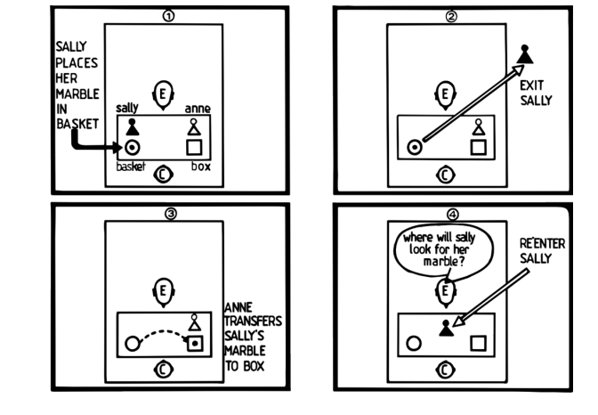
Figure 1a. This is a vignette shown during the False Belief Task. The participants must infer what Sally is thinking upon re-entering the room after Anne moves her ball from the original location.^{[5]}

Eyes Test. The Eyes Test is a more advanced ToM task designed to assess higher-level mentalizing and ToM capabilities of autistic young adults. Baron-Cohen created this task in a subsequent study in response to the criticism he received from his initial study, which stated that since some autistic individuals were able to pass the False-Belief Task once they were older, there is no true deficit in ToM.^{[6]} This subsequent study aimed to test autistic individuals’ abilities to infer the mental states and emotions of another individual. During this task, participants must look at an image of another person’s eyes, and after being given four possible options, correctly identify which emotion that person is feeling. The correct answers were determined and agreed upon by a panel of eight judges who were blind to the hypotheses of the study. Neurotypical individuals and individuals with Tourette’s syndrome were mostly correct in their assessments of each emotion, whereas autistic individuals were frequently incorrect.
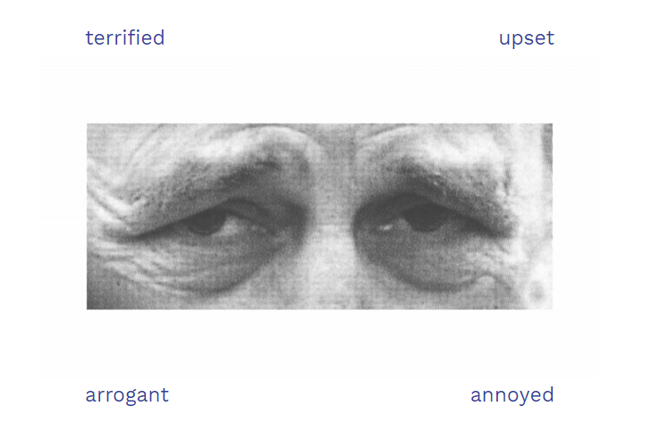
Figure 1b. This is an example of a trial in the Eyes Task. There are four total answer choices, two of which are aimed to be distractors. Looking at this image, the participants must guess which one of the choices the individual in the photo is feeling.^{[6]}

Faux Pas Task. The Faux Pas Task is another popular ToM task that assesses the ability to use the inferences about another person’s mental state when explaining or predicting future actions.^{[1]} During this task, the participant must read a short story or look at a comic that includes two characters conversing. One character makes a well-meaning comment that has an unanticipated, negative reaction from the other character. The participants’ goal is to identify this unintentionally offensive remark and describe why it was perceived negatively by the other character. Neurotypical individuals were able to accurately identify this instance and describe why it was perceived negatively, whereas the autistic participants had more difficulties with interpreting this situation.
From these results, Baron-Cohen and other researchers concluded that autistic children had a deficit in ToM and overall social cognition.
1.2 Ecological validity in traditional ToM tasks
While it is evident that there are differences in the way autistic and neurotypical individuals make social inferences, there is still little knowledge regarding what these differences are, specifically if and how autistic individuals gather and use social statistics when inferring the intentions of others. One factor that may be contributing to this gap in knowledge is the lack of ecological validity in the ToM assessment tasks. Ecological validity refers to the idea that the results from a study or experimental task can be replicated in and applied to real life. In real-world settings, social interactions are highly dynamic and require individuals to use and synthesize various pieces of data in real time. Many of the traditional ToM tasks, such as the False-Belief Task and the Faux Pas task, do not reflect real-world interactions and simply require the participants to be passive observers of an interaction. Therefore, we cannot determine how accurately these tasks measure the participants’ the abilities to perspective-take and infer mental states.^{[9]}
Additionally, researchers have been using neurotypical processes of social reasoning as the standard for competent ToM and social skills. This is evident in the way traditional ToM tasks are designed, where the standard or “correct” way of completing these tasks is derived from a neurotypical point of view. These standards lead to the conclusion that neurotypical individuals have competent ToM skills, and autistic individuals do not. However, this conclusion still does not explain if autistic individuals track and synthesize social information, and how this is done in a way that may be different from neurotypical individuals. While there is still limited knowledge related to these questions, the existing literature proposes some hypotheses that begin to explain how autistic individuals process social information, and how this differs from neurotypical individuals. These explanations focus on the ways autistic individuals use social priors, situational prior knowledge, and sensory information when making decisions.
1.3 Differences in generalization and usage of script knowledge, social priors, and sensory information

Social Priors. In the context of social situations, we also employ similar generalization techniques. Autistic and neurotypical individuals place different levels of importance on the initial impressions they develop about the other person they are interacting with. These initial impressions, or social priors, are the preliminary pieces of information gathered about another person’s mental states, intentions, and beliefs. Both autistic and neurotypical individuals are sensitive to these social priors, and use them during the initial stages of interacting with someone. However, as an interaction progresses, the intentions and mental states of another person may change several times (also referred to as the volatility of an interaction).^{[3]} Neurotypical individuals are sensitive to this volatility and will very quickly begin to use the incoming data to update their knowledge of the other person’s intentions, discarding any irrelevant prior knowledge. Conversely, autistic individuals appear to continue relying on social priors and do not as actively incorporate new social data that is presented throughout the interaction.^{[7]}
Situational Script Knowledge. Autistic individuals may also rely less on situational script knowledge than their neurotypical peers. Situational script knowledge is prior knowledge an individual has that is related to the typical sequence of actions that occur during social interactions. This prior knowledge is then generalized towards novel social situations an individual encounters. Neurotypical individuals rely on this situational script knowledge, alongside semantic knowledge and episodic memory, to contextualize the incoming information they receive during the interaction itself. This allows them to infer the mental states and intentions of others more easily, thus allowing them to succeed in the traditional ToM tasks. Autistic individuals are less inclined to utilize this background knowledge when entering novel social situations. It has been proposed that their decreased reliance on situational background knowledge may be a contributing factor to their perceived inability to infer others’ mental states and intentions.^{[1]}
Sensory Input. Autistic individuals may rely more heavily on sensory and visuo-spatial information during an interaction than neurotypical individuals. Sensory information is a necessary component to how we process social information, and is used by both neurotypical and autistic individuals.^{[1]} Neurotypical individuals typically integrate sensory and visual information with the prior situational and semantic knowledge, as well as the incoming information they receive during the interaction. Autistic individuals rely most heavily on sensory stimuli during an interaction, and make social decisions based on the sensory information they receive without considering prior knowledge or situational factors.^{[4]}
1.4 Current Study
To understand how autistic individuals track and utilize social data when inferring the intentions of others during an ongoing interaction, our study’s experimental task will be an interactive game that provides each participant with dynamic social information. During the task, the participant will guess a predetermined correct color, green or blue. They will be able to use the advice given by the two Advisors (a Helpful one and an Ambiguous one), as well as a randomly generated computer guess. The advisors will have different intentions: one will be more helpful and the other will be more misleading. Initially, both Advisors will be equally helpful, but at a fixed point in the experiment, one of the Advisors will become more unhelpful than the other. However, the participant will have no knowledge of which advisor has which intention. Based on the advisors’ advice and feedback they receive about the correctness of their guess, the participants will need to use these factors to infer the intentions each advisor has. With this inference, they will then have to determine whose advice to use or discard. We will describe possible outcomes related to how we believe the Autistic and Neurotypical participants will perform.
A1. Autistic and neurotypical participants will have similar levels of accuracy and utilize the same pieces of information to achieve this. If alternative 1 is observed, then autistic and neurotypical participants will display similar accuracy levels and abilities in distinguishing the intentions between the two advisors. We believe that in this case, both groups of participants will follow both advisors initially, determine which advisor is more helpful, and then react accordingly by decreasing the amount of times they follow the Ambiguous advisor.
A2. Autistic and neurotypical participants will have similar levels of accuracy, but they may use different pieces of information to achieve this. If alternative 2 is observed, then autistic participants may display similar levels of accuracy, but differences in levels of distinction between the intentions of the two advisors. We believe that in this instance, both groups of participants may make a distinction between the intentions of the two Advisors, however the Autistic participants may make less of a distinction than the Neurotypical participants throughout the experiment, or rely more heavily on the computer guess.
A3. Autistic and neurotypical participants will not have similar levels of accuracy or levels of distinction between the intentions of the Advisors. If alternative 3 is observed, then the autistic participants will not be as accurate as the neurotypical participants, and may also not make a distinction between the two Advisor’s intentions. We believe that if this is the case, the rate at which the autistic participants follow each Advisor will remain equal and consistent throughout the course of the experiment, regardless of whether or not they are interacting with the Helpful or Ambiguous Advisor.
II. METHODS
2.1 Participants
The participants in this study consisted of 15 Neurotypical adults and 4 Autistic adults. All participants were between the ages of 18-23, and were current undergraduate students or recent graduates of various colleges or universities across the country. The Autistic participants have received a clinical diagnosis of Autism Spectrum Disorder based on the DSM-V criteria independent of this present study. None of the participants in either group disclosed any prior diagnoses of speech or language disorders. Two of the neurotypical participants were from outside the United States. All participants spoke English proficiently. All participants gave written consent to participate in this study.
2.2 Procedures
Familiarization Task. The experimental task took place entirely over the Zoom platform, over the course of 1.5 hours. After confirming the participants met all eligibility requirements, they were asked to download a series of PowerPoints through a Box Folder. The first PowerPoint consisted of the Familiarization Task. During this task, the participants were asked to watch two videos that the advisors made. The videos contained introductory information about each advisor, and were labeled each as “Advisor 1” and “Advisor 2.” In the videos, the two Advisors introduced themselves, what they enjoyed doing for fun, and listed a few words to describe themselves, such as “creative” and “nice.” These videos were intended to help the participants gain an understanding of the types of people each Advisor was. The participants were not required to respond to the videos.
Experimental task. Afterwards, the participants were given instructions on how to properly set up their Zoom screen in preparation for the experimental task. This task was based on the game used in Diaconescu and colleagues’ (2014) study that analyzed social data tracking.^{[3]} Our experimental task was an interactive game that required the participant to correctly guess a predetermined color: green or blue. To help them make their decision, they were given two pieces of information: the advice presented by the Helpful and Ambiguous advisors, as well as a randomly generated computer guess.
Once the participants were ready to begin the experimental task, they downloaded the second PowerPoint that contained the first 45 trials of the experiment. At the beginning of the PowerPoint, there was a slide containing the instructions regarding the setup and objective of the experiment. The experimenter read the directions aloud while participants followed along. The participants were instructed to guess a hidden color in the box, either green or blue. To make their guess, they were able to use the advice from two Advisors, as well as a randomly generated computer guess. They were also informed that some of these pieces of advice were going to be more helpful than others. After the participants verbally made their guess, they were able to advance to the next slide to reveal what the correct answer was. After the participants understood the task, they received an opportunity to practice going through two example trials, one with each Advisor, in order to familiarize themselves with the procedures.

Image | Description
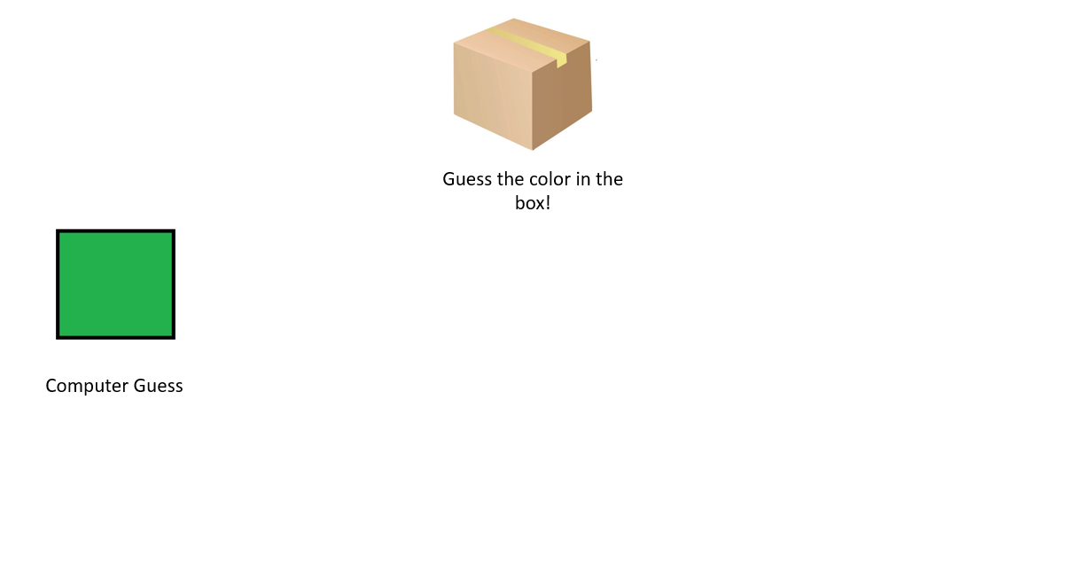 | Scene 1: There is a box with the color “hidden” inside, and the computer-generated guess on the left.
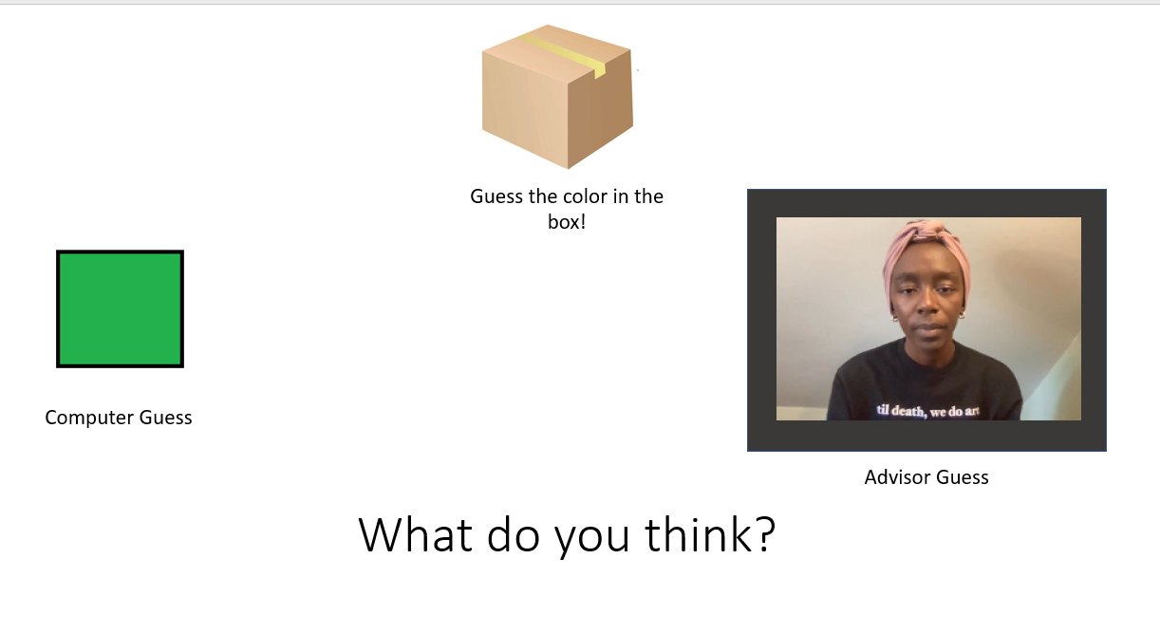 | Scene 2: On the right hand side is the video of the Advisor’s guess (e.g. “I think the correct color is blue”), and at the bottom is a text box that prompts the participants to make their guess.
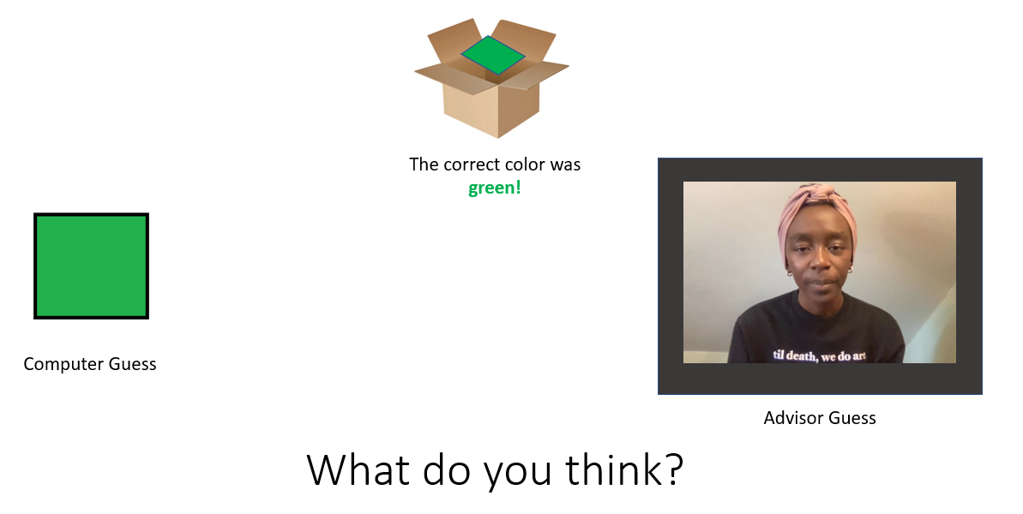 | Scene 3: At the top, the box “opens” to reveal the correct color. Underneath, it also states what the correct color was.
Figure 2a. This chart shows the sequence of images and videos of a sample trial.
The experimental task then began. For the first part of every trial, there was a brown box that appeared on the top of the screen, as well as the computer-generated guess on the left hand side. The participant could then advance to the next slide, where the Advisor’s guess would appear. The Advisor’s guess consisted of a short video with them verbally making their recommendation. The Advisors varied the way in which they phrased their recommendations for each trial, such as “I think the correct color is green” and “choose blue.” After 1.5 seconds, a text box appeared at the bottom of the slide, prompting the participant to guess the color in the box. After the participants verbally respond with their guess, the next slide informs them of the correct answer by “opening” up the box and displaying the correct answer. The participants then completed these trials throughout the course of the experiment.
Post-Experimental Surveys. At the end of the experiment, the participants were administered three questionnaires. This allowed us to assess the participants’ own perception regarding their perspective-taking abilities. One of the questionnaires was an original survey, asking the participants to reflect on their abilities and confidence levels when having to predict the Advisors’ intentions. The second questionnaire was the Autism Quotient (AQ), a subjective questionnaire that assessed the presence of autistic-like traits. The third questionnaire was a standardized survey called the Social Problem-Solving Inventory (SPSI) ^{[8]}, which served a similar purpose of gauging the participant’s insight regarding their own social problem-solving skills.
2.3 Materials
Variables. The independent variables for this task were the Helpful and Ambiguous advisors, and the computer-generated guess. The dependent variables were the number of correct responses each participant had at the end of the experiment, as well as their ability to distinguish between the intentions of the two advisors.
Manipulation. There were two versions of the experiment, one with each Advisor being the Helpful and Ambiguous Advisor. Seven of the Neurotypical participants received Version 1 (“Advisor 1” was Helpful) and eight received Version 2 (“Advisor 2” was Helpful). For the Autistic group, two participants received Version 1 and the other two received Version 2.
The materials for each part of the experiment were displayed in three separate PowerPoint presentations. The first PowerPoint contained the stimuli for the familiarization task. The second PowerPoint contained the first 45 trials of the experiment, and the third PowerPoint contained the last 45 trials. Additionally, the randomly generated computer guess was given using a green or blue colored square.
There was a total of 90 trials, which were split into 3 different phases. Each phase contained six blocks, with every block containing five trials. The Helpful and Ambiguous advisors alternated with each other and provided advice for three blocks of every phase. Phase I (30 trials) had both advisors acting with helpful intentions, regardless of their role. During this period, the Advisors were both 80% correct (i.e. 4 out of every 5 trials are correct). Phase II (30 trials) was the experimental manipulation stage, where the Ambiguous Advisor began to provide mostly incorrect advice while the helpful advisor continued to provide helpful information. The Ambiguous Advisor provided advice with 20% accuracy (i.e. 1 out of every 5 trials was correct), and the Helpful Advisor continued to provide advice with 80% accuracy. Phase III (30 trials), the final phase, was designed to give the participant an opportunity to continue adjusting their strategy based on the knowledge they gathered about the intentions of each advisor. The proportions in which the Advisors were helpful or unhelpful remained the same from the previous phase. The computer generated guess was 60% accurate throughout all three phases.
III. RESULTS
This task analyzed autistic and neurotypical individual’s decisions when presented with dynamic information about a communicative partner’s intentions. To provide insight into this question, we analyzed the performance of neurotypical and autistic individuals on this task using the R programming software. For each analysis, the independent variables were the Advisor condition and the Phase number (I, II or III), and the dependent variables were the accuracy levels of the participants and the responses they gave. Across all analyses, we calculated our primary dependent measure by scoring each participants’ responses per trial with either a 1 or a 0, depending on the measure we were seeking.
We will implement our analyses in two parts. First, we will look at the preference the participants had for either Advisor group across all three Phases. Next, we will look at the participant’s accuracy levels on the task overall.
3.1 Preference
We completed an analysis where the dependent variable was the preference the participants showed between the Helpful and Ambiguous Advisors. To calculate this preference, we assigned a value of 1 for every trial the participant’s responses agreed with the Advisor, and a value of 0 for every trial the participant’s responses disagreed. We took the average of these values for every participant, and then averaged those values to generate the group patterns. Figure 3a below shows the distribution of preference for the Neurotypical participants.
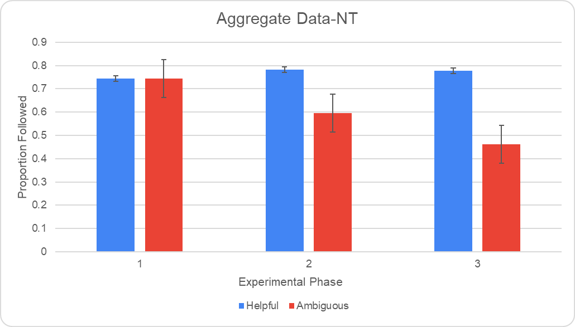
Figure 3a. This graph shows the levels at which the neurotypical participants distinguished between the two Advisors. They preferred the Helpful Advisor overall, especially in Phase II and III.
In general, the Neurotypical participants make a distinction between the Advisor’s intentions, showing preference for the Helpful Advisor. During Phase I, the Neurotypical participants did not make any distinctions between the Advisors, as both were followed about 74% of the time. During Phase II, we detected a decrease in following of the Ambiguous Advisor to 59%, and a slight increase in the following of the Helpful Advisor to 78%. Finally, in Phase III, this distinction continued to increase, with the Ambiguous Advisor’s followings decreasing to 46%, while the Helpful Advisor remained 78%.
Figure 3b illustrates the preference patterns for the Autistic participants.
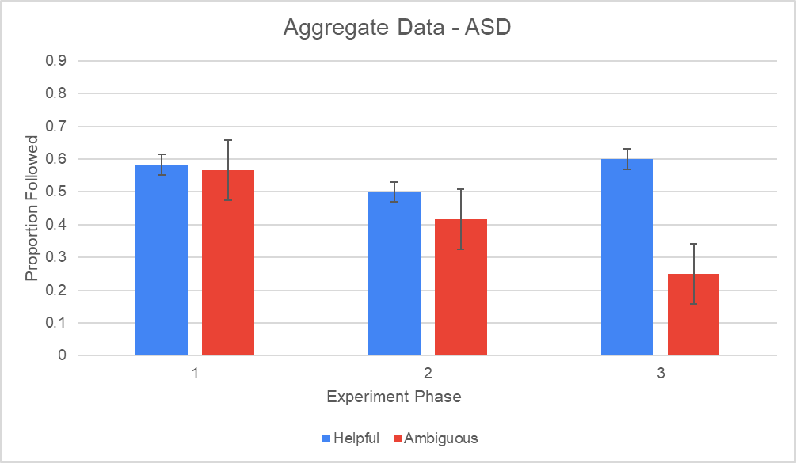
Figure 3b. This graph shows the levels at which the autistic participants distinguished between the two Advisors. Similar to the neurotypical participants, the autistic participants preferred the Helpful Advisor overall, especially in Phase II and III.
In general, we see that Autistic participants also make a distinction between the two Advisors. During Phase I, Autistic participants follow the Helpful and Ambiguous Advisors at similar rates (58% and 57%, respectively). During Phase II, the participants followed both Advisors at a decreased rate, following the Helpful Advisor 50% and the Ambiguous Advisor 42%. Finally, during Phase III, the participants increased the rate at which they followed the Helpful Advisor to 60%, while the Ambiguous Advisor was followed at only 25%.
We ran a 3-way ANOVA and confirmed there was a significant effect of Advisor condition [F(1,17= 12.98, p = .002], as both participant groups favored the Helpful Advisor over the Ambiguous Advisor. There was also significant Advisor and Phase interaction [F(2,34) = 6.55, p = .004], showing that during Phases II and III, the Ambiguous Advisor was followed less than the Helpful Advisor for everyone, a pattern that drives this interaction. Finally, we found a main effect of diagnosis, which indicates that the Neurotypical participants preferred the Advisors in general, more than the Autistic participants [F(1,17) = 6.49, p = .02].
We also created an individual differences graph that showed the variation in Advisor preference for both groups (see Figure 3c). The solid bars indicate the group average and highlights the variability of preferences among each participant. The Autistic participant group shows a larger degree of variability due to the low sample size.

Figure 3c. This is the individual differences graph for Advisor preference. The top graph shows the differences for the Neurotypical group, and the bottom graph shows the differences for the Autistic group.

3.2 Accuracy
The overall accuracy of the two groups were very similar. The Neurotypical participants were 57% accurate, while the Autistic participants were 60% accurate. To confirm this overall accuracy, we ran a 3-way ANOVA and found a non-effect of group on the level of accuracy [F(1,17) = 0.14 p = .71], indicating that both participant groups were accurate at similar levels.
However, the two groups employed different strategies to achieve this level of accuracy. To illustrate this, we broke down the levels of accuracy the participants achieved with either of the Advisor conditions. Figure 3d shows the levels of accuracy the Neurotypical participants had with either the Helpful and Ambiguous Advisors.
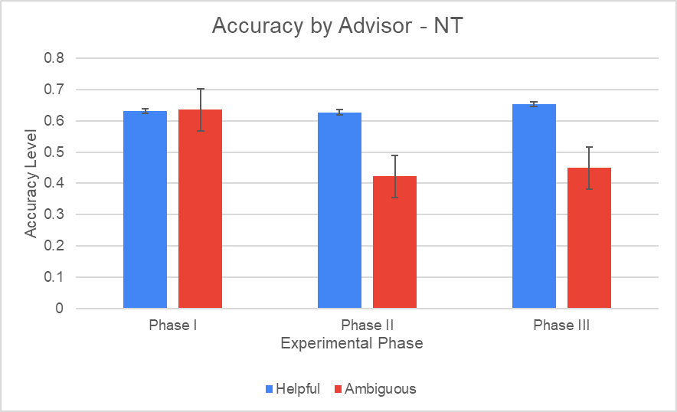
Figure 3d. This graph shows the level of accuracy the neurotypical participants had with each Advisor. Overall, they were more accurate when they followed the Helpful Advisor.
In Phase I, we do not detect a difference in levels of accuracy between the two Advisors, as they are accurate while following both. In Phase II and III, we see that the Neurotypical participants are less accurate with the Ambiguous Advisors than the Helpful ones. This is caused by the high levels at which the Neurotypical participants favor the Advisors over the computer.
Figure 3e shows the levels of accuracy the Autistic participants had with either of the Advisors.
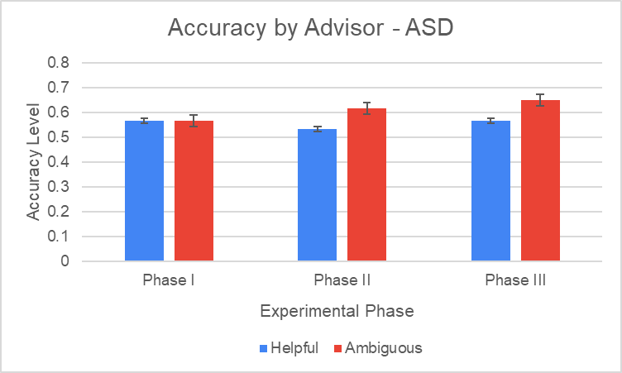
Figure 3e. This graph shows the level of accuracy the neurotypical participants had with each Advisor. Overall, they had similar levels of accuracy with both Advisors.
During all three Phases, the participants were equally accurate with both Advisors, and were slightly more accurate during the Ambiguous condition. Since Autistic participants generally disliked the Advisors in general, we can see that the less they followed the Advisors, especially in Phases II and III, the more accurate they were.
To confirm this data pattern, we ran another 3-way ANOVA. We found an Advisor and Group interaction [F(1,17) = 6.19, p = .02]. There was a large effect of Advisor condition on the Neurotypical participants since they were more accurate with the Helpful Advisor, while there was no effect of Advisor condition on the Autistic participants since they were equally accurate with either Advisor. This interaction was most prominent in Phase II, and still present but less prominent in Phase III.
We once again generated an individual differences graph that looked at the variation in accuracy in the two groups (see Figure 3f). There were also larger average bars for the autistic group, again due to the small sample size.
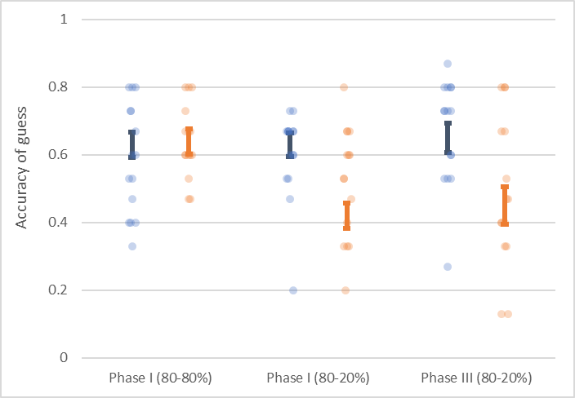
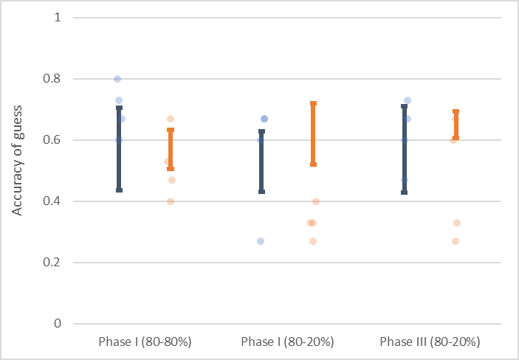
Figure 3f. This is the individual differences graph for accuracy. The top graph shows the differences for the Neurotypical group, and the bottom graph shows the differences for the Autistic group.

IV. DISCUSSION
4.1 General Analysis
This study looked at the social decisions that autistic and neurotypical adults made when presented with dynamic social information. To do this, we designed an experimental task that engaged the participants in a real-time interaction through a guessing game. For each trial, the participants had to guess a hidden color in a box, using the input of a Helpful and Ambiguous advisor, as well as a randomly-generated computer guess. Results indicated that both Neurotypical and Autistic participants performed at similar levels of accuracy in determining the correct color, and were able to distinguish between the intentions of the two Advisors when asked directly through the surveys. It was also observed that both groups used different pieces of information to complete the task. Neurotypical participants preferred the Advisor over the computer, and then made a distinction between the intentions and followed the Helpful Advisor more frequently. Autistic participants did not prefer the Advisor over the computer, and did not appear to make as clear of a distinction between the intentions of the Advisors.
The findings of this study may provide additional insight into the way autistic individuals gather and utilize social information. Primarily, these results begin to alter our understanding of the communicative differences between autistic and neurotypical individuals. Previous emotional and social cognitive tasks administered to autistic individuals indicated that autistic individuals were incapable of perceiving various social cues needed to engage in social interactions. The results from these tasks indicate that autistic individuals do make distinctions between the two Advisors’ intentions, and react accordingly.
Additionally, these results may indicate that autistic and neurotypical individuals utilize different pieces of information when engaging in social interactions. For instance, one of these pieces of information is trust. When we engage in social situations, our inferences about other people’s intentions can be based on how much we trust or do not trust an individual or group of individuals. Over time, our general levels of trust are based on helpful and misleading interactions we’ve had with others. It may be possible, then, that the autistic participants did not trust the Advisors as much as the neurotypical participants did due to having lower levels of overall trust in people.^{[10]} This may be an important factor to consider when analyzing how autistic individuals react in social situations.
This experimental task was also higher in ecological validity and more representative of social interactions. This task was able to measure more accurately how individuals react to and use pieces of social data that change over time. While previous experimental tasks were static and focused on measuring perception and cognition, our task focused more heavily on cognition and action. In addition, the subjective surveys that asked the participants directly about their reactions to and opinions of various pieces of data allowed us to paint a more complete picture of what participants did with the real-time information that was presented to them.
One limitation of this study is the sample size for the two participant groups, specifically the Autistic group. Administering this study on more participants for both groups may provide more comprehensive and accurate results regarding the effects of dynamic social information on one’s ability to infer other people’s intentions. Another limitation of this study was the scripted nature of the task. While it did more closely mimic an interaction with dynamic pieces of social information, the participants still did not physically interact with another person in real-time. Finally, this study tested only a subset of the autistic population (young adult autistic individuals who are attending college), and did not reflect the racial, cultural or gender diversity representative of the general population.
Future studies may address these limitations by examining what types of information autistic individuals use during an interaction. This may be done by implementing experimental tasks that allow for an autistic individual to interact with another person in real-time, or ones that include autistic participants interacting with each other. Additionally, the administration of questionnaires or surveys that require the participants to reflect on their own social skills may provide additional insight about an individual’s thought processes that are not reflected in the raw data. Finally, future studies may test a broader range of individuals who fall under the autism umbrella, as well as those who come from various cultural, social and linguistic backgrounds. These types of adjustments may help develop a more comprehensive profile of the communicative abilities autistic individuals have.
The findings from these studies can also have implications for clinical settings. Social skills interventions may be updated to enhance and build on the skills autistic individuals currently have, instead of asking them to simply mimic neurotypical forms of interaction. By developing therapy that is more focused on abilities rather than deficits, it may be more effective in facilitating productive interactions between autistic individuals and their peers. This perspective may also allow clinicians to inform parents, caregivers, teachers, and other neurotypical peers about some of the differences in the way autistic individuals may process and respond to social situations. Since communication is a two-way process, providing neurotypical individuals with this insight can also allow them to understand how to better adjust their expectations or behavior to successfully interact with autistic individuals.

References

- Zalla, T., Korman, J. (2018), Prior knowledge, episodic control and theory of mind in Autism: Toward an integrative account of social cognition. Frontiers in Psychology, 9 (Sep). Doi: 10.3389/fpsyg.2018.00752
- Lai, M, Lombardo, M., et. al (2014). Autism. The Lancet, 2014, pp. 896-910. Doi: 10.1016/S0140-6736(13)61539-1
- Diaconescu, A., Mathys, C., et. al (2014). Inferring on the Intentions of Others by Hierarchical Bayesian Learning. PLoS Computational Biology, 10(9). Doi: 10.1371/journal.pcbi.1003810
- Chambon, V., Farrer, C., et. al (2017). Reduced sensitivity to social priors during action prediction in adults with autism spectrum disorders. Cognition, Vol 160, pp. 17-26. Doi: 10.1016/j.cognition.2016.12.005
- Baron-Cohen, S., Leslie, A., et. al (1985). Does the autistic child have a "theory of mind"? Cognition, 21(1), pp. 37-46. Doi: https://doi.org/10.1016/0010-0277(85)90022-8
- Baron-Cohen, S., Jolliffe, T., et. al (1997). Another Advanced Test of Theory of Mind: Evidence from Very High Functioning Adults with Autism or Asperger Syndrome. J Child Psychol Psychiatry, 38(7), pp. 813-822. Doi: 10.1111/j.1469-7610.1997.tb01599.x
- Maurer, C., Chambon, V., et. al (2018). The influence of prior reputation and reciprocity on dynamic trust-building in adults with and without autism spectrum disorder. Cognition, Vol. 172, pp. 1-10. Doi: 10.1016/j.cognition.2017.11.007
- D’Zurilla, T., Nezu, A., et. Al (2002). The Social Problem-Solving Inventory-Revised (SPSI-R). Multi-Health Systems.
- Quesque, F., Rosetti, Y. (2020). What Do Theory-of-Mind Tasks Actually Measure? Theory and Practice. Perspectives on Psychological Science, 15(2), pp. 384-396. Doi: 10.1177/1745691619896607
- Landrum A., Eaves, B., et. al (2014). Learning to trust and trusting to learn: a theoretical framework. Trends Cogn Sci. 19(3), pp 109-11. doi: 10.1016/j.tics.2014.12.007

