Prince George’s County
Food Scraps Composting Pilot Program

Prepared by: Brandt Anzalone, Patrick Bevan, Clyde Boyer, Elliott Brody, Julius Cochran, Yared Demissie, Jonathan Gorczyca, Benjamin Grove, Chaya Johnson, Ingride Ngaku, Bianca Reginauld, Corey Sackalosky, Jason Schneider, Charis Smith, Samuel Soon, Caroline Swetonic, Christopher Tang

Under the supervision of Nicole Mogul

Course #: CPSP249E
The University of Maryland – College Park
Spring 2018
PALS - Partnership for Action Learning in Sustainability
An initiative of the National Center for Smart Growth



Gerrit Knaap, NCSG Executive Director
Uri Avin, PALS Director

Contents

Introduction

Design Project 1
Recommendations

Design Project 2
Recommendations

Design Project 3
Recommendations

Design Project 4
Recommendations

Overall Recommendations

Synthesis

Introduction
This project’s goal was to construct innovative ways to promote composting through the Prince George’s County Composting Pilot Program, working with the County’s project manager Denice Curry. Throughout this semester, we split the investigations into four different Design Projects. In these Design Projects, we cultivated our interviewing skills, learning how to note details and analyze body language and expressions, and used these skills to help us design prototypes that might motivate various groups of people to compost.

This course not only involved learning about composting and sustainability, but also about ourselves; the lessons learned can continue to be cultivated throughout our lives and help us in future endeavors.

Design Project 1
The first Design Project involved cultivating our interview skills by becoming more introspective and learning to analyze people and their mannerisms. This involved watching people and using audio files to guide us through reflecting on the details surrounding a person and their body language.

Almost all of us were uncomfortable with this idea, as it moved us outside our comfort zones to analyze people in a way we’d never done before. We also used empathy maps to analyze each response to a question and separated the answers into one of four categories: See, Think, Feel, and Say/Do. Using these maps made it easy to see where we were lacking and so change questions’ wording to get more detailed answers. This allowed us to develop more thought provoking questions and get more detailed and reflective answers from interviewees by analyzing their body language.

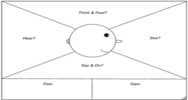
An empathy map used to analyze interview answers

The food audits were useful in understanding how much food is wasted in every meal. Leftovers were sorted into food groups—fruits, vegetables, proteins, dairy, etc.—and when clearing off a single plate it didn’t seem like much waste. But at the end of the day, when the buckets were weighed, we could see that up to 10 pounds of just vegetables were wasted in a day.

This activity made us more conscious about how much food is wasted unknowingly. A video about preventing food waste mentioned that food waste was the “world’s dumbest problem,” which is true in the sense that it can be prevented by getting food to those who need it. Even food scraps can have a purpose by being made into compost.

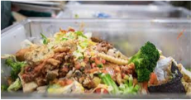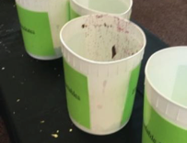
The food group buckets at a food audit

Recommendations
Based on this design project, we recommend that the County observe people’s habits to gain familiarity with how they treat waste. Ideally this would take place in people’s homes, but if that’s not possible, perhaps in a public place where composting is available. The County should also interview residents (both those signed up for the composting pilot and those who aren’t) to learn residents’ attitudes about food waste, composting, recycling and trash, not to teach residents about the program. An empathy map would help the County derive the deeper meanings and feelings behind residents’ responses. What people think and what they say are often two different things, and responses can yield deeper understandings about what people value.

Design Project 2
The second design project involved learning more about composting by visiting the Terp Farm and the Western Branch composting facility. The Terp Farm is run by the Department of Dining Services and the College of Agriculture and Natural Resources, and it produces a lot of food that ends up in UMD diners.

While the Terp Farm produces its own compost, it can’t be used to grow food because it hasn’t been certified to meet necessary standards. Thus, the Farm gets compost from the Western Branch. But this compost isn’t the best because the soil is very fine and doesn’t have many aggregates, unlike the compost made at the Terp Farm. Organic matter in compost is made by raising the temperature to 180°C so organisms can feed and keep the temperature high.

A tour of the Western Branch composting facility was an eye-opening experience. While we knew the basics—that it’s primarily about reusing waste and using the natural chemical processes to make the soil fertile and more nutritious—it was amazing to see the huge piles of dirt and the actual process.

It’s interesting to note that there is little competition in compost production, and this facility has a monopoly on practically all the compost produced in the Prince George’s County area, which could provide a steady income stream.

Overall, both these trips were unique experiences that helped us understand why composting is important and its effects on the County as a whole. The visits, and learning from those who create compost and shared their experiences, showed the intricacies of creating compost exactly to standard, and stressed how much it benefits the County.

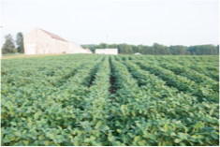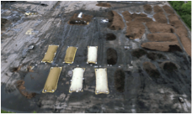
Terp Farm Western Branch

After the field trips, we prepared our interview questions for those participating in the Capitol Heights composting pilot program. Knocking on doors to find interviewees wasn’t too successful; very few people were willing to be interviewed. So, we headed to a local mall, and while people there weren’t originally part of our demographic, they provided valuable insight into why people may choose to not compost.

The biggest takeaway from this experience was that it’s okay to hear “No” multiple times. This lesson can be applied in our lives, such as when applying for jobs and internships, because we’ve all gone through the worst thing that could happen, putting yourself out there and being turned down. Drawing from this experience will be beneficial and allow us to be more open to taking risks.
Recommendations
In this design project we learned to fail. Something that the County might take from this lesson is that failure is fine, as long as you learn from it. It is difficult to make other recommendations for the County based on this, but it is a general approach to new situations in terms of trying something, just to get the experience of picking yourself back up again.

Design Project 3
This project was to learn about business models and crafting a prototype that would appeal to a certain target group, convincing them to compost. We studied various business models and products, including a lamp for those who can’t afford a light at night. We learned that the light had to be recreated many times to meet the wants and needs of the people it was to benefit, which meant multiple brainstorming and interview sessions to learn how they would use the light. This showed us that a prototype must truly benefit the consumer and must be revised many times before a final product is developed. It showcased the importance of reflexive engineering.

We also studied the case of a company that posted a website for a product that didn’t actually exist—a software to teach a foreign language. When people clicked through, they found a survey with questions about what they were looking for in a product. This seemed like a really useful way to gather feedback before moving too far along in creating a product.

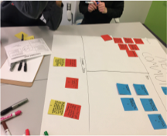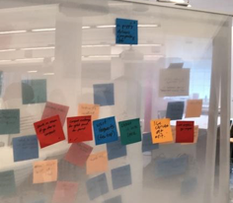
A student-created business model to help design the first prototypes

In teams, the class picked different target groups, such as college students living in apartments or middle-class families with small children, and developed questions specific to understanding each target group’s wants and needs. In analyzing the interview responses, we prioritized wants and needs based on collected data and then brainstormed ideas that might convince the target groups to compost.
For example, for college students living in apartments, we decided students would be motivated to compost if it weren’t confusing and time consuming. One motivator might be to give out prizes to the floor that composted the most. After interviewing middle-class families with small children, the biggest composting issue was infrequent compost pick-ups and the resulting smell. A proposed idea was to have families drop off compost at the grocery store, integrating composting into their day.

After crafting prototypes, each team tested them on their target group. While some people liked the prototypes and the ideas they represented, others offered criticism and ideas for improvements, and some just didn’t like the ideas at all. It was difficult to take criticism and incorporate it into the prototypes. We had worked hard on the ideas and spent time and effort creating what we thought were perfect solutions. Overall, one of the main takeaways from this project was what we learned from the business model. If the customers don’t like the idea, it’s not good enough, no matter what the creators think.

Recommendations
The County should be sure to testing ideas, just for the purpose of getting people to talk about an idea. It doesn’t have to be a final concept for this method to work; it just has to elicit some kind of reaction.

Also, before committing to an approach, the County might try putting together a rudimentary mock-up that conveys a proposal’s general sense. Testing it with target groups could generate more insight than interviews, because people have an actual object to interact with. This is an important part of design because it allows testing before spending money, and is also a way to collect customer data so you can design a project that people really want.

Design Project 4
After creating a strong prototype, we brainstormed the wildest ideas possible to motivate people to compost. This helped broaden our minds to new ideas and encouraged a different and creative thinking process. We analyzed the various components of the idea we all liked and tried to incorporate those components into a feasible plan. The class generated many creative ideas to encourage composting, including an obstacle course based on the show “Wipeout.”

We followed the same process as earlier, crafting the ideas and interviewing various people. We discovered that a lot of people were concerned about how the idea would be implemented and the details behind it, which was something we hadn’t focused on. Thus, it was difficult to determine if people actually liked the idea. Overall, this brainstorming process was a unique experience that changed our ways of approaching a problem and showed that even the wildest ideas have merit.

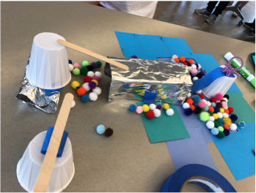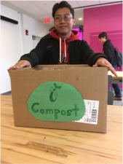
Design Project 4 Prototypes

Recommendations
In this part of the course we learned to let go of feasibility when developing innovative ideas. It doesn’t matter that an idea won’t be implemented because it’s physically or financially impossible. What matters is pursuing the idea, having fun, and developing ideas without judging them. The process might not make sense and might seem pointless, but it has real benefit in creating something new and useful.

Overall Recommendations
From Design Projects 1 and 2 we learned that interviewing people is an important part of understanding other perspectives. By cultivating interviewing skills and the ability to analyze, we garnered information from what a person might not be saying, which helped determine the beliefs and ideals that influence a person’s opinion. However, we also realized that while it can be difficult to obtain interviews, each interview provides valuable information.

Another lesson was understanding how much food is wasted every day and how simple it would be to prevent food waste. It brings to light the importance of solving this problem, which many people don’t understand because they lack access to this information. Thus, we believe that the County should bring more awareness to the topic of food waste and sustainability by hosting events geared toward how much food is wasted, including giving talks and interactive activities on how composting can help combat food waste. These programs would be especially important at schools, to educate the next generation.

Once people are more informed about composting, the County should interview as many people as possible who do and don’t compost to understand their motivations. We suggest using empathy maps to help analyze responses to garner maximum information. It would be helpful to know if there are similar reasons for actions and if there are differences that could be overcome. For example, is composting a matter of education, awareness, or convenience. It’s also important to meet regularly with stakeholder groups, such as those in charge of composting facilities and farms, to determine what is feasible and to shape solutions with multiple groups working together.

From Design Projects 3 and 4, we learned how to test preliminary ideas for feedback and feasibility. If the products and ideas we designed to encourage composting met resistance, we designed new ones, even if we believed our idea or product was great. Thus, we advise the County to implement more composting pilot programs in different areas of the County to get more feedback faster on different ideas. Each pilot program should be directed to a specific user group and their needs. For example, the Capital Heights composting program encourages composting with regular household pick-ups, but in a different neighborhood allowing people dispose of their compost at a local grocery store, would provide different feedback and may have different results in motivating people to compost.

Other ideas that could be implemented are a composting rewards program, that would reward people for how much they compost. Or, composting bins could be altered to make it easy for children to compost, which may promote composting among families.

Finally, the last takeaway would be that every idea is useful, even if it’s not feasible; it can inspire new ideas, reactions, and prototypes. Pursuing multiple ideas, each improved by feedback from pilot programs, would help the County create the most inclusive composting program that would provide maximum benefit for the County and its people.

Synthesis
Throughout the semester, we consistently shared our findings, experiences, and thoughts about the activities we did. Open discussion was always encouraged and by sharing our thoughts and ideas, we were able to understand new perspectives and contemplate new ideas.

Most class members learned a lot about themselves and increased their confidence. We have all come a long way from barely being able to conduct an interview to being able to hold a 15-minute conversation with a stranger. There has been a lot of personal growth throughout this semester and this course has taught us as much about ourselves as it did about sustainability.

One takeaway is that when creating a consumer product, their opinions should be incorporated throughout the design and not just at the end. It is important to keep the customers’ wants and needs in mind, otherwise the product will most likely fail, which is why reflexive engineering is important.

Another takeaway was being able to interact comfortably with others, especially strangers. Putting a pilot program into action requires collaboration with a lot of people, most of whom you don’t know. If there isn’t interaction between the key groups, it won’t work out. Being able to express ideas in clearly and coherently to others will create successful interactions.

Finally, we learned the importance of being creative. Initially, and for some team members, this was difficult because courses often require students to follow guidelines for every project. However, after the first projects, it became easier to understand that not everyone had to have the same format or results, and to truly have fun creating the projects. Overall, this class taught us about composting as well as ourselves, and that we’ve all gained skills from this class that will benefit us in future experiences, careers, and endeavors.

