ABSTRACT
Title of Document:

Effect of Addiction Modeling Reinforcement Schedules on Delay Discounting

Shir Boger, Luqman Croal-Abrahams, Milad Emamian, Spencer Ollayos, Avi Packer, Jennifer Rottenberg, Sina Shahamatdar, Casey Smith, Jigisha Srivastav, David Teitelbaum, Louis Wolff
Directed By:

Dr. Richard Yi, Center for Addictions,
Personality, and Emotion Research
Elevated delay discounting, in which delayed rewards quickly lose value as a function of time, is associated with substance use and abuse. Currently, the direction of causation is unclear: while some research indicates that elevated delay discounting leads to future substance use, it is also possible that chronic substance use and specifically the rate of reinforcement associated with drug use, leads to elevated delay discounting. This project aims to examine the latter possibility. 47 participants completed ten 30-minute daily sessions of a visual attention task, and were reinforced at a rate intended to model drug use (fixed ratio 1) or drug abstinence (fixed ratio 10). Baseline and post-training rates of delay discounting were assessed for hypothetical $50 and $1000. Area under the curve of the indifference points as a function of delay was calculated. A greater area under the curve suggests more self-control, whereas a lower value represents more impulsiveness. Results at the monetary value of both $50 and $1000 showed increased impulsivity in relation to the control for both the FR1 and FR10 groups indicating that the two schedules may both model drug use.

Effect of Addiction Modeling Reinforcement Schedules on Delay Discounting
Shir Boger, Luqman Croal-Abrams, Milad Emamian, Spencer Ollayos, Avi Packer, Jennifer Rottenberg, Sina Shahamatdar, Casey Smith, Jigisha Srivastav, David Teitelbaum, Louis Wolff
Mentor: Dr. Richard Yi
Thesis submitted in partial fulfillment of the requirements of the Gemstone Program, University of Maryland, 2014

Advisory Committee:
Dr. Richard Yi, University of Maryland, Mentor
Dr. Will Aklin
Dr. Redonna Chandler
Dr. David Haaga
Dr. Rebecca Hamilton
Dr. Carl Lejuez
Dr. Joydeep Srivastava

© Copyright by:
Shir Boger, Luqman Croal-Abrams, Milad Emamian, Spencer Ollayos, Avi Packer, Jennifer Rottenberg, Sina Shahamatdar, Casey Smith, Jigisha Srivastav, David Teitelbaum, Louis Wolff

2014

Acknowledgements
We would like to thank our mentor Dr. Richard Yi for his continuous support and guidance. We would also like to thank Ms. Allison Stuppy for helping us coordinate our research activities, as well as CAPER for donating their time and space in support of our research efforts. We would like to thank our librarian Mrs. Gerri Foudy for aiding our literature review. Finally, we would like to thank the Gemstone staff for providing additional support throughout our time in the program.
Table of Contents
Acknowledgements………………………………………………………………………..ii
Table of Contents…………………………………………………………………………iii
List of Figures……………………………………………………………………………..v
List of Tables……………………………………………………………………………..vi
1 - Introduction……………………………………………………………………………1
1.a – Overall Problem of Substance Abuse………………………………………..1
1.a.i – Background………………………………………………………...1
1.a.ii – Effects on Individuals……………………………………………..2
1.a.iii – Effects on Society……………….………………………………..5
1.b – Previous Attempts to Rectify the Situation…………………………………..8
1.b.i – Stricter Laws……………………………………………………….8
1.b.ii – Pharmacological Intervention……………………………………11
1.b.iii – Non-Drug-Based Treatment…………………………………….12
1.c – Impulsivity and Addictive Substances……………………………………..16
1.c.i – Background……………………………………………………….16
1.c.ii – Psychology of Impulsivity……………………………………….18
1.c.iii – Link to Drug Addiction…………………………………………19
1.c.iv – Reinforcement and Drug Administration………………………..21
1.c.v – Hypothesis………………………………………………………..27
2 – Methodology…………………………………………………………………………29
2.a – Participants………………………………………………………………...29
2.b – Materials…………………………………………………………………...29
2.b.i – Pre- and Post-Training Assessments……………………………..29
2.b.ii – Training Task ……………………………………………………32
2.c – Procedures…………………………………………………………………34
2.d – Statistical Analysis…………………………………………………………37
2.d.i – Program………….………………………………………………..37
2.d.ii – Formatting………….……………………………………………38
2.d.iii – Correlations………..……………………………………………40
2.d.iv – Covariates………………………………………………………40
2.d.v – Main Analysis……………………………………………………41
3 – Results and Data Analysis …………………………………………………………42
3.a – Introduction and Validation of Measures…………………………………42
3.a.i – Overview …………………………………………………………42
3.a.ii – Correlations between Measures of Delay Discounting………42
3.a.iii – Testing for Confounding Variables……………………………43
3.b – Hypothesis Testing ……………………………………………………57
3.b.i – Tests Using LNK……………………………………………… 57
3.b.ii – Tests Using AUC………………………………………………62
3.c – Secondary Measures…………………………………………………… 67
3.c.i – Correlations with Delay Discounting Measures…………………67
3.c.ii – Correlations among Other Secondary Measures…………………71
3.c.iii – Validation ANOVA for Qualitative Substance Abuse………….72
3.c.iv – Validation Chi-Square for Qualitative Substance Abuse ……….73
4 – Discussion……………………………………………………………………………76
4.a – Interpretation of Results……………………………………………………76
4.b – Secondary results - Correlational matrix………………...………..………82
4.c – Weakness, Limitations, and Future Directions………….…………………83
4.d – Conclusion…………………………………………………………………85
Appendix A ……………………………………………………………………………87
Appendix B ……………………………………………………………………………88
Appendix C ……………………………………………………………………………89
Appendix D ……………………………………………………………………………90
Appendix E ……………………………………………………………………………91
Appendix F ……………………………………………………………………………92
Appendix G ……………………………………………………………………………94
Appendix H ……………………………………………………………………………95
Appendix I ……………………………………………………………………………96
Appendix J.……………………………………………………………………………100
Appendix K……………………………………………………………………………101
Appendix L……………………………………………………………………………102
Appendix M……………………………………………………………………………103
References………………………………………………………………………………108

List of Figures
Figure 1. Ambiguous connection between impulsivity and drug use……………………22
Figure 2. Model-free calculation of delay discounting data……………….…………….42
Figure 3. Interaction effect of group assignment by two-week interval. ………………..61
Figure 4. Reformulation of the interaction effect of group assignment by two-week interval…………………………………………………………………….……………..62
Figure 5. Main effect of reward size on AUC……..…………………………………….63
Figure 6. Main effect of two-week interval on AUC……………………………………64
Figure 7. Interaction of group assignment with two-week interval………….…………..65
Figure 8. Reformulation of the interaction of group assignment with two-week interval…. ……………………………………………………………………………………………66
List of Tables
Table 1. Example Indifference Points……………………………………………………39
Table 2. Pearson’s r Correlation Matrix for Pretest Measures of Delay Discounting…...43
Table 3. Distribution of Cigarette Smokers and Nonsmokers by Group…………..…44
Table 4. Distribution of Alcohol Use Among Groups………………………...…………44
Table 5. Distribution of Marijuana Use Among Groups……………………...…………45
Table 6. Distribution of Gender Among Groups…………………..……………………46
Table 7. Distribution of Academic Rank Among Groups……………..………………47
Table 8. Distribution of Ethnicity Among Groups………………...……………………48
Table 9. Age Distributions Across Groups…………………………...…………………49
Table 10. Distribution of Family Income Among Groups………………………………50
Table 11. Distribution of Undergraduate GPA Among Groups……...…………………50
Table 12. SAT Score Distributions by Group…………………………………………..51
Table 13. Distributions of Quantitative Substance Use Among Groups………………53
Table 14. Group Distributions of BIS Scores………………………………………..…55
Table 15. Group Distributions of Eysenck Personality Scale Scores…………..………57
Table 16. Distribution of LNK by Reward Size…………………………..……………62
Table 17. Distribution Statistics for AUC………………………………..………………67
Table 18. Correlations Between Age and Delay Discounting Measures on Pre-Assessment………………………………………………………………………………68
Table 19. Correlation Between Family Income and Delay Discounting Measures on Pre-Assessment…………………….……………………………………………..…………68
Table 20. Correlation Between Measures of Academic Performance and Pretest Measures of Delay Discounting…………………………...………………………………………69
Table 21. Correlations Between Self-Reported Substance Use Frequencies and Pretest Delay Discounting Measures…………………………………………………….………70
Table 22. Correlations Between Pretest Delay Discounting Measures and Alternative Pretest Measures of Impulsivity……………………………………………………….…71
Table 23. Relative Distribution of Cigarette and Alcohol Use…………………..………74
Table 24. Relative Distribution of Cigarette and Marijuana Use…….…………………74
Table 25. Relative Distribution of Alcohol and Marijuana Use……....…………………75

1. Introduction
a. Overall Problem of Substance Abuse
i. Background
Approximately 23 million people in America alone are believed to suffer from some type of substance abuse (National Institute on Drug Abuse [NIDA], 2009), which is characterized as a pattern of drug use which causes significant problems. The effects of substance abuse are extensive and include the failure to attend work or school, poor judgment in dangerous situations, legal problems, and interference in friendship and family relationships. As a medically recognized brain disorder, substance abuse specifically refers to using illicit drugs like marijuana, cocaine, heroin, and methamphetamines as well as legal ones like alcohol, nicotine, and prescription drugs (“Substance abuse/chemical dependency,” 2014). Substance abuse presents a serious challenge both within America and abroad. Worldwide, some 230 million adults are believed to have used illicit drugs at least once in 2010 – this represents almost one in 20 adults – and of this population at least 15.3 million are thought to have more serious drug disorders. Furthermore, 148 countries specifically report occurrences of injectable drug use, a problem further exacerbated by the elevated rate of HIV infection for this more vulnerable group of substance abusers (Mathers et al., 2008).
In America, the damage to the economy from substance abuse is estimated to total hundreds of billions of dollars. The most commonly abused legal drug in America is alcohol (“Substance Abuse/Chemical Dependency,” 2014), and together with tobacco carries health care expenditures nearing 125 billion dollars. When the productivity and crime-related costs of all drug abuse is taken into account, the full economic loss totals 600 billion dollars (NIDA, 2012). Perhaps more concerning than the damage to the economy is that the overwhelming majority of Americans who struggle with drug abuse underestimate the severity of their problem. The issue is compounded as many among those who do recognize the seriousness of their condition, approximately 300 thousand people, are unsuccessful in their efforts to obtain treatment.
ii. Effects on Individuals
Alcohol abuse in particular presents a challenge to societal health both in America and around the world. Indeed, alcohol abuse is considered one of the leading preventable causes of death and in the US takes a toll of 75 thousand deaths per year (Midanik et al., 2004). The effect is comparable worldwide with recent estimates placing global deaths attributable to alcohol at 2.5 million deaths each year. Furthermore, alcohol abuse presents an increased threat to young adults as worldwide 320 thousand people between the ages of 15 and 29 die every year because of alcohol-related reasons. This represents nine percent of total deaths for this age group per year (Chan, Dennis, & Funk, 2008). In America specifically, underage drinking leads to five thousand deaths annually in addition to a cost of nearly 90 billion dollars to the nation (Hardwood, 2000).
Alcohol abuse negatively impacts both the user and those whom the user interacts with, often creating long-term costs that may not initially be obvious. Consider that in America in 2001, roughly six million individuals below the age of 18 lived in a family in which at least one provider abused substances or alcohol. For these children, living with a drug abusing parent places them at increased risk of poor health and behavioral outcomes (Osborne & Berger, 2009). In fact, the children of alcoholics become four times more likely to develop problems with alcohol themselves (Substance Abuse and Mental Health Services Adminstration, 2002). Children also may be afflicted with fetal alcohol syndrome, which results from alcohol abuse by pregnant women and is one of the top three known causes of birth defects. Individuals afflicted with fetal alcohol syndrome suffer the consequences of alcohol abuse throughout their lives, experiencing growth deficiencies and permanent damage to the central nervous system and yet the condition is completely preventable (Burke, 1988).
Numerous, debilitating health risks are associated with various types of substance use. A number of other drugs are associated with a whole host of deleterious health consequences. Among prescription drugs, barbiturates are commonly abused and have contributed to the development of nausea, seizures, and comas; cocaine use has been linked with tremors, seizures, psychosis, and heart failure; LSD is associated with nausea, depression, paranoia, and psychosis; marijuana is correlated to memory impairment, cognitive problems, infertility, and potential respiratory damage; heroin is connected to impotence, seizures, and death; PCP has been related to violent behavior, high blood pressure, convulsions, and lung failure; and amphetamines have been linked to the development of impotence, tremors, seizures, and psychosis (“Effects of Alcohol and Drug Abuse”, 2013). Each of these drugs bears considerable dangers in their own right, hazards which are aggravated by additional risky behaviors. For instance, consuming any of these drugs in higher doses tends to induce stronger and more damaging health effects. Combination of these drugs with each other also tends to increase the potency of their negative health consequences, such as the fatal grouping of tranquilizers and barbiturates with alcohol. Also, the purity of illicit drugs is rarely assured, and as such the consumption of impure or more dangerous substitutes contributes to the increased risk of use. Together these factors boost the likelihood that illicit as well as legal drug abuse may cause immediate and life-threatening health complications, including but not limited to heart and respiratory failure as well as coma. Additional adverse effects of these drugs should be noted as follows:
1. Cocaine use has several adverse effects, including cardiovascular complications like arrhythmias, increased heart rate, and increased blood pressure. It also produces deleterious neuropsychiatric effects such as paranoia, and the long-term use of cocaine is implicated in cognitive and psychomotor deficits (Santos et al., 2012). Cocaine smoking specifically can lead to increased irritability, depression, and violence (Markowitz, 2005). Furthermore, users of cocaine were 2.5 times more likely than non-users to commit a crime (Bennett, Holloway, & Farrington, 2008). Some 15.6 percent of cocaine abusers have been found to make the transition from abuse to dependence at some point in their lives, with half of the transitions taking place after 1.42 years (Florez-Salamanca et al., 2013).
2. Marijuana: A twin study comparing cognitive functioning in twins in which one brother reported marijuana use and the other did not noted a significant long-term difference in cognitive functioning between the two (Lyons et al., 2004). Additionally, in the short-term the effects of marijuana include psychomotor impairment and concentration deficits, and college students have been found to underestimate the cognitive impairment of driving while high or riding with a high driver (Arterberry et al., 2013). Some 9.6 percent of marijuana users have been observed to make the transition from abuse to dependence at some point in their lifetime, with half of the transitions occurring 1.83 years after the onset of abuse (Florez-Salamanca et al., 2013).
3. Heroin: More extensive heroin use is statistically significantly associated with a greater severity of dependence, major depression, antisocial personality disorder and criminal history (Marel et al., 2013). Heroin users have also shown a higher risk of both suicide and other-cause mortality than the general population, especially for female users (Lee, 2013). When compared to a group of healthy controls, recently-abstaining heroin users were shown to make significantly poorer decisions on the Iowa Gambling Task as well as a delay discounting task, and further suggested that their inflexibility in adjusting decision-making behaviors indicated long-term negative psychological effects even after a lengthy abstinent duration (Li et al., 2013).
iii. Effects on Society
Substance abuse carries significant financial costs, the effects of which permeate various aspects of the economy including the healthcare system and labor force. Families with a single alcoholic member face health care costs double those of families without one. The healthcare system is unnecessarily stressed by conditions like up to half of emergency room admissions being alcohol related (Burke, 1988). More recently, the sum of drug treatment and medical consequences is estimated to contribute 11 billion dollars in healthcare costs (National Drug Intelligence Center [NDIC], 2011).
In 2007, the total economic cost of drug abuse in the US was estimated to be 193 billion dollars. This figure accounts for health care costs as well as the 120 billion dollars that were lost to productivity issues like participation in drug abuse treatment, incarceration, and premature death (NDIC, 2011). Previous estimates for 1983 place the cost to the nation at approximately 177 billion dollars for alcohol and non-alcohol drug abuses together (Burke, 1988), while in 1992 the total economic cost was estimated to be 246 billion dollars (Hardwood, Fountain, & Livermore, 1998). Together the persistence of these costs reflects a continuing and undiminished burden on the economy in recent decades. The cost to the labor force is observed through the varied participation rates of drug abusers. Of adult drug users in 2009, 13 percent were unemployed and an additional 21 percent were removed from the labor force entirely. Additionally, a correlation was observed between unemployed workers and drug use in which the unemployed were twice as likely as their employed counterparts to report current drug use (NDIC, 2011). Higher rates of turnover are also witnessed among drug users, as from 2002 to 2004 full-time adult employees reporting illicit drug use were twice as likely as their counterparts to have worked for at least three employers in the previous year. During this time, the drug users were additionally more likely to have missed a greater number of workdays as a result of both illness and truancy (NDIC, 2011).
Substance abuse correlates with negative financial effects outside of the US as well. In Russia, adult men surveyed regarding their alcohol patterns revealed a relationship between those more likely to indulge in hazardous alcohol abuse and those who have lower levels of education and lack employment (Tomkins et al., 2007). An examination of the income-generating behaviors of intravenous drug abusers in Norway found that 43 percent of drug abusers had also sold drugs in the previous month, while almost half of females were involved in prostitution (Bretteville-Jensen & Sutton, 1996). In Australia in 2005, legal and illicit drug abuse together is estimated to total 55 billion dollars in cost to the national economy (Collins & Lapsley, 2008). Regardless of whether the abuse is of illegal or legal drugs, drug abuse is frequently observed alongside significant financial expense to society in a variety of different settings and through a number of pathways.
Substance abuse also has the potential to influence the occurrence of crime. The US Department of Justice finds that 54 percent of individuals convicted for violent crimes in state prisons had used alcohol before committing the crime, and additionally reports that ten percent of youths convicted for homicide were under the influence of alcohol or other drugs when the offense took place (Johnson & Belfer, 1995). The California Civil Addict Program found that during periods of daily use, both self-reported criminal activity as well as arrest rates for property crimes increased as when compared to durations of less-than-daily and no narcotics use (McGlothlin, Anglin, & Wilson, 1978). Anglin & Speckart (1986) observed a similar result in which narcotics use, property crime, and dealing are found to be significantly associated for the duration of elevated narcotics use, but that during periods of lower narcotics use this trio is unrelated. Additionally, he finds that dealing frequently predicts subsequent narcotics involvement. This pattern manifests itself again when observing heroin and cocaine users, as decreases in regular heroin use were strongly associated with drops in crime (Gossop, Marsden, Stewart, & Rolfe, 2000) and more frequent use of cocaine was correlated with higher rates of crime (Nurco, Hanlon, & Kinlock, 1991). A higher level of criminal activity was also observed to precede narcotics addiction (Nurco, Hanlon, Kinlock, & Duszynski, 1998) and greater levels of both lifetime as well as current illicit drug use are observed among prisoners and arrestees as compared to the general population (Nurco, Hanlon, & Kinlock, 1991). Although the relationships between drug abuse and criminal activity are of a correlational nature, this link has been observed numerous times and demonstrates the far-reaching associations of substance abuse. Due to the magnitude of the criminal and economic costs associated with substance abuse, politicians have increasingly turned towards drug control spending to contain the problem.
b. Previous Attempts to Rectify the Situation
i. Stricter Laws
Policymakers have in the past attempted to eliminate the problems associated with drug abuse by broadly banning the use of certain classes of substances, but such efforts have largely failed. American politicians enacted the nationwide prohibition of alcohol from 1920 to 1933 in an effort to reduce crime and corruption and generally improve on social problems associated with alcohol during the period, such as hygiene and the tax burden created by prisons (Thornton, 1991). In fact, a number of measures indicate that the harshness of Prohibition standards actually led to increased rates of alcohol consumption, crime, and unhealthy habits. Per capita consumption of alcoholic beverages, as measured in pure alcohol, had been steadily decreasing in the decade before Prohibition. At the onset of Prohibition per capita consumption of pure alcohol per year measured at approximately 0.8 gallons, while by 1929 this rate had risen to 1.3 gallons per person (Warburton, 1932). This effect was further compounded by the quality of the alcohol consumed, as the potency of alcoholic products rose during this time period. Due to the constraints and additional costs of producing and shipping lower percentage alcohols like beers, producers and consumers increasingly favored stronger alcoholic beverages. Indeed, in the period from 1890 to 1960 exclusive of Prohibition, American expenditure on stronger distilled spirits roughly equals amounts spent on other lighter alcoholic products, while during Prohibition the American public spends 70 to 90 percent of its alcohol-related expenditure on distilled spirits (Licensed Beverage Industry, 1961). Thus enacting Prohibition was observed to have increased alcohol consumption as well as increasing the potency of and decreasing the quality of alcohol due to the lack of regulation. Furthermore, enforcement of prohibition led to increased crime rates. The homicide rate increased from 5.6 per 100,000 before Prohibition to 10 per 100,000 during the 1920’s (Thornton, 1991), while between 1914 and 1932 the number of federal convicts increased 561 percent (Wooddy, 1934). The cost to law enforcement also increased dramatically during the 1920s, with the Bureau of Prohibition’s annual budget increasing approximately 200 percent from 4.4 million dollars to 13.4 million dollars by the decade’s end (United States Bureau of Industrial Alcohol, 1924). In a similar vein, smoking bans have often been considered for combatting tobacco use. A systematic review of smoke-free workplaces aimed to compare the effects of such workplaces on smoking in their employees and to compare this result to those achieved via tax increases. Their analysis concluded that a completely smoke-free workplace would be associated with a 3.8 percent reduction in smoking prevalence. In order for a comparable 3.8 percent reduction to be achieved via cigarette taxation, the tax per pack of cigarettes would need to be quadrupled (Fichtenberg & Glantz, 2002). Although a 3.8 percent reduction is substantial, such tax increases are unrealistic. Smoking bans have shown to be successful in at college campuses (Ohmi, 2013), but would be less feasible for bans on alcohol or illegal narcotics. Such bans and tax schemes can reduce consumption only marginally, and would be ineffective in terms of long term viability due to the small magnitude of the effect.
In light of the persistent association between substance abuse and billions of dollars of damage to the American economy alone, in recent decades policymakers have repeatedly attempted and failed to reduce the consequences of drug use. While in 1986 18 out of every 100 thousand citizens were incarcerated for drug offenses, by 1996 this rate had more than tripled to 63 incarcerations per 100 thousand citizens (Schiraldi, Holman, & Beatty, 2000). Both state and federal incarceration rates for all offenses increased by 200 percent, a growth driven by the ten-fold explosion of drug offending over a comparable period (Blumstein & Beck, 1999). From 1980 to 1996, drug offending is estimated to have developed from being a crime with one of the fewest number of offenders to the crime with the largest number of prisoners. Blumstein & Beck measure the incarceration rate for drugs in 1996 as 148 adults per 100 thousand, a level representing a nine-fold increase since 1980 and which exceeded the rate of incarceration for the entire US prison system in 1973. Since 1970 and through 2010, the US drug addiction rate has fluctuated but consistently remained between one and 1.5 percent of the total population (US Department of Health and Human Services, 2011). While the drug addiction rate exhibits little change, expenditure for drug control has ballooned in the same period. In 1970 US expenditure for drug control was below one billion dollars per year and has grown since then to almost 20 billion dollars per year in 2010, representing in total approximately 1.5 trillion dollars towards drug control spending in the last forty years (International Centre for Science in Drug Policy, 2010). Policymakers have followed a trend of increasing spending on drug control and yet the general rate of drug addiction in the last forty years has not been significantly lowered. In the decade from 2002 to 2011 NIDA observes that rates of addiction to illicit drugs followed a similar trend, as one-month usage rates of cocaine, marijuana, hallucinogens, psychotherapeutics and other illicit drugs have not significantly changed and in some cases are even reported to have increased (NIDA, 2013). It is apparent that in the last few decades, drug abuse rates have not been meaningfully impacted by the steadily increasing spending of policymakers towards drug control. Instead, drug abuse rates remain essentially constant while society becomes additionally burdened by higher incarceration rates and expenditures.
ii. Pharmacological Intervention
Development of pharmacological treatments has accompanied and been employed in conjunction with policy attempts to ameliorate substance abuse issues in America. In 1977, the compound disulfiram was incorporated into the first chemical intervention for treating alcoholism. Ingestion of disulfiram before alcohol consumption alters the body’s metabolism to produce negative and unpleasant symptoms like palpitations and headaches should alcohol subsequently be imbibed, with the intention of making users averse to future abuse. However, the value of treatments implementing disulfiram is mixed. A study on 123 alcoholics found that there was no statistically significant relationship between the duration of disulfiram treatment and the length of an abstinent period (Böhme & Platz, 1974). On the other hand, Whyte and O’Brien (1974) observed that subcutaneous implantation of disulfiram-containing compounds significantly lengthened periods of abstinence, relative to a control group. Other compounds have also been selected for their potential to treat alcohol, such as acamprosate and naltrexone. While these drugs demonstrate some potential to treat alcoholism they carry wildly inconsistent success rates as for both drugs only 18 to 61 percent of patients were able to remain abstinent over the course of the study; furthermore, these rates do not vary significantly from placebo control groups (Boothby & Doering, 2005). Responses to drug-based therapies have been similar for stimulant drugs as evidenced by the general ineffectiveness of replacement therapy, the medical practice of introducing drug addicts to legal, less-pleasurable versions of their dependent drug while under medical supervision. Indeed, the development of agonist-like replacement pharmacotherapies shows promise for both the treatment of stimulant abuse and dependence (Grabowski, Shearer, Merrill, & Negus, 2004).
Although research into pharmacological interventions has not produced a silver bullet for treating alcoholism or other drug addictions, the implementation of pharmacological interventions with a focus on behavioral and psychological effects reveals new potential to inform treatments. For example, past reviews on disulfiram treatment of alcohol dependence have concluded that unsupervised self-administration of disulfiram has little value as a treatment, but that the supervised administration of disulfiram does have utility (Hughes & Cook, 1997; Anton 2001). Such results indicate that the consistency of administration plays an important role in the success of the therapy, independently of the substance of the therapy itself. Therapies intended to aid those with poor self-control may realize greater benefits by focusing on the behavioral aspects of recovery from substance abuse.
iii. Non-Drug-Based Treatment
In order to facilitate the efforts of those with worse self-control in their attempts to prevent and curb substance abuse, researchers have proposed a variety of non-pharmacological therapies which have been met with widely differing rates of success. For instance, bibliotherapy, in which books serve as a source of therapeutic aid to individuals recovering from substance abuse disorders, has been administered with modest levels of success. Miller and Taylor (1980) examine the effectiveness of bibliotherapy in reducing alcohol consumption and promoting moderate drinking patterns for problem drinkers. While he observed a statistically significant reduction in alcohol consumption after the conclusion of ten sessions, at three-month and twelve-month follow ups the success rates progressively worsened (Miller & Taylor, 1980), indicating the ineffectiveness of bibliotherapy as a treatment for the long term. Another effort to aid problem drinkers focused on brief behavioral treatments intended to progress towards either abstinence or controlled drinking goals. While a statistically significant decrease in alcohol consumption among a small subset of the group was reported at a three-month follow up, long-term failure rates remain uninspiring as after 3.5 years over 70 percent of the original participants were either still impaired, unimproved or otherwise unaccounted for (Graver & Miller, 1988). Although some of these non-drug-based therapies show limited success in the short run, their inability to achieve long-term success is unsatisfactory.
Family and couples treatments are a diverse group of behavioral therapies that share a common focus of engaging individuals within family and social systems as a means of reducing the rates of attrition among individuals seeking treatment. Such an effect has in particular proved promising for reducing dropout rates among adolescents participating in home-based therapies as they increase the involvement of service providers (Henggeler, Pickrel, Brondino, & Crouch, 1996). Multi-systemic therapies intended to target several causes of substance abuse emphasize the role of family members as active collaborators in treatment and have reported some success in improving retention rates among juvenile substance-abuse offenders as compared to those who receive more traditional community services (Henggeler, Clingempeel, Brondino, & Pickrel, 2002). Including family-level counseling alongside other individualized treatments can also increase the efficacy of treatments, as for the case where men entering naltrexone treatment who additionally received family counseling reported higher retention rates and fewer drug-related problems through a one-year follow-up (Fals-Stewart & O’Farrell, 2003). Couples therapies have also demonstrated potential advantages over traditional individual treatments, like a methadone-maintenance treatment program that examined male patients who either solely received intense individual treatment or who additionally received behavior couples therapy. The addition of the couples therapy was found to reduce positive opioid tests in addition to patients reporting fewer social and family problems (Fals-Stewart, O’Farrell, & Birchler, 2001). It is important to note that that levels of efficacy for such methods could vary as couples and family treatments as a group encompass a variety of approaches, often employing combinations of techniques like communications or skill trainings as well as family or individual therapies, and additionally frequently depend on the willingness of family members who are not substance abusers to contribute to the treatment (Barrett, Slesnick, Brody, Turner, & Peterson, 2001).
Therapeutic goal management (TGM) therapy, designed to aid homeless men with co-occurring substance abuse, investigated the potential of focusing on systematically setting, observing, and supporting patients’ personalized goals in several areas including abstinence from substance use. As a person-centered, recovery-oriented treatment, TGM focused on facilitating relationships between therapist and participant while emphasizing personal strengths to encourage participants towards short as well as long-term goals. The authors observed increased levels of abstinence among participants who completed more treatment and supported the idea that providing more intensive and earlier contact to cocaine abusers could improve long-term outcomes like drug abstinence and achievement of goals set while participating in the program (Davidson et al., 2013). Other therapies more so rooted in motivational psychology are generally referred to as motivational interviewing. Such methods tend to focus on increasing patients’ inherent enthusiasm for change, and have been considered for treatment of substance abusers with varying degrees of success. One such application provided motivational interviewing to adults dependent on marijuana and noted decreases in marijuana use as compared to a control group (Stephens, Roffman, & Curtain, 2001), while others have failed to find improvements in substance abuse outcomes for patients undergoing community-based treatments while receiving motivational interviewing as well (Miller, Yahne, & Tonigan, 2003).
Another investigation of therapies for problem drinkers reveals the differential success of various methods of content delivery and additionally demonstrates that success strongly depends on the experience of the therapist. With the aim of moderate drinking or abstinence, problem drinkers were instructed primarily via a manual, a shorter pamphlet, or sessions directly with a therapist. Not only did success rates vary across the different methods, men as a group responded poorly to all three treatments, with only 31 percent of men categorized as moderate drinkers at a one-year follow up. Furthermore, success rates for the therapist treatment condition fluctuated with the practitioners’ experience and those with more training reported significantly reduced rates of participant dropout as compared to their less-experienced counterparts (Sanchez-Craig, Spivak, & Davilla, 1991). Thus, besides the responsiveness of gender and the route of content delivery, the level of experience of therapists is an important consideration in counseling problem drinkers. More recently, computer and other electronic devices have been considered as potential agents for behavioral change leading to cessation of tobacco smoking. Internet sites, computer programs, and text messaging were evaluated as both content delivery vehicles as well as for cost effectiveness. When compared to no intervention, these methods were associated with statistically significant albeit small reductions in smoking cessation (Chen et al., 2012). Although these methods could be implemented in a cost-effective fashion, the comparability of success rates between the three routes remains inconclusive and the small size of the effect necessitates implementation as a supplement to another therapy for smoking cessation. While there appear to be limited successes with these various methods of content delivery, as standalone therapies they tend to be lacking due to the inconsistent responses of different audiences as well as the generally limited size of the effect.
c. Impulsivity and Addictive Substances
i. Background
Impulsivity is a characteristic defined by taking actions that are “poorly conceived, prematurely expressed, unduly risky, or inappropriate to the situation and that often result in undesirable outcomes” (Evenden, 1999). It is believed to play a role in a number of maladaptive behaviors and is heavily intertwined with measures of individuals’ self-control.
Investigation of the relationship between an individual’s self-control and substance abuse has uncovered a correlational association especially pertinent to the nation’s youth. Researchers have studied the correlation between substance abuse and scores on a social self-control self-report measure, which accounts for how individuals exercise self-control in response to interpersonal interactions. (Pokhrel, Sussman, Rohrbach, & Sun, 2007). For instance, individuals with lower social self-control have also been found to partake in behaviors that emphasize immediate gratification in favor of possible social alienation (Pokhrel, Sussman, Sun, Kniazer, & Masagutov, 2010). After accounting for personality disorders and demographic variables, social self-control has been found to be associated with a number of different routes of drug use, such as 30-day cigarette smoking, marijuana smoking, alcohol drinking and hard drug use (Sussman, McCuller, & Dent, 2003). The role of temperament during a child’s development has also been considered as the temperament characteristics of a child together with environmental contexts contribute substantially to the development of self-control. As stronger self-control is linked with health-promoting behaviors, Wills and Dishion suggests that temperament and self-control may together moderate the potential onset and escalation of substance use (Wills & Dishion, 2004). As the development of general self-control for young adults may influence future substance use, the Wills group also probed for potential associations between behavioral and emotional self-control with substance use in adolescents. In particular, these domains of self-control were related to tobacco, alcohol and marijuana use in middle and high school students. Students with higher levels of self-regulation in these measures were inversely related to substance use, while worse behavioral and emotional control were directly associated with drug use (Wills, Walker, Mendoza, & Ainette, 2006). More specifically, social self-control has been investigated as a potential predictor of drug use among high school students. Social self-control and baseline drug use measurements were obtained and then measured again one year later, with researchers confirming that social self-control predicted recent alcohol, marijuana and problem drug use. The reverse relationship was also confirmed, in which initial baseline measurements of cigarette, marijuana, and hard and problem drug use predicted lower follow-up social self-control measurements. Together these results demonstrate that social self-control and drug use are inversely related, and that a lack of social self-control in young adults anticipates subsequent drug use (Pokhrel, Sussman, Rohrbach, & Sun, 2007). However, for those who lack these dimensions of self-control, avoiding substance abuse could be facilitated by supplementary techniques intended on addressing the user’s impulsivity.
ii. Psychology of Impulsivity
Several attempts to create tests to quantify impulsivity have yielded two commonly used measures, the Eysenck Personality Questionnaire (EPQ) and the Barratt Impulsivity Scale (BIS). The EPQ is a 100 question self-report measure that quantifies impulsivity across neuroticism, extraversion, and psychoticism, three personality measures significant to Eysenck’s theory of personality (Eysenck & Eysenck, 1978). These scores are tabulated by probing for different facets of an individual’s personality and so facilitate quantifying aspects of a participant’s impulsivity and personality. Similarly, BIS is a 30 question self-report measure specifically intended to measure the personality construct of impulsivity (Patton, Stanford, & Barratt, 1995). These measures have been found to correlate well with each other, but both fail to correlate with behavioral assessments of impulsivity indicating that self-report and behavioral tasks likely quantify different components of impulsive behavior (Morgan, Gray, & Snowden, 2011; Reynolds, Ortengren, Richards, & de Wit, 2006).
Due to the poor correlation between self-report measures and behavioral assessments of impulsivity, BIS and EPQ may supplement other approaches like delay discounting which reflect a person’s impulsivity. Delay discounting suggests that a result that is delayed temporally will decrease in value hyperbolically in relation to an increased duration between the present time and the receipt of the result (Mazur, Stellar, & Waraczynski, 1987). An individual’s level of delay discounting may be quantified by measuring the rate at which he discounts outcomes in response to varied time delays. For example, an individual offered 50 dollars now is likely to value this immediate payment as subjectively worth more than an offer of 50 dollars six months from now; similarly, most individuals would value an offer of 50 dollars one year from now as being subjectively worth less than the offer of 50 dollars six months from now. Delay discounting is related to several other discounting measures like work discounting and probability discounting. The former captures a person’s willingness to do work in exchange for a specific reward, while the latter measures an individual’s preference for a guaranteed reward when offered a larger reward at various probabilities (Mitchell, 1999). As delay discounting correlates more strongly with the BIS and EPQ than does either work or probability discounting, Mitchell suggests that delay discounting more reliably measures impulsivity.
iii. Link to Drug Addiction
Delay discounting as a measure of impulsivity has also found relevant applications for many different substance abuses. Smoking populations have also been compared to non-smoking populations to determine whether the smokers have higher rates of impulsivity than their counterparts. Personality questionnaires like BIS and EPQ measured a statistically significant, higher impulsivity in smokers than their peers. Smokers also tended to choose smaller, more immediate rewards in preference to larger, delayed ones as compared to the non-smoking group, again signifying higher levels of impulsivity in smokers (Mitchell, 1999). Together these tasks indicate that tobacco smokers are more impulsive than those who never smoked. When presented with both delayed monetary rewards and delayed health outcomes, smokers discounted more heavily than never-before smokers (Baker, Johnson, & Bickel, 2003).
Other types of substance use disorders have also been studied with respect to their effects of impulsivity and delay discounting. Heroin addicts were found to exhibit discounting rates which demonstrated that they were significantly more impulsive than controls involving hypothetical amounts of money. The differences in impulsivity greatly increased in magnitude when hypothetical amounts of heroin were used in the discounting task instead of money (Madden, Petty, Badger, & Bickel, 1997). Additionally, consistent results have been documented in the study of 3,4-methylenedioxymethamphetamine (MDMA), which found that users of this illicit drug exhibited higher rates of delay discounting relative to a control group on non-drug users (Parrott, Sisk, & Turner, 2000).
Impulsivity has also been shown to predict cocaine self-administration in animal models. Female rats were categorized into high- and low-impulsive groups by allowing them to select smaller, immediate food rewards or larger, deferred outcomes as a measure of their levels of delay discounting. Later these rats were allowed to self-administer cocaine, after which a greater percentage of the rats in the high-impulsive group acquired cocaine self-administration and did so at a rate significantly faster than that of the low-impulsive group (Perry, Nelson, & Carroll, 2005). Subsequent investigation revealed a similar effect in male rats (Perry, Nelson, & Carroll, 2008), reinforcing the delay discounting model of impulsivity as a predictor of subsequent increased susceptibility to cocaine self-administration. In humans, elevated delayed discounting predicts future impulsive behavior including cigarette smoking (Audrain-McGovern et al., 2009) as well as higher rates of alcohol intoxication for social drinkers (Moore & Cusens, 2010). In adolescents being treated for marijuana use, delay discounting was measured to predict treatment outcome. Participants completed a delay discounting task before beginning behavioral treatment, and delay discounting measured at a magnitude of one thousand dollars predicted results during treatment as those with higher levels of delay discounting responded worse to treatment outcomes (Stanger et al., 2012).
Other works have examined whether drug abuse may serve as a predictor of impulsive choices, suggesting that long-term drug abuse is associated with heightened impulsivity which may in turn promote compulsive drug-seeking and taking behaviors (Jentsch & Taylor, 1999). They go on to hypothesize that chronic drug abuse is responsible for reducing the inhibitory control functions of the frontal cortex, which would in turn impair proper modulation of responses to reward stimuli. A review across several different measures of impulsive behaviors concludes that drugs of abuse do alter performance regardless of the particular construct measuring impulsivity (de Wit, 2009). de Wit further suggests that a link exists between the effects of drug use and observed differences between users and non-users, concluding that while the trait of impulsivity may increase the tendency to use drugs, that future research could demonstrate that impulsive behavior can in turn also result from drug use.
To summarize what this study focuses on, Figure 1 below depicts the relationship we set out to investigate. As represented on the left-hand side of this figure, previous research has established a causal link from impulsivity to drug use – an impulsive person is more likely to engage in the use of illicit drugs. The relationship depicted on the right-hand side of the figure, however, is still uncertain. We are asking: is it true that the act of consuming drugs can increase a user’s impulsivity? The connection leading from drug use to impulsivity is still ambiguous and further research is required to fully elucidate the nature of this relationship.
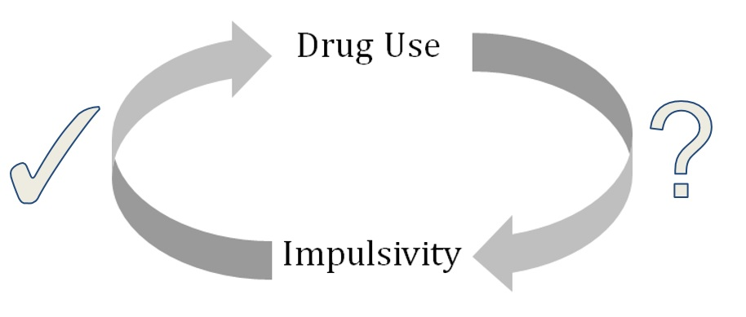
Figure 1. Depiction of the currently understood relationship between drug use and impulsivity in the addiction research literature.

iv. Reinforcement and Method of Administration
The pharmacological effects of drugs are not the only aspects of a drug that influence a user’s change in behavior – human and nonhuman studies have provided conclusive evidence that drug abuse can be understood as operant behavior that is motivated independently of drugs’ toxicological effects (Silverman, 2004). Operant conditioning is a learning principle that occurs as a result of cause-and-effect relationships between actions and their consequences. Operant conditioning dictates that a behavior will increase in frequency and intensity when it has a positive consequence (whether the positive consequence is the administration of a positive stimulus or the removal of a negative stimulus). Furthermore, a behavior will decrease in frequency and intensity when it has negative consequences (whether the negative consequence is the administration of a negative stimulus or the removal of a positive stimulus). A deceptively simple learning paradigm, operant conditioning can be modulated through the manipulation of a number of variables: the time at which the consequence is administered and the size/severity of the consequence among other variables.
Addiction can be conceptualized through the lens of operant conditioning. Something can be addictive only if it offers a positive reward. The operant conditioning of addictive substances is particularly troubling because the administered reward is often immediate and intense whereas the rewards of healthier behaviors is often delayed (example: strengthening muscles after multiple visits to the weight room throughout weeks of training) (Silverman, 2004).
Furthermore, punishment, or the administration of negative consequences, can play a role in curtailing addiction. Unfortunately, the negative consequences of drug addiction are usually not immediately felt, but come after addiction has induced psychological and physiological changes in the addicted individual’s body. Operant conditioning has also been used in addiction treatment programs. Research has shown that abstinence, as the desired behavior, can be perpetuated if rewarded with a positive stimulus (Prendergast, Podus, Finney, Greenwell, & Roll, 2006). Furthermore, deviation from abstinence can be discouraged through the use of a negative stimulus. Such treatment programs have shown promising short-term results but have questionable long-term efficacy (Drummond, Cooper, & Glautier, 2006).
Schedules of reinforcement are tools of operant learning theory that may be used to either promote or diminish the occurrence of a specified behavior. Reinforcement schedules characterize how often a reward is provided in response to how often a target behavior is performed (Freeman & Lattal, 1992). These schedules may either be continuous, in which an individual is rewarded for every performance of the desired behavior, or may be delayed, in which the participant is rewarded after completing a pre-determined number of target behaviors. A participant’s response patterns to behavioral tasks are overwhelmingly influenced by different schedules of reinforcement (Lee, 2007). In squirrel monkeys, combining various reinforcement schedules with either a food or cocaine reward yielded response patterns that did not differ significantly with respect to the type of reward but that did vary with the changing reinforcement schedules (Goldberg, 1973). Differences in the schedule of reinforcement drive participants’ response patterns regardless of the specific nature of the outcome.
Behavioral patterns may also emerge as acute consequences of using drugs and occur in a short duration after the administration of the substance. Drugs of abuse, such as d-amphetamine, are commonly believed to increase risk-taking and maladaptive behavior. However, research has demonstrated that the acute effects of certain drugs of abuse are in disagreement with this commonly held belief. de Wit, Enggasser, and Richards (2002) found that acute administration of d-amphetamine actually decreased impulsive responding on behavioral tasks measuring delay discounting and the inhibition of inappropriate responses. Acute and moderate doses of d-amphetamine brought about effects that are opposite to the behavioral patterns that occur in response to larger, chronic doses of this drug. Similarly, MDMA has been found to improve performance on a stop-signal task, which is used as a behavioral measure of impulsivity and determines the ability of participants to inhibit an activated or pre-cued response (Ramaekers & Kuypers, 2006). Correspondingly, a body of literature has indicated that alcohol also does not increase cognitive impulsivity. Ortner, MacDonald, and Olmdstead (2003) observed that alcohol tended to produce more cautious decision making while in the intoxicated state. Moreover, Richards, Zhang, Mitchell, and de Wit (1999) have reported that alcohol use does not acutely and detrimentally affect discounting of delayed monetary rewards. It has been postulated that at some degree of chronic intake, drugs of abuse transition from decreasing impulsivity to increasing impulsivity and begin producing maladaptive behavior. It is noteworthy that, although the present study is primarily concerned with the long-term effects of reinforcing schedules on behavior, the acute effects of drugs may differ, and sometime directly oppose, their chronic effects on certain behavioral patterns, such as impulsive decision-making.
Beyond the acute effects of drug administration, there has been investigation into the experimental relationship between exposure to different schedules of reinforcement and the potential effect on behavior under future schedules of reinforcement, with the intention of uncovering the potential effect of history on future responses. Indeed, a number of animal models have been used to investigate how drug conditions may affect the responses to the pattern of reinforcement in which a subject is only rewarded for those responses which are spaced apart by some minimum time interval. Such differential reinforcement of low response rate (DRL) models bear many similarities to interval reinforcement schedules and are generally designed and expected to reduce response rates. DRL schedules bear similarities to interval reinforcement schedules, however their main difference is that only in DRL schedules do premature responses reset the time that is required between each response. Early studies on DRL schedules were some of the first that attempted to replicate the relations between drug effects and the environmental contingencies that are maintaining a certain behavior at the time. It was recognized that drugs operated through mechanisms that were independent of its pharmacological variables, and DRL studies sought to clarify the interrelationship between drugs and behavior.
Reinforcement schedules are demonstrated as having persistently impacted behavioral responses (Okouchi, 2007), as participants trained under a given schedule will generate response patterns characteristic of that initial schedule even when later placed under a different schedule. Early evidence towards such relationships demonstrated that human participants initially trained under either a fixed-ratio (FR) or DRL schedule would subsequently respond differently when placed on a fixed-interval (FI) schedule of reinforcement. In this work, those participants who first underwent FR schedules later displayed higher rates of response during the FI schedules, while those who first experienced DRL schedules would go on to exhibit lower response rates under the FI schedule (Weiner, 1964). Comparable results have been demonstrated in a rat model, in which groups of rats were initially exposed to 50 sessions on either a FR or DRL food reinforcement schedule before being shifted to a FI food reinforcement schedule. Rats first exposed to the FR schedule later responded at significantly higher rates during the FI schedule than did those rat from the DRL schedule, a difference which persisted after 93 sessions of the subsequent FI schedule and which further suggests that the response rate under a FI schedule is dependent on the subject’s history of responding during previous schedules (Urbain, Poling, Millam, & Thompson, 1978). On the other hand, the effect of schedule history on a later schedule like a variable-interval (VI) one appears does not appear to be readily observed as with the effect of history on response during FI schedules. Pigeons trained on either a FR or DRL schedule and then exposed to a VI schedule produced similar response rates (Nader & Thompson, 1987), although the number of subjects per group was limited to four per condition. Additionally, groups of rats trained on either a FR or DRL schedule produced the expected initial difference, in which the FR-trained rats responded at higher rates than did the DRL-trained rats, but after exposure to VI schedules both groups’ response rates nearly converged (Poling, Krafft, & Chapman, 1980). These studies indicate that there exists some potential for operation under previous reinforcement schedules to have an influence on subsequent exposure to reinforcement schedules, but that certain schedules may bear more influence than do others.
Some initial DRL experiments measured the effects of alcohol and amphetamines on rat responses to 21-second schedules (i.e. rats were only rewarded for responses that were spaced apart by at least 21 seconds) and observed a large increase in the total response output for amphetamine conditions as well as a decrease in the average time between responses relative to a control (Sidman, 1956). The same group also found that for the alcohol condition that the total response rate was reduced but that there was a negligible difference in the reinforcement rate. In this study however, the drug conditions do not provide reinforcement due to the nature of forced administration by the researchers. It has been postulated that DRL schedules could potentially reduce the rate of impulsive behavior because they would teach the subject to actively inhibit responding by limiting the rate of reinforcement (Hearst, Koresko, & Poppen, 1964). However, Hearst et al. (1964) failed to find any direct evidence for inhibitory stimulus control. A later experiment investigated the responses of rats on a DRL schedule, in which the rats were either injected with a control saline solution or an alcoholic solution before each training session. Although the researchers noted that they believed that the schedule of reinforcement does influence the effect of drugs on behavior, they did not observe a significant difference in responses between the two groups (Flynn, 1975) that could be attributed to the lack of self-administration of the drug. More recent research on human subjects have observed that DRL schedules are effective in reducing responses that occur at a low or moderate rate, however these studies did not target behaviors that would be considered inappropriate and their goal was not to completely eliminate the behavior itself (Anglesea, Hoch, & Taylor, 2008; Austin & Bevan, 2011). Consequently, these human studies fail to adequately address the underlying process by which substance use influences behavior because they do not modulate the forms of impulsive decision-making that are characteristic of substance use disorders (Kirshenbaum, Brown, Hughes, & Doughty, 2010).
While the previous studies reflect between-subject comparisons, another work on pigeons demonstrated behavioral effects of schedule history within individual subjects. In this study, pigeons were exposed to either a FR or a DRL schedule before being placed under either a FI or VI schedule, and differences in performance based on what schedule was originally received were observed to persist for as long as 60 sessions under the later schedule (Freeman & Lattal, 1992). While in such cases history effects are witnessed in ongoing behaviors, in other instances history effects may be considered latent as they can influence how drugs affect schedule-controlled responding while not actually creating measurable changes in behavior during baseline conditions. In one such example, d-amphetamine administered to squirrel monkeys caused an increase in punished responding if preceded by a history of shock postponement, whereas ordinarily d-amphetamine was observed to decrease punished lever pressing. Their responses rates were found to be similar both before and after the training under the historical condition, and the behavioral history only displayed an effect during the administration of d-amphetamine (Barrett, 1977). Other investigations compare the effect of exposure to multiple different schedules and the potential for each exposure and the order of schedules to influence performance under later schedules. Weiner found that humans exposed to DRL, FR, and FI schedules in that order had response rates under the FI schedule that more closely resembled those from the more distant DRL schedule than the FR schedule in place right before the FI schedule, indicating the potential for responding to be influenced by exposure to schedules further in the past (Weiner, 1969). Humans exposed to another series of reinforcement schedules, which included mixed FR-DRL training schedules, multiple FI-FI testing, and other conditions, also demonstrated that remote histories may have potential effects on later schedules (Hirai, Okouchi, & Lattal, 2011). While the entire set of conditions for which exposure to a past schedule can influence behavior in a future schedule has not yet been elucidated, it is evident that the potential exists for training under certain types of schedules to affect future behaviors.
The lasting, negative effects that substance users experience are at least partially dependent on the schedule of reinforcement, and substance abuse via a self-administered schedule presents long-term consequences for users’ impulsivity. For those with substance use disorder in particular, these patients do not explicitly select between two clearly described outcomes like quantities of food or money, but may still generally be thought of as preferring a more immediate reinforcement as opposed to a deferred, larger reinforcement (Yi, 2009). For example, the impulsivity levels of cocaine users were measured once as a baseline and again after a thirty-day period of abstinence and then subsequently compared to non-users. Over the course of this abstinent period, the delay discounting levels for cocaine users remained elevated when compared to the control, indicating potentially lasting effects to the cocaine users’ impulsivity levels (Heil, 2006). Similar results have also been observed in rats, with rats in a cocaine self-administration group demonstrating more impulsive choices after a three-week withdrawal period as compared to a control group (Mendez, 2010).
The enduring effects of substance use on users’ impulsivity vary with the method of administration (i.e. self-administration vs. experimenter-administered), as different methods reinforce along varying schedules. In particular, whether the subject self-administers a drug via as an action it chooses to perform or is involuntarily administered a drug via say injection constitutes a pertinent difference in administration method. For instance, the rate of delay discounting in rats being administered cocaine was found to decrease after administration, but upon cessation subsequently adjusted back to the baseline rate of delay discounting observed before injection (Logue, 1992). While this appears to indicate a transient effect of drug use on a user’s impulsivity, in this case the rats were not self-administering cocaine as they received cocaine via intra-peritoneal injections. Indeed, the researchers were not administering cocaine as an offered choice within a reward-based structure, and so the "reward" was unconnected to any behavior. Because the rats had no behavioral control over the reward process, this design is not an example of operant conditioning, and the results indicate that the presence of operant factors may be necessary to achieve the sustained effects that are typically associated with drug use. Researchers conducting an investigation on the effects of tricyclic antidepressants on rat performance on a DRL schedule found statistically significant differences between groups, in which rats continuously administered a constant dose of the antidepressant IMI experienced a progressive increase in reinforcements which exceed the effect seen with a single administration of the drug (McGuire, 1980). They postulated that the difference in the effects observed with either single or chronic doses of IMI was a result of exposure to operant situations altering the metabolism of these drugs. In both of these cases, it is important to note researchers’ administration of drug to the subjects, as opposed to the self-administration of the drug by subjects as a result of their own choices. While substance abuse has often been associated with a preference for immediate rewards over deferred ones, the changes in delay discounting tied to the reinforcement schedule of drugs like cocaine or antidepressant suggests self-administration itself can engender a continuing, elevated level of impulsivity in users. In these cases, the schedule of reinforcement associated with self-administration may be an important distinction in comparison to administration by researchers, and so prompts a consideration of the effects of the associated schedules independent of the specific drugs involved.
v. Hypothesis
An association exists between addiction and impulsivity, with a user’s propensity towards selecting the more impulsive of two outcomes correlating with a number of substance uses. Given the importance of delay discounting in this relationship, this study investigates whether an individual’s level of delay discounting may be actively trained by participating in behaviors on varying schedules of reinforcement. Engaging in chronic drug use has been correlated with increased levels of impulsivity (Fillmore & Rush, 2002), prompting us to use an experimental procedure to directly compare the effects of varying schedules of reinforcement on an individual’s level of impulsivity. Additionally, the DRL literature that has been reviewed here suggests that past training history may have the capacity to influence future behavior on a behavioral measure of impulsivity. We hypothesize that participants exposed to a schedule modeling impulsive behavior will exhibit an increase in impulsivity, while those exposed to a schedule modeling less impulsive behavior will demonstrate a decrease in impulsivity as compared to the no-training-task (NTT) condition.
2. Methodology
a. Participants
Participants were recruited through SONA, the University of Maryland, College Park (UMCP) human subject pool management software. This system only recruited students registered at the UMCP, limiting the participant demographic to students enrolled at the university. The study was listed as “Analyzing the Effects of Learning on Delayed Gratification” (AELDG) so as to avoid revealing the team moniker of “ADDICT” and thereby avoiding potentially suggesting the focus of the study to participants. 69 participants were recruited and assigned to three groups. 23 participants were assigned to the fixed-ratio 1 (FR-1) training group, 24 participants were assigned to the fixed-ratio 10 (FR-10) training group, and 22 participants were assigned to NTT.
Participants were assigned to groups on
b. Materials
All electronic assessments, the delay discounting task, and the visual attention task were run on a Dell Latitude D630 laptop computer running the Windows XP operating system.
i. Pre- and Post-Training Assessments
At the participant’s first session, demographics questionnaire, Eysenck Personality Questionnaire (EPQ), Barratt Impulsiveness Scale (BIS-11), and delay discounting task (DDT) were administered. At the participant’s final session, the same DDT was administered. At the study’s conclusion, participants were compensated $20 for pre-training and an additional $20 for post-training.
1. Demographics Questionnaire (see Appendix A): Participants were asked to complete a paper demographics questionnaire, which asked for gender, age, academic rank (ie, freshman, sophomore, junior, or senior), ethnic identity, total family/household income, SAT score (math and verbal sub-scores), cumulative university GPA, rate of cigarette smoking, rate of alcohol drinking, and rate of marijuana smoking.
2. Eysenck Personality Questionnaire (EPQ) (see Appendices B, C): This 63 item self-report measure was designed to assess personality traits along three dimensions: psychoticism, extraversion, and neuroticism (Eysenck, Eysenck, & Barrett, 1985). It outputs two values, an impulsive score and a venturesome score. Participants responded to a series of questions in a binary yes or no fashion (Appendix C). The electronic version of this assessment was administered via a Microsoft Access form.
3. Barratt Impulsiveness Scale (BIS-11) (see Appendix D): A 30 item self-report measure designed to assess the personality construct of impulsiveness (Patton, Stanford, & Barratt, 1995), it provides three values: a non-planning score, a motor score, and a cognitive score. Participants respond to a series of questions by indicating one of four frequencies ranging from rarely/never to almost always (Appendix D). This is the eleventh version of the original Barratt Impulsiveness Scale. The electronic version of this assessment was administered via a Microsoft Access form.
4. Delay Discounting Task (DDT) (see Appendices E, F): A personal computer was used to run a program that conducts a binary choice DDT using varying hypothetical magnitude of money and delays ranging from one day to 25 years (Appendix E). The existence of a magnitude effect, in which individuals delay discount larger rewards at lower rates than they do smaller rewards, has been observed in participants evaluating hypothetical monetary gains (Baker, Johnson, & Bickel, 2003). In order to better reflect the variation of delay discounting with the magnitude of the reward, two sizes were specified for the size of the hypothetical reward in question, with one being $50 and the other being $1000. For the given magnitude being measured, participants were presented with two hypothetical monetary alternatives, one of which was a larger amount of money available following a delay (the Larger-Later or LL option) and the other was a smaller sum of money available immediately (the Smaller-Sooner or SS option). For the first administration of the DDT, the LL option and delay were specified by the researcher, and the SS alternative was presented as half of the LL option. If the participant chose the SS option in the first trial, then the SS option in the second round was decreased by a magnitude of one half, whereas if the LL option were chosen first then the SS option offered in the second round increased by one-half the original, first SS option. Every successive choice would increase or decrease the subsequent SS value by 50 percent of the magnitude of the previous adjustment. At each trial, the participant was presented with only two outcomes (SS and LL) on screen (Appendix F). In this manner, the SS value was titrated over six trials in order to determine an indifference point at the given delay. Indifference points were obtained at the hypothetical magnitudes of both $50 and $1000, and at each of the following delays: one month, six months, one year, and five years. The delays were presented in an increasing order. For each delay and hypothetical monetary amount, the DDT provided two text files that recorded the participants’ selections and reported their indifference point.
ii. Training Task
A specific visual attention task (VAT) was designed in the form of a web-based application for daily participant training sessions. Upon starting the program, the application was set to automatically run in the Google Chrome web browser. After adjusting these parameters to the desired condition depending on the participant’s group (Appendix G), selecting “run” would display a waiting screen that offered no study information and only allowed participants to begin the training session.
Participants were faced with a full-screen window of the training task seen in Appendix H. The task primarily consisted of a screen divided into four separate squares, while to the right of these squares a thermometer-shaped display served as a visual representation of the user’s accumulated earnings in that session. The four squares each contained a single, capital letter, which would appear on screen for two seconds before a new set of four letters would appear. A correct response was defined as a click on the letter X. A mouse was connected to the personal computer for ease of clicking. An incorrect response was defined as a click on any quadrant which did not contain the letter X, and was accompanied by an error noise. If an incorrect response was made when an X was present in another quadrant, the participant was unable to subsequently secure a correct response for that two-second grouping. As the 30-minute training session began, the bank amount and the thermometer reading reset to $0.00. Upon clicking a square containing an X, participants in the FR-1 condition were rewarded with $0.05, which was displayed visually as a sum of money in the participant’s bank and by an increase in the thermometer reading. Additionally, this increase in the bank balance was accompanied by an audible “ka-ching” sound. For participants in the FR-10 condition, the bank balance increased by $0.50 after making ten correct responses and was similarly accompanied by the audible “ka-ching” sound. Correct responses for this task were not required to be consecutive. The number of solvable screens was set to 400 and the duration of the training session was set to 30 minutes – these conditions were equal for both the FR-1 and FR-10 groups. Both groups were capable of earning a maximum of potentially $20, as the FR-1 group earned $0.05 per correct response (400 * $0.05 = $20.00) and the FR-10 group earned $0.50 for every tenth correct response (400 * $0.50 = $20.00).
This computerized VAT was intended to provide participants a consistent, distinguishable environment so as to ensure participant recognition of the learning environment and to trigger responses that reflected participant training during the pre- and post-assessments. In order to maintain this environment, participants were required to wear a head-mounted display (HMD) which consisted of a pair Vuzix video eyewear glasses with attached headphones. The HMD limited the user’s peripheral vision while also creating a field of view that consisted solely of the computer’s display. Furthermore, the HMD’s headphones provided the ability to reduce external noise while also playing the sound associated with the correct and incorrect responses.
c. Procedures
Before arriving for the first session, participants were assigned to either the FR-1 training condition, the FR-10 training condition, or the NTT condition. In order to obtain equal sample sizes for all experimental groups, participant assignment obeyed the following procedure: the first participant to sign up for the study was assigned to the FR-1 condition, the second to the FR-10 condition, and the third to the NTT condition. This pattern was repeated in sequence for all participants, except when participant dropout occurred. For each participant that left the study prior to completing the post-assessment, a new participant was recruited into the same condition as the participant who had dropped out of the study. Participants were assigned to groups prior to their first session and before we had any knowledge of their individual characteristics. All participants were assigned alphanumeric identification keys to preserve anonymity and maintain the security of the data. After registering via the UMCP SONA system, participants were emailed with directions for finding the Center for Addictions, Personality and Emotions Research (CAPER) (the location of all sessions), and subsequently emailed reminders nightly for all of their future sessions.
Upon entering the CAPER facilities for the first session, participants were greeted by a researcher and directed to an available research room where all equipment, including the personal computer, VAT, and electronic assessments, would be already prepared and ready to run by the researcher. Participants were then seated and then handed the consent form (see Appendix I), which described the purpose of the study, procedures, potential risks and discomforts, potential benefits, confidentiality, right to withdraw and questions, participant rights, statement of consent, and the signature and date. During this time the researcher reviewed each of the sections presented in the consent form with the participant. Following a verbal description of each section, the participant was instructed to carefully read the form and ask any questions when finished. Researchers were prepared to answer any questions regarding the study’s guidelines, the participant’s privacy, and any general questions on the participant’s expectations. Once the participant had thoroughly read the form and the researcher had addressed any questions, the consent to engage in the study was provided by signing and dating the form. After consenting, the participant’s ID number was assigned and written on the consent form, with completion of the consent form and the participant’s signature indicating an understanding of the study’s guidelines. These forms were kept in a locked office file cabinet to protect the participants’ identities.
A paper demographics questionnaire was then completed (Appendix A) as participants supplied as much information as they were comfortable sharing. A number of participants did not recall their SAT score and were asked to provide an estimate. Afterwards, the BIS-11 and EPQ that were pre-loaded on the computer were completed by the participant. As this is the first opportunity to do so, at this time the participant was briefly left alone in the room while the consent form was delivered to the secured file cabinet. After this, the DDT was then completed by the participant. It was explained to the participants that the following task would involve making decisions on whether they prefer hypothetical sums of money over various periods of time, and that they should treat all such decisions as though they were actually being offered real money. The HMD was then worn for the first time as the DDT was completed using the mouse while viewing the options via the HMD. The DDT was first measured at a magnitude of $50 and time delays of one month, six months, one year, and five years. The same task was then repeated at a magnitude of $1000 and time delays of one month, six months, one year, and five years.
Participants were then asked to schedule their remaining sessions. For NTT participants (AELDG3##), a single session was scheduled 13 days after their first session to complete a post-session. If this was not possible, the participant was asked to complete the post-session either 12 or 14 days after the first session. At this time, no NTT participants were dismissed. For training group participants (those in either the FR-1 or FR-10 condition), at this time the next nine sessions were scheduled, for a total of ten session including the first one they were currently at. Participants were informed that the second through ninth sessions were 30-minute training sessions that would only consist of administering the VAT, and that the final, tenth session would consist of a 30-minute training session and was then followed by a post-assessment and compensation. Weekday scheduling was organized in such a fashion as to maximize the number of consecutive sessions. For these training participants, at this time the compensation scheme was explained as well (Appendix J). Participants were informed that the monetary amounts they scored in the following VAT would potentially contribute to their final compensation for the study, such that from the first five sessions there would be one contribution, another selection from their sixth through eighth sessions, and one final addition from their ninth or tenth session. The potential for participants to earn payments was back loaded so as to reduce rates of attrition. Thus, it was explained that from the ten training session participants would have three of the sessions randomly selected to contribute to their compensation after the post-assessment, for a maximum compensation of $60 from training.
After scheduling, the waiting screen of the VAT was demonstrated while the rules of the game were explained. Researchers explained that the participants would be compensated in proportion to the number of correct responses scored, but not necessarily for each individual correct response. The appearance and objective of the VAT were described, participants were prompted to ask any questions for clarifications, and any such confusion was resolved before beginning the first training session. At the conclusion of this half-hour session, participants were dismissed for the day. Participants then returned to CAPER over the next nine weekdays for their remaining training sessions, until ten sessions had been completed in total. At the conclusion of the tenth training session, training participants were again administered the DDT. For NTT participants arriving for their second and final session, no training was completed and solely the DDT and compensation were administered. Once again, for all participants the DDT was first completed at a magnitude of $50 and time delays of one month, six months, one year, and five years, and then the DDT was measured again at a magnitude of $1000 over the same time delays. Afterwards, compensation was provided such that either $40 was given to NTT participants or a variable amount between $40 to $100 (depending on performance in the training sessions) was provided for training condition participants. Participants were then asked to complete the appropriate receipt form (Appendices K, L) before being debriefed and completing their participation in this study.
d. Statistical Analysis
i. Program
Unless otherwise noted, all analyses were performed using the IBM SPSS statistical package (version 22).
ii. Formatting
From the calculated indifference points at each time interval, measures of delay discounting were calculated in two separate models.
The hyperbolic model assumes that the indifference points decrease hyperbolically over time, so that the subjective value of a reward decreases rapidly over a short time and then more slowly over longer delays. This model has been used in previous studies with good demonstrated fit (Kirby and Marakovic, 1995; Madden, 2003). In order to fit the data to a hyperbolic model, we used a nonlinear regression according to the formula below, where x represents the indifference point, D represents the time delay for reward presentation, and k represents the calculated regression coefficient.
x = 1/(1+ k*D)
In order to achieve a normal distribution, calculated values of k were then transformed into the variable LNK according to a simple logarithmic function below for ease of data presentation and analysis. Our statistical tests assume a normal distribution of the variables, and so the logarithmic transformation is appropriate (Stangor, 2010).
LNK = ln(k)
We also decided to consider a model-free calculation that would look directly at the responses of the participants and would not make any assumptions regarding which function fits the data best, in order to avoid relying on a model that might not necessarily fit the data. The model-free calculation calculated the area under the curve (AUC) for a curve that connected each indifference point with a straight line, as demonstrated by the example Table 1 below and Figure 2 on the following page.
Table 1
Example Indifference Points for Hypothetical Participants
Delay (Days) | 0 | 30 | 182.5 | 365 | 1825
High Impulsivity | 1.0 | 0.6 | 0.4 | 0.25 | 0.05
Low Impulsivity | 1.0 | 0.8 | 0.65 | 0.55 | 0.4
Table 1. Example indifference points for two hypothetical participants, one with high impulsivity and one with low impulsivity, were created to demonstrate the AUC calculation.
Figure 2. Example graphical representation of the calculation of AUC. The data points in Table 1 were used to create a delay discounting curve for the model-free calculation.
The values of the indifference points and the time delays between them partitioned the curves into trapezoidal segments with areas given by the formula below, where A refers to the segmental area, d refers to the difference between time delays, x₁ refers to the first indifference point value, and x₂ refers to the second indifference point value.
A = (d/2)*(x₁ + x₂)
The sum of the areas of each trapezoidal segment yields a total area under the curve. For ease of analysis, this value was then divided by the total area available (1825 in the example curve above) to give a standardized value. This value represents the ratio of the area under the curve to the potential area under the curve for that set of time delays (i.e. the value that would have been achieved for an individual with zero delay discounting).
iii. Correlations
In order to examine relationships among collected measurements and compare these to previously acknowledged trends in the field, correlations among all numerical variables were analyzed (Eysenck and BIS sub-scores, LNK and AUC measures of delay discounting, GPA, SAT scores, age, and quantitative measures of substance use).
iv. Covariates
In addition to the main measures, supplemental data that were related to impulsivity were collected. The participants completed two self-report measures of impulsivity, the Barratt Impulsivity Scale and the Eysenck Personality Questionnaire. We also collected demographics data. We recorded age and gender, as previous studies have shown younger age and male gender to be associated with delay discounting (Kirby, 1996; Steinberg, 2009). The demographics questionnaire also assessed alcohol use, cigarette use, and marijuana use, as substance abuse is associated with impulsivity (Dawe & Loxton, 2004). These substance use data were collected numerically (number of uses per week) and categorically (use versus nonuse). In order to explore additional relationships among demographic variables and impulsivity, we collected data on academic standing, ethnicity, family income, SAT verbal and math scores, and GPA.
The additional data collected in the demographics, Eysenck, and BIS assessments were tested for significant differences among the three experimental groups. For non-numerical variables (gender, academic standing, ethnicity, family income category, cigarette use, alcohol use, marijuana use), a Pearson's Chi-Square test was used to assess for significant differences. For numerical variables (age, SAT math score, SAT verbal score, GPA, cigarettes per week, alcoholic drinks per week, marijuana uses per week, BIS non-planning score, BIS motor score, BIS cognitive score, Eysenck impulsivity score, Eysenck venturesome score), a one-way ANOVA was used. Any significant differences among groups for any of these supplemental measures would warrant the measures being included as covariates in the main statistical analysis detailed in the next section.
v. Main Analysis
The main analysis is a 3x2x2 mixed-measures ANOVA, testing for significant interactions of group assignment and reward size for pre- and post-assessments. The analysis was performed separately for hyperbolic (LNK) and model-free (AUC) results. Any covariates from the other data would be included as well.

3. Results and Data Analysis
a. Introduction and Validation of Measures
i. Overview
In all, data were collected for 69 participants. Except where noted, all 69 participants provided data for all assessments. Some participants declined to provide certain information or answer certain questions, which is noted in the relevant data sections. Group 1, the FR-1 schedule, contained 23 participants, while Group 2, the FR-10 schedule, contained 24 participants. 22 participants were placed in Group 3 (no-training-task or NTT), in which they did not participate in any training sessions between the pre- and post- assessments.
ii. Correlations Between Measures of Delay Discounting
In order to validate our measures of delay discounting, we assessed a Pearson's correlation (r) for both measures (AUC and LNK) at both levels of reward ($50 and $1000) for the pre-test. As expected, both delay discounting measures (AUC and LNK) were highly correlated across both reward sizes ($50 and $1000). Table 2 below presents the correlation matrix for these measures. All of the results presented are statistically significant (p < .05).

Table 2
Correlations Among Measures of Delay Discounting
 | LNK _50 | LNK _1000 | AUC _50 | AUC _1000
LNK _50 | 1 | .825 | -.963 | -.805
LNK _1000 | .825 | 1 | -.799 | -.961
AUC _50 | -.963 | -.799 | 1 | .785
AUC _1000 | -.805 | -.961 | .785 | 1
Table 2. Pearson's r correlation matrix for pretest measures of delay discounting. Values of LNK were positively correlated with each other and negatively correlated with values of AUC. All correlations were statistically significant (p < .05).
iii. Testing for Confounding Variables
In order to assess for confounding variables, all factors and measures collected during the pre-assessment (demographics data, BIS and Eysenck assessments, and Delay Discounting task results) were compared among the three groups. The qualitative factors (qualitative substance use, academic rank, ethnicity, and gender) were analyzed using a Pearson's Chi-Square test. The quantitative measures (delay discounting data, BIS and Eysenck scores, quantitative substance use, family income level, age, SAT scores, and college GPA) were included as dependent variables in a one-way ANOVA by group.
Table 3 below shows the distribution of cigarette use (a qualitative measure that assessed use as opposed to nonuse without any measure of frequency, duration, or other degrees of use) across groups. No significant difference in gender distribution among groups was detected, X² (2, N = 69) = 1.964, p > .05.

Table 3
Cigarette Smoker Distribution Among Groups
 |  | Cigarette_Smoker |  | Total
 |  | No | Yes
Group | FR-1 | 23 | 0 | 23
 | FR-10 | 22 | 2 | 24
 | NTT | 21 | 1 | 22
Total |  | 66 | 3 | 69
Table 3. Distribution of cigarette smokers and nonsmokers by group. No significant difference was detected in distribution among groups, X² (2, N = 69) = 1.964, p > .05
Table 4 on the next page shows the distribution of alcohol use (a qualitative measure of use versus nonuse with no mention of frequency or other quantification of use) across groups. No significant difference in distribution among groups was detected, X² (2, N = 69) = 4.551, p > .05.
Table 4
Alcohol Use Distribution Among Groups
 |  | Drinks_Alcohol |  | Total
 |  | No | Yes
Group | FR-1 | 3 | 20 | 23
 | FR-10 | 6 | 18 | 24
 | NTT | 9 | 13 | 22
Total |  | 18 | 51 | 69
Table 4. Distribution of alcohol use among groups. No significant difference in distribution among groups was detected, X² (2, N = 69) = 4.551, p > .05.
Table 5 demonstrates the distribution of marijuana use (a qualitative measure of use versus nonuse without any mention of frequency of use or any other quantification of the degree of use) among groups. No significant difference in distribution among groups was detected, X² (2, N = 69) = 1.829, p > .05.
Table 5
Distribution of Marijuana Smoking Among Groups
 |  | Smokes_Marijuana |  | Total
 |  | No | Yes
Group | FR-1 | 19 | 4 | 23
 | FR-10 | 22 | 2 | 24
 | NTT | 17 | 5 | 22
Total |  | 58 | 11 | 69
Table 5. Distribution of marijuana use among groups. No significant difference in distribution among groups was detected, X² (2, N = 69) = 1.829, p > .05.
Table 6 displays the distribution of gender across groups. Overall, the study included more females than males, but no significant difference in gender distribution among groups was detected, X² (2, N = 69) = .542, p > 0.05.

Table 6
Gender Distribution Among Groups
 |  | Gender |  | Total
 |  | Female | Male
Group | FR-1 | 15 | 8 | 23
 | FR-10 | 15 | 9 | 24
 | NTT | 11 | 11 | 22
Total |  | 41 | 28 | 69
Table 6. Distribution of gender among groups. No significant difference in gender distribution among groups was detected, X² (2, N = 69) = .542, p > 0.05.
Table 7 on the following page demonstrates the distribution of academic rank across groups. One participant declined to provide any academic rank (not the same as providing a rank of "other"). No significant difference in distribution of academic rank among groups was detected, X² (10, N = 68) = 8.149, p > .05.
Table 7
Distribution of Academic Rank Among Groups
 |  | Academic Rank |  |  |  |  |  | Total
 |  | Freshman | Graduate | Junior | Other | Senior | Sophomore
Group | FR-1 | 3 | 0 | 5 | 0 | 11 | 4 | 23
 | FR-10 | 2 | 0 | 9 | 1 | 10 | 2 | 24
 | NTT | 4 | 1 | 6 | 0 | 6 | 4 | 21
Total |  | 9 | 1 | 20 | 1 | 27 | 10 | 68
Table 7. Distribution of academic rank among groups. No significant difference in distribution of academic rank among groups was detected, X² (10, N = 68) = 8.149, p > .05.
Table 8 on the next page demonstrates the distribution of ethnicity across groups. Although interim analyses had indicated a difference in the distribution of ethnicity across groups (specifically, relatively high numbers of White/Caucasian participants in groups 1 and 2 versus relatively high numbers of Asian/Southeast Asian and Black/African American participants in Group 3), the final analyses indicated that this was not a statistically significant relationship, X² (8, N = 69) = 15.155, p > .05.

Table 8
Distribution of Ethnicity Among Groups
 |  | Ethnicity |  |  |  |  | Total
 |  | Asian/Southeast Asian | Black/African American | Hispanic/Latino | Mixed Asian-Caucasian | White/Caucasian
Group | FR-1 | 2 | 3 | 2 | 0 | 16 | 23
 | FR-10 | 2 | 4 | 0 | 0 | 18 | 24
 | NTT | 5 | 8 | 2 | 1 | 6 | 22
Total |  | 9 | 15 | 4 | 1 | 40 | 69
Table 8. Distribution of ethnicity among groups. Contrary to our preliminary results, distribution of ethnicities did not differ significantly among groups, X² (8, N = 69) = 15.155, p > .05.
As mentioned previously, all quantitative measures were assessed as dependent variables in a one-way ANOVA by group in order to ensure that there were no pre-existing differences in group composition. The following presentations represent the results of that ANOVA, with each variable treated separately.
Participants in the study ranged from 18 to 26 years of age, with a mean age of 20.449. There was no detected difference in age distribution among groups, F(2, 66) = .702, p > .05. The mean ages for individual groups are available in the Table 9 on the next page.
Table 9
Age Distribution Across Groups
 | N | Mean | Std. Deviation
FR-1 | 23 | 20.1304 | 1.28997
FR-10 | 24 | 20.6250 | 1.34528
NTT | 22 | 20.5909 | 2.03912
Total | 69 | 20.4493 | 1.57682
Table 9. Age distributions of groups. There was no detected difference in age distribution among groups, F(2, 66) = .702, p > .05
Family income data was collected in ranges of annual dollars. In scoring the data, these bins of ten thousand dollars were encoded with a single number (a response in the range of 0-9999 annual dollars receives a score of 0, a response in the range of 10000-19999 receives a score of 1, and a response in the range of 100000 or more receives a score of 10). One participant declined to provide this information. Among the remaining 68 participants, the mean score was 7.75. We failed to detect any difference in family income distribution across groups, F(2, 65) = .499, p > .05. Statistics on the distributions of family incomes for individual groups are available in Table 10 below.

Table 10
Group Distribution of Family Income (Tens of Thousands of Dollars Annually)
 | N | Mean | Standard Deviation
FR-1 | 23 | 8.61 | 2.572
FR-10 | 24 | 7.88 | 3.288
NTT | 21 | 6.67 | 3.624
Total | 68 | 7.75 | 3.229
Table 10. Distribution of family income among groups. All results are presented in tens of thousands of dollars annually. We failed to detect any difference in family income distribution across groups, F(2, 65) = .499, p > .05.
Cumulative undergraduate GPA values were reported by 62 participants with a minimum value of 2.08, a maximum value of 4.00, and a mean reported value of 3.260. We failed to detect any significant differences among groups, F(2, 59) = 1.142, p > .05. Distribution statistics for each group are presented in Table 11.
Table 11
Group Distributions of Undergraduate GPA
 | N | Mean | Standard Deviation
FR-1 | 22 | 3.3691 | .48598
FR-10 | 24 | 3.2269 | .37853
NTT | 16 | 3.1613 | .46300
Total | 62 | 3.2604 | .44196
Table 11. Distributions of undergraduate GPA among groups. No statistically significant difference among groups was detected, F(2, 59) = 1.142, p > .05.
Of the 69 participants, 49 reported SAT math scores, with a minimum reported score of 480, a maximum reported score of 780, and a mean reported score of 657.755. No significant differences in SAT math scores were detected among groups, F(2, 46) = .064, p > .05. SAT verbal scores were provided by 48 participants with a minimum of 420, a maximum of 800, and a mean of 638.750. Again, no significant differences were detected across groups, F(2, 45) = .340, p > .05. The distribution statistics for individual groups are available in the Table 12 on the following page.
Table 12
SAT Score Distribution Among Groups
 |  | N | Mean | Standard Deviation
SAT_Math | FR-1 | 19 | 657.8947 | 79.55284
 | FR-10 | 15 | 652.6667 | 78.32776
 | NTT | 15 | 662.6667 | 70.65678
 | Total | 49 | 657.7551 | 75.06290
SAT_Verbal | FR-1 | 18 | 636.6667 | 86.63650
 | FR-10 | 15 | 653.3333 | 90.05289
 | NTT | 15 | 626.6667 | 92.71051
 | Total | 48 | 638.7500 | 88.35675
Table 12. Pretest SAT score distribution by group. No significant differences were detected for either math scores, F(2, 46) = .064, p > .05, or verbal scores, F(2, 45) = .340, p > .05.
Frequency of substance abuse was assessed in terms of cigarettes per day, alcoholic beverages per week, and instances of marijuana use in the last month. Participants that indicated no use on the qualitative substance use reports were given a score of 0 for these measures, even if they did not explicitly indicate a frequency of 0 for uses of that substance. There were no participants that reported a nonzero frequency of use after reporting no use on the corresponding qualitative report. However, 2 participants reported marijuana use and reported frequency of 0 instances in the last month. These results were not considered to be contradictory and the data were entered without alteration.
Among 69 participants, the average reported number of daily cigarettes was .035. No significant differences were found between groups, F(2, 66) = 1.177, p > .05. The mean reported number of weekly alcoholic beverages was 4.004. Similarly, there was no difference detected between groups, F(2, 66) = .651, p > .05. The mean reported number of marijuana uses in the preceding month was .681. Again, no significant differences were found among groups, F(2, 66) = 1.959, p > .05. Table 13 contains individual group distribution statistics.

Table 13
Distributions of Quantitative Substance Use Among Groups
 |  | N | Mean | Standard Deviation
Cigarettes_per_day | FR-1 | 23 | .0000 | .00000
 | FR-10 | 24 | .0833 | .31851
 | NTT | 22 | .0195 | .09168
 | Total | 69 | .0352 | .19551
Alcoholic_beverages_per_week | FR-1 | 23 | 3.2261 | 2.89721
 | FR-10 | 24 | 4.8125 | 4.74069
 | NTT | 22 | 3.9341 | 6.19430
 | Total | 69 | 4.0036 | 4.75432
Mariujuana_use_in_last_month | FR-1 | 23 | .5217 | 1.75472
 | FR-10 | 24 | .2083 | .72106
 | NTT | 22 | 1.3636 | 3.03229
 | Total | 69 | .6812 | 2.06150
Table 13. Distribution of quantitative substance use measures among groups. Of note, the FR-1 group contained no cigarette smokers. No significant differences among groups were detected with regard to cigarette use frequency, F(2, 66) = 1.177, p > .05; alcoholic beverage frequency, F(2, 66) = .651, p > .05; or marijuana use frequency F(2, 66) = 1.959, p > .05.
The BIS responses for three participants were not recovered due to a malfunction in the computer program that administered these tasks. For the 66 response sets that were obtained, each BIS subscore was considered individually in addition to the aggregate score. The mean BIS nonplanning subscore was 22.17; no significant differences were detectable along group lines, F(2, 63) = .299, p > .05. The mean BIS motor subscore was 21.17. We failed to detect any significant differences among groups, F(2, 63) = 1.672, p > .05. The mean BIS cognitive subscore was 17.26, with no detectable difference among groups, F(2, 63) = .430, p > .05. As expected given the results for each subscore, the BIS total score had a mean of 60.59 and did not appreciably differ between groups, F(2, 63) = .778, p > .05. Full distribution statistics for individual groups are presented in Table 14 below (continued on the next page).

Table 14
Groups Distributions of BIS Scores
 |  | N | Mean | Standard Deviation
BIS11_Nonplanning | FR-1 | 23 | 21.61 | 5.332
 | FR-10 | 22 | 22.32 | 3.329
 | NTT | 21 | 22.62 | 4.477
 | Total | 66 | 22.17 | 4.422
BIS11_Motor | FR-1 | 23 | 20.74 | 3.374
 | FR-10 | 22 | 20.32 | 3.643
 | NTT | 21 | 22.52 | 5.372
 | Total | 66 | 21.17 | 4.234
BIS11_Cognitive | FR-1 | 23 | 16.91 | 3.753
 | FR-10 | 22 | 16.95 | 4.402
 | NTT | 21 | 17.95 | 4.330
 | Total | 66 | 17.26 | 4.126
BIS11_Total | FR-1 | 23 | 59.26 | 10.905
 | FR-10 | 22 | 59.59 | 9.752
 | NTT | 21 | 63.10 | 12.763
 | Total | 66 | 60.59 | 11.140
Table 14. Group distributions of pretest BIS scores. No significant differences were found among groups with regard to nonplanning subscore, F(2, 63) = .299, p > .05; motor subscore, F(2, 63) = 1.672, p > .05; cognitive subscore, F(2, 63) = .430, p > .05; or total score, F(2, 63) = .778, p > .05.
The Eysenck scores for three participants were not recovered due to the same computer malfunction discussed previously. For the remaining 66 participants, the mean reported Eysenck impulsivity subscore was 9.35 (minimum 0, maximum 19). No significant differences across groups were detected F(2, 63) = 1.353, p > .05. The maximum reported Eysenck venturesome subscore was 17, and the minimum score was 1, with a mean reported score of 9.92. No significant differences across groups were detected, F(2, 63) = .220, p > .05. In alignment with the subscore results, the total Eysenck scores had a mean of 19.27 (minimum 7, maximum 34). We continued to fail to detect any statistically significant differences among groups, F(2, 63) = 1.084, p > .05. Table 15 contains all distribution statistics for individual groups.

Table 15
Group Distribution of Eysenck Scores
 |  | N | Mean | Standard Deviation
Eysenck_Impulsivity | FR-1 | 23 | 9.00 | 4.000
 | FR-10 | 22 | 8.59 | 3.887
 | NTT | 21 | 10.52 | 4.273
 | Total | 66 | 9.35 | 4.074
Eysenck_Venturesome | FR-1 | 23 | 9.78 | 3.176
 | FR-10 | 22 | 9.64 | 4.552
 | NTT | 21 | 10.38 | 3.853
 | Total | 66 | 9.92 | 3.844
Eysenck_Total | FR-1 | 23 | 18.78 | 5.213
 | FR-10 | 22 | 18.23 | 6.941
 | NTT | 21 | 20.90 | 6.617
 | Total | 66 | 19.27 | 6.289
Table 15. Group distribution of [Eysenck Personality Scale] scores. No significant differences were detected in the group distributions of impulsivity subscores, F(2, 63) = 1.35, p > .05; venturesome subscores, F(2, 63) = .22, p > .05; or total scores, F(2, 63) = 1.08, p > .05.
b. Hypothesis Testing
All hypothesis testing was conducted using a 3x2x2 mixed-design ANOVA with group assignment as a between-groups variable. The reward size during the delay discounting task and the two-week interval between pre-assessment and post-assessment were treated as within-groups variables.

i. Tests Using LNK
In accordance with the main hypothesis, a significant interaction was found between group assignment and the two-week interval, F(2, 66) = 3.82, p < .05. More specifically, the FR-1 group remained largely constant from pretest (M = -7.035, SE = .398) to posttest (M = -7.245, SE = .392), F(1, 21) = .69, p > .05; the FR-10 group's pretest (M = -6.544, SE = .389) and posttest (M = -6.614, SE = .383) scores were not significantly different, F(1, 22) = .08, p > .05; while NTT group pretest scores (M = -5.817, SE = .407) were higher than posttest scores (M = -6.813, SE = .400), F(1, 20) = 14.84, p < .05. When the FR-1 and FR-10 groups were compared directly to each other, no significant interaction between group assignment and two-week interval was observed, F(1, 45) = .178, p > .05. The nature of the interaction effect is demonstrated in the graph on the following page. In light of the significant interaction effect, the main effect of the two-week training period, F(1, 66) = 8.471, p < .05, is not to be considered on its own. No main effect of group assignment was found, F(2, 66) = .1250, p > .05, although the presence of the interaction effect again makes any interpretation of the main effect or lack thereof insufficient to describe the data.

Figure 3. Interaction effect of group assignment by two-week interval. While NTT displayed a decrease in mean LNK from pre-assessment to post-assessment, the FR-1 and FR-10 groups remained more constant. Error bars represent the standard error.
For clarity of presentation, this representation was reformulated to highlight the change of the FR-1 and FR-10 groups relative to NTT. In Figure 4 on the following page, the data are standardized as comparisons to NTT.

Figure 4. Reformulation of the interaction effect of group assignment by two-week interval. The presented points represent the difference between the group mean LNK and the NTT mean LNK (NTT results not shown). Error bars represent the standard error of the original data points.
As expected and outlined in our literature review, we found a statistically significant main effect of reward size during the delay discounting task, F(1, 66) = 190.17, p < .05. Specifically, the task involving the larger delayed reward (M = -7.544, SE = .221) was associated with a decreased rate of delay discounting compared to the task involving the smaller delayed reward (M = -5.812, SE = .229). There were no interactions detected between this effect and group assignment, F(2, 66) = 1.175, p > .05, or between the reward size and the two-week period, F(2, 66) = .773, p > .05. Given the lack of interactions with the other factors, we feel that it is appropriate to present the main effect. Figure 5 below demonstrates the main effect discussed, and Table 16 presents a more complete description of the distributions. There was no observed three-way interaction between group assignment, the two-week period between pre- and post-assessments, and reward size, F(2, 66) = .079, p > .05.

Figure 5. Main effect of reward size on LNK. The smaller reward size of $50 was associated with a higher mean Error bars represent the standard error.
Table 16
Distributions of LNK
 |  | Mean | Standard Deviation | N
lnk_pre_50 | 1 | -6.23200 | 2.327199 | 23
 | 2 | -5.52588 | 2.132048 | 24
 | 3 | -4.90119 | 1.703165 | 22
 | Total | -5.56207 | 2.116383 | 69
lnk_pre_1000 | 1 | -7.83783 | 2.145728 | 23
 | 2 | -7.56145 | 1.796039 | 24
 | 3 | -6.73267 | 1.810351 | 22
 | Total | -7.38933 | 1.952119 | 69
lnk_post_50 | 1 | -6.51935 | 2.378771 | 23
 | 2 | -5.64594 | 1.719395 | 24
 | 3 | -6.04724 | 1.910138 | 22
 | Total | -6.06503 | 2.022209 | 69
lnk_post_1000 | 1 | -7.96986 | 2.075774 | 23
 | 2 | -7.58174 | 2.103998 | 24
 | 3 | -7.57942 | 1.861780 | 22
 | Total | -7.71038 | 1.998988 | 69
Table 16. Distribution of LNK by reward size, pre- and post-assessments, and group assignment.
ii. Tests Using AUC
The observed main effects in the AUC measure were in agreement with the results outlined for the LNK measure. There was a statistically significant interaction between group assignment and pre-post changes in AUC F(2, 66) = 3.86, p < .05. This reflected the fact that the FR-1 group pretest scores (M = .605, SE = .051) and posttest scores (M = .610, SE = .050) remained largely constant, like the FR-10 group pretest scores (M = .552, SE = .050) and posttest scores (M = .564, SE = .049), while the control group pretest scores (M = .435, SE = .052) were significantly lower than posttest scores (M = .563, SE = .051). The nature of the interaction effect is shown in Figure 6. Simple effects tests confirmed the significance of the NTT results, F(1, 20) = 12.97, p < .05, as contrasted with FR-1 results, F(1, 21) = .02, p < .05, and FR-10 results, F(1, 22) = .13, p < .05). The observed main effect of the two-week period, F(1, 66) = 8.47, p < .05, is therefore better explained by the interaction effect. Similarly, although no main effect of group assignment was detected, F(2, 66) = 1.276, p > .05, the interaction effect supersedes any analysis based on an interpretation of main effects.

Figure 6. Interaction of group assignment with two-week interval. The mean AUC remained largely constant in the FR-1 and FR-10 groups, while the NTT group displayed an increase in mean AUC from pre-assessment to post-assessment. Error bars represent the standard error.
To highlight the movement of the FR-1 and FR-10 groups in relation to the NTT group, the data were once again reformulated by subtracting the NTT group's mean AUC. This reformulation is presented in Figure 7.

Figure 7. Reformulation of the interaction of group assignment with two-week interval. Each data point represents the difference between the group mean AUC and the NTT group AUC (data for the NTT group not shown). Error bars represent standard errors.
In agreement with the results for the LNK measure, the AUC measure exhibited a statistically significant main effect of reward size, F(1, 66) = 166.701, p < .05. Again, the smaller reward size (M = .438, SE = .030) was associated with a smaller AUC (corresponding to a higher rate of delay discounting) than the larger reward size (M = .672, SE = .028). This main effect did not display any significant interactions with group assignment, F(2, 66) = 1.991, p > .05, or with changes from pre- to post-assessment, F(1, 66) = .306, p > .05. Similarly, we detected no three-way interaction between the factors, F(2, 66) = .347, p > .05. Figure 8 on the next page demonstrates the main effect just discussed, and Table 17 presents a complete description of the data organized by experimental group and pre- versus post-assessment.

Figure 8. Main effect of reward size on AUC. The larger reward size of $1000 was associated with a larger mean AUC than the smaller reward size of $50. Error bars represent the standard error.
Table 17
Distributions of AUC
 |  | Mean | Standard Deviation | N
AUC_pre_50 | FR-1 | .50588 | .296734 | 23
 | FR-10 | .42466 | .261764 | 24
 | NTT | .29879 | .231831 | 22
 | Total | .41160 | .274673 | 69
AUC_pre_1000 | FR-1 | .70499 | .258340 | 23
 | FR-10 | .67907 | .259923 | 24
 | NTT | .57147 | .248323 | 22
 | Total | .65340 | .258441 | 69
AUC_post_50 | FR-1 | .52517 | .304022 | 23
 | FR-10 | .42876 | .238382 | 24
 | NTT | .44222 | .265888 | 22
 | Total | .46519 | .269838 | 69
AUC_post_1000 | FR-1 | .69449 | .236110 | 23
 | FR-10 | .69973 | .260879 | 24
 | NTT | .68317 | .250256 | 22
 | Total | .69270 | .245855 | 69
Table 17. Distribution statistics for AUC on pre- and post-assessments, divided by reward size and group assignment.
c. Secondary Measures
i. Correlations with Delay Discounting Measures
Age was correlated with both LNK (r = .270, p < .05) and AUC (r = -.248, p < .05) under the $50 condition of the delay discounting task. Of note, this is the opposite direction of correlation that would be predicted from existing research (Green, Fry, & Meyerson, 1994). Correlations with age were not significant for either measure under the $1000 condition. All 69 participants provided ages. Table 18 displays the correlations of age and delay discounting measures.

Table 18
Correlations of Age and Delay Discounting Measures
 | LNK $50 | LNK $1000 | AUC $50 | AUC $1000
Pearson Correlation | .270 | .158 | -.248 | -.179
Sig. (2-tailed) | .025 | .195 | .040 | .142
Table 18. Correlations between age of participants and measures of delay discounting on the pre-assessment. Of note, age displayed statistically significant correlations, positively with LNK and negatively with AUC, under the $50 conditions.

Family income was correlated with LNK at both the $50 condition (r = -.318, p < .05) and the $1000 condition (r = .339, p < .05). Correlations between family income and AUC were not significant for either reward size. Data for family income were provided by 68 participants. Table 19 contains full correlation values for family income levels and
Table 19
Correlations of Family Income and Delay Discounting Measures
 | LNK $50 | LNK $1000 | AUC $50 | AUC $1000
Pearson Correlation | -.318 | -.217 | .339 | .237
Sig. (2-tailed) | .008 | .075 | .005 | .052
Table 19. Correlations between family income and delay discounting measures assessed during the pre-assessment. Correlations were significant between family income and LNK (r = -.318, p < .05) and AUC (r = .339, p < .05) under the $50 reward condition.
SAT math scores were provided by 49 participants, and were not significantly correlated with any of the delay discounting measures. SAT verbal scores were provided by 48 participants, and were significantly correlated with LNK (r = -.365, p < .05) and AUC (r = .417, p < .05) under the $1000 condition only. Neither measure significantly correlated with SAT verbal scores under the $50 condition. Undergraduate GPA was provided by 62 participants. Pretest LNK values were negatively correlated with GPA under both the $50 (r = -.463, p < .05) and $1000 (r = -.404, p < .05) conditions. Similarly, the provided GPA scores were positively correlated with AUC values under the $50 (r = .499, p < .05) and $1000 (r = .424, p < .05) conditions. The correlation matrix for delay discounting measures and academic performance scores is presented in Table 20 below.
Table 20
Correlations Between Delay Discounting Measures and Academic Performance Measures
 |  | LNK_50 | LNK_1000 | AUC_50 | AUC_1000
SAT Math | Pearson Correlation | -.103 | -.125 | .134 | .161
SAT Verbal | Pearson Correlation | -.243 | -.365 | .275 | .417
Cumulative GPA | Pearson Correlation | -.463 | -.404 | .499 | .424
Table 20. Correlations between measures of academic performance and pretest measures of delay discounting. SAT verbal scores correlated positively with AUC scores (r = .417, p < .05) and negatively with LNK scores (r = -.365, p < .05) under the $1000 condition only. Undergraduate GPA was correlated negatively with LNK values under both the $50 (r = -.463, p < .05) and $1000 (r = -.404, p < .05) conditions, and positively with AUC values under the $50 (r = .499, p < .05) and $1000 (r = .424, p < .05) conditions.
All 69 participants provided self-reports of substance use frequency (including implied frequencies of 0 when participants indicated no substance use). Self-reported frequency of cigarette use correlated positively with LNK values under the $50 condition
(r = .313, p < .05) and negatively with AUC values under the $1000 condition (r = -.243, p < .05). The remaining correlations between delay discounting measures and self-reported substance use frequencies were not significant. The full correlation matrix is presented in Table 21.
Table 21
Correlations Between Substance Use and Delay Discounting Measures
 | LNK $50 | LNK $1000 | AUC $50 | AUC $1000
Cigarettes  Per Day | .313 | .147 | -.228 | -.243
Alcoholic Beverages  Per Week | -.074 | -.083 | .040 | .071
Marijuana Uses  in Last Month | -.057 | .003 | .078 | .011
Table 21. Correlations between self-reported substance use frequencies and pretest delay discounting measures. Cigarette use correlated positively with LNK values under the $50 condition (r = .313, p < .05) and negatively with AUC values under the $1000 condition (r = -.243, p < .05).
Due to a technical error in the computerized assessment, the results of the BIS and Eysenck were not recorded for 3 participants. The remaining 66 participants fully completed both measures. Neither the total BIS score nor any subscore of the BIS was significantly correlated with any measure of delay discounting. Similarly, total Eysenck score and Eysenck venturesome subscore were not significantly correlated with any delay discounting measure. However, the Eysenck impulsivity subscore was negatively correlated with AUC values at both the $50 (r = -.242, p < .05) and $1000 (r = -.256, p < .05) reward sizes. The LNK values were not correlated significantly with Eysenck impulsivity subscores at either reward size. Table 22 on the following page contains the relevant correlation values.

Table 22
Correlations Among Delay Discounting Measures and Other Measures of Impulsivity (BIS and Eysenck)
 | LNK $50 | LNK $1000 | AUC $50 | AUC $1000
BIS11 Nonplanning | .164 | .174 | -.226 | -.179
BIS11 Motor | .028 | .060 | -.084 | -.066
BIS11 Cognitive | .004 | -.008 | -.071 | .019
BIS11 Total | .077 | .089 | -.148 | -.089
Eysenck Impulsivity | .207 | .225 | -.242 | -.256
Eysenck Venturesome | -.019 | -.042 | .008 | .030
Eysenck Total | .122 | .120 | -.152 | -.147
Table 22. Correlations between pretest delay discounting measures and alternative pretest measures of impulsivity. Eysenck impulsivity subscores were negatively correlated with AUC values under both the $50 (r = -.242, p < .05) and $1000 (r = -.256, p < .05) reward conditions.
ii. Correlations Among Other Secondary Measures
Participants provided 49 SAT math scores, 48 SAT verbal scores, and 62 GPA scores. SAT math scores were positively correlated with SAT verbal scores (r = .428, p < .05) and GPA (r = .369, p < .05). SAT verbal scores and GPA were positively correlated as well (r = .457, p < .05). SAT math scores were additionally correlated negatively with frequency of cigarette use (r = .345, p < .05) and positively with Eysenck venturesome subscores (r = .313, p < .05). No other significant correlations were detected for SAT verbal scores or undergraduate GPA.
Frequency of cigarette use was not correlated significantly with frequency of alcohol or marijuana use, but alcohol and marijuana use frequencies were positively correlated with each other (r = .297, p < .05). The frequencies of substance use were not significantly correlated with BIS total scores or any BIS subscore, but marijuana use frequency was correlated with Eysenck impulsivity subscores (r = .258, p < .05), venturesome subscores (r = .279, p < .05) and total scores (r = .337, p < .05).
As anticipated and outlined in the literature review, Eysenck and BIS results were highly correlated. In particular, the Eysenck impulsivity subscore was correlated positively with BIS nonplanning (r = .649, p < .05), motor (r = .723, p < .05), cognitive (r = .540, p < .05), and total (r = .733, p < .05) scores.
iii. Validation ANOVA for Qualitative Substance Use
In order to validate our qualitative variables, we conducted a one-way ANOVA for each of the qualitative substance use measures against the battery of quantitative pre-assessment measures.
Qualitative cigarette use was found to predict a number of measures. Among these were delay discounting results under the $50 condition for both LNK, F(1, 68) = 5.154, p < .05, and AUC, F(1, 68) = 4.030, p < .05. Smokers gave more impulsive results under these conditions with higher LNK (M = -2.928, SD = 2.068) than nonsmokers (M = -5.682, SD = 2.054) and lower AUC (M = .107, SD = .080) than nonsmokers (M = .425, SD = .272). In keeping with these results, we observed an effect of cigarette use on Eysenck impulsivity subscores, F(1, 65) = 4.994, p < .05; BIS cognitive subscores, F(1, 65) = 5.053, p < .05; and BIS total scores, F(1, 65) = 4.822, p < .05. There was no observed effect of cigarette use on delay discounting in the $1000 condition. Qualitative cigarette use also predicted undergraduate GPA, F(1, 61) = 4.696, p < .05. The smokers reported lower GPA (M =2.737, SD = .247) than nonsmokers (M = 3.287, SD = .434). An effect was found on SAT math scores, F(1, 48) = 6.364, p < .05, but only one smoker reported this score. Descriptive statistics for these distributions are available in the appended tables.
Qualitative alcohol use was not found to predict any measure other than the unsurprising effect on alcohol use frequency, F(1, 68) = 22.808, p < .05. Qualitative marijuana use also predicted alcohol use frequency, F(1, 68) = 4.846, p < .05, with marijuana users reporting more frequent alcohol use (see table for means). Marijuana users had higher BIS motor subscores, F(1, 65) = 6.865, p < .05, and total BIS scores, F(1, 65) 4.898, p < .05. Finally, marijuana users had higher Eysenck scores for impulsive subscore, F(1, 65) = 6.485, p < .05; venturesome subscore, F(1, 65) = 10.228, p < .05; and total score, F(1, 65) = 13.979, p < .05. Distributive statistics may be found in the appended tables.
iv. Validation Chi-Square for Qualitative Substance Use
In agreement with the quantitative correlational data, qualitative cigarette use was not significantly predictive of qualitative alcohol use, X² (1, N = 69) = .085, p > .05; or of qualitative marijuana use, X² (1, N = 69) = .708, p > .05. Similar agreement was found in the mutually predictive distributions of alcohol and marijuana use, X² (1, N = 69) = 4.619, p < .05. The distributions are presented in Table 23-25 on the following pages.
Table 23
Relative Distributions of Cigarette and Alcohol Use
 |  | Drinks_Alcohol |  | Total
 |  | No | Yes
Cigarette_Smoker | No | 17 | 49 | 66
 | Yes | 1 | 2 | 3
Total |  | 18 | 51 | 69
Table 23. Relative distributions of cigarette and alcohol use. No significant association was found between use versus nonuse of alcohol and use versus nonuse of cigarettes, X² (1, N = 69) = .085, p > .05.
Table 24
Relative Distributions of Cigarette and Marijuana Use
 |  | Smokes_Marijuana |  | Total
 |  | No | Yes
Cigarette_Smoker | No | 56 | 10 | 66
 | Yes | 2 | 1 | 3
Total |  | 58 | 11 | 69
Table 24. Relative distributions of cigarette and marijuana use. Use versus nonuse of cigarettes and marijuana were not mutually predictive, X² (1, N = 69) = .708, p > .05.

Table 25
Relative Distributions of Alcohol and Marijuana Use
 |  | Smokes_Marijuana |  | Total
 |  | No | Yes
Drinks_Alcohol | No | 18 | 0 | 18
 | Yes | 40 | 11 | 51
Total |  | 58 | 11 | 69
Table 25. Relative distributions of alcohol and marijuana use. Use of alcohol tended to occur with use of marijuana, X² (1, N = 69) = 4.619, p < .05. In fact, all participants that reported marijuana use also reported alcohol use.

4. Discussion
In this section we will summarize the results, analyze various interpretations and possible alternatives, make connections to current literature, and contextualize our results. Additionally we will discuss weaknesses and limitations of our study, as well as potential future directions for similar research.
a. Interpretation of Results
As previously mentioned, delay discounting was measured using the AUC and LNK methods. The high correlation between the measures of delay discounting, AUC and LNK, indicate that both methods measured the same variable, and we will focus our analysis on the AUC results.
As described in out methodology, participants were assigned in such a way as to maintain equal numbers of participants in each condition (unequal numbers in the final sizes of each group represent the effects of participant dropout during the final phase of data collection, after which no additional participants were enrolled). The assignment of participants to conditions occurred prior to any pretest measure, and depended only on the order in which they enrolled in the study. Therefore, we are confident that we have introduced no biases with respect to the composition of the groups. As demonstrated by our extensive testing, the groups displayed no pre-existing differences on any demographic variable, quantitative or qualitative. We also failed to detect any pretest differences among groups with respect to the BIS and Eysenck assessments. Therefore, we are confident that any differences between groups can be attributed to the experimental manipulation (reinforcement schedule or lack of training task) rather than to any of these alternative variables.
The AUC measure exhibited a statistically significant main effect of reward size, where a small reward size was associated with a smaller AUC than a larger reward size. Due to the way that it is calculated, a smaller AUC corresponds to a higher rate of delay discounting. Thus, the smaller reward size tended to produce a higher rate of delay discounting. This finding is consistent with the literature, as participants tend to give less impulsive responses on delay-discounting assessments when larger rewards are in question. This known effect did not display any significant interactions with the other variables of our ANOVA.
We observed a large increase in the absolute value of AUC from pretest to posttest for the NTT condition. We feel that the most likely explanation for this trend is that some retesting effect exists. Such effects are common in studies that repeat measures (Stangor, 2010). Although the two-week interval was likely enough time for participants to forget their pre-assessment responses, participants that repeat a delay discounting task without performing any other action in between are more likely to provide less impulsive responses the second time (R. Yi, personal communication, March 5, 2014). Given that a retesting effect appeared for participants not undergoing experimental manipulation, we feel that the trends for FR-1 and FR-10 should be interpreted in the context of this effect. Before proceeding to the analysis, however, we would like to consider and refute a number of alternate explanations as to why NTT is associated with markedly decreased impulsivity, rather than stable levels.
One possibility is that this represents a random movement and cannot be meaningfully construed as a result of the training conditions or lack thereof. We feel confident in our ability to reject this possibility based on the results that we obtained, with simple effects tests demonstrating that the observed pre-to-post changes within the NTT group are highly unlikely to occur by chance. A future project might assess additional measures such as the BIS and Eysenck in the post-assessment as well as in the pre-assessment in order to more accurately characterize the change in impulsivity. Furthermore, we propose that future studies might follow participants over a more extended period with a greater number of delay-discounting tests administered during the study. A greater number of longitudinal measurements might better characterize the change in impulsivity over time. With a sufficiently lengthy study, it might even be possible to change the reinforcement schedules for the participants between intervals of the study to assess how rapidly the reinforcement schedule alters delay discounting levels.
Another possibility that we have considered is that the overall monetary compensation provided to the participants was a factor that influenced decisions in the delay-discounting task. No-training control participants were only rewarded $40 for participation in the study, while participants in the FR-1 and FR-10 groups were compensated up to $100. We might, therefore, wonder whether the participants in the NTT displayed a different pattern of change from pre-assessment to post-assessment than the FR-1 and FR-10 participants because they were expecting a smaller reward at the conclusion of the study. We find this explanation to be unlikely, because the FR-1 and FR-10 groups did not change significantly from pre-assessment to post-assessment. If the anticipated reward for completing the study was the factor that governed changes from pre-assessment to post-assessment, then the FR-1 and FR-10 groups should have displayed an exaggerated version of the NTT change corresponding to their larger compensation amount. Such a change would also fit with the effect of reward size that we observed, with participants anticipating a larger reward size giving less impulsive responses. The pattern of changes that we observed therefore defies any trend that would be expected if the different compensation amount given to the NTT group were to explain differences between the NTT group and the FR-1 and FR-10 groups. Nonetheless, we propose that a future study might compensate the NTT group and the groups that complete the training task equal amounts so as to conclusively dismiss this alternative explanation.
A third possibility that we have considered is that the participants in NTT differed from the other participants in some characteristic that was not measured. For example, it has been suggested to us that the profile of students participating in psychological studies may change over the course of a semester, with some students waiting until near the end of the semester to sign up for studies that they need for course credit. We believe that this particular case is not a compelling explanation of our data, as our study was not applicable towards course credit. Additionally, students from all groups were recruited throughout the semester. During any given time of the study, participants from all three groups were attending sessions in the laboratory (or, in the case of NTT, were in the waiting period between pre-assessment and post-assessment). Nonetheless, it remains theoretically possible that the participants in NTTs had some characteristic difference that would explain their behavior better than would the experimental manipulation. We have, however, attempted to account for all likely variables with our demographics and personality assessments, and we feel that we have screened participants to the extent reasonable for characteristics that would play a role in changing delay discounting over time.
Having considered a number of alternative explanations for the apparent decrease in impulsivity from pre- to post-assessment in the NTT group, we continue to believe that a retesting effect as mentioned above is the most likely explanation for the trend in the raw NTT data. FR-1 and FR-10 groups are also subject to this retesting effect, and any deviation from the baseline trend should be attributed to the experimental manipulation. Therefore, we have chosen to use NTT as a baseline by comparing pre- and post-measures of delay discounting within FR-1 and FR-10 groups relative to NTT (see Figure 7).
Both groups that underwent training, FR-1 and FR-10, saw an increase in impulsivity relative to NTT. The increase in impulsivity relative to NTT was expected in the FR-1 group, but we had expected that participants in the FR-10 training group would display a decrease in impulsivity relative to NTT. The increase in impulsivity relative to NTT displayed by the FR-10 group is therefore a finding contrary to the expected result formulated by our hypothesis. Indeed, the FR-10 group is visually much more similar to the FR-1 group than to NTT. We attribute this similarity to the reinforcement schedules, FR-1 and FR-10, being too similar in frequency of reward. Participants in the FR-1 group were rewarded for every correct response, which occurred at intervals of approximately 3 seconds. On the other hand, participants in the FR-10 group were rewarded for every 10 correct responses, which occurred at intervals of approximately 30 seconds. This suggests that since both the FR-1 and FR-10 groups were rewarded within a matter of seconds of correctly exhibiting the response, both training conditions could be accurately said to simulate the reinforcement schedules of drug use. Typically, a non-drug-like reinforcement schedule would likely occur on a scale of weeks, not seconds or minutes. The FR-10 reinforcement schedule was too similar to a drug-like reinforcement schedule and therefore produced similar results. Although our data does not fully support our original hypothesis, the significant differences between the training groups (FR-1 and FR-10 combined) and NTT show that rewarding participants under the FR-1 and FR-10 conditions resulted in increased impulsivity relative to control.
b. Secondary Results – Correlational Matrix
Participants in all groups completed a demographics questionnaire, the BIS-11 and Eysenck assessments, and the delay discounting task during their first session. The data from the demographics questionnaire and the self-report measures were primarily utilized to establish that the groups were not measurably different prior to the study with respect to any of the tested variables. However, we also used these pre-assessment measures to supplement our main analysis by assessing correlations among the measures and with the delay discounting results.
As previously mentioned in the results, age was negatively correlated with AUC under the $50 condition of the delay discounting task. However, correlations with age were not significant under the $1000 condition. The correlation between age and AUC suggests that younger participants were generally less impulsive. Typically, it is found that impulsivity decreases with age. This finding could be related to the restriction of range in the ages of the participants in this study. As a statistical matter, restriction of range alone might suffice to explain this oddity, but the specific range in which we worked might offer another explanation as to why the $50 condition specifically was associated with this unexpected result. Since all participants were between the ages of 18-25 years old, the $1,000 reward magnitude may have been too large for this age group and therefore was viewed more abstractly. On the other hand, the $50 reward magnitude may have represented a more tangible amount for participants of this age. In any case, the observed result is contrary to the existing literature and likely represents a chance finding rather than a true reflection of the relationship between age and impulsivity.
Additionally, undergraduate GPA was positively correlated with AUC values under both the $50 and $1,000 conditions. This correlation suggests that undergraduate students with higher GPAs were generally less impulsive than undergraduate students with lower GPAs. This is consistent with other research findings (Kirby, Winston, & Santiesteban, 2005).
As previously discussed, cigarette use was found to predict a number of measures. Smokers generally gave more impulsive results under the $50 reward condition for AUC than nonsmokers. Cigarette use was also negatively correlated with undergraduate GPA, where smokers reported lower GPA than nonsmokers. This result is consistent with the finding the students with lower GPA tended to be more impulsive (if cigarette use is accepted as an impulsive behavior). Interestingly, other behavioral measures of impulsive substance use such as frequency of alcohol use and marijuana use were not well correlated with delay discounting results (although marijuana use was correlated with Eysenck impulsivity scores). Particularly given the purpose of our research, we would have preferred to see more obvious connections between delay discounting and substance use frequency. However, our current study did not attempt to assess more problematic substance use behaviors that might be more indicative of addiction than simple frequency of use. For example, we could have asked participants for how often they drank more than they intended to. Therefore, we remain confident in the weight of evidence presented in our literature review that impulsivity is closely linked to substance abuse.
c. Weakness, Limitations, and Future Directions
We have identified a number of limitations in the design of our study that might explain certain unexpected features of our results or affect the applicability of our results to further research on the problem of substance abuse. Alongside these factors, we present suggestions for future studies that might modify or replace elements of our design in order to overcome these limitations.
All study participants were University of Maryland students between 18-25 years old. Such a sample demographic could limit the external validity of this study and our results may not be generalizable for a larger population. A future study might attempt to repeat our design, or a modified version thereof, using a broader range of ages.
Additionally, our results suggest that the reinforcement schedules between the two training groups were too similar. The results indicate that throughout the duration of study, participants in NTT became less impulsive, while those in FR-1 and FR-10 remained relatively unchanged. We had expected NTT to remain constant, FR-1 to increase in impulsivity, and FR-10 to decrease in impulsivity. However, as previously discussed, FR-1 and FR-10 proved to be too similar and therefore provided very similar results. There are many possible approaches that could be used to strengthen results in future studies and create a greater difference between groups.
As previously discussed, both training groups were rewarded for exhibiting the targeted action within a matter of seconds and therefore both mirrored drug use. Typically, a non-drug-like reinforcement schedule would likely occur on a scale of weeks, not seconds or minutes. Therefore, this suggests a possible new direction for new research. Participants trained under the drug-like reinforcement schedule would remain on the FR-1 schedule, while participants trained under the non-drug-like reinforcement schedule would be rewarded on various days of the study. This would create a larger distinction between the time of reward between the two groups.
Another limitation associated with this study was that NTT participants were compensated in a different manner and amount than participants in FR-1 and FR-10. NTT participants were compensated $40 for completing the pre and posttest assessments, while FR-1 and FR-10 participants were compensated up to $100, consisting of $40 for the pre and post assessments and a maximum of $60 for their participation in the training period with the virtual computerized task. In order to rule out the compensation amount as an explanatory factor in the relative increase in impulsivity displayed by the FR-1 and FR-10 groups, we propose that a future study should introduce a control element that is compensated an equivalent amount but does not undergo any training.
Additionally, participants in all groups were compensated on the last day of the two-week training period. Participants in groups FR-1 and FR-10 were reinforced throughout the duration of the study solely with hypothetical rewards from the virtual computerized task. This could suggest that hypothetical monetary rewards may not be an effective method of reinforcing participants. However, all training group participants earned the maximum $60 possible for their training condition. Future studies could reward the FR-1 participants after each session as an additional form of reinforcement and reward FR-10 participants at the end of the two week training period.
One major difference between the two training groups and NTT was that the two training groups came into the lab for 10 consecutive weekdays to participate in the virtual computerized task. On the other hand, participants in NTT only came in at the beginning and end of the training period and did not complete the virtual computerized task. As a result, NTT does not represent a true control condition for the FR-1 and FR-10 groups. Participants in the FR-1 and FR-10 groups showed an increase in impulsivity that might suggest that the physical act of coming into the lab every day for two weeks was in itself an act of reinforcement for these groups. Thus, the relative increase in impulsivity seen in these groups may not have been solely due to the reinforcement received during training, but also due to the reinforcement of coming in to the training facility every day.
To account for the reinforcing effects of study attendance in future research, all three groups could start at an FR-50 reinforcement schedule. Control participants would now undergo training and remain on this reinforcement schedule for the durations of the two week experimental period. Participants in the condition intended to model drug use would experience a reinforcement schedule which titrates from FR-50 to FR-1 in increments of 5, while participants in the condition intended to model more self-controlled behavior would experience a reinforcement schedule which titrates from FR-50 to FR-100 in increments of 5. This should provide a greater distinction between the two experimental groups as well as eliminate the potential lab attendance confounding variable.
d. Conclusion
Overall, our study supported the general idea of our hypothesis. We had expected that the impulsivity of participants in the FR-1 group would increase relative to NTT and that the impulsivity of participants in the FR-10 group would decrease relative to NTT. The reinforcement schedule for participants in the FR-1 and FR-10 proved to be too similar and therefore yielded similar results. Both experimental groups underwent conditions that were meant to represent drug use, and both groups exhibited an increase in impulsivity relative to the control group. Although there is still further research to be done, our results suggest that the reinforcement schedule of drug use increases a person’s impulsivity, completing the cycle of drug addiction and impulsivity. Since our data suggest that the reinforcement schedule of drug use can increase a person’s impulsivity subsequently fueling further drug abuse (completing the cycle), we can conclude that current pharmacological rehabilitation methods may not be effective because they primarily focus on the toxicity of the drug. Further research could be done to establish ways that incorporate methods of combatting the reinforcement schedule associated with addictive behaviors to potentially break the cycle of drug addiction and impulsivity.

Appendix A: Demographics Questionnaire
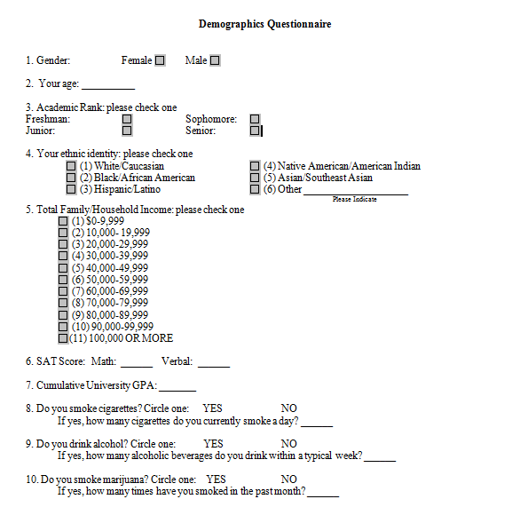
Appendix B: Eysenck Questionnaire Instructions
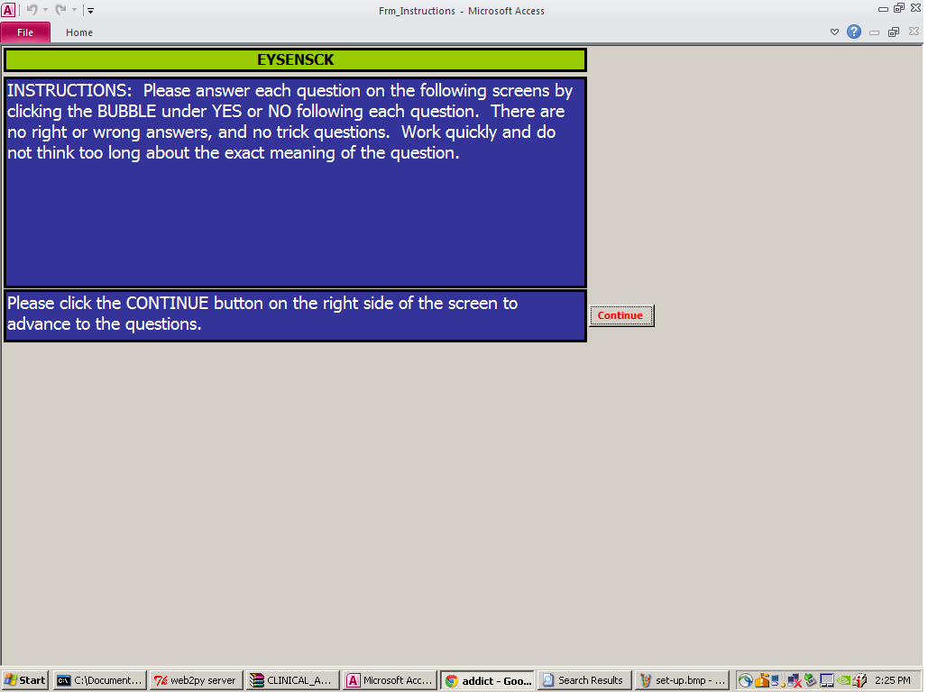
Appendix C: Eysenck Questionnaire Screenshot
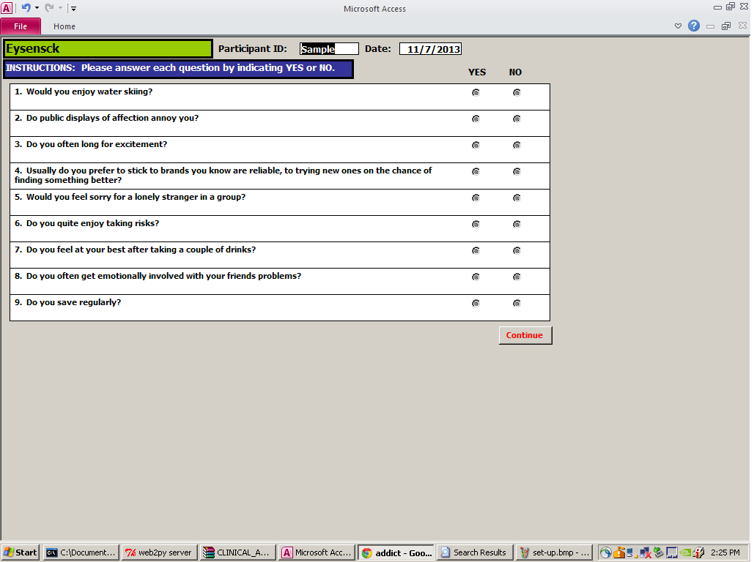
Appendix D: BIS Questionnaire Screenshot
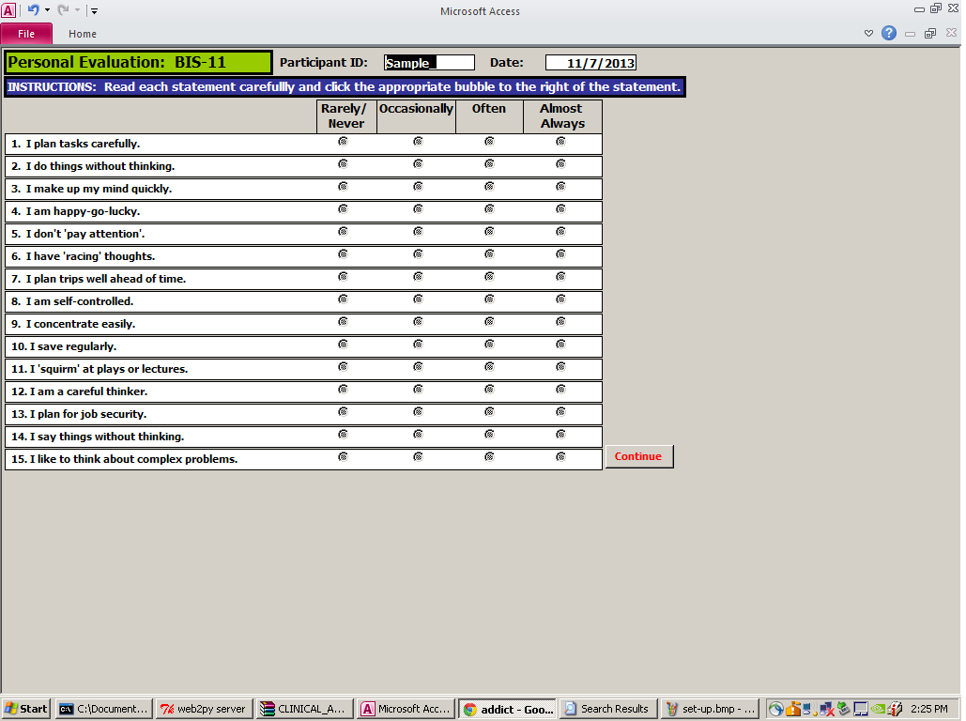
Appendix E: Delay Discounting Task Configuration
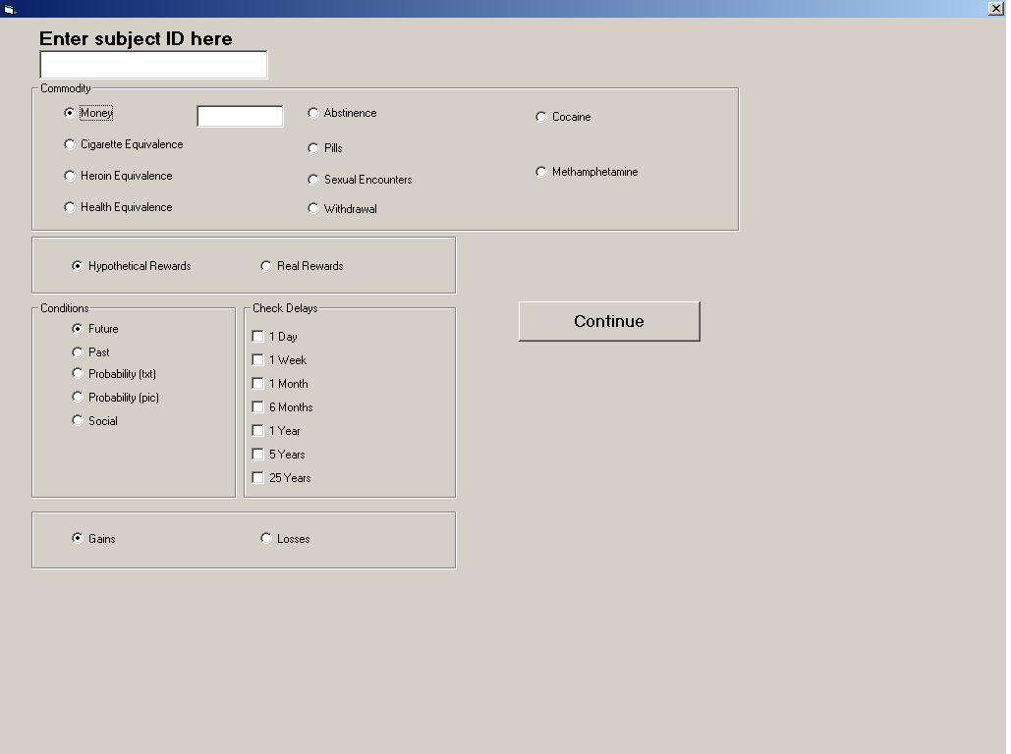
Appendix F: Delay Discounting Task – Screenshots
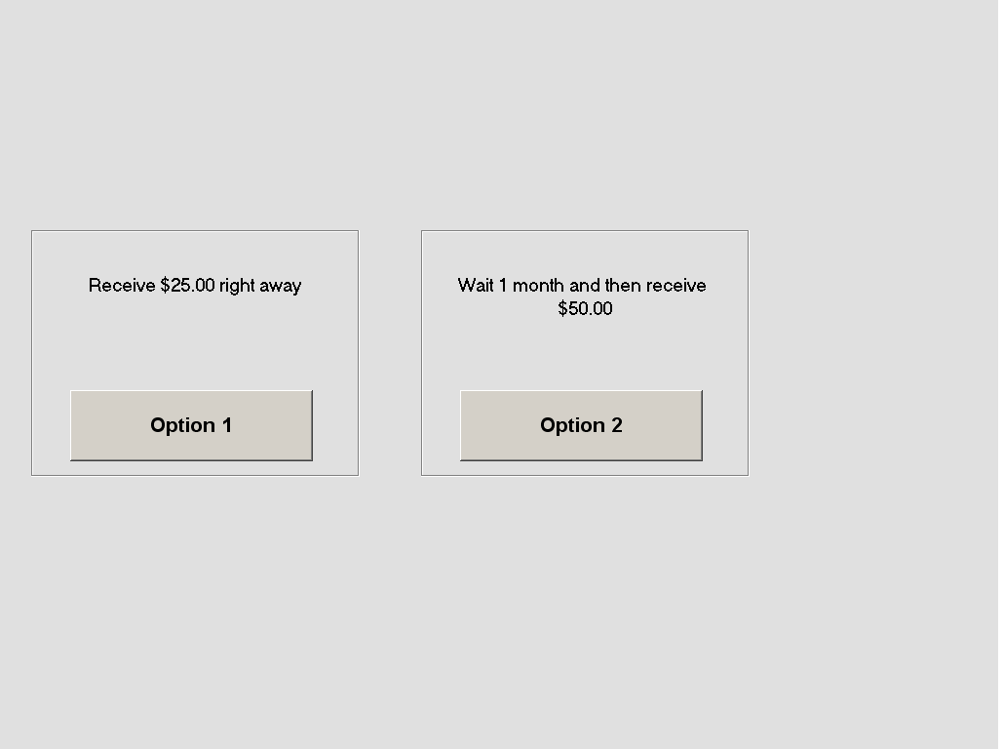
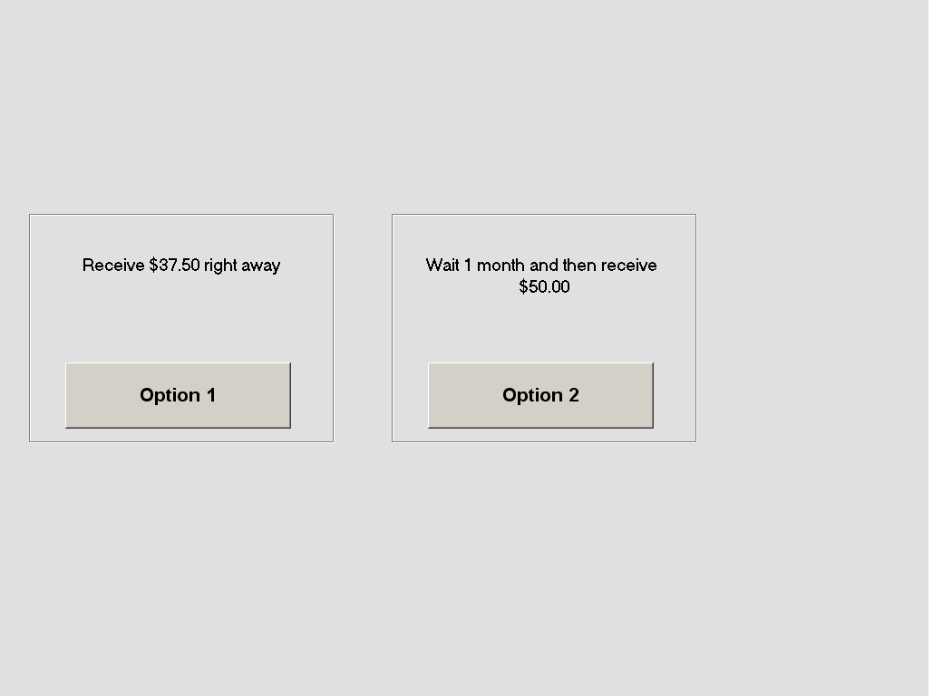
Appendix G: Training Task Set Up
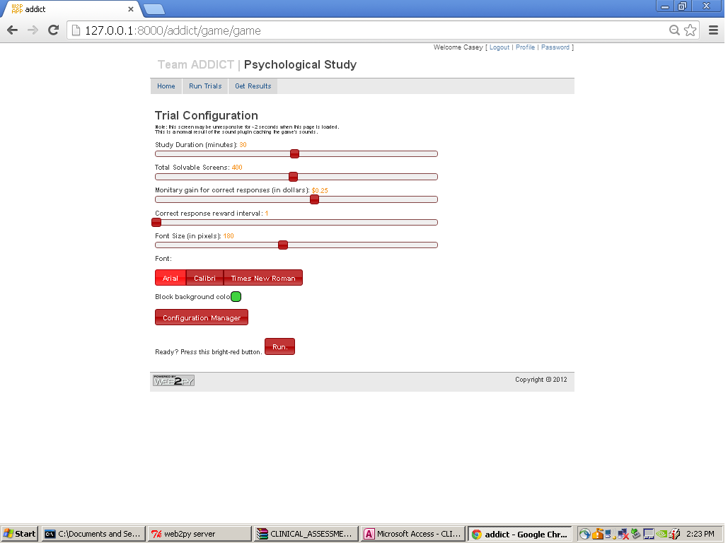
Appendix H: Training Task Screenshot
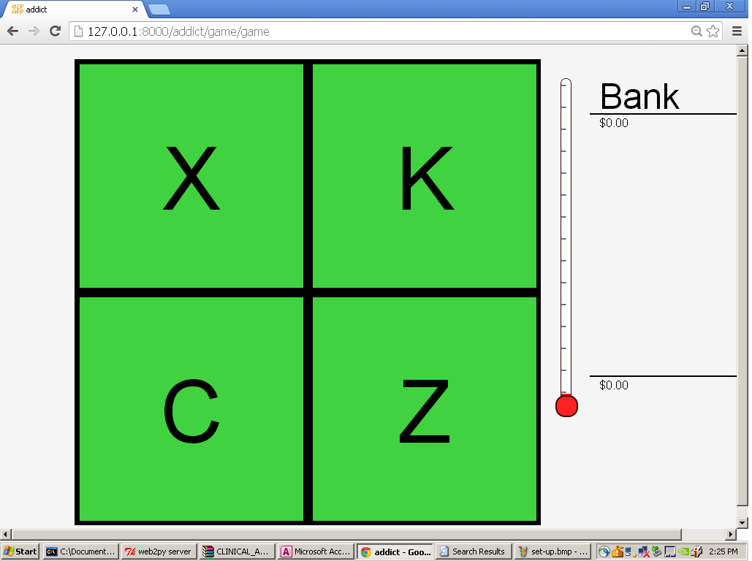
Appendix I: Consent Form
Consent Form
Project Title | Analyzing Effects of Learning on Delayed Gratification
Purpose of the Study | The purpose of this research project is to study the factors that influence how individuals make decisions between outcomes that might occur immediately and might occur after waiting a period of time.
Procedures | The study involves attending 2 assessment sessions. Your visit today is the first of these assessment sessions, and the second assessment session will occur approximately 2 weeks from today. The assessment sessions will take approximately 30 minutes, and will be composed of a number of questionnaires asking you to evaluate how you behave in typical situations, and a computerized decision-making assessment. Following this consent process today, you will be asked to complete a brief demographics survey comprised of questions regarding drug and alcohol use as well as background information about your age, gender, and ethnicity.  Between the 2 assessment sessions, you may or may not be asked to attend 10 daily (weekday) training sessions, depending on which group you are randomly assigned to, lasting approximately 30 minutes each. During these training sessions, you will complete a visual attention task that involves paying attention to a computer monitor and responding to earn money.  During the computerized decision-making assessments and the training sessions (if you are asked to attend them), you will be wearing a head-mounted device (HMD) which is comprised of vision goggles and earphones.  You will be compensated $40 for complying with the conditions of the study and completing both assessment sessions. This will be paid to you at the end of the second assessment session. If you are asked to attend the training sessions, you will earn money for your performance on the visual attention task. If you are asked to attend the training sessions, you will be compensated for 3 of these 10 sessions. The first compensation will be randomly selected from your first 5 completed sessions. The next will be randomly selected from the following 3 sessions, and the final compensation payment will be randomly selected from the final 2 sessions. While you will not receive your performance earning for each training session, you should perform at your best in each training session because it may be selected for payment. The maximum you can earn in each training session is $20. If all 10 sessions are completed then you can earn a maximum of $60 for the training.  Total compensation for participants who are not asked to attend training sessions will be $40. Total compensation for participants who are asked to attend training sessions will be up to $100. Your total earnings will be paid out at the end of the study.  You will be responsible for any taxes assessed on the compensation.  ☐ Check here if you expect to earn $600 or more as a research participant in UMCP studies in this calendar year. You must provide your name, address and SSN to receive compensation.  ☐ Check here if you do not expect to earn $600 or more as a research participant in UMCP studies in this calendar year. Your name, address, and SSN will not be collected to receive compensation.
Potential Risks and Discomforts | There are minimal risks from participating in this research. Be aware that a breach in confidentiality is one risk of participation.
Potential Benefits | You will not directly benefit by taking part in this study. However, the data you provide may help us to better understand factors related to self-controlled and impulsive decision-making.
Confidentiality | Any potential loss of confidentiality will be minimized by the following: 1) Your name or other identifying information will not be included on the questionnaires and computer data; 2) All data will be identified with an alphanumeric code that is not related to your identity; 3) your identity will be linked to your data only through an identification key; 4) only the researchers will have access to that identification key; 5) all information will be stored in a locked cabinet; and 6) computer files will be password protected. Data we collect will be kept for no more than 10 years and then will be destroyed.  If we write a report or article about this research project, your identity will be protected to the maximum extent possible. Your information may be shared with representatives of the University of Maryland, College Park or governmental authorities if you or someone else is in danger or if we are required to do so by law. In accordance with legal requirements and/or professional standards, we will disclose to the appropriate individuals and/or authorities any information that comes to our attention concerning child abuse or neglect or potential harm to you or others, or if a court of law issues a subpoena for your research records.
Right to Withdraw and Questions | Your participation in this research is completely voluntary. You may choose not to take part at all. If you decide to participate in this research, you may stop participating at any time. If you decide not to participate in this study or if you stop participating at any time, you will not be penalized or lose any benefits to which you otherwise qualify.  If you decide to stop taking part in the study, if you have questions, concerns, or complaints, or if you need to report an injury related to the research, please contact the principal investigator Richard Yi Ph.D. 2103 Cole Field House, College Park, MD 20742, phone (301) 405-7724 or email umdresearchstudy@gmail.com.
Participant Rights | If you have questions about your rights as a research participant or wish to report a research-related injury, please contact:  University of Maryland College Park  Institutional Review Board Office  1204 Marie Mount  College Park, Maryland, 20742  E-mail: irb@umd.edu;  Telephone: 301-405-0678  This research has been reviewed according to the University of Maryland, College Park IRB procedures for research involving human subjects.
Statement of Consent | Your signature indicates that you are at least 18 years of age; you have read this consent form or have had it read to you; your questions have been answered to your satisfaction and you voluntarily agree to participate in this research study. You will receive a copy of this signed consent form.  If you agree to participate, please sign your name below.
Signature and Date | Name of Participant  [Please Print]
 | Signature of Participant
 | Date

Appendix J: Compensation Form
Participant Compensation

Participant Name:____________________________________________________ Participant ID: _________
Session #1
Session #3

Session #5
Session #8
Session #10
Total
Session #6
Session #9
Session #7
Session #4
Session #2

Appendix K: Participant Receipt for Under $600
University of Maryland College Park
Individual Receipt Form
[Under $600]

I have earned ________________ as participant compensation on ___________________________.

Signature of Recipient: __________________________________________
Date: __________________________
___________________________________________________________________
FOR OFFICE USE ONLY
IRBNet #: 319235-2
Participant Study ID: _________
Amount Received: ___________ Date: _________________
Initials of Person Dispersing Compensation: _________________
Appendix L: Participant Receipt for Over $600
University of Maryland College Park
Individual Receipt Form
[$600 and Over]

I have earned ________________ as participant compensation on ___________________________.

Signature of Recipient: __________________________________________
Date: __________________________
___________________________________________________________________
FOR OFFICE USE ONLY
IRBNet #: 319235-2
Participant Study ID:_____________
Amount Received: ___________ Date: _________________
Printed Name:________________________________
Address:_______________________________________________
Social Security Number:________________________
Initials of Person Dispersing Compensation: _________________

Appendix M: Descriptive Statistics for Validation ANOVA of Qualitative Substance Use
Table M1
Cigarette Use Validation
 |  | N | Mean | Std. Deviation
lnk_pre_50 | N | 66 | -5.68180 | 2.054141
 | Y | 3 | -2.92823 | 2.067915
 | Total | 69 | -5.56207 | 2.116383
lnk_pre_1000 | N | 66 | -7.45357 | 1.968850
 | Y | 3 | -5.97589 | .671734
 | Total | 69 | -7.38933 | 1.952119
AUC_pre_50 | N | 66 | .42545 | .272496
 | Y | 3 | .10695 | .079529
 | Total | 69 | .41160 | .274673
AUC_pre_1000 | N | 66 | .66537 | .255915
 | Y | 3 | .39016 | .183701
 | Total | 69 | .65340 | .258441
SAT Math Scores | N | 48 | 661.4583 | 71.19017
 | Y | 1 | 480.0000 | .
 | Total | 49 | 657.7551 | 75.06290
SAT Verbal Scores | N | 47 | 641.7021 | 86.88621
 | Y | 1 | 500.0000 | .
 | Total | 48 | 638.7500 | 88.35675
Cumulative_GPA | N | 59 | 3.2871 | .43407
 | Y | 3 | 2.7367 | .24705
 | Total | 62 | 3.2604 | .44196
Cigarettes_per_day | N | 66 | .0000 | .00000
 | Y | 3 | .8100 | .59858
 | Total | 69 | .0352 | .19551
Alcoholic_beverages_per_week | N | 66 | 4.1250 | 4.82304
 | Y | 3 | 1.3333 | 1.15470
 | Total | 69 | 4.0036 | 4.75432
Mariujuana_use_in_last_month | N | 66 | .6667 | 2.08536
 | Y | 3 | 1.0000 | 1.73205
 | Total | 69 | .6812 | 2.06150
BIS11_Nonplanning | N | 63 | 21.94 | 4.381
 | Y | 3 | 27.00 | 2.000
 | Total | 66 | 22.17 | 4.422
BIS11_Motor | N | 63 | 21.00 | 4.254
 | Y | 3 | 24.67 | 1.528
 | Total | 66 | 21.17 | 4.234
BIS11_Cognitive | N | 63 | 17.02 | 4.026
 | Y | 3 | 22.33 | 3.215
 | Total | 66 | 17.26 | 4.126
BIS11_Total | N | 63 | 59.95 | 10.971
 | Y | 3 | 74.00 | 4.359
 | Total | 66 | 60.59 | 11.140
Eysenck_Impulsivity | N | 63 | 9.11 | 3.992
 | Y | 3 | 14.33 | 2.517
 | Total | 66 | 9.35 | 4.074
Eysenck_Venturesome | N | 63 | 9.87 | 3.892
 | Y | 3 | 11.00 | 3.000
 | Total | 66 | 9.92 | 3.844
Eysenck_Total | N | 63 | 18.98 | 6.239
 | Y | 3 | 25.33 | 4.619
 | Total | 66 | 19.27 | 6.289
Table M1. Descriptive statistics for distributions of pretest measures as dependent variables in a one-way ANOVA with cigarette use as the explanatory variable. The rows denoted N correspond to no cigarette use, and those denoted Y correspond to cigarette use.
Table M2
Alcohol Use Validation
 |  | N | Mean | Std. Deviation
lnk_pre_50 | N | 18 | -4.88427 | 2.034105
 | Y | 51 | -5.80130 | 2.112109
 | Total | 69 | -5.56207 | 2.116383
lnk_pre_1000 | N | 18 | -6.89772 | 1.635297
 | Y | 51 | -7.56284 | 2.038556
 | Total | 69 | -7.38933 | 1.952119
AUC_pre_50 | N | 18 | .32120 | .250195
 | Y | 51 | .44351 | .278104
 | Total | 69 | .41160 | .274673
AUC_pre_1000 | N | 18 | .58020 | .247428
 | Y | 51 | .67924 | .259638
 | Total | 69 | .65340 | .258441
SAT_Math | N | 10 | 630.0000 | 106.77078
 | Y | 39 | 664.8718 | 64.51731
 | Total | 49 | 657.7551 | 75.06290
SAT_Verbal | N | 9 | 623.3333 | 139.46326
 | Y | 39 | 642.3077 | 74.10737
 | Total | 48 | 638.7500 | 88.35675
Cumulative_GPA | N | 13 | 3.1735 | .36083
 | Y | 49 | 3.2835 | .46162
 | Total | 62 | 3.2604 | .44196
Cigarettes_per_day | N | 18 | .0833 | .35355
 | Y | 51 | .0182 | .09143
 | Total | 69 | .0352 | .19551
Alcoholic_beverages_per_week | N | 18 | .0000 | .00000
 | Y | 51 | 5.4167 | 4.78892
 | Total | 69 | 4.0036 | 4.75432
Mariujuana_use_in_last_month | N | 18 | .0000 | .00000
 | Y | 51 | .9216 | 2.35663
 | Total | 69 | .6812 | 2.06150
BIS11_Nonplanning | N | 16 | 22.44 | 3.741
 | Y | 50 | 22.08 | 4.650
 | Total | 66 | 22.17 | 4.422
BIS11_Motor | N | 16 | 19.63 | 2.187
 | Y | 50 | 21.66 | 4.614
 | Total | 66 | 21.17 | 4.234
BIS11_Cognitive | N | 16 | 15.94 | 3.235
 | Y | 50 | 17.68 | 4.316
 | Total | 66 | 17.26 | 4.126
BIS11_Total | N | 16 | 58.00 | 6.703
 | Y | 50 | 61.42 | 12.164
 | Total | 66 | 60.59 | 11.140
Eysenck_Impulsivity | N | 16 | 8.25 | 3.256
 | Y | 50 | 9.70 | 4.273
 | Total | 66 | 9.35 | 4.074
Eysenck_Venturesome | N | 16 | 9.31 | 3.497
 | Y | 50 | 10.12 | 3.962
 | Total | 66 | 9.92 | 3.844
Eysenck_Total | N | 16 | 17.56 | 5.416
 | Y | 50 | 19.82 | 6.499
 | Total | 66 | 19.27 | 6.289
Table M2. Descriptive statistics for distributions of pretest measures as dependent variables in a one-way ANOVA with alcohol use as the explanatory variable. The rows denoted N correspond to no alcohol use, and those denoted Y correspond to alcohol use.
Table M3
Marijuana Use Validation
 |  | N | Mean | Std. Deviation
lnk_pre_50 | N | 58 | -5.36862 | 2.059734
 | Y | 11 | -6.58210 | 2.216727
 | Total | 69 | -5.56207 | 2.116383
lnk_pre_1000 | N | 58 | -7.30657 | 1.965554
 | Y | 11 | -7.82567 | 1.908585
 | Total | 69 | -7.38933 | 1.952119
AUC_pre_50 | N | 58 | .38630 | .265445
 | Y | 11 | .54499 | .296841
 | Total | 69 | .41160 | .274673
AUC_pre_1000 | N | 58 | .64603 | .262829
 | Y | 11 | .69229 | .241767
 | Total | 69 | .65340 | .258441
SAT_Math | N | 40 | 657.2500 | 79.45286
 | Y | 9 | 660.0000 | 55.00000
 | Total | 49 | 657.7551 | 75.06290
SAT_Verbal | N | 39 | 637.6923 | 94.74235
 | Y | 9 | 643.3333 | 56.56854
 | Total | 48 | 638.7500 | 88.35675
Cumulative_GPA | N | 51 | 3.2489 | .46015
 | Y | 11 | 3.3136 | .35923
 | Total | 62 | 3.2604 | .44196
Cigarettes_per_day | N | 58 | .0345 | .20652
 | Y | 11 | .0391 | .12965
 | Total | 69 | .0352 | .19551
Alcoholic_beverages_per_week | N | 58 | 3.4698 | 4.70860
 | Y | 11 | 6.8182 | 4.11869
 | Total | 69 | 4.0036 | 4.75432
Mariujuana_use_in_last_month | N | 58 | .0000 | .00000
 | Y | 11 | 4.2727 | 3.46672
 | Total | 69 | .6812 | 2.06150
BIS11_Nonplanning | N | 55 | 21.78 | 4.483
 | Y | 11 | 24.09 | 3.700
 | Total | 66 | 22.17 | 4.422
BIS11_Motor | N | 55 | 20.58 | 4.026
 | Y | 11 | 24.09 | 4.206
 | Total | 66 | 21.17 | 4.234
BIS11_Cognitive | N | 55 | 16.91 | 4.111
 | Y | 11 | 19.00 | 3.924
 | Total | 66 | 17.26 | 4.126
BIS11_Total | N | 55 | 59.27 | 10.855
 | Y | 11 | 67.18 | 10.628
 | Total | 66 | 60.59 | 11.140
Eysenck_Impulsivity | N | 55 | 8.80 | 3.889
 | Y | 11 | 12.09 | 4.036
 | Total | 66 | 9.35 | 4.074
Eysenck_Venturesome | N | 55 | 9.29 | 3.750
 | Y | 11 | 13.09 | 2.625
 | Total | 66 | 9.92 | 3.844
Eysenck_Total | N | 55 | 18.09 | 5.926
 | Y | 11 | 25.18 | 4.622
 | Total | 66 | 19.27 | 6.289
Table M3. Descriptive statistics for distributions of pretest measures as dependent variables in a one-way ANOVA with marijuana use as the explanatory variable. The rows denoted N correspond to no marijuana use, and those denoted Y correspond to marijuana use.

References
Anglin, M. D., & Speckart, G. (1986). Narcotics use, property crime, and dealing: Structural dynamics across the addiction career. Journal of Quantitative Criminology, 2(4), 355-375.
Anton, R. F. (2000). Pharmacologic approaches to the management of alcoholism. The Journal of Clinical Psychiatry, 62, 11-17.
Arterberry, B. J., Treloar, H. R., Smith, A. E., Martens, M. P., Pedersen, S. L., & McCarthy, D. M. (2013). Marijuana use, driving, and related cognitions. Psychology of Addictive Behaviors, 27(3), 854.

Audrain-McGovern, J., Rodriguez, D., Epstein, L. H., Cuevas, J., Rodgers, K., & Wileyto, E. P. (2009). Does delay discounting play an etiological role in smoking or is it a consequence of smoking? Drug and alcohol dependence, 103(3), 99-106.

Baker, F., Johnson, M. W., & Bickel, W. K. (2003). Delay discounting in current and never-before cigarette smokers: similarities and differences across commodity, sign, and magnitude. Journal of Abnormal Psychology, 112(3), 382.

Barrett, J. (1977). Effects of d-Amphetamine on responding simultaneously maintained and punished by presentation of electric shock. Psychopharmacology, 54(2), 119- 124.
Barrett, H., Slesnick, N., Brody, J. L., Turner, C. W., & Peterson, T. R. (2001). Treatment outcomes for adolescent substance abuse at 4-and 7-month assessments. Journal of Consulting and Clinical Psychology, 69(5), 802.

Bennett, T., Holloway, K., & Farrington, D. (2008). The statistical association between drug misuse and crime: A meta-analysis. Aggression and Violent Behavior, 13(2), 107-118.
Blumstein, A., & Beck, A. J. (1999). Population growth in US prisons, 1980-1996. Crime & Justice, 26, 17.

Böhme, K., & Piltz, E. (1974). Ist die Disulfiram-Behandlung heute noch sinnvoll?. DMW-Deutsche Medizinische Wochenschrift, 99(28), 1492-1496.

Boothby, L. A., & Doering, P. L. (2005). Acamprosate for the treatment of alcohol dependence. Clinical Therapeutics, 27(6), 695-714.
Bretteville-Jensen, A. L., & Sutton, M. (1996). The income‐generating behaviour of injecting drug‐users in Oslo. Addiction, 91(1), 63-79.
Burke, T. R. (1988). The economic impact of alcohol abuse and alcoholism. Public Health Reports, 103(6), 564.
Chan, Y. F., Dennis, M. L., & Funk, R. R. (2008). Prevalence and comorbidity of major internalizing and externalizing problems among adolescents and adults presenting to substance abuse treatment. Journal of Substance Abuse Treatment, 34(1), 14-24.
Chen, Y.F., Madan, J., Welton, N., Yahaya, I., Aveyard, P., Bauld, L., … & Munafo, M.R. (2012). Effectiveness and cost-effectiveness of computer and other electronic aids for smoking cessation: A systematic review and network meta- analysis. Health Technology Assessment, 16(38), 1-205.
Chiara, G. D., & Imperato, A. (1988). Drugs Abused By Humans Preferentially Increase Synaptic Dopamine Concentrations In The Mesolimbic System Of Freely Moving Rats. Proceedings of the National Academy of Sciences, 85(14), 5274-5278.
Collins, D. J., & Lapsley, H. M. (2008). The costs of tobacco, alcohol and illicit drug abuse to Australian society in 2004/05. Canberra: Department of Health and Ageing.
Davidson, A., Jensen, M., Burgess, E., Stevens, A., Hayes, L., Sieweke, S., ... & Schumacher, J. E. (2013). Effects of therapeutic goal management (TGM) on treatment attendance and drug abstinence among men with co-occurring substance use and axis I mental disorders who are homeless: results of the Birmingham EARTH program. Addiction Science & Clinical Practice, 8(1), 17.
Dawe, S., & Loxton, N. J. (2004). The role of impulsivity in the development of substance use and eating disorders. Neuroscience & Biobehavioral Reviews, 28(3), 343-351.
de Wit, H. (2009). Impulsivity as a determinant and consequence of drug use: a review of underlying processes. Addiction Biology, 14(1), 22-31.
de Wit, H., Enggasser, J. L., & Richards, J. B. (2002). Acute administration of d-amphetamine decreased impulsivity in healthy volunteers. Neuropsychopharmacology, 27(5), 813-825.
Drummond, D., Cooper, T., & Glautier, S. (2006). Conditioned learning in alcohol dependence: implications for cue exposure treatment. Addiction, 85(6), 725-743.
Effects of alcohol and drug abuse. (2013). Retrieved March 27, 2014, from www.med.unc.edu/alcohol/education/prevention/life.html.
Ehrenreich, H., & Krampe, H. (2004). Does disulfiram have a role in alcoholism treatment today? Not to forget about disulfiram's psychological effects. Addiction, 99(1), 26-27.
Evenden, J.L. (1999). Varieties of Impulsivity. Psychopharmacology, 146(4), 3448-361.

Eysenck, S.B.B., & Eysenck, H.J. (1978). Impulsiveness and venturesomeness: Their position in a dimensional system of personality description. Psychological Record, 45(3f), 261-281.

Eysenck, S. B. G., Eysenck, H. J., & P. Barrett (1985). A Revised Version of the Psychoticism Scale. Personality and Individual Differences, 6(1), 21-29.

Fals-Stewart, W., & O'Farrell, T. J. (2003). Behavioral family counseling and naltrexone for male opioid-dependent patients. Journal of Consulting and Clinical Psychology, 71(3), 432.

Fals-Stewart, W., O'Farrell, T. J., & Birchler, G. R. (2001). Behavioral couples therapy for male methadone maintenance patients: effects on drug-using behavior and relationship adjustment. Behavior Therapy, 32(2), 391-411.

Fichtenberg, C. M., & Glantz, S. A. (2002). Effect of smoke-free workplaces on smoking behaviour: systematic review. BMJ: British Medical Journal, 325(7357), 188.

Fillmore, M. T., & Rush, C. R. (2002). Impaired inhibitory control of behavior in chronic cocaine users. Drug and Alcohol Dependence, 66(3), 265-273.

Florez-Salmanca, L., Secades-Villa, R., Hasin, D. S., Cottler, L., Wang, S., Grant, B. F., & Blanco, C. (2013). Probability and predictors of transition from abuse to dependence on alcohol, cannabis, and cocaine: Results from the National Epidemiologic Survey on Alcohol and Related Conditions. The American Journal of Drug and Alcohol Abuse, 39(3), 168-179.
Flynn, W. E., & Harris, D. R. (1975). DRL responding by rats during initial and prolonged alcohol administration. Journal of Studies on Alcohol and Drugs, 36(1), 21.
Freeman, T. J., & Lattal, K. A. (1992). Stimulus Control of Behavioral History. Journal of the Experimental Analysis of Behavior, 57(1), 5-15.
Goldberg, S. R. (1973). Comparable Behavior Maintained Under Fixed-Ration and Second-Order Schedules of Food Presentation, Cocaine Injection or d-Amphetamine Injection in the Squirrel Monkey. The Journal of Pharmacology and Experimental Therapeutics, 186, 18-30.

Gossop, M., Marsden, J., Stewart, D., & Rolfe, A. (2000). Reductions in acquisitive crime and drug use after treatment of addiction problems: 1-year follow-up outcomes. Drug and Alcohol Dependence, 58(1), 165-172.
Grabowski, J., Shearer, J., Merrill, J., & Negus, S. S. (2004). Agonist-like, replacement pharmacotherapy for stimulant abuse and dependence. Addictive Behaviors, 29(7), 1439-1464.
Graver, R.A. & Miller, W.R. (1988). Abstinence or controlled drinking goals for problem drinkers: A randomized clinical trial. Psychology of Addictive Behaviors, 2(1), 20-33.
Green, L., Fry, A. F., & Myerson, J. (1994). Discounting of delayed rewards: A life-span comparison. Psychological Science, 5(1), 33-36.
Hardwood, H., Fountain, D., & Livermore, G. National Institute on Drug Abuse. (1998). Economic Cost of Alcohol and Drug Abuse in the United States, 1992.
Hardwood, H. National Institute on Alcohol Abuse and Alcoholism. (2000). Updating estimates of economic costs of alcohol in the United States: Estimates, update methods, and data reports.
Hearst, E., Koresko, M. B., & Poppen, R. (1964). Stimulus generalization and the response-reinforcement contingency. Journal of the Experimental Analysis of Behavior, 7(5), 369-380.
Heil, S., Johnson, M., Higgins, S., & Bickel, W. (2006). Delay discounting in currently using and currently abstinent cocaine-dependent outpatients and non-drug-using matched controls. Addictive Behaviors, 31(7), 1290-1294.

Henggeler, S. W., Pickrel, S. G., Brondino, M., & Crouch, J. L. (1996). Eliminating (almost) treatment dropout of substance abusing or dependent delinquents through home-based multisystemic therapy. American Journal of Psychiatry, 153(3), 427-428.

Henggeler, S. W., Clingempeel, W. G., Brondino, M. J., & Pickrel, S. G. (2002). Four-year follow-up of multisystemic therapy with substance-abusing and substance-dependent juvenile offenders. Journal of the American Academy of Child & Adolescent Psychiatry, 41(7), 868-874.

Hirai, M., Okouchi, H., Matsumoto, A., & Lattal, K. A. (2011). Some determinants of remote behavioral history effects in humans. Journal of the Experimental Analysis of Behavior, 96(3), 387-415.

Hughes, J. C., & Cook, C. C. (1997). The efficacy of disulfiram: a review of outcome studies. Addiction, 92(4), 381-395.

International Centre for Science in Drug Policy. (2010). Tools for Debate: US Federal Government Data on Cannabis Production. Vancouver, BC: ICSDP.
Jentsch, J. D., & Taylor, J. R. (1999). Impulsivity resulting from frontostriatal dysfunction in drug abuse: implications for the control of behavior by reward- related stimuli. Psychopharmacology, 146(4), 373-390.
Johnson, E. M., & Belfer, M. L. (1995). Substance abuse and violence: cause and consequence. Journal of Health Care for the Poor and Underserved, 6(2), 113- 21.
Kawagoe, R., Takikawa, Y., & Hikosaka, O. (1998). Expectation of reward modulates cognitive signals in the basal ganglia. Nature Neuroscience, 1(5), 411-416.
Kirby, K. N., & Maraković, N. N. (1996). Delay-discounting probabilistic rewards: Rates decrease as amounts increase. Psychonomic Bulletin & Review, 3(1), 100-104.
Kirby, K. N., Winston, G. C., & Santiesteban, M. (2005). Impatience and grades: Delay- discount rates correlate negatively with college GPA. Learning and Individual Differences, 15(3), 213-222.
Kirshenbaum, A. P., Brown, S. J., Hughes, D. M., & Doughty, A. H. (2008). Differential-reinforcement-of-low-rate-schedule performance and nicotine administration: a systematic investigation of dose, dose-regimen, and schedule requirement. Behavioural Pharmacology, 19(7), 683.
Kitson, T. M. (1977). The disulfiram-alcohol reaction: a review. Journal of Studies on Alcohol, 38(1), 96−113.
Kramer, T. J., & Rilling, M. (1970). Differential reinforcement of low rates: A selective critique. Psychological Bulletin, 74(4), 225-254.
Lee, R., Sturmey, P., & Fields, L. (2007). Schedule-induced and operant mechanisms that influence response variability: a review and implications for future investigations. Psychological Record, 57(3), 429-455.
Lee, C. T., Chen, V. C., Tan, H. K., Chou, S. Y., Wu, K. H., Chan, C. H., & Gossop, M. (2013). Suicide and other-cause mortality among heroin users in Taiwan: A prospective study. Addictive Behaviors, 38(10), 2619-2623.
Li, X., Zhang, F., Zhou, Y., Zhang, M., Wang, X., & Shen, M. (2013). Decision-making deficits are still present in heroin abusers after short-to long-term abstinence. Drug and Alcohol Dependence, 130(1), 61-67.
Licensed Beverage Industry. (1961). Facts about the Licensed Beverage Industry. New York: LBI. 54-55.
Logue, A. W., Tobin, H., Chelonis, J., Wang, R., Geary, N., & Schachter, S. (1992). Cocaine decreases self-control in rats: a preliminary report. Psychopharmacology, 109(1-2), 245-247.

Lyons, M. J., Bar, J. L., Panizzon, M. S., Toomey, R., Eisen, S., Xian, H., & Tsuang, M. T. (2004). Neuropsychological consequences of regular marijuana use: a twin study. Psychological Medicine, 34(7), 1239-1250.

Madden, G. J., Begotka, A. M., Raiff, B. R., & Kastern, L. L. (2003). Delay discounting of real and hypothetical rewards. Experimental and Clinical Psychopharmacology, 11(2), 139.
Madden, G. J., Petty, N. M., Badger, G. J., & Bickel, W. K. (1997). Impulsive and self-control choices in opioid-dependent patients and non-drug-using control participants: Drug and monetary rewards. Experimental and Clinical Psychopharmacology, 5(3), 256-262.
Markowitz, S. (2005). Alcohol, drugs and violent crime. International Review of Law and Economics, 25(1), 20-44.
Marel, C., Mills, K. L., Darke, S., Ross, J., Slade, T., Burns, L., & Teesson, M. (2013). Static and dynamic predictors of criminal involvement among people with heroin dependence: Findings from a 3-year longitudinal study. Drug and Alcohol Dependence, 133(2), 600-606.
Mathers, B. M., Degenhardt, L., Phillips, B., Wiessing, L., Hickman, M., Strathdee, S. A., … & Mattick, R. P. (2008). Global epidemiology of injecting drug use and HIV among people who inject drugs: a systematic review. The Lancet, 372(9651), 1733-1745.
Mazur, J. E., Stellar, J. R., & Waraczynski, M. (1987). Self-control choice with electrical stimulation of the brain as a reinforcer. Behavioural Processes, 15(2), 143-153.
McGlothlin, W. H., Anglin, M. D., & Wilson, B. D. (1978). Narcotic addiction and crime. Criminology, 16(3), 293-316.
McGuire, P. S., & Seiden, L. S. (1980). Differential effects of imipramine in rats as a function of DRL schedule value. Pharmacology Biochemistry and Behavior, 13(5), 691-694.

Midanik, L.T., Chaloupka, F.J., Saitz, R., Toomey, T.L., Dufour, M., Landen, M., … & Miller, J.W. (2004). Alcohol-attributable deaths and years of potential life lost --- United States, 2001. Morbidity and Mortality Weekly Report, 53(337), 866-870.
Mendez, I., Simon, N., Hart, N., Mitchell, M., Nation, J., Wellman, P., & Setlow, B. (2010). Self-administered cocaine causes long-lasting increases in impulsive choice in a delay discounting task. Behavioral Neuroscience, 124(4), 470-477.
Miller, W. R., & Taylor, C. A. (1980). Relative effectiveness of bibliotherapy, individual and group self-control training in the treatment of problem drinkers. Addictive Behaviors, 5(1), 13-24.
Miller, W. R., Yahne, C. E., & Tonigan, J. S. (2003). Motivational interviewing in drug abuse services: a randomized trial. Journal of Consulting and Clinical Psychology, 71(4), 754.

Mitchell, S. H. (1999). Measures of impulsivity in cigarette smokers and non-smokers. Psychopharmacology, 146(4), 455-464.

Moore, S. C., & Cusens, B. (2010). Delay discounting predicts increase in blood alcohol level in social drinkers. Psychiatry Research, 179(3), 324-327.

Morgan, J. E., Gray, N. S., & Snowden, R. J. (2011). The relationship between psychopathy and impulsivity: A multi-impulsivity measurement approach. Personality and Individual Differences, 51(4), 429-434.

Nader, M. A., & Thompson, T. (1987). Interaction of methadone, reinforcement history, and variable interval performance. Journal of the Experimental Analysis of Behavior, 48, 303-315.
National Drug Intelligence Center. (2011). National threat assessment: The economic impact of illicit drug use on American society. Washington, DC: Department of Justice.
Schiraldi, V., Holman, B., & Beatty, P. (2000, July). Poor prescription: The costs of imprisoning drug offenders in the United States. Retrieved from http://www.drugpolicy.org/docUploads/PoorPrescription.pdf.
Substance Abuse and Mental Health Services Administration (2002). Results from the 2001 National Household Survey on Drug Abuse: Volume I. Summary of National Findings (Office of Applied Studies, NHSDA Series H-17, DHHS Publication No. SMA 02-3758). Rockville, MD.
National Institute on Drug Abuse. (2009). Treatment approaches for drug addiction.
National Institute on Drug Abuse. (2013). Drug facts: Nationwide trends.
National Institute on Drug Abuse. (2012). The Science of Drug Abuse and Addiction. Rockville, MD: NIDA Press Office.
Nurco, D. N., Hanlon, T. E., & Kinlock, T. W. (1991). Recent research on the relationship between illicit drug use and crime. Behavioral Sciences & the Law, 9(3), 221-242.
Nurco, D. N., Hanlon, T. E., Kinlock, T. W., & Duszynski, K. R. (1988). Differential criminal patterns of narcotic addicts over an addiction career. Criminology, 26(3), 407-423.
Ohmi, H., Okizaki, T., Meadows, M., Terayama, K., & Mochizuki, Y. (2013). An exploratory analysis of the impact of a university campus smoking ban on staff and student smoking habits in Japan. Tobacco Induced Diseases, 11(1), 19.
Okouchi, H. (2007). An Exploration of Remote History Effects in Humans. The Psychological Record, 57, 241-263.
Ortner, C. N., MacDonald, T. K., & Olmstead, M. C. (2003). Alcohol intoxication reduces impulsivity in the delay-discounting paradigm. Alcohol and Alcoholism, 38(2), 151-156.
Osborne, C., & Berger, L. (2009). Parental Substance Abuse and Child Well-Being. Journal of Family Issues, 30(3), 341-370.
Parrott, A. C., Sisk, E., & Turner J. J. (2000) Psychobiological problems in heavy ‘ecstasy’ (MDMA) polydrug users. Drug and Alcohol Dependence, 60(1), 105-110.
Patton, J. H., Stanford, M. S., & Barratt, E. S. (1995). Factor Structure of the Barratt Impulsiveness Scale. Journal of Clinical Psychology, 51, 768-774.
Perry, J. L., Nelson, S. E., & Carroll, M. E. (2008). Impulsive choice as a predictor of acquisition of IV cocaine self-administration and reinstatement of cocaine-seeking behavior in male and female rats. Experimental and Clinical Psychopharmacology, 16(2), 165.
Pokhrel, P., Sussman, S., Rohrbach, L.A., & Sun, P. (2007). Prospective associations of social self-control with drug use among youth from regular and alternative high school. Substance Abuse Treatment, Prevention, and Policy, 2(22), 1-8.
Pokhrel, P., Sussman, S., Sun, P., Kniazer, V., & Masagutov, R. (2010). Social self- control, sensation seeking and substance use in samples of US and Russian adolescents. American Journal of Health Behavior, 34(3), 374.

Poling, A., Krafft, K., & Chapman, L. (1980). d-Amphetamine, operant history, and variable-interval performance. Pharmacology Biochemistry and Behavior, 12, 559-562.

Prendergast, M., Podus, D., Finney, J., Greenwell, L., & Roll, J. (2006). Contingency management for treatment of substance use disorders: A meta‐analysis. Addiction, 101(11), 1546-1560.
Ramaekers, J. G., & Kuypers, K. P. (2006). Acute effects of 3, 4-methylenedioxymethamphetamine (MDMA) on behavioral measures of impulsivity: Alone and in combination with alcohol. Neuropsychopharmacology, 31(5), 1048-1055.
Reynolds, B., Ortengren, A., Richards, J. B., & de Wit, H. (2006). Dimensions of impulsive behavior: Personality and behavioral measures. Personality and Individual Differences, 40, 305-315.
Richards, J. B., Zhang, L., Mitchell, S. H., & de Wit, H. (1999). Delay or probability discounting in a model of impulsive behavior: Effect of alcohol. Journal of the Experimental Analysis of Behavior, 71(2), 121-143.
Sanchez-Craig, M., Spivak, K., & Davila, R. (1991). Superior outcomes of females over males after brief treatment for the reduction of heavy drinking: Replication and report of therapist effects. British Journal of Addiction, 86(7), 867-876.
Santos, S., Brugal, M. T., Barrio, G., Castellano, Y., Domingo-Salvany, A., Espelt, A., ... & de la Fuente, L. (2012). Assessing the effect of patterns of cocaine and alcohol use on the risk of adverse acute cocaine intoxication. Drug and Alcohol Review, 31(4), 439-446.
Sidman, M. (1956). Drug-behavior interaction. Annals of the New York Academy of Sciences, 65(4), 282-302.
Silverman, K. (2004). Exploring the limits and utility of operant conditioning in the treatment of drug addiction. The Behavior Analyst, 27(2), 209-230.
Stanger, C., Ryan, S. R., Fu, H., Landes, R. D., Jones, B. A., Bickel, W. K., & Budney, A. J. (2012). Delay discounting predicts adolescent substance abuse treatment outcome. Experimental and Clinical Psychopharmacology, 20(3), 205.
Stangor, C. (2010). Research methods for the behavioral sciences. Cengage Learning.
Steinberg, L., Graham, S., O’Brien, L., Woolard, J., Cauffman, E., & Banich, M. (2009). Age differences in future orientation and delay discounting. Child Development, 80(1), 28-44.
Stephens, R. S., Roffman, R. A., & Curtin, L. (2000). Comparison of extended versus brief treatments for marijuana use. Journal of Consulting and Clinical Psychology, 68(5), 898.
Substance abuse/chemical dependency. (2014). Retrieved March 27, 2014, from http://www.massgeneral.org/conditions/condition.aspx?id=454.
Sussman, S., McCuller, W.J., Dent, C.W. (2003). The associations of social self-control, personality disorders, and demographics with drug use among high risk youth, Addictive Behaviors, 28(6), 1159-1166.
Thornton, M. (1991). Alcohol prohibition was a failure. Cato Policy Analysis, 157. Retrieved from http://www.cato.org/publications/policy-analysis/alcohol-prohibition-was-failure.
Tomkins, S., Saburova, L., Kiryanov, N., Andreev, E., McKee, M., Shkolnikov, V., & Leon, D. A. (2007). Prevalence and socio‐economic distribution of hazardous patterns of alcohol drinking: study of alcohol consumption in men aged 25–54 years in Izhevsk, Russia. Addiction, 102(4), 544-553.
United States Bureau of Industrial Alcohol. (1924). Statistics concerning intoxicating liquors. Washington: United States Government.
Urbain, C., Poling, A., Millam, J., & Thompson, T. (1978). d-Amphetamine and fixed-interval performance: Effects of operant history. Journal of the Experimental Analysis of Behavior, 29, 385-392.
US Department of Health and Human Services. (2011). Results from the 2010 national survey on drug use and health: Summary of findings (HHS Publication No. (SMA) 11-4658). Rockville, MD: Center for Behavioral Health Statistics and Quality.
Warburton, C. (1932). The Economic Results of Prohibition. New York: Columbia University Press. 23-26, 72.
Weiner, H. (1964). Conditioning history and human fixed-interval performance. Journal of the Experimental Analysis of Behavior, 7, 383-385
Weiner, H. (1969). Controlling human fixed-interval performance. Journal of the Experimental Analysis of Behavior. 12, 349–373.
Whyte, C. R., & O'Brien, P. M. J. (1974). Disulfiram implant: a controlled trial.The British Journal of Psychiatry, 124(578), 42-44.
Wills, T.A. & Dishion, T.J. (2004). Temperament and adolescent substance use: A transactional analysis of emerging self-control, Journal of Clinical Child and Adolescent Psychology, 33(1), 69-81.
Wills, T.A., Walker, C., Mendoza, D., & Ainette, M.G. (2006). Behavioral and emotional self-control: Relations to substance use in samples of middle and high school students, Psychology of Addictive Behaviors, 20(3), 265-278.
Wise, R. A. (1996). Addictive Drugs and Brain Stimulation Reward. Annual Review of Neuroscience, 19(1), 319-340.
Wooddy, C. H. (1934). The Growth of the Federal Government, 1915-1932. New York: McGraw-Hill.
Yi, R., Mitchell, S. H., & Bickel, W. K. (2009). Delay Discounting and Substance Abuse- Dependence. In G. J. Madden & W. K. Bickel (Eds.), Impulsivity: The Behavioral and Neurological Science of Discounting (pp. 191-211), Washington DC, US: American Psychological Association.
Zald, D. H., Boileau, I., El-Dearedy, W., Gunn, R., McGlone, F., Dichter, G. S., & Dagher, A. (2004). Dopamine transmission in the human striatum during monetary reward tasks. The Journal of Neuroscience, 24(17), 4105-4112.

